APPENDIX B.2 STATE ADVANCE LETTER

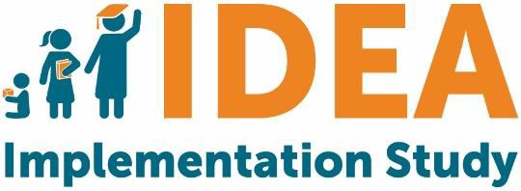 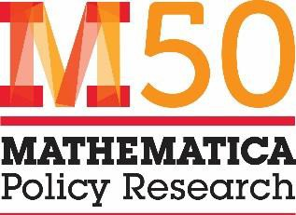

[Address]

[City, State ZIP] [Date]

Dear [First name last name],

OMB #

OMB Expiration Date

I am writing to invite you to take part in the *Individuals with Disabilities Education Act (IDEA) State and Local Implementation Study 2019,* sponsored by the U.S. Department of Education (ED). This important study will develop a national picture of state, district, and school implementation of IDEA. It will provide (1) the Department of Education, Congress, and other stakeholders with knowledge that can inform how services are provided to children, and (2) states, districts, and schools with an understanding of how others are implementing IDEA.

As a recipient of IDEA funding, your state is expected to complete three surveys for this study (Education Department General Administrative Regulations Section, 34 C.F.R. § 76.591). Each survey may take up to one hour to complete. Your participation is needed for the [Part C/Part B 619/Part B 611] survey, which can be taken online at the following location:

* [For Part C Coordinator: Survey focused on services under Part C: [Insert link]]
* [For Part B 619 Coordinator: Survey focused on services under Part B 619: [Insert link]]
* [For Special Education Director: Survey focused on services under Part B 611: [Insert link]]

School districts in your state have been randomly selected to participate as well, as part of a nationally-representative sample. We are asking them to complete two surveys in the fall of 2019, one focused on services for preschool-age children and one focused on school-age children. We have also selected a set of schools in each district to complete one survey each.

ED has selected Mathematica Policy Research, an independent policy research organization, to conduct the study. At this time, Mathematica seeks your state’s participation to ensure a successful survey effort. The integrity of the study requires participation from all states, as well as selected districts and schools. If you have questions about completion of the survey, please direct them to Lisbeth Goble at Mathematica (833-238-7224 or IDEA@mathematica-mpr.com). Questions about the overall study can be directed to Amy Johnson, the Project Director at Mathematica (609-936-2714 or ajohnson@mathematica-mpr.com) or the Project Officer at ED, Erica Johnson (202-245-7676 or Erica.Johnson@ed.gov). The latter two telephone numbers require a toll call.

Mathematica follows the confidentiality and data protection requirements of IES (The Education Sciences Reform Act of 2002, Title I, Part E, Section 183). Responses to this data collection will be used only for research purposes. Please note that data on state policies and resources/supports may be reported by state. Thus, while information about individual respondents will not be released, data displayed by state could be attributed to the state agency or possibly an individual respondent. We will not provide information that identifies respondents to anyone outside the study team, except as required by law.

Thank you in advance for your cooperation with this important effort. Our study team recognizes the many demands placed on state staff and has limited this data collection to only the most important and relevant information.

Sincerely,

[Insert Signature] Amy Johnson

Project Director, *IDEA State and Local Implementation Study*

**Notice of Confidentiality**

Responses to this study’s data collection will be used only for statistical purposes. All information that would permit identification of the state or individual respondent will be kept confidential (per The Education Sciences Reform Act of 2002), will be used only by persons engaged in and for the purposes of the survey, and will not be disclosed or released to others for any purpose except as required by law. Study reports may present information by state.

**Paperwork Reduction Act of 1995**

According to the Paperwork Reduction Act of 1995, no persons are required to respond to a collection of information unless such collection displays a valid OMB control number. Public reporting burden for this collection of information is estimated to average 60 minutes per response, including time for reviewing instructions, searching existing data sources, gathering and maintaining the data needed, and completing and reviewing the collection of information. The obligation to respond to this collection is required to obtain or retain benefit(Education Department General Administrative Regulations Section, 34 C.F.R. § 76.591). If you have comments or concerns regarding the status of your individual submission of this survey, please contact the U.S. Department of Education, 400 Maryland Ave., SW, Washington, DC 20202-4537 or email ICDocketMgr@ed.gov directly. [Note: Please do not return the completed survey to this address.]