APPENDIX B.3

SCHOOL DISTRICT RECRUITMENT LETTER

UNITED STATES DEPARTMENT OF EDUCATION

Dear [TITLE] [LAST NAME]:
We encourage your participation in the Individuals with Disabilities Education Act (IDEA) State and Local Implementation Study 2019, sponsored by the U. S. Department of Education (ED). This important study will develop a national picture of state, district, and school implementation of IDEA. It will provide (1) the Department of Education, Congress, and other stakeholders with knowledge that can inform how services are provided to children, and (2) states, districts, and schools with an understanding of how others are implementing IDEA. This study will not examine your school district’s compliance with IDEA.

Your school district has been randomly selected to participate, as part of a nationally-representative sample. Your district will be asked to complete two surveys, one focused on services for preschool-age children and one focused on school-age children, in Fall 2019. As a recipient of IDEA funding, school districts are expected to complete these surveys (Education Department General Administrative Regulations Section, 34 C.F.R. § 76.591). Along with your district, a set of schools within your district have also been selected to participate by completing one survey each.
Each survey may take up to one hour to complete. These surveys may be collected a second time during the 2022– 2023 school year.

Information collected for this study will be kept strictly confidential. Study reports will present summative information only and no districts or schools will be identified. The study will not collect any information from students or their families, nor any personally identifiable information on students.

ED has selected Mathematica Policy Research, an independent policy research organization, to conduct the study. At this time, Mathematica seeks your district’s participation, to ensure a successful survey effort. The integrity of the study requires participation from selected districts and schools.

If you have questions about completion of the survey, please direct them to Lisbeth Goble at Mathematica (833-238- 7224 or IDEA@mathematica-mpr.com). Questions about the overall study can be directed to Amy Johnson, the Project Director at Mathematica (609-936-2714 or ajohnson@mathematica-mpr.com) or the Project Officer at ED, Erica Johnson (202-245-7676 or Erica.Johnson@ed.gov). The latter two telephone numbers require a toll call.

We thank you in advance for your cooperation with this important effort. We recognize the many demands placed on district and school staff and have sought to limit this data collection to only the most important and relevant information.
Sincerely,

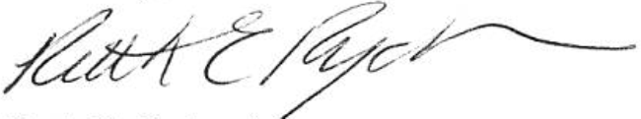

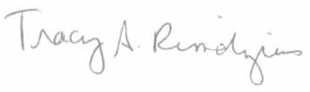
Tracy Rimdzius
Acting Associate Commissioner National Center for Education Evaluation and Regional Assistance Institute of Education Sciences,
U.S. Department of Education
Ruth Ryder Acting Director
Office of Special Education Programs,
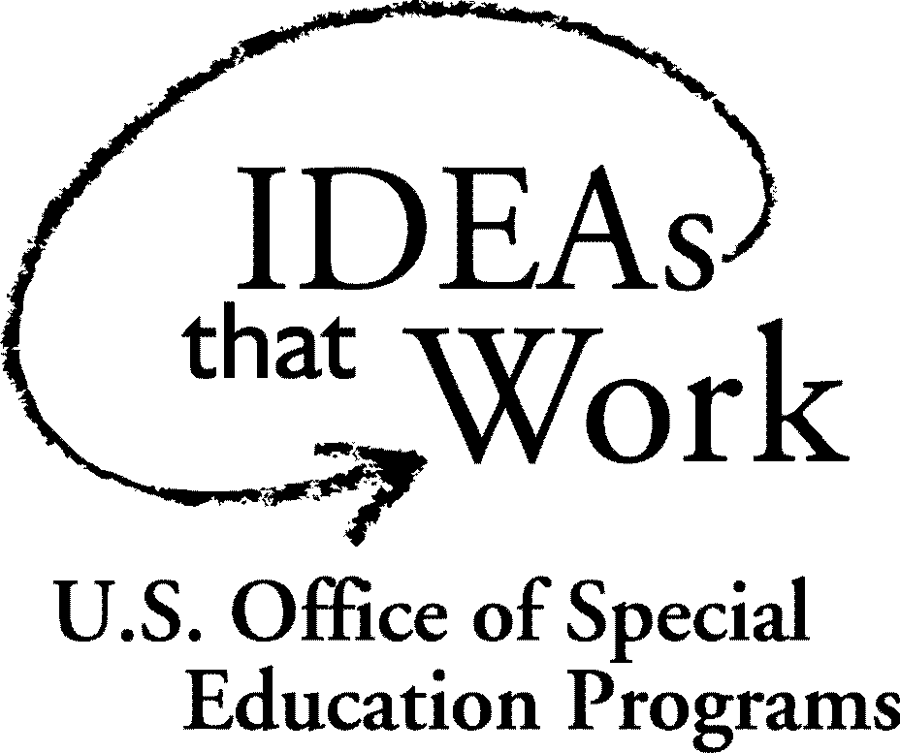
U.S. Department of Education

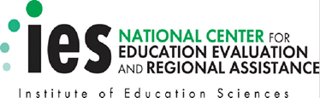

Notice of Confidentiality
Responses to this study’s data collection will be used only for statistical purposes. The reports prepared for this study will summarize findings across the sample and will not associate responses with a specific individual. All information that would permit identification of the district or individual respondent will be kept confidential (per The Education Sciences Reform Act of 2002), will be used only by persons engaged in and for the purposes of the survey, and will not be disclosed or released to others for any purpose except as required by law. Study reports may present information by state.
Paperwork Reduction Act of 1995
According to the Paperwork Reduction Act of 1995, no persons are required to respond to a collection of information unless such collection displays a valid OMB control number. Public reporting burden for this collection of information is estimated to average 60 minutes per response, including time for reviewing instructions, searching existing data sources, gathering and maintaining the data needed, and completing and reviewing the collection of information. The obligation to respond to this collection is required to obtain or retain benefit (Education Department General Administrative Regulations Section, 34 C.F.R. § 76.591). If you have comments or concerns regarding the status of your individual submission of this survey, please contact the U.S. Department of Education, 400 Maryland Ave., SW, Washington, DC 20202-4537 or email ICDocketMgr@ed.gov directly. [Note: Please do not return the completed survey to this address.]

