APPENDIX B.5

SCHOOL DISTRICT PARTICIPATION LETTER

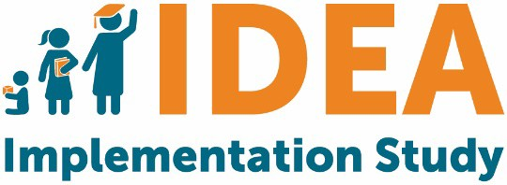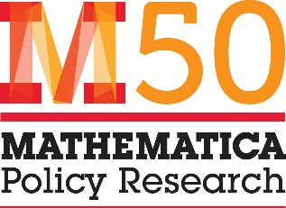
OMB #
OMB Expiration Date

Please review and sign this participation letter and return it to Mathematica using the provided prepaid envelope.

Dear IDEA Implementation Study Team:

I have reviewed the description of the U.S. Department of Education’s IDEA State and Local Implementation Study 2019. I understand that [District] has been selected to participate and, as a recipient of IDEA funding, is expected to complete the evaluation’s online surveys. Mathematica Policy Research, an independent policy research organization, will ask for our cooperation in completing surveys during the 2019–2020 school year and again during the 2022–2023 school year. This effort is not a compliance study or a study of the results or effectiveness of IDEA. The information collected will (1) provide the Department of Education, Congress, and other stakeholders with knowledge that can inform the next reauthorization of IDEA and ultimately how services are provided to children and (2) provide states and districts information on how others are implementing IDEA. Survey responses will be kept confidential and results will be reported in aggregate form only. The study does not involve the sharing of any student-identifying information.

Surveys:
Districts are expected to complete two 60-minute web surveys: one with questions focused on Part B Program for Preschool- Age Children and one on Part B Program for School-Age Children. Below, please indicate the individual who is currently the most appropriate respondent for completing each survey:

Part B Program for Preschool-Age Children
Name: | Title:
Telephone: | Email:

Part B Program for School-Age Children
Name: | Title:
Telephone: | Email:

Schools will be asked to complete one 45-minute survey in each year of data collection. The following schools have been selected to participate in the evaluation. Please add a check mark in box after the school name, if a school will be closed or no longer in your district in school year 2019-2020:

- [SCHOOL 1] Closed? ☐
- [SCHOOL 2] Closed? ☐
- [SCHOOL 3] Closed? ☐
- [SCHOOL 4] Closed? ☐
- [SCHOOL 5] Closed? ☐
- [SCHOOL 6] Closed? ☐
- [SCHOOL 7] Closed? ☐
- [SCHOOL 8] Closed? ☐
- [SCHOOL 9] Closed? ☐
- [SCHOOL 10] Closed? ☐

[District] agrees to participate in the IDEA Implementation Study and complete the requested surveys in school years 2019–20 and 2022–23.
Signed: Name: Title:
District: [District]

Notice of Confidentiality
Responses to this study’s data collection will be used only for statistical purposes. The reports prepared for this study will summarize findings across the sample and will not associate responses with a specific individual. All information that would permit identification of the district or individual respondent will be kept confidential (per The Education Sciences Reform Act of 2002), will be used only by persons engaged in and for the purposes of the survey, and will not be disclosed or released to others for any purpose except as required by law. Study reports may present information by state.
Paperwork Reduction Act of 1995
According to the Paperwork Reduction Act of 1995, no persons are required to respond to a collection of information unless such collection displays a valid OMB control number. Public reporting burden for this collection of information is estimated to average 60 minutes per response, including time for reviewing instructions, searching existing data sources, gathering and maintaining the data needed, and completing and reviewing the collection of information. The obligation to respond to this collection is required to obtain or retain benefit (Education Department General Administrative Regulations Section, 34 C.F.R. § 76.591). If you have comments or concerns regarding the status of your individual submission of this survey, please contact the U.S. Department of Education, 400 Maryland Ave., SW, Washington, DC 20202-4537 or email ICDocketMgr@ed.gov directly. [Note: Please do not return the completed survey to this address.]

