APPENDIX B.7 DISTRICT ADVANCE LETTER

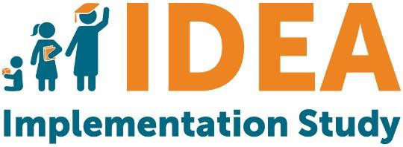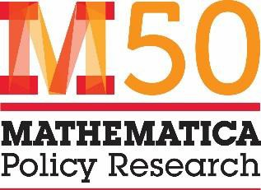

[Address]
[City, State ZIP] [Date]
Dear [First name last name],
OMB #
OMB Expiration Date

I am writing to invite you to take part in the Individuals with Disabilities Education Act (IDEA) State and Local Implementation Study 2019, sponsored by the U.S. Department of Education (ED). This important study will develop a national picture of state, district, and school implementation of IDEA. It will provide (1) the Department of Education, Congress, and other stakeholders with knowledge that can inform how services are provided to children, and (2) states, districts, and schools with an understanding of how others are implementing IDEA. This study will not examine your school district’s compliance with IDEA.

Your school district has been randomly selected to participate in this study, as part of a nationally-representative sample. As a recipient of IDEA funding, your school district is expected to complete two surveys, one focused on services for preschool-age children with disabilities and one focused on school-age children with disabilities (Education Department General Administrative Regulations Section, 34 C.F.R. § 76.591). Each survey may take up to one hour to complete. To complete the surveys online, please go to the following locations:

[FILL WITH APPROPRIATE SURVEY]
- Survey focused on services for preschool-age children with disabilities: [Insert link]
- Survey focused on services for school-age children with disabilities: [Insert link]

ED has selected Mathematica Policy Research, an independent policy research organization, to conduct the study. At this time, Mathematica seeks your district’s participation to ensure a successful survey effort. A set of schools within your district has also been selected to participate, by completing one survey each. The integrity of the study requires participation from all selected districts and schools. If you have questions about completion of the survey, please direct them to Lisbeth Goble at Mathematica (833-238-7224 or IDEA@mathematica-mpr.com).
Questions about the overall study can be directed to Amy Johnson, the Project Director at Mathematica (609-936- 2714 or ajohnson@mathematica-mpr.com) or the Project Officer at ED, Erica Johnson (202-245-7676 or Erica.Johnson@ed.gov). The latter two telephone numbers require a toll call.

Mathematica follows the confidentiality and data protection requirements of IES (The Education Sciences Reform Act of 2002, Title I, Part E, Section 183). The study will not collect any information from students or their families, nor any personally identifiable information on students. Responses to this data collection will be used only for research purposes. The reports prepared for the study will summarize findings across the sample and will not associate responses with a specific district, school, or individual. We will not provide information that identifies respondents to anyone outside the study team, except as required by law.
Thank you in advance for your cooperation with this important effort. Our study team recognizes the many demands placed on school staff and has limited this data collection to only the most important and relevant information.
Sincerely,
[Insert signature] Amy Johnson
Project Director, IDEA State and Local Implementation Study

Notice of Confidentiality
Responses to this study’s data collection will be used only for statistical purposes. The reports prepared for this study will summarize findings across the sample and will not associate responses with a specific individual. All information that would permit identification of the district or individual respondent will be kept confidential (per The Education Sciences Reform Act of 2002), will be used only by persons engaged in and for the purposes of the survey, and will not be disclosed or released to others for any purpose except as required by law. Study reports may present information by state.
Paperwork Reduction Act of 1995
According to the Paperwork Reduction Act of 1995, no persons are required to respond to a collection of information unless such collection displays a valid OMB control number. Public reporting burden for this collection of information is estimated to average 60 minutes per response, including time for reviewing instructions, searching existing data sources, gathering and maintaining the data needed, and completing and reviewing the collection of information. The obligation to respond to this collection is required to obtain or retain benefit (Education Department General Administrative Regulations Section, 34 C.F.R. § 76.591). If you have comments or concerns regarding the status of your individual submission of this survey, please contact the U.S. Department of Education, 400 Maryland Ave., SW, Washington, DC 20202-4537 or email ICDocketMgr@ed.gov directly. [Note: Please do not return the completed survey to this address.]

