*National Center for Education Statistics*

*National Assessment of Educational Progress*

*National Assessment of Education Progress (NAEP)*

*2019 and 2020*

*Long-Term Trend (LTT) 2020 Update*

*Appendix D3*

*Long Term Trend (LTT) 2019- 2020 Communications and Recruitment Materials*

*OMB# 1850-0928 v.15*

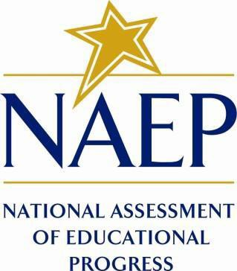

March 2019

**The final versions of LTT 2020 communication materials will be submitted in June 2019, with an associated 30-day public comment period. The following Appendices will be revised from those in Appendix D1 and D2 of this submission (used in NAEP 2019) and added in June 2019 to Appendix D3 (this document) for use in LTT 2020:**

* **Facts for Teachers, Appendix D1-7 (old) - Appendix D3-15 (new)**
* **Templates for State Specific SD Inclusion Policy, Appendix D1-8 (old) - Appendix D3-16 (new)**
* **Templates for State Specific ELL Inclusion Policy, Appendix D1-9 (old) - Appendix D3-17 (new)**
* **Best Practices for Students age 17, Appendix D1-10 (old) - Appendix D3-18 (new)**
* **References for Best Practices, Appendix D1-11 (old) - Appendix D3-19 (new), and**
* **Parent/Guardian Letter in Spanish, translation of Appendix D3-7 and D3-8 - Appendix D3-20 and D3-21 (new).**

**Should any additional revisions be necessary, they will be submitted by October 2019.**

Table of Contents

**Appendix D3-1**: 2019-2020 Facts for Districts 3

**Appendix D3-2**: 2019-2020 Facts for Principals 6

**Appendix D3-3**: 2019-2020 Notification Letter from Chief State School Officer to District Superintendent 10

**Appendix D3-4**: 2020 NAEP in Your School, Public 12

**Appendix D3-5**: 2020 NAEP in Your School, Private 16

**Appendix D3-6**: 2019-2020 Save-the-Date Letter from the NAEP Coordinator to School Principal 19

**Appendix D3-7**: 2019-2020 Parent/ Guardian Notification Letter, Public 21

**Appendix D3-8**: 2020 Parent/ Guardian Notification Letter, Private 23

**Appendix D3-9**: 2020 Private School Endorsement Letter 25

**Appendix D3-10**: 2019-2020 Notification Letter from NAEP State Coordinator to Principals 27

**Appendix D3-11**: 2020 School Coordinator Responsibilities: A Guide to MyNAEP, Public 31

**Appendix D3-12**: 2020 School Coordinator Responsibilities: A Guide to MyNAEP, Private 36

**Appendix D3-13**: 2019-2020 Assessment Details Letter from NAEP State Coordinator to School Coordinator 41

**Appendix D3-14**: 2019-2020 Assessment Details Letter from the NAEP State Coordinator to Principals 44

### **Appendix D3-1**: 2019-2020 Facts for Districts

**NAEP 2019-2020**

**Facts for Districts**

Page One Sidebar

**NAEP is an integral part of education in the United States.**

* Elected officials, policymakers, and educators all use NAEP results to develop ways to improve education.
* NAEP is a congressionally mandated project administered by the National Center for Education Statistics (NCES), within the U.S. Department of Education and the Institute of Education Sciences.
* NAEP serves a different role than state assessments. While states have their own unique assessments with different content standards, the same NAEP assessment is administered in every state, providing a common measure of student achievement.
* Depending on the type of NAEP assessment that is administered, the data can be used to compare and understand the performance of demographic groups within your state, the nation, other states, and districts that participate in the Trial Urban District Assessment (TUDA). NAEP is not designed to collect or report results for individual students, classrooms, or schools.
* To provide a better understanding of educational experiences and factors that may be related to students’ learning, students are asked to complete questionnaires. There are no teacher or school questionnaires in the long- term trend assessment.

Page One Body

*“Informational assessment materials were accessible and easy to understand. The NAEP representative assigned to our school was supportive and very knowledgeable about assessment protocols and what our school needed to do to be well prepared. On testing day, the NAEP team was organized and administered the assessment efficiently.”*

*- Ronda E. George, Assistant Principal, Noe Middle School, Louisville, KY*

**The National Assessment of Educational Progress (NAEP), first administered in 1969,** is the largest nationally representative and continuing assessment of what our nation’s students know and can do in various subjects such as civics, geography, mathematics, reading, science, U.S. history, and writing. The results of NAEP are released as The Nation’s Report Card.

District staff play an essential role in NAEP. Superintendents and district staff can work closely with principals to explain the importance of the assessment to teachers and participating students. When students take part in the assessment and give their best effort, NAEP results provide the most accurate measure possible of student achievement across the country.

NAEP representatives will bring all necessary materials to schools on assessment day. Schools will only need to provide space with desks or tables for students to take the assessment. The table below shows which subjects and student groups will be assessed during the 2019-2020 school year. National results will be released for the long-term trend assessment.

|  |  |  |  |  |  |
| --- | --- | --- | --- | --- | --- |
|  | **The NAEP 2019-2020 Assessment** | | | | |
| **Age or Grade** | **Type of NAEP** | **Subjects** | **Format** | **National Results** | **Assessment Window** |
| **9-year-olds** | Long-term trend | Reading | Paper & Pencil | **√** | **January 6, 2020 – March 13, 2020** |
| Mathematics | Paper & Pencil | **√** |
| **13-year-olds** | Long-term trend | Reading | Paper & Pencil | **√** | **October 14, 2019 – December 20, 2019** |
| Mathematics | Paper & Pencil | **√** |
| **17-year-olds** | Long-term trend | Reading | Paper & Pencil | **√** | **March 16, 2020 – May 22, 2020** |
| Mathematics | Paper & Pencil | **√** |

Page One Footer

For more information about NAEP, visit [www.nces.ed.gov/nationsreportcard](http://www.nces.ed.gov/nationsreportcard).

Page Two Body

**It’s important to know...**

**NAEP long-term trend assessments measure student performance in mathematics and reading and have allowed the performance of today’s students to be compared with students since the early 1970s.** Long-term trend assessments are administered periodically to 9-, 13-, and 17-year-olds.

**Main NAEP is administered to fourth, eighth, and twelfth graders in a variety of subjects.** For all main NAEP and LTT assessments, results are available at the national-level. Depending on the assessment year and subject, main NAEP results may also be available at the state-level and for large urban districts participating in the TUDA program.

**NAEP is considered the gold standard of assessments because of its high technical quality.** From the development of assessment frameworks and questions to the reporting of results, NAEP represents the best thinking of assessment and content specialists, state education staff, and teachers from around the nation. NAEP is a trusted resource that measures student progress and helps inform policy decisions that improve education in the United States.

**NAEP results are reported for different demographic groups and are not reported for individual students or schools.** Within a school, just some of the student population participates, and student responses are combined with those from other participating students to produce the results.

**A carefully designed sampling process ensures that NAEP-selected schools and students are representative of all schools and students across the United States.** To ensure that the sample represents all students in the nation’s schools, a broad range of accommodations are allowed for students with disabilities and English language learners.

**NAEP is designed to cause minimal disruption of classroom instruction.** Including transition time, directions, and completion of a short five-minute questionnaire, it takes approximately 90 minutes for students to complete the NAEP assessment. Each student is assessed in only one subject. Teachers do not need to prepare their students to take the assessment but should encourage students to do their best. NAEP representatives provide significant support to your district’s schools by working with the designated coordinator in each school to organize assessment activities.

**NAEP items can be used as a helpful educational resource in the classroom.** Teachers and district staff can use the NAEP Questions Tool (<http://nces.ed.gov/nationsreportcard/nqt>) to see how students’ performance compares nationally on specific items. Released NAEP items come with a scoring guide, sample student responses, and performance data.

Visit the NAEP website at <http://nces.ed.gov/nationsreportcard> to access this information and more.

*National Center for Education Statistics (NCES) is authorized to conduct NAEP by the National Assessment of Educational Progress Authorization Act (20 U.S.C. §9622). All of the information provided by participants may be used only for statistical purposes and may not be disclosed, or used, in identifiable form for any other purpose except as required by law (20 U.S.C. §9573 and 6 U.S.C. §151). By law, every NCES employee as well as every NCES agent, such as contractors and NAEP coordinators, has taken an oath and is subject to a jail term of up to 5 years, a fine of $250,000, or both if he or she willfully discloses ANY identifiable information about participants. Electronic submission of participant’s information will be monitored for viruses, malware, and other threats by Federal employees and contractors in accordance with the Cybersecurity Enhancement Act of 2015. The collected information will be combined across respondents to produce statistical reports*.

Page Two Footer

Find us on: [insert social media icons]

### **Appendix D3-2**: 2019-2020 Facts for Principals

NAEP 2019-2020 Long-Term Trend

Facts for Principals

Page One Sidebar

**NAEP is an integral part** **of education in the United States**.

* Elected officials, policymakers, and educators all use NAEP results to develop ways to improve education.
* NAEP is a congressionally mandated project administered by the National Center for Education Statistics (NCES), within the U.S. Department of Education and the Institute of Education Sciences.
* NAEP serves a different role than state assessments. While states have their own unique assessments with different content standards, the same NAEP assessment is administered in every state, providing a common measure of student achievement.
* Depending on the type of NAEP assessment that is administered, the data can be used to compare and understand the performance of demographic groups within your state, the nation, other states, and districts that participate in the Trial Urban District Assessment (TUDA). NAEP is not designed to collect or report results for individual students, classrooms, or schools.
  + To provide a better understanding of educational experiences and factors that may be related to students’ learning, students are asked to complete questionnaires. There are no teacher or school questionnaires in the long- term trend assessment.

Page One Body

“The NAEP representatives were informative and provided specific instructions when administering the assessment. Their professionalism and knowledge before the assessment ensured that the students had a positive experience with NAEP.”

—Amneris Montalvo, NAEP School Coordinator, Citrus Grove Middle School, Miami, FL

**The National Assessment of Educational Progress (NAEP), first administered in 1969,** is the largest nationally representative and continuing assessment of what our nation’s students know and can do in various subjects such as civics, geography, mathematics, reading, science, U.S. history, and writing. The results of NAEP are released as The Nation’s Report Card.

NAEP is designed to be minimally disruptive to schools, and NAEP representatives will provide significant support to your school on assessment day. As principals, you make an important contribution to the program by selecting and empowering a NAEP school coordinator, meeting with teachers and participating students, and encouraging your students to participate and do their best. You are essential partners in NAEP. When students participate and give their best effort, NAEP results provide the most accurate measure possible of student achievement across the country.

During the 2019-2020 school year, the NAEP long-term trend assessment will be administered in your school. NAEP long-term trend assessments measure student performance in mathematics and reading, and have allowed the performance of today’s students to be compared with students since the early 1970s. The table below describes the 2019-2020 assessment program for which national results will be available. For more information about the long-term trend assessment, visit [https://nces.ed.gov/nationsreportcard/ltt](https://nces.ed.gov/nationsreportcard/ltt/).

Assessments in mathematics and reading will be conducted with representative samples of 9-, 13-, and 17-year-old students on the following schedule. Each student will be assessed in only one subject.

Age 13: October 14, 2019 – December 20, 2019

Age 9: January 6, 2020 – March 13, 2020

Age 17: March 16, 2020 – May 22, 2020

|  |  |  |  |  |  |
| --- | --- | --- | --- | --- | --- |
|  | **The NAEP 2019-2020 Assessment** | | | | |
| **Age or Grade** | **Type of NAEP** | **Subjects** | **Format** | **National Results** | **Assessment Window** |
| **9-year-olds** | Long-term trend | Reading | Paper & Pencil | **√** | **January 6, 2020 – March 13, 2020** |
| Mathematics | Paper & Pencil | **√** |
| **13-year-olds** | Long-term trend | Reading | Paper & Pencil | **√** | **October 14, 2019 – December 20, 2019** |
| Mathematics | Paper & Pencil | **√** |
| **17-year-olds** | Long-term trend | Reading | Paper & Pencil | **√** | **March 16, 2020 – May 22, 2020** |
| Mathematics | Paper & Pencil | **√** |

Page One Footer

For more information about NAEP, visit [www.nces.ed.gov/nationsreportcard](http://www.nces.ed.gov/nationsreportcard).

Page Two Body

**It’s important to know...**

**NAEP long-term trend assessments measure student performance in mathematics and reading and have allowed the performance of today’s students to be compared with students since the early 1970s.** Long-term trend assessments are administered periodically to 9-, 13-, and 17-year-olds.

**Main NAEP is administered to fourth, eighth, and twelfth graders in a variety of subjects.** For all main NAEP and LTT assessments, results are available at the national-level. Depending on the assessment year and subject, main NAEP results may also be available at the state-level and for large urban districts participating in the TUDA program.

**NAEP is considered the gold standard of assessments because of its high technical quality.** From the development of assessment frameworks and questions to the reporting of results, NAEP represents the best thinking of assessment and content specialists, state education staff, and teachers from around the nation. NAEP is a trusted resource that measures student progress and helps inform policy decisions that improve education in the United States.

**NAEP results are reported for different demographic groups and are not reported for individual students or schools.** Within a school, just some of the student population participates, and student responses are combined with those from other participating students to produce the results.

**A carefully designed sampling process ensures that NAEP-selected schools and students are representative of all schools and students in their district, state, and across the United States.** To ensure that the sample represents all students in the nation’s schools, a broad range of accommodations are allowed for students with disabilities and English language learners.

**NAEP is designed to cause minimal disruption of classroom instruction.** Including transition time, directions, and completion of a short five-minute questionnaire, it takes approximately 90 minutes for students to complete the assessment. Each student is assessed in only one subject. Teachers do not need to prepare their students to take the assessment but should encourage students to do their best. NAEP representatives provide significant support to your school by working with the designated coordinator in your school to organize assessment activities.

**NAEP items can be used as a helpful educational resource in the classroom.** Teachers and district staff can use the NAEP Questions Tool (<http://nces.ed.gov/nationsreportcard/nqt>) to see how students’ performance compares nationally on specific items. Released NAEP items come with a scoring guide, sample student responses, and performance data.

Visit the NAEP website at <http://nces.ed.gov/nationsreportcard>to access this information and more.

*National Center for Education Statistics (NCES) is authorized to conduct NAEP by the National Assessment of Educational Progress Authorization Act (20 U.S.C. §9622). All of the information provided by participants may be used only for statistical purposes and may not be disclosed, or used, in identifiable form for any other purpose except as required by law (20 U.S.C. §9573 and 6 U.S.C. §151). By law, every NCES employee as well as every NCES agent, such as contractors and NAEP coordinators, has taken an oath and is subject to a jail term of up to 5 years, a fine of $250,000, or both if he or she willfully discloses ANY identifiable information about participants. Electronic submission of participant’s information will be monitored for viruses, malware, and other threats by Federal employees and contractors in accordance with the Cybersecurity Enhancement Act of 2015. The collected information will be combined across respondents to produce statistical reports.*

Page Two Footer

Find us on: [insert social media icons]

### **Appendix D3-3**: 2019-2020 Notification Letter from Chief State School Officer to District Superintendent

**Early May NAEP 2019-2020 Notification Letter From**

**CHIEF STATE SCHOOL OFFICER TO DISTRICT SUPERINTENDENT**

**Red text should be customized before mail merge: highlighted text represents mail merge fields**

Dear District Superintendent name,

I am pleased to notify you that number schools in your district have been selected to participate in the 2019-2020 administration of the National Assessment of Educational Progress (NAEP). NAEP is the largest nationally representative and continuing assessment of what students in the United States know and can do in various subjects. It is administered by the National Center for Education Statistics (NCES), within the U.S. Department of Education. Selected schools represent schools across the nation, and their participation provides an accurate picture of student performance. School District will play an important role by participating, and I know that we can count on your full support to make this a meaningful experience for your schools and students.

Selected schools are notified in advance so that principals can place the assessment windows on their calendars and incorporate NAEP into the planned school program. A few additional schools within School District may also be selected at a later date; your NAEP State Coordinator will contact you should this happen. Starting in May 2019 and continuing through June, each school will receive its assessment date. Schools may work with the NAEP State Coordinator if there is a conflict with the scheduled date.

Beginning in October 2019 and continuing through May 2020, NAEP will administer long-term trend (LTT) assessments in mathematics and reading. The attached list of district schools selected for NAEP shows the age group for each selected school.

* Age 13: October 14–December 20, 2019
* Age 9: January 6–March 13, 2020
* Age 17: March 16–May 22, 2020

The data collected can be linked to NAEP assessments conducted in the early 1970s to measure progress over time. National-level results will be released as The Nation’s Report Card. As in previous years, NAEP representatives provide significant support to schools: they bring all necessary materials and equipment, and administer the assessment.

Please include the NAEP assessment windows on your district test calendar. Information about NAEP can be found in the enclosures listed below and at <http://nces.ed.gov/nationsreportcard>. Name, our NAEP State Coordinator, will contact your staff with additional information.

Thank you for supporting this important assessment and for helping accomplish our goal of 100 percent participation.

Sincerely,

Name of Chief State School Officer

Enclosures: List of district schools selected for NAEP

*Facts for Districts* *–* Link for electronic mailing

CC: State Testing Director

District Testing Director

NAEP State Coordinator

*National Center for Education Statistics (NCES) is authorized to conduct NAEP by the National Assessment of Educational Progress Authorization Act (20 U.S.C. §9622). All of the information provided by participants may be used only for statistical purposes and may not be disclosed, or used, in identifiable form for any other purpose except as required by law (20 U.S.C. §9573 and 6 U.S.C. §151). By law, every NCES employee as well as every NCES agent, such as contractors and NAEP coordinators, has taken an oath and is subject to a jail term of up to 5 years, a fine of $250,000, or both if he or she willfully discloses ANY identifiable information about participants. Electronic submission of participant’s information will be monitored for viruses, malware, and other threats by Federal employees and contractors in accordance with the Cybersecurity Enhancement Act of 2015. The collected information will be combined across respondents to produce statistical reports.*

### **Appendix D3-4**: 2020 NAEP in Your School, Public

**NAEP 2020 in Your School**

**Long-Term Trend, Ages 9, 13, 17**

Page One Sidebar

**What is NAEP?**

**The National Assessment of Educational Progress (NAEP) is an essential measurement of student achievement in the United States.**

* First administered in 1969, NAEP is the largest continuing and nationally representative assessment of what our nation’s students know and can do in various subjects such as mathematics and reading.
* The schools and students participating in NAEP make an important contribution by representing other schools and students across the country.
* NAEP is considered the gold standard of assessments because of its high technical quality. From developing frameworks and questions to the reporting of results, NAEP represents the best thinking of assessment and content specialists, state education staff, and teachers from around the nation.
* NAEP is a common measure of academic progress across the nation and over time. The results are released as The Nation's Report Card.

Page One Body

From October 2019 and continuing through May 2020, NAEP field staff will administer the long-term trend assessments in mathematics and reading in schools across the country. Long-term trend (LTT) results can be linked to NAEP assessments first administered in the early 1970s, allowing us to measure progress over a span of nearly 50 years. The age samples for long-term trend assessments are 9-, 13-, and 17-year-olds. The assessment window for each age group is as follows:

* Age 13: October 14, 2019 – December 20, 2019
* Age 9: January 6, 2020 – March 13, 2020
* Age 17: March 16, 2020 – May 22, 2020

Results will be reported at the national level. NAEP data are used by teachers, principals, parents, policymakers, and researchers to assess students’ progress in various subject areas and to develop ways to improve education in the United States.

**What is involved?**

Selected students will participate in paper-based mathematics or reading assessments, and each student will be assessed in only one subject. NAEP representatives will bring all materials and equipment to the school on assessment day. Students will spend up to 90 minutes completing the assessment. This includes transition time, directions, and completion of a student survey questionnaire. The questionnaire provides valuable information about students’ educational experiences and opportunities to learn both inside and outside of the classroom. There will be no school or teacher questionnaires for the long-term trend assessment.

**How many students will be assessed?**

Nationally, across both mathematics and reading and all three age groups, about 48,000 students will be assessed.

For more information about NAEP, visit [www.nces.ed.gov/nationsreportcard](http://www.nces.ed.gov/nationsreportcard).

Page Two Body

**It’s important to know...**

**Who will be responsible for coordinating and administering NAEP?**

Your NAEP State Coordinator, NAEP representatives, and school staff will work together to coordinate and administer the assessment. A member of your school’s staff will need to be assigned to serve as the school coordinator and be the primary contact for the assessment. This person should be:

* familiar with how students participate in statewide assessments; and
* comfortable using a computer to collect and enter student information online.

**The NAEP State Coordinator works at your state department of education and will be responsible for:**

* working with schools to confirm the assessment date;
* communicating with principals about the importance of NAEP and student participation;
* providing schools with instructions for preparing a list of students and information about notifying parents of participating students;
* providing guidance for including students with disabilities and English language learners; and
* responding to questions from the school community throughout the assessment period.

**NAEP representatives employed by a U.S. Department of Education contractor to work directly with schools will be responsible for:**

* selecting a random sample of students from the school list of students in the appropriate age group;
* verifying information that the school coordinator has provided via the MyNAEP website, which will serve as the primary resource and action center throughout the NAEP assessment process;
* working with the school coordinator to finalize assessment logistics;
* bringing all assessment materials to the school on the scheduled day; and
* conducting the assessment.

**Each principal will be responsible for:**

* assigning a school staff member to serve as school coordinator;
* including the NAEP assessment date on the school calendar;
* empowering the designated school coordinator to work with the NAEP representative and NAEP State Coordinator to prepare for the assessment; and
* informing school staff and students about NAEP and why student participation is critically important.

**The school coordinator will be responsible for:**

* confirming the scheduled assessment date with the NAEP State Coordinator;
* registering for the MyNAEP website and providing information about the school;
* if requested, overseeing the submission of an electronic list of students in the appropriate age group;
* using the MyNAEP website to prepare for the assessment;
* informing parents of the assessment (more information will be provided on how to complete this task);
* communicating with the NAEP representative to finalize assessment preparations;
* organizing the availability of school space for the assessment, including room(s) and desks or tables; and
* collaborating with school staff to ensure a high rate of student participation.

**Detailed information about the school coordinator’s responsibilities will be sent at the beginning of the school year.**

*National Center for Education Statistics (NCES) is authorized to conduct NAEP by the National Assessment of Educational Progress Authorization Act (20 U.S.C. §9622). All of the information provided by participants may be used only for statistical purposes and may not be disclosed, or used, in identifiable form for any other purpose except as required by law (20 U.S.C. §9573 and 6 U.S.C. §151). By law, every NCES employee as well as every NCES agent, such as contractors and NAEP coordinators, has taken an oath and is subject to a jail term of up to 5 years, a fine of $250,000, or both if he or she willfully discloses ANY identifiable information about participants. Electronic submission of participant’s information will be monitored for viruses, malware, and other threats by Federal employees and contractors in accordance with the Cybersecurity Enhancement Act of 2015. The collected information will be combined across respondents to produce statistical reports.*

Page Two Footer

Find us on: [**Facebook, Twitter and YouTube logos**]

### **Appendix D3-5**: 2020 NAEP in Your School, Private

**NAEP 2020 in Your Private School**

**Long-Term Trend, Ages 9, 13, and 17**

*Page 1 Sidebar*

**What is NAEP?**

**The National Assessment of Educational Progress (NAEP) is an essential measurement of student achievement in the United States.**

* First administered in 1969, NAEP is the largest continuing and nationally representative assessment of what our nation’s public and private school students know and can do in various subjects.
* NAEP is considered the gold standard of assessments because of its high technical quality. From developing frameworks and questions to the reporting of results, NAEP represents the best thinking of assessment and content specialists and teachers from around the nation.
* The schools and students participating in NAEP make an important contribution by representing other schools and students across the country.
* NAEP is a common measure of academic progress across the nation and over time. The results are released as The Nation’s Report Card.

*Page 1 Text*

**Why assess private schools?**

Private school data are essential for a complete picture of education in the United States and to inform future policy decisions. Private schools represent about 25 percent of schools in the nation and educate approximately 9 percent of its students. NAEP has consistently demonstrated how student performance in private schools compares positively to student performance in public schools.

**Why participate in NAEP?**

Your school has been selected to represent other private schools across the nation, and it is vital that all selected students participate. Doing so helps accurately capture the nation’s student progress. Students who participate in NAEP perform a valuable community service and enable The Nation’s Report Card to provide a more inclusive representation of what our nation’s students know and can do in key subject areas.

NAEP has the support of numerous private school organizations, including the National Association of Independent Schools (NAIS), the National Catholic Educational Association (NCEA), and the Council for American Private Education (CAPE).

**The NAEP 2020 program in your school**

From October 2019 and continuing through May 2020, NAEP field staff will administer the long-term trend assessments in mathematics and reading in public and private schools across the country. Long-term trend (LTT) results can be linked to NAEP assessments first administered in the early 1970s, allowing us to measure progress over a span of nearly 50 years. The age samples for long-term trend assessments are 9-, 13-, and 17-year-olds. The assessment window for each age group is as follows:

* Age 13: October 14, 2019 – December 20, 2019
* Age 9: January 6, 2020 – March 13, 2020
* Age 17: March 16, 2020 – May 22, 2020

Selected students will participate in paper-based mathematics or reading assessments, and each student will be assessed in only one subject. NAEP representatives will bring all materials and equipment to the school on assessment day. Students will spend up to 90 minutes completing the assessment. This includes transition time, directions, and completion of a student survey questionnaire. The questionnaire provides valuable information about students’ educational experiences and opportunities to learn both inside and outside of the classroom. There will be no school or teacher questionnaires for the long-term trend assessment.

*Page 2 Sidebar*:

**For more information about NAEP visit:**

* Program overview <http://nces.ed.gov/nationsreportcard>
* Private school participation <https://nces.ed.gov/nationsreportcard/participating/private_nonpublic.aspx>

*Page 2 Inset:*

*“The Council for American Private Education (CAPE) strongly encourages private schools to participate in NAEP, an essential measure of student achievement in the United States.”*

Michael Schuttloffel

Executive Director, CAPE

*Page 2 Text*:

**What are the responsibilities of NAEP representatives?**

**NAEP representatives work directly with schools and are responsible for:**

* Confirming the assessment date and time with the school;
* Providing schools with instructions for preparing a list of eligible students from which a random sample will be selected for participation in the assessment;
* Providing schools with information about notifying parents of selected students;
* Providing resources, guidelines, and support to assist the school coordinator in completing activities and finalizing assessment arrangements;
* Bringing all assessment materials and equipment to the school on assessment day;
* Conducting the assessments; and
* Responding to questions from the school throughout the assessment period.

**What are the responsibilities of the principal and school coordinator?**

**The principal is responsible for:**

* Including the NAEP assessment date on the school calendar;
* Designating a school coordinator to work with NAEP representatives and to prepare for the assessment; and
* Informing school staff about NAEP and why participation is critically important.

**The school coordinator is responsible for:**

* Confirming that the suggested assessment date works with the school calendar;
* Securing space for the assessment to take place;
* Providing a list of eligible students from which a random sample will be selected for participation in the assessment (student and school names will not be included in any reports);*
* Informing parents about the assessment;
* Completing preassessment activities with guidance and support from NAEP representatives; and
* Ensuring that students attend the session on the assessment date.

Find us on:

[**Facebook, Twitter and YouTube logos**]

*\* National Center for Education Statistics (NCES) is authorized to conduct NAEP by the National Assessment of Educational Progress Authorization Act (20 U.S.C. §9622). All of the information provided by participants may be used only for statistical purposes and may not be disclosed, or used, in identifiable form for any other purpose except as required by law (20 U.S.C. §9573 and 6 U.S.C. §151). By law, every NCES employee as well as every NCES agent, such as contractors and NAEP coordinators, has taken an oath and is subject to a jail term of up to 5 years, a fine of $250,000, or both if he or she willfully discloses ANY identifiable information about participants. Electronic submission of participant’s information will be monitored for viruses, malware, and other threats by Federal employees and contractors in accordance with the Cybersecurity Enhancement Act of 2015. The collected information will be combined across respondents to produce statistical reports.*

### **Appendix D3-6**: 2019-2020 Save-the-Date Letter from the NAEP Coordinator to School Principal

**NAEP 2019–2020 Save-the-Date Letter From**

**NAEP STATE COORDINATOR TO SCHOOL PRINCIPAL – For All Sampled Schools**

**Red text should be customized before mail merge; highlighted text represents mail merge fields**

Save the date! NAEP is coming on assessment date.

Dear Principal:

In May, I notified you that school name was selected to participate in the 2019–2020 administration of the National Assessment of Educational Progress (NAEP). This letter includes the scheduled assessment date for your school.

Age-year-olds from your school will take the assessment on assessment date. Please place the NAEP assessment date on your 2019–2020 school calendar. Approximately estimated student sample students from your school will be selected to participate, but that number will vary depending on actual fall 2019 student enrollment numbers. The assessment will take about 90 minutes for most students, including transition time, directions, and completion of a survey questionnaire. NAEP representatives will provide significant support to your school, bring all necessary materials and equipment, and administer the assessment.

If you have questions or a conflict with the scheduled assessment date, please contact me at telephone number or email address by date. I will send you more information about preparing for the assessment at the beginning of the school year.

NAEP is a common measure of student achievement across the country and is used to inform education policies and practices. Schools and students have an important role in ensuring that NAEP results are accurate. Our goal is 100 percent participation in this important assessment, and we know that we can count on you to help us reach it.

Sincerely,

NAEP State Coordinator

CC: District Test Coordinator

Enclosure: *NAEP in Your School* *2019–2020*

*National Center for Education Statistics (NCES) is authorized to conduct NAEP by the National Assessment of Educational Progress Authorization Act (20 U.S.C. §9622). All of the information provided by participants may be used only for statistical purposes and may not be disclosed, or used, in identifiable form for any other purpose except as required by law (20 U.S.C. §9573 and 6 U.S.C. §151). By law, every NCES employee as well as every NCES agent, such as contractors and NAEP coordinators, has taken an oath and is subject to a jail term of up to 5 years, a fine of $250,000, or both if he or she willfully discloses ANY identifiable information about participants. Electronic submission of participant’s information will be monitored for viruses, malware, and other threats by Federal employees and contractors in accordance with the Cybersecurity Enhancement Act of 2015. The collected information will be combined across respondents to produce statistical reports.*

### **Appendix D3-7**: 2019-2020 Parent/ Guardian Notification Letter, Public

**NAEP 2019–2020 PARENT/GUARDIAN NOTIFICATION LETTER**

(School Letterhead)

**(Insert Date Here)**

Dear Parent or Guardian:

(School name) will participate in the National Assessment of Educational Progress (NAEP) on (date). NAEP is the largest nationally representative and continuing assessment of what students know and can do in various subjects. NAEP is administered by the National Center for Education Statistics, within the U.S. Department of Education. NAEP is different from our state assessments because it is a common measure of achievement across the country. The results are released as The Nation’s Report Card, which provides information about student achievement to educators, parents, policymakers, and the public.

Your child (will/may) take a mathematics or reading assessment. In addition to subject area questions, NAEP questionnaires are voluntarily completed by students. The questionnaires help by providing valuable information about participating students’ educational experiences and opportunities to learn both in and out of the classroom. More information about NAEP questionnaires is available at <https://nces.ed.gov/nationsreportcard/parents> under the section “What Questions Are on the Test?”

The assessment takes about 90 minutes for most students, including transition time and directions.

**The information collected is used for statistical purposes only.**

* Your child’s grades will not be affected.
* Students may be excused for any reason, are not required to complete the assessment, and may skip any question.
* While the assessment is voluntary, NAEP depends on student participation to help policymakers improve education. However, if you do not want your child to participate, please notify me in writing by (date).

There is no need to study in preparation for NAEP, but please encourage your child to do his or her best. A brochure that explains what participation in NAEP means for you and your child is available at <http://nces.ed.gov/nationsreportcard/pdf/parents/2012469.pdf>. Contact (name) at (telephone number) or at (email address) if you have any questions.

We are excited that our school is participating in NAEP. We know that (school name)’s students will show what our nation’s students know and can do.

Sincerely,

(School Principal’s Name)

*National Center for Education Statistics (NCES) is authorized to conduct NAEP by the National Assessment of Educational Progress Authorization Act (20 U.S.C. §9622) and to collect students’ education records from education agencies or institutions for the purposes of evaluating federally supported education programs under the Family Educational Rights and Privacy Act (FERPA, 34 CFR §§ 99.31(a)(3)(iii) and 99.35). All of the information provided by participants may be used only for statistical purposes and may not be disclosed, or used, in identifiable form for any other purpose except as required by law (20 U.S.C. §9573 and 6 U.S.C. §151). By law, every NCES employee as well as every NCES agent, such as contractors and NAEP coordinators, has taken an oath and is subject to a jail term of up to 5 years, a fine of $250,000, or both if he or she willfully discloses ANY identifiable information about participants. Electronic submission of participant’s information will be monitored for viruses, malware, and other threats by Federal employees and contractors in accordance with the Cybersecurity Enhancement Act of 2015. The collected information will be combined across respondents to produce statistical reports.*

### **Appendix D3-8**: 2020 Parent/ Guardian Notification Letter, Private

**NAEP 2020 PARENT/GUARDIAN NOTIFICATION LETTER PRIVATE SCHOOL**

(School Letterhead)

**(Insert Date Here)**

Dear Parent or Guardian:

We are pleased to notify you that (school name) has been selected to represent private schools across the nation by participating in the National Assessment of Educational Progress (NAEP) on (date). NAEP is the largest nationally representative and continuing assessment of what students in public and private schools know and can do in various subjects. It is administered by the National Center for Education Statistics, within the U.S. Department of Education. NAEP is different from state and school assessments because it provides a common measure of student achievement across the country. The results are released as The Nation’s Report Card, which provides information about student achievement to educators, parents, policymakers, and the public.

Your child (will/may) take an assessment in mathematics or reading. In addition to subject-area questions, NAEP questionnaires are voluntarily completed by students. The questionnaires provide valuable information about participating students’ educational experiences and opportunities to learn both in and out of the classroom. More information is available at <https://nces.ed.gov/nationsreportcard/parents> under the section “What Questions Are on the Test?”

The assessment takes about 90 minutes for most students, including transition time and directions.

**The information collected is used for statistical purposes only.**

* Your child’s grades will not be affected.
* Students may be excused for any reason, are not required to complete the assessment, and may skip any question.
* While the assessment is voluntary, NAEP depends on student participation to help policymakers improve education. However, if you do not want your child to participate, please notify me in writing by (date).

There is no need to study in preparation for NAEP, but please encourage your child to do his or her best. A brochure that explains what participation in NAEP means for you and your child is available at <https://nces.ed.gov/nationsreportcard/pdf/parents/2012469.pdf>. Contact (name) at (telephone number), or at (email address) if you have any questions. To learn more about private school participation in NAEP, visit <https://nces.ed.gov/nationsreportcard/participating/private_nonpublic.aspx>.

We are excited that our school is participating in NAEP. We know that (school name)'s students will show what our nation’s students in private schools know and can do.

Sincerely,

School Principal

*National Center for Education Statistics (NCES) is authorized to conduct NAEP by the National Assessment of Educational Progress Authorization Act (20 U.S.C. §9622) and to collect students’ education records from education agencies or institutions for the purposes of evaluating federally supported education programs under the Family Educational Rights and Privacy Act (FERPA, 34 CFR §§ 99.31(a)(3)(iii) and 99.35). All of the information provided by participants may be used only for statistical purposes and may not be disclosed, or used, in identifiable form for any other purpose except as required by law (20 U.S.C. §9573 and 6 U.S.C. §151). By law, every NCES employee as well as every NCES agent, such as contractors and NAEP coordinators, has taken an oath and is subject to a jail term of up to 5 years, a fine of $250,000, or both if he or she willfully discloses ANY identifiable information about participants. Electronic submission of participant’s information will be monitored for viruses, malware, and other threats by Federal employees and contractors in accordance with the Cybersecurity Enhancement Act of 2015. The collected information will be combined across respondents to produce statistical reports.*

*.*

### **Appendix D3-9**: 2020 Private School Endorsement Letter

**NAEP 2020 Sample Endorsement Letter**

**From Private School Organization to Private School Administrator**

**Red text should be customized and letter should be finalized on organization letterhead**

Spring 2019

Dear Administrator:

I am writing to encourage you to participate in the 2020 National Assessment of Educational Progress (NAEP). Your decision has important implications for the entire private school community.

First administered in 1969, NAEP is the largest continuing and nationally representative measure of private and public school student achievement across the country. Your school’s participation will help make it possible for private school data to be reported and contribute to the picture of education across the nation and to future policy decisions. NAEP data have consistently shown across subjects and over time that students in private schools score higher than students in public schools.

Private schools account for about 25 percent of all schools in the nation and educate approximately 9 percent of all school children across the country. Therefore, it is important that our students' performance be included in all data that describe the condition of education in the United States. With your support, private schools can achieve excellent participation, and private school results can be reported.

A NAEP representative will contact you soon to discuss assessment details. In the meantime, please visit the NAEP website at https://nces.ed.gov/nationsreportcard for complete information about NAEP. For information for private schools, including a short four-minute video in which heads of school and teachers discuss their experiences with NAEP and the value of participating, visit <https://nces.ed.gov/nationsreportcard/participating/private_nonpublic.aspx>.

NAEP representatives will administer the assessment and provide all materials and equipment necessary to conduct the assessment. The assessment will only take about 90 minutes, including transition time and directions, and NAEP representatives will work closely with you to schedule the assessment at a time convenient for your school and students.

For the benefit of the private school community and to provide the most accurate information about student achievement in the United States, I strongly urge you to participate. Our goal is 100 percent school participation, and I am counting on you to help us reach that goal.

If you have questions or concerns about participating in NAEP, please contact [private school organization contact person and contact information] OR Mary Erbe at 502-459-0478 or maryerbe@naepmail.westat.com.

Sincerely,

[Name]

Private School Organization

Title

### 

### **Appendix D3-10**: 2019-2020 Notification Letter from NAEP State Coordinator to Principals

**May NAEP 2019**–**2020 Notification Letter From**

**NAEP STATE COORDINATOR TO SCHOOL PRINCIPAL: For LTT Age 9**

**Red text should be customized before mail merge; highlighted text represents mail merge fields**

Dear Principal,

I am pleased to inform you that school name has been selected to represent schools across the nation by participating in the 2019–2020 administration of the National Assessment of Educational Progress (NAEP). NAEP is the largest nationally representative and continuing assessment of what students in the United States know and can do in various subjects. It is administered by the National Center for Education Statistics (NCES), within the U.S. Department of Education. As part of the NAEP 2019–2020 program, students will participate in mathematics and reading long-term trend assessments. Each student will be assessed in only one subject. Results will be released as The Nation’s Report Card.

The long-term trend (LTT) data collected can be linked to NAEP assessments conducted in the early 1970s to measure progress over time. The age samples for the NAEP long-term trend assessments are 9-, 13-, and 17-year-olds. For now, I am writing only to notify you of the assessment. In June, I will send you an assessment date. If the date presents a conflict for your school, we will work together to identify an alternate. Our goal is to schedule the assessment prior to the beginning of the school year so that you may include the assessment date on your 2019–2020 school calendar.

At the beginning of the school year, I will send you detailed assessment information and will ask you to identify a school coordinator, provide a student list, and submit additional information. NAEP representatives will provide significant support to your school by administering the assessment and bringing all materials and equipment. Outlined below is a broad overview of the assessment:

* **Subjects:** Mathematics and reading
* **Students to be assessed:** 9-year-olds
* **Assessment window:** January 6–March 13, 2020
* **Assessment duration:** Approximately 90 minutes for students
* **Assessment administrator:** NAEP representatives

More information about NAEP can be found in the enclosures listed below and at <http://nces.ed.gov/nationsreportcard/ltt/>. If you have questions, please contact me at telephone number or via email at email address.

Our chief state school officer, name, and your district superintendent, name, support NAEP and look forward to your school’s participation. We know that we can count on you to help reach our goal of 100 percent participation.

Sincerely,

NAEP State Coordinator

Enclosures: *Facts for Principals –* Link for electronic mailing

CC: District Test Director

*National Center for Education Statistics (NCES) is authorized to conduct NAEP by the National Assessment of Educational Progress Authorization Act (20 U.S.C. §9622) and to collect students’ education records from education agencies or institutions for the purposes of evaluating federally supported education programs under the Family Educational Rights and Privacy Act (FERPA, 34 CFR §§ 99.31(a)(3)(iii) and 99.35). All of the information provided by participants may be used only for statistical purposes and may not be disclosed, or used, in identifiable form for any other purpose except as required by law (20 U.S.C. §9573 and 6 U.S.C. §151). By law, every NCES employee as well as every NCES agent, such as contractors and NAEP coordinators, has taken an oath and is subject to a jail term of up to 5 years, a fine of $250,000, or both if he or she willfully discloses ANY identifiable information about participants. Electronic submission of participant’s information will be monitored for viruses, malware, and other threats by Federal employees and contractors in accordance with the Cybersecurity Enhancement Act of 2015. The collected information will be combined across respondents to produce statistical reports.*

**May NAEP 2019**–**2020 Notification Letter From**

**NAEP STATE COORDINATOR TO SCHOOL PRINCIPAL: For LTT Age 13**

**Red text should be customized before mail merge; highlighted text represents mail merge fields**

Dear Principal,

I am pleased to inform you that school name has been selected to represent schools across the nation by participating in the 2019–2020 administration of the National Assessment of Educational Progress (NAEP). NAEP is the largest nationally representative and continuing assessment of what students in the United States know and can do in various subjects. It is administered by the National Center for Education Statistics (NCES), within the U.S. Department of Education. As part of the NAEP 2019–2020 program, students will participate in mathematics and reading long-term trend assessments. Each student will be assessed in only one subject. Results will be released as The Nation’s Report Card.

The long-term trend (LTT) data collected can be linked to NAEP assessments conducted in the early 1970s to measure progress over time. The age samples for the NAEP long-term trend assessments are 9-, 13-, and 17-year-olds. For now, I am writing only to notify you of the assessment. In June, I will send you an assessment date. If the date presents a conflict for your school, we will work together to identify an alternate. Our goal is to schedule the assessment prior to the beginning of the school year so that you may include the assessment date on your 2019–2020 school calendar.

At the beginning of the school year, I will send you detailed assessment information and will ask you to identify a school coordinator, provide a student list, and submit additional information. NAEP representatives will provide significant support to your school by administering the assessment and bringing all materials and equipment. Outlined below is a broad overview of the assessment:

* **Subjects:** Mathematics and reading
* **Students to be assessed:** 13-year-olds
* **Assessment window:** October 14–December 20, 2019
* **Assessment duration:** Approximately 90 minutes for students
* **Assessment administrator:** NAEP representatives

More information about NAEP can be found in the enclosures listed below and at <http://nces.ed.gov/nationsreportcard/ltt/>. If you have questions, please contact me at telephone number or via email at email address.

Our chief state school officer, name, and your district superintendent, name, support NAEP and look forward to your school’s participation. We know that we can count on you to help reach our goal of 100 percent participation.

Sincerely,

NAEP State Coordinator

Enclosures: *Facts for Principals –* Link for electronic mailing

CC: District Test Director

*National Center for Education Statistics (NCES) is authorized to conduct NAEP by the National Assessment of Educational Progress Authorization Act (20 U.S.C. §9622) and to collect students’ education records from education agencies or institutions for the purposes of evaluating federally supported education programs under the Family Educational Rights and Privacy Act (FERPA, 34 CFR §§ 99.31(a)(3)(iii) and 99.35). All of the information provided by participants may be used only for statistical purposes and may not be disclosed, or used, in identifiable form for any other purpose except as required by law (20 U.S.C. §9573 and 6 U.S.C. §151). By law, every NCES employee as well as every NCES agent, such as contractors and NAEP coordinators, has taken an oath and is subject to a jail term of up to 5 years, a fine of $250,000, or both if he or she willfully discloses ANY identifiable information about participants. Electronic submission of participant’s information will be monitored for viruses, malware, and other threats by Federal employees and contractors in accordance with the Cybersecurity Enhancement Act of 2015. The collected information will be combined across respondents to produce statistical reports.*

**May NAEP 2019**–**2020 Notification Letter From**

**NAEP STATE COORDINATOR TO SCHOOL PRINCIPAL: For LTT Age 17**

**Red text should be customized before mail merge; highlighted text represents mail merge fields**

Dear Principal,

I am pleased to inform you that school name has been selected to represent schools across the nation by participating in the 2019–2020 administration of the National Assessment of Educational Progress (NAEP). NAEP is the largest nationally representative and continuing assessment of what students in the United States know and can do in various subjects. It is administered by the National Center for Education Statistics (NCES), within the U.S. Department of Education. As part of the NAEP 2019–2020 program, students will participate in mathematics and reading long-term trend assessments. Each student will be assessed in only one subject. Results will be released as The Nation’s Report Card.

The long-term trend (LTT) data collected can be linked to NAEP assessments conducted in the early 1970s to measure progress over time. The age samples for the NAEP long-term trend assessments are 9-, 13-, and 17-year-olds. For now, I am writing only to notify you of the assessment. In June, I will send you an assessment date. If the date presents a conflict for your school, we will work together to identify an alternate. Our goal is to schedule the assessment prior to the beginning of the school year so that you may include the assessment date on your 2019–2020 school calendar.

At the beginning of the school year, I will send you detailed assessment information and will ask you to identify a school coordinator, provide a student list, and submit additional information. NAEP representatives will provide significant support to your school by administering the assessment and bringing all materials and equipment. Outlined below is a broad overview of the assessment:

* **Subjects:** Mathematics and reading
* **Students to be assessed:** 17-year-olds
* **Assessment window:** March 16–May 22, 2020
* **Assessment duration:** Approximately 90 minutes for students
* **Assessment administrator:** NAEP representatives

More information about NAEP can be found in the enclosures listed below and at <http://nces.ed.gov/nationsreportcard/ltt/>. If you have questions, please contact me at telephone number or via email at email address.

Our chief state school officer, name, and your district superintendent, name, support NAEP and look forward to your school’s participation. We know that we can count on you to help reach our goal of 100 percent participation.

Sincerely,

NAEP State Coordinator

Enclosures: *Facts for Principals –* Link for electronic mailing

CC: District Test Director

*National Center for Education Statistics (NCES) is authorized to conduct NAEP by the National Assessment of Educational Progress Authorization Act (20 U.S.C. §9622) and to collect students’ education records from education agencies or institutions for the purposes of evaluating federally supported education programs under the Family Educational Rights and Privacy Act (FERPA, 34 CFR §§ 99.31(a)(3)(iii) and 99.35). All of the information provided by participants may be used only for statistical purposes and may not be disclosed, or used, in identifiable form for any other purpose except as required by law (20 U.S.C. §9573 and 6 U.S.C. §151). By law, every NCES employee as well as every NCES agent, such as contractors and NAEP coordinators, has taken an oath and is subject to a jail term of up to 5 years, a fine of $250,000, or both if he or she willfully discloses ANY identifiable information about participants. Electronic submission of participant’s information will be monitored for viruses, malware, and other threats by Federal employees and contractors in accordance with the Cybersecurity Enhancement Act of 2015. The collected information will be combined across respondents to produce statistical reports.*

### **Appendix D3-11**: 2020 School Coordinator Responsibilities: A Guide to MyNAEP, Public

### 

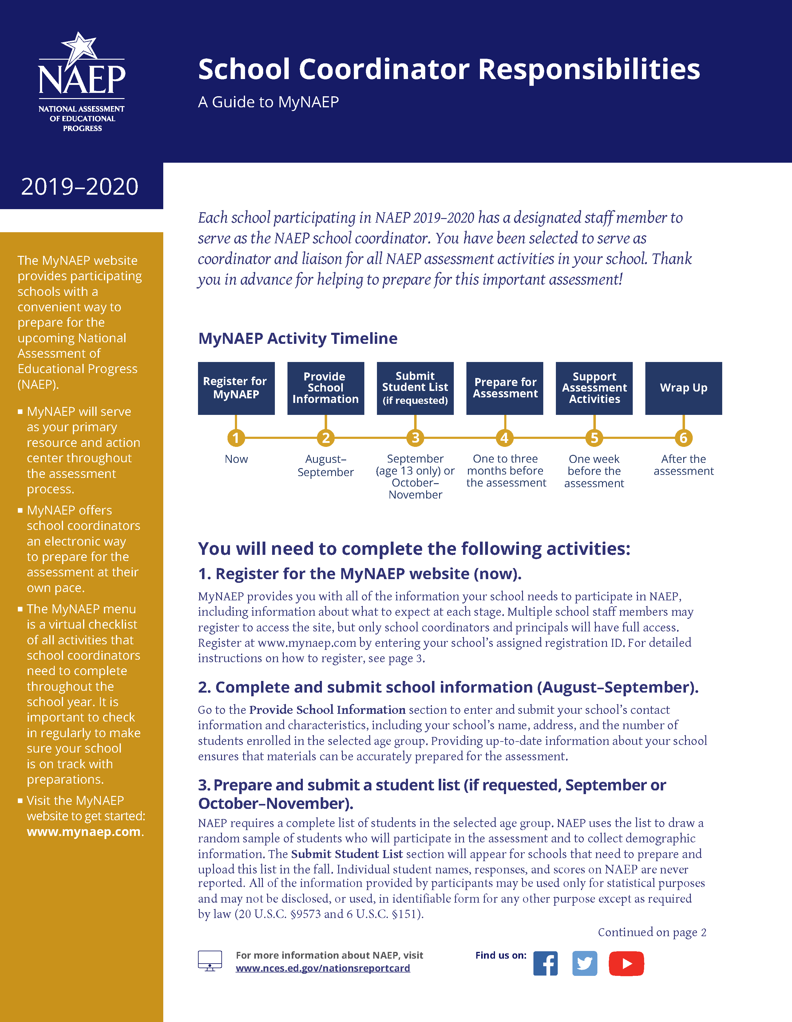

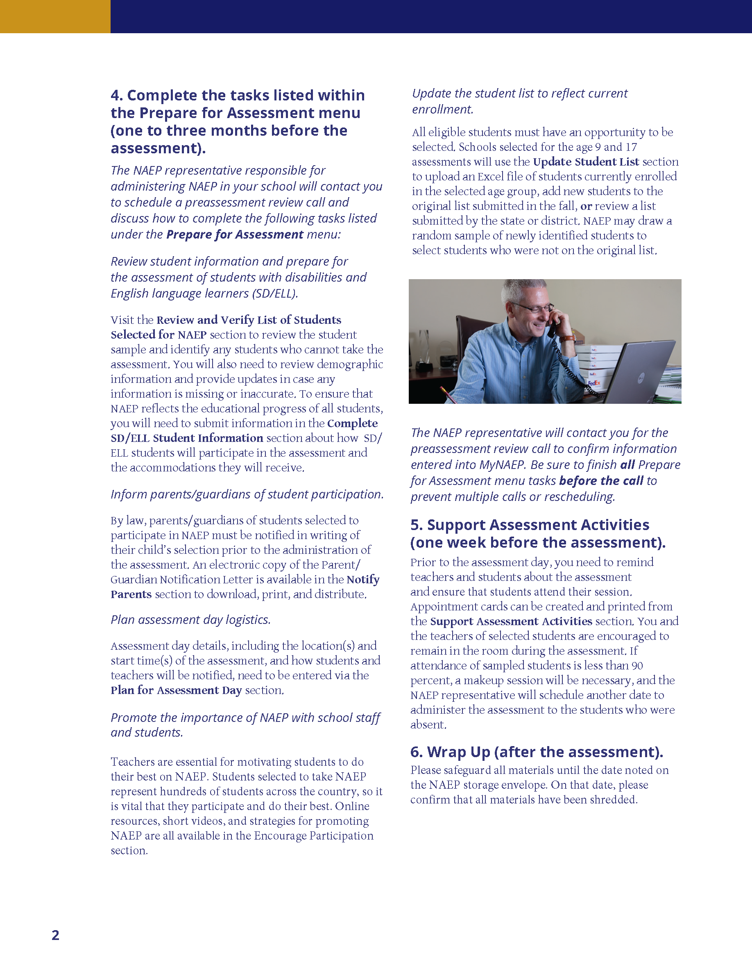

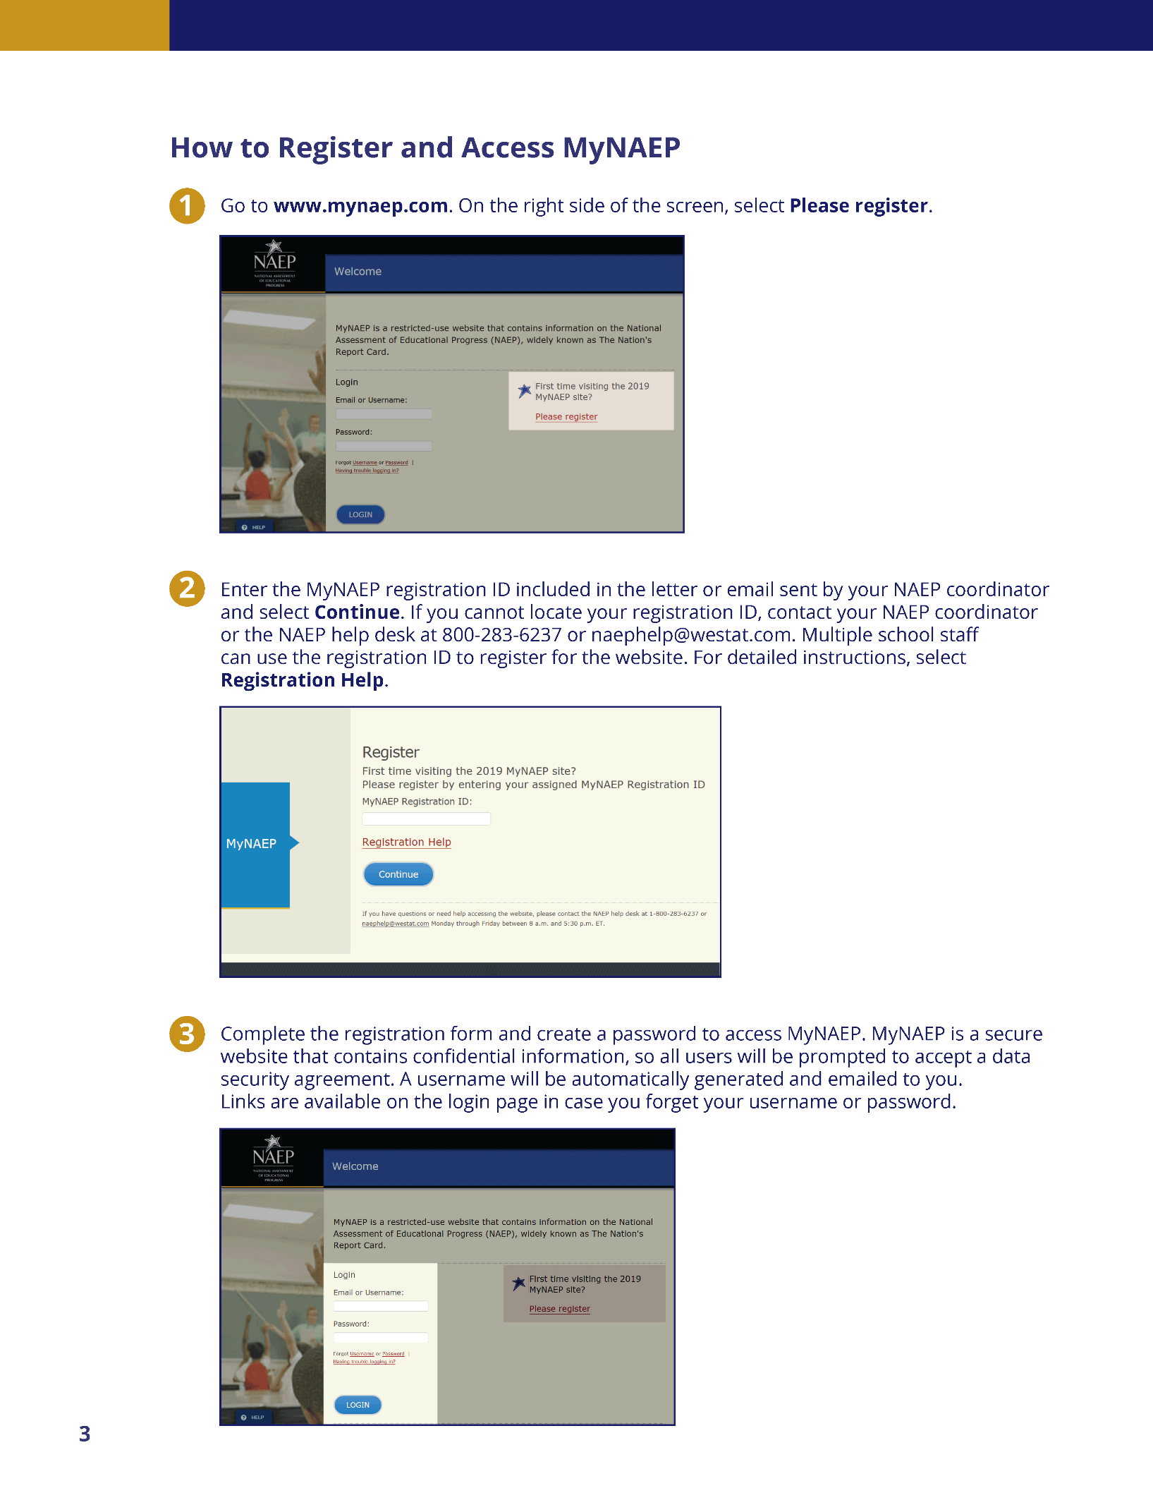

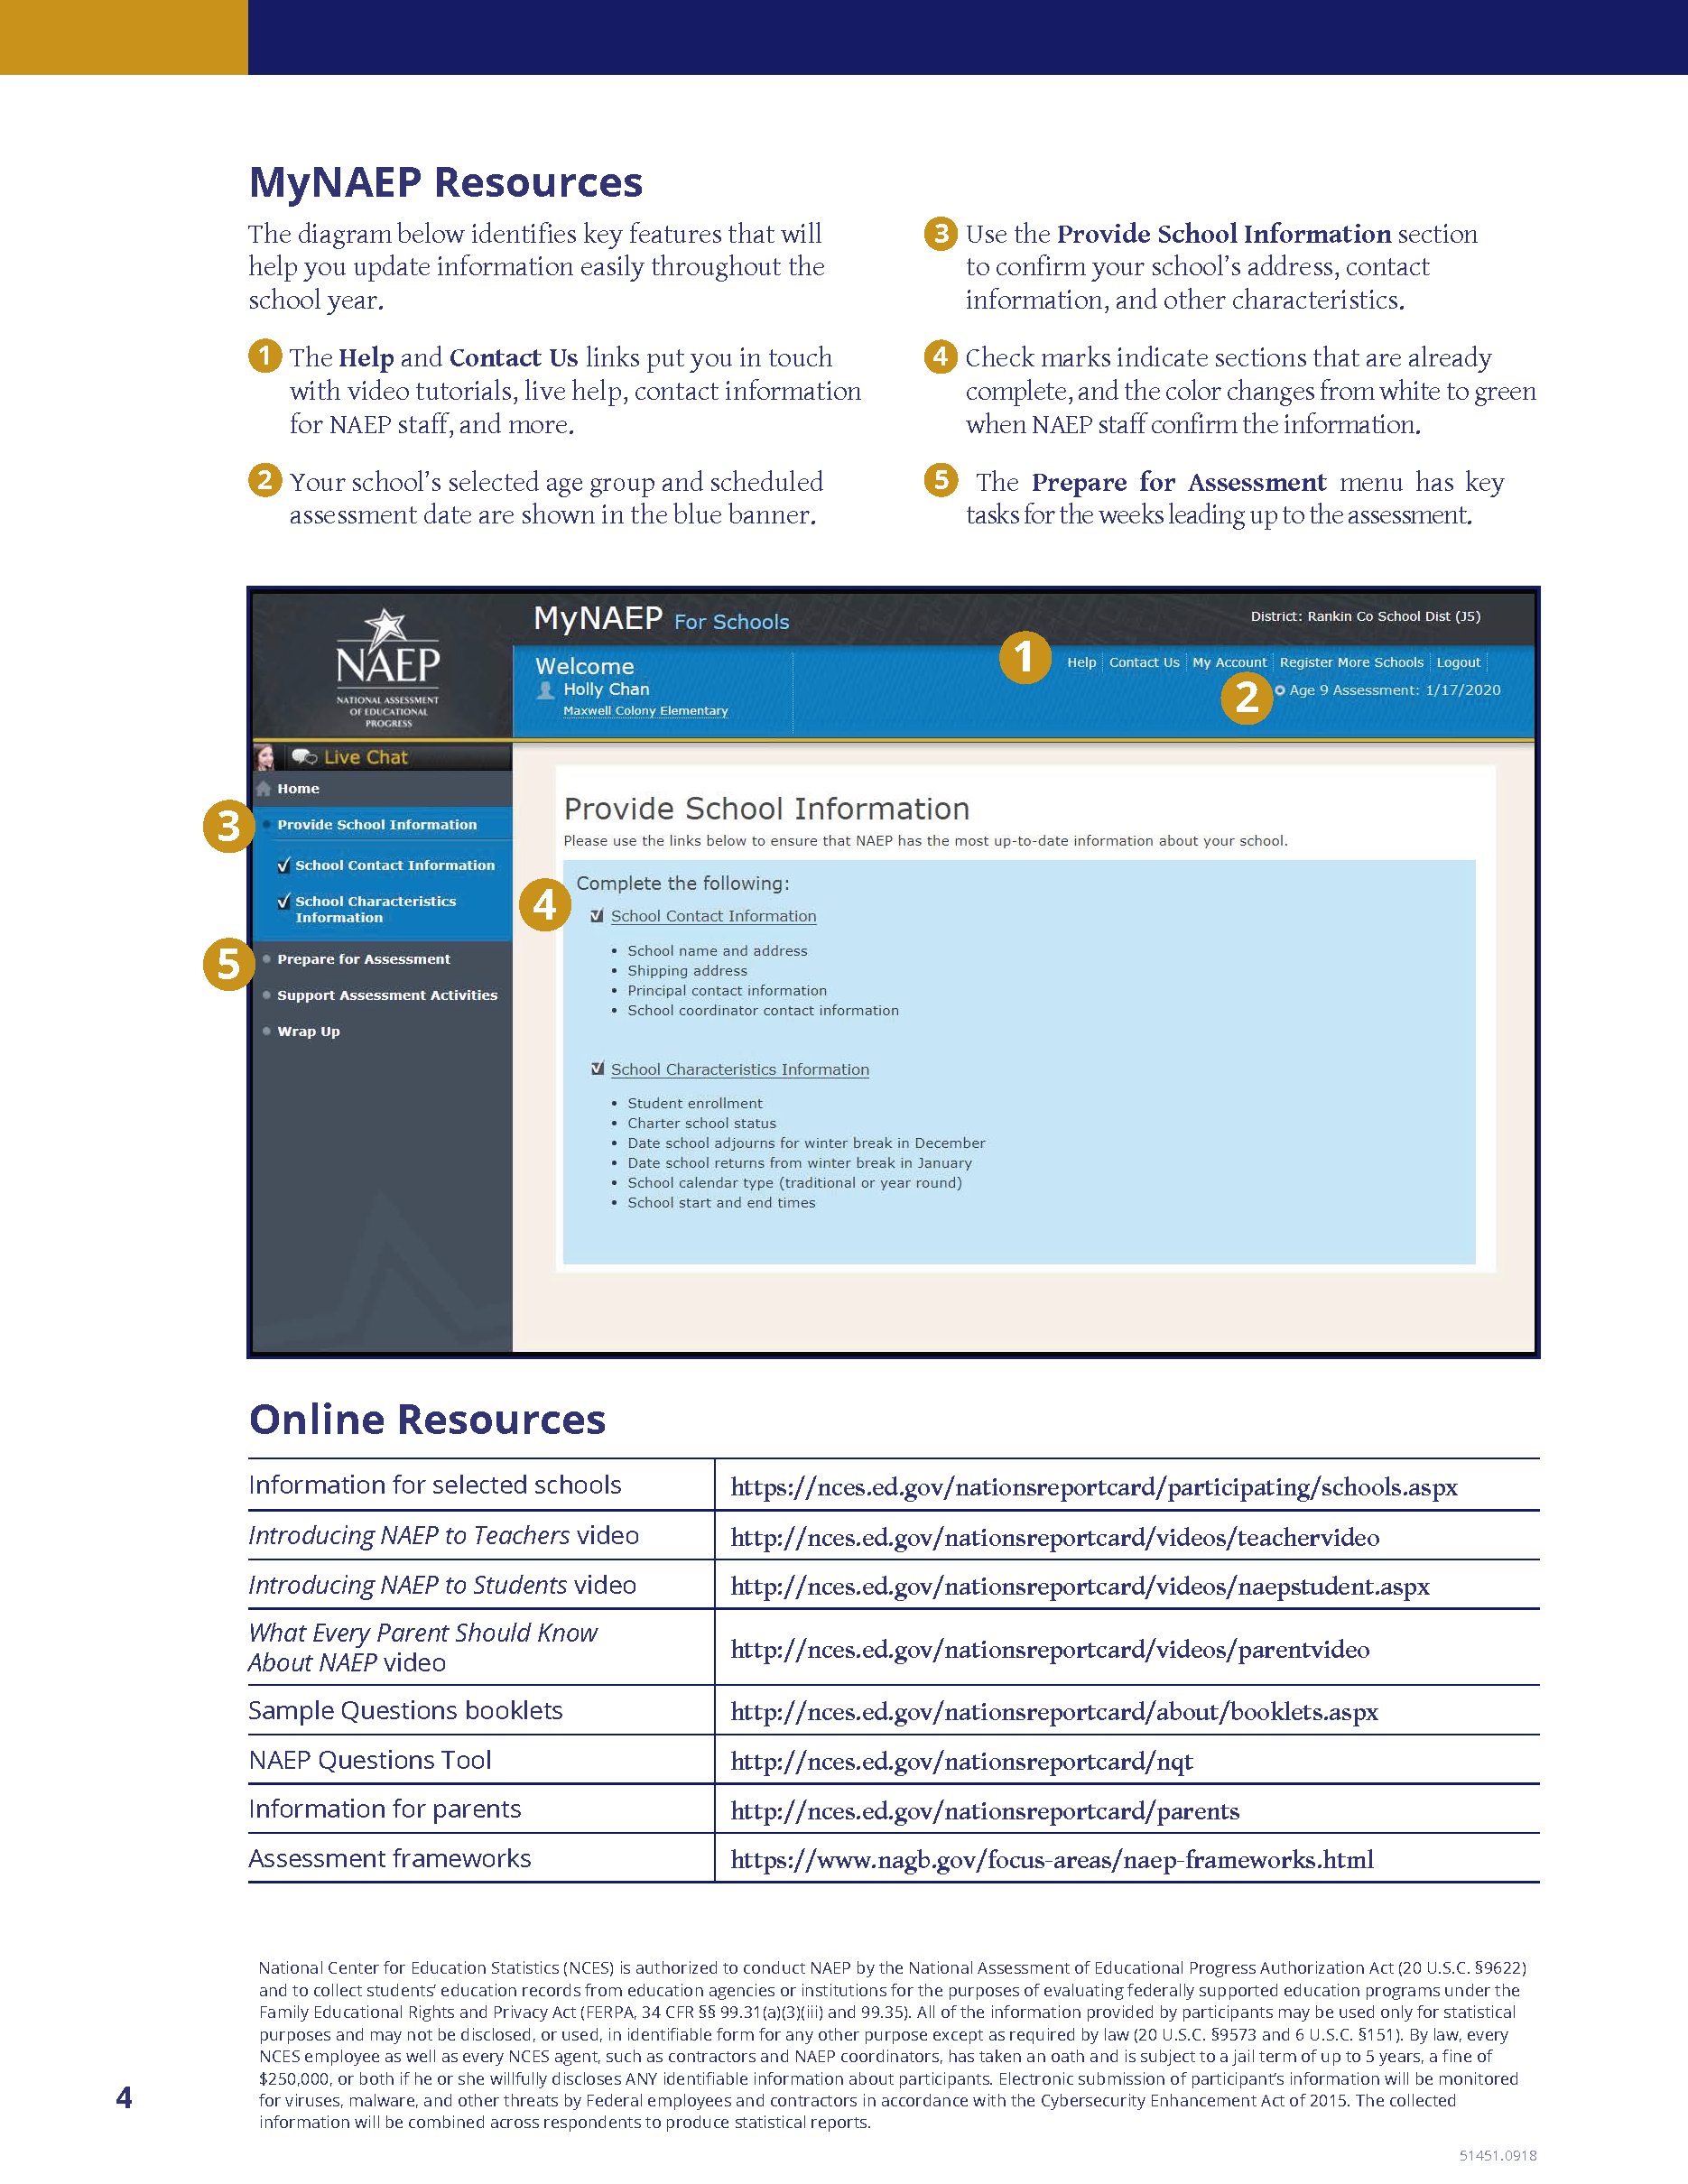

### **Appendix D3-12**: 2020 School Coordinator Responsibilities: A Guide to MyNAEP, Private

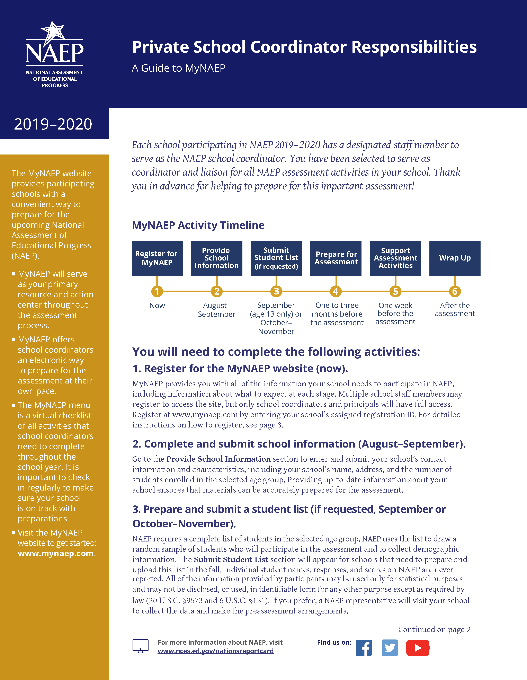

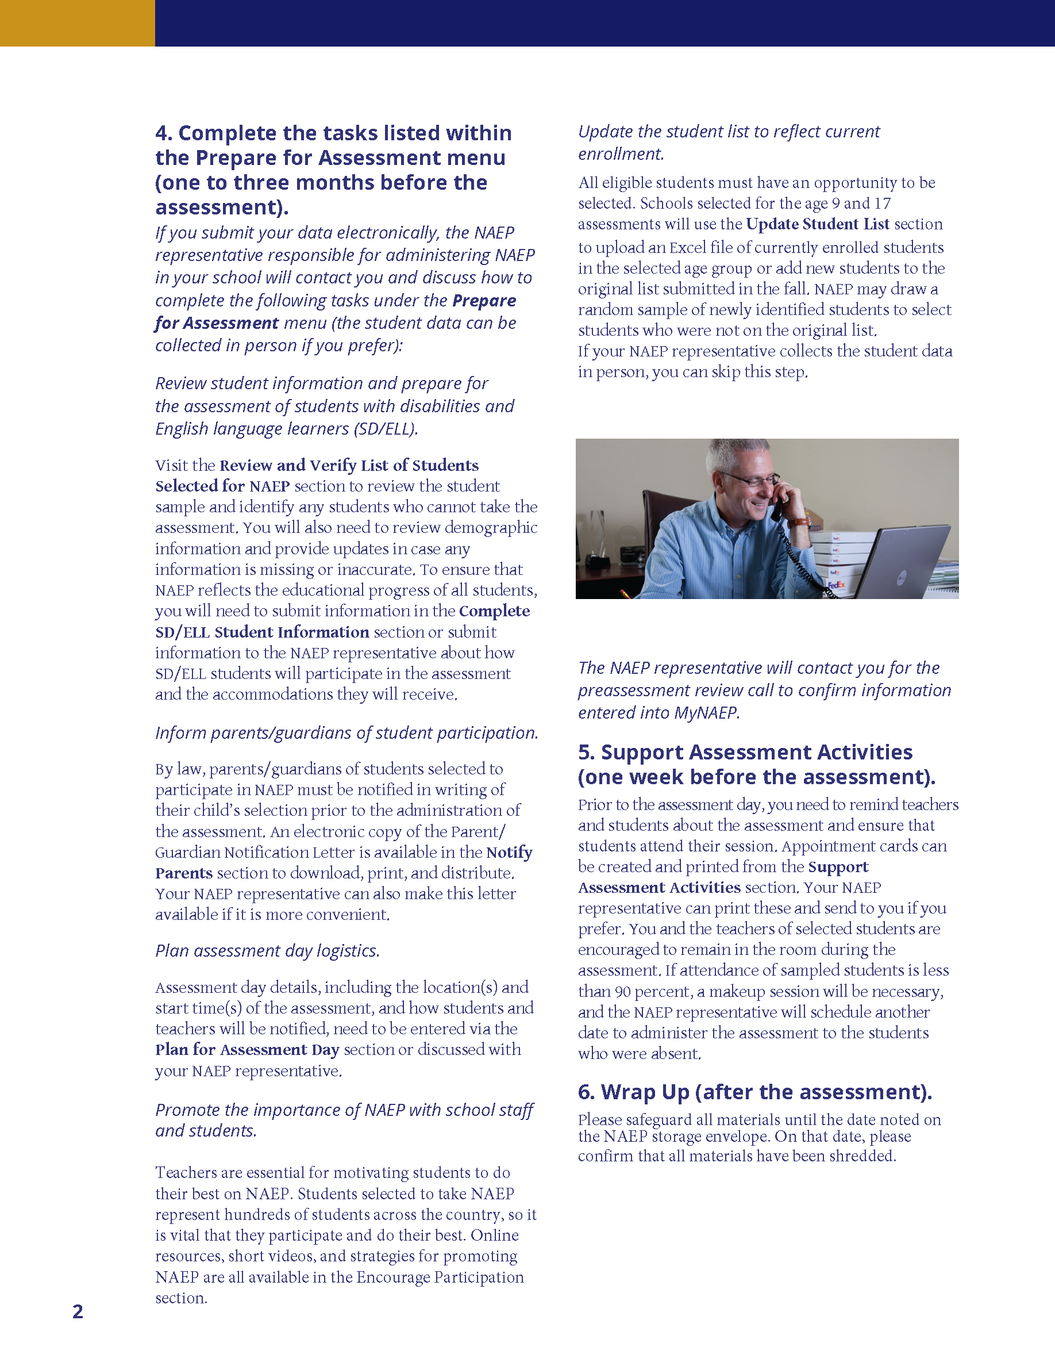

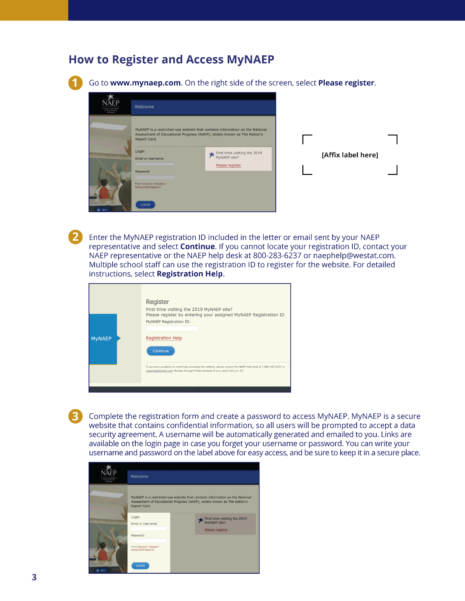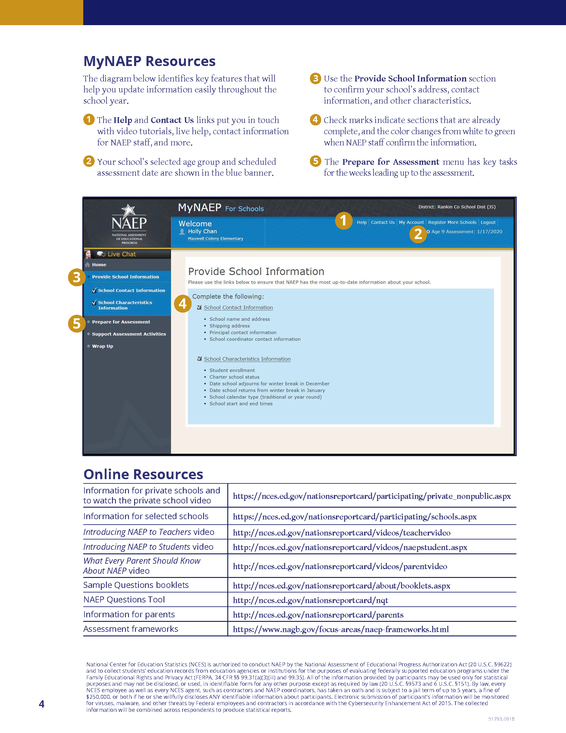

### **Appendix D3-13**: 2019-2020 Assessment Details Letter from NAEP State Coordinator to School Coordinator

**NAEP 2019–2020 Assessment Details Letter**

**NAEP STATE COORDINATOR TO SCHOOL COORDINATOR**

**Red text should be customized before mail merge, highlighted text represents mail merge fields.**

Dear School Coordinator:

Welcome to the 2019–2020 National Assessment of Educational Progress (NAEP). I look forward to working with you to coordinate NAEP at school name. A sample of age-year-old students will take mathematics and reading assessments on assessment date. Each student will take only one assessment.

As the school coordinator, you will have a number of responsibilities critical to making NAEP a success. The MyNAEP website is designed to assist you with these responsibilities. The timeline below indicates when you will need to complete specific MyNAEP sections.

* **August–September:** Register at [www.mynaep.com](http://www.mynaep.com) with the following registration ID: **MyNAEP Registration ID**. Answer the questions in the **Provide School Information** section by date. For instructions, see the enclosed *School Coordinator Responsibilities: A Guide to MyNAEP*.
* *The following red text should only be included for schools that are submitting their own student lists.* **September** *(for age 13)* **October–November** *(for ages 9 & 17)***:** Prepare and submit a list of all age-year-old students electronically in the **Submit Student List** section by date. Please see the enclosed Student List Submission Instructions.
* **September–October** *(for age 13)* **November–December** *(for age 9)* **February–March** *(for age 17)***:** An assigned NAEP representative who is responsible for administering the assessment will contact you. At that time, you will log onto the MyNAEP site with the representative and discuss how to complete the **Prepare for Assessment** section. Major tasks are highlighted below.
  + Provide information about students with disabilities and English language learners (SD/ELL) so that assessment administrators can plan appropriate testing accommodations. You can request MyNAEP access for your school’s SD/ELL specialists on the **Complete SD/ELL Student Information** page so that they can assist with this task.
  + Notify parents/guardians that their children have been selected for the assessment. A sample parent/guardian notification letter is enclosed and will be available on the MyNAEP website for you to customize and print on your school letterhead.
  + Schedule assessment sessions and reserve space at your school.
  + *The following red text should not be included for long-term trend age 13.* Update the student list to add any new students who have enrolled since the fall. NAEP will draw a random sample from this group to ensure that all students have an opportunity to be selected for NAEP.
  + Participate in a preassessment review call with your assigned NAEP representative. During this call, you will review and confirm information entered into MyNAEP and other assessment details. Be sure to complete all **Prepare for Assessment** activities before the scheduled call.
* **One week before the assessment:** Visit the **Support Assessment Activities** section to print student appointment cards and notify teachers in advance so they know when to release students from class.
* **After the assessment:** Safeguard all confidential hardcopy materials until the date noted on the NAEP storage envelope. Shred all materials on the specified date.

During the assessment, we would appreciate the presence of a school staff person as an observer in each session. A staff member’s presence can have a positive impact on students’ motivation and performance.

More information about your responsibilities is provided in the enclosed *School Coordinator Responsibilities: A Guide to MyNAEP.* Additional information about NAEP can be found at <http://nces.ed.gov/nationsreportcard>.

Thank you in advance for your cooperation and effort in helping to coordinate this important assessment. If you have any questions, please feel free to contact me at telephone number or email address.

Sincerely,

NAEP State Coordinator

Enclosures: NAEP folder, including the following:

*School Coordinator Responsibilities: A Guide to MyNAEP*

Student List Submission Instructions

Parent/Guardian Notification Letter

MyNAEP Registration Instructions

*National Center for Education Statistics (NCES) is authorized to conduct NAEP by the National Assessment of Educational Progress Authorization Act (20 U.S.C. §9622) and to collect students’ education records from education agencies or institutions for the purposes of evaluating federally supported education programs under the Family Educational Rights and Privacy Act (FERPA, 34 CFR §§ 99.31(a)(3)(iii) and 99.35). All of the information provided by participants may be used only for statistical purposes and may not be disclosed, or used, in identifiable form for any other purpose except as required by law (20 U.S.C. §9573 and 6 U.S.C. §151). By law, every NCES employee as well as every NCES agent, such as contractors and NAEP coordinators, has taken an oath and is subject to a jail term of up to 5 years, a fine of $250,000, or both if he or she willfully discloses ANY identifiable information about participants. Electronic submission of participant’s information will be monitored for viruses, malware, and other threats by Federal employees and contractors in accordance with the Cybersecurity Enhancement Act of 2015. The collected information will be combined across respondents to produce statistical reports.*

### 

### **Appendix D3-14**: 2019-2020 Assessment Details Letter from the NAEP State Coordinator to Principals

### 

**Early Fall NAEP 2019–2020 Assessment Details Letter**

**NAEP STATE COORDINATOR TO PRINCIPALS**

**Red text should be customized before mail merge, highlighted text represents mail merge fields.**

Dear principal name:

At the end of the school year, I notified school name of its selection to participate in the National Assessment of Educational Progress (NAEP). I am following up with you to provide additional information about the upcoming assessment.

To prepare for the assessment, please:

* Place the NAEP assessment date, assessment date, on your school calendar.
* Review the enclosed *School Coordinator Responsibilities: A Guide to MyNAEP* and designate a NAEP school coordinator to serve as the liaison for all NAEP activities in your school. **Give the enclosed folder to your designated NAEP school coordinator**. The school coordinator should
  + **know how to collect student information,** such as birth dates, demographic information, and if any students have withdrawn;
  + **be comfortable using a computer,** since all assessment preparation activities will be completed online; and
  + **be familiar with how students participate in statewide assessments.**

A NAEP representative responsible for administering the assessment will contact your school coordinator in September*(for age 13),* November*(for age 9), and/or* February*(for age 17)*. During the assessment, we would appreciate the presence of a school staff person as an observer in each session. A staff member’s presence can have a positive impact on students’ motivation and performance.

Again, I would like to express my appreciation for your assistance with this very important assessment of our nation’s students. Our chief state school officer, name, supports NAEP and encourages your students’ participation.

I look forward to collaborating with you and your school coordinator to ensure a successful NAEP administration. If you would like to access the MyNAEP site ([www.mynaep.com](http://www.mynaep.com)), please register with this ID number: MyNAEP Registration ID. MyNAEP is a protected site, so you will need to create your own password. Should you have questions, please contact me at telephone number or email address.

Sincerely,

NAEP State Coordinator

Enclosures: NAEP folder for your NAEP school coordinator, including the following:

Letter to your school coordinator

*School Coordinator Responsibilities: A Guide to MyNAEP*

MyNAEP Registration Instructions

Student List Submission Instructions

Parent/Guardian Notification Letter

*National Center for Education Statistics (NCES) is authorized to conduct NAEP by the National Assessment of Educational Progress Authorization Act (20 U.S.C. §9622) and to collect students’ education records from education agencies or institutions for the purposes of evaluating federally supported education programs under the Family Educational Rights and Privacy Act (FERPA, 34 CFR §§ 99.31(a)(3)(iii) and 99.35). All of the information provided by participants may be used only for statistical purposes and may not be disclosed, or used, in identifiable form for any other purpose except as required by law (20 U.S.C. §9573 and 6 U.S.C. §151). By law, every NCES employee as well as every NCES agent, such as contractors and NAEP coordinators, has taken an oath and is subject to a jail term of up to 5 years, a fine of $250,000, or both if he or she willfully discloses ANY identifiable information about participants. Electronic submission of participant’s information will be monitored for viruses, malware, and other threats by Federal employees and contractors in accordance with the Cybersecurity Enhancement Act of 2015. The collected information will be combined across respondents to produce statistical reports.*