## Request for Approval under the “Generic Clearance for Citizen Science and Crowdsourcing Projects” (OMB Control Number: 2080-0083)

**TITLE OF INFORMATION COLLECTION:**

CyanoScope:Mapping Cyanobacteria One Slide at a Time

**PURPOSE:**

The main scientific goal of this ongoing project is to develop a national library of identified cyanobacteria photographs that can be used for spatial distribution and occurrence modeling.

**NEED AND AUTHORITY FOR COLLECTION:**

Safe Drinking Water Act § 1442, 42 U.S.C. § 300j-1, authorizes the Administrator to conduct research, studies, and demonstrations relating to the causes, diagnosis, treatment, control, and prevention of risks to human health related to drinking water supply, and to share information and make recommendations based on this research and investigation.

**USES OF RESULTING DATA:**

The data will be used for spatial distribution and occurrence modeling.

**DATA COLLECTION METHODS**:

After training and obtaining a digital microscope kit, citizen scientists collect water samples from local lakes or ponds and then take microscope photos of the cyanobacteria present in the samples. These photos are then shared on the cyanoScope project of iNaturalist (www.inaturalist.org/projects/cyanoscope). The iNaturalist site allows participants to interact with the cyanoScope community and have experts assist with genus and species level identification.

**PARTICIPANT UNIVERSE:**

|  |  |  |  |  |
| --- | --- | --- | --- | --- |
| Category of Respondent | No. of Respondents | Number of responses per respondent | Participation Time per response | Burden Hours |
| Participant | 1000 | 10 | 1 hour | 10,000 |

**AGENCY COST:** EPA labor costs are calculated using an hourly rate for a GS-14 (step 1) based in Washington, DC[1] including an additional 60% for overhead and benefits. This project is estimated to occupy approximately 50 hours of an FTE annually at a cost of $3,952.

**STATISTICAL ANALYSIS:**

The data collected will be analyzed with spatial distribution and occurrence modeling. No contractor will be used for the survey.

**DATA QUALITY ASSESSMENT PROCEDURES:**

This project falls under an EPA approved QAPP that has been operable since the inception of the project. Details regarding data collection, taxonomic verification and reconciliation, and enumeration are all covered within the approved QAPP and within the crowdsourcing database of iNaturalist.

**ADMINISTRATION OF THE INSTRUMENT:** (Check all that apply)

[x] Web-based or Social Media

[ ] Telephone

[ ] In-person

[ ] Mail

[ ] Other, Explain

**INSTRUMENT:** See screen shots documenting survey below.

**CONTACT NAME:** Alison Parker **EMAIL:** [Parker.Alison@epa.gov](mailto:Parker.Alison@epa.gov)

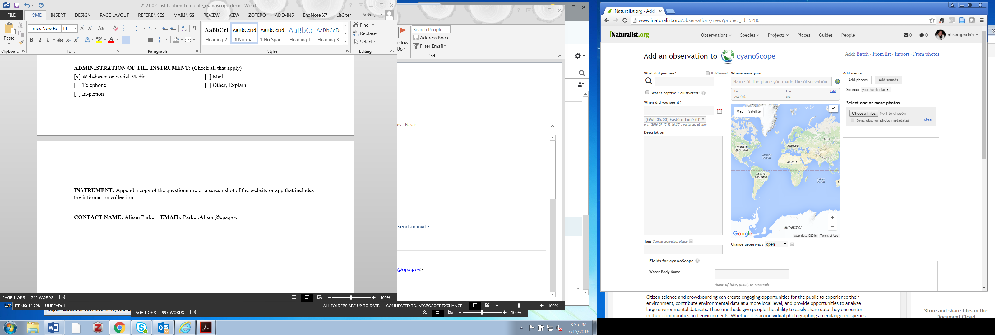

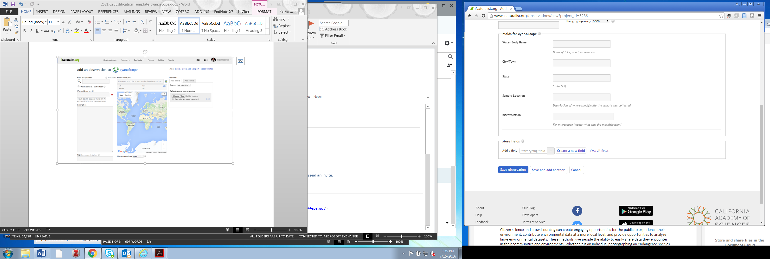

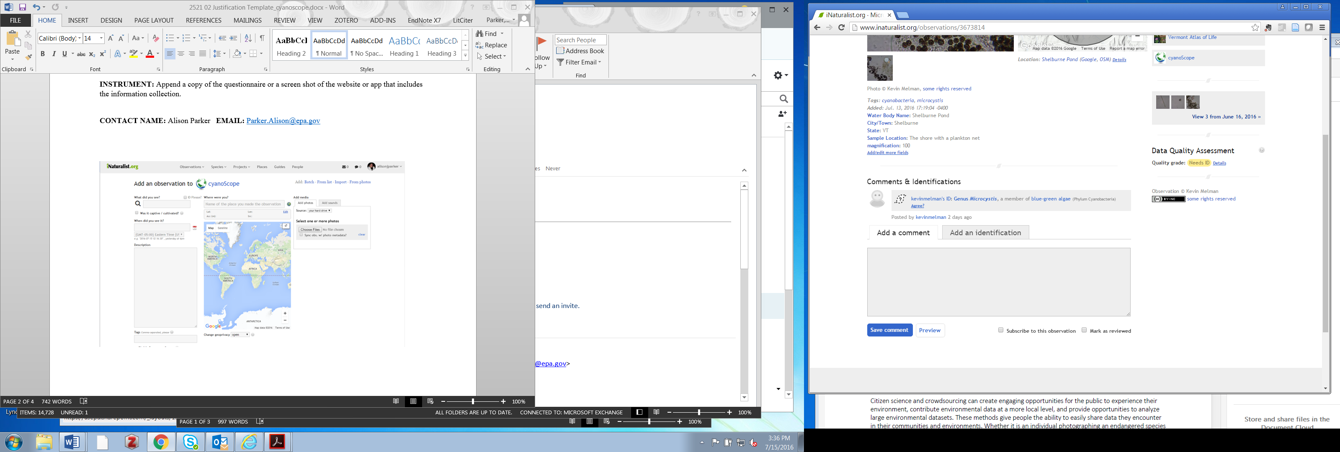

1. https://www.opm.gov/policy-data-oversight/pay-leave/salaries-wages/salary-tables/18Tables/html/DCB_h.aspx