Dear FNAME LNAM:

The Office of Aerospace Medicine strives to continuously improve airman medical certification services provided to you. Every two years we ask you to complete evaluation of our airman medical certification services to help identify areas for improvement.

You can expect to receive your email invitation to complete the survey early next week. For your convenience, you will be able to complete the survey online using a direct link that will be provided in your invitation email. You will also receive an invitation letter via US Postal mail.

- If you do not receive your survey invitation email, please send an email to:
9-AMC-SurveySupport@faa.gov or call (405) 954-8579 Monday through Friday, 9:00 a.m. to 5:00 p.m. Central.

Your participation in this evaluation is greatly appreciated and will help us improve our services and support to you and other airmen.

Sincerely,
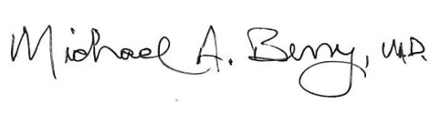
Dr. Michael A. Berry, MD
Federal Air Surgeon
FAA Office of Aerospace Medicine

