|  |  |
| --- | --- |
|  | Civil Aerospace Medical Institute  PO Box 25082  Oklahoma City, OK 73125 |

**DATE**

Last Chance

Online Survey Closes DATE

FNAM LNAM

ADDRESS CITY STATE ZIP

Dear FNAM LNAM:

I encourage you to take this opportunity to have your voice heard by participating in a survey evaluation of our airman medical certification services. Your input is vital in our effort to improve medical certification services for all airmen applicants.

Participation in the survey is voluntary and your feedback is anonymous. Your responses will be kept private to the extent provided by law. Your responses go directly to a contractor for removal of any personally identifiable information, before the FAA has access to the dataset.

It should take approximately 15 minutes to complete the survey.

For your convenience, you may complete the survey online using your computer or mobile device, or complete and return the attached paper survey. Submit only **one** survey.

* To access the online survey, either scan the QR code using your mobile device or go to the Internet and type the following into the web address bar: **bit.ly/Airman18**

Note: The survey cannot be located using a search engine.

Follow these steps to locate the address bar on your Internet browser: (1) go to the Internet, (2) on your keyboard hold down the **Alt** key and press the **D** key to activate and highlight the address bar, (3) type the survey web address: **bit.ly/Airman18** and press the Enter key.

* At the survey log in screen, enter this password: **A#A#**  (use upper-case letters) and click the ‘Next’ button.
* For technical support or to receive a direct link to the survey by email, send an email to: [9-AMC-SurveySupport@faa.gov](mailto:9-AMC-SurveySupport@faa.gov) or call (405) 954-8579 Monday through Friday, 9:00 a.m. to 5:00 p.m. Central.

Your participation in this evaluation is greatly appreciated and will help us improve our services to you. The online survey will be available until **DATE**. We will accept paper surveys through **DATE**.

Sincerely,

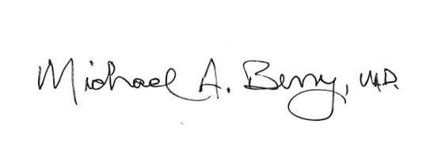

Dr. Michael A. Berry, MD

Federal Air Surgeon

FAA Office of Aerospace Medicine