Dear FNAME LNAM:

My office is again conducting a survey evaluation of our airman medical certification services to help identify areas for improvement. You were randomly selected to participate out of all airmen who annually apply for a medical certificate from an Aviation Medical Examiner (AME). As an airman, you are in a unique position to provide us valuable feedback based on your experiences with the medical certification process. I would like to emphasize that your input is vital in our effort to improve medical certification services for all airmen applicants (OMB 2120-0707).
Participation in the survey is voluntary and your feedback is anonymous. Your responses will be kept private to the extent provided by law. Your responses go directly to a contractor for removal of any personally identifiable information, before the FAA has access to the dataset.

I encourage you to submit your feedback without hesitation to ensure your voice is heard. It takes approximately 20 minutes to complete the survey. For your convenience, you may complete the survey online or request a paper survey.
[Click HERE to TAKE survey]
- If the above link does not take you to the survey, please copy the entire web address below and paste it into your browser's address bar.
${l://SurveyURL}
- For survey support or to request a paper survey, call (405) 954-8579 Monday through Friday 9:00 a.m. to 5:00 p.m. Central or send an email to: 9-AMC-SurveySupport@faa.gov
- For medical certification questions call (405) 954-4821 (Option 1) Monday through Friday 8:00 a.m. to 4:15 p.m. Central.

Your participation in this evaluation is greatly appreciated and will help us improve our services and support to you and other airmen.

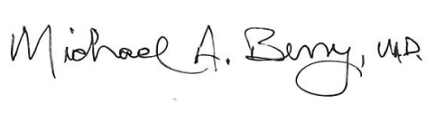
Sincerely,

Dr. Michael A. Berry, MD
Federal Air Surgeon
FAA Office of Aerospace Medicine

P.S. If you decline the invitation to participate in this year’s survey, click: #Opt out link# and your name will be removed from the list.

