Appendix A. Survey Instruments and Experiments.
Item 1. Initial Outreach and Enrollment Survey.
To be administered to account holders and users of ML facilities in both Dallas and Washington, DC to encourage participation in our research.

Dear Traveler,

As a (NTTA / TransUrban) customer you have been randomly selected to participate in a short survey being conducted by the Texas A&M Transportation Institute and Westat Inc. for the Federal Highway Administration. We are conducting travel research to improve the transportation system. As part of this research we are looking for people to answer survey questions about themselves, their current travel, and potential future travel. At this stage we are just asking a few questions to see if you are interested and eligible for this study. You are under no obligation to answer any of these questions.

To participate, please go to: http://www.travelsurvey.org (questions found here)
This research study has been reviewed by the Human Subjects' Protection Program and/or the Institutional Review Board at Texas A&M University. For research-related problems or questions regarding your rights as a research participant, you can contact these offices at (979) 458-4067 or irb@tamu.edu.

If you desire additional information about this study or have technical problems completing the online survey, please contact the research team at (979) 845-9875 or TravelSurvey@TTIMAIL.TAMU.EDU.

Screening Questions:
- Do you drive on ______________? (The highway depends on location: I-95 in DC/North Tarrant Express (NTE) in Dallas). If No, thank and terminate survey.
- When driving on (I-95/NTE) which lanes do you use? Check all that apply.
- Regular, not tolled, lanes
- Express, tolled, lanes
- How often do you drive on the (I-95/NTE)?
  - Several times per week
  - About once per week
  - About once per month
  - Less than once per month (if this, thank and terminate survey)
We want to get a wide range of individuals and their opinions for this study so we will now ask a few questions about you so we can get people from all walks of life for our study.
- What is your sex?
  - Male
  - Female
- What is your annual household income range?
  - Less than $50,000 per year
  - $50,000 to $100,000 per year
  - $100,000 to $150,000 per year
  - More than $150,000 per year
- What is your age?
  - 20 and younger
  - 21 to 30 years old
  - 31 to 40 years old
  - 41 to 50 years old
  - 51 to 60 years old
  - 61 to 70 years old
  - Older than 70
- Are you employed outside of the home?
  - Yes
  - No
- Would you be willing to fill in a longer survey about your travel and yourself? It would take about 2 hours and we would pay you $50 for participating.
  - Yes
  - No
- Would you be willing to take part in a laboratory study where we would ask you questions about your potential travel given travel options? This would be done in XXXX location and take about 2 hours. We would pay you approximately $75 for participating.
  - Yes
  - No
- Would you be willing to take part in an on-road study where we record which lanes you choose (tolled or non-tolled) on (I-95/NTE) over a period of 3 months? You would be paid $250 for participating.
  - Yes
  - No

Item 2. Survey of Students to Obtain Demographic Data, Travel Data, and Individual Differences.
To be administered to 400 students on the Texas A&M campus. We will recruit from the Economic Research Laboratory database, so subjects will have already opted-in to email recruitment for economics experiments. Students are regularly recruited through emails, flyers and class participation to join this database (independent from our involvement).
The sample will provide base information for use throughout the study. We anticipate the survey will take less than 2 hours. Students will be paid on average $37.50 for completing this survey and Item 3: The Behavioral Economics Experiment.

Dear Student,
Thank you for agreeing to participate in this transportation study. In this part of the study you will be asked to fill in the following survey to the best of your ability. After this you will be asked to participate in a computer lab study that will also ask you transportation-based questions. For doing both parts of the study you will be paid between $30 and $45. Payment will vary based on your choices in the lab study.
Questions:
- In the past 6 months have you traveled on a freeway where some lanes are free and some lanes are tolled? (Texas examples include Katy Freeway (I-10, example image shown below), US 290, I-45 North, Gulf Freeway, LBJ, North Tarrant Express, 635 Express Lanes, MoPac.
- Yes
- No (jump to Question 14)

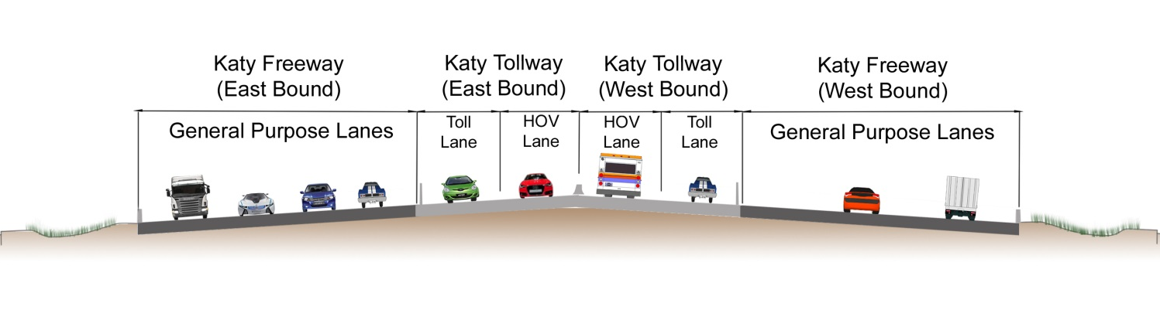
These questions relate to the most recent time you drove on the Freeway with tolled lanes:
- What was the purpose of your most recent trip? (Choose one of the following answers) (Randomize order)
- Commuting to or from my place of work (going to or from work)
- Recreational/Social/Shopping/Entertainment/Personal Errands
- Work related (other than to or from home to work)
- To attend class at school or an educational institute
- Other _______

- On your most recent trip did you travel in the non-toll lanes or the tolled lanes?
- Non-toll lanes
- Tolled lanes (toll and HOV lanes)

- On what day of the week was your most recent trip? (Choose one of the following answers)
  - Sunday
  - Monday
  - Tuesday
  - Wednesday
  - Thursday
  - Friday
  - Saturday

- What time of day did that trip start? (for example, when did you leave your house or driveway?) Choose one of the following answers:
- Drop down menu with times of day

- What kind of vehicle did you use for your most recent trip?
Choose one of the following answers:
- Motorcycle
- Passenger car, SUV, or pick-up truck
- Bus

If the answer is Passenger car, SUV, or pick-up truck:

How many people including you, were in the Passenger Car/SUV/Pick-up Truck? Choose one of the following answers:
- 1
- 2
- 3
- 4
- 5 or more

If your answer is not "1":

Were you the driver or a passenger on this recent trip? Choose one of the following answers:
- Driver
- Passenger

If "Driver" then
How much extra time did it take to pick up and drop off the passenger(s)?
- ___________(minutes)

Who did you travel with on this recent trip? Check any that apply (Randomize order)
- Neighbor
- Child
- Co-worker/person in the same, or a nearby, office building
- Adult family member
- Another commuter in a casual carpool (also known as slugging)
- Other:__________

If the answer is Bus:

How much did you pay to ride the bus each way? Choose one:
- $_____per trip
- $_____per day
- $_____per week
- $_____per month

- What was your travel time on that trip (from the time you got in your vehicle to when your arrived at your destination)
_________minutes

- [if answer to 3 is non-toll lanes] Have you ever used the tolled lanes?
- Yes
- No

- [if answer to 8 is no] What are the primary reasons you do NOT use the toll lanes? (Check all that apply) (Randomize order)
- Access to/from to the toll lanes is not convenient for my trips
- I have the flexibility to travel at less congested times
- I do not feel safe traveling on the toll lanes
- The toll is too expensive for me
- The toll lanes do not offer me enough time savings
- It is too complicated/confusing to use the toll lanes
- I avoid toll roads whenever possible
- I don’t want to have a toll transponder in my vehicle
- I don’t have a credit card needed to setup a toll transponder account
- I don't like that the toll changes based on the time of day
- I don’t have anyone to carpool with
- Other: _________________

- [if answer to 8 is yes] What are the main reasons you do use the toll lanes? (check all that apply) (Randomize order)
- Access to/from to the toll lanes is convenient for my trips
- Being able to use the lanes for free/reduced toll as a carpool
- Travel times on the toll lanes are consistent and predictable
- The toll lanes save me time
- During the peak hours the toll lanes will not be congested
- The toll lanes are safer than the general purpose lanes
- The toll lanes are less stressful than the general purpose lanes
- Trucks and large vehicles are not allowed on the toll lanes
- Someone else pays my tolls
- Other: _________________

- [if answer to 8 is yes] On average, how much was the toll for your trip on the toll lanes?
- Less than $ 1.00
- $ 1.00 - $ 1.99
- $ 2.00 - $ 3.99
- More than $ 4.00
- Don’t remember

- What is the ZIP Code of your recent trip's origin (as indicated in the trip purpose question)? _____________

- What is the ZIP Code of your recent trip's destination (as indicated in the trip purpose question)? _____________

- Are you….[please choose only one]
- Male
- Female

- Which of the following age categories represents your age? [please choose only one]
- 18-24
- 25-34
- 35-44
- 45-54
- 55-64
- 65 and over
- Refused

- What is your race/ethnicity? [please choose only one]
- White
- Hispanic or Latino"
- Not Hispanic or Latino
- Black or African American
- Asian
- American Indian or Alaska Native
- Native Hawaiian or Other Pacific Islander
- Refused

- What is your highest level of education? [please choose only one]
- Less than high school
- High school graduate
- Some college or vocational school
- College Graduate
- Postgraduate degree
- Refused

- What category best describes your occupational or work status?
- Professional / Managerial
- Technical
- Sales
- Administrative / Clerical
- Manufacturing
- Stay-at-home homemaker / parent
- Student
- Self-employed
- Unemployed / Seeking work
- Retired
- Other (specify):

- What is your annual HOUSEHOLD income?
- Less than $ 10,000
- $ 10,000 - $ 14,999
- $ 15,000 - $ 24,999
- $25,000 to $34,999
- $35,000 to $49,999
- $50,000 to $74,999
- $75,000 to $99,999
- $100,000 to $199,999
- $200,000 or more
- Refused
- It's easier to tell my hourly wage rate: __________

INSTRUCTIONS
This is a 10-minute timed test and because it is timed, it requires uninterrupted, undisturbed time to complete it. And so if you do not have 10 minutes of uninterrupted, undisturbed time, then please log out and come back when you have time to complete the test. Once you start this test, you will be unable to pause it.

When you click on the right arrow below, you will be presented with a set of problems. There are a total of 60 items, but the test will probably be too long for you to finish. However, complete as many items as you can in the allotted time. Work quickly and accurately. Do not spend too much time on any one item. Your score will be the number of items that you answer correctly.

You may also want to have scratch paper and a pen or pencil ready before you start since some of the problems you will encounter may require some "figuring out". Please do not use a calculator, a dictionary, or any other aid.

[Three (3) sample items are presented below. The remaining 57 items are not different in form and format from these examples and hence provide a reasonable facsimile of the items participants will be completing. The general mental ability test is obviously a cognitive assessment for which there are correct/incorrect answers; consequently, reproducing all the items in the public domain threatens test security and subsequently, the validity and utility of the test, as well as the propriety terms of its use.]

- What is 15% of 200?

○ 15
○ 20
○ 30
○ 45

- 0 5 0 5 1 4 1

○ 0
○ 1
○ 4
○ 5

- FAST is most similar in meaning to

○ Light
○ Quick
○ Primary
○ Attach

INSTRUCTIONS
Listed below are phrases describing people's behaviors. Please use the scale provided below to identify how accurately each statement describes you. Describe yourself as you generally are now, not as you wish to be in the future. Describe yourself as you honestly see yourself in relation to other people you know of the same sex and roughly the same age as you. Please read each statement carefully, and then rate the extent to which it accurately describes you.

 | Very Inaccurate | Inaccurate | Neither Inaccurate nor Accurate | Accurate | Very Accurate
Am always prepared.
Pay attention to details.
Get chores done right away.
Like order.
Follow a schedule.
Am exacting in my work.
Do things according to plan.
Continue until everything is perfect.
Make plans and stick to them.
Love order and regularity.
Like to tidy up.
Leave my belongings around.
Make a mess of things.
Often forget to put things back in their proper place.
Shirk my duties.
Neglect my duties.
Waste my time.
Do things in a half-way manner.
Find it difficult to get down to work.
Leave a mess in my room.

INSTRUCTIONS
A number of statements are listed below. Please use the scale provided to indicate the extent to which you agree with them.
 | Completely Disagree |  |  |  |  | Completely Agree
I don’t like situations that are uncertain.
I dislike questions which could be answered in many different ways.
I find that a well ordered life with regular hours suits my temperament.
I feel uncomfortable when I don’t understand the reason why an event occurred in my life.
I feel irritated when one person disagrees with what everyone else in a group believes.
I don’t like to go into a situation without knowing what I can expect from it.
When I have made a decision, I feel relieved.
When I am confronted with a problem, I’m dying to reach a solution very quickly.
I would quickly become impatient and irritated if I would not find a solution to a problem immediately.
I don’t like to be with people who are capable of unexpected actions.
I dislike it when a person’s statement could mean many different things.
I find that establishing a consistent routine enables me to enjoy life more.
I enjoy having a clear and structured mode of life.
I do not usually consult many different opinions before forming my own view.
I dislike unpredictable situations.

INSTRUCTIONS
Below are seven (7) problems that vary in difficulty. You have 10 minutes to complete them. Try to answer as many as you can.

1. A bat and a ball cost $1.10 in total. The bat costs $1.00 more than the ball. How much does the ball cost?
__________ cents

2. If it takes 5 machines 5 minutes to make 5 widgets, how long would it take 100 machines to make 100 widgets?
__________ minutes

3. In a lake, there is a patch of lily pads. Every day, the patch doubles in size. If it takes 48 days for the patch to cover the entire lake, how long would it take for the patch to cover half of the lake?
__________ days

4. If John can drink one barrel of water in 6 days, and Mary can drink one barrel of water in 12 days, how long would it take them to drink one barrel of water together?
__________ days

5. Jerry received both the 15th highest and the 15th lowest mark in the class. How many students are in the class?
__________ students

6. A man buys a pig for $60, sells it for $70, buys it back for $80, and sells it finally for $90. How much has he made?
__________ dollars

7. Simon decided to invest $8,000 in the stock market one day early in 2008. Six months after he invested, on July 17, the stocks he had purchased were down 50%. Fortunately for Simon, from July 17 to October 17, the stocks he had purchased went up 75%. At this point, Simon has:

○ broken even in the stock market.
○ is ahead of where he began.
○ has lost money.

Item 3. Computer Based Behavioral Economics Tests – Students.
Before the behavioral economics experiment begins, the same 400 Texas A&M students will answer the final three questions from the Cognitive Reflection Test (Frederick, 2005). The three questions are as follows:

- A bat and a ball cost $1.10 in total. The bat costs $1.00 more than the ball. How much does the ball cost? _____ cents
- If it takes 5 machines 5 minutes to make 5 widgets, how long would it take 100 machines to make 100 widgets? _____ minutes
- In a lake, there is a patch of lily pads. Every day, the patch doubles in size. If it takes 48 days for the patch to cover the entire lake, how long would it take for the patch to cover half of the lake? _____ days

Each subject will take part in an experiment where they choose on a computer screen between two roads. Choosing one road will cause a subject to gain a payoff of $0.20; choosing the other will lead to a variable depending on an estimate of "traffic." To observe "traffic" subjects will need to hover their mouse over a box of 50 small letters and count the "a's" and "e's". The payoff for the variable road is $0.50 minus $0.04 for every letter a and e in the box. Generally, the second option will have enough a's and e's to keep payoffs between $0.10-$0.30. It may look something like the following (note that developing this experiment is a major part of this research and therefore is not complete):

This choice will be repeated 100 times. Each time the signal of traffic will change.

We suspect there will be a great deal of heterogeneity in how often subjects check their traffic signal before making a decision. We aim to classify subjects into infrequent and frequent checkers and correlate these types with our survey responses.

Item 4. Survey of Drivers to Obtain Demographic Data, Travel Data, and Psychological Traits.
To be administered to 120 drivers in the Washington, DC area and 120 drivers in the Dallas area. Will be based on responses to Item 1. This will provide base information for use throughout the study. We anticipate the survey will take less than 2 hours. Drivers will be paid $50 for completing this survey.

Dear Traveler,
Thank you for agreeing to participate in this transportation study. In this part of the study you will be asked to fill in the following survey to the best of your ability. After this you will be asked to participate in a computer lab study which will also ask you transportation-based questions.
Questions:
- In the past 6 months have you traveled on (NTE in Dallas / I-95 in DC) where some lanes are free and some lanes are tolled?
- Yes
- No (Need to find family member who does use the correct freeways as they were prescreened to be users of these freeways)

These questions relate to the most recent time you drove on the NTE / I-95:
- What was the purpose of your most recent trip? (Choose one of the following answers) (Randomize order)
- Commuting to or from my place of work (going to or from work)
- Recreational/Social/Shopping/Entertainment/Personal Errands
- Work related (other than to or from home to work)
- To attend class at school or an educational institute
- Other _______

- On your most recent trip did you travel in the non-toll lanes or the tolled lanes?
- Non-toll lanes
- Tolled lanes (toll and HOV lanes)

- On what day of the week was your most recent trip? (Choose one of the following answers)
  - Sunday
  - Monday
  - Tuesday
  - Wednesday
  - Thursday
  - Friday
  - Saturday

- What time of day did that trip start? (for example, when did you leave your house or driveway?) Choose one of the following answers:
- Drop down menu with times of day

- What kind of vehicle did you use for your most recent trip?
Choose one of the following answers:
- Motorcycle
- Passenger car, SUV, or pick-up truck
- Bus

If the answer is Passenger car, SUV, or pick-up truck:

How many people including you, were in the Passenger Car/SUV/Pick-up Truck? Choose one of the following answers:
- 1
- 2
- 3
- 4
- 5 or more

If your answer is not "1":

Were you the driver or a passenger on this recent trip? Choose one of the following answers:
- Driver
- Passenger

If "Driver" then
How much extra time did it take to pick up and drop off the passenger(s)?
- ___________(minutes)

Who did you travel with on this recent trip? Check any that apply (Randomize order)
- Neighbor
- Child
- Co-worker/person in the same, or a nearby, office building
- Adult family member
- Another commuter in a casual carpool (also known as slugging)
- Other:__________

If the answer is Bus:

How much did you pay to ride the bus each way? Choose one:
- $_____per trip
- $_____per day
- $_____per week
- $_____per month

- What was your travel time on that trip (from the time you got in your vehicle to when your arrived at your destination)
_________minutes

- [if answer to 3 is non-toll lanes] Have you ever used the tolled lanes?
- Yes
- No

- [if answer to 8 is no] What are the primary reasons you do NOT use the toll lanes? (Check all that apply) (Randomize order)
- Access to/from to the toll lanes is not convenient for my trips
- I have the flexibility to travel at less congested times
- I do not feel safe traveling on the toll lanes
- The toll is too expensive for me
- The toll lanes do not offer me enough time savings
- It is too complicated/confusing to use the toll lanes
- I avoid toll roads whenever possible
- I don’t want to have a toll transponder in my vehicle
- I don’t have a credit card needed to setup a toll transponder account
- I don't like that the toll changes based on the time of day
- I don’t have anyone to carpool with
- Other: _________________

- [if answer to 8 is yes] What are the main reasons you do use the toll lanes? (check all that apply) (Randomize order)
- Access to/from to the toll lanes is convenient for my trips
- Being able to use the lanes for free/reduced toll as a carpool
- Travel times on the toll lanes are consistent and predictable
- The toll lanes save me time
- During the peak hours the toll lanes will not be congested
- The toll lanes are safer than the general purpose lanes
- The toll lanes are less stressful than the general purpose lanes
- Trucks and large vehicles are not allowed on the toll lanes
- Someone else pays my tolls
- Other: _________________

- [if answer to 8 is yes] On average, how much was the toll for your trip on the toll lanes?
- Less than $ 1.00
- $ 1.00 - $ 3.99
- $ 4.00 - $ 6.99
- More than $ 7.00
- Don’t remember

- What is the ZIP Code of your recent trip's origin (as indicated in the trip purpose question)? _____________

- What is the ZIP Code of your recent trip's destination (as indicated in the trip purpose question)? _____________

- Are you….[please choose only one]
- Male
- Female

- Which of the following age categories represents your age? [please choose only one]
- 18-24
- 25-34
- 35-44
- 45-54
- 55-64
- 65 and over
- Refused

- What is your race/ethnicity? [please choose only one]
- White/Caucasian
- Hispanic/Latino
- African American
- Asian American
- Native American
- Refused

- What is your highest level of education? [please choose only one]
- Less than high school
- High school graduate
- Some college or vocational school
- College Graduate
- Postgraduate degree
- Refused

- What category best describes your occupational or work status?
- Professional / Managerial
- Technical
- Sales
- Administrative / Clerical
- Manufacturing
- Stay-at-home homemaker / parent
- Student
- Self employed
- Unemployed / Seeking work
- Retired
- Other (specify):

- What is your annual HOUSEHOLD income?
- Less than $ 10,000
- $ 10,000 - $ 14,999
- $ 15,000 - $ 24,999
- $25,000 to $34,999
- $35,000 to $49,999
- $50,000 to $74,999
- $75,000 to $99,999
- $100,000 to $199,999
- $200,000 or more
- Refused
- It's easier to tell my hourly wage rate: __________

INSTRUCTIONS
This is a 10-minute timed test and because it is timed, it requires uninterrupted, undisturbed time to complete it. And so if you do not have 10 minutes of uninterrupted, undisturbed time, then please log out and come back when you have time to complete the test. Once you start this test, you will be unable to pause it.

When you click on the right arrow below, you will be presented with a set of problems. There are a total of 60 items, but the test will probably be too long for you to finish. However, complete as many items as you can in the allotted time. Work quickly and accurately. Do not spend too much time on any one item. Your score will be the number of items that you answer correctly.

You may also want to have scratch paper and a pen or pencil ready before you start since some of the problems you will encounter may require some "figuring out". Please do not use a calculator, a dictionary, or any other aid.

[Three (3) sample items are presented below. The remaining 57 items are not different in form and format from these examples and hence provide a reasonable facsimile of the items participants will be completing. The general mental ability test is obviously a cognitive assessment for which there are correct/incorrect answers; consequently, reproducing all the items in the public domain threatens test security and subsequently, the validity and utility of the test, as well as the propriety terms of its use.]

1. What is 15% of 200?

○ 15
○ 20
○ 30
○ 45

2. 0 5 0 5 1 4 1

○ 0
○ 1
○ 4
○ 5

3. FAST is most similar in meaning to

○ Light
○ Quick
○ Primary
○ Attach

INSTRUCTIONS
Listed below are phrases describing people's behaviors. Please use the scale provided below to identify how accurately each statement describes you. Describe yourself as you generally are now, not as you wish to be in the future. Describe yourself as you honestly see yourself in relation to other people you know of the same sex and roughly the same age as you. Please read each statement carefully, and then rate the extent to which it accurately describes you.

 | Very Inaccurate | Inaccurate | Neither Inaccurate nor Accurate | Accurate | Very Accurate
Am always prepared.
Pay attention to details.
Get chores done right away.
Like order.
Follow a schedule.
Am exacting in my work.
Do things according to plan.
Continue until everything is perfect.
Make plans and stick to them.
Love order and regularity.
Like to tidy up.
Leave my belongings around.
Make a mess of things.
Often forget to put things back in their proper place.
Shirk my duties.
Neglect my duties.
Waste my time.
Do things in a half-way manner.
Find it difficult to get down to work.
Leave a mess in my room.

INSTRUCTIONS
A number of statements are listed below. Please use the scale provided to indicate the extent to which you agree with them.
 | Completely Disagree |  |  |  |  | Completely Agree
I don’t like situations that are uncertain.
I dislike questions which could be answered in many different ways.
I find that a well ordered life with regular hours suits my temperament.
I feel uncomfortable when I don’t understand the reason why an event occurred in my life.
I feel irritated when one person disagrees with what everyone else in a group believes.
I don’t like to go into a situation without knowing what I can expect from it.
When I have made a decision, I feel relieved.
When I am confronted with a problem, I’m dying to reach a solution very quickly.
I would quickly become impatient and irritated if I would not find a solution to a problem immediately.
I don’t like to be with people who are capable of unexpected actions.
I dislike it when a person’s statement could mean many different things.
I find that establishing a consistent routine enables me to enjoy life more.
I enjoy having a clear and structured mode of life.
I do not usually consult many different opinions before forming my own view.
I dislike unpredictable situations.

INSTRUCTIONS
Below are seven (7) problems that vary in difficulty. You have 10 minutes to complete them. Try to answer as many as you can.

1. A bat and a ball cost $1.10 in total. The bat costs $1.00 more than the ball. How much does the ball cost?
__________ cents

2. If it takes 5 machines 5 minutes to make 5 widgets, how long would it take 100 machines to make 100 widgets?
__________ minutes

3. In a lake, there is a patch of lily pads. Every day, the patch doubles in size. If it takes 48 days for the patch to cover the entire lake, how long would it take for the patch to cover half of the lake?
__________ days

4. If John can drink one barrel of water in 6 days, and Mary can drink one barrel of water in 12 days, how long would it take them to drink one barrel of water together?
__________ days

5. Jerry received both the 15th highest and the 15th lowest mark in the class. How many students are in the class?
__________ students

6. A man buys a pig for $60, sells it for $70, buys it back for $80, and sells it finally for $90. How much has he made?
__________ dollars

7. Simon decided to invest $8,000 in the stock market one day early in 2008. Six months after he invested, on July 17, the stocks he had purchased were down 50%. Fortunately for Simon, from July 17 to October 17, the stocks he had purchased went up 75%. At this point, Simon has:

○ broken even in the stock market.
○ is ahead of where he began.
○ has lost money.

Item 5. Computer Based Behavioral Economics Tests – DC and Dallas Drivers.
The 120 drivers in each of Dallas and DC will participate in the same BE experiment as the Texas A&M students to first give proof of concept to the idea they can be classified as choosers and non-choosers. Before the behavioral economics experiment begins, drivers will answer the final three questions from the Cognitive Reflection Test (Frederick, 2005). The three questions are as follows:

- A bat and a ball cost $1.10 in total. The bat costs $1.00 more than the ball. How much does the ball cost? _____ cents
- If it takes 5 machines 5 minutes to make 5 widgets, how long would it take 100 machines to make 100 widgets? _____ minutes
- In a lake, there is a patch of lily pads. Every day, the patch doubles in size. If it takes 48 days for the patch to cover the entire lake, how long would it take for the patch to cover half of the lake? _____ days

Each driver will take part in an experiment where they choose on a computer screen between two roads. Choosing one road will cause a subject to gain a payoff of $0.20; choosing the other will lead to a variable depending on an estimate of "traffic." To observe "traffic" subjects will need to hover their mouse over a box of 50 small letters and count the "a's" and "e's". The payoff for the variable road is $0.50 minus $0.04 for every letter a and e in the box. Generally, the second option will have enough a's and e's to keep payoffs between $0.10-$0.30. This choice will be repeated 100 times. Each time the signal of traffic will change. The average driver will be paid $75 per person (partially from the answers to the questions and partially a lump sum).

The experiment may look something like the following (note that developing this experiment is a major part of this research and therefore is not complete):

We suspect there will be a great deal of heterogeneity in how often driver checks their traffic signal before making a decision. We aim to classify subjects into infrequent and frequent checkers and correlate these types with our survey responses. We will also correlated the degree of checking with their actual surveyed driving behavior.

Item 6. Driving Simulator study.
To be administered to drivers in the Washington, DC area. We anticipate the session will take less than 2 hours. Drivers will be paid $75 for completing this session.
Example of simulator:

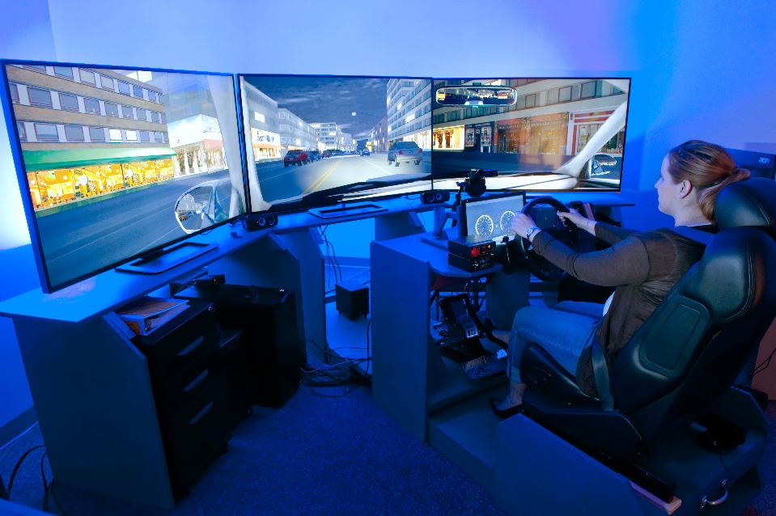

Simulator Study Intake Questions
Thank you for calling about the Behavioral Economics Study. If you participate in the study, you will come to Westat’s office in Rockville and perform a variety of tasks while seated at a computer station and a driving simulator. Each session will last up to two hours. You will receive $75 for completing the session. I have a few questions I need to ask to determine your eligibility. Before I get into those questions, do you have any questions about the study or what you would be doing during the session?

- Do you have a valid U.S. driver’s license? ___Yes ___No

- About how many miles do you drive per year? _____________ (minimum 3,000)

- In the past 6 months have you traveled on I-95 in DC where some lanes are free and some lanes are tolled?
- Yes
- No (Need to find family member who does use the correct freeways as they were prescreened to be users of these freeways)

These questions relate to the most recent time you drove on the I-95:
- What was the purpose of your most recent trip? (Choose one of the following answers) (Randomize order)
- Commuting to or from my place of work (going to or from work)
- Recreational/Social/Shopping/Entertainment/Personal Errands
- Work related (other than to or from home to work)
- To attend class at school or an educational institute
- Other _______

- On your most recent trip did you travel in the non-toll lanes or the tolled lanes?
- Non-toll lanes
- Tolled lanes (toll and HOV lanes)

- Do you have any medical, visual, or hearing problems that seriously affect your ability to drive? (serious issues should be reviewed by project director)
_____________________________________________________________________________________

- Are you allergic to alcohol or hand sanitizer? ____Yes ____No

- Do you wear glasses or contact lenses when you drive? (if contacts, ask if they are colored contacts)
__glasses __regular contacts __colored contacts __none

- Do you have any vision conditions such as cataracts, glaucoma, retinopathy, macular degeneration, or lazy eye? ___No Yes (explain): ________________________________________________________________

- When you drive, do you use one foot for the gas and brake pedals, or do you use both feet?
__one __both (ineligible)

- What is your age? _____

- Do you often experience motion sickness in a moving vehicle or other situations? __yes __no

- Can I have your name? ______________________________________________

- What is your daytime phone number? ___________________________________

- Do you have an email address where I can send you information about the study?

- When can you be available to participate?
__Weekday mornings __Weekday afternoons __Weekday evenings __Weekend mornings or afternoons

- Where did you hear about this study? ___________________________________

- And finally, would you like to be added to a database to be notified of future Westat studies?
__Yes __No

Then participants will ‘drive’ in the driving simulator on a freeway that has managed lanes. Their choices on which lanes they tend to use will be monitored based on traffic conditions, toll rate, and potential offers for using the MLs (discounted coffee for example). This will last less than 2 hours. The exact makeup of the simulator experiment is not known as developing this is a significant part of the research.

Item 7. Field Study intake and instructions
Drivers paid a total of $250 for completing both this and item 8.
Field study pictures:

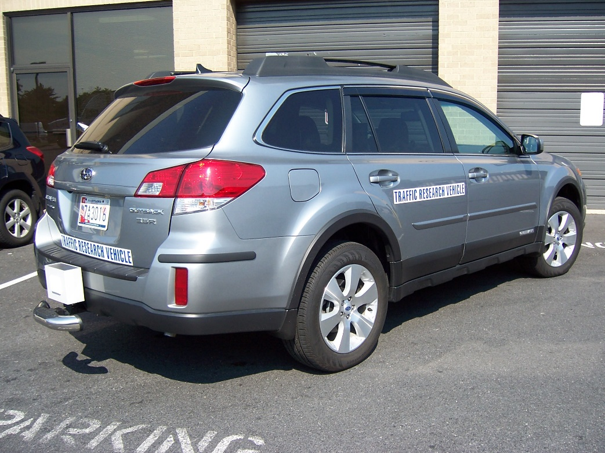
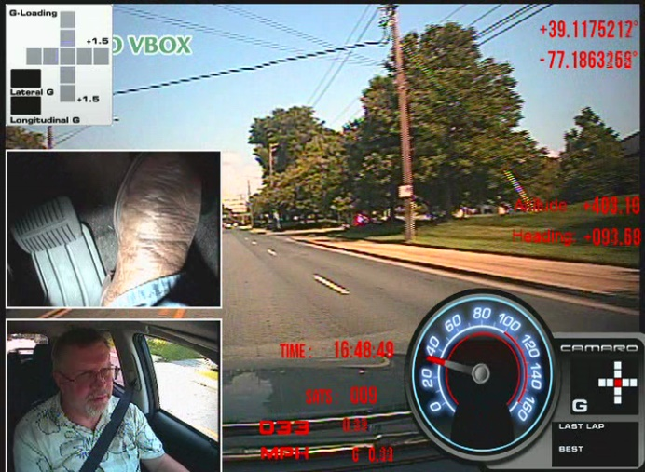

Field Study Screener
Thank you for your interest in the Managed Lanes Study. If you participate in this study, you will drive your vehicle just as you would if you were not in the study. The difference will be we will monitor your use of the GPLs and MLs on I-95/NTE over the next 3 months. You will receive $250 for completing the study and the follow-up survey (item 8).
I have a few questions I need to ask to verify your eligibility. Your ability to participate will depend on your eligibility and our need for participants with a variety of characteristics. If you are invited to participate, we will first need to verify your driving records to ensure that you have not had any major driving violations in the past few years.
- What is your age? __________
- For how many years have you had a valid U.S. driver’s license?
- Has your license been suspended or revoked within the past five years __Yes __No
- How many days per week do you typically drive? ______
- In the past 6 months have you traveled on (NTE in Dallas / I-95 in DC) where some lanes are free and some lanes are tolled?
- Yes
- No (Need to find family member who does use the correct freeways as they were prescreened to be users of these freeways)

These questions relate to the most recent time you drove on the NTE / I-95:
- What was the purpose of your most recent trip? (Choose one of the following answers) (Randomize order)
- Commuting to or from my place of work (going to or from work)
- Recreational/Social/Shopping/Entertainment/Personal Errands
- Work related (other than to or from home to work)
- To attend class at school or an educational institute
- Other _______

- On your most recent trip did you travel in the non-toll lanes or the tolled lanes?
- Non-toll lanes
- Tolled lanes (toll and HOV lanes)

- Have you ever been diagnosed with a hearing impairment? __Yes __No
- Do you have any reason to believe you have a hearing impairment? __Yes __No
- Do you use a hearing aid? __Yes __No
- Do you have any issues with your vision, including colorblindness? __Yes __No
- May I have your name? ___________________________
- May I have your daytime phone number? _____________________
- Is there an email address where I can send you information about the study? _______________ ___________________________________________________________________________
Before you can participate in the study, we will need to check your driving records to ensure that you haven’t had any recent major violations. We will mail a form to you to fill out and return to us. You will need to provide your name, address, date of birth, and driver’s license number. All information you provide will be kept confidential and will only be used to determine your eligibility.
- What address would you like us to send the form to? _________________________________ ___________________________________________________________________________
Thank you for your interest in this study. We will mail the driving records release form to you shortly. Please sign and return it to us at your earliest convenience. Once we verify your driving records we can schedule you for a session.

Item 8. Field Study Post Drive Survey
- Have you ever used the tolled lanes on your trips?
- Yes
- No

- [if answer to 1 is no] What are the primary reasons you did NOT use the toll lanes? (Check all that apply) (Randomize order)
- Access to/from to the toll lanes is not convenient for my trips
- I have the flexibility to travel at less congested times
- I do not feel safe traveling on the toll lanes
- The toll is too expensive for me
- The toll lanes do not offer me enough time savings
- It is too complicated/confusing to use the toll lanes
- I avoid toll roads whenever possible
- I don’t want to have a toll transponder in my vehicle
- I don’t have a credit card needed to setup a toll transponder account
- I don't like that the toll changes based on the time of day
- I don’t have anyone to carpool with
- Other: _________________

- [if answer to 2 is yes] What are the main reasons you used the toll lanes? (check all that apply) (Randomize order)
- Access to/from to the toll lanes is convenient for my trips
- Being able to use the lanes for free/reduced toll as a carpool
- Travel times on the toll lanes are consistent and predictable
- The toll lanes save me time
- During the peak hours the toll lanes will not be congested
- The toll lanes are safer than the general purpose lanes
- The toll lanes are less stressful than the general purpose lanes
- Trucks and large vehicles are not allowed on the toll lanes
- Someone else pays my tolls
- Other: _________________

- [if answer to 8 is yes] On average, how much was the toll for your trip on the toll lanes?
- Less than $ 1.00
- $ 1.00 - $ 1.99
- $ 2.00 - $ 3.99
- More than $ 4.00
- Don’t remember

