OMB No. 2577-0267 Expires 09/30/2019
Office of Public and Indian Housing (PIH)
Enterprise Income Verification (EIV) System
User Access Authorization Form and
Rules of Behavior and User Agreement
Instructions

Instructions for Completing This Form
Paperwork Reduction Notice: The information collection requirements contained in this notice have been approved by the Office of Management and Budget (OMB) under the Paperwork Reduction Act of 1995 (44 U.S.C. 3520) and assigned OMB control number(s) 2577-0267. In accordance with the Paperwork Reduction Act, HUD may not conduct or sponsor, and a person is not required to respond to, a collection of information unless the collection displays a currently valid OMB control number.
Public reporting burden for this collection of information is estimated to average 1.0 and 0.25 hours for initial and periodic responses, respectively. This includes the time for collecting, reviewing, and reporting the data. The information is being collected for the authorization and accountability of all individuals that will access HUD’s EIV system. Response to this request for information is required in order for HUD to comply with the Federal Privacy Act’s (5 USC 552a) requirement that HUD account for all individuals who will have access to a system containing personally identifying information of individuals assisted by the Federal government. HUD may not collect this information, and you are not required to complete this form unless it displays a currently valid OMB number. Limited confidentiality is assured.
This form must be completed each time an individual requests initial access to the PIH EIV System, a user’s access is to be modified, reinstated or terminated. This form must also be completed by any individual who will not access the EIV System but will view and/or handle printed or electronic EIV information. Initial access and the most recent access modification requests must be maintained (electronic retention is acceptable) for the entire duration that the individual will access the EIV system and/or information and is subject to inspection and/or audit. Access termination requests must be maintained for a period of three years from the termination request date.
How to complete this form. An explanation for each item is listed below.
Part I. Access Authorization
If you will not access the EIV system, but will view printed or electronic EIV information, check the checkbox above Section A. of the form. Do not complete sections B – E. Maintain the complete form on file. Do not send the completed form to your local HUD office.
Section A. Authorized User Details
1. Enter your Public Housing Agency’s code. The code consists of two alpha and three numeric characters. For example, DC451. HUD employees and contractors should enter the state abbreviation of where the office is located, followed by three zeros (i.e. DC000, KS000).
Rev. July 2013 Page 1 of 11 Form HUD-52676-I

OMB No. 2577-0267 Expires 09/30/2019
- Public Housing Agencies should enter complete agency name. Do not use abbreviations. For example, District of Columbia Housing Authority, not DCHA.
Management Agents hired by the Public Housing Agency should enter their complete company name. For example, District Realty Company.
HUD Headquarters employees should enter “HUD Headquarters” and the program office name. For example, HUD Headquarters, Office of Public and Indian Housing.
HUD Field Office employees should enter their Office Name. For example, Baltimore HUB or Omaha Program Center.
HUD Contractors should enter their complete company name and HUD office location and program office. For example, ABC Consulting, HUD Headquarters, Real Estate Assessment Center.
- Enter complete mailing address.
- Enter complete first name, middle initial and last name.
- There are two types of users: internal (HUD users) and external (PHA users). Enter your HUD-assigned WASS (Web Access Security Subsystems) user ID. This number consists of 6 alpha and numeric characters and begins with the letter C, H, or M. You must have a WASS user ID in order to access the EIV system. If you do not have a WASS ID, you may register for one online at:
http://www.hud.gov/offices/reac/online/online registration.cfm.
- Enter your position title. Do not use abbreviations.
- Enter your complete telephone number and include extension, if applicable.
- Enter your complete business email address.
- Enter your fax number.
- Select the type of work which involves the use of the EIV system. Check all that apply.
a. If box 11 is selected, do not complete Sections B-E.
Section B. Type of Action Requested
- Check this box to add EIV access for initial access requests for new users.
- Check this box to reinstate EIV access for an individual who had access but was terminated as a result of either an automatic system or other type of termination.
- Check this box to modify (add or remove) an existing user’s EIV role assignments or public housing development assignments.
- Check this box to terminate an existing user’s access.
Section C. PHA User Access Roles (External Users)
There are numerous roles which serve to limit a PHA user’s access to data within the EIV system. Below is a listing of these roles. Based on the user’s business needs, select the appropriate role(s) for the user.
1 - PHA Occupancy – Public Housing: This role allows the PHA user to access the following functions in EIV: Debts Owed to PHAs & Terminations Report and Search for Former Tenant (nationally), Income Discrepancy Report, Income Information and Verification Reports for the Public Housing program. The user is permitted to access specific information for the designated public housing developments assigned to the user’s ID. See Exhibit 1 for display of EIV functions available to a user assigned this role.
Rev. July 2013 Page 2 of 11 Form HUD-52676-I

OMB No. 2577-0267 Expires 09/30/2019

Check box number 1 in Section C, if you work with Public Housing families and checked box number 2, 8, or 9 in Section A, Item 10.
2. PHA Occupancy – Voucher: This role allows the PHA user to access the following functions in EIV: Debts Owed to PHAs & Terminations Report and Search for Former Tenant (nationally), Income Discrepancy Report, Income Information and Verification Reports for the Housing Choice Voucher (HCV) program. The user is permitted to access specific information for all Section 8 families under the PHA’s jurisdiction. See Exhibit 1 for display of EIV functions available to a user assigned this role.
Check box number 2 in Section C, if you work with Section 8 families and checked box number 2, 8, or 9 in Section A, Item 10.
Exhibit 1:
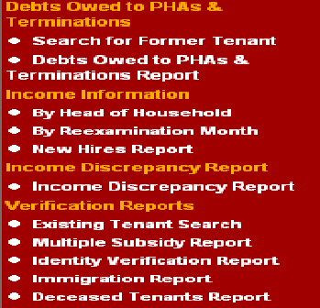
3. PHA Occupancy – Application Processor*: This role allows the PHA user to access the following verification reports: Debts Owed to PHAs & Terminations Report and Search for Former Tenant (nationally), Existing Tenant Search and Multiple Subsidy Report. See Exhibit 2 for display of EIV functions available to a user assigned this role.
Check box number 3 in Section C, if you work with Public Housing and/or Section 8 families applying for rental assistance, and checked box number 1 in Section A, Item 10.
* This role limits the user’s access to only the Debts Owed to PHAs & Terminations Report and Search for Former Tenant and Multiple Subsidy Report and Existing Tenant Search functions. Do not need to select this role if you have been assigned the PHA Occupancy – Public Housing or PHA Occupancy – Voucher role.

Rev. July 2013 Page 3 of 11 Form HUD-52676-I

OMB No. 2577-0267 Expires 09/30/2019
Exhibit 2:
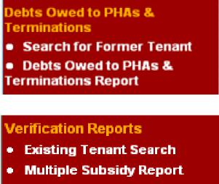
4. Program Administrator – Public Housing: This role allows the PHA user to review, enter, update or delete debts or terminations of former public housing tenants in the Debts Owed to PHAs and Terminations module, access the Debts Owed & Terminations Report and Search for Former Tenants (nationally). See Exhibit 3 for display of EIV functions available to a user assigned this role.
Check box number 4 in Section C, if your Executive Director, or designee has authorized you to only enter debt and termination information of former Public Housing tenants into EIV and you checked box number 10 in Section A, Item 10,
Exhibit 3:
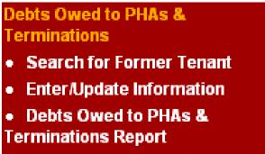
5. Program Administrator – Voucher: This role allows the PHA user to review, enter, update or delete debts or terminations of former Housing Choice Voucher (HCV) tenants in the Debts Owed to PHAs and Terminations module, access the Debts Owed to PHAs & Terminations Report and Search for Former Tenants (nationally). See Exhibit 4 for display of EIV functions available to a user assigned this role.
Check box number 5 in Section C, if your Executive Director, or designee has authorized you to only enter debt and termination information of former Section 8 tenants into EIV and you checked box number 10 in Section A, Item 10.
Rev. July 2013 Page 4 of 11 Form HUD-52676-I

OMB No. 2577-0267 Expires 09/30/2019
Exhibit 4:
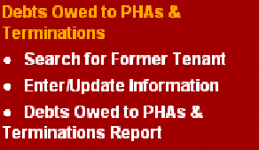
6. PHA User Administrator: This role allows the user to request EIV access for PHA staff; assign, modify and remove roles; assign public housing developments; certify users, terminate EIV access; and view User Role History, Termination and Certification reports. See Exhibit 5 for display of EIV functions available to a user assigned this role.
Check box number 6 in Section C, if you checked box number 4, 5, or 6 in Section A, Item 10.
Note: Medium, large and very large PHAs must have at least two User Administrators. The User Administrator may not be assigned the Security Administrator role, unless the PHA is designated as a small PHA.
Exhibit 5:
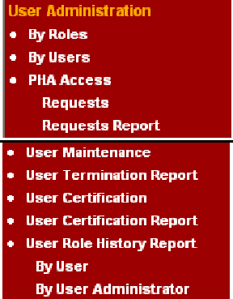
7. PHA Security Administrator: This role allows the user to monitor staff access to the EIV system by viewing the various audit reports: User Session and Activity and Tenant Data Access Reports. See Exhibit 6 for display of EIV functions available to a user assigned this role.
Check box number 7 in Section C, if you checked box number 3 in Section A, Item 10.
Note: Medium, large and very large PHAs must have at least two Security Administrators. The Security Administrator may not be assigned the User Administrator role, unless the PHA is designated as a small PHA.
Rev. July 2013 Page 5 of 11 Form HUD-52676-I

OMB No. 2577-0267 Expires 09/30/2019
Exhibit 6:
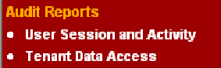
Note: If the type of action requested (in Section B) is Modify Access, the user should check both previously assigned roles and new roles to be assigned to the user’s ID. The most recent access modification request must be maintained on file.
Guide to Selecting the Appropriate PHA User Roles to be Assigned to a PHA User ID
 | Box Checked in  Section A, Item 10  (Type of Work) | Box to Check in Section C  (PHA User Access Role)
2, | 8, or 9 | 1
2, | 8, or 9 | 2
1 |  | 3
10 |  | 4
10 |  | 5
4, | 5, or 6 | 6
3 |  | 7

Note: If you select 1 and 2, 8, and/or 9 in Section A.10, you do not check box 3 in Section C.
If you select 3 and 4, 5, and/or 6, do not check both boxes 6 and 7 in Section C, unless you are a PHA with combined (Public Housing & Section 8) unit count of 250 or less. Otherwise, you may only check one box – 6 or 7 in Section C.
Section D. Public Housing Portfolio
This section applies to only PHA users. A user who has been assigned the PHA Occupancy – Public Housing role must have the applicable public housing projects, now known as Asset Management Projects (AMPs), assigned to their user ID so that the user may view income data of tenants that reside within the designated AMPs. If this is not done, the user will not be able to view income data of public housing tenants.
List the designated AMP numbers to be assigned to the user ID. AMP information is displayed in EIV’s User Administration module. If the user is authorized to access more than nine AMPs, list the AMP numbers on a separate sheet of paper and attach (or append) to the form. If the user is authorized to access income data of all public housing tenants, check the checkbox in this section.
Rev. July 2013 Page 6 of 11 Form HUD-52676-I

OMB No. 2577-0267 Expires 09/30/2019
Section E. HUD User Access Roles (Internal Users)
There are numerous roles which serve to limit a user’s access to data within the EIV system. Below is a listing of these roles. Based on the user’s business needs, select the appropriate role(s) for the user.
1. Occupancy Specialist: This role allows the HUD user to access the following functions in EIV: Debts Owed to PHAs & Terminations Report and Search for Former Tenant (nationally), Income Discrepancy Report, Income Information and Verification Reports for the Public Housing and Housing Choice Voucher programs. The user is permitted to access information for the designated region(s) assigned to the user’s ID. See Exhibit 7 for display of EIV functions available to a user assigned this role.
Exhibit 7:
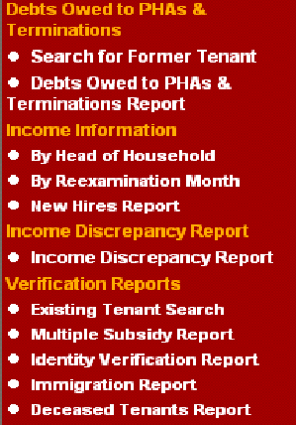
2. Security Administrator: This role allows the user to monitor HUD and PHA staff access to the EIV system by viewing the various audit reports: User Session and Activity and Tenant Data Access Reports. The user is permitted to access information for the designated region(s) assigned to the user’s ID. See Exhibit 8 for display of EIV functions available to a user assigned this role.
Note: HUD Field Offices must have at least two Security Administrators. The Security Administrator may not be assigned the User Administrator role.
Exhibit 8:
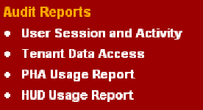
Rev. July 2013 Page 7 of 11 Form HUD-52676-I

OMB No. 2577-0267 Expires 09/30/2019
3. User Administrator: This role allows the user to approve PHA EIV access requests; assign, modify and remove roles to PHA and Field Office staff user IDs; assign public housing developments; certify users, terminate EIV access; and view PHA Access Requests, User Role History, Termination, and Certification reports. See Exhibit 9 for display of EIV functions available to a user assigned this role.
Note: HUD Field Offices must have at least two User Administrators. The User Administrator may not be assigned the Security Administrator role.
Exhibit 9:
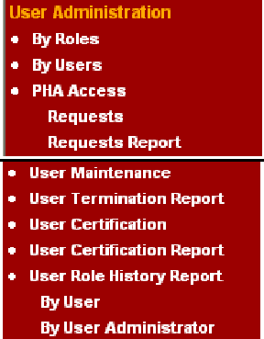
4. HUD OIG: This role allows the HUD OIG user to access the following functions in EIV: Debts Owed to PHAs & Terminations Report and Search for Former Tenant (nationally), Income Discrepancy Report, Income Information and Verification Reports for the Public Housing and Housing Choice Voucher programs. The user is permitted to access information for the designated region(s) assigned to the user’s ID. See Exhibit 10 for display of EIV functions available to a user assigned this role.
Note: This role is designated for only HUD OIG personnel.
Exhibit 10:
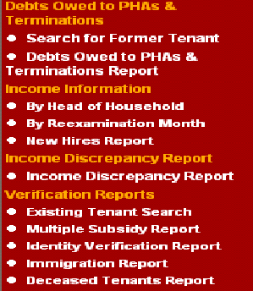
Rev. July 2013 Page 8 of 11 Form HUD-52676-I

OMB No. 2577-0267 Expires 09/30/2019
5. HQ PIH DHAP: This role allows the HUD Headquarters’ user to access the following functions in EIV: Income Discrepancy Report, Income Information and Verification Reports for the Disaster Housing Assistance program. See Exhibit 11 for display of EIV functions available to a user assigned this role.
Exhibit 11:
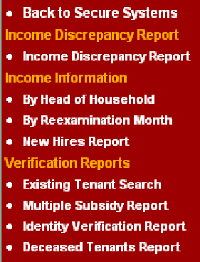
HQ ­ User Administrator: This role allows the user to approve and grant EIV access requests for HUD and PHA staff; assign, modify and remove roles; assign public housing developments; certify users, terminate EIV access; and view User Role History, Termination and Certification reports.
This role is reserved for only HUD Headquarters’ staff.
6. HQ System Administrator: This role is reserved for HUD Headquarters’ system administrator.
7. HQ PIH Help Desk/TAC: This role is reserved for HUD Headquarters’ approved Help Desk staff.
Guide to Selecting the Appropriate HUD User Roles to be Assigned to HUD Field Office staff’s User ID
Box Checked in  Section A, Item 10  (Type of Work) | Box to Check in Section E  (HUD User Access Role)
7, 8, or 9 | 1
3 | 2
5 or 6 | 3
HHQ roles will be approved by EIV System Owner or HQ System Administrator

Rev. July 2013 Page 9 of 11 Form HUD-52676-I

OMB No. 2577-0267 Expires 09/30/2019
Section F. Authorization
The Authorizing official or designee is required to sign and date this form to authorize a user’s access request to access the EIV system or ability to view and/or handle printed or electronic EIV data.
PHAs – The Executive Director or his/her designee must sign and date this form for all PHA staff and PHA-hired management agents.
HUD Employees - The employee’s first line supervisor is required to sign and date this form.
HUD Contractors – The Government Technical Monitor (GTM) or first line HUD supervisor of the HUD office for which the contractor is providing services to is required to sign and date this form.
Section G. For HUD Use Only
This section is to be completed by the designated EIV coordinator in the local HUD office. The EIV Coordinator is required to indicate the date the form was received and processed, his/her name, action taken (approved or denied) and if the request was denied, specify the reason the request was denied.
The EIV Coordinator is required to maintain this form for the duration of the individual’s access and for a period of three years from the termination date of the user’s EIV access.
Electronic retention of this form is permissible.
Part II. Rules of Behavior
Each user who requests access to and will use the EIV system and any individual who will not access the EIV system but will view and/or handle printed or electronic EIV information is required to read all elements of Part II.
Part III. User Agreement
Each user who requests access to and will use the EIV system and any individual who will not access the EIV system, but will view and/or handle printed or electronic EIV information is required to read all elements of Part III, certify that s/he has participated in HUD-sponsored PIH EIV System training and annual Security Awareness training, and agree to comply with and follow all HUD standards, policies, and procedures related to EIV system and data use, by signing and dating this form.
Rev. July 2013 Page 10 of 11 Form HUD-52676-I

OMB No. 2577-0267 Expires 09/30/2019

Local HUD Offices and Designated EIV Coordinators
PHAs are required to send completed forms to the local HUD office. A listing of each local HUD office including the address, telephone number, fax number, and designated EIV coordinators and their respective telephone numbers and email addresses is listed below. Do not forward this form to HUD Headquarters in Washington, DC. Only your local HUD office can process your form. Only typewritten forms will be accepted. You may fax, email, or mail the completed form to the U.S. Department of Housing and Urban Development in your region.

Rev. July 2013 Page 11 of 11 Form HUD-52676-I

