Attachment A3

AISL Monitoring System Screenshots: OPMS Annual Survey

Annual Survey Screenshots for
The NSF Advancing Informal STEM Learning (AISL) Program’s
Online Project Monitoring System (OPMS)
NOTE: The OPMS Annual Survey collects data for the previous calendar year (i.e., January 1 – December 31 of the previous year).

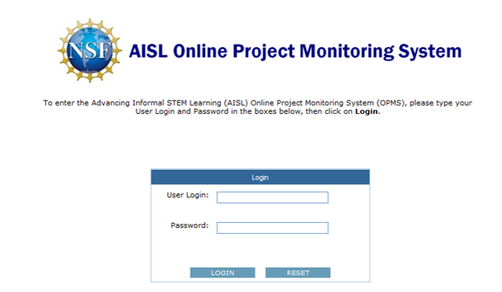

OMB # 3145-0226, Expiration Date: 2/29/2016
Advancing Informal STEM Learning (AISL)
Online Project Monitoring System (OPMS)
Sponsored by the
National Science Foundation
Conducted by
Westat
1650 Research Boulevard
Rockville, Maryland 20850

Privacy Notice
Information from this monitoring system will be retained by the National Science Foundation, a federal agency, and will be an integral part of its Privacy Act System of Records in accordance with the Privacy Act of 1974 and maintained in the Education and Training System of Records, 63 Fed. Reg. 264, 272 (January 5, 1998). These are confidential files accessible only to appropriate National Science Foundation (NSF) officials, their staffs, and their contractors responsible for monitoring, assessing, and evaluating NSF programs. Only data in highly aggregated form, or data explicitly requested as “for general use,” will be made available to anyone outside of the National Science Foundation for research purposes. Data submitted will be used in accordance with criteria established by NSF for monitoring research and education grants, and in response to Public Law 99-383 and 42 U.S.C. 1885c.
Public Burden
Submission of the requested information is voluntary. Failure to provide full and complete information, however, may reduce the possibility for continued support thorough the award/project subject to this survey. The public reporting burden for this collection of information is estimated to average 24.0 person hours for the Baseline submission, 8.0 person hours for each Annual Report, and 16.0 person hours for the Closeout Report, including the time for reviewing instructions. Send comments regarding this burden estimate or any other aspect of this collection of information, including suggestions for reducing this burden, to Suzanne Plimpton, Reports Clearance Officer for OMB Collection 3145-0226, National Science Foundation, 4201 Wilson Blvd., Suite 1265, Arlington, VA 22230.
If you have any questions, contact isehelp@westat.com
Contact Us

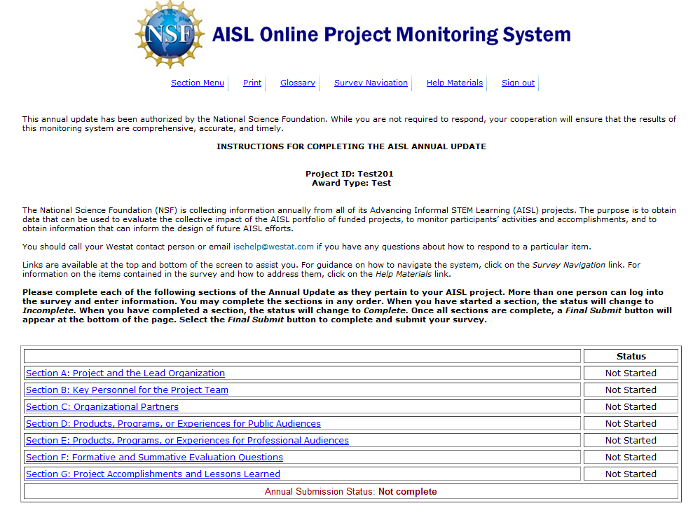

Section A: Project and the Lead Organization

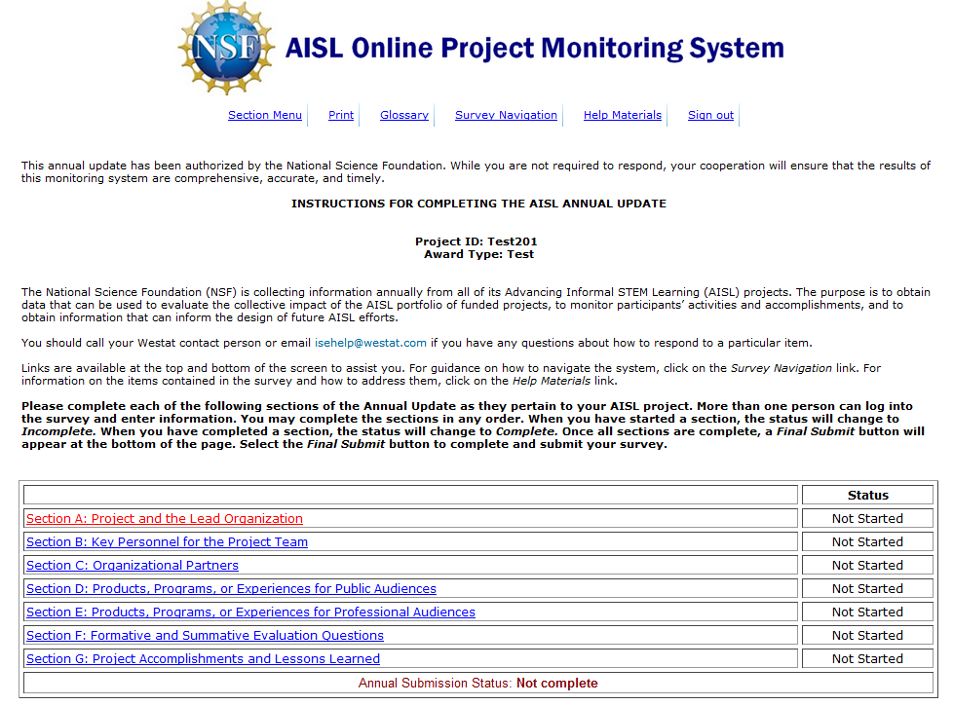

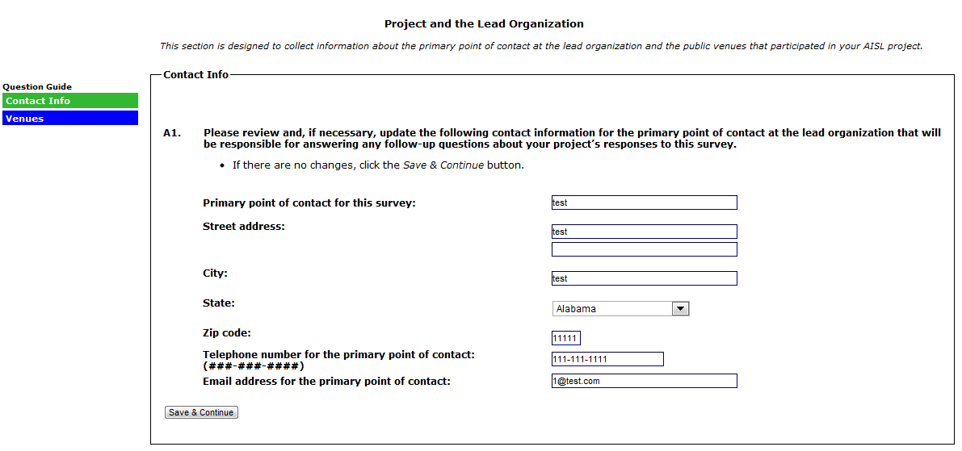

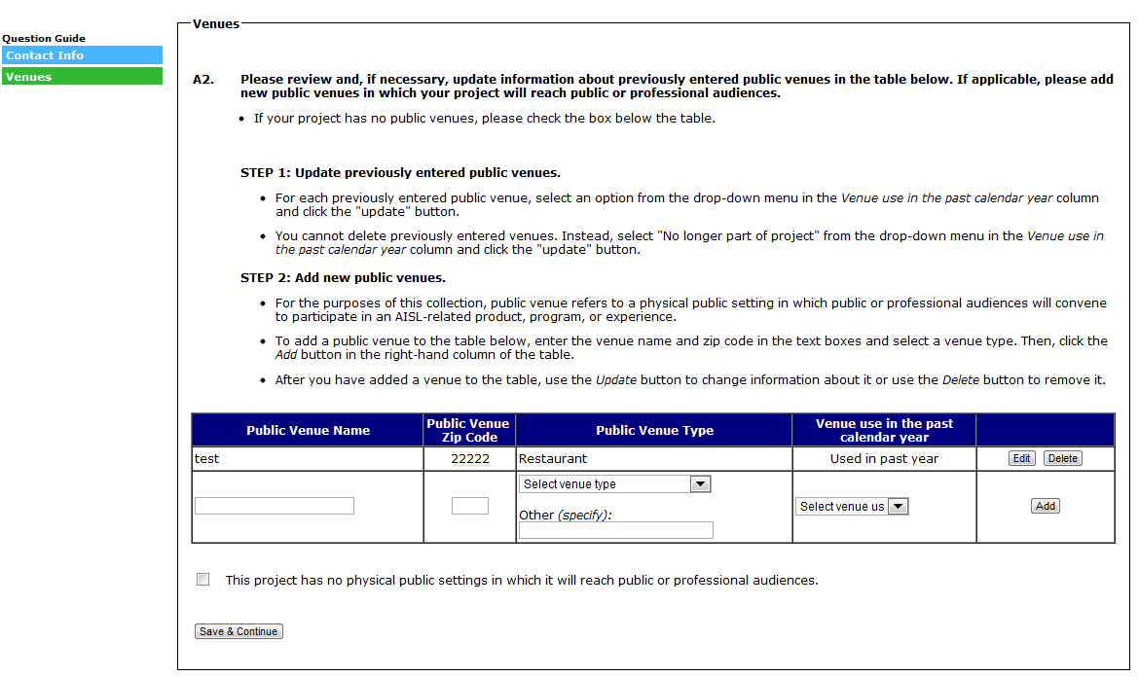
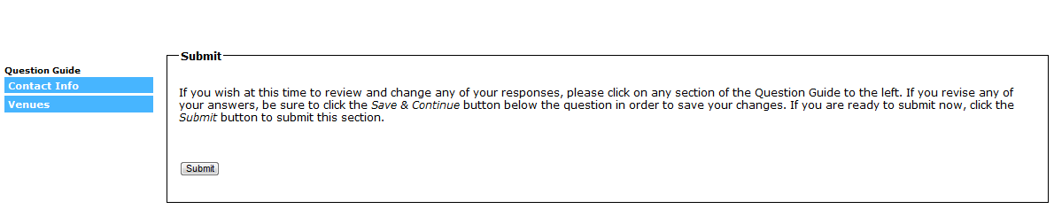
(SELECTING “SUBMIT” WILL SUBMIT SECTION A, MARK SECTION A AS “COMPLETE” ON THE SECTION MENU, AND RETURN TO THE SECTION MENU)

Section B: Key Personnel for the Project Team

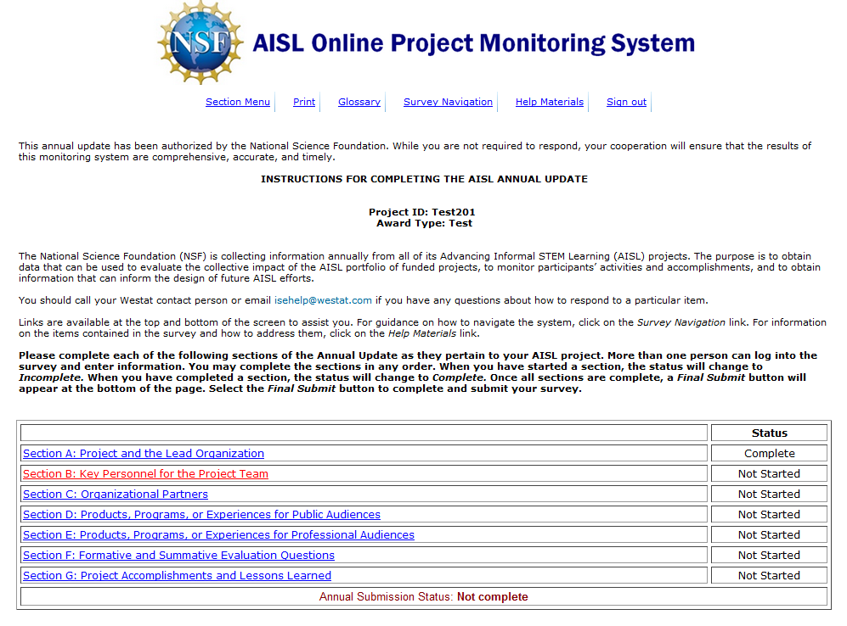

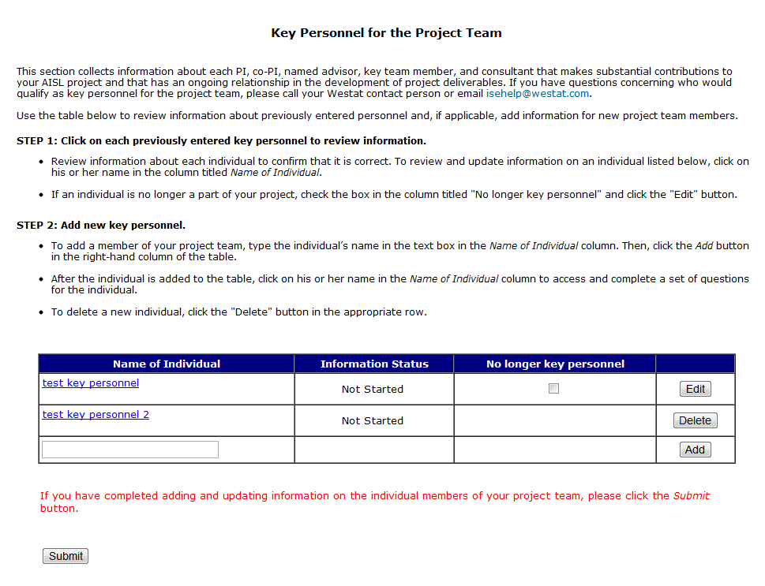

(B1-B4 ARE REVIEWED FOR EACH PERSON ENTERED IN A PREVIOUS REPORT. EACH PERSON ENTERED IN A PREVIOUS REPORT WILL HAVE AN “EDIT” BUTTON IN THE FAR RIGHT COLUMN OF THE KEY PERSONNEL TABLE. B1-B4 ARE
SKIPPED IF THE BOX IS SELECTED IN THE COLUMN INDICATING THAT THE PERSON IS “NO LONGER KEY PERSONNEL.”)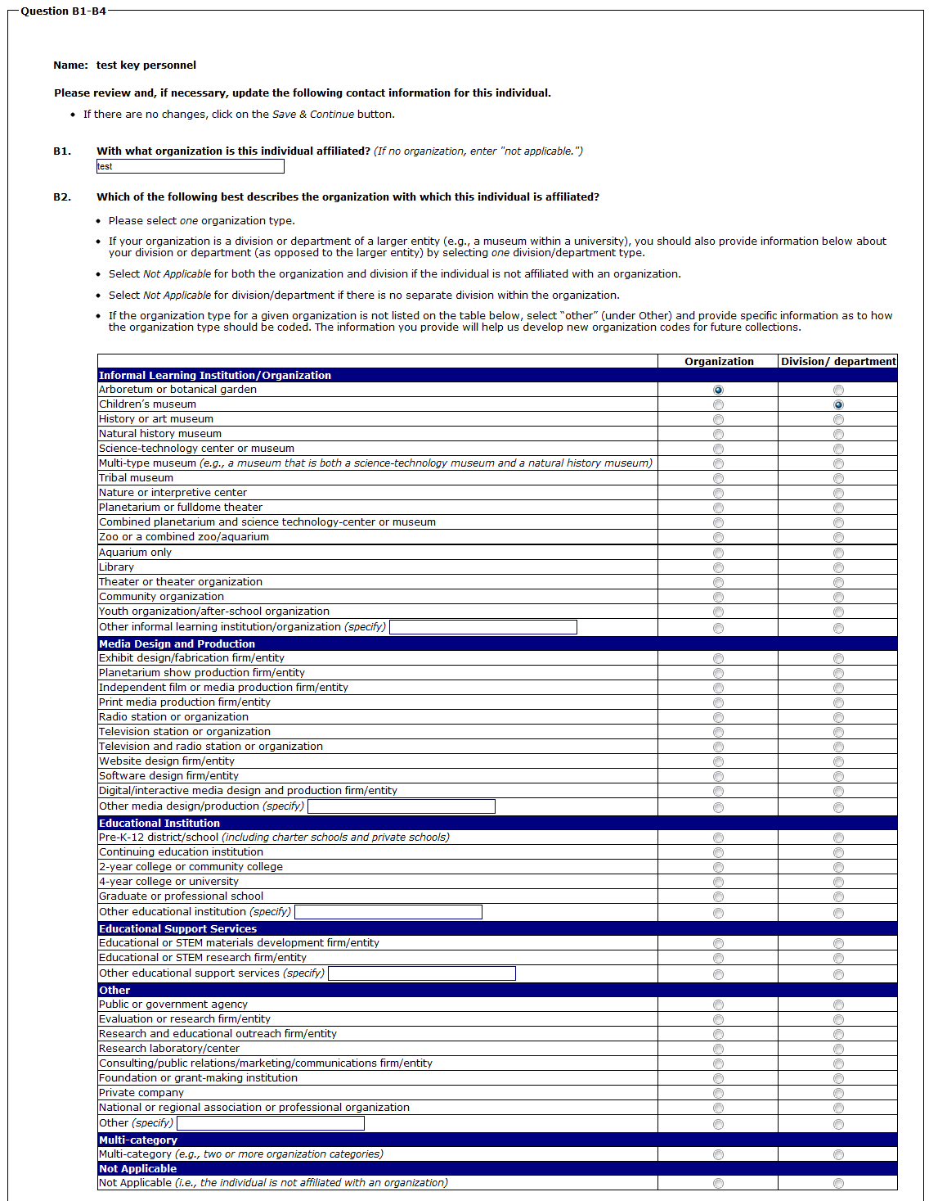
(CONTINUED ON NEXT PAGE)

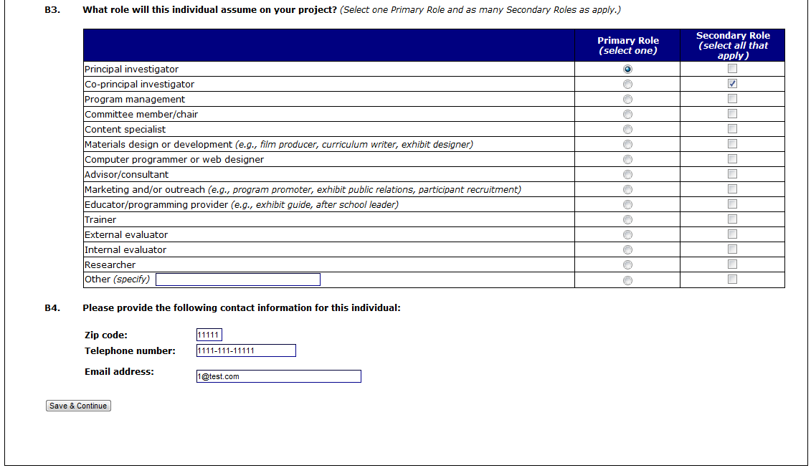
(SELECTING “SAVE & CONTINUE” WILL RETURN YOU TO THE KEY PERSONNEL MAIN PAGE)

(B5-B8 ARE COMPLETED FOR EACH PERSON ENTERED IN THE CURRENT REPORT. EACH PERSON ENTERED IN THE CURRENT REPORT WILL HAVE A “DELETE” BUTTON IN THE FAR RIGHT COLUMN OF THE KEY PERSONNEL TABLE.)
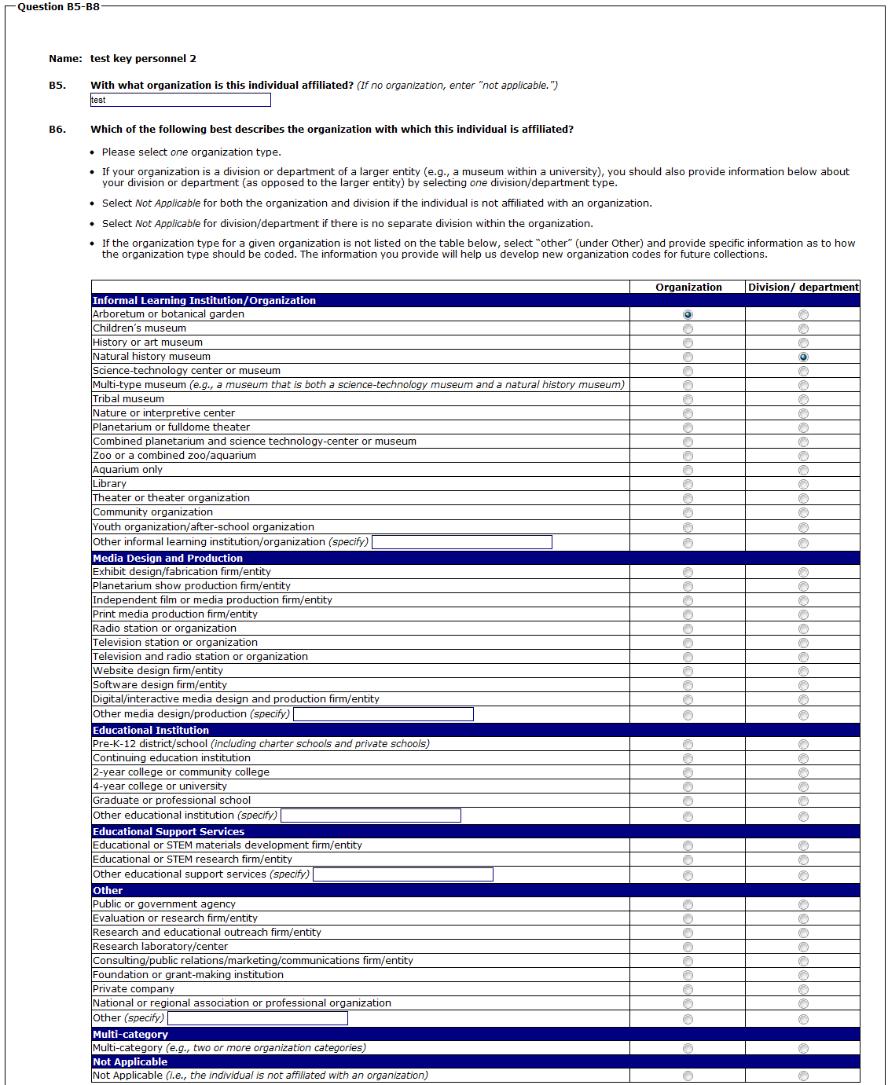
(CONTINUED ON NEXT PAGE)
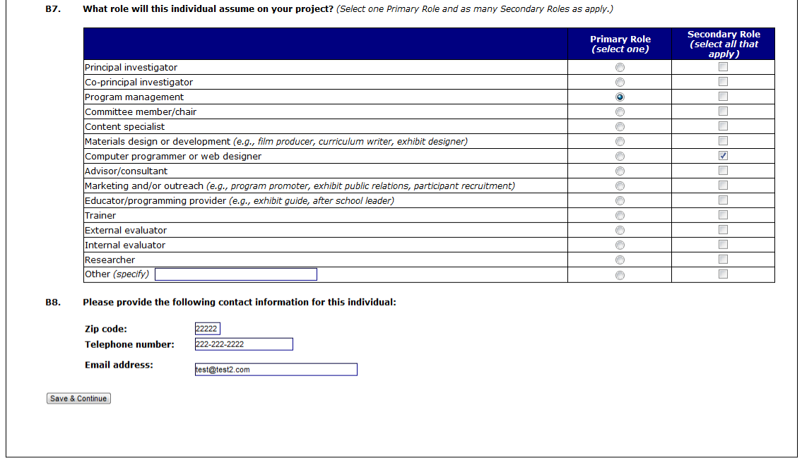
(SELECTING “SAVE & CONTINUE” WILL RETURN YOU TO THE KEY PERSONNEL MAIN PAGE)

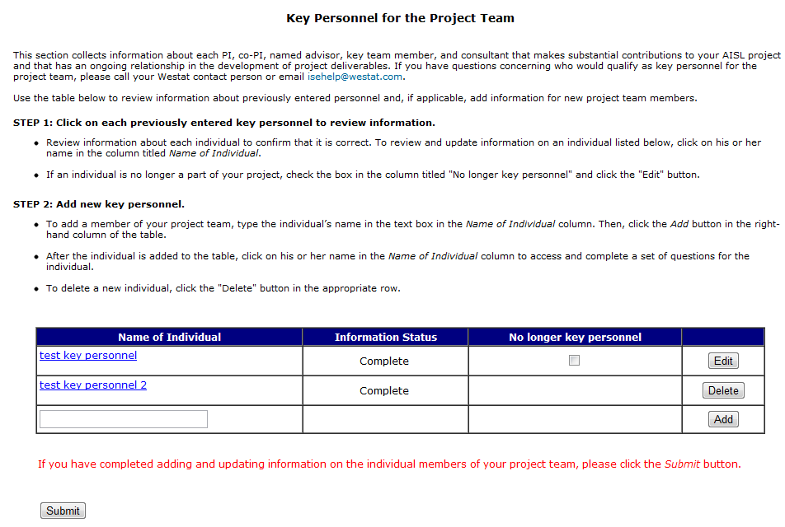
(SELECTING “SUBMIT” WILL SUBMIT SECTION B, MARK SECTION B AS “COMPLETE” ON THE SECTION MENU, AND RETURN TO THE SECTION MENU)

Section C: Organizational Partners
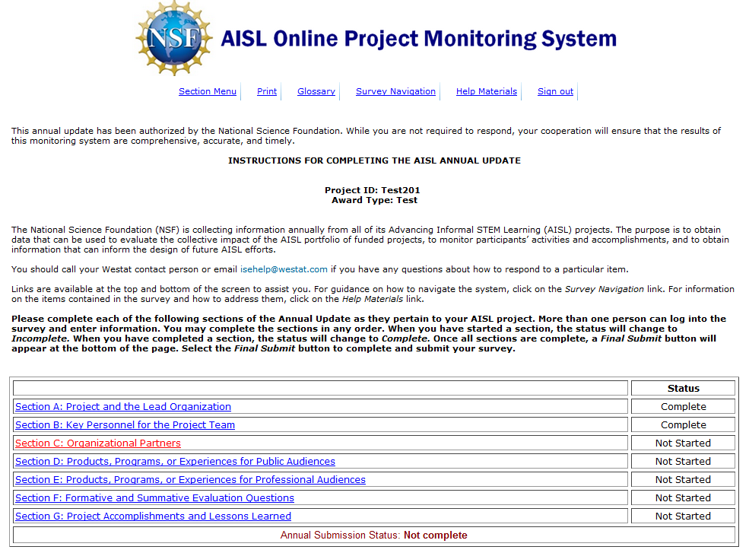

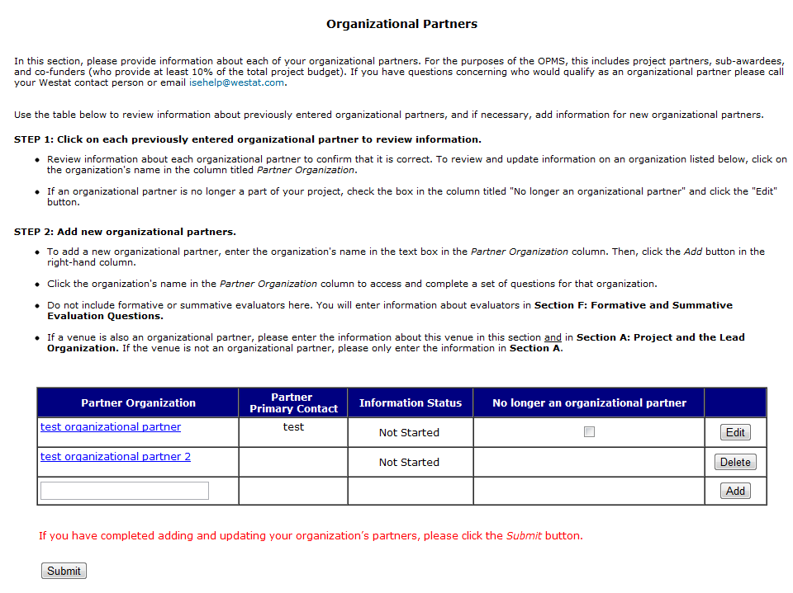

(C1-C5 ARE COMPLETED FOR EACH PARTNER ENTERED IN THE CURRENT REPORT. EACH PARTNER ENTERED IN THE CURRENT REPORT WILL HAVE A “DELETE” BUTTON IN THE FAR RIGHT COLUMN OF THE PARNTER TABLE.)
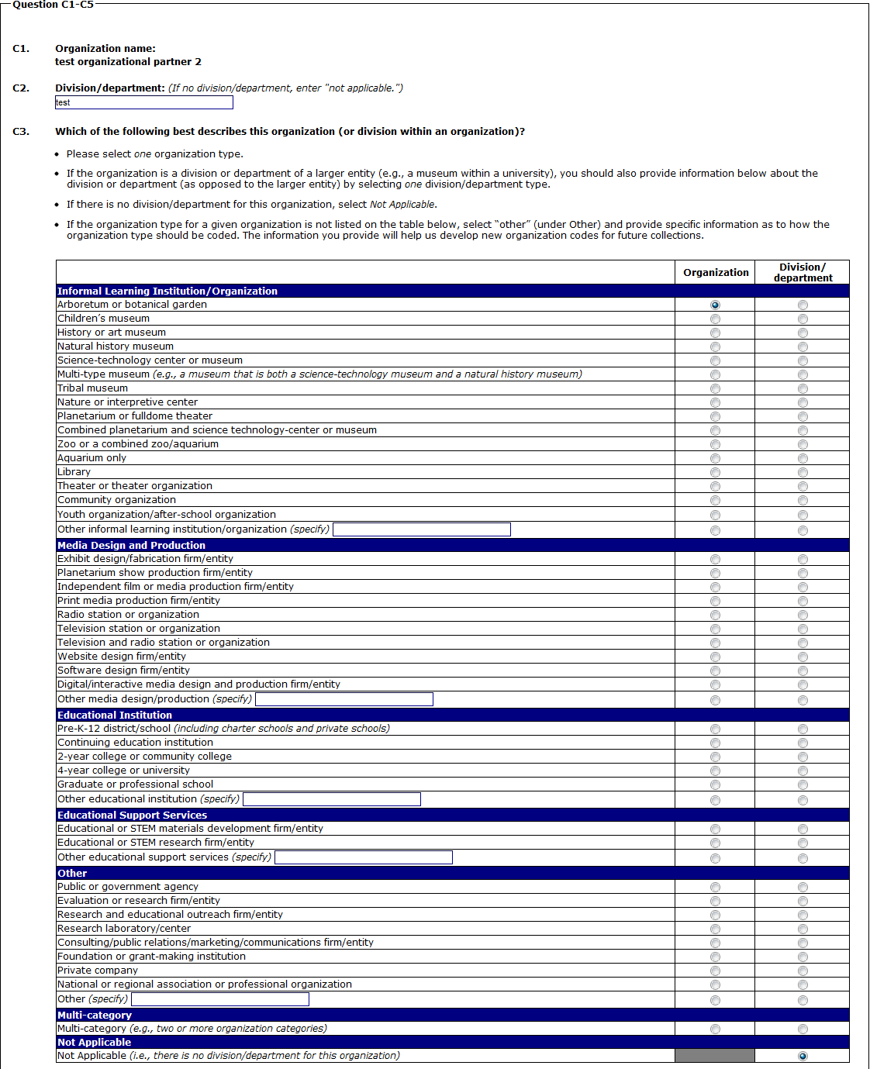
(CONTINUED ON NEXT PAGE)

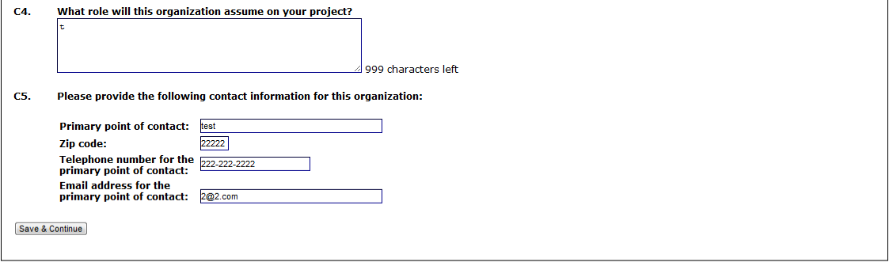
(SELECTING “SAVE & CONTINUE” WILL RETURN YOU TO THE PARTNER MAIN PAGE)

(C6 IS REVIEWED AND UPDATED FOR EACH PARTNER ENTERED IN A PREVIOUS REPORT. EACH PARTNER ENTERED IN A PREVIOUS REPORT WILL HAVE AN “EDIT” BUTTON IN THE FAR RIGHT COLUMN OF THE PARTNER TABLE. C6 IS SKIPPED IF THE BOX IS SELECTED IN THE COLUMN INDICATING THAT THE PARTNER IS “NO LONGER AN ORGANIZATIONAL PARTNER.”)
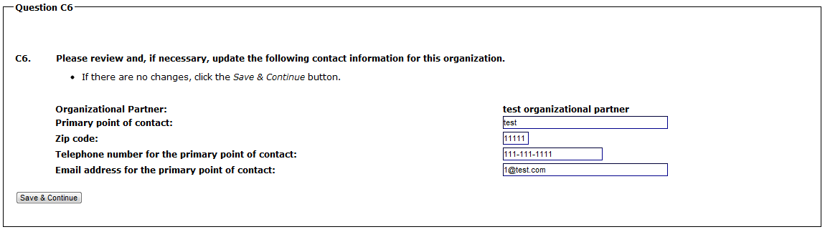

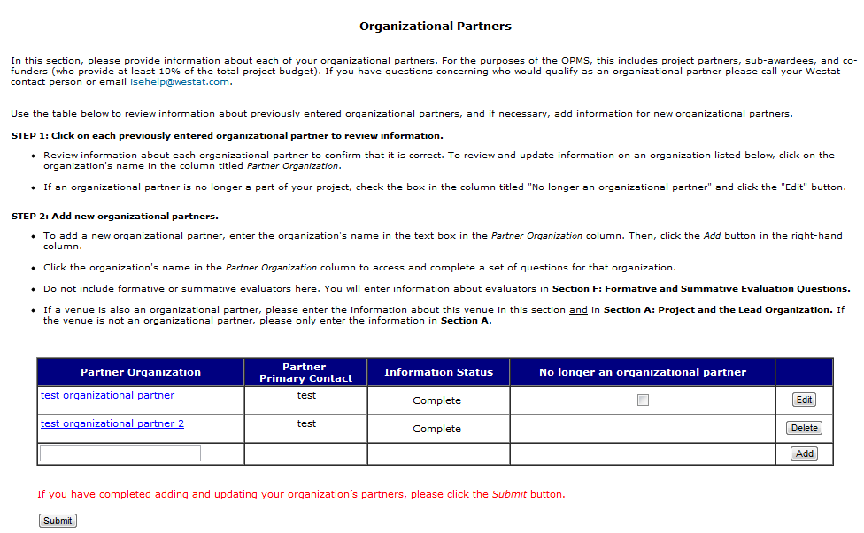
(SELECTING “SUBMIT” WILL SUBMIT SECTION C, MARK SECTION C AS “COMPLETE” ON THE SECTION MENU, AND RETURN TO THE SECTION MENU)

Section D: Products, Programs, or Experiences for Public Audiences

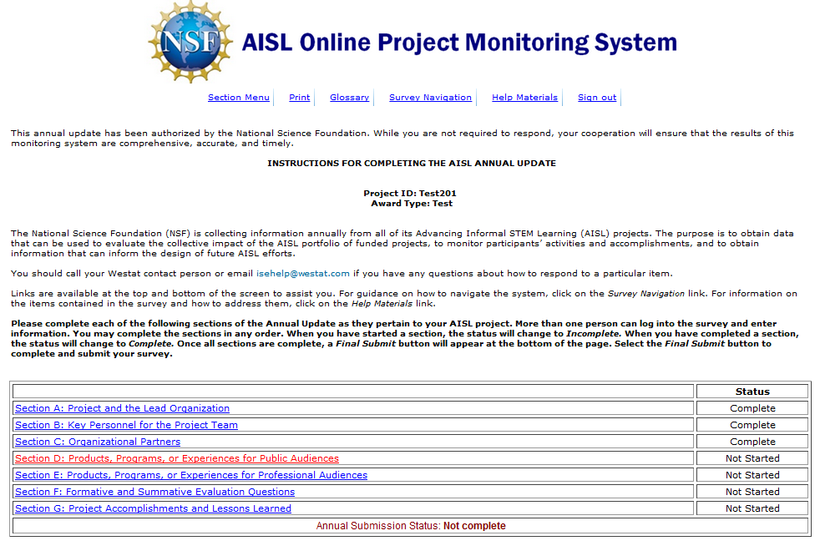

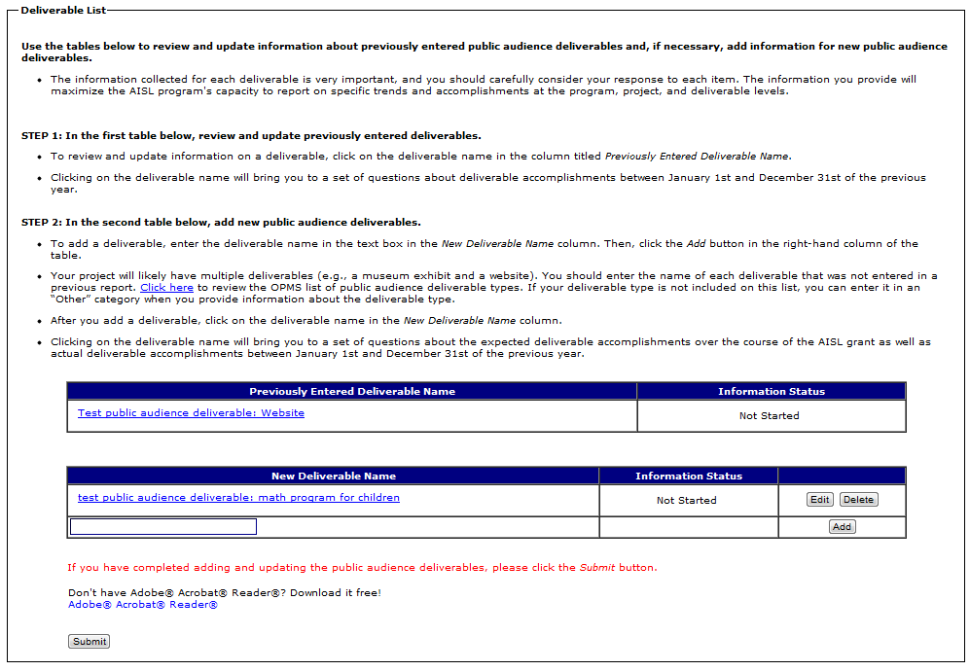

(SELECTING A DELIVERABLE IN THE “PREVIOUSLY ENTERED DELIVERABLE” TABLE WILL BRING YOU TO D2-D9F. D2-D9F ASK ABOUT DELIVERABLE ACTIVITIES IN THE PAST CALENDAR YEAR, OR JANUARY 1 – DECEMBER 31 OF THE PREVIOUS YEAR.)
(SELECTING A DELIVERABLE IN THE “NEW DELIVERABLE” TABLE WILL BRING YOU TO D10-D24B. D10-D19D ARE QUESTIONS ABOUT WHAT THE DELIVERABLE WILL ACCOMPLISH OVER THE COURSE OF THE GRANT. D20-D24B ARE QUESTIONS ABOUT WHAT THE DELIVERABLE ACCOMPLISHED IN THE PAST CALENDAR YEAR, OR JANUARY 1 – DECEMBER 31 OF THE PREVIOUS YEAR.)
(SELECTING A DELIVERABLE IN THE “PREVIOUSLY ENTERED DELIVERABLE” TABLE WILL BRING YOU TO D2-D9F)
(SELECTING “NO” TO D3 SKIPS TO D8/IMPACT LIST)
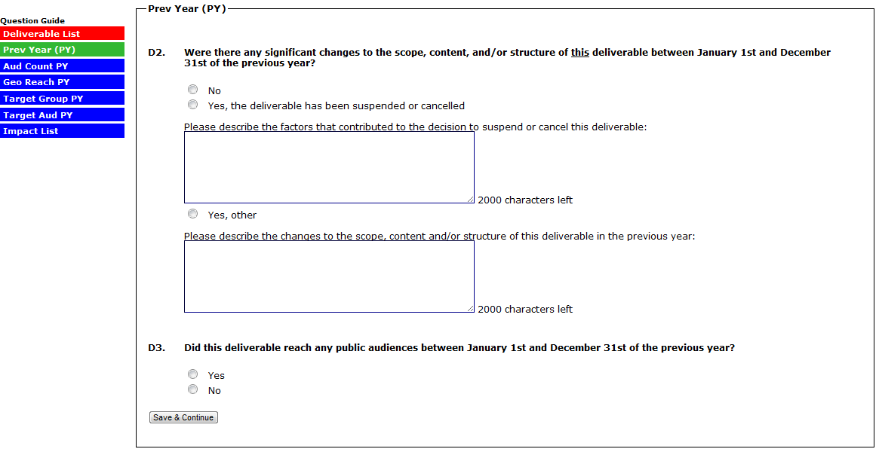

(THE VERSION OF D4 THAT APPEARS FOR “AUD COUNT PY” DEPENDS ON THE DELIVERABLE TYPE SELECTED WHEN THE DELIVERABLE WAS ADDED IN A PREVIOUS REPORT. THE VERSION OF D4 BELOW CORRESPONDS TO A DELIVERABLE TYPE OF “WEBSITE.”)

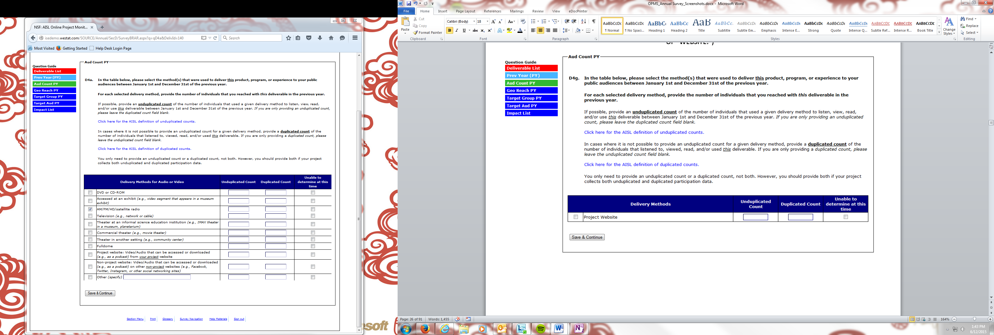
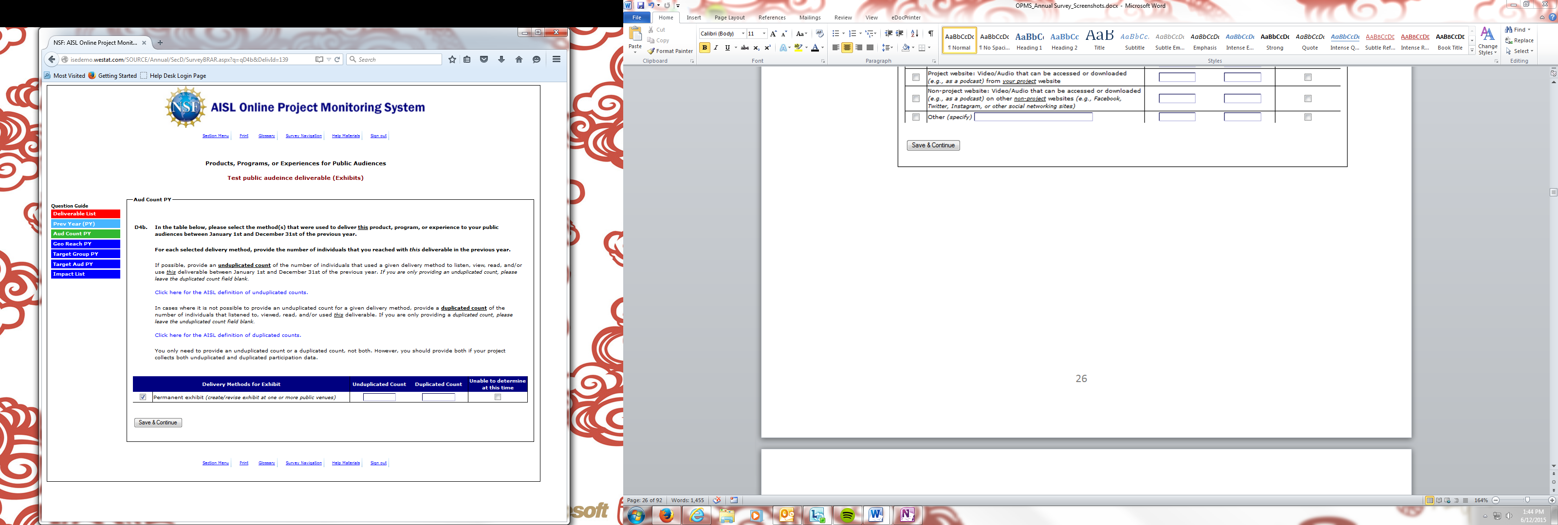
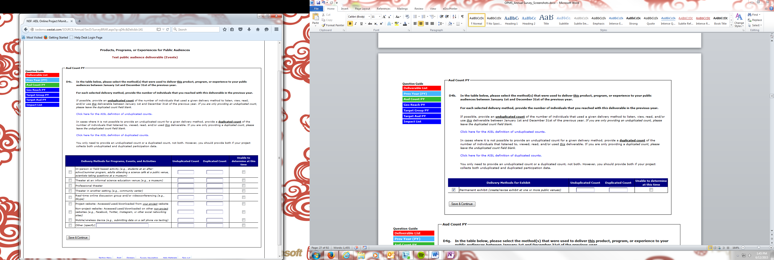

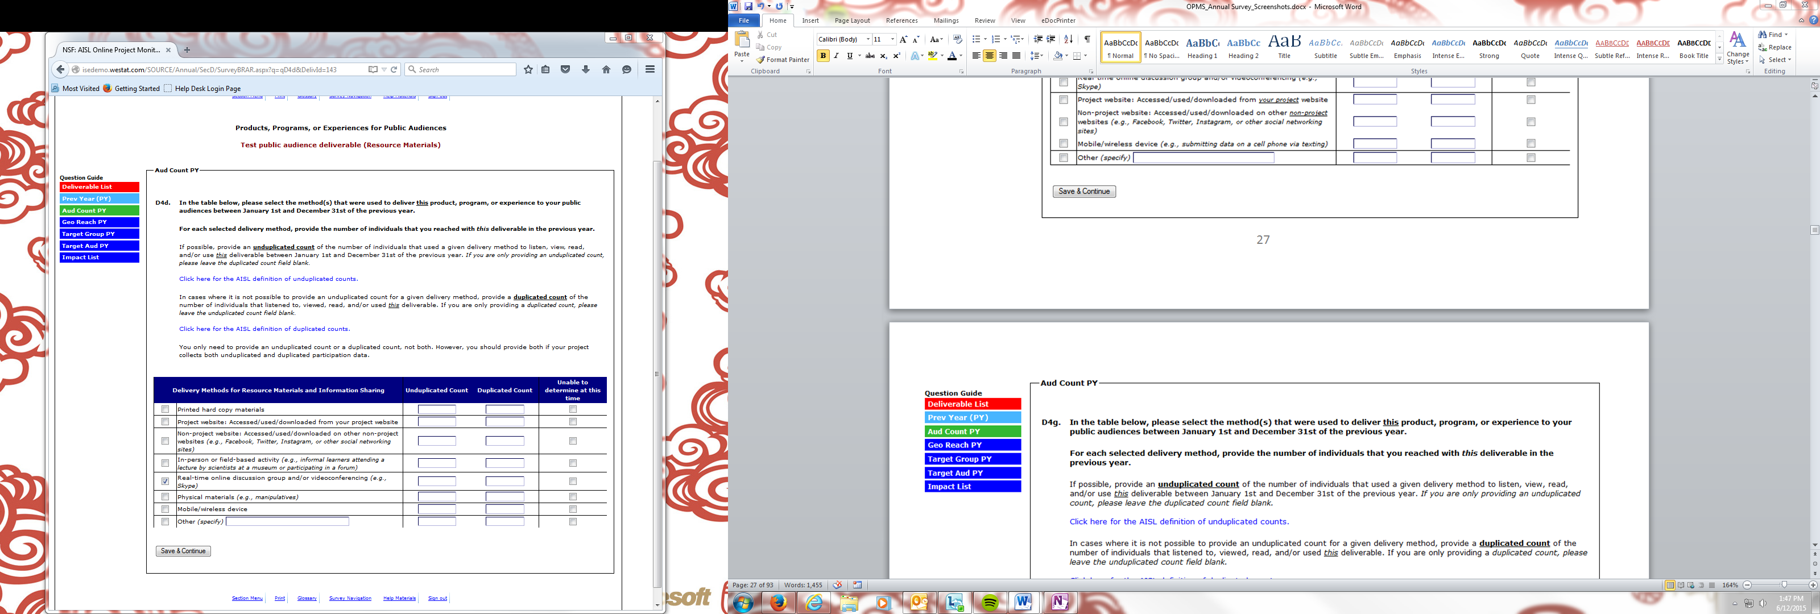
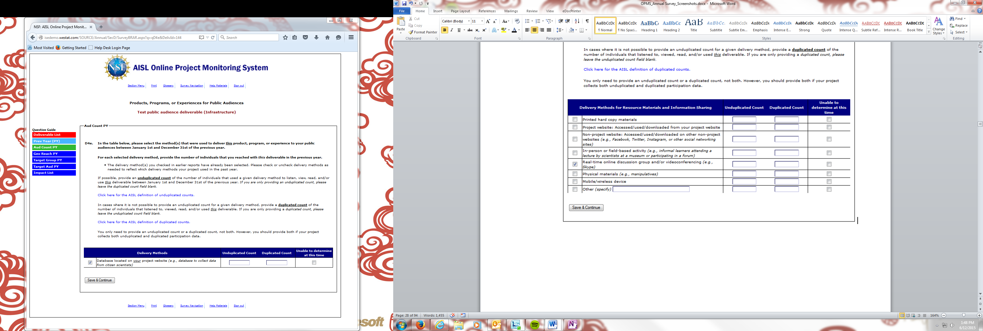
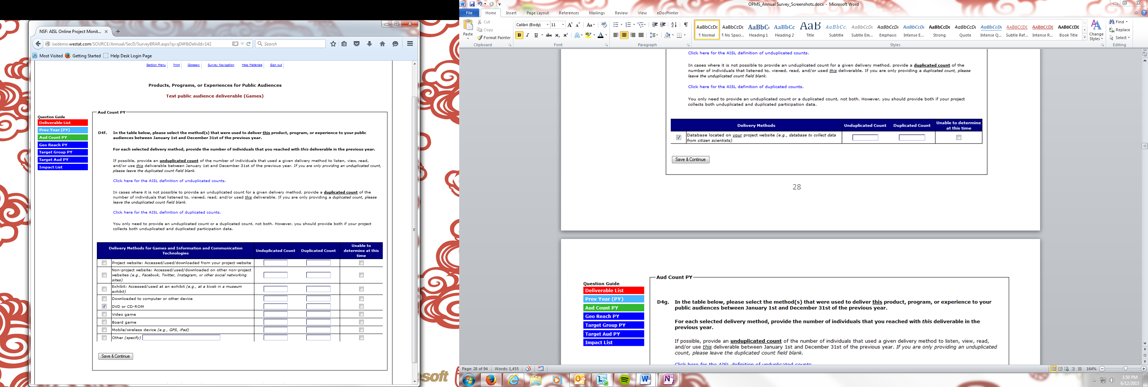
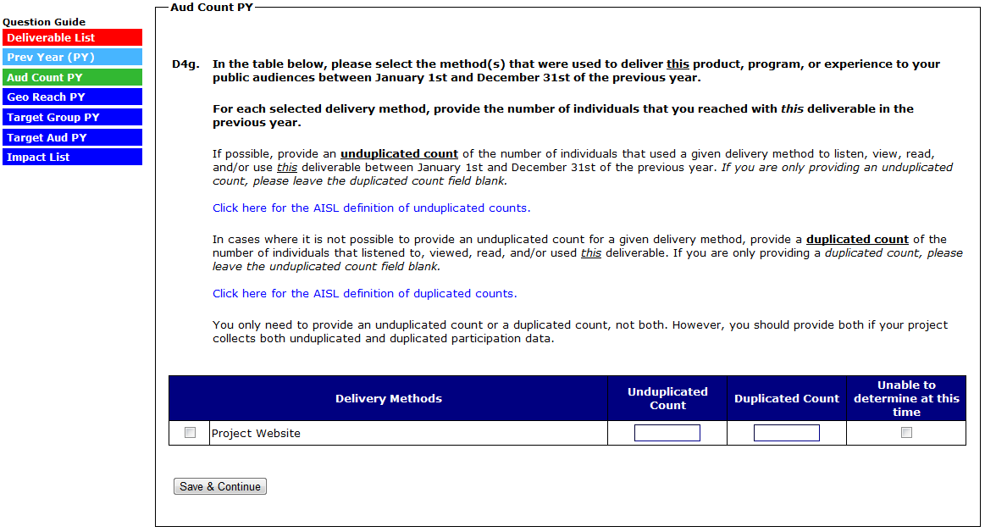
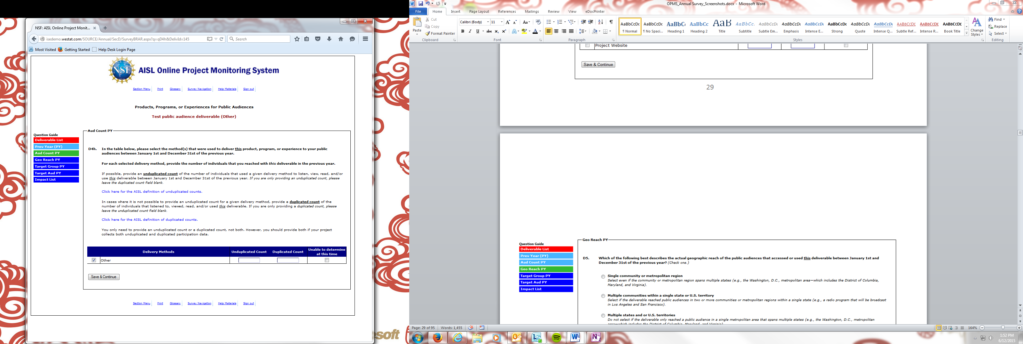
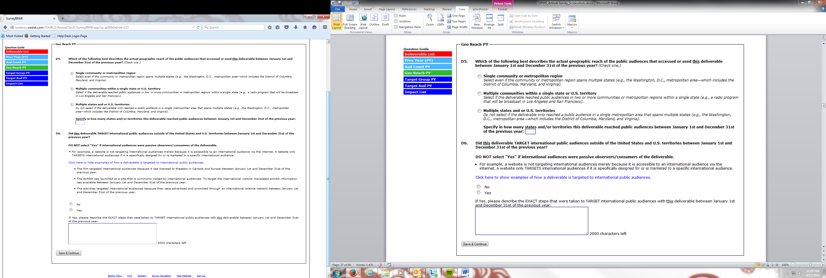

(SELECTING “THE GENERAL PUBLIC ONLY” IN D7 SKIPS TO D8/IMPACT LIST)
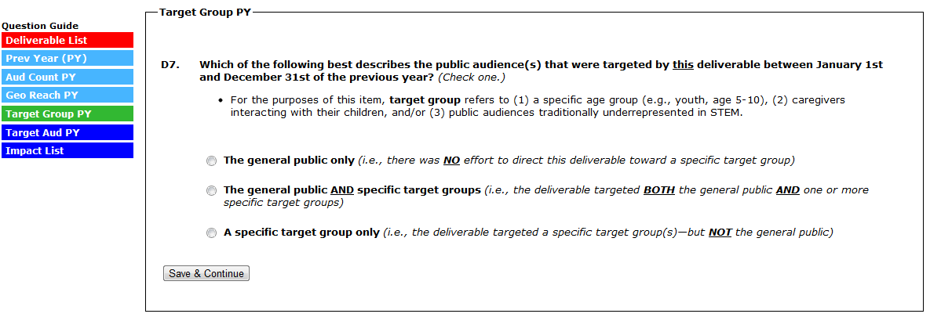

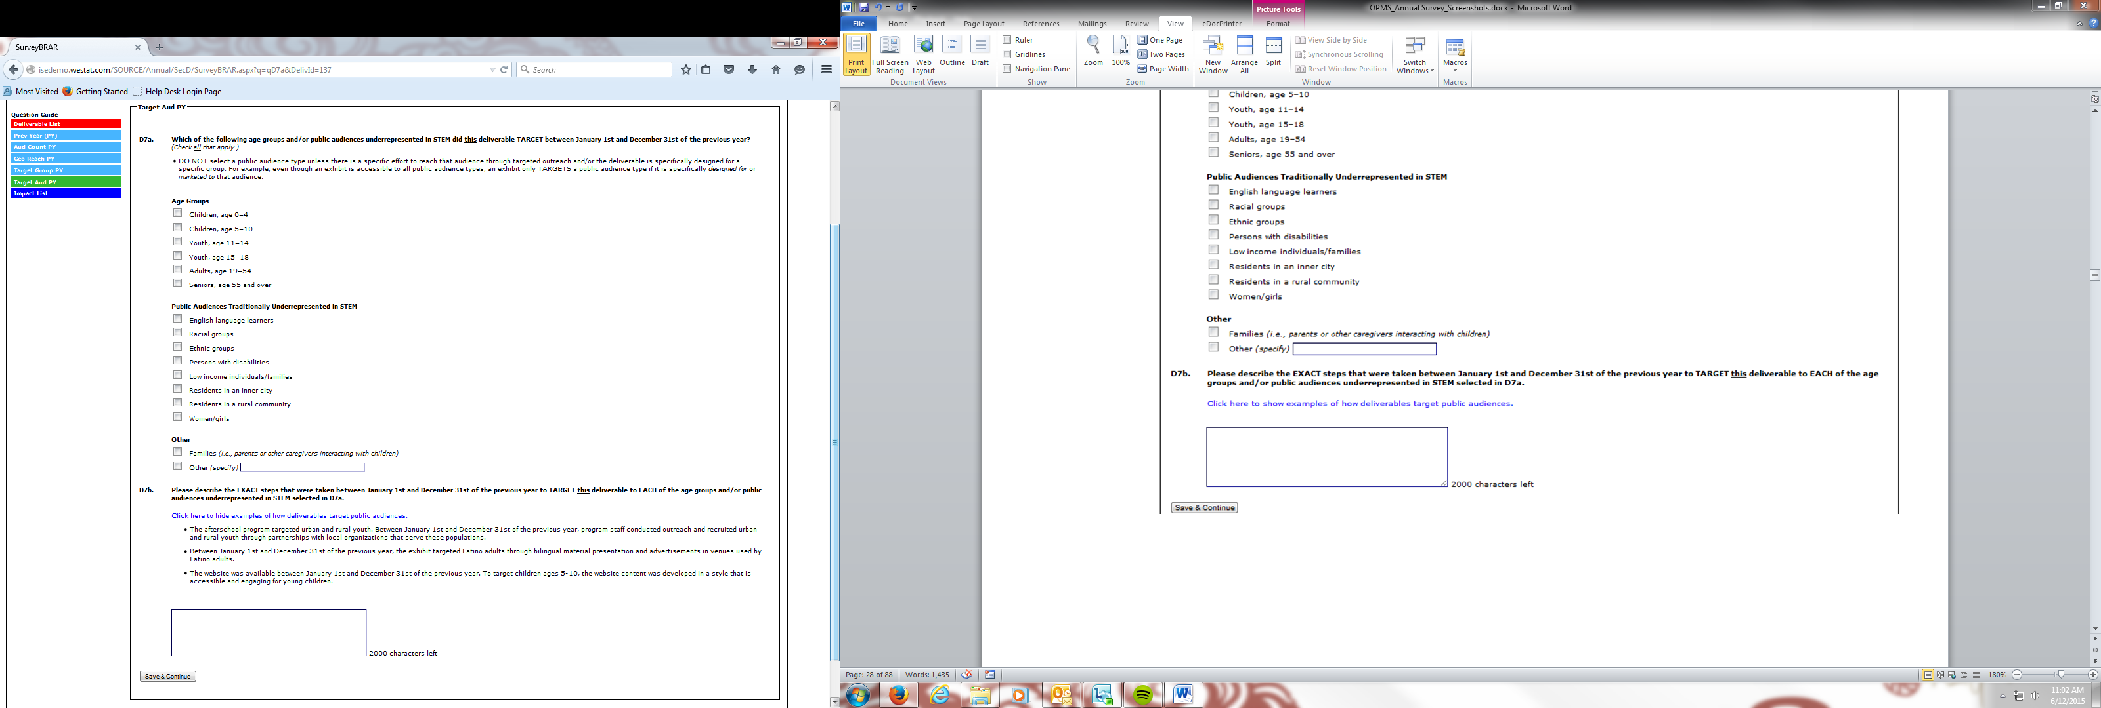
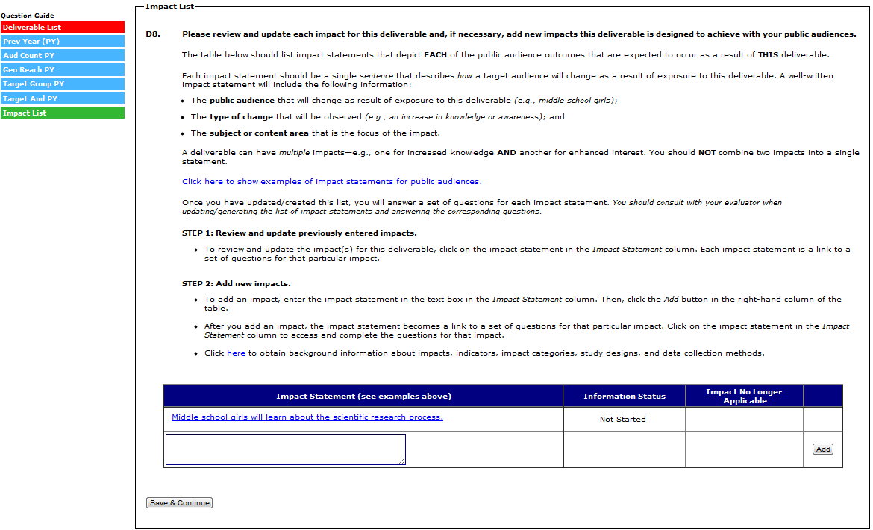

(D8A-9B IS COMPLETED/REVIEWED AND UPDATED FOR EACH IMPACT STATEMENT ENTERED IN A PREVIOUS REPORT. EACH IMPACT ENTERED IN A PREVIOUS REPORT WILL HAVE NO BUTTONS/OPTIONS IN THE FAR RIGHT COLUMN OF THE IMPACT TABLE.)

(SELECTING “NO” TO D8 RETURNS YOU TO THE IMPACT LIST– NO OTHER IMPACT QUESTIONS ARE ASKED)
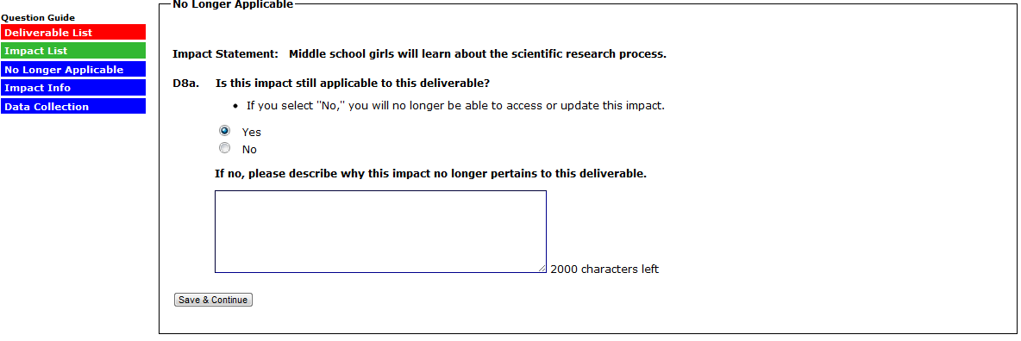
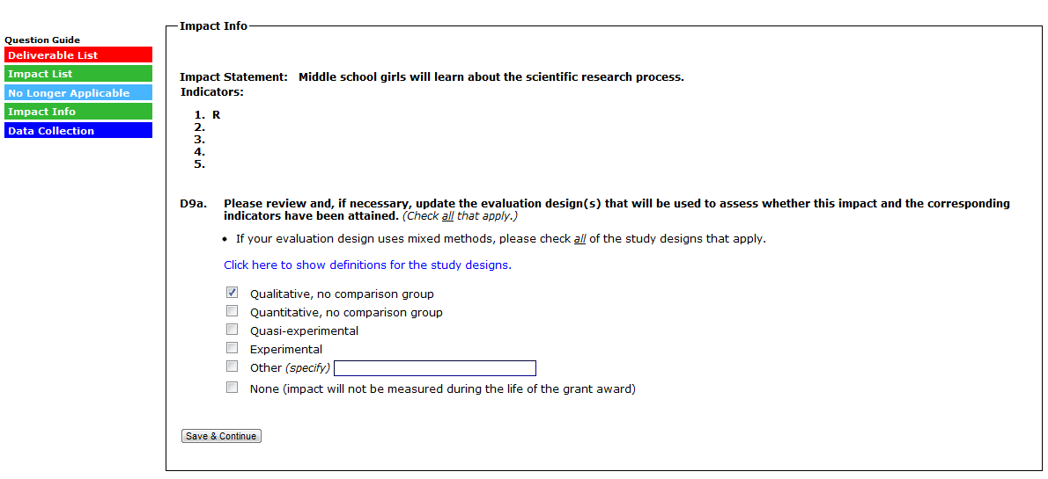
(SELECTING “NONE” TO D9A SKIPS D9B AND RETURNS YOU TO THE IMPACT LIST)
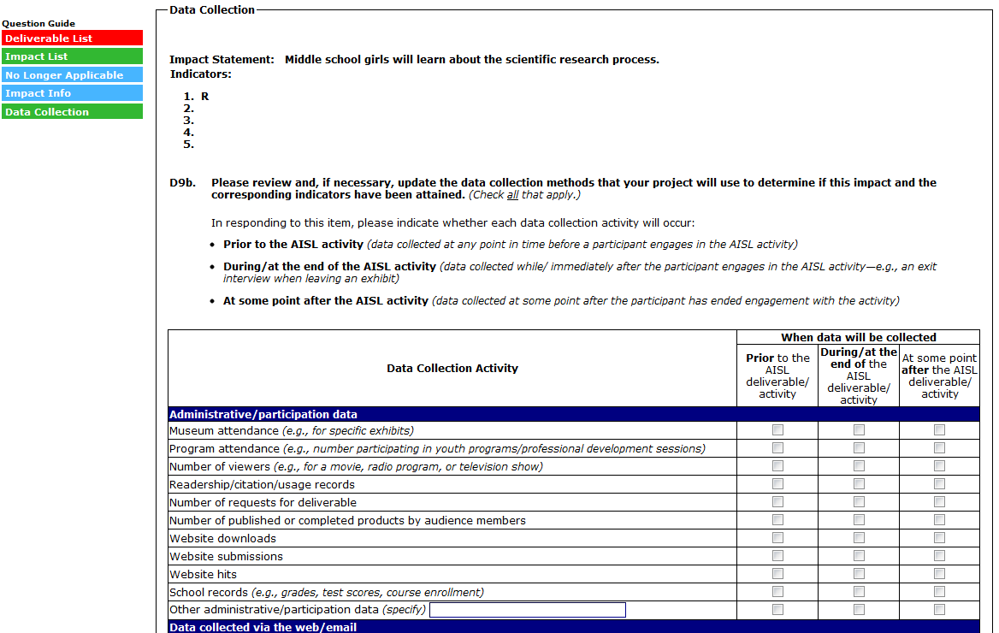
(CONTINUED ON NEXT PAGE)

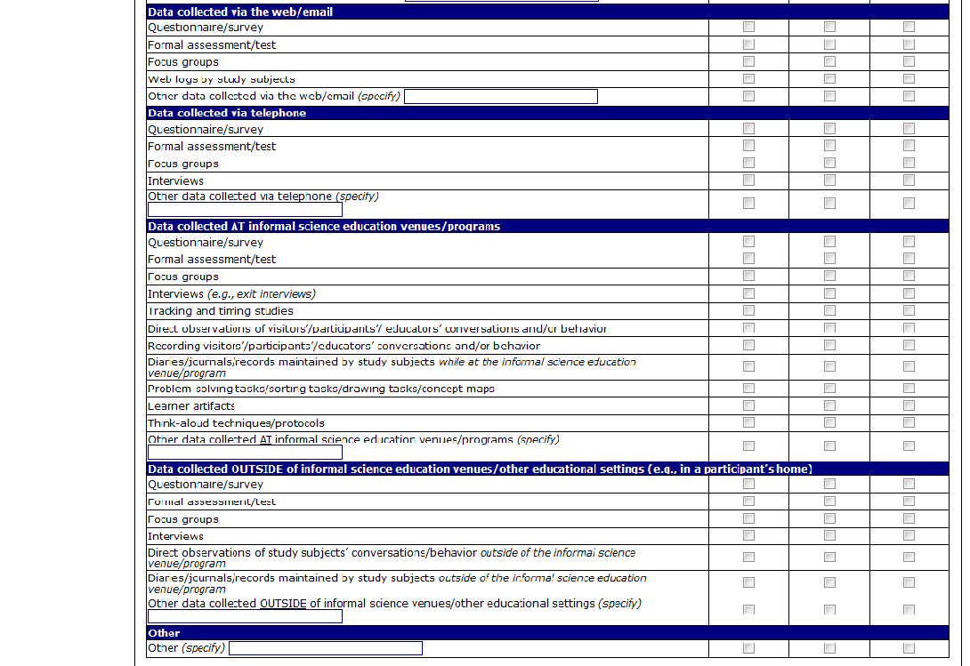

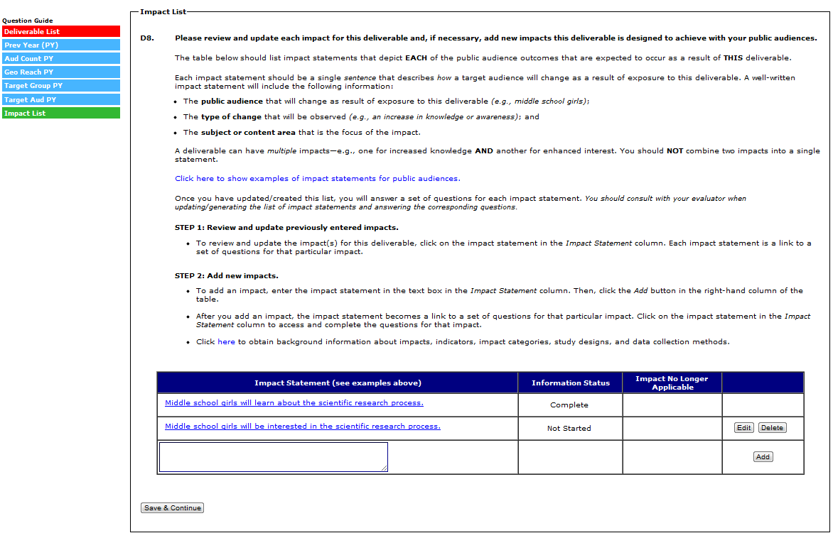

(D9C-D9F ARE COMPLETED FOR EACH IMPACT STATEMENT ADDED IN THE CURRENT REPORT. EACH IMPACT ENTERED IN THE CURRENT REPORT WILL HAVE AN “EDIT” AND “DELETE” BUTTON IN THE FAR RIGHT COLUMN OF THE IMPACT TABLE.)

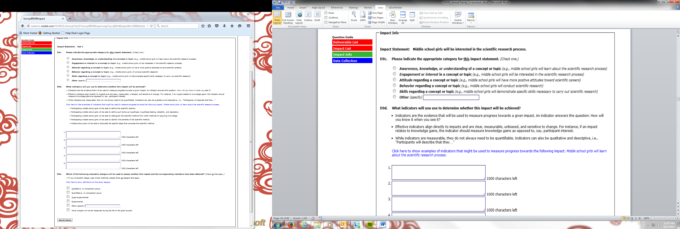
(SELECTING “NONE” IN D9E WILL SUBMIT THE IMPACT, SKIP D9F, AND RETURN TO THE IMPACT LIST)
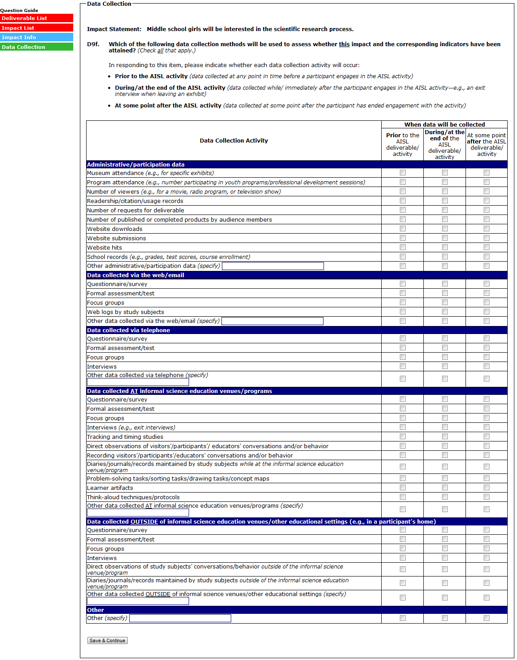
(SELECT “SAVE & CONTINUE” TO SUBMIT THE IMPACT AND RETURN TO THE IMPACT LIST)
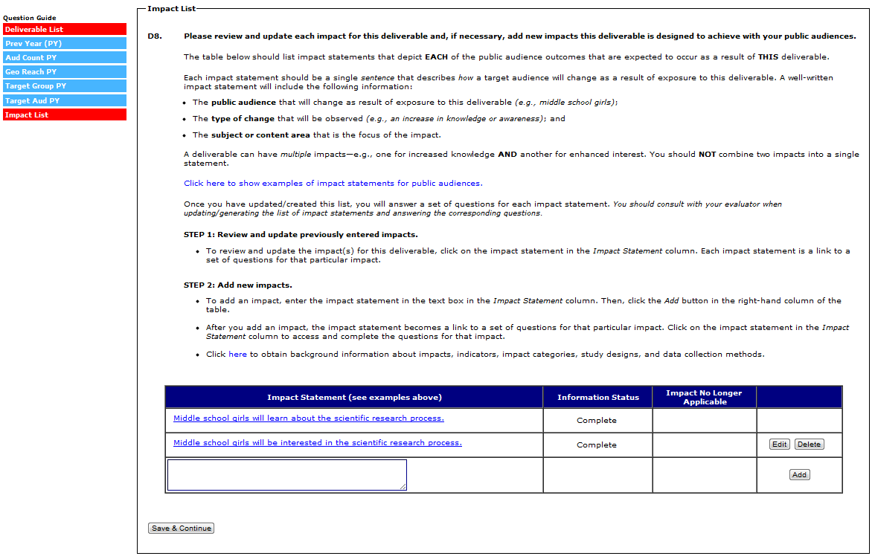
(SELECT “SAVE AND CONTINUE” TO SUBMIT THE DELIVERABLE AND RETURN TO THE DELIVERABLE LIST)

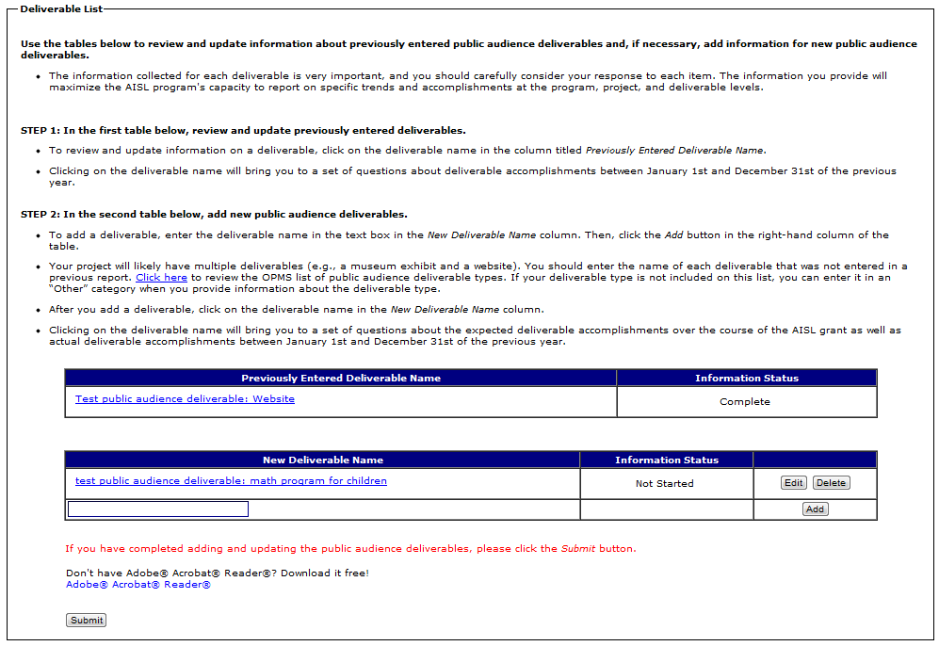

(SELECTING A DELIVERABLE IN THE “NEW DELIVERABLE” TABLE WILL BRING YOU TO D10-D24B. D10-D19D ARE QUESTIONS ABOUT WHAT THE DELIVERABLE WILL ACCOMPLISH OVER THE COURSE OF THE GRANT. D20-D24B ARE QUESTIONS ABOUT WHAT THE DELIVERABLE ACCOMPLISHED IN THE PAST CALENDAR YEAR, OR JANUARY 1 – DECEMBER 31 OF THE PREVIOUS YEAR.)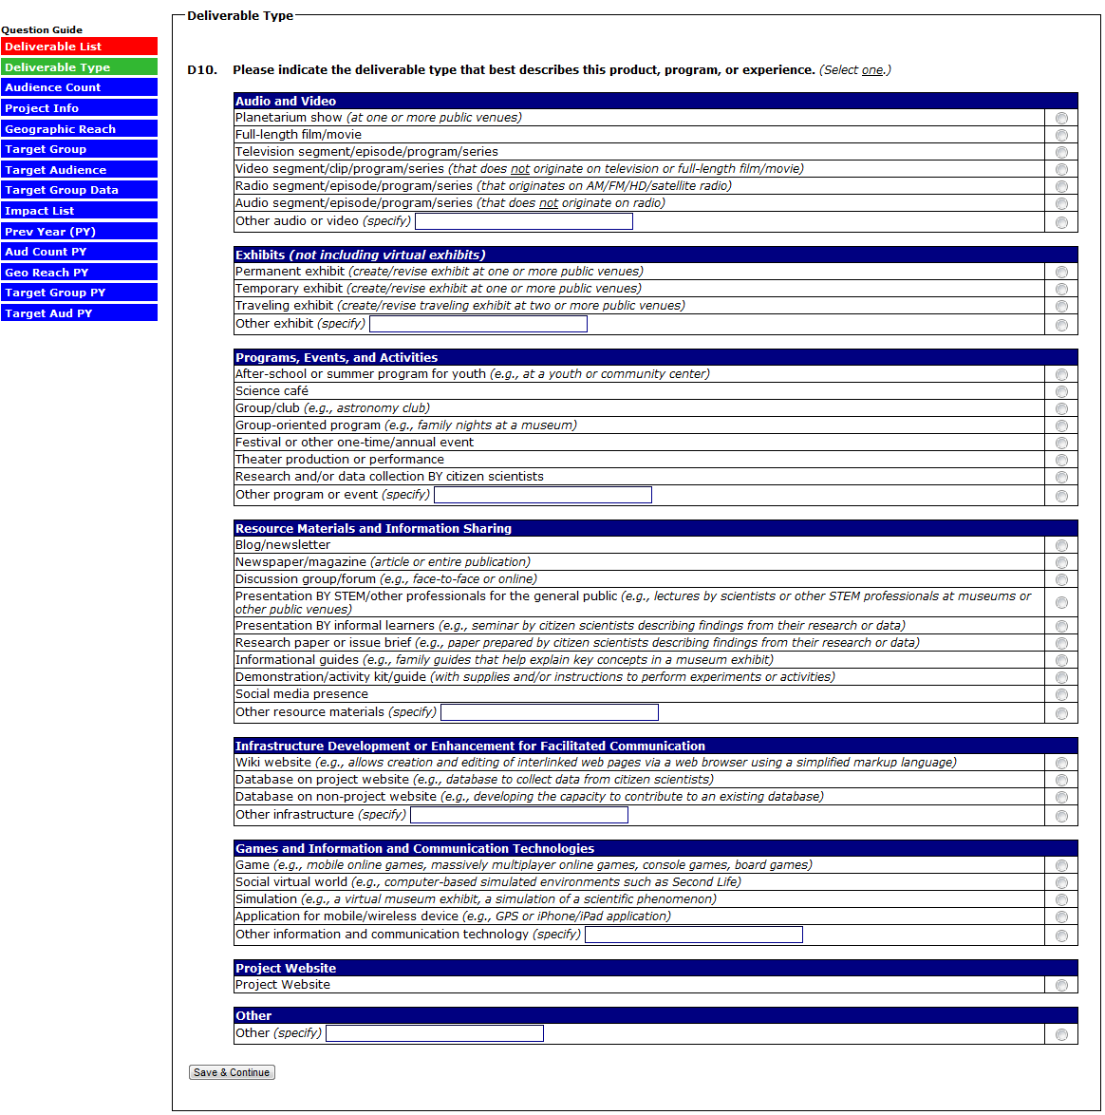
(D10A IS ONLY ANSWERED IF THE DELIVERABLE TYPE SELECTED IN D10 IS “WEBSITE”)
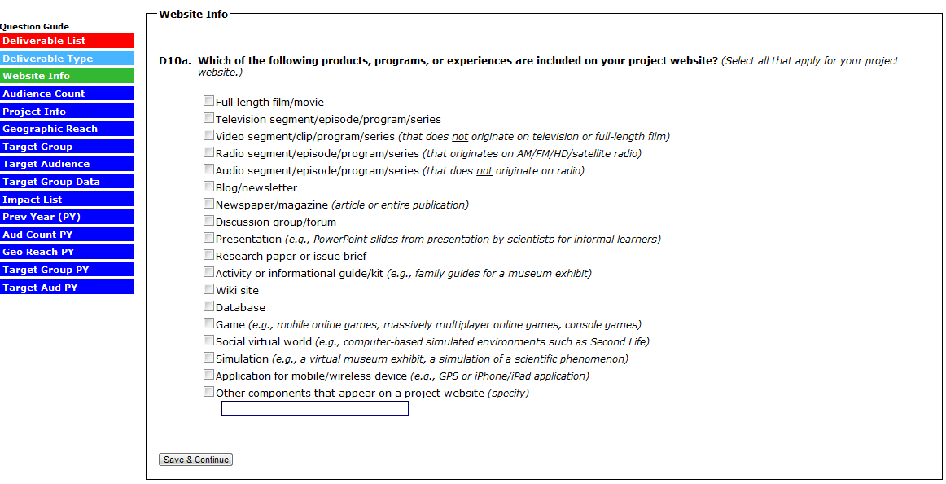

(EACH OF THE EIGHT DELIVERABLE CATEGORIES IN D10 (E.G., AUDIO AND VIDEO) SKIPS TO A UNIQUE D11A-H (AUDIENCE COUNT) QUESTION. ALTHOUGH ALL EIGHT D11 ITEMS ARE DISPLAYED BELOW, ONLY ONE OF THE D11 QUESTOINS IS ANSWERED FOR EACH DELIVERABLE.)
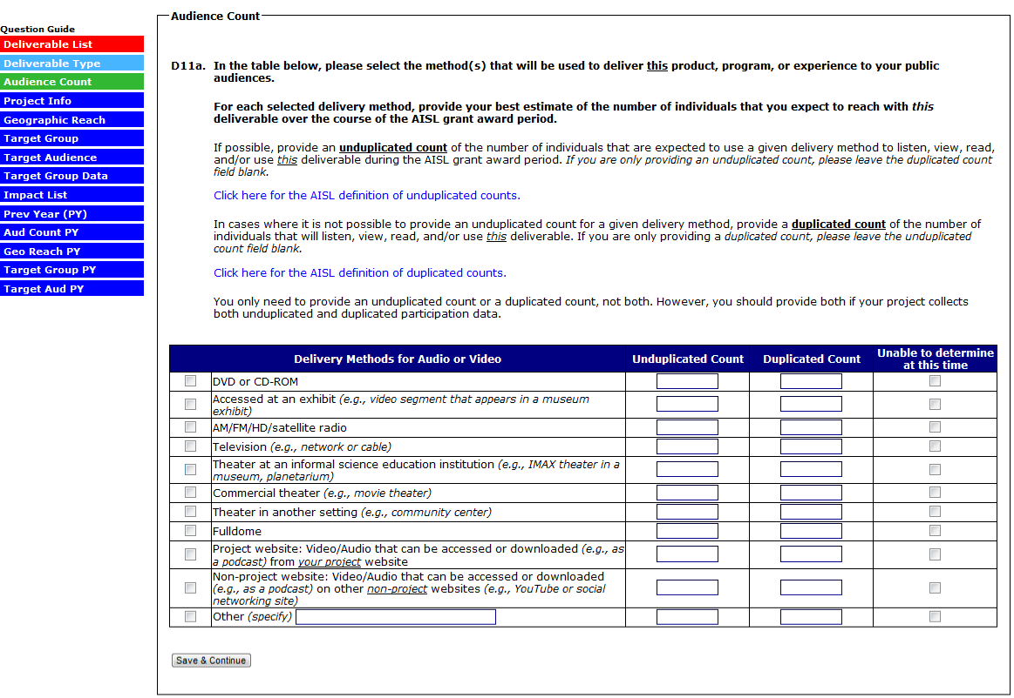
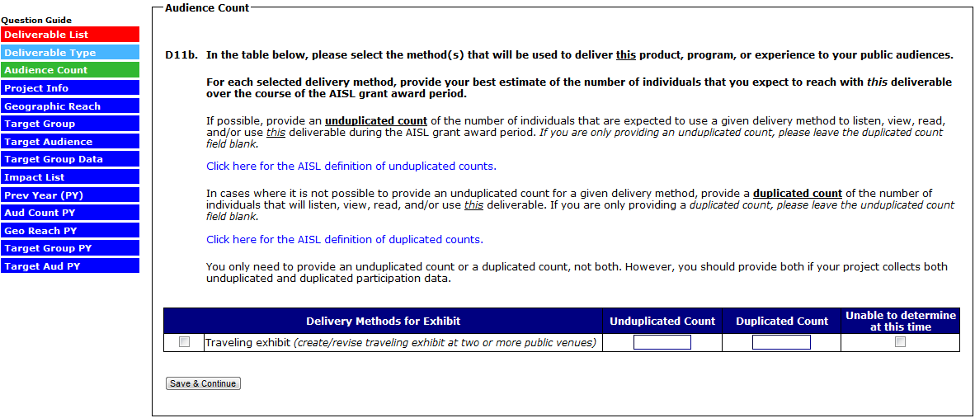
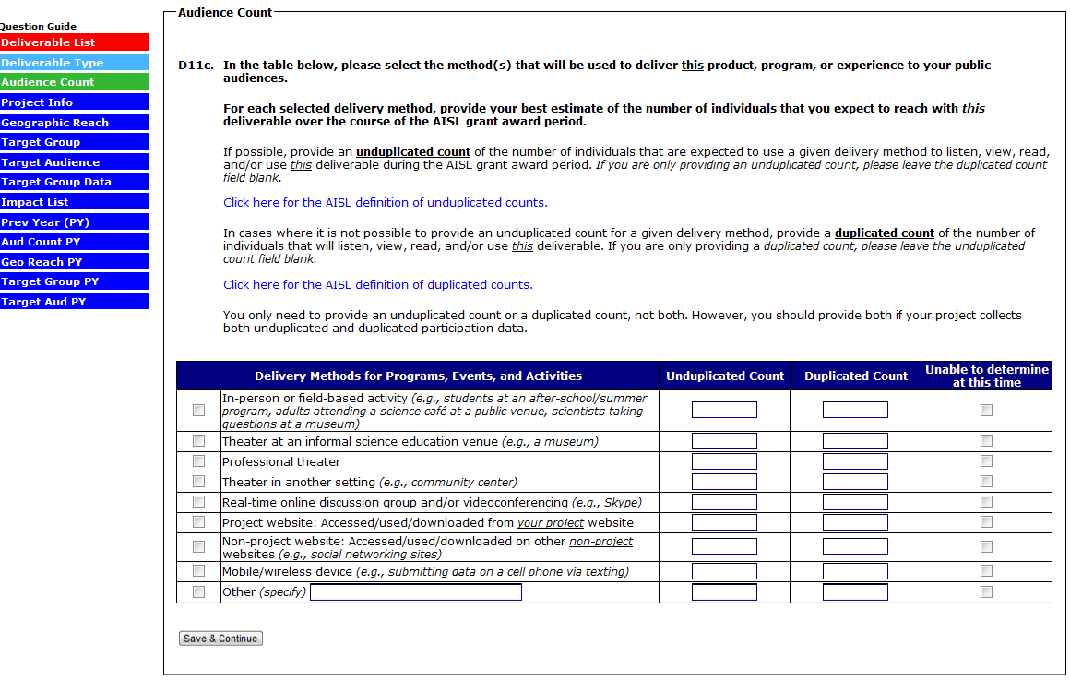
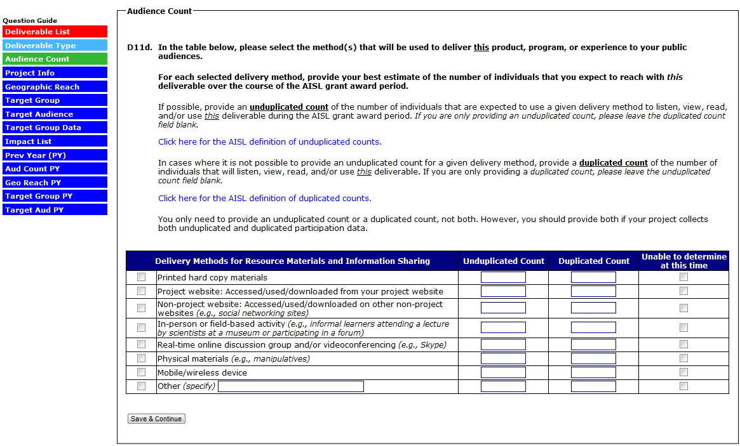
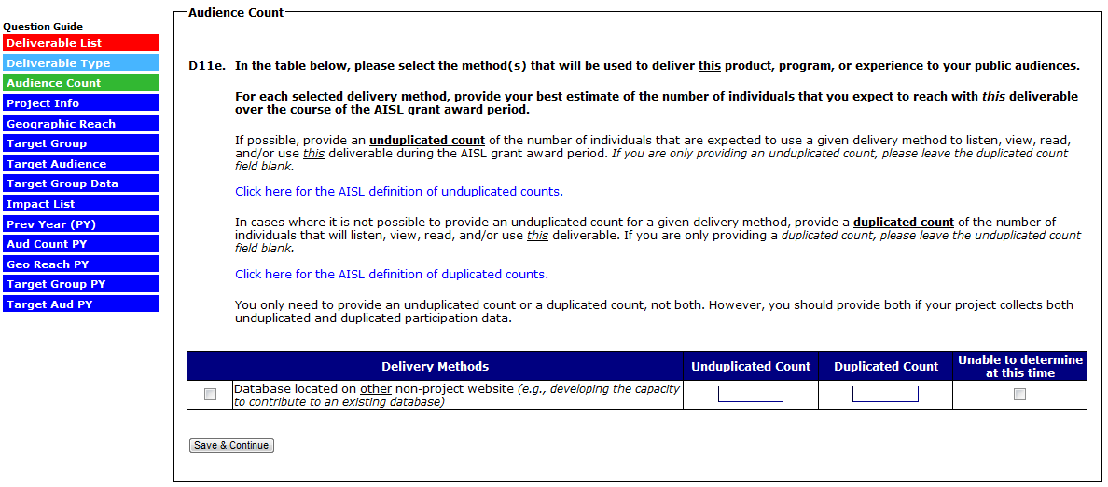
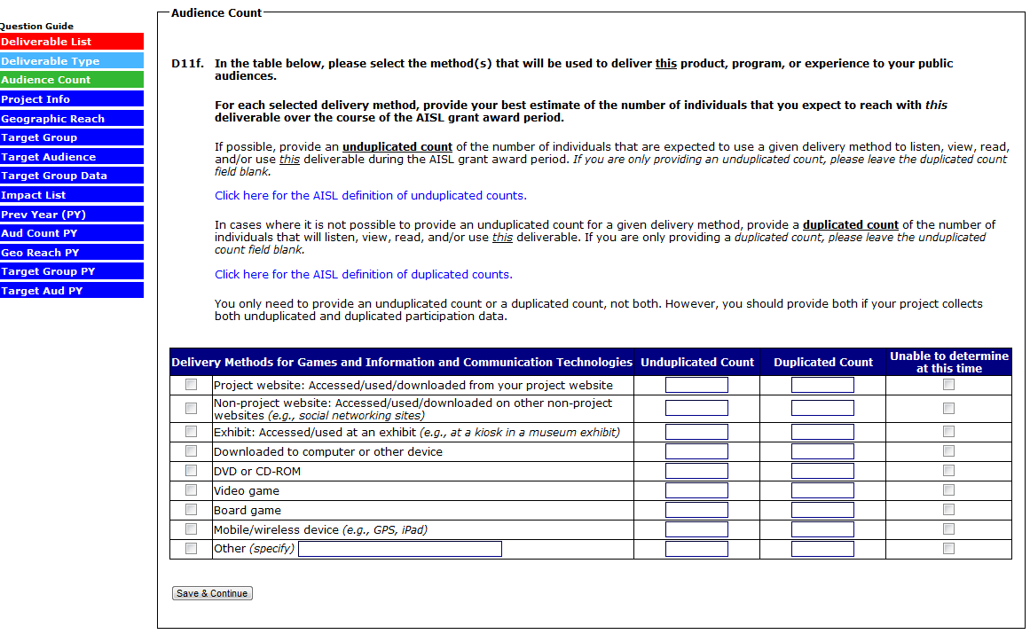

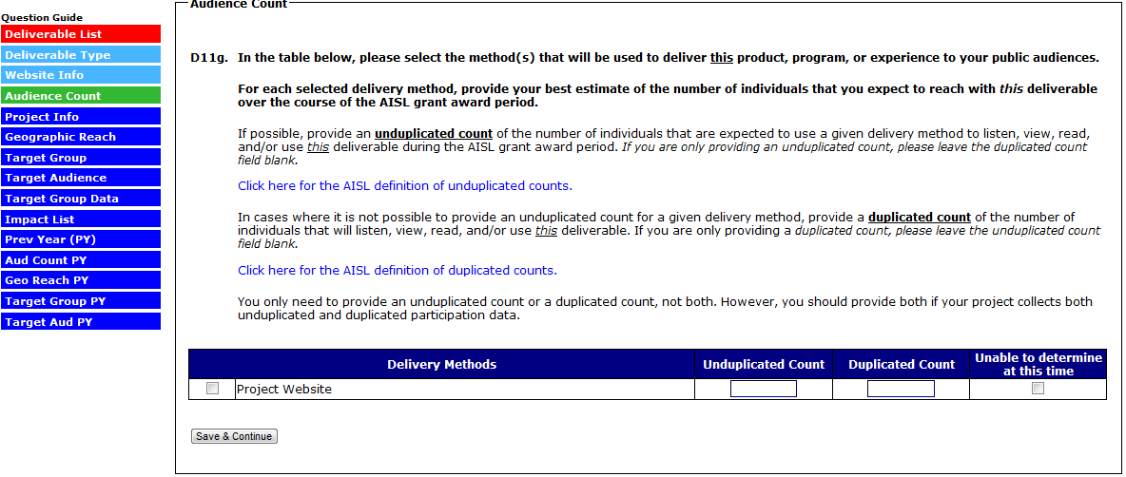
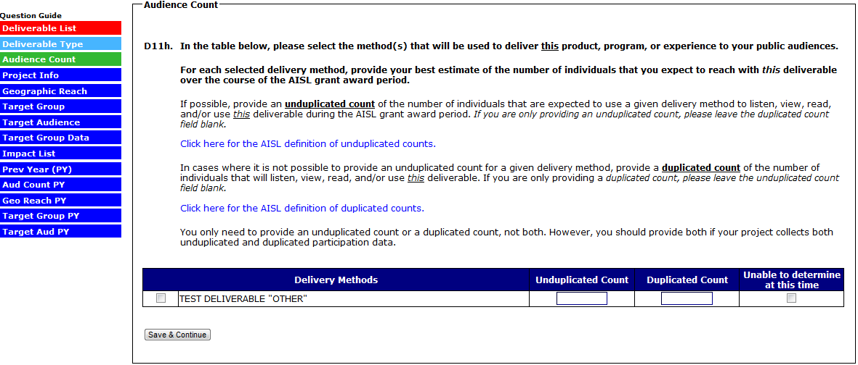

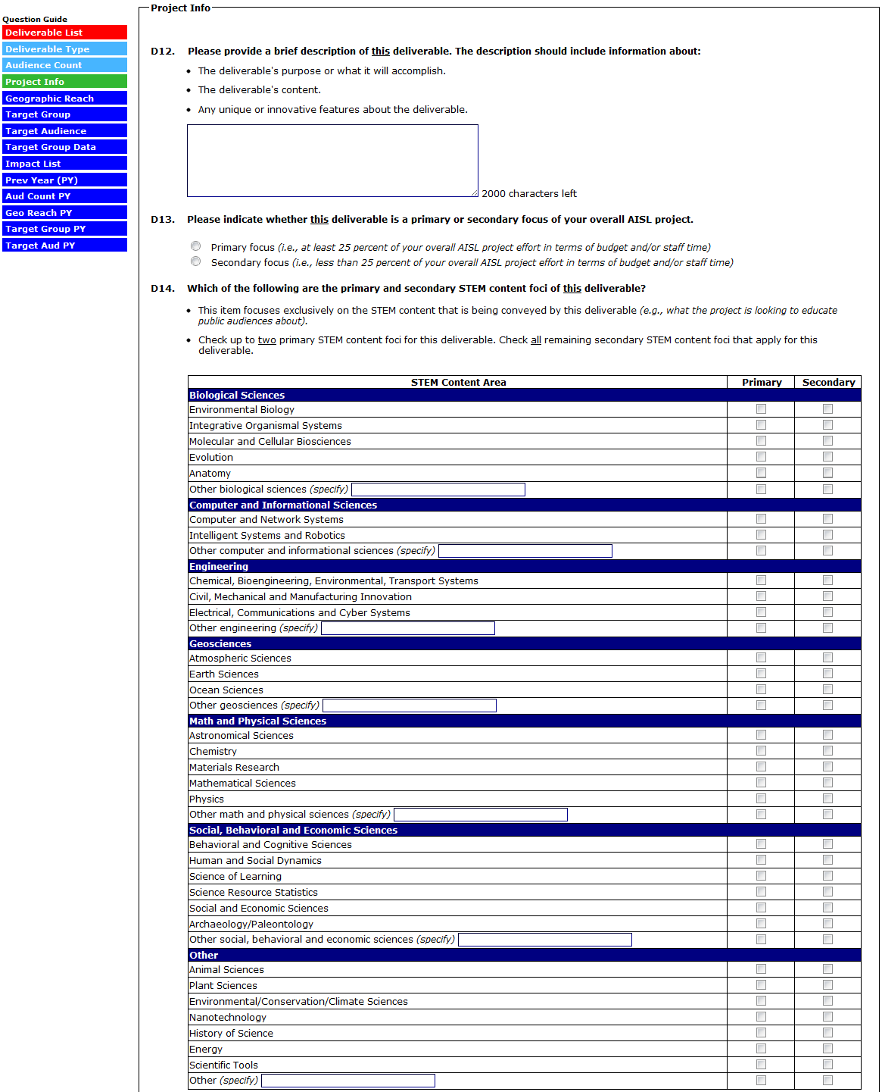
(CONTINUED ON NEXT PAGE)

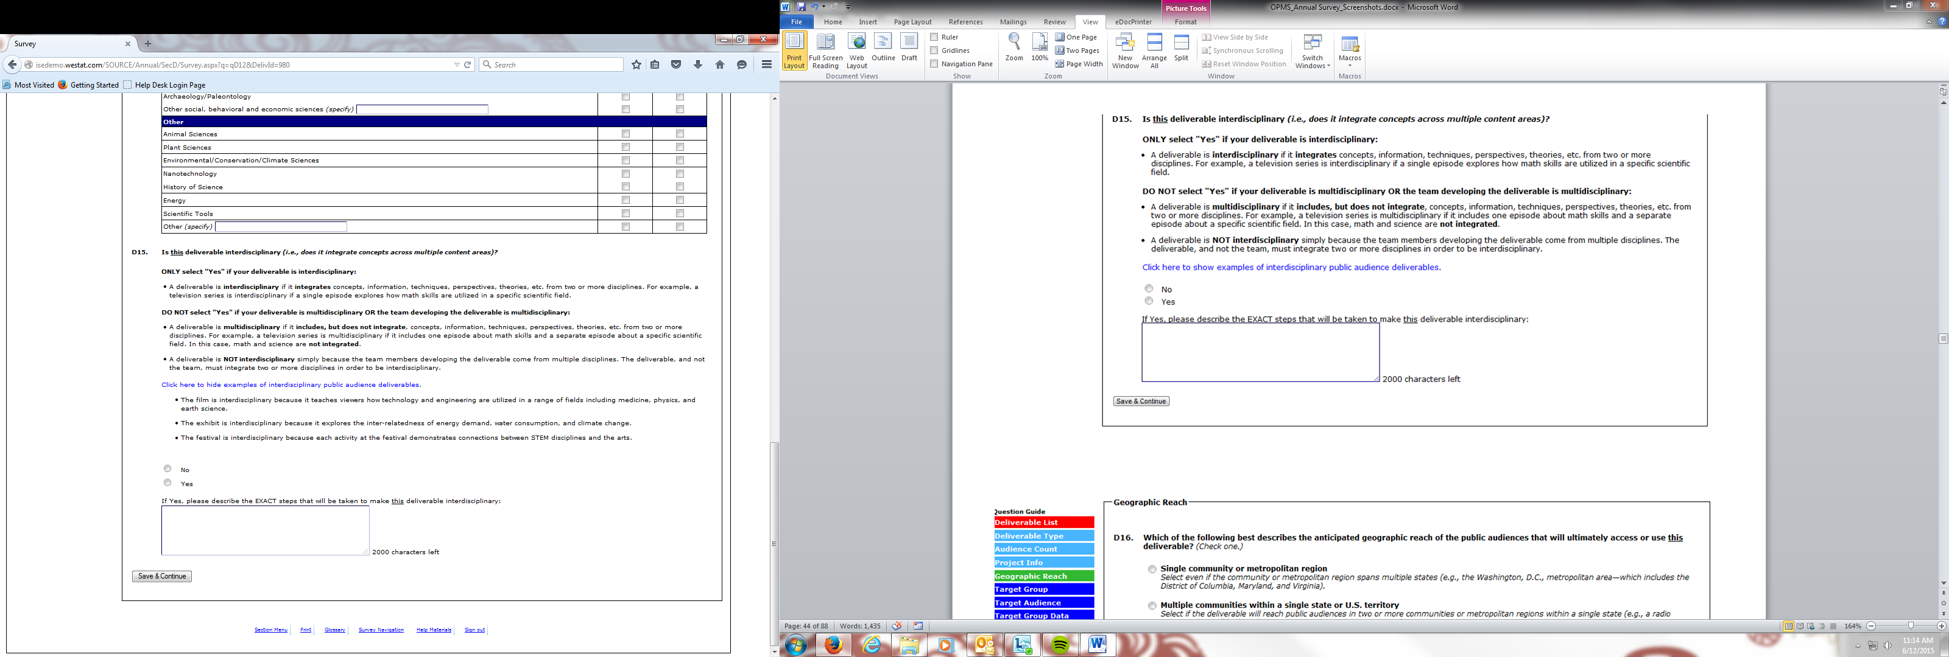
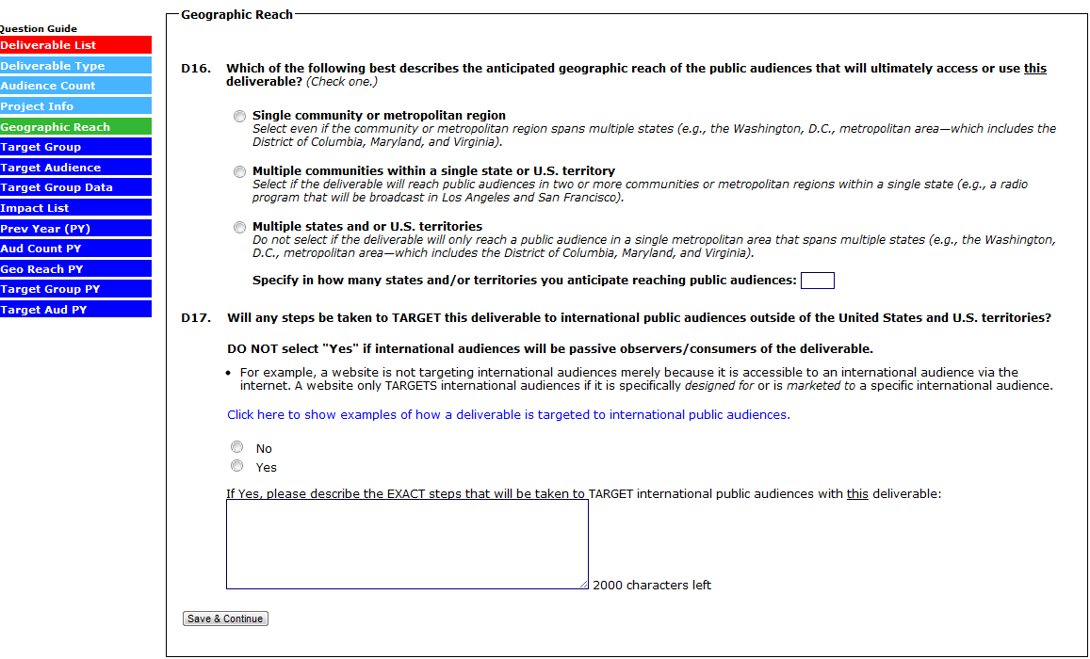
(SELECTING “THE GENERAL PUBLIC ONLY” IN D18 SKIPS D18A AND D18B)
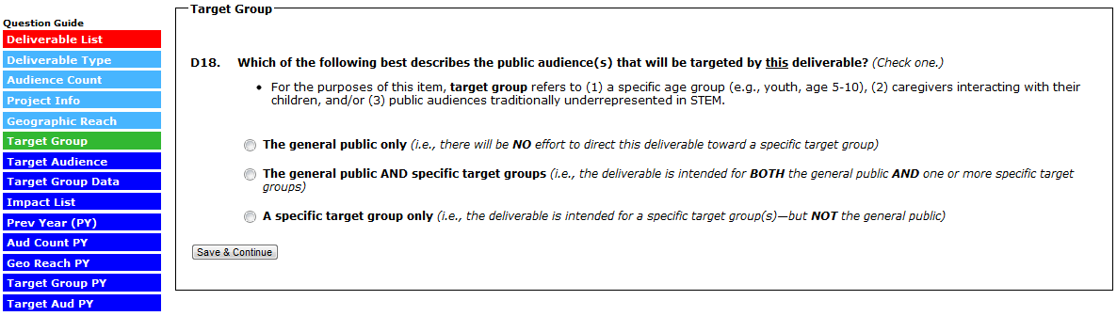
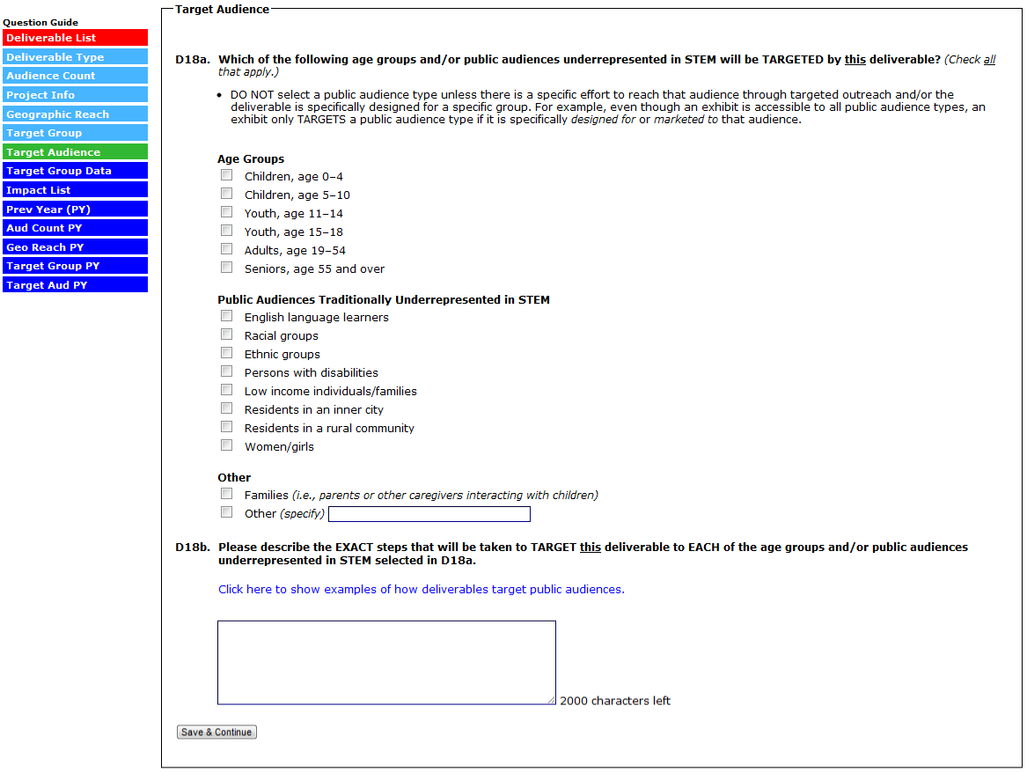

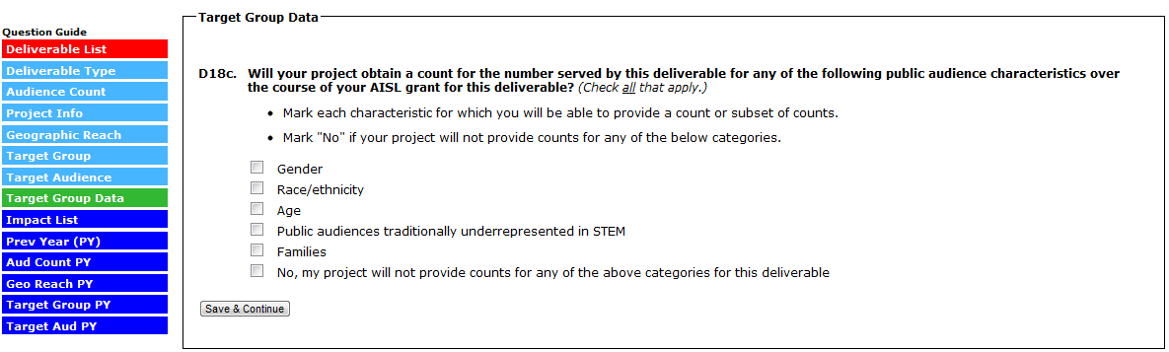

(SELECTING “THERE ARE NO IMPACTS FOR THIS DELIVERABLE” (OPTION AVAILABLE ONLY FOR DELIVERABLES MARKED “SECONDARY FOCUS” IN D13) WILL SKIP TO D20. FOR EACH IMPACT STATEMENT ENTERED INTO THE TABLE, ANSWER D19A-D19D)

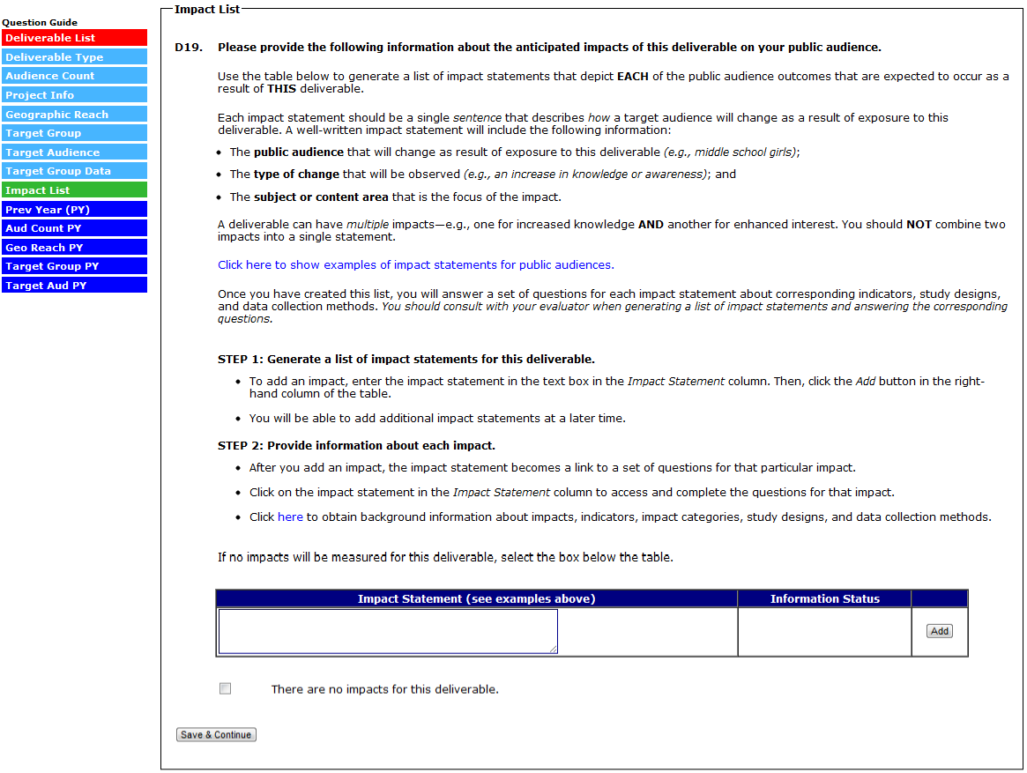

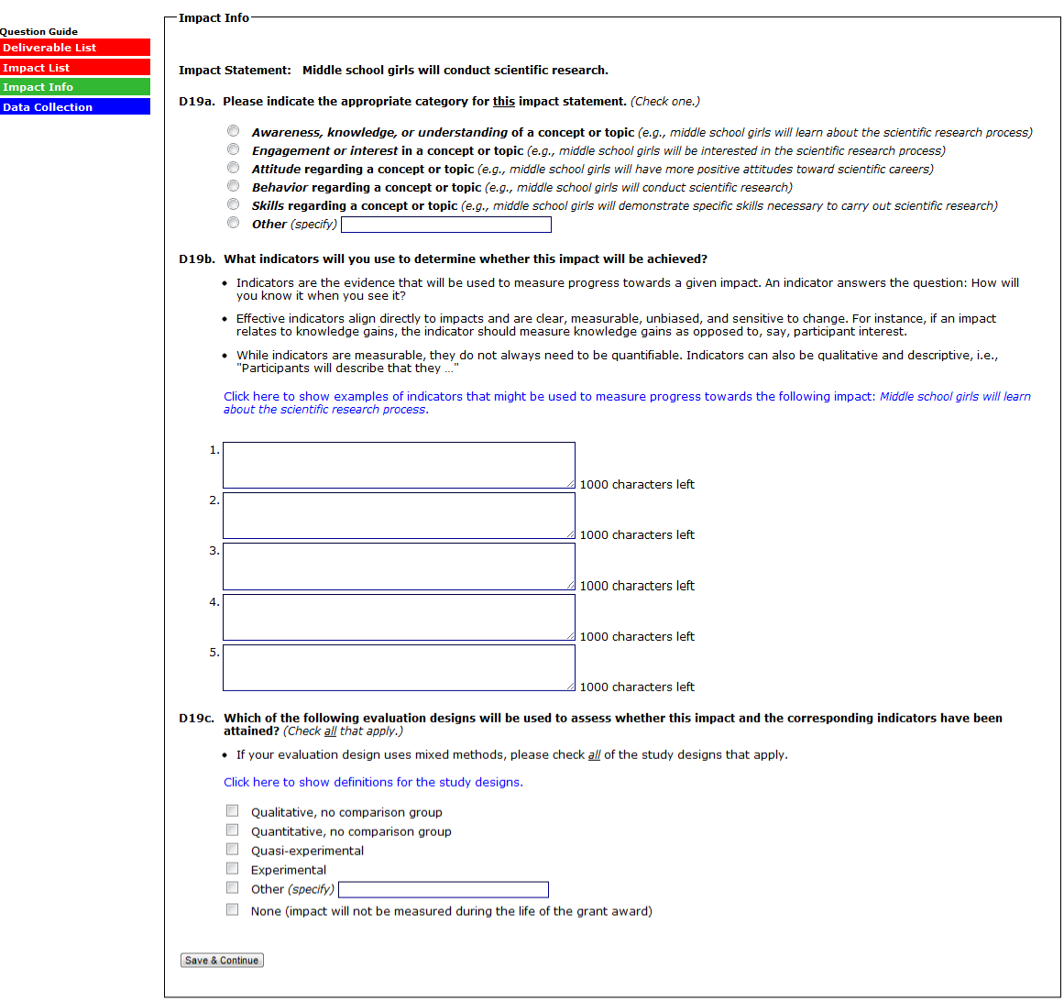
(SELECTING “NONE” TO D19C SKIPS D19D AND RETURNS YOU TO THE IMPACT LIST)

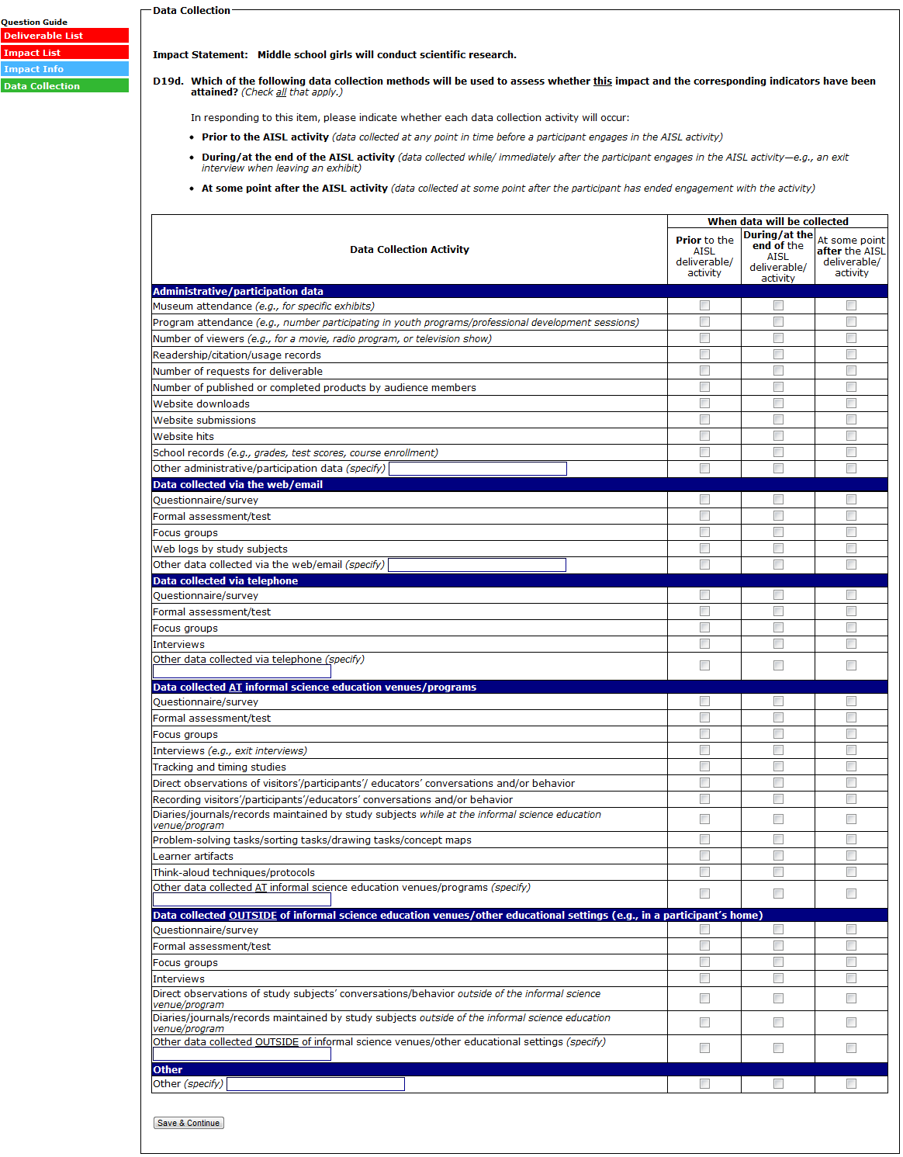
(SELECTING “SAVE & CONTINUE” RETURNS YOU TO THE IMPACT LIST)
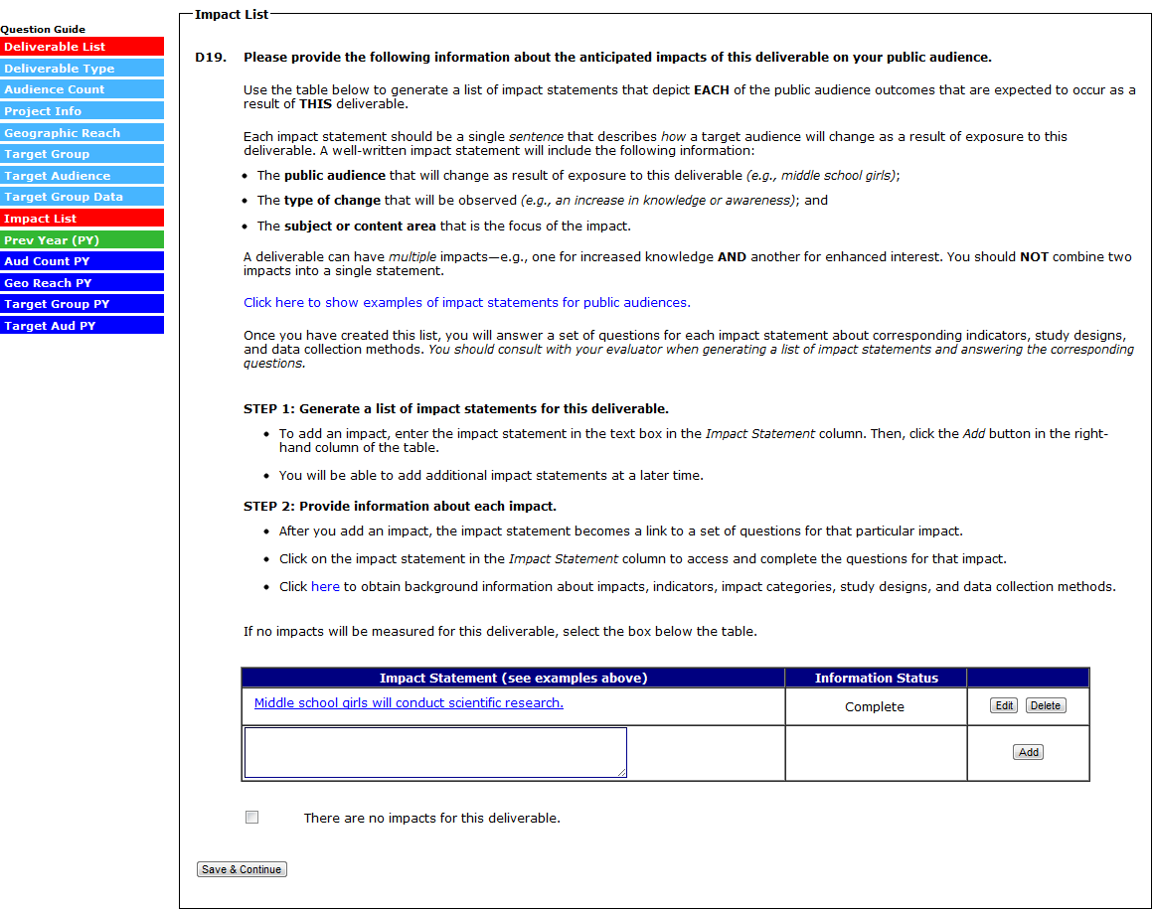
(SELECTING “NO” TO D20 SKIPS THE REMAINING QUESTIONS, SUBMITS THE DELIVERABLE, AND RETURNS YOU TO THE DELIVERABLE LIST)
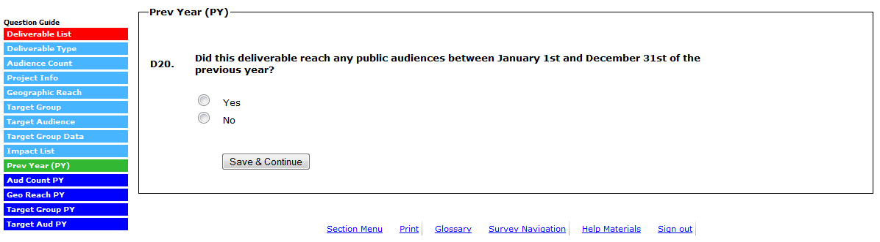

(SELECTING “YES” TO D20 BRINGS UP THE FOLLOWING POP UP)
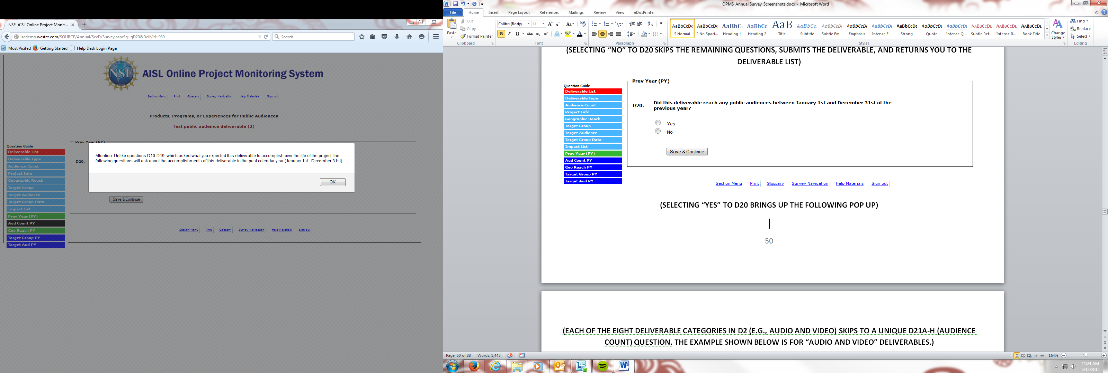

(EACH OF THE EIGHT DELIVERABLE CATEGORIES IN D2 (E.G., AUDIO AND VIDEO) SKIPS TO A UNIQUE D21A-H (AUDIENCE COUNT) QUESTION. THE EXAMPLE SHOWN BELOW IS FOR “AUDIO AND VIDEO” DELIVERABLES.)

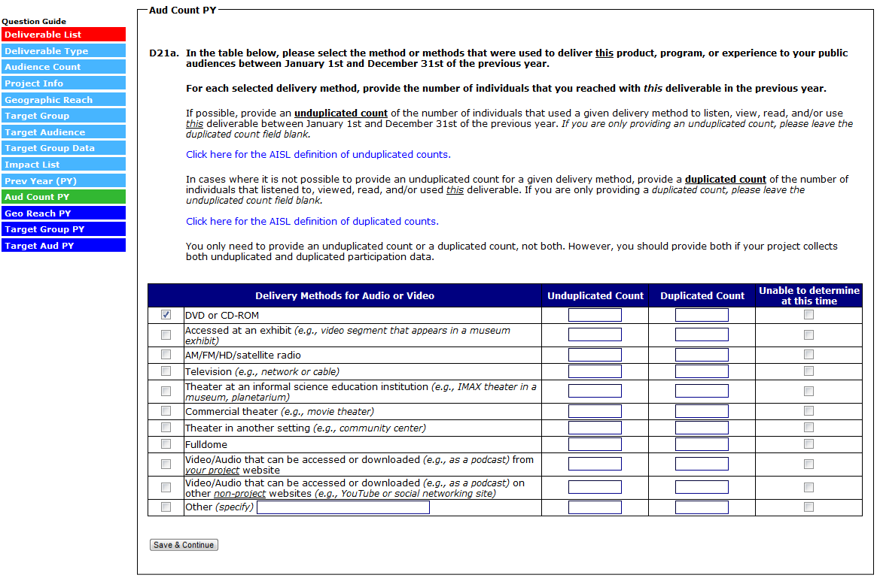

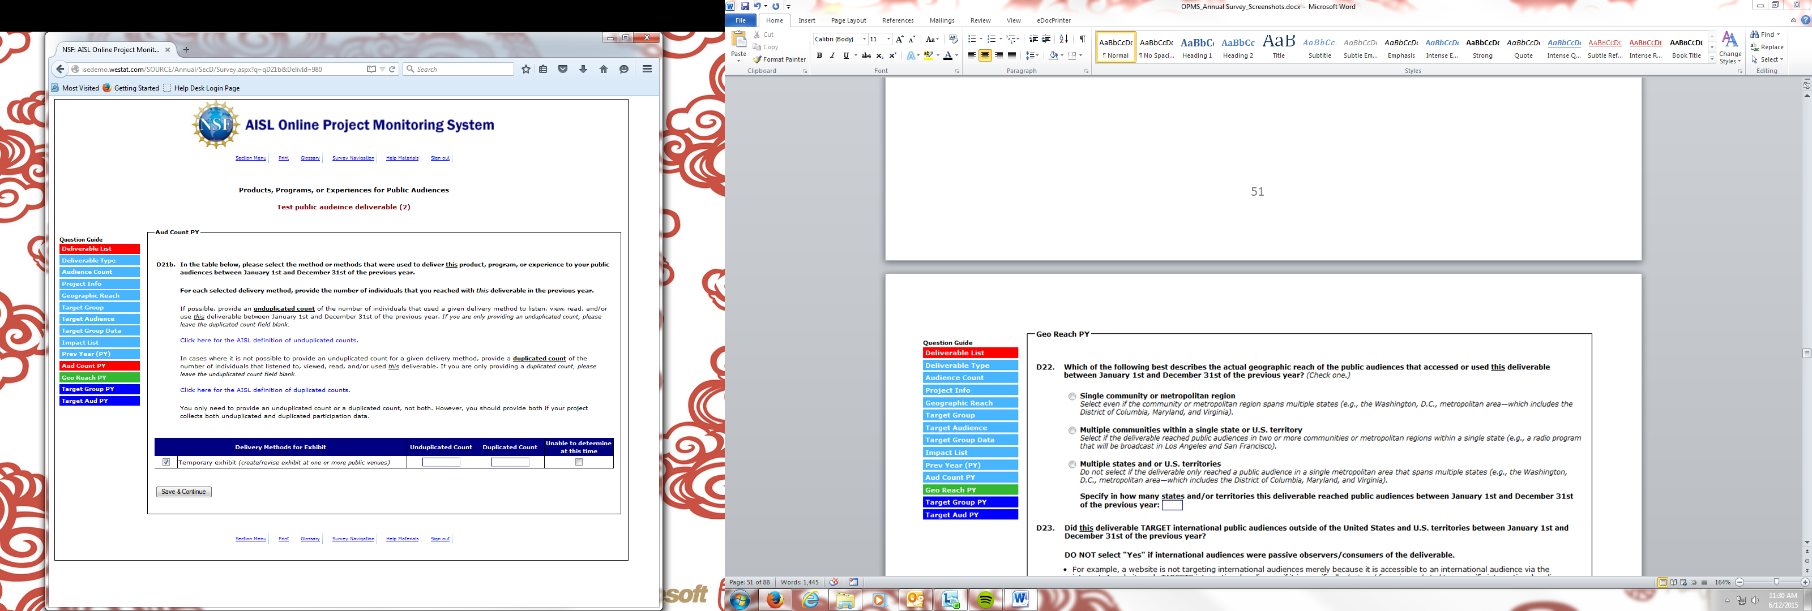
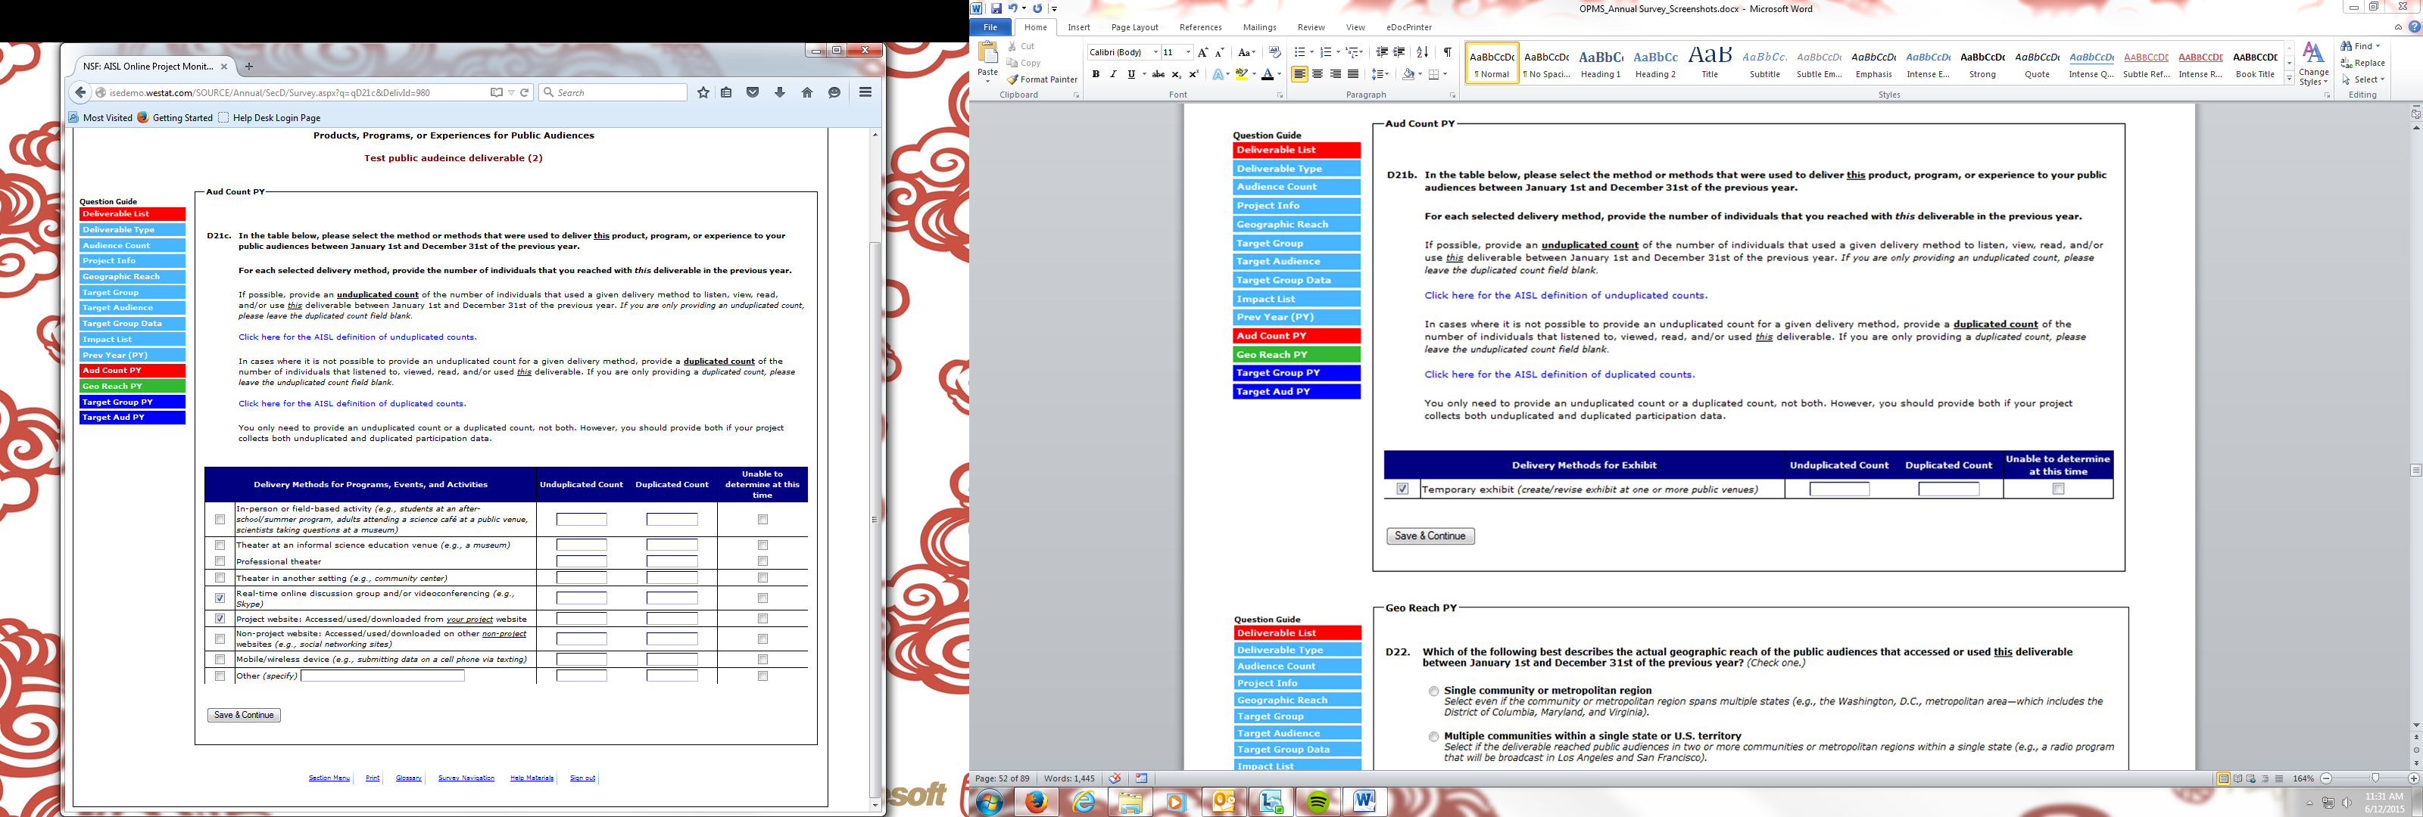

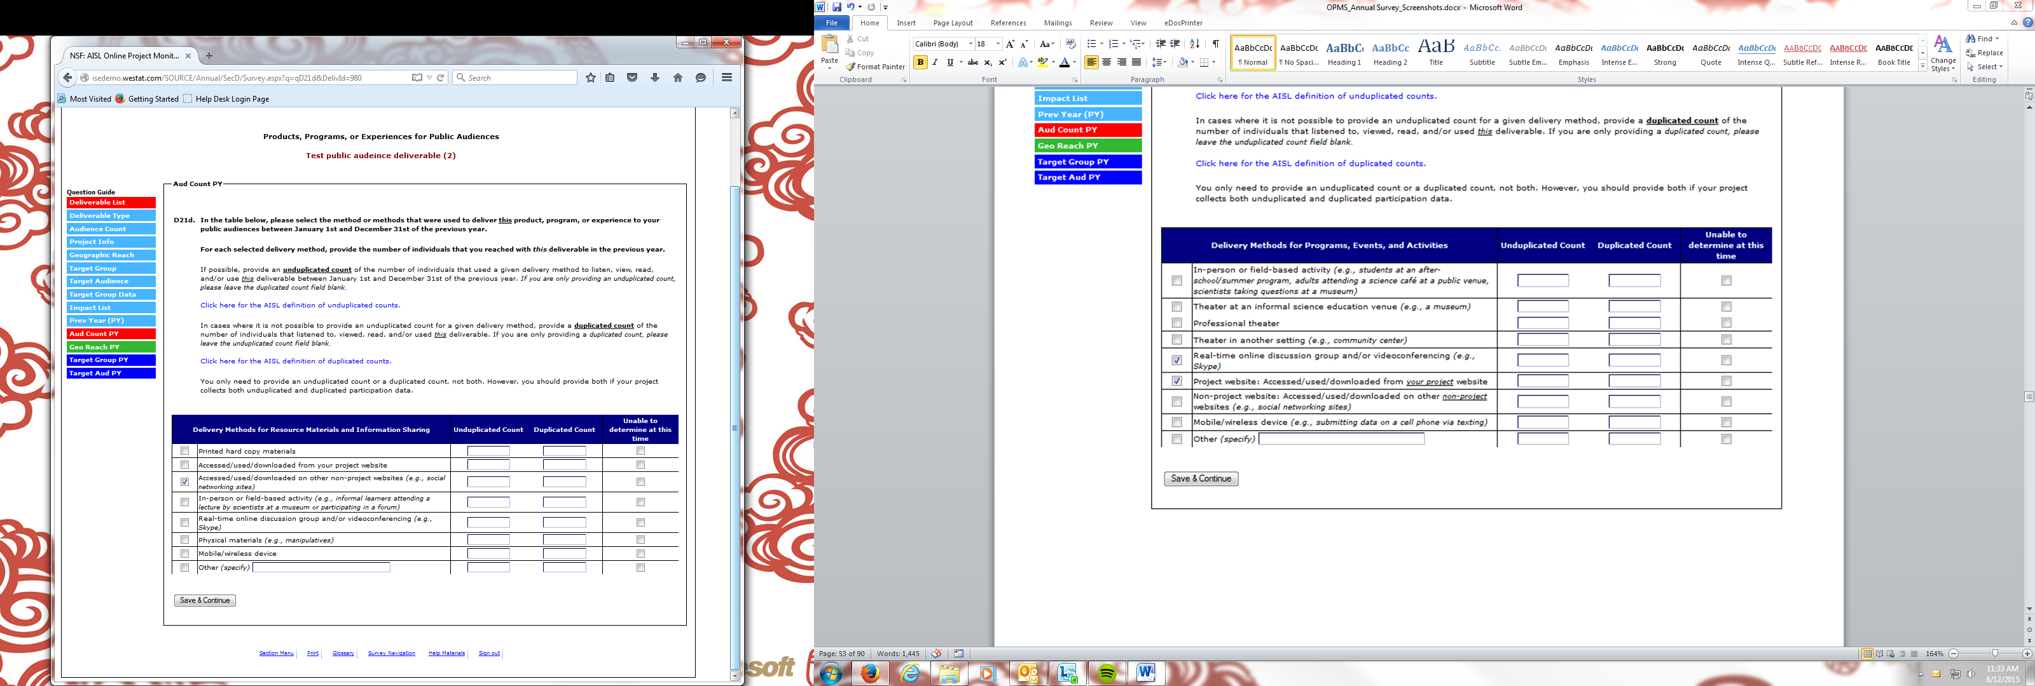
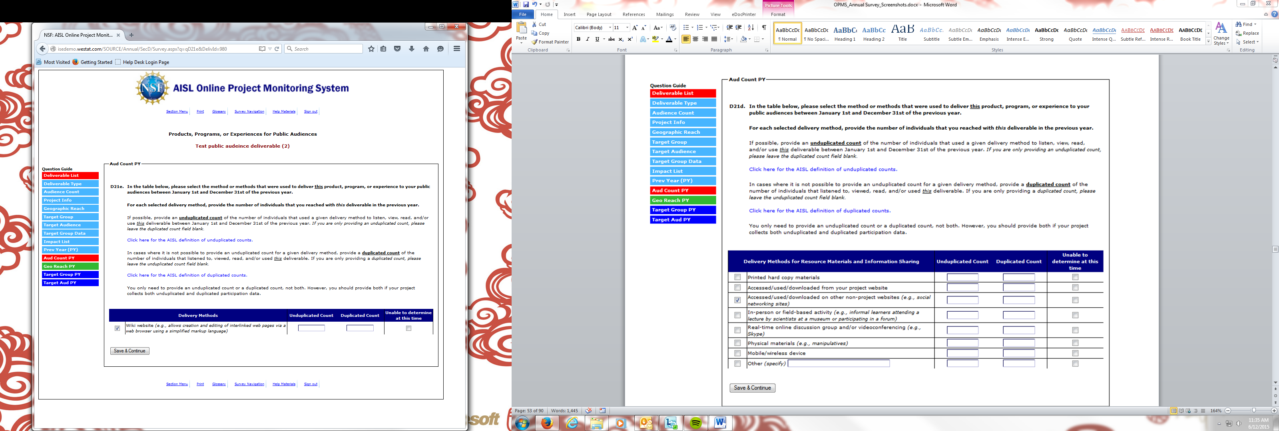

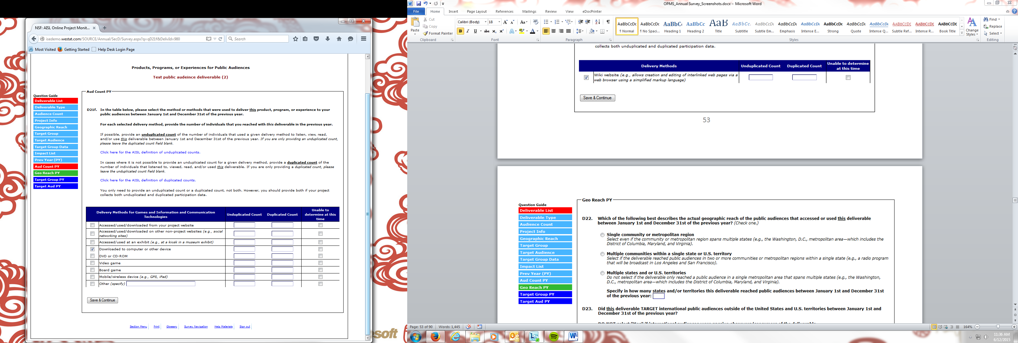
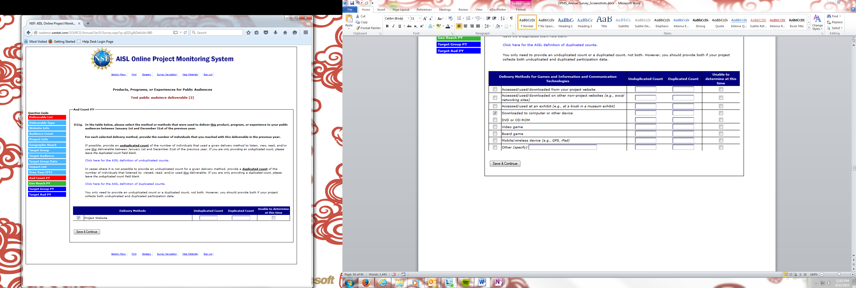
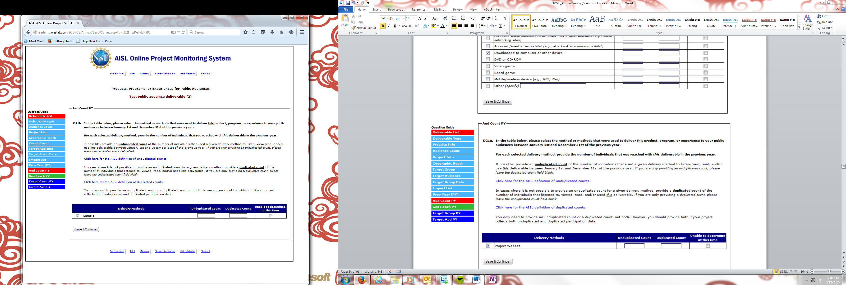

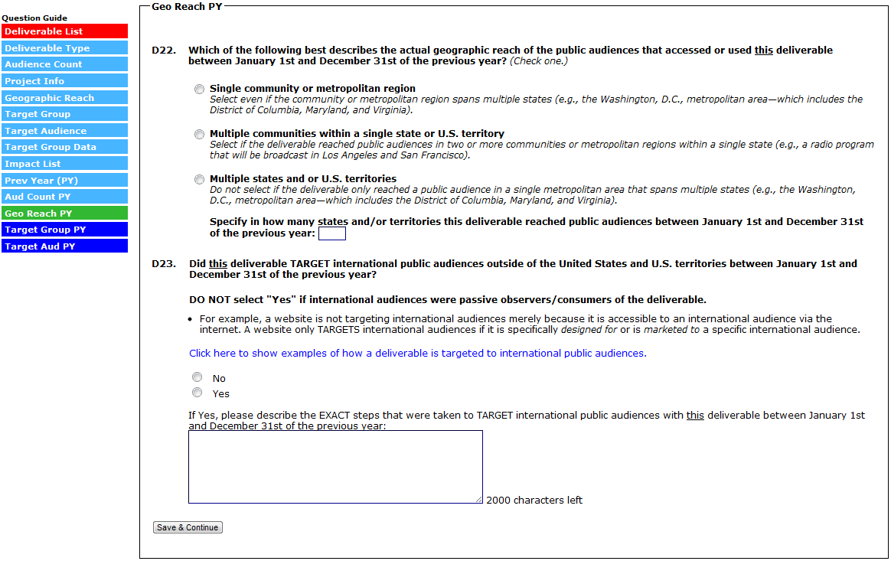
(IN D24, SELECTING “THE GENERAL PUBLIC ONLY” AND THEN “SAVE & CONTINUE” SKIPS D25, SUBMITS THE DELIVERABLE, AND RETURNS YOU TO THE DELIVERABLE LIST)
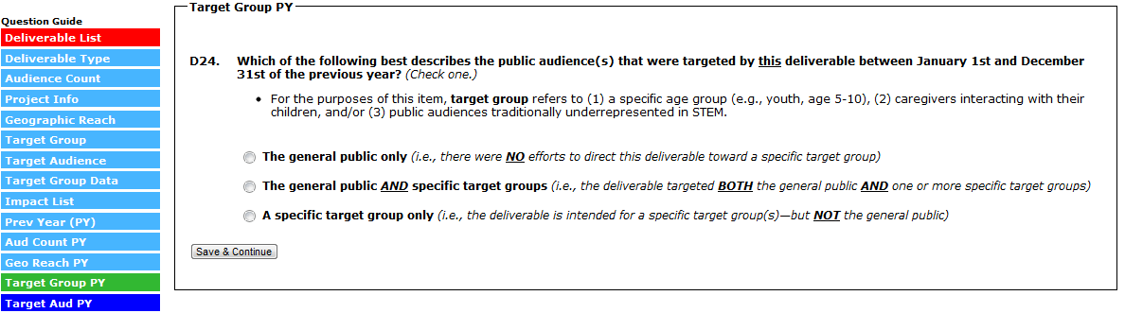

(IN D24A, SELECTING “SAVE & CONTINUE” SUBMITS THE DELIVERABLE AND RETURNS YOU TO THE DELIVERABLE LIST)
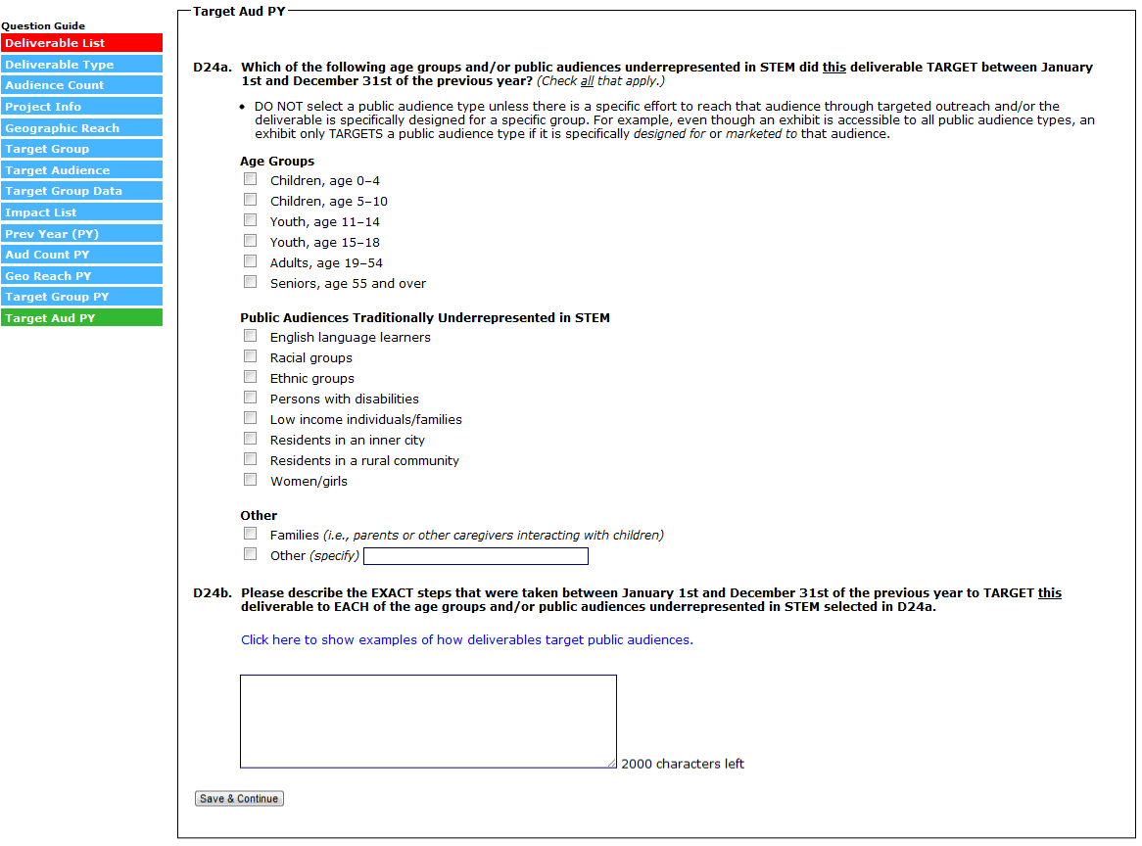

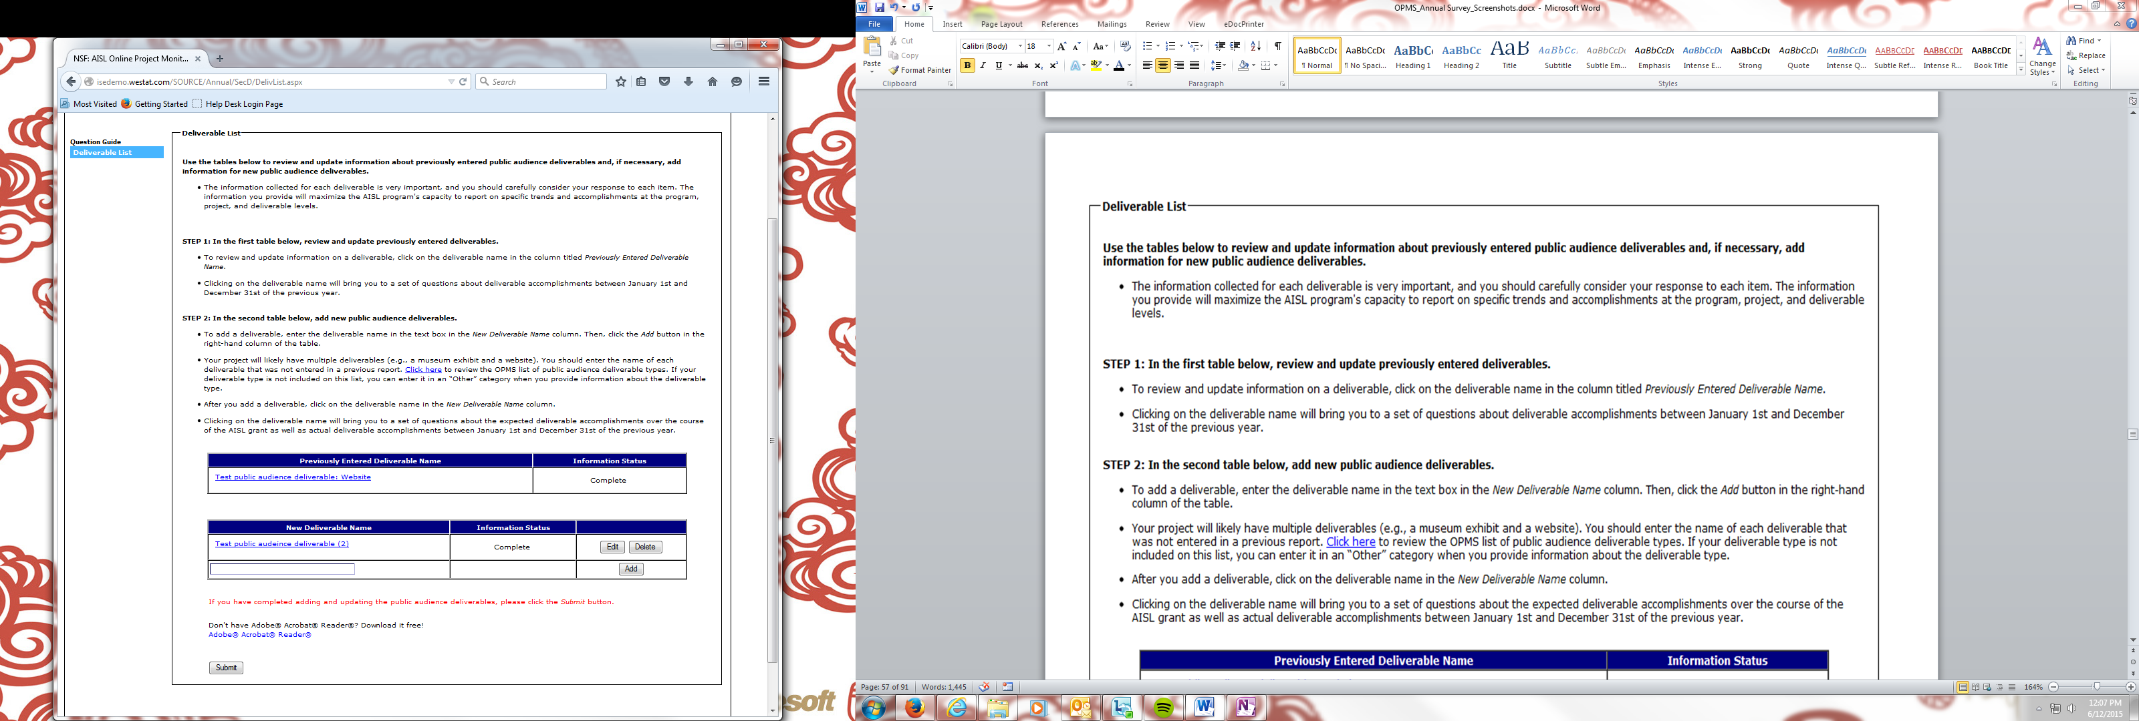
(SELECT “SUBMIT” TO SUBMIT SECTION D AND RETURN TO THE SECTION MENU)

Section E: Products, Programs, or Experiences for Professional Audiences

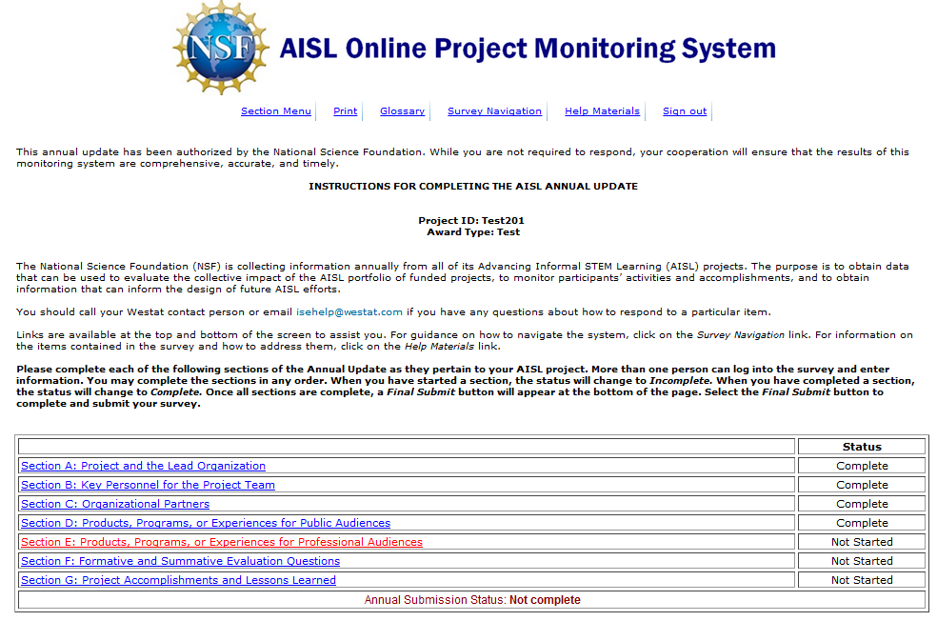

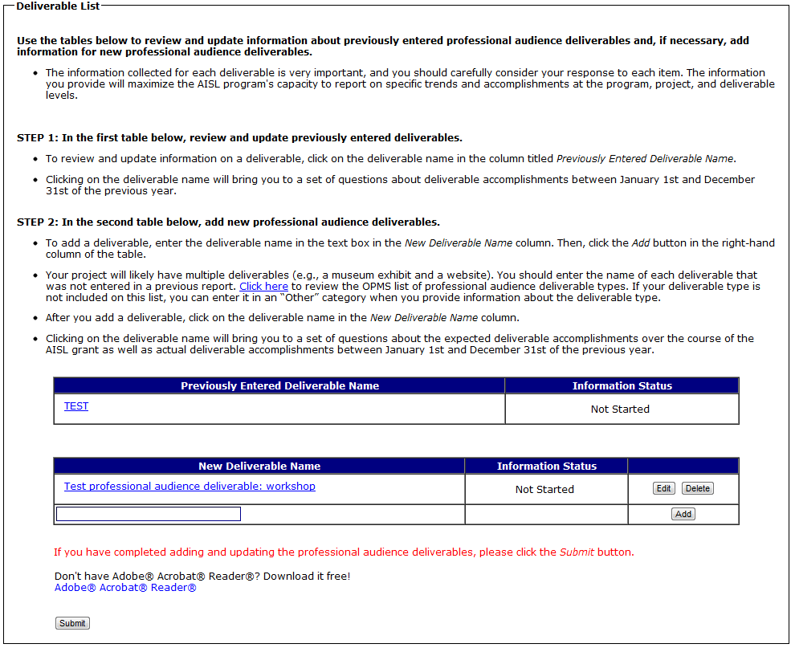
(SELECTING A DELIVERABLE IN THE “PREVIOUSLY ENTERED DELIVERABLE” TABLE WILL BRING YOU TO E2-E8F. E2-E8F ASK ABOUT DELIVERABLE ACTIVITIES IN THE PAST CALENDAR YEAR, OR JANUARY 1 – DECEMBER 31 OF THE PREVIOUS YEAR.)
(SELECTING A DELIVERABLE IN THE “NEW DELIVERABLE” TABLE WILL BRING YOU TO E9-E22. E9-E18D ARE QUESTIONS ABOUT WHAT THE DELIVERABLE WILL ACCOMPLISH OVER THE COURSE OF THE GRANT. E19-E22 ARE QUESTIONS ABOUT WHAT THE DELIVERABLE ACCOMPLISHED IN THE PAST CALENDAR YEAR, OR JANUARY 1 – DECEMBER 31 OF THE PREVIOUS YEAR.)

(SELECTING A DELIVERABLE IN THE “PREVIOUSLY ENTERED DELIVERABLE” TABLE WILL BRING YOU TO E2-E8F)
(SELECTING “NO” TO E3 SKIPS TO E7/IMPACT LIST)
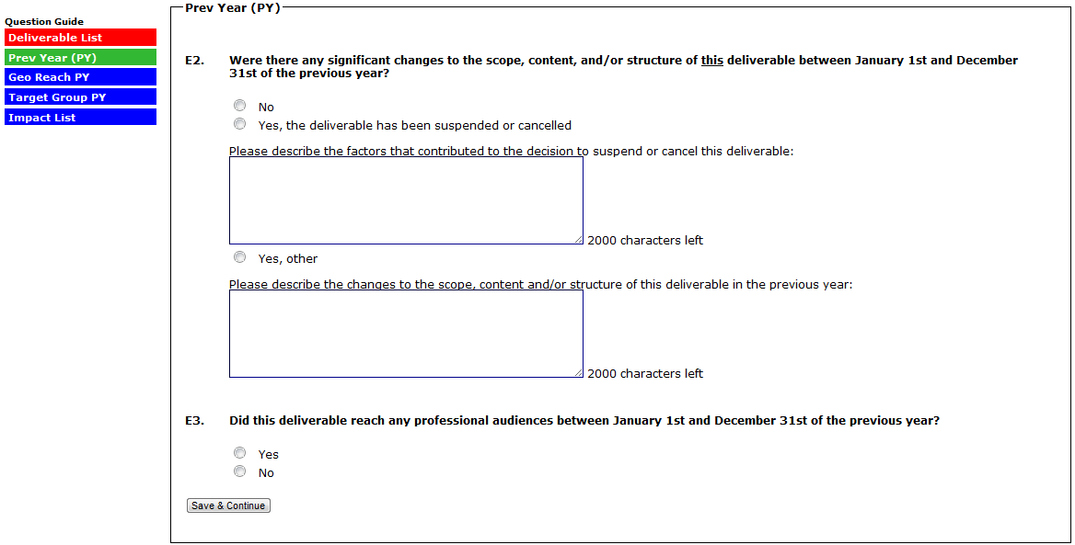
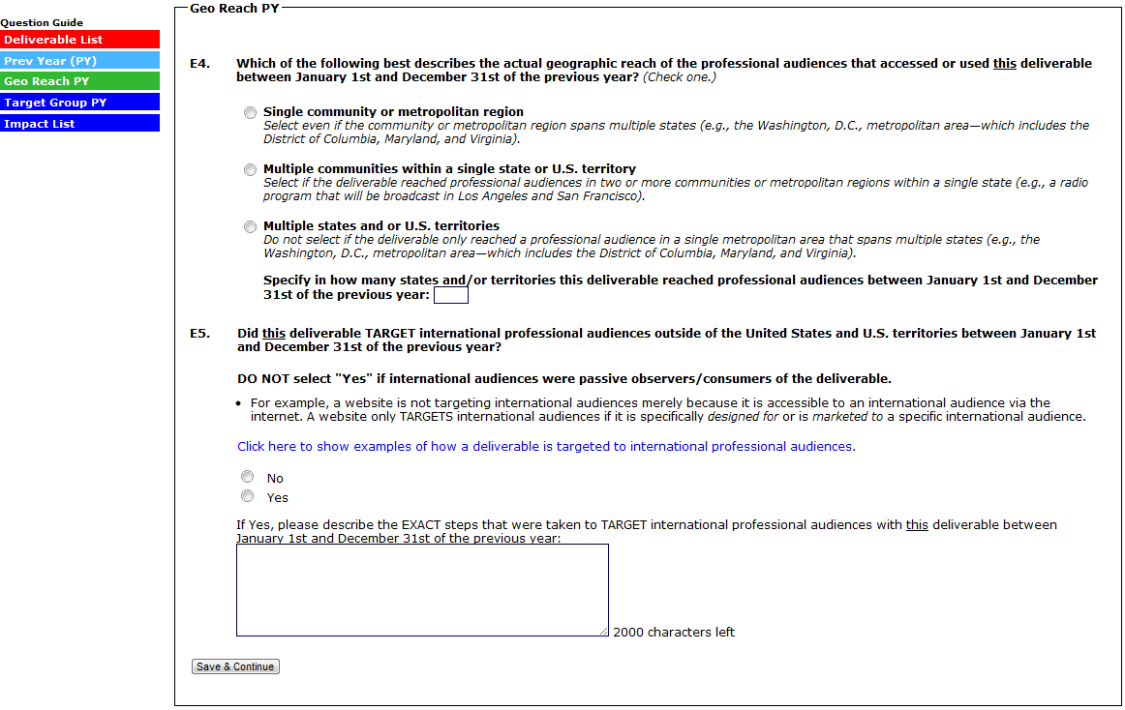

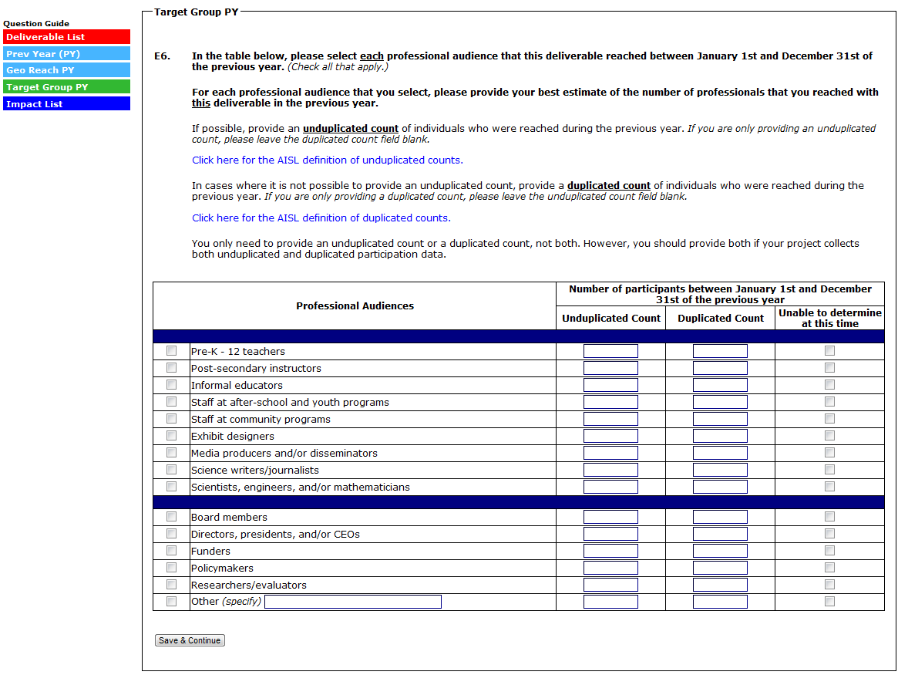

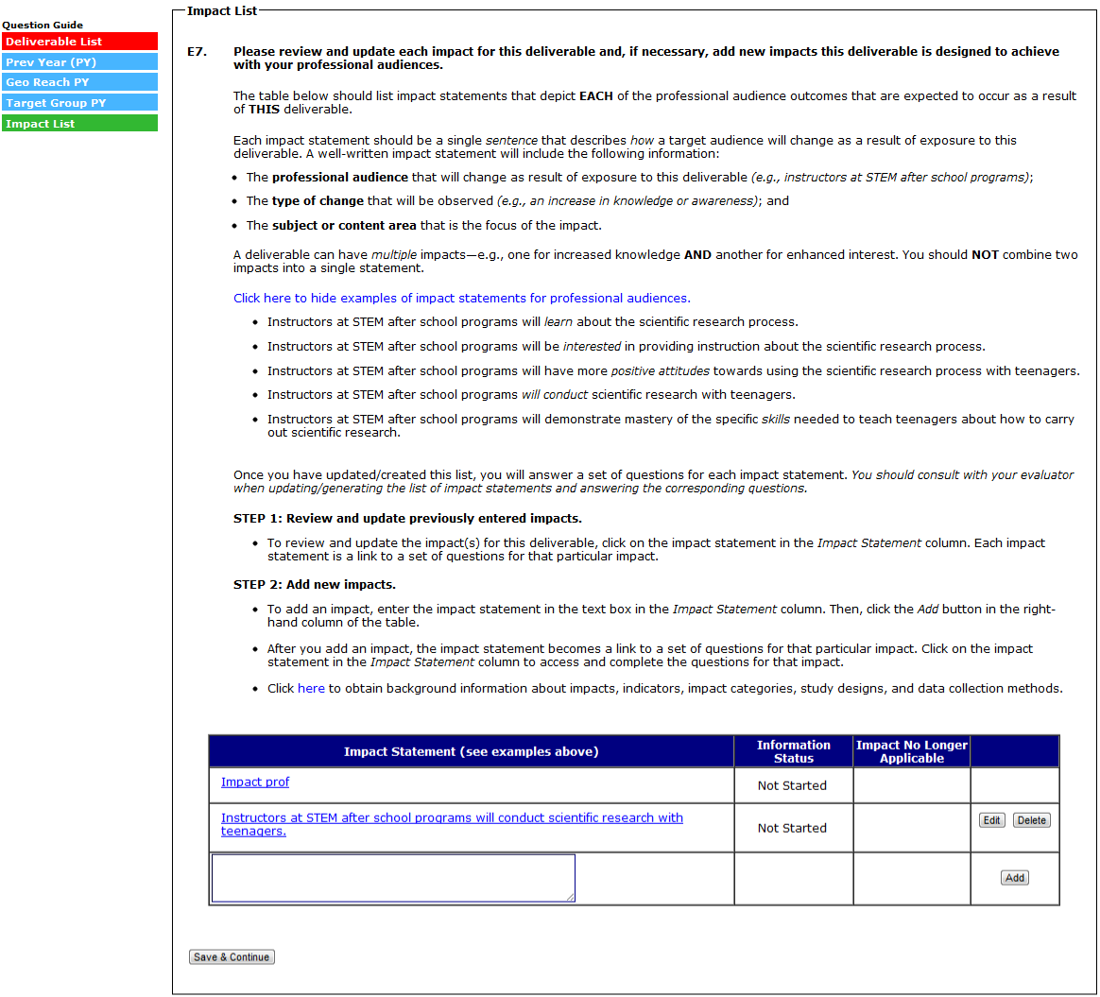

(E7A-E8B ARE COMPLETED/REVIEWED AND UPDATED FOR EACH IMPACT STATEMENT ENTERED IN A PREVIOUS REPORT. EACH IMPACT ENTERED IN A PREVIOUS REPORT WILL HAVE NO BUTTONS/OPTIONS IN THE FAR RIGHT COLUMN OF THE IMPACT TABLE.)
(SELECTING NO TO E7A RETURNS YOU TO THE IMPACT LIST– NO OTHER IMPACT QUESTIONS ARE ASKED)

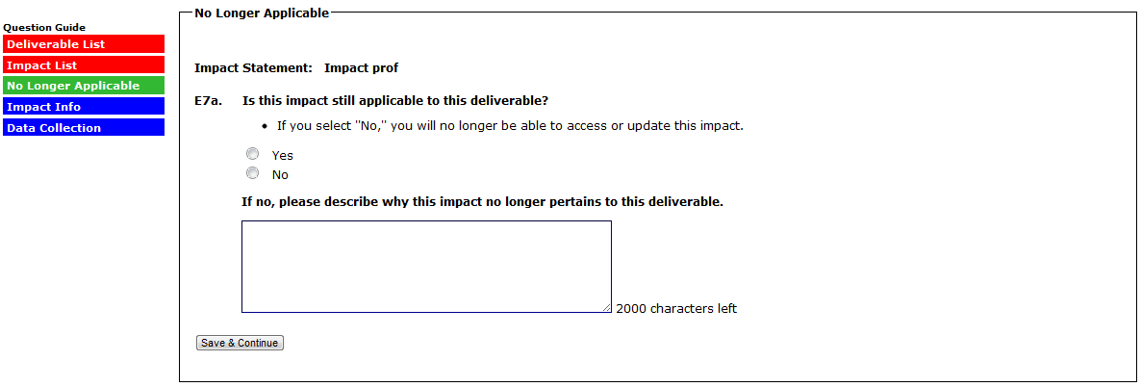

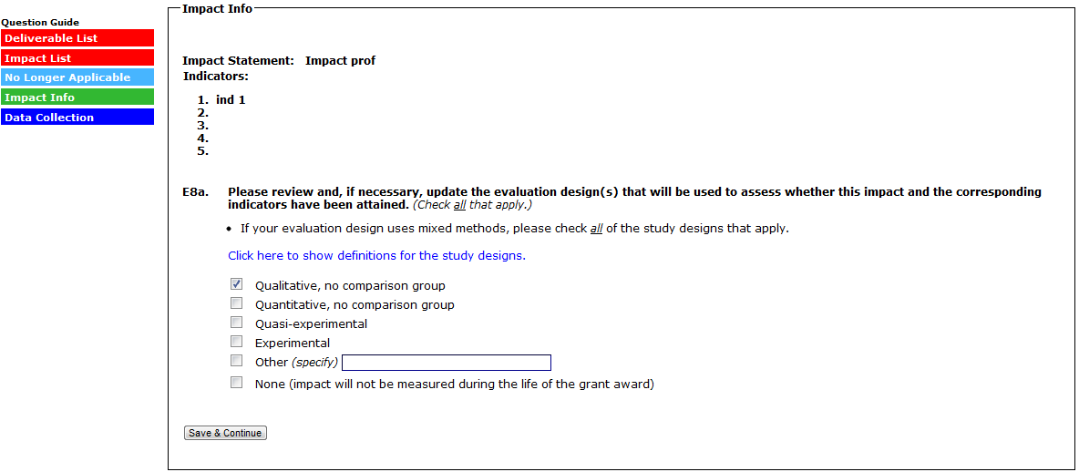
(SELECTING “NONE” TO E8A SKIPS D8B AND RETURNS YOU TO THE IMPACT LIST)
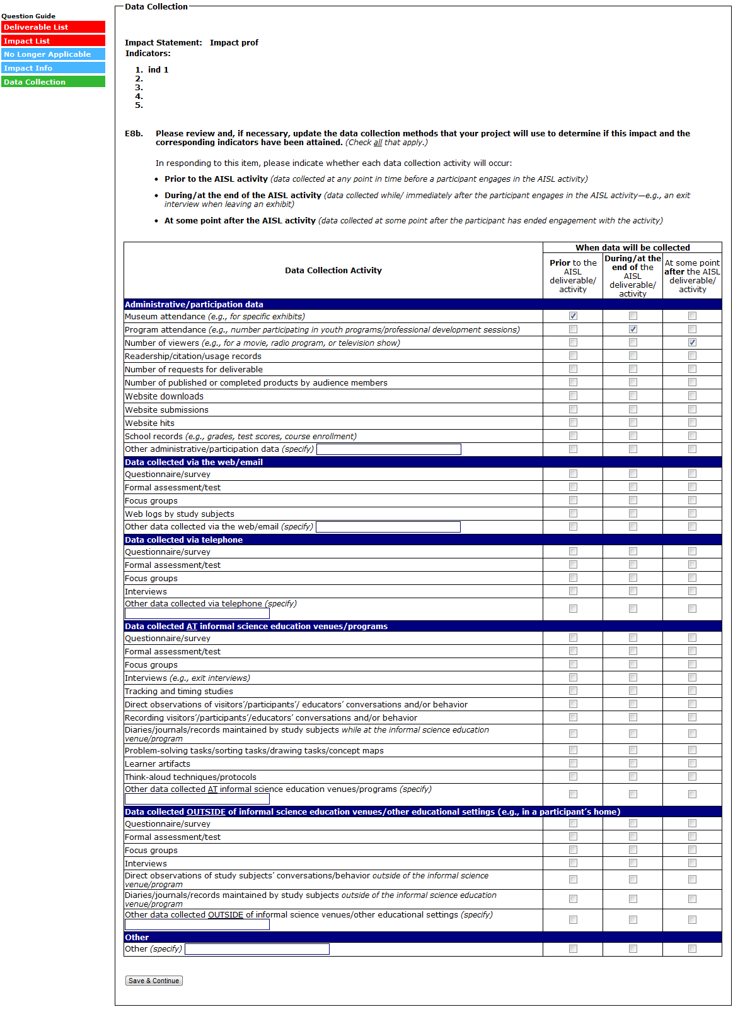
(SELECT “SAVE AND CONTINUE” TO SUBMIT THE IMPACT AND RETURN TO THE IMPACT LIST)
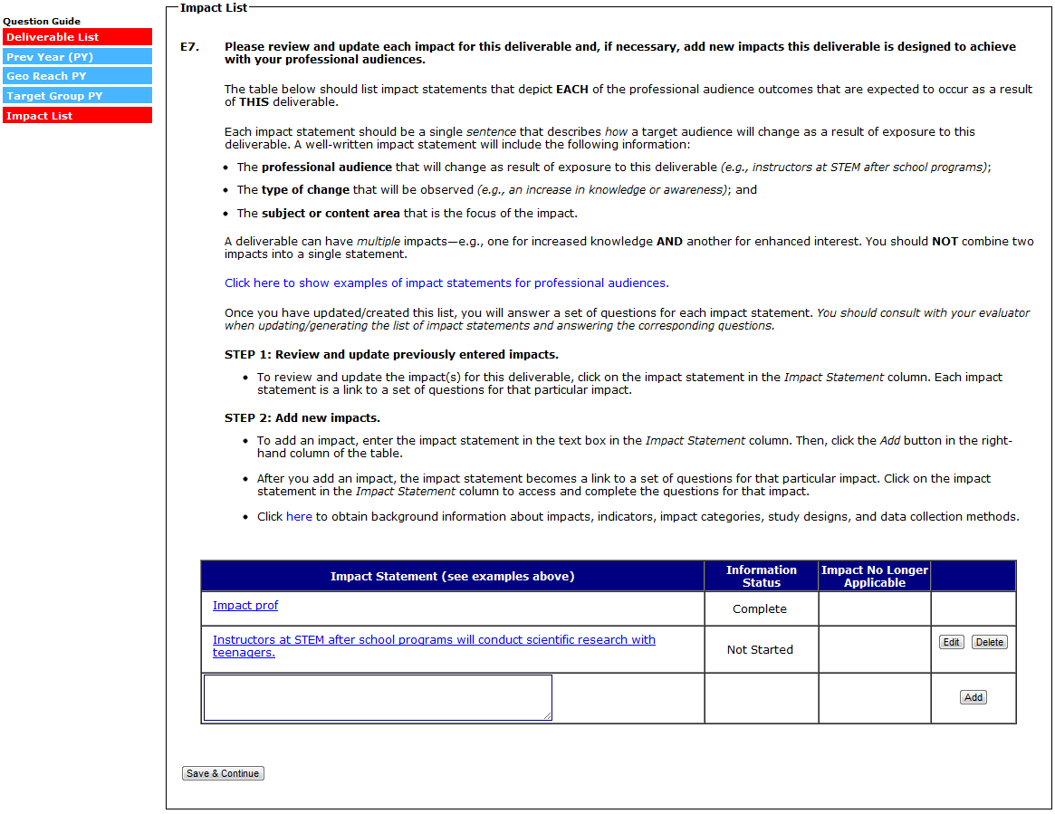

(E8C-E8F ARE COMPLETED FOR EACH IMPACT STATEMENT ADDED IN THE CURRENT REPORT. EACH IMPACT ENTERED IN THE CURRENT REPORT WILL HAVE AN “EDIT” AND “DELETE” BUTTON IN THE FAR RIGHT COLUMN OF THE IMPACT TABLE.)
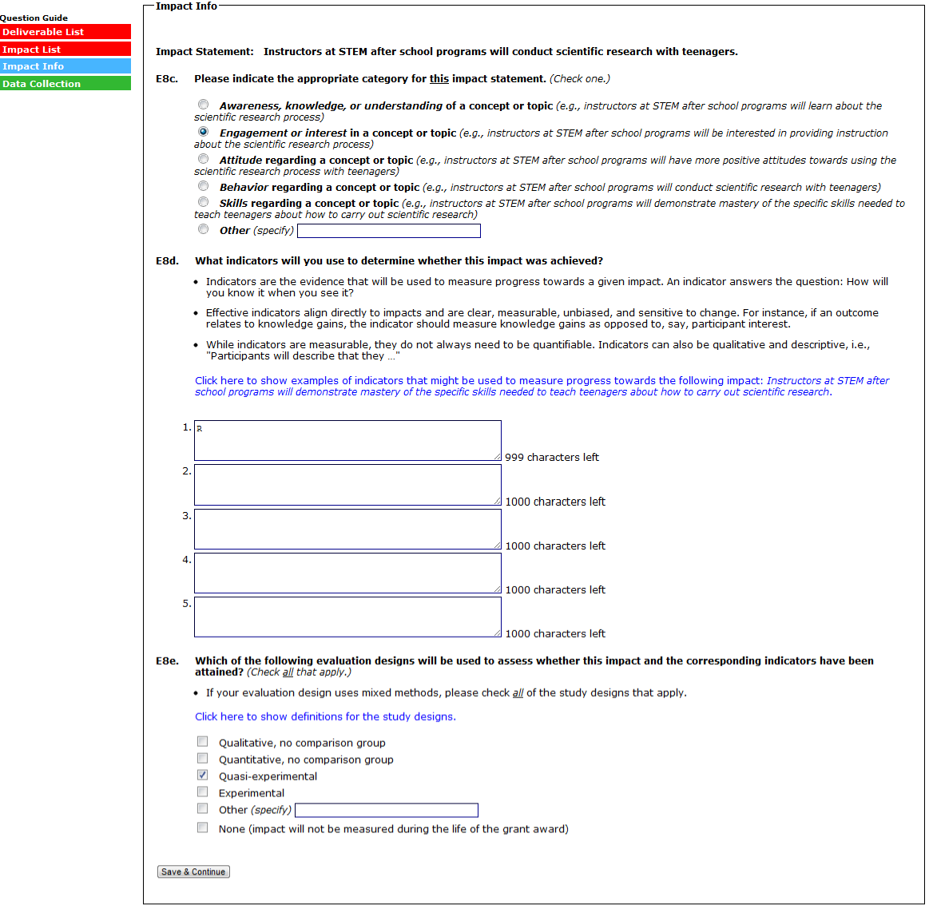
(SELECTING “NONE” IN E8E WILL SKIP E8F, SUBMIT THE IMPACT, AND RETURN TO THE IMPACT LIST)

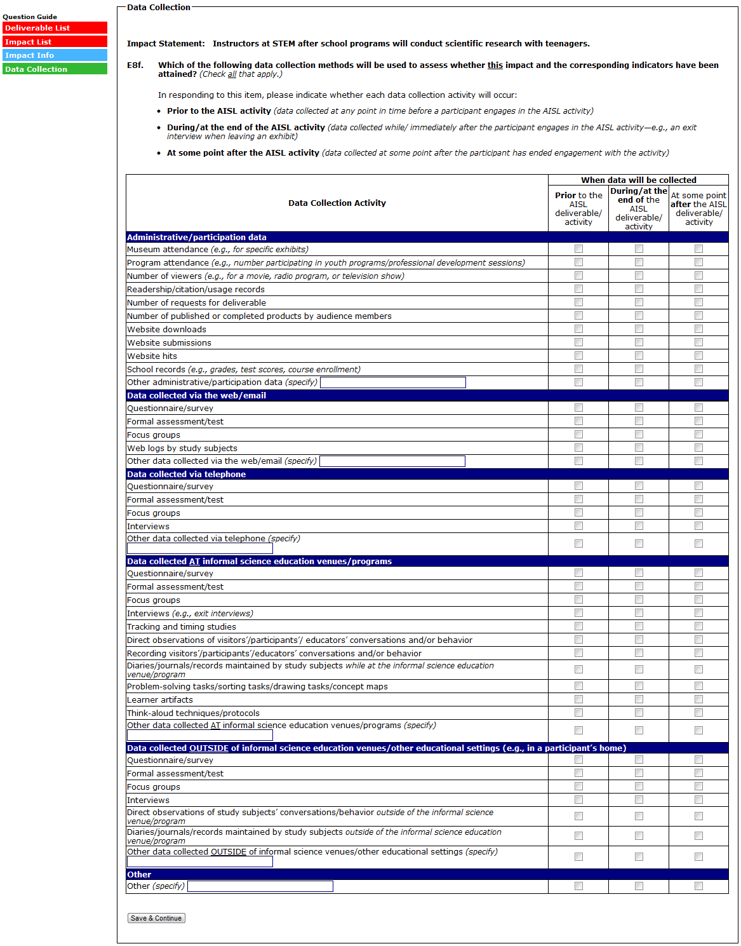
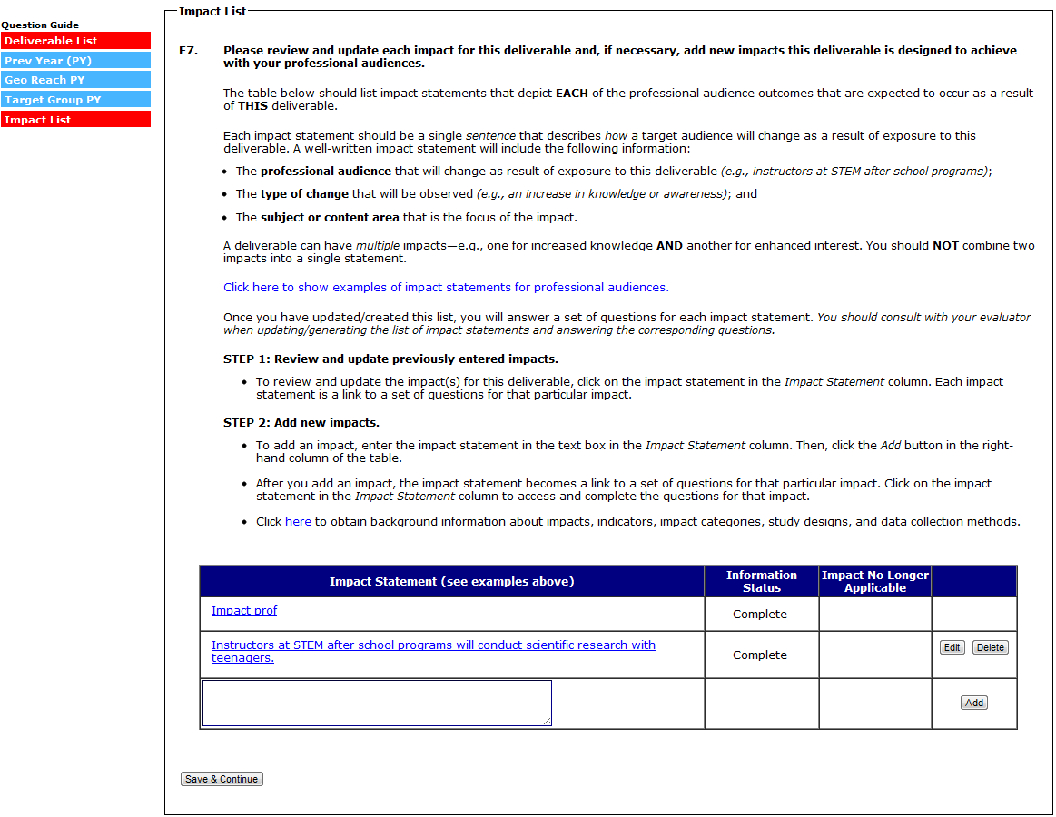
(SELECT “SAVE AND CONTINUE” TO SUBMIT THE DELIVERABLE AND RETURN TO THE DELIVERABLE LIST)
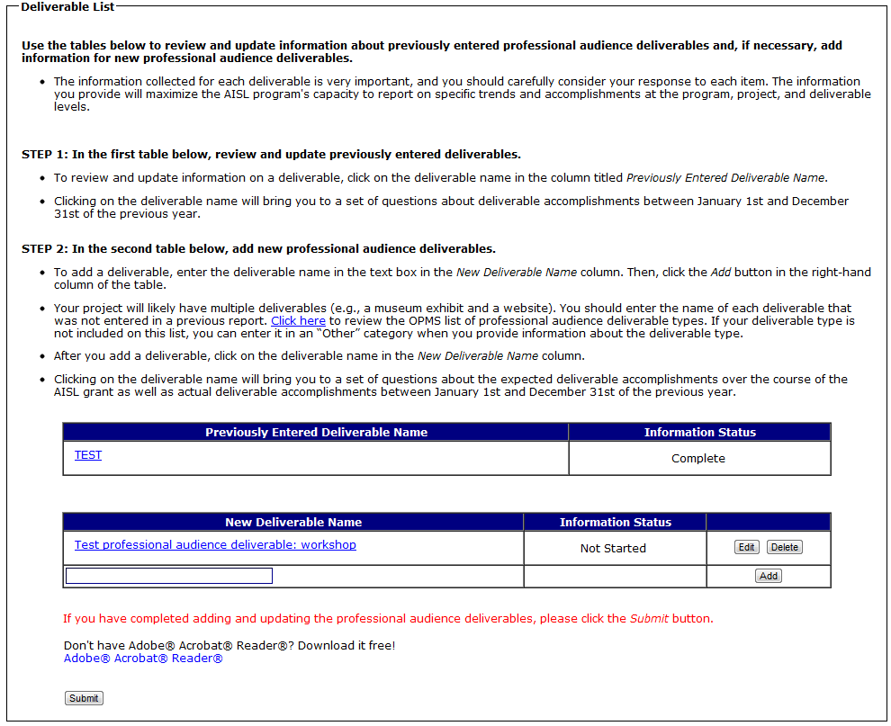

(SELECTING A DELIVERABLE IN THE “NEW DELIVERABLE” TABLE WILL BRING YOU TO E9-E22. E9-E18D ARE QUESTIONS ABOUT WHAT THE DELIVERABLE WILL ACCOMPLISH OVER THE COURSE OF THE GRANT. E19-E22 ARE QUESTIONS ABOUT WHAT THE DELIVERABLE ACCOMPLISHED IN THE PAST CALENDAR YEAR, OR JANUARY 1 – DECEMBER 31 OF THE PREVIOUS YEAR.)
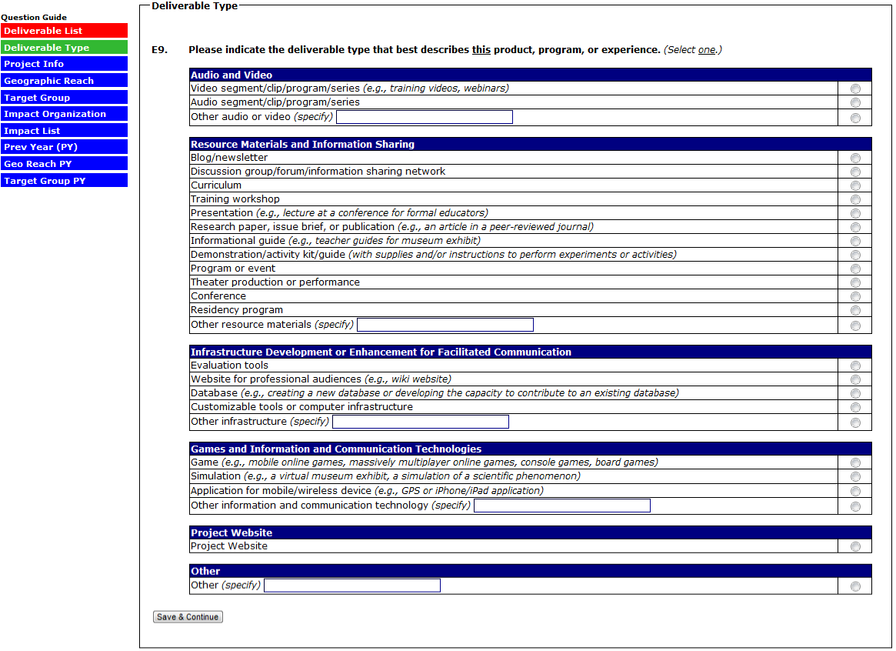

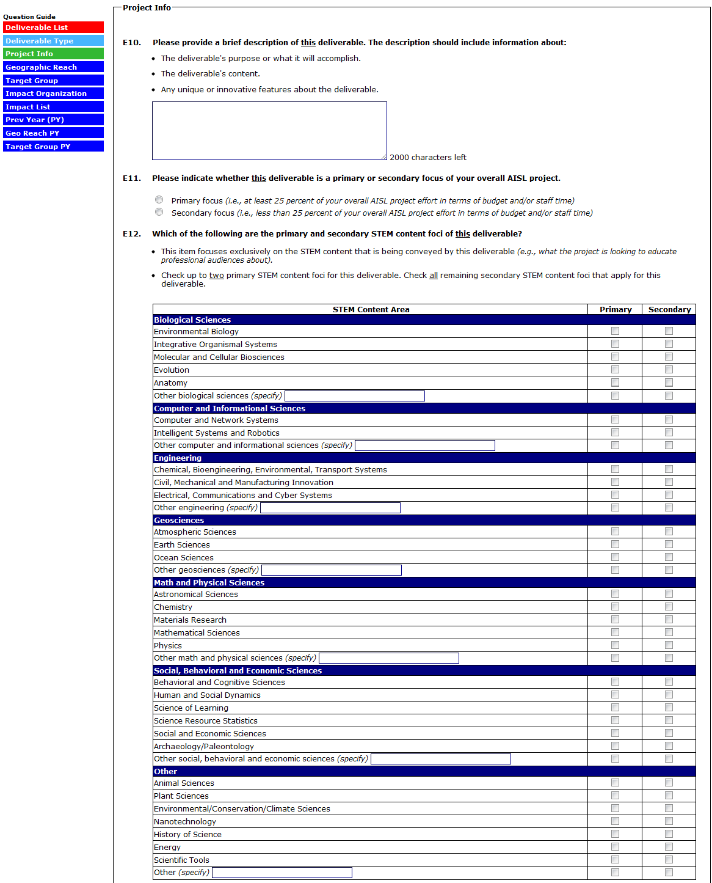
(CONTINUED ON NEXT PAGE)
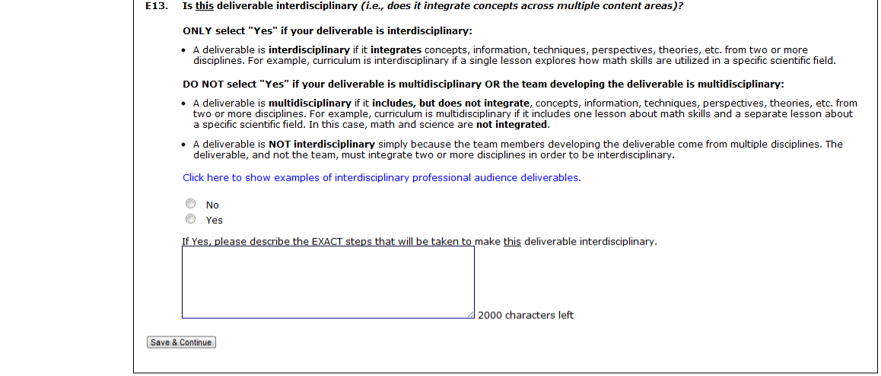

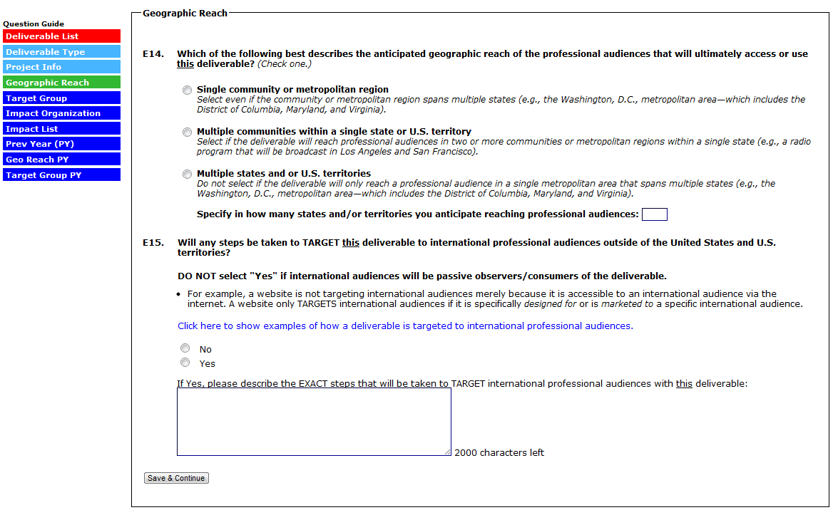

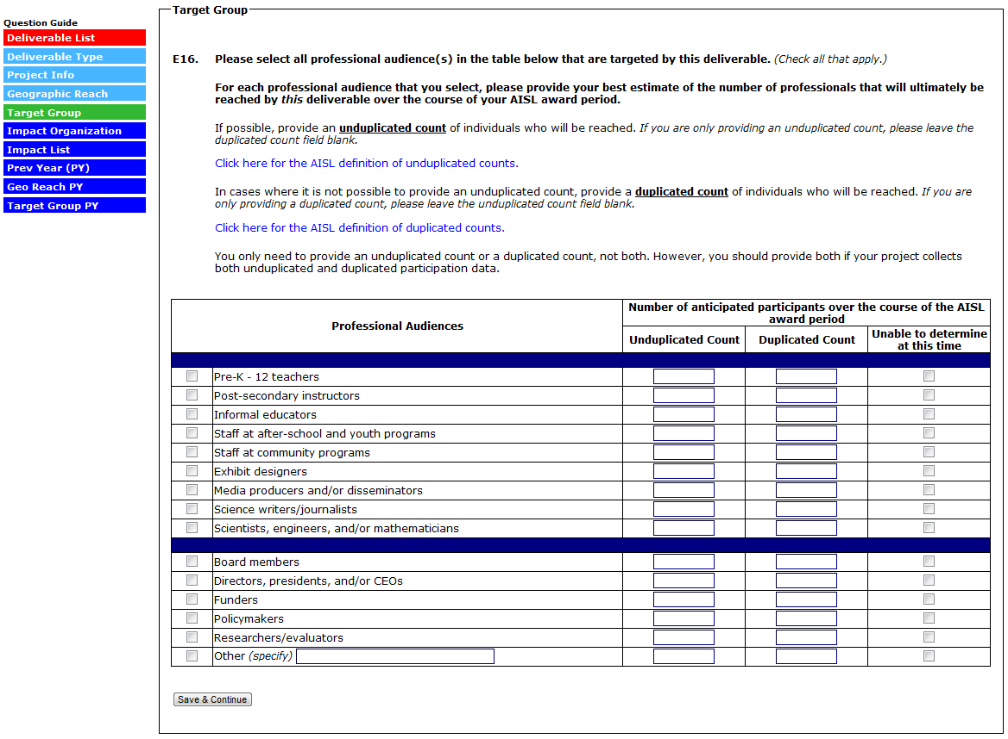
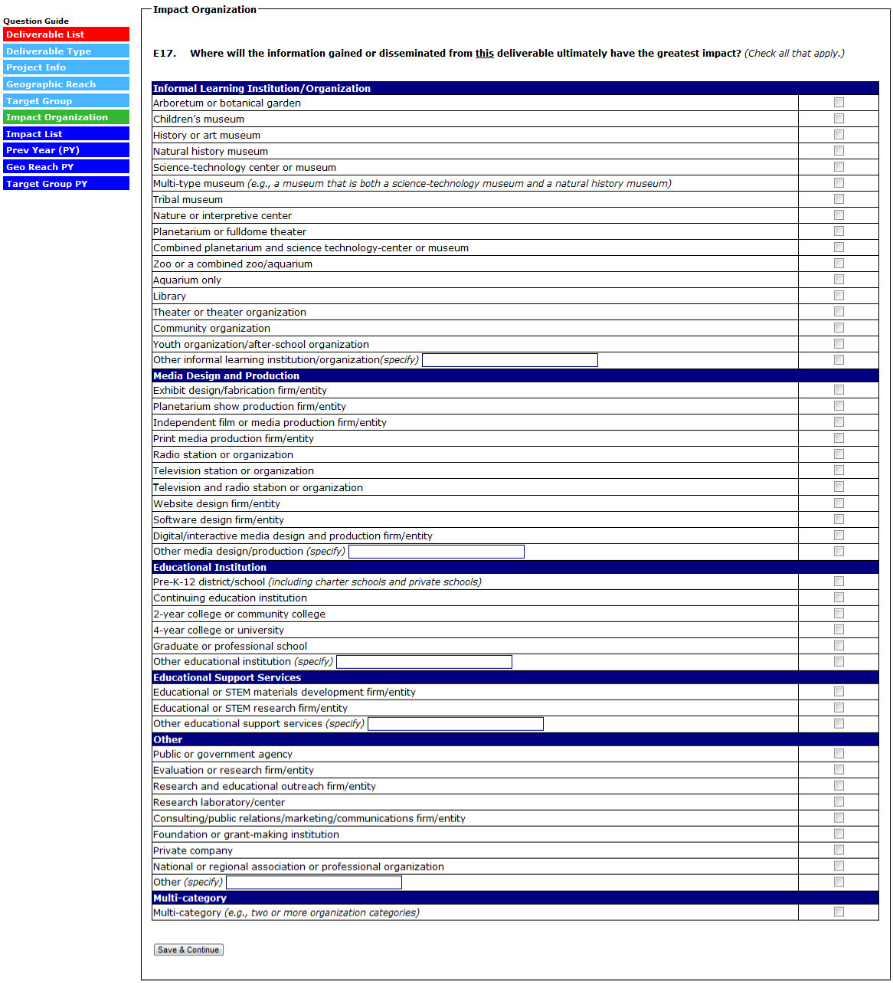
(SELECTING “THERE ARE NO IMPACTS FOR THIS DELIVERABLE” (OPTION AVAILABLE ONLY FOR DELIVERABLES MARKED “SECONDARY FOCUS” IN E11) WILL SKIP TO E19. FOR EACH IMPACT STATEMENT ENTERED INTO THE TABLE, ANSWER E18A-E18D.)
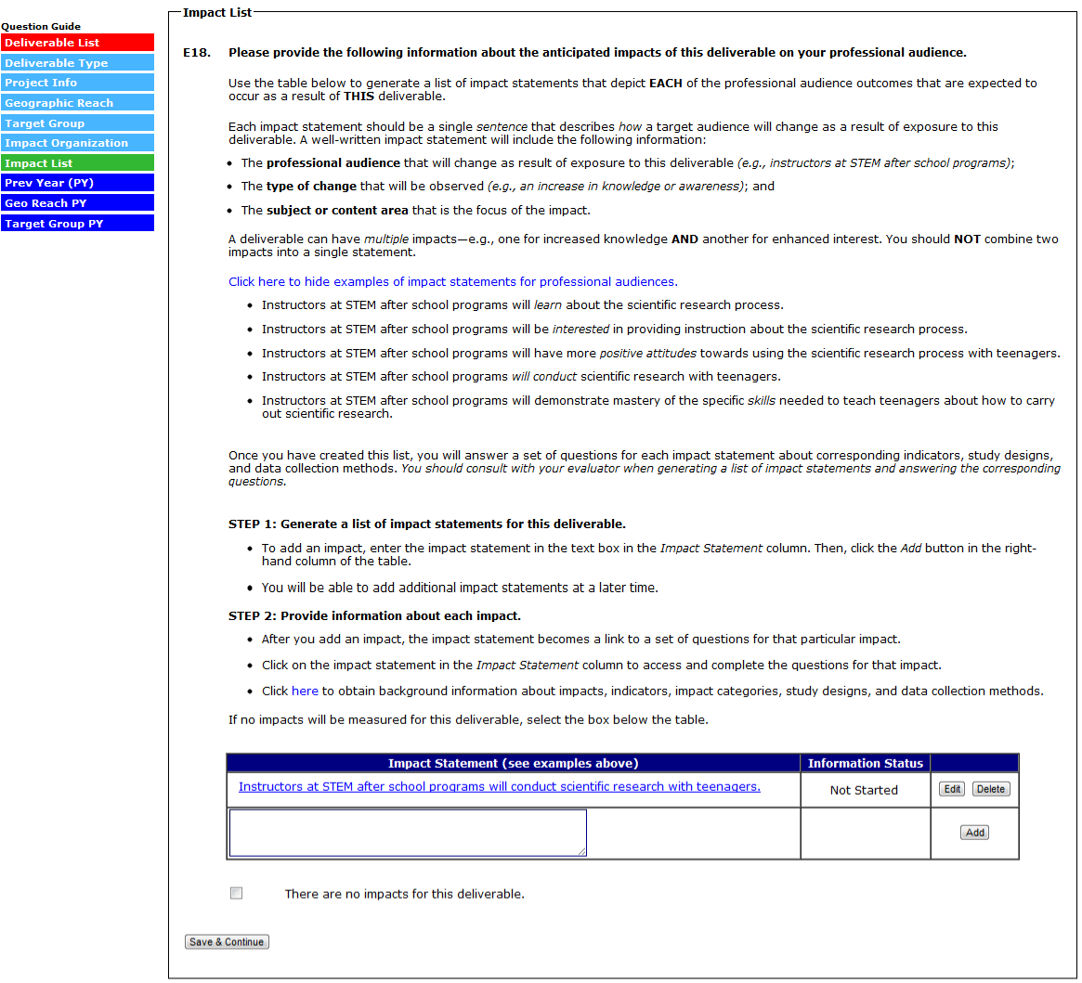
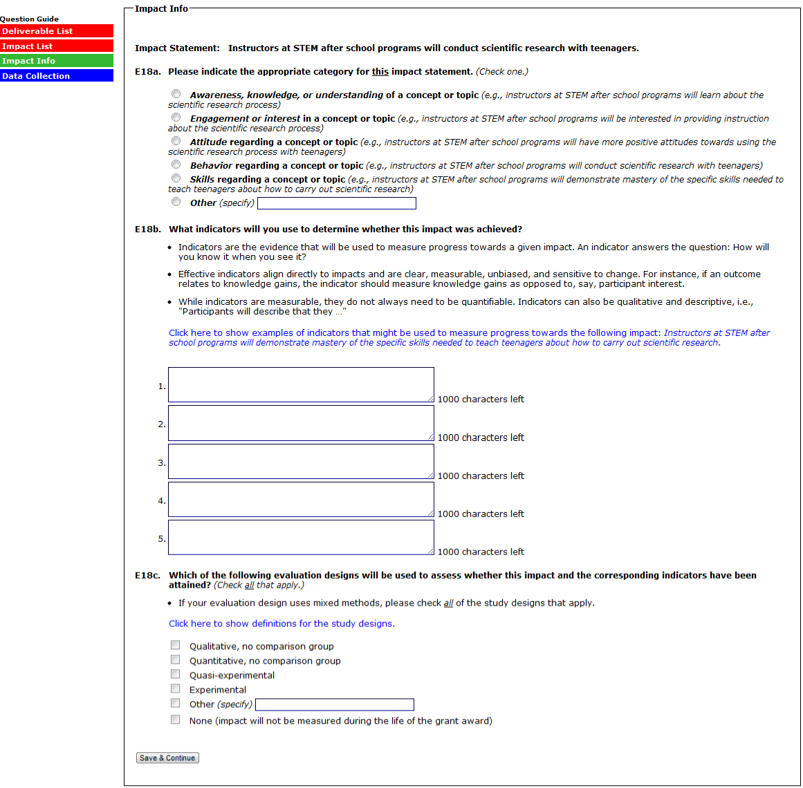
(SELECTING “NONE” TO E18C SKIPS E18D, SUBMITS THE IMPACT, AND RETURNS YOU TO THE IMPACT LIST)
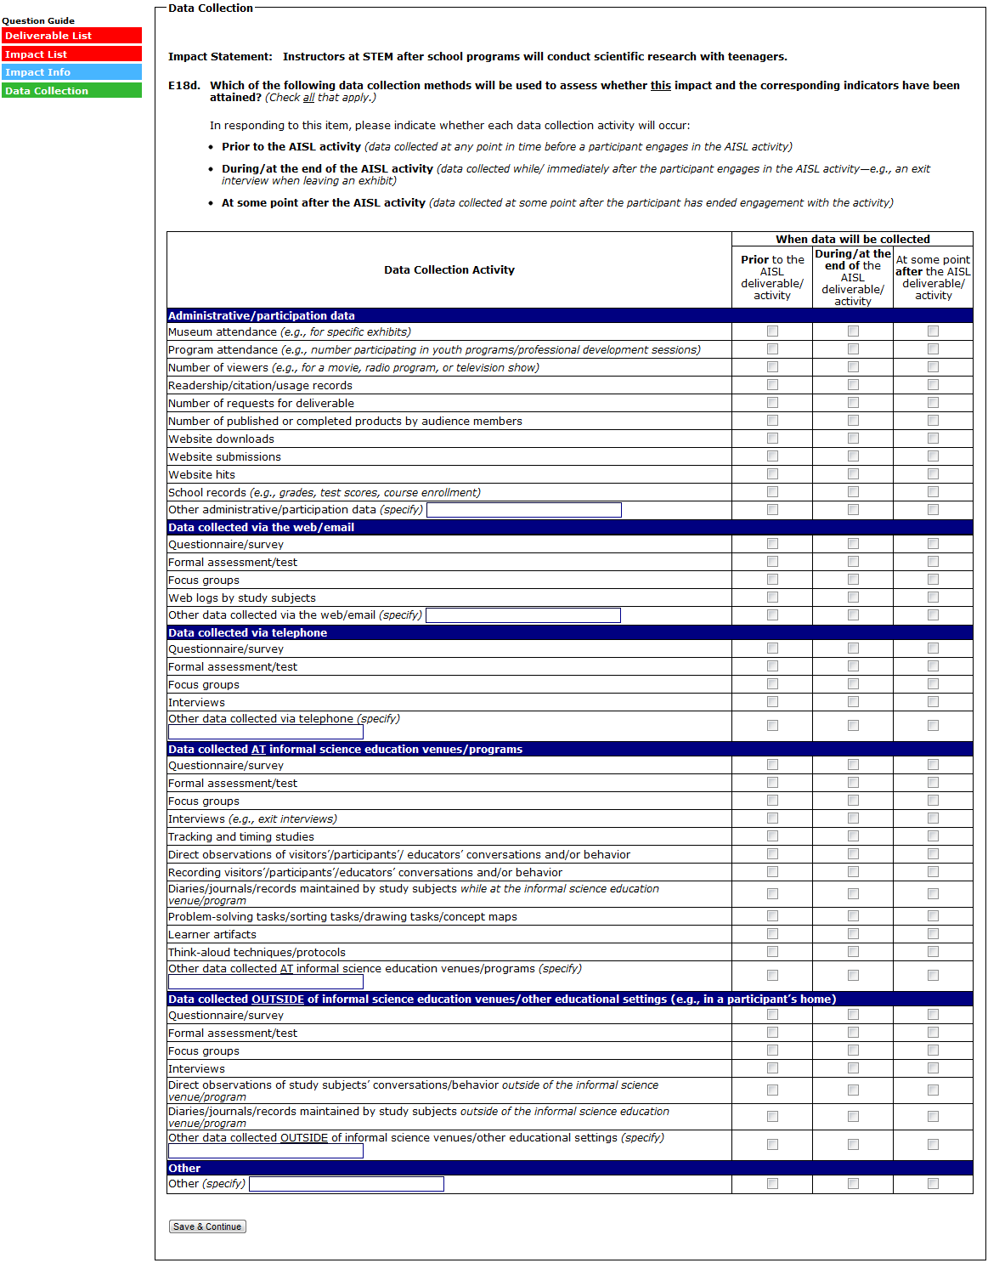
(SELECTING “SAVE & CONTINUE” RETURNS YOU TO THE IMPACT LIST)
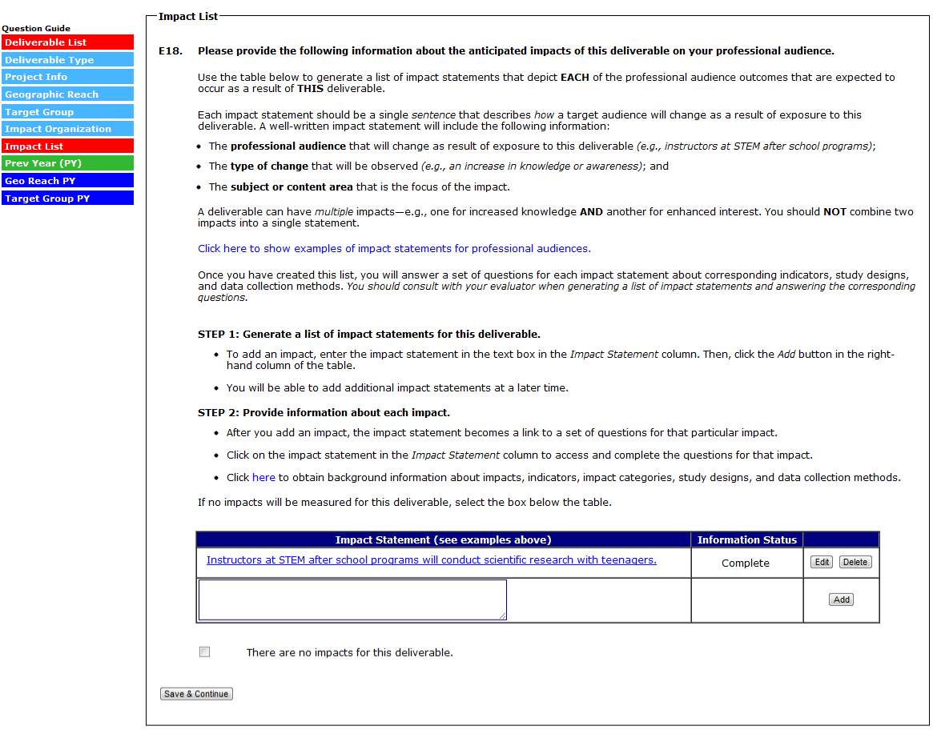

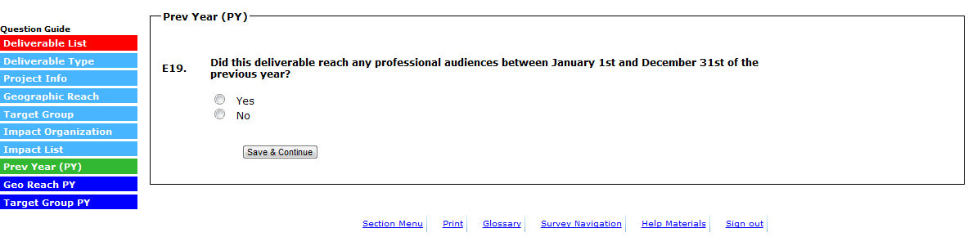
(SELECTING “NO” TO E19 SKIPS THE REMAINING QUESTIONS, SUBMITS THE DELIVERABLE, AND RETURNS YOU TO THE DELIVERABLE LIST. SELECTING “YES” TO E19 BRINGS UP THE FOLLOWING POP UP)

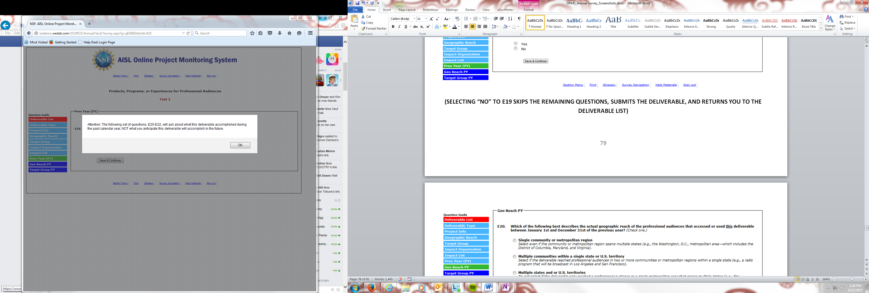
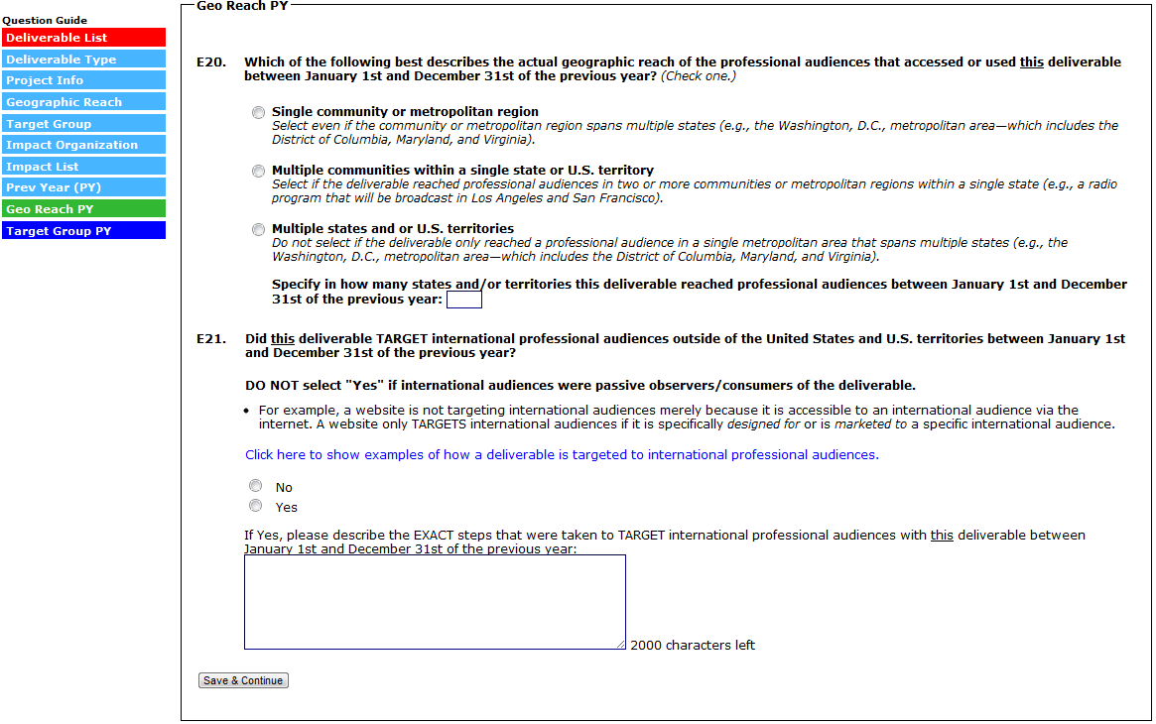

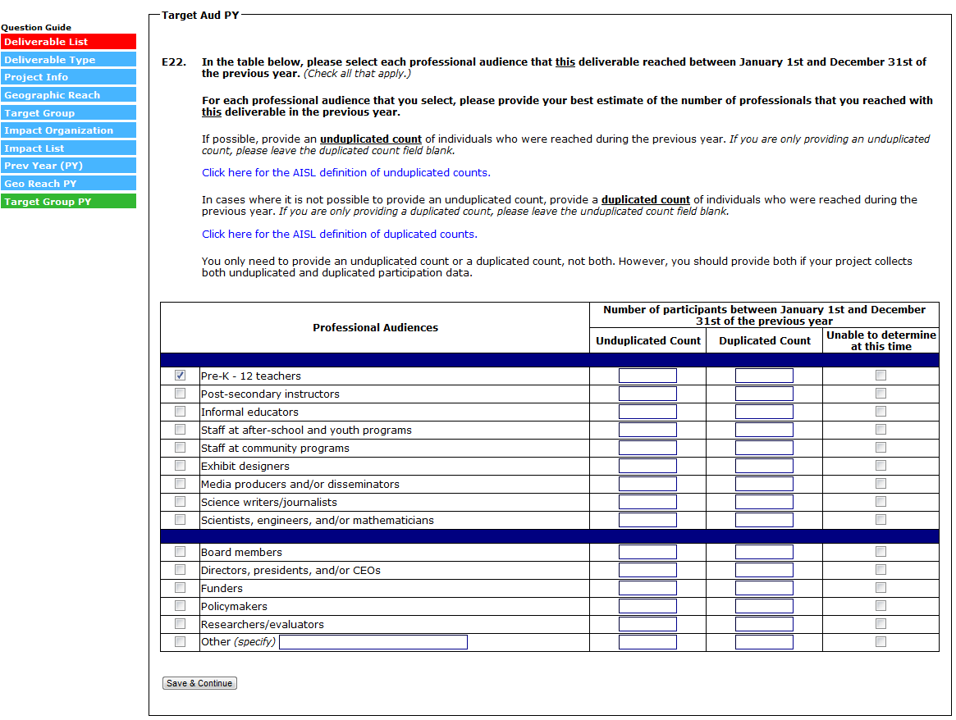
(SELECT “SAVE & CONTINUE” TO SUBMIT THE DELIVERABLE AND RETURN TO THE DELIVERABLE LIST)

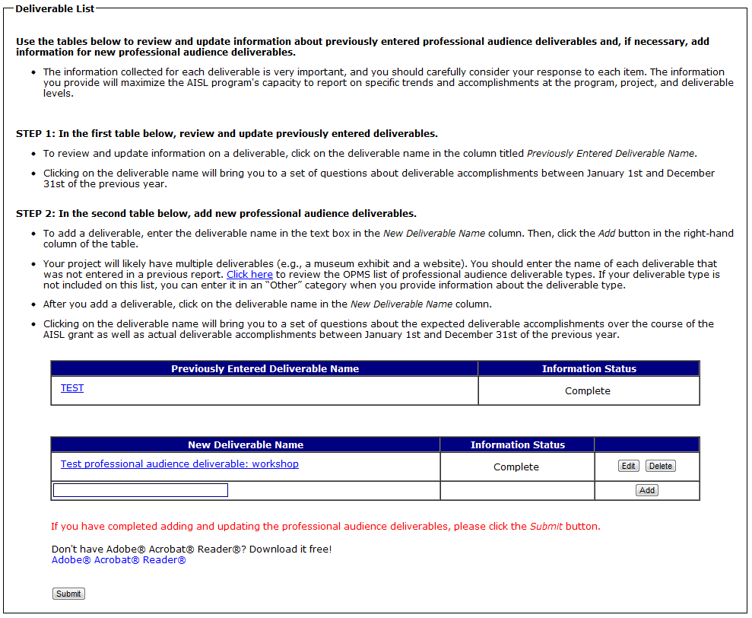
(SELECT “SUBMIT” TO SUBMIT SECTION E AND RETURN TO THE SECTION MENU)

Section F: Formative and Summative Evaluation Questions
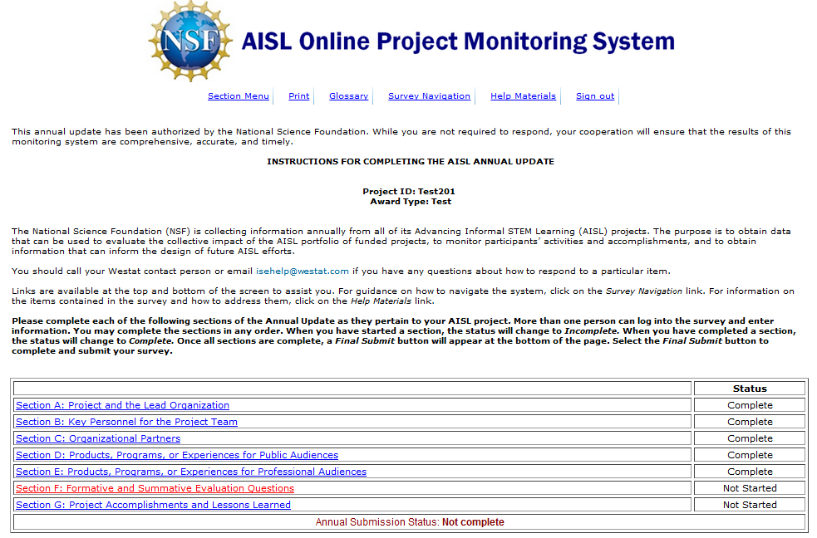

(SELECTING “THIS PROJECT HAS NO FORMATIVE EVALUATION” WILL SKIP TO F3)
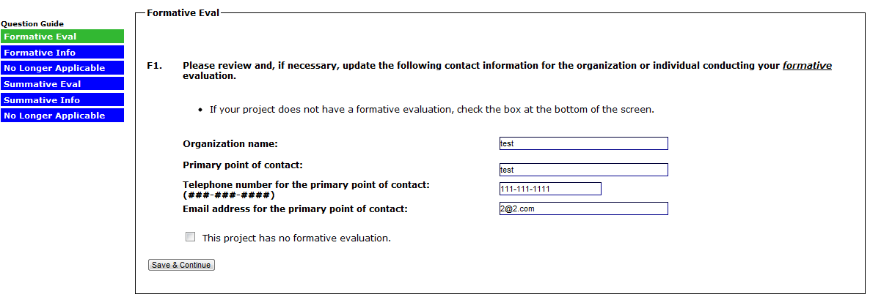
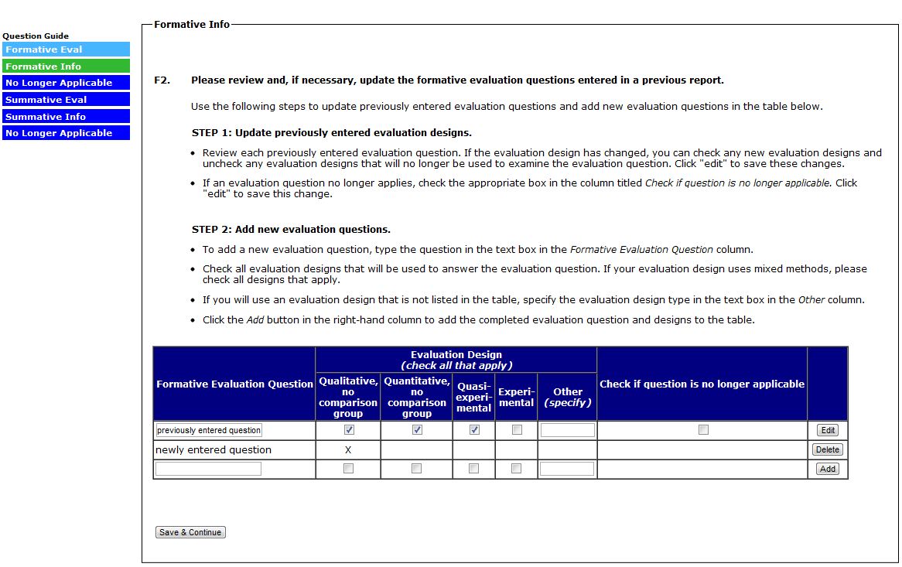

(FOR EACH EVALUATION QUESTION MARKED “NO LONGER APPLICABLE” IN F2, ANSWER F2A)
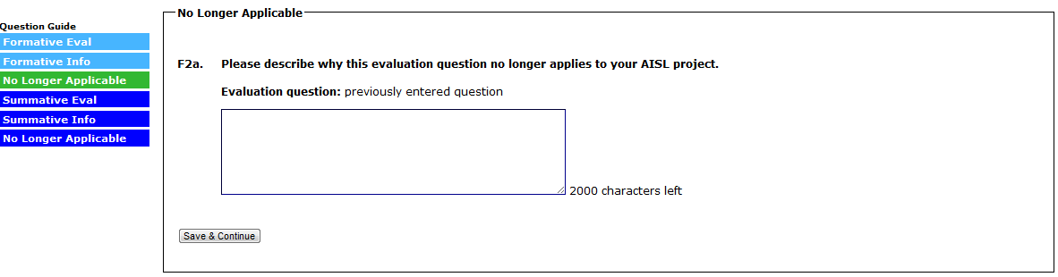

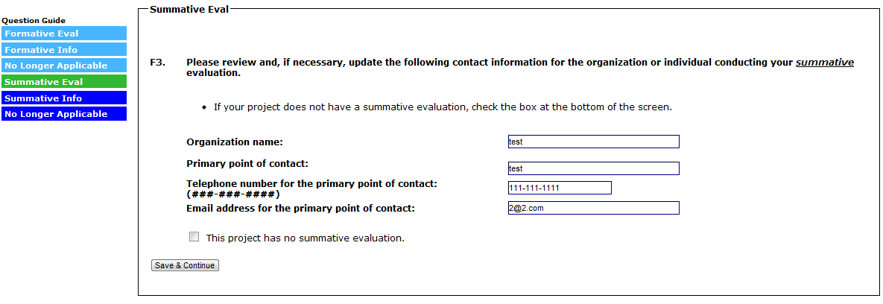
(SELECTING “THIS PROJECT HAS NO SUMMATIVE EVALUATION” WILL SKIP TO A SUBMIT PAGE FOR SECTION F)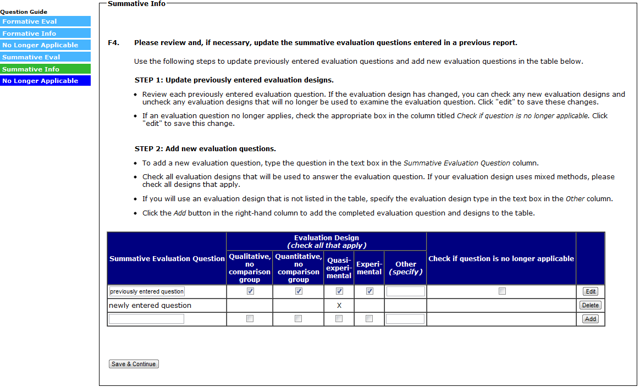
(FOR EACH EVALUATION QUESTION MARKED “NO LONGER APPLICABLE” IN F4, ANSWER F4A)
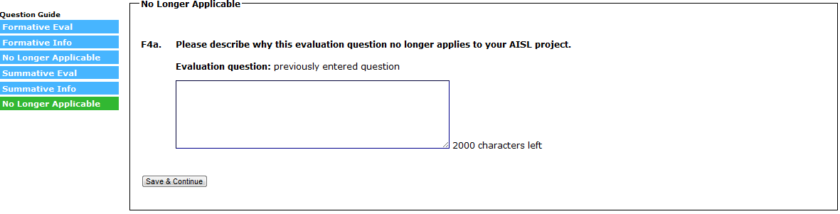
(SELECT “SUBMIT” TO SUBMIT SECTION F AND RETURN TO THE SECTION MENU)
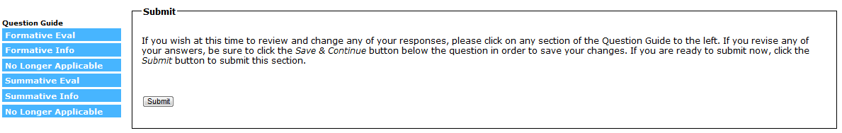

Section G: Project Accomplishments and Lessons Learned

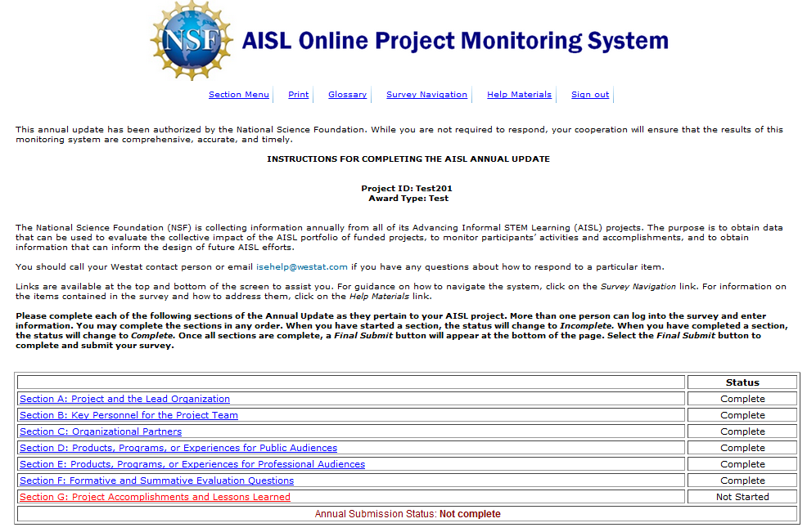
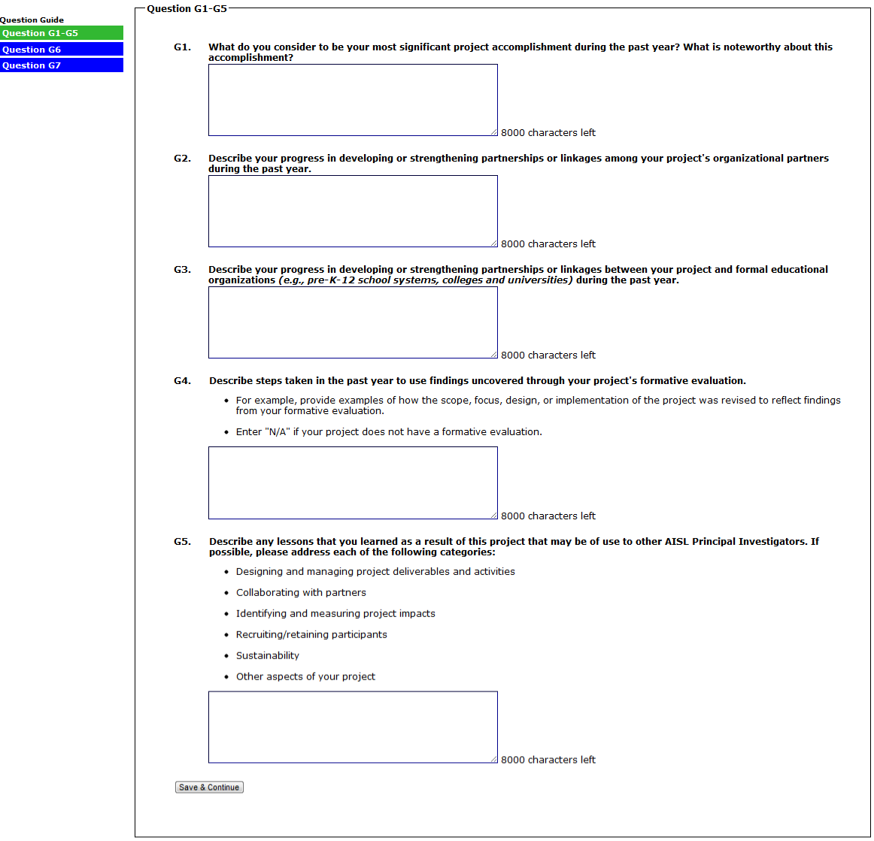
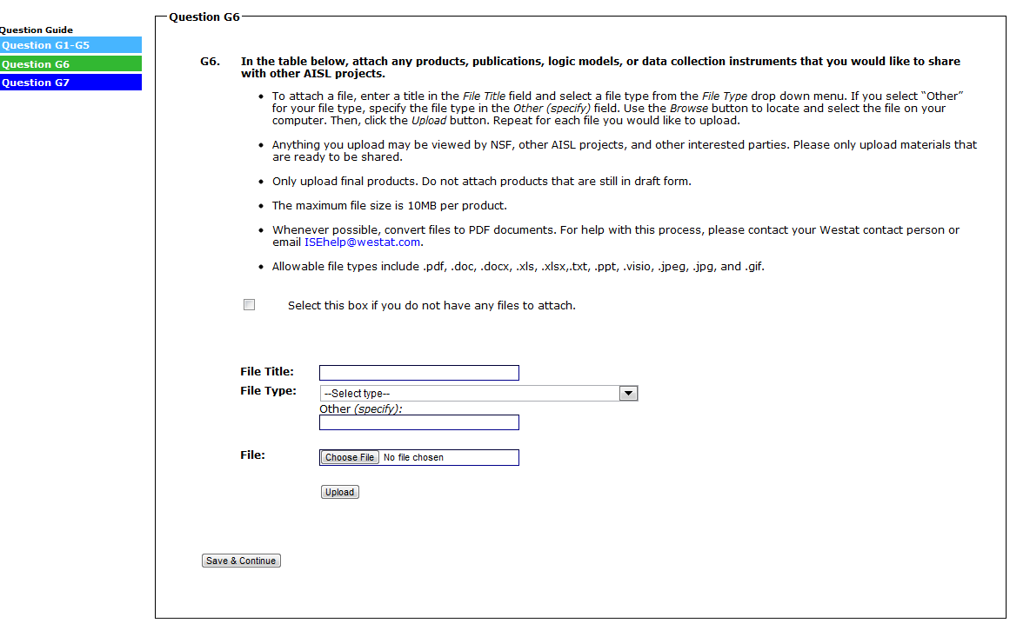
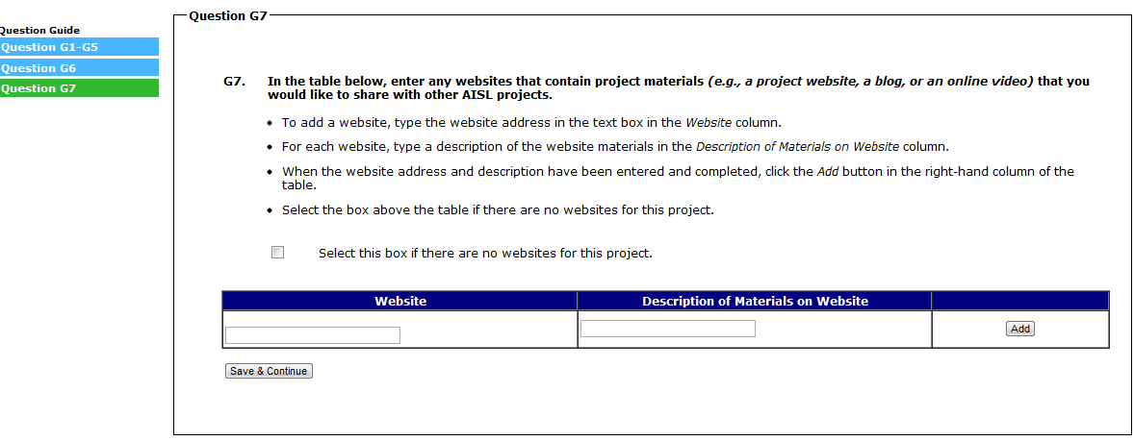
(SELECT “SAVE AND CONTINUE” TO SUBMIT SECTION G AND RETURN TO THE SECTION MENU)

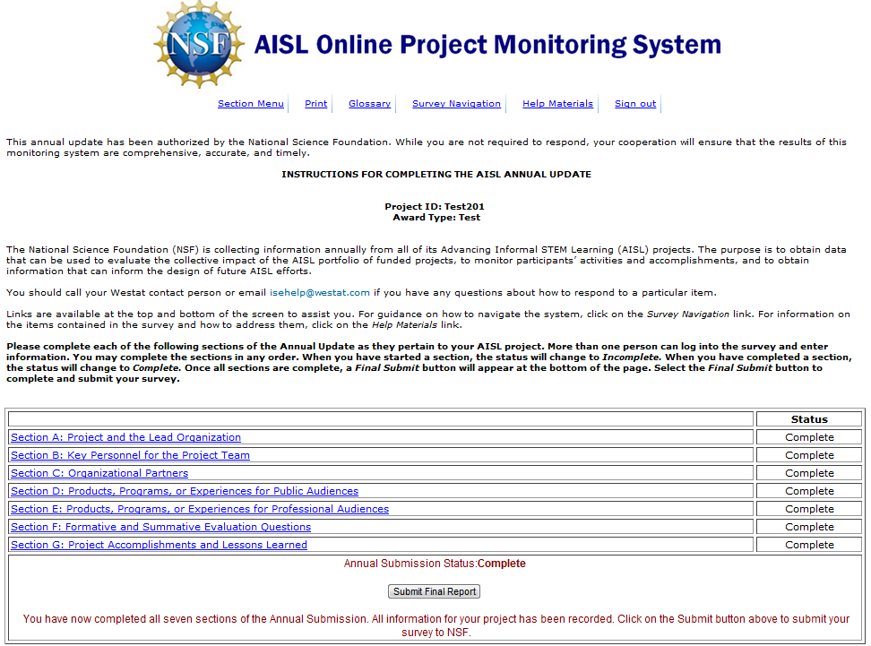
(SELECT “SUBMIT FINAL REPORT” BUTTON TO SUBMIT THE REPORT)

