Attachment A4

AISL Monitoring System Screenshots: OPMS Closeout Survey

Closeout Survey Screenshots for
The NSF Advancing Informal STEM Learning (AISL) Program’s
Online Project Monitoring System (OPMS)
NOTE: The OPMS Closeout Survey collects information on project activities and accomplishments over the course of the AISL grant.

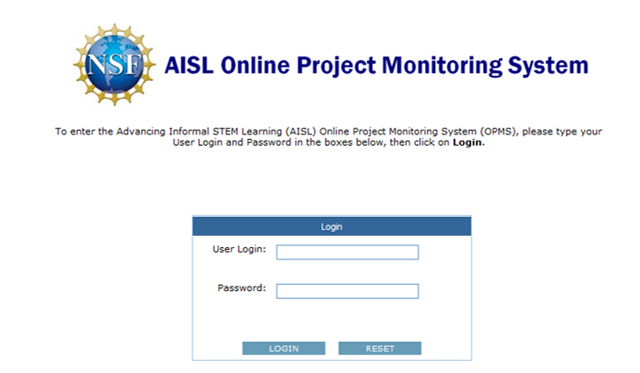

OMB # 3145-0226, Expiration Date: 2/29/2016
Advancing Informal STEM Learning (AISL)
Online Project Monitoring System (OPMS)
Sponsored by the
National Science Foundation
Conducted by
Westat
1650 Research Boulevard
Rockville, Maryland 20850

Privacy Notice
Information from this monitoring system will be retained by the National Science Foundation, a federal agency, and will be an integral part of its Privacy Act System of Records in accordance with the Privacy Act of 1974 and maintained in the Education and Training System of Records, 63 Fed. Reg. 264, 272 (January 5, 1998). These are confidential files accessible only to appropriate National Science Foundation (NSF) officials, their staffs, and their contractors responsible for monitoring, assessing, and evaluating NSF programs. Only data in highly aggregated form, or data explicitly requested as “for general use,” will be made available to anyone outside of the National Science Foundation for research purposes. Data submitted will be used in accordance with criteria established by NSF for monitoring research and education grants, and in response to Public Law 99-383 and 42 U.S.C. 1885c.
Public Burden
Submission of the requested information is voluntary. Failure to provide full and complete information, however, may reduce the possibility for continued support thorough the award/project subject to this survey. The public reporting burden for this collection of information is estimated to average 24.0 person hours for the Baseline submission, 8.0 person hours for each Annual Report, and 16.0 person hours for the Closeout Report, including the time for reviewing instructions. Send comments regarding this burden estimate or any other aspect of this collection of information, including suggestions for reducing this burden, to Suzanne Plimpton, Reports Clearance Officer for OMB Collection 3145-0226, National Science Foundation, 4201 Wilson Blvd., Suite 1265, Arlington, VA 22230.
If you have any questions, contact isehelp@westat.com
Contact Us

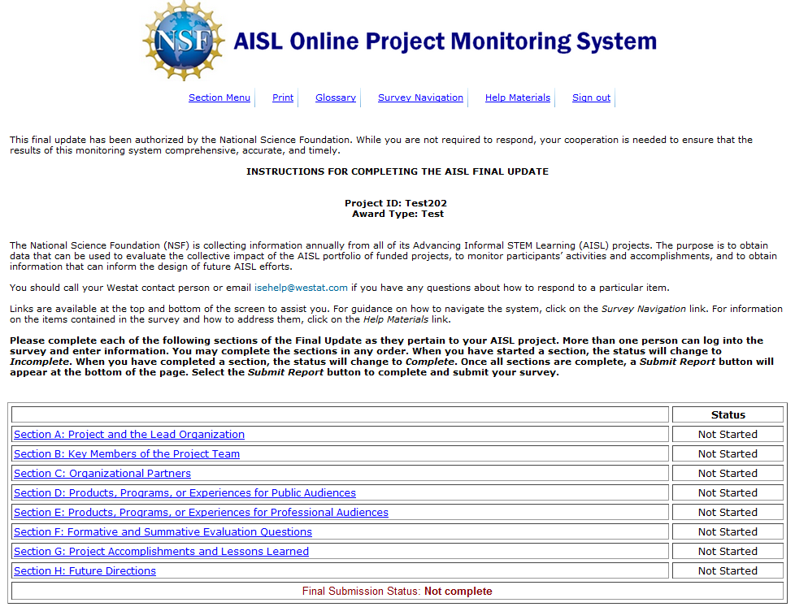

Section A: Project and the Lead Organization

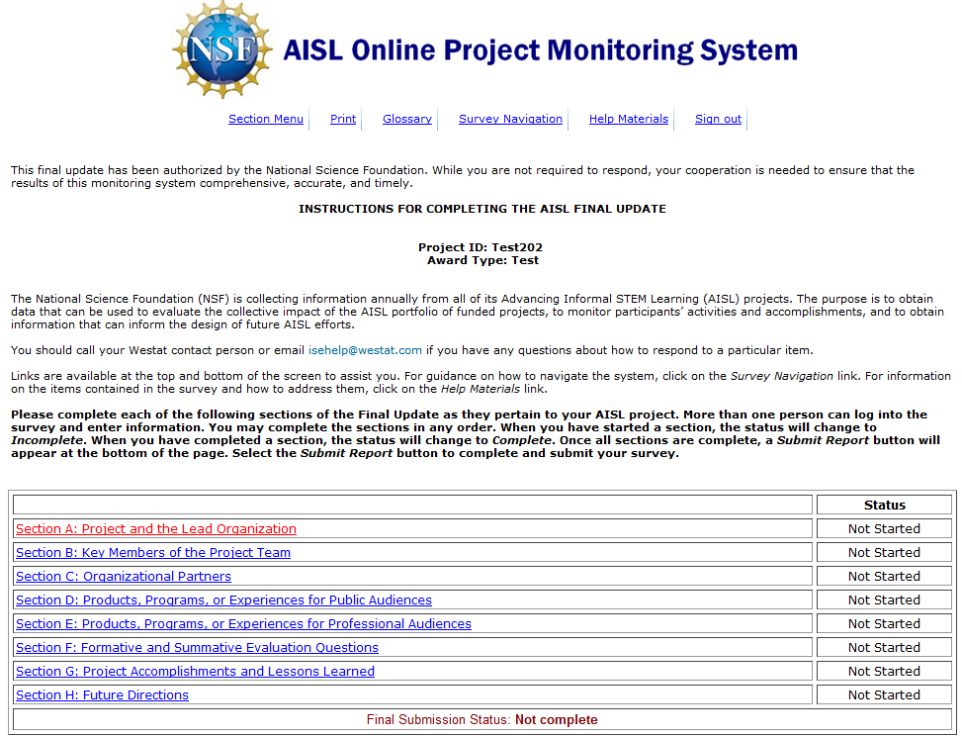

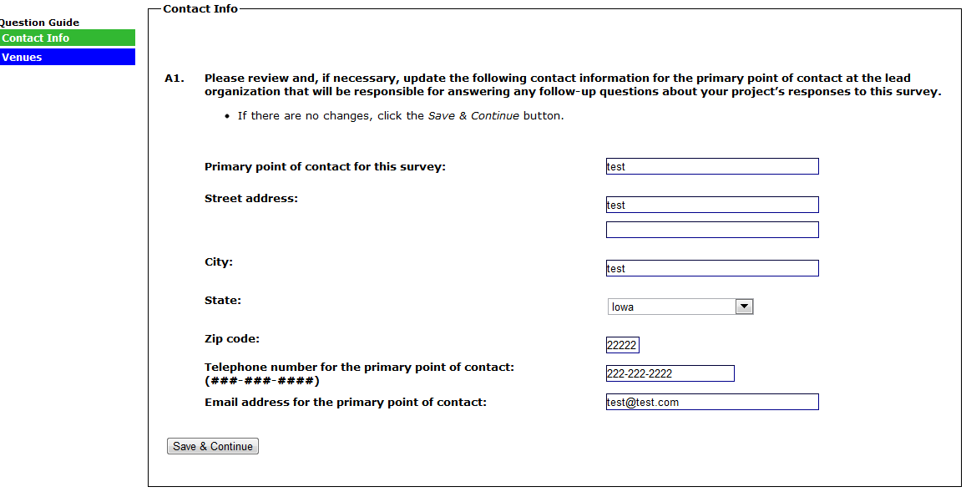
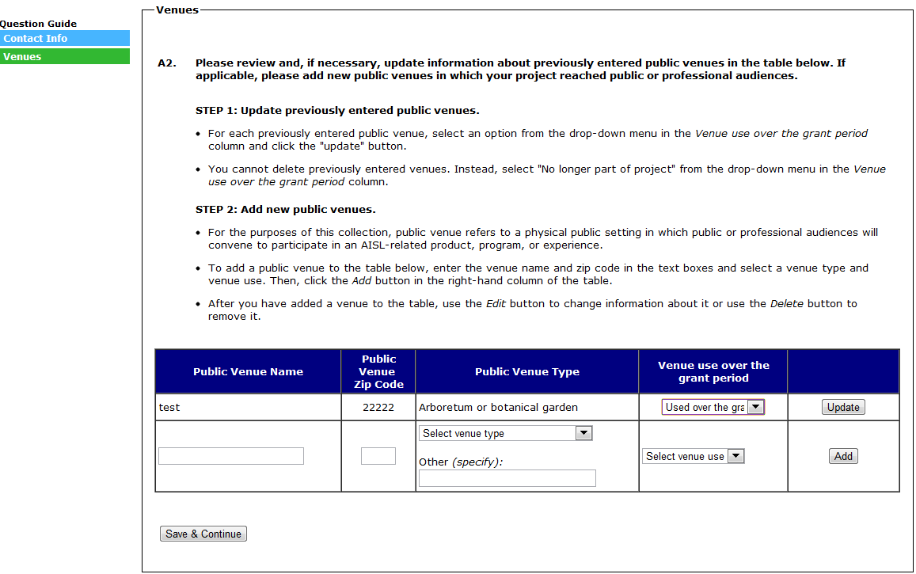

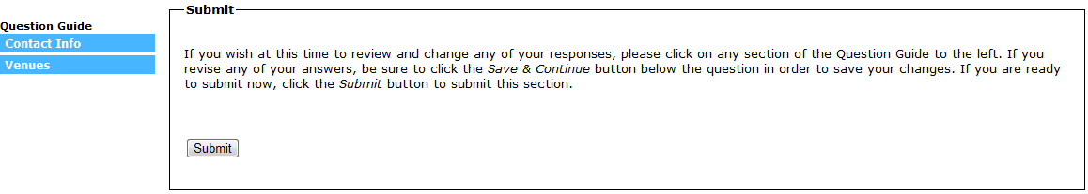
(SELECTING “SUBMIT” WILL SUBMIT SECTION A, MARK SECTION A AS “COMPLETE” ON THE SECTION MENU, AND RETURN TO THE SECTION MENU)

Section B: Key Members of the Project Team

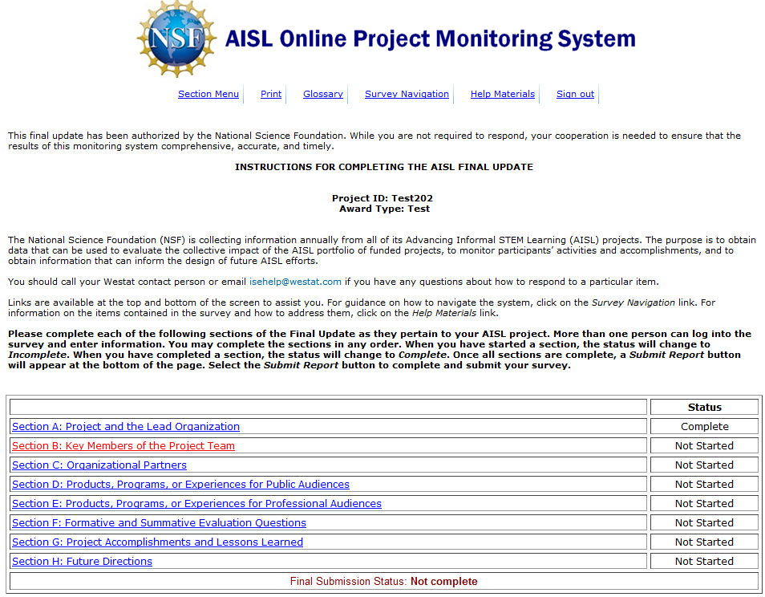

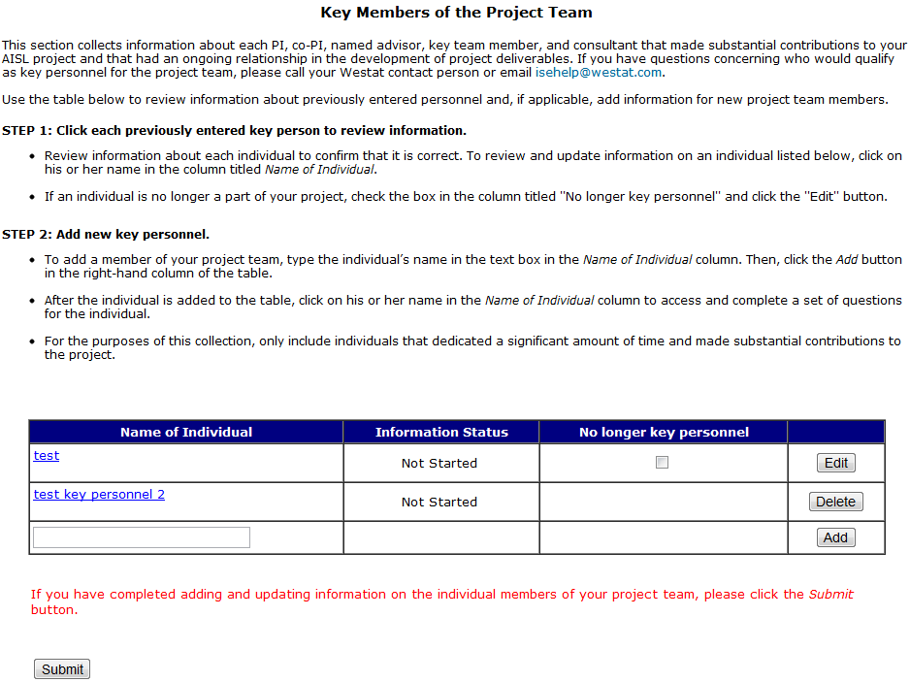

(B1-B4 ARE REVIEWED FOR EACH PERSON ENTERED IN A PREVIOUS REPORT. EACH PERSON ENTERED IN A PREVIOUS REPORT WILL HAVE AN “EDIT” BUTTON IN THE FAR RIGHT COLUMN OF THE KEY PERSONNEL TABLE. B1-B4 ARE SKIPPED IF THE BOX IS SELECTED IN THE COLUMN INDICATING THAT THE PERSON IS “NO LONGER KEY PERSONNEL.”)
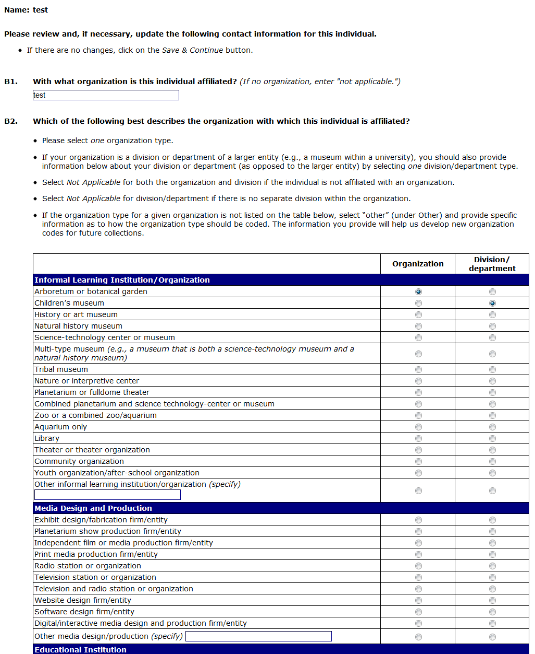
(CONTINUED ON NEXT PAGE)
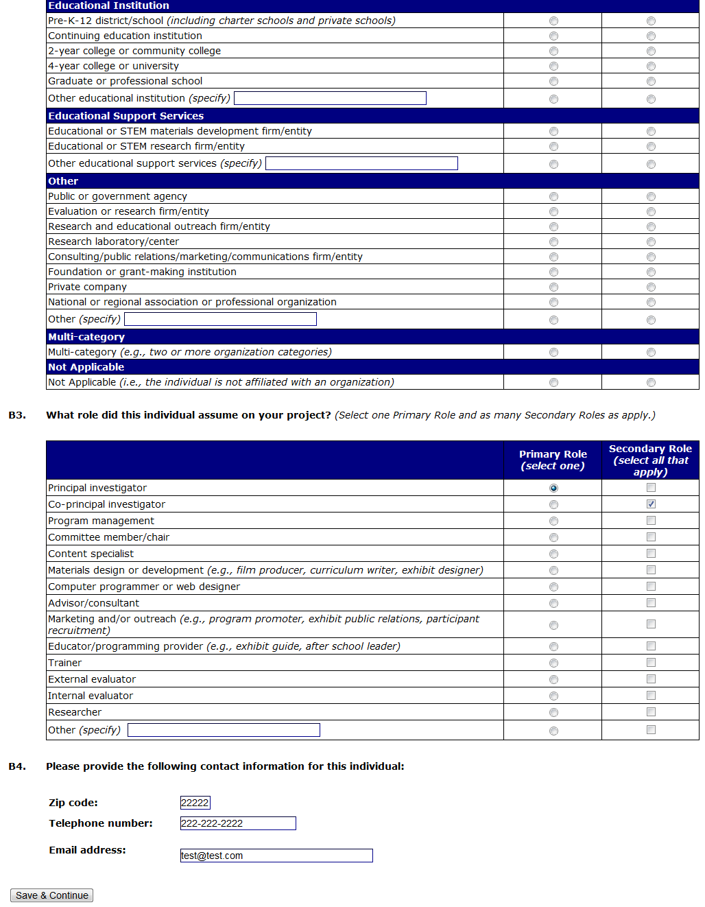
(SELECTING “SAVE & CONTINUE” WILL RETURN YOU TO THE KEY PERSONNEL MAIN PAGE)
(B5-B8 ARE COMPLETED FOR EACH PERSON ENTERED IN THE CURRENT REPORT. EACH PERSON ENTERED IN THE CURRENT REPORT WILL HAVE A “DELETE” BUTTON IN THE FAR RIGHT COLUMN OF THE KEY PERSONNEL TABLE.)

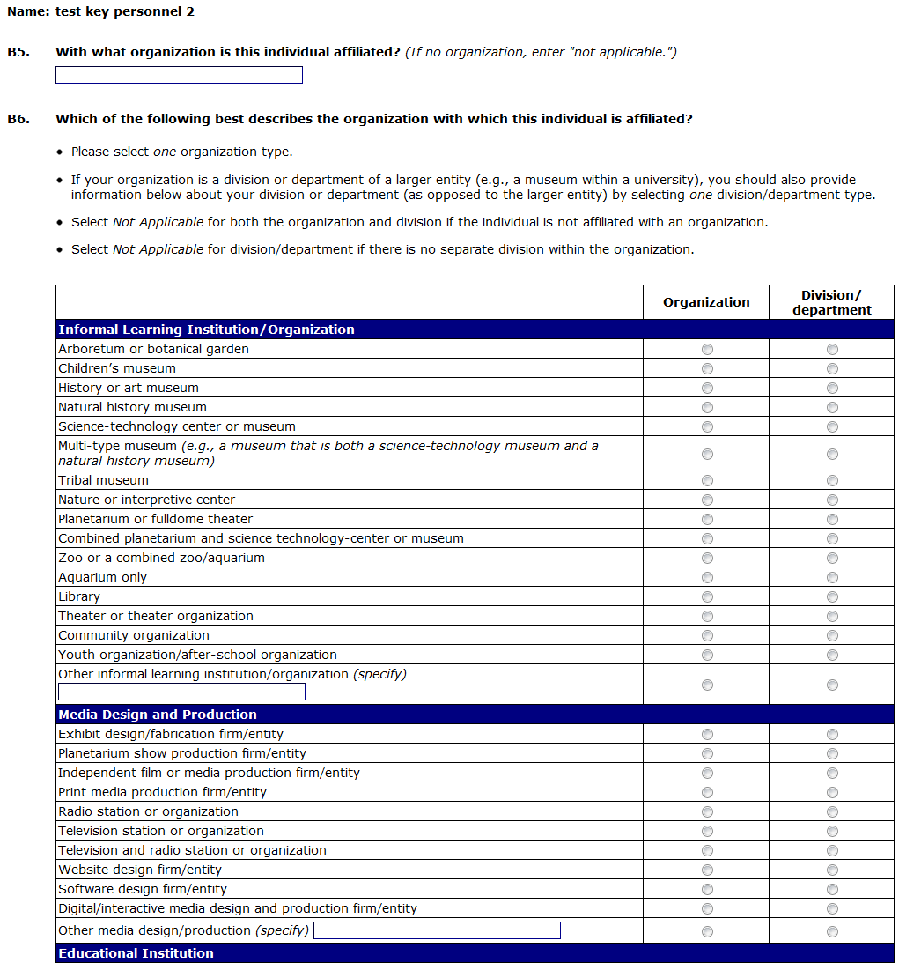
(CONTINUED ON NEXT PAGE)
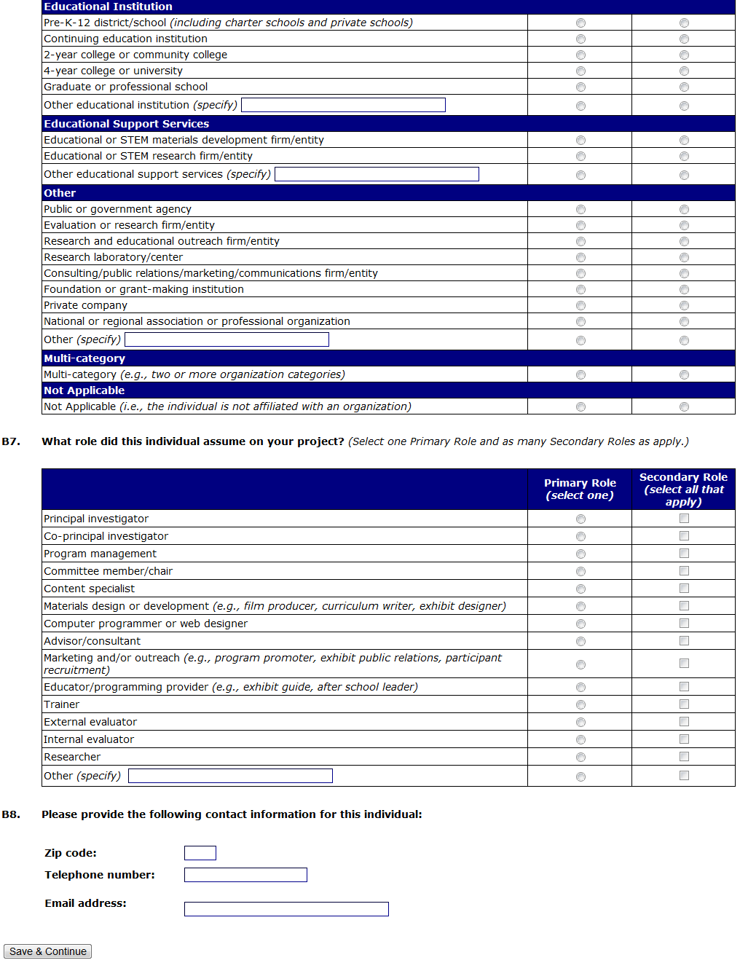
(SELECTING “SAVE & CONTINUE” WILL RETURN YOU TO THE KEY PERSONNEL MAIN PAGE)
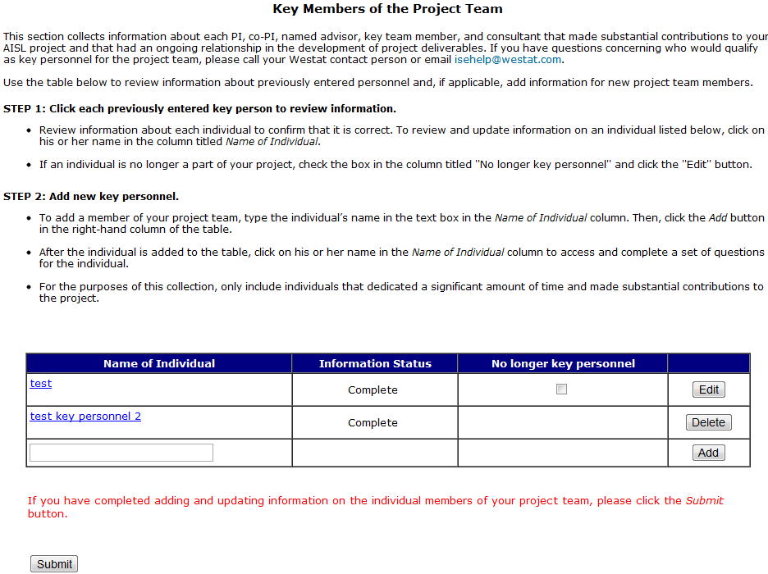
(SELECTING “SUBMIT” WILL SUBMIT SECTION B, MARK SECTION B AS “COMPLETE” ON THE SECTION MENU, AND RETURN TO THE SECTION MENU)

Section C: Organizational Partners

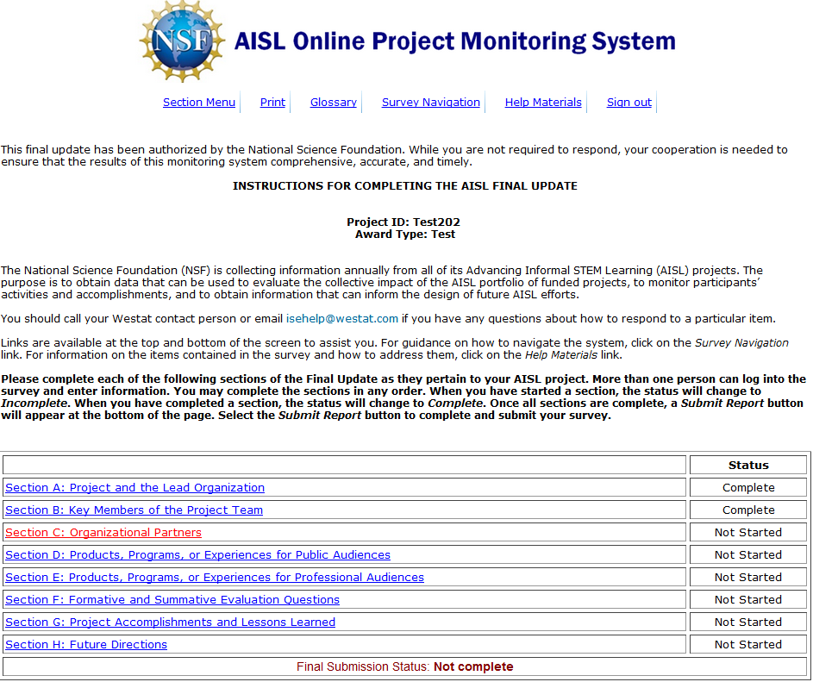

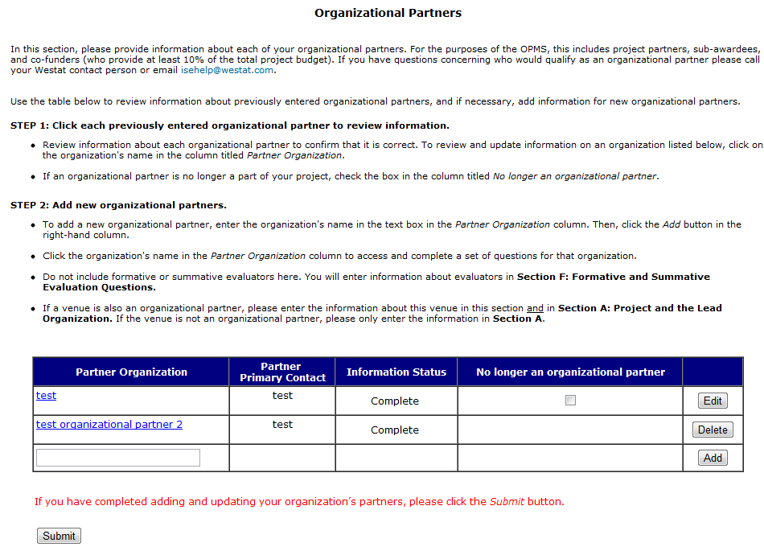

(C1-C5 ARE COMPLETED FOR EACH PARTNER ENTERED IN THE CURRENT REPORT. EACH PARTNER ENTERED IN THE CURRENT REPORT WILL HAVE A “DELETE” BUTTON IN THE FAR RIGHT COLUMN OF THE PARTNER TABLE.)

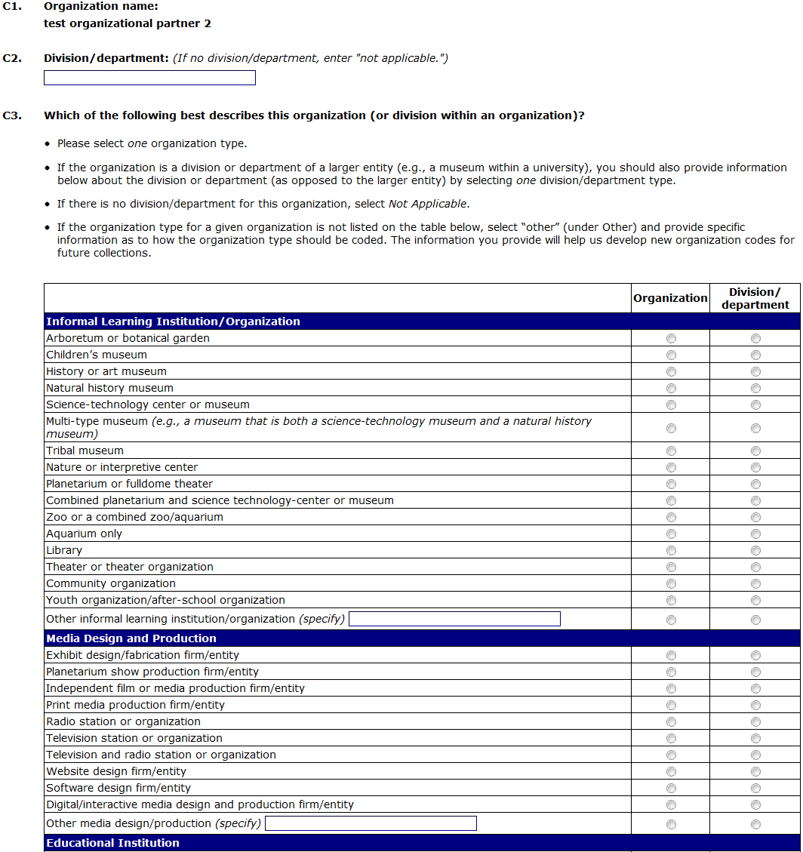
(CONTINUED ON NEXT PAGE)
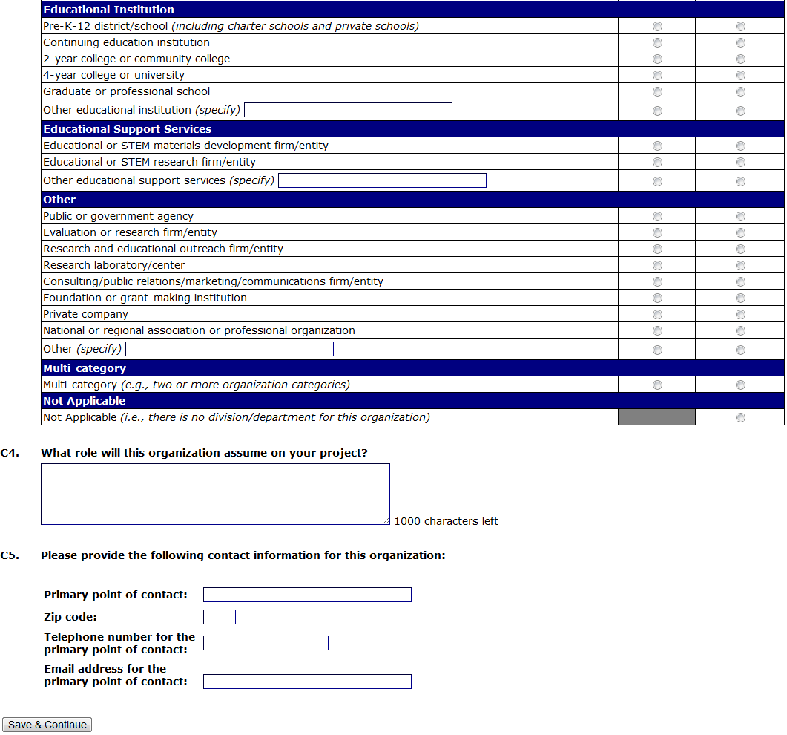
(SELECTING “SAVE & CONTINUE” WILL RETURN YOU TO THE PARTNER MAIN PAGE)

(C6 IS REVIEWED AND UPDATED FOR EACH PARTNER ENTERED IN A PREVIOUS REPORT. EACH PARTNER ENTERED IN A PREVIOUS REPORT WILL HAVE AN “EDIT” BUTTON IN THE FAR RIGHT COLUMN OF THE PARTNER TABLE. C6 IS SKIPPED IF THE BOX IS SELECTED IN THE COLUMN INDICATING THAT THE PARTNER IS “NO LONGER AN ORGANIZATIONAL PARTNER.”)
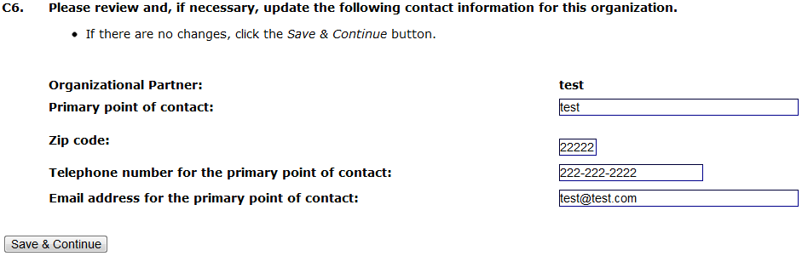

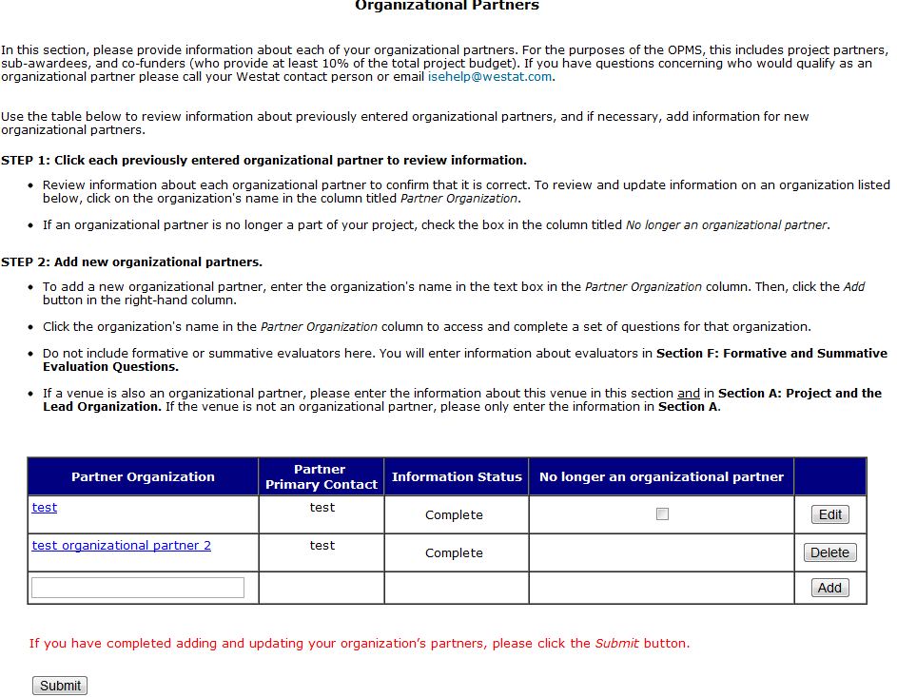
(SELECTING “SUBMIT” WILL SUBMIT SECTION C, MARK SECTION C AS “COMPLETE” ON THE SECTION MENU, AND RETURN TO THE SECTION MENU)

Section D: Products, Programs, or Experiences for Public Audiences

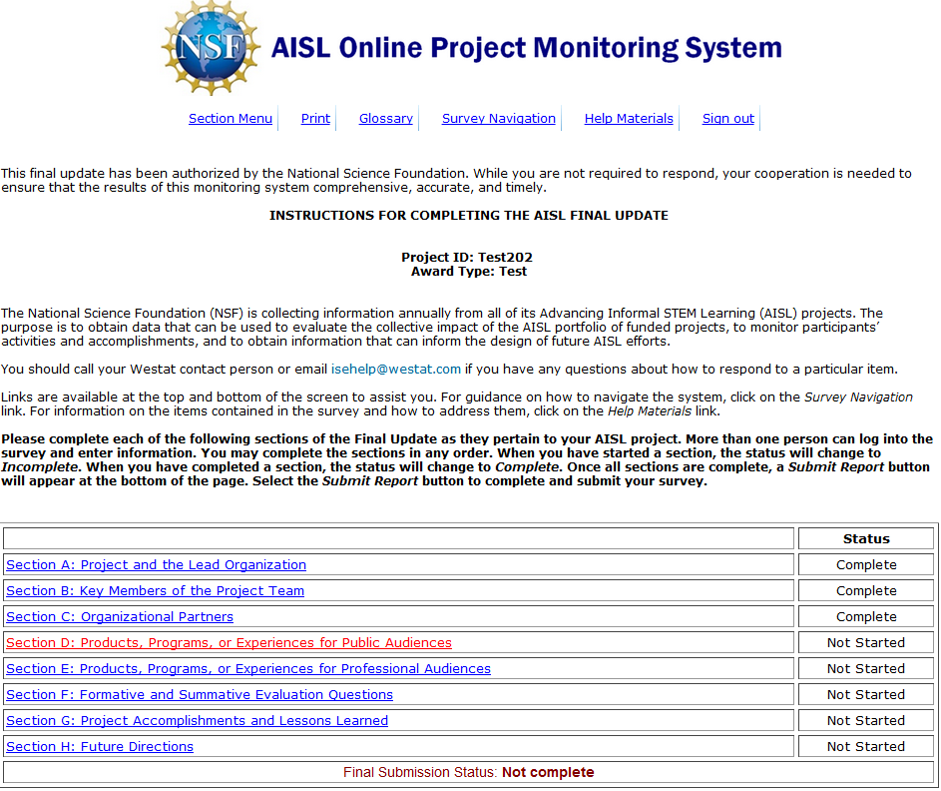

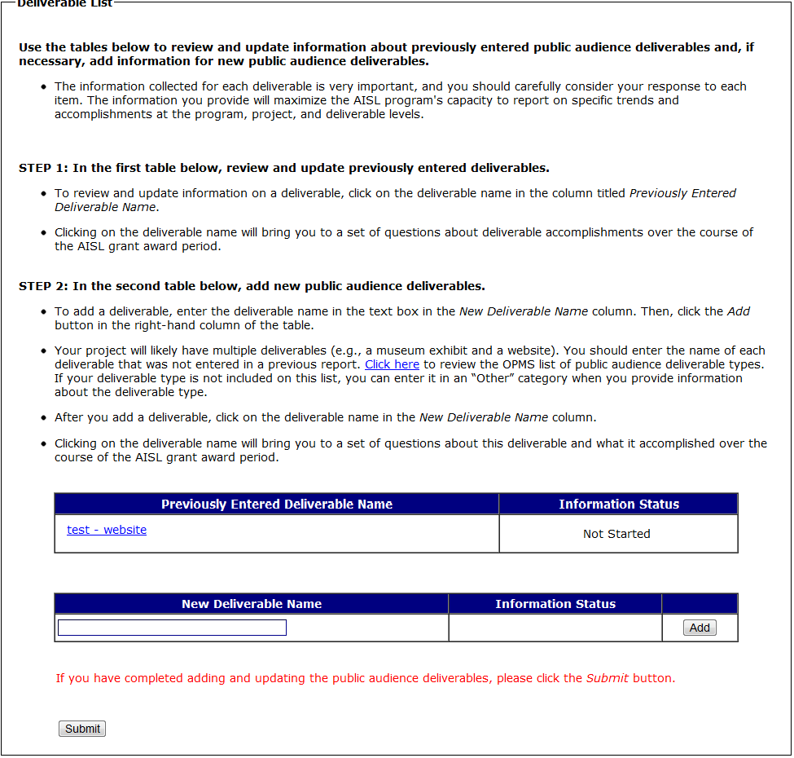
(SELECTING A DELIVERABLE IN THE “PREVIOUSLY ENTERED DELIVERABLE” TABLE WILL BRING YOU TO D2-D12D. D2- D12D ASK ABOUT DELIVERABLE ACTIVITIES OVER THE COURSE OF THE AISL GRANT.)
(SELECTING A DELIVERABLE IN THE “NEW DELIVERABLE” TABLE WILL BRING YOU TO D13-D25. D13-D25 ASK ABOUT DELIVERABLE ACTIVITIES OVER THE COURSE OF THE AISL GRANT.)

(SELECTING A DELIVERABLE IN THE “PREVIOUSLY ENTERED DELIVERABLE” TABLE WILL BRING YOU TO D2)
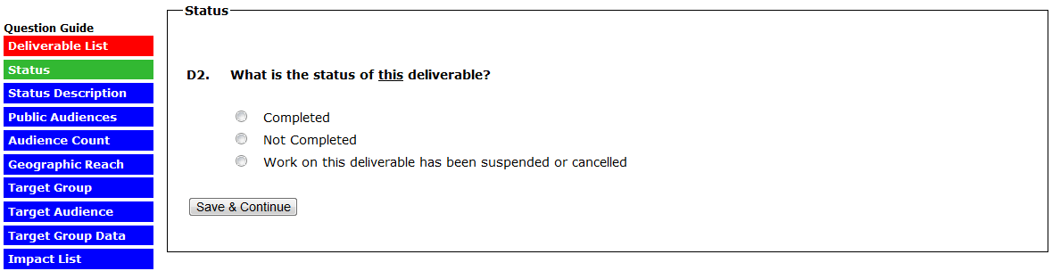
(IN D2, SELECTING “COMPLETE” SKIPS TO D2A)
(IN D2, SELECTING “NOT COMPLETE” SKIPS TO D2B)
(IN D2, SELECTING “WORK ON THE DELIVERABLE HAS BEEN SUSPENDED OR CANCELLED” SKIPS TO D2C)
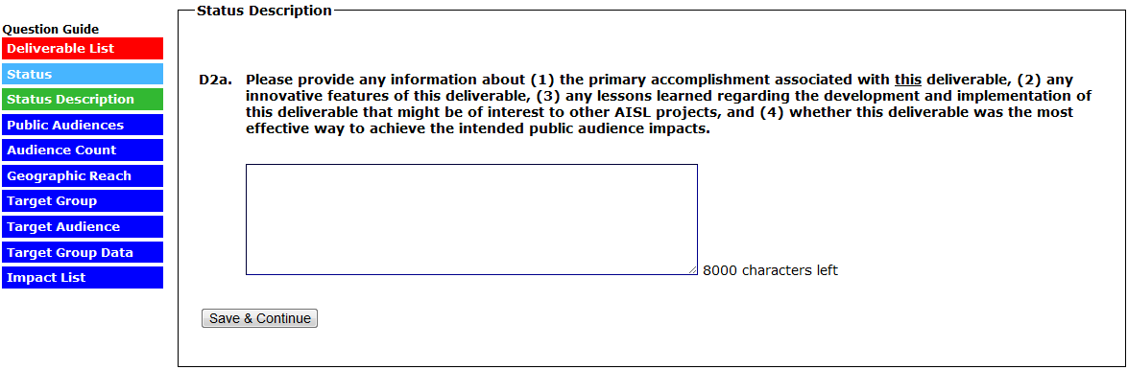
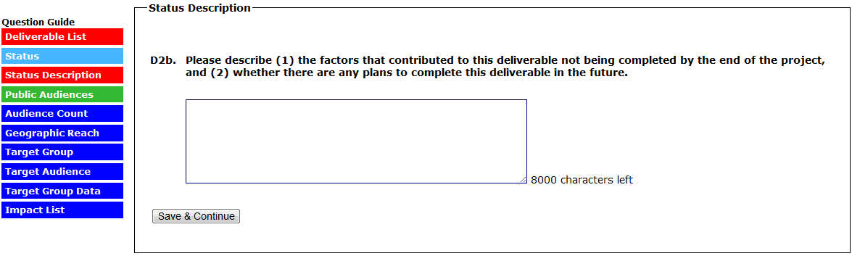
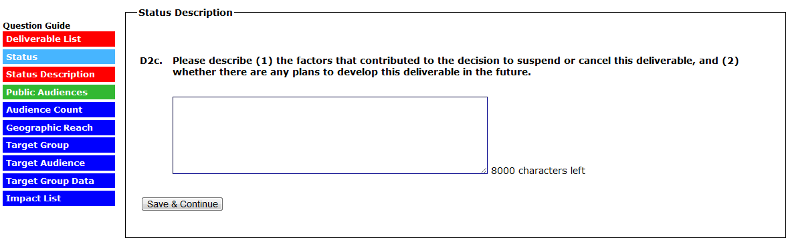
(SELECTING NO TO D3 SKIPS TO D9/IMPACT LIST)
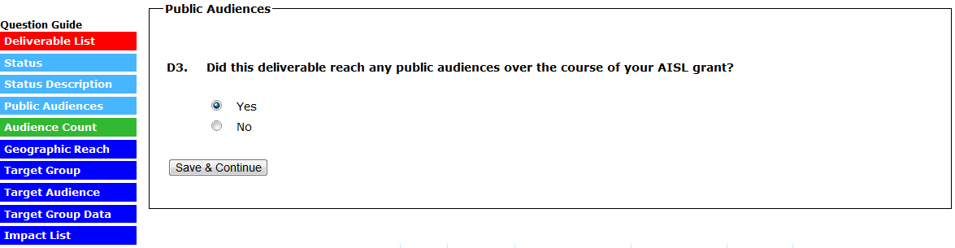
(THE VERSION OF D4 THAT APPEARS FOR “AUDIENCE COUNT” DEPENDS ON THE DELIVERABLE TYPE SELECTED WHEN THE DELIVERABLE WAS ADDED IN A PREVIOUS REPORT. ALTHOUGH ALL EIGHT D4 ITEMS ARE DISPLAYED BELOW, ONLY ONE OF THE D4 QUESTIONS IS ANSWERED FOR EACH DELIVERABLE.)
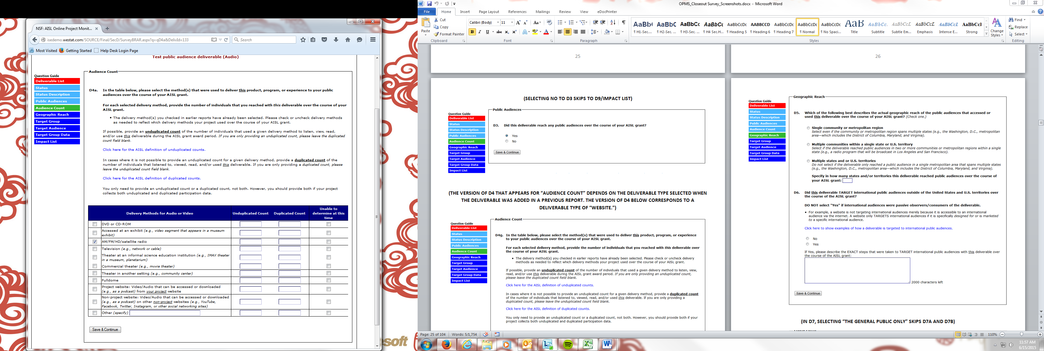

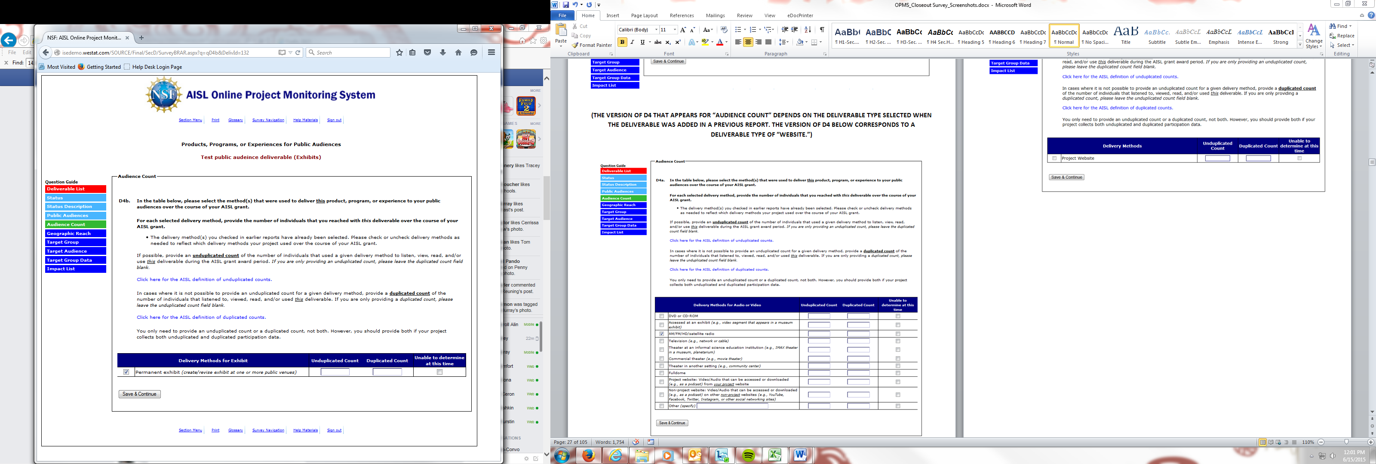
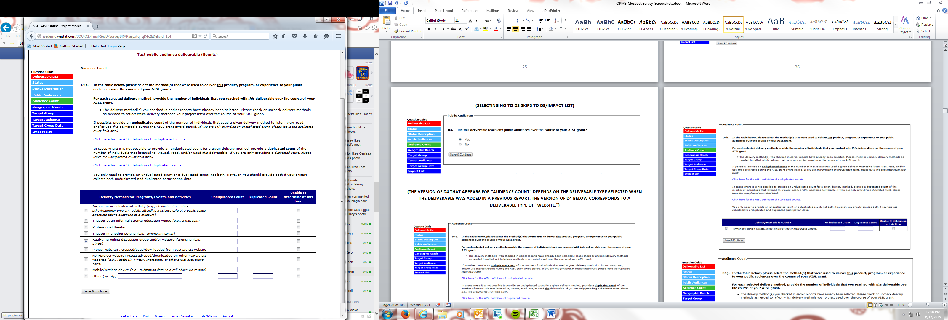

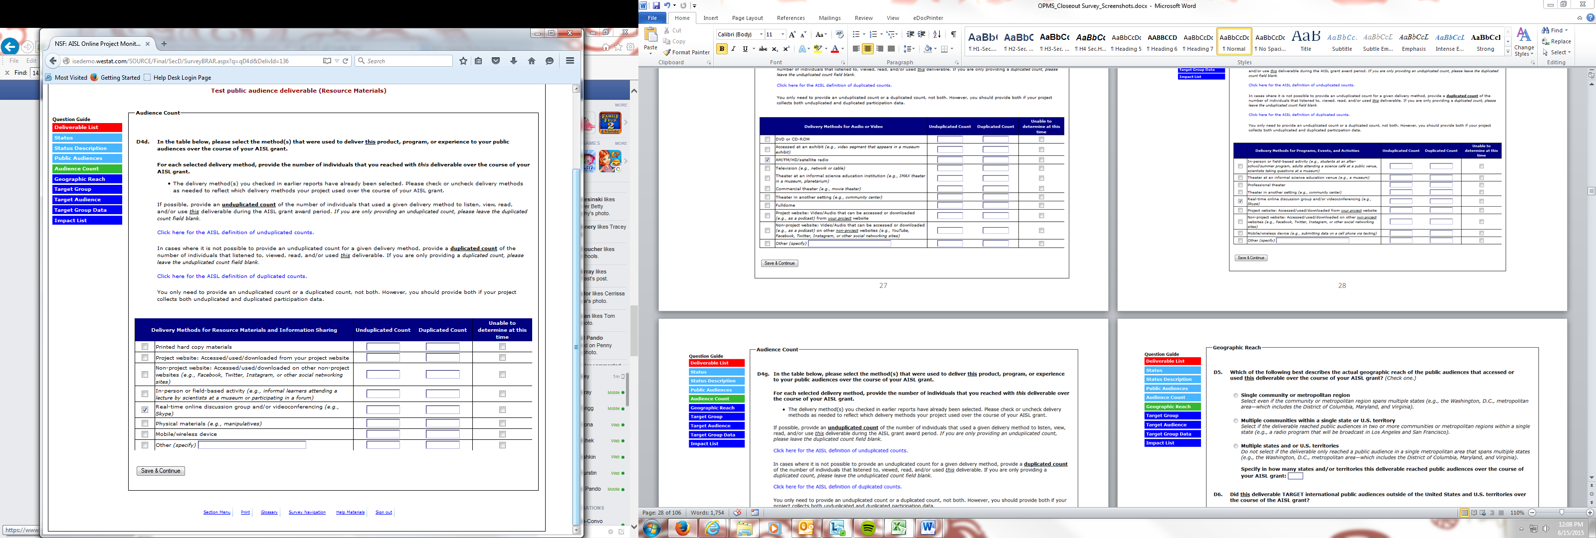
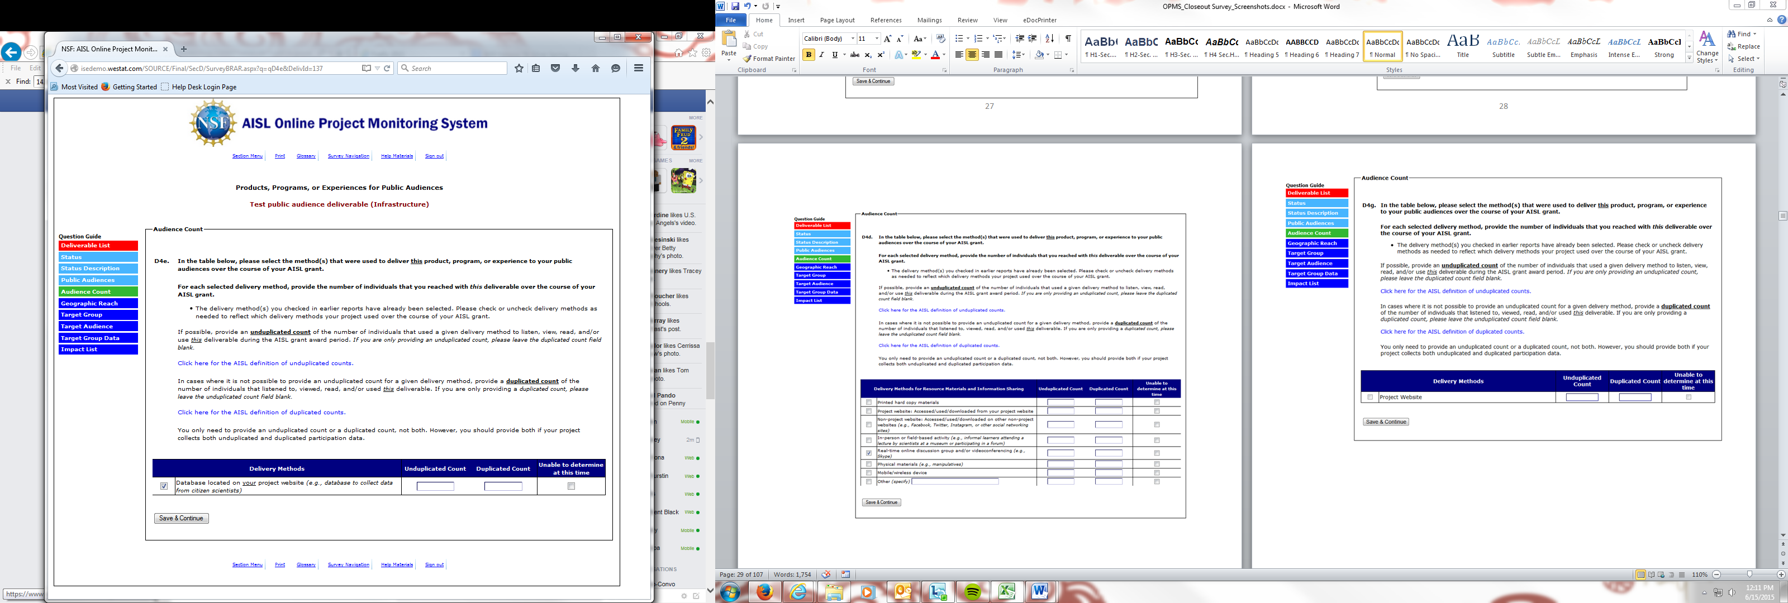

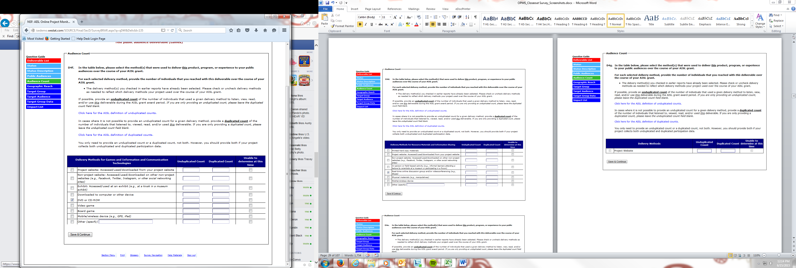
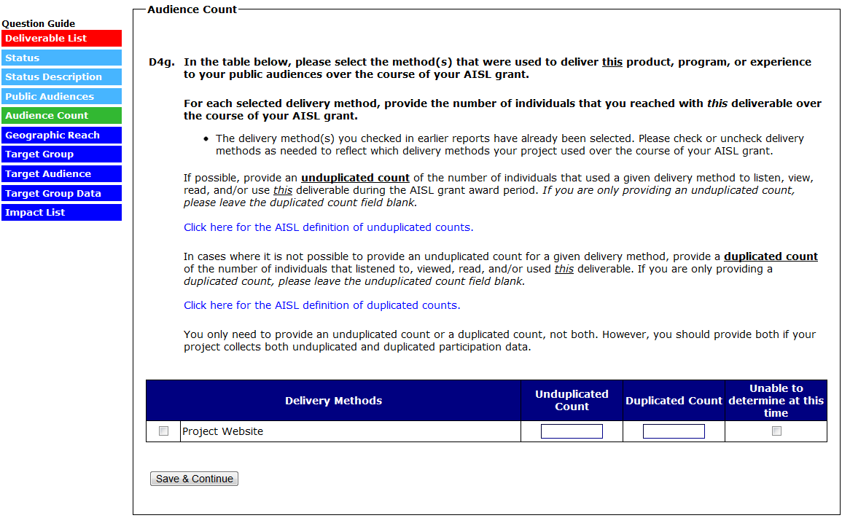

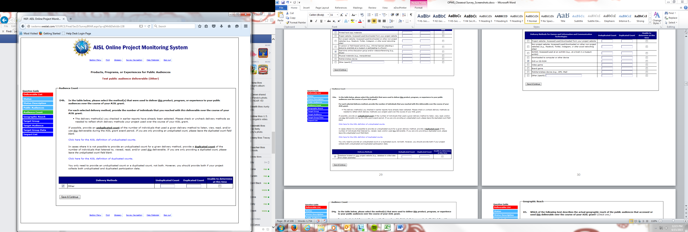

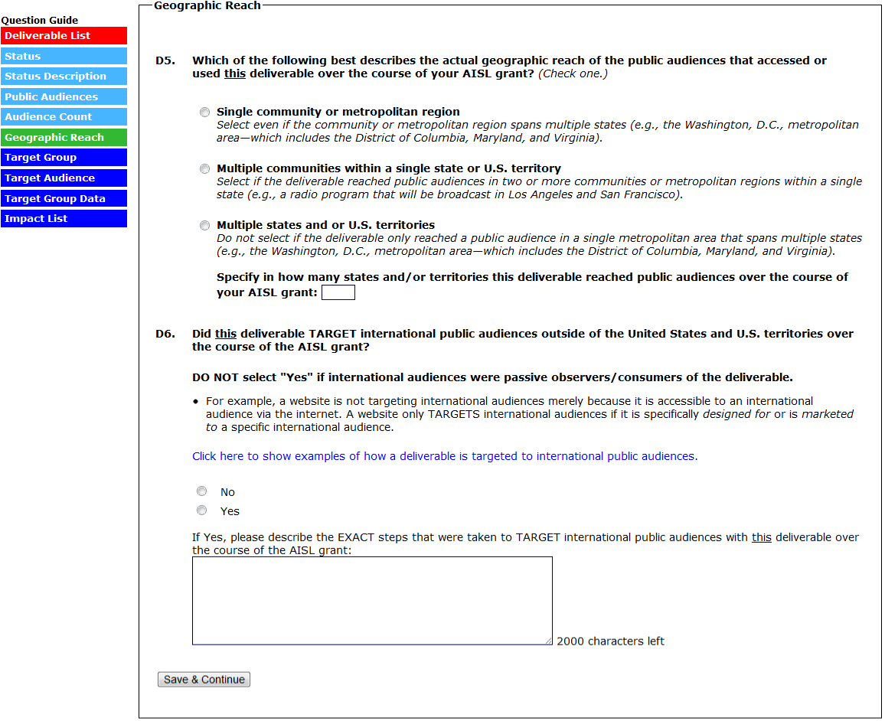
(IN D7, SELECTING “THE GENERAL PUBLIC ONLY” SKIPS D7A AND D7B)
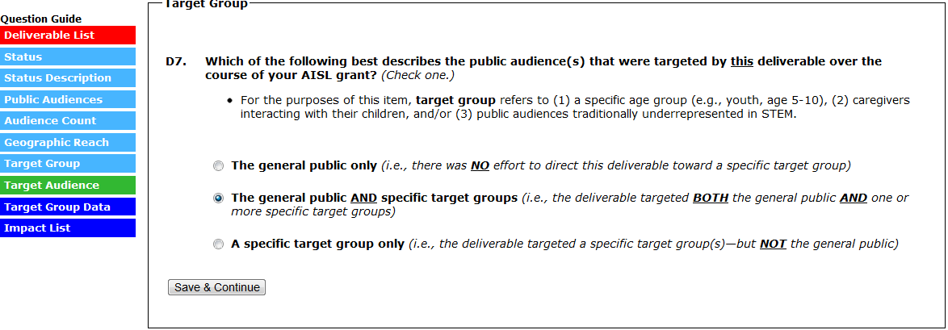

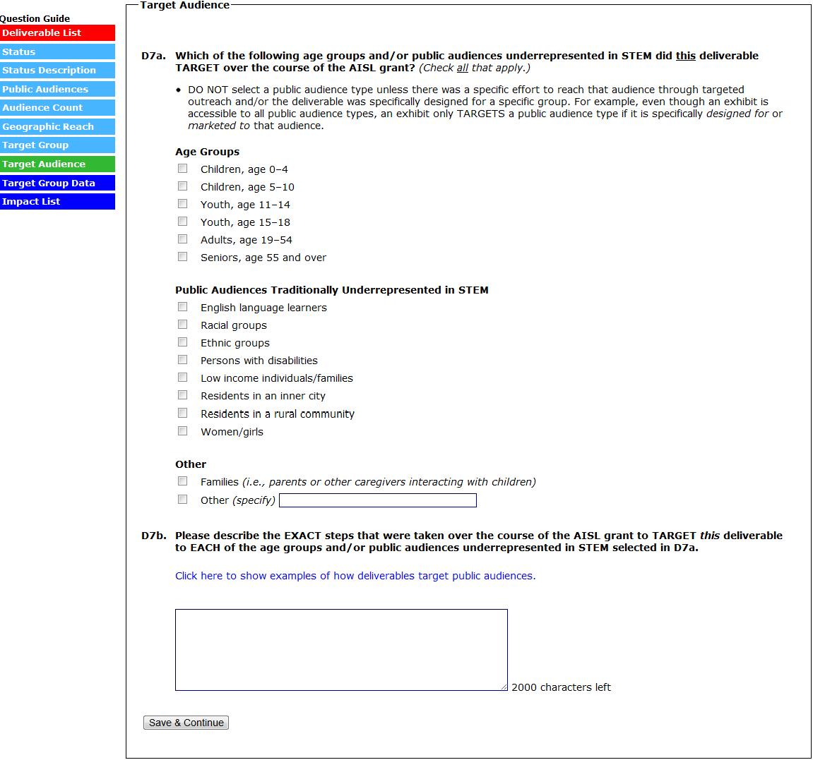
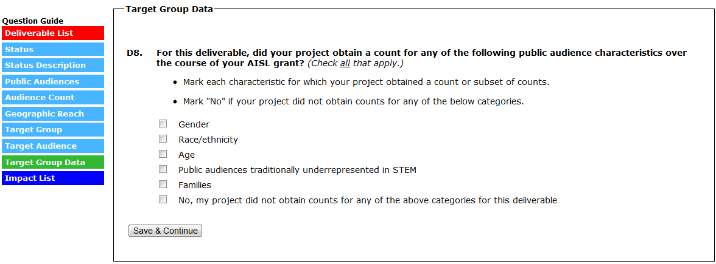
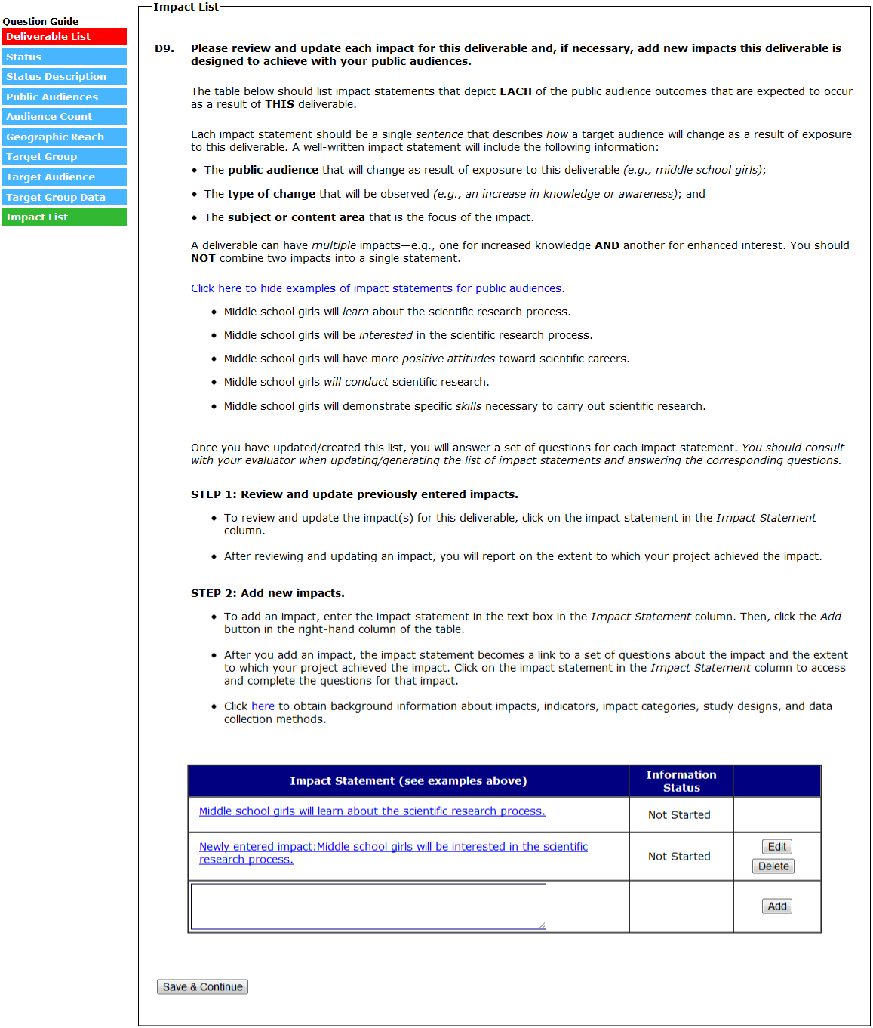
(D10A to D11A-E ARE COMPLETED/REVIEWED AND UPDATED FOR EACH IMPACT STATEMENT ENTERED IN A PREVIOUS REPORT. EACH IMPACT ENTERED IN A PREVIOUS REPORT WILL HAVE NO BUTTONS/OPTIONS IN THE FAR RIGHT COLUMN OF THE IMPACT TABLE.)
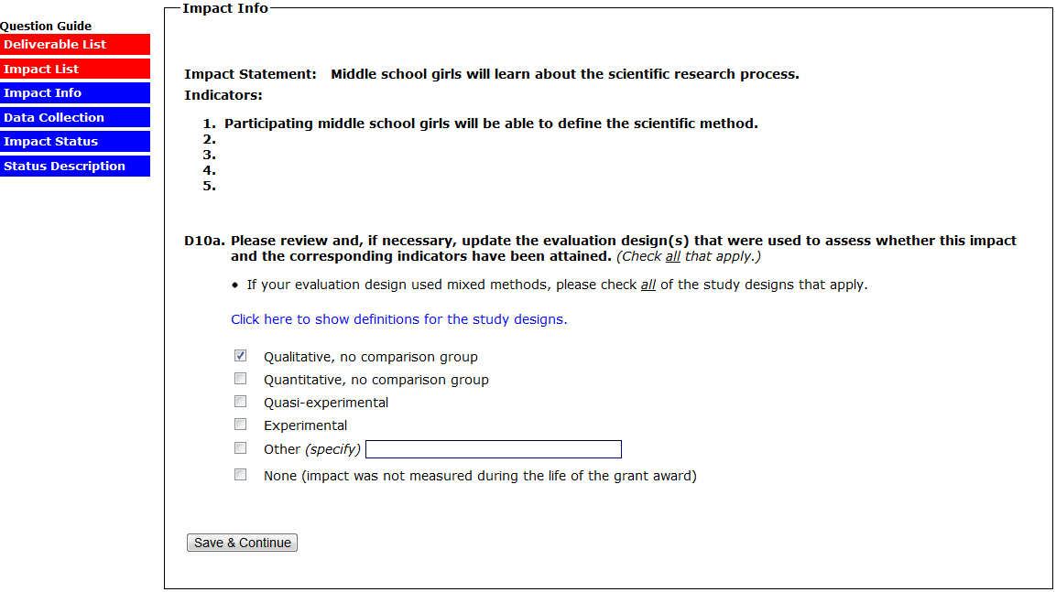
(SELECTING “NONE” TO 10A SKIPS D10B)
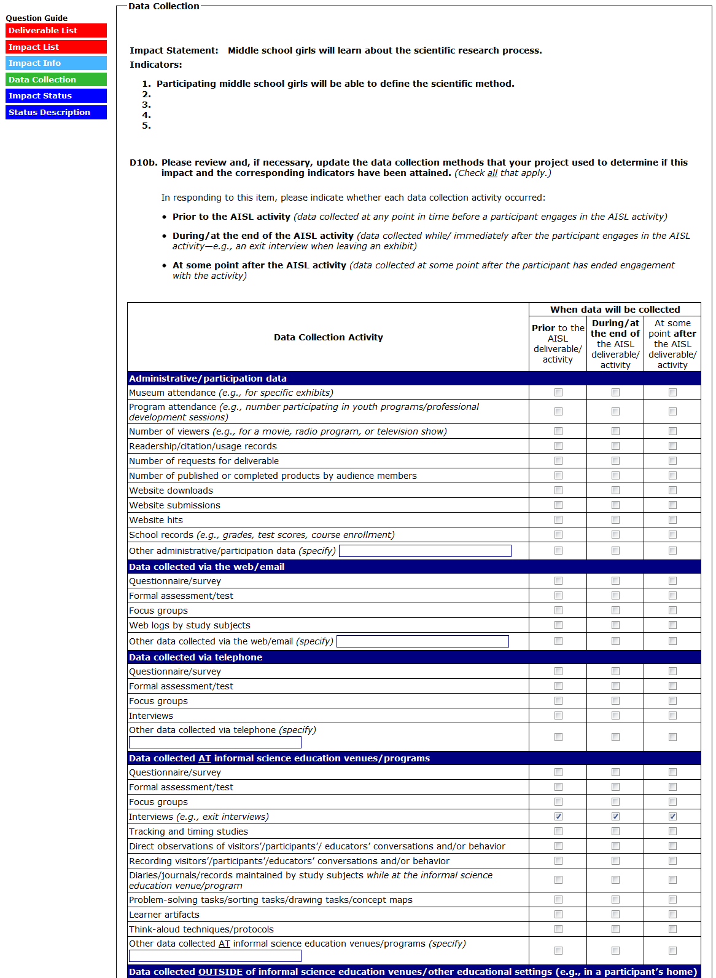
(CONTINUED ON NEXT PAGE)
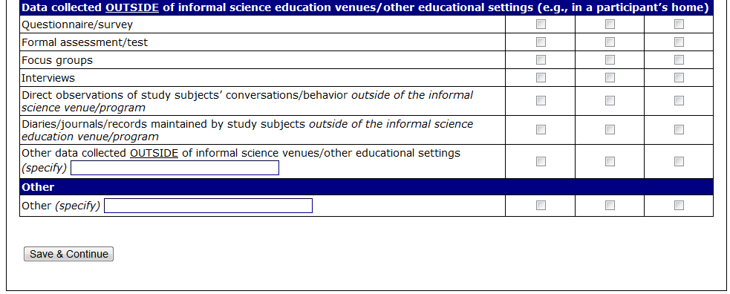
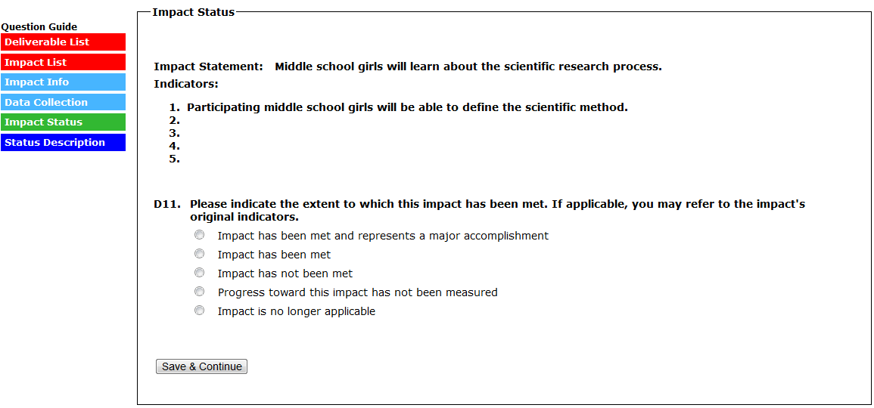
(IN D11, SELECTING “IMPACT HAS BEEN MET AND REPRESENTS A MAJOR ACCOMPLISHMENT” SKIPS TO D11A)
(IN D11, SELECTING “IMPACT HAS BEEN MET” SKIPS TO D11B)
(IN D11, SELECTING “IMPACT HAS NOT BEEN MET” SKIPS TO D11C)
(IN D11, SELECTING “PROGRESS TOWARD THIS IMPACT HAS NOT BEEN MEASURED” SKIPS TO D11D)
(IN D11, SELECTING “IMPACT IS NO LONGER APPLICABLE” SKIPS TO D11E)
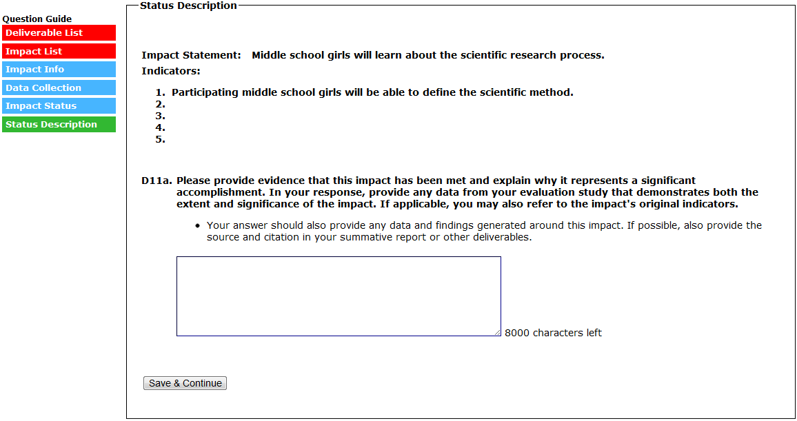
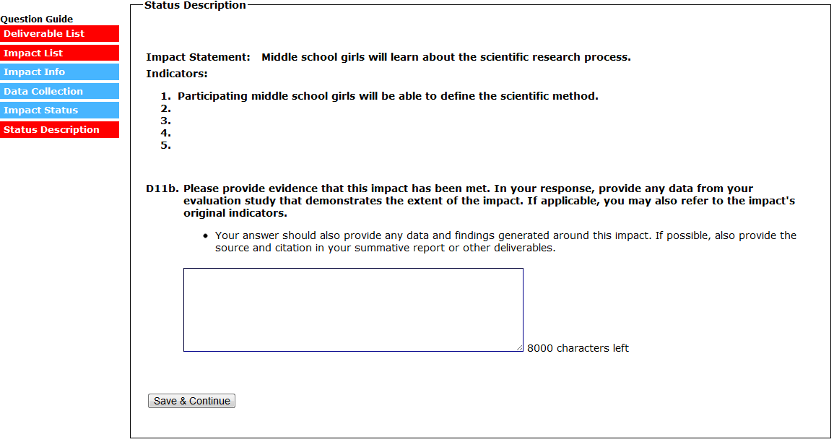
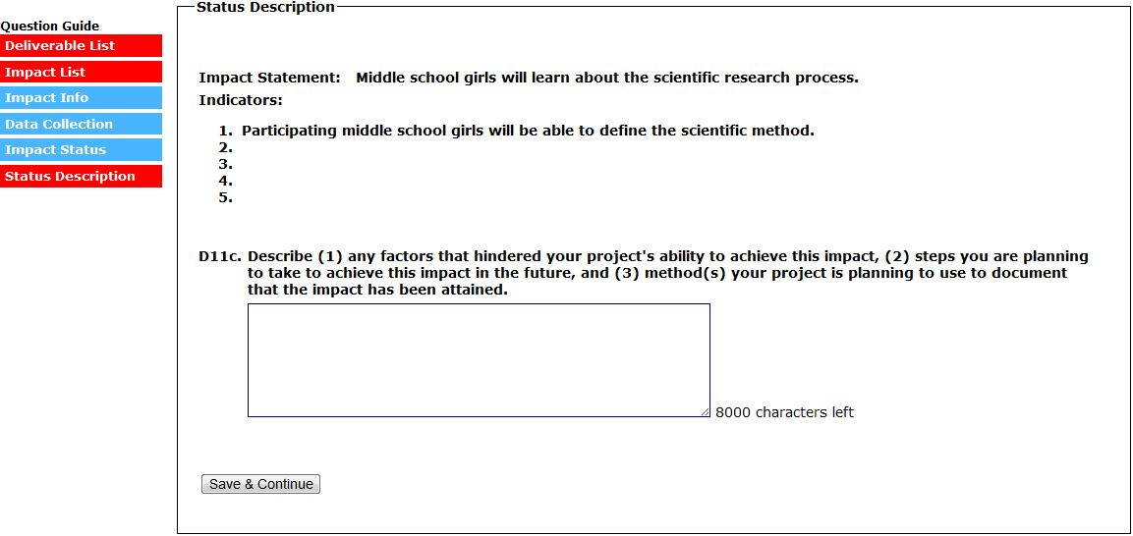

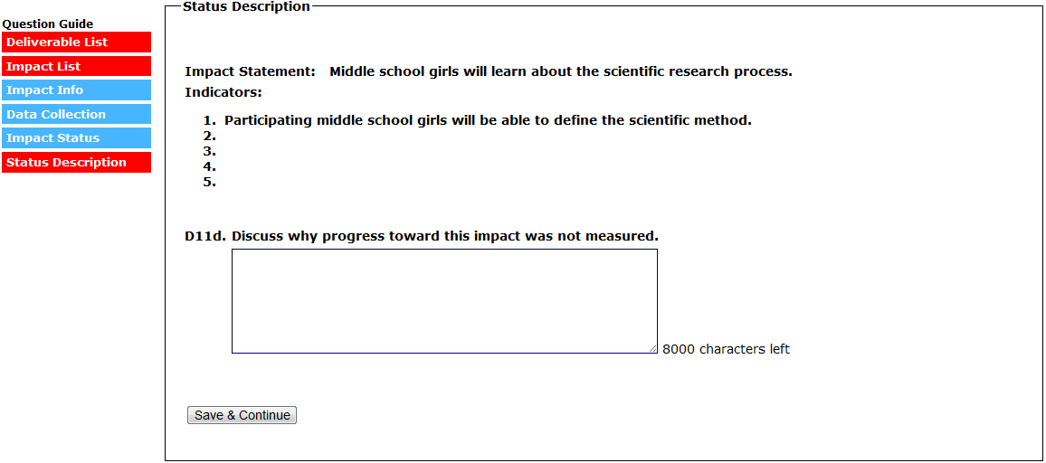
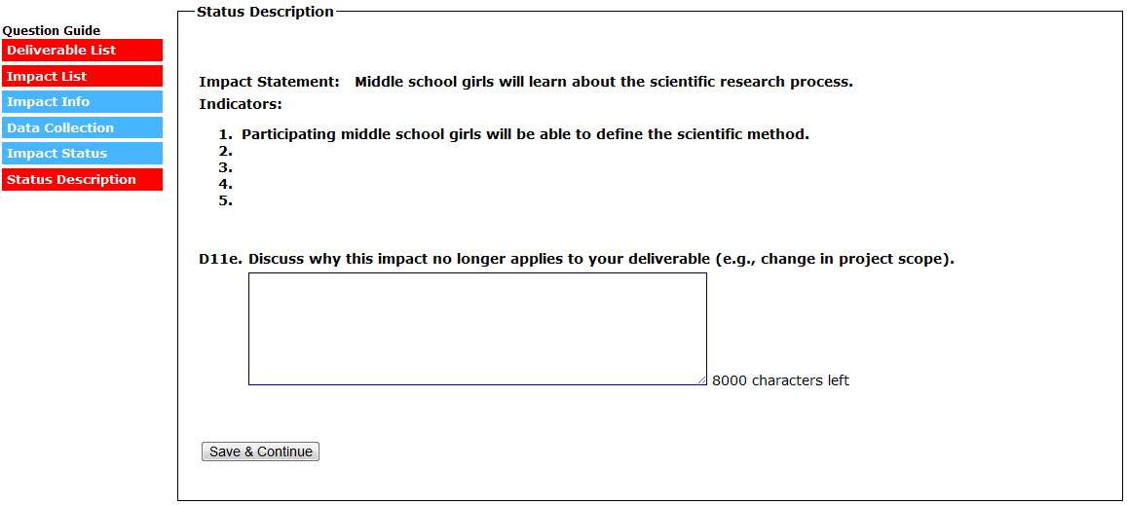
(SELECT “SAVE & CONTINUE” TO SUBMIT THE IMPACT AND RETURN TO THE IMPACT LIST)
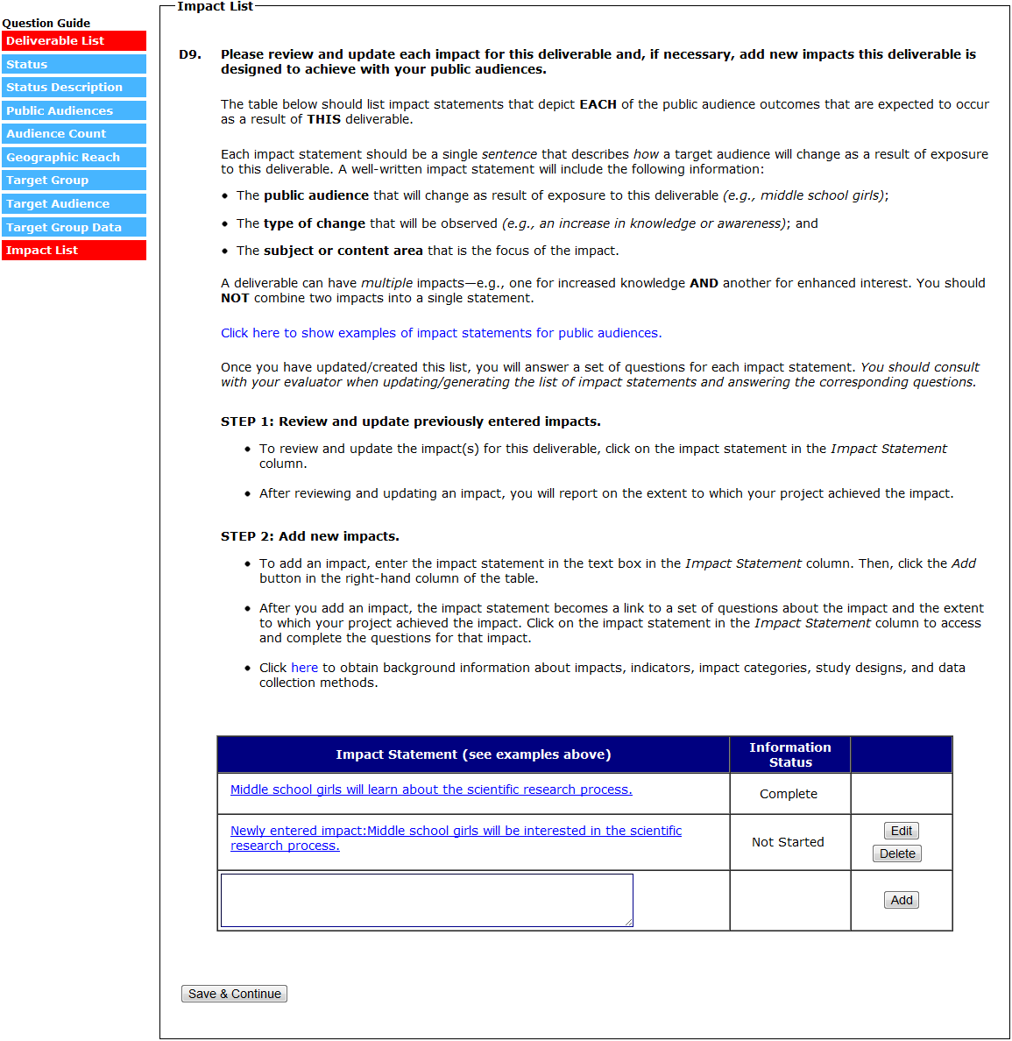
(D12A TO D11A-E ARE COMPLETED FOR EACH IMPACT STATEMENT ADDED IN THE CURRENT REPORT. EACH IMPACT ENTERED IN THE CURRENT REPORT WILL HAVE AN “EDIT” AND “DELETE” BUTTON IN THE FAR RIGHT COLUMN OF THE IMPACT TABLE.)

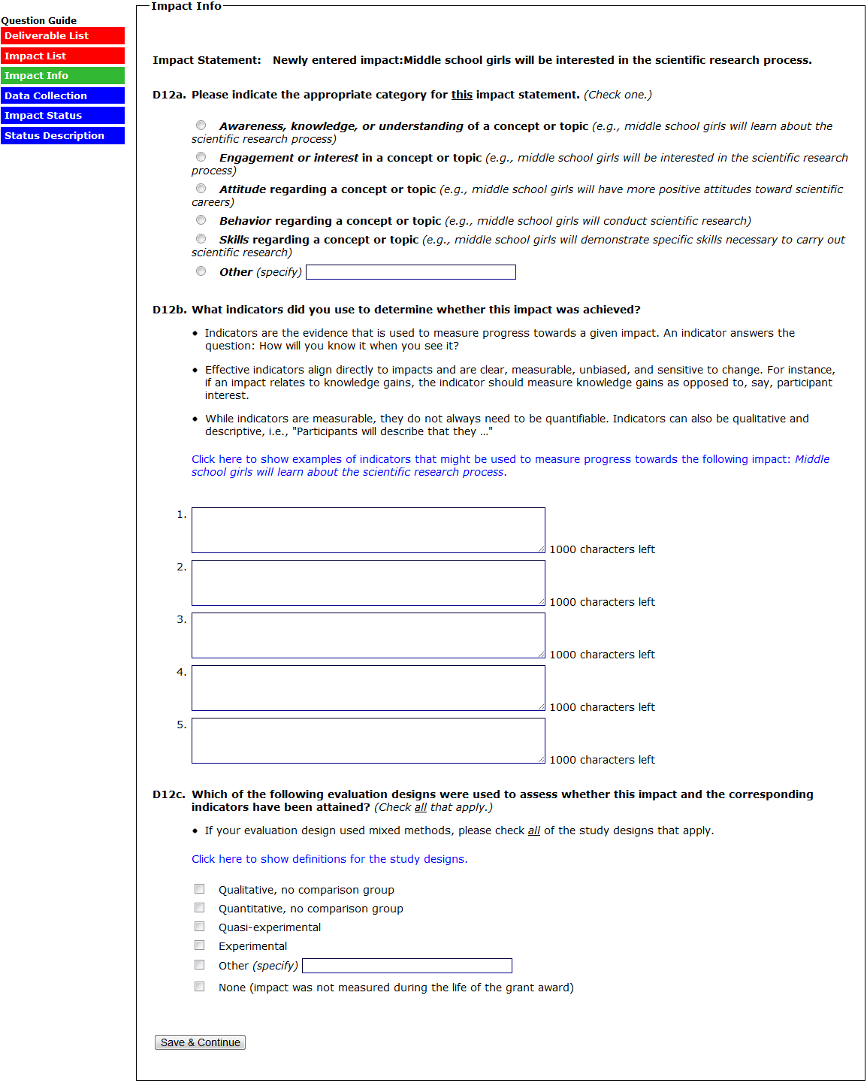
(SELECTING “NONE” TO 12C SKIPS D10D)
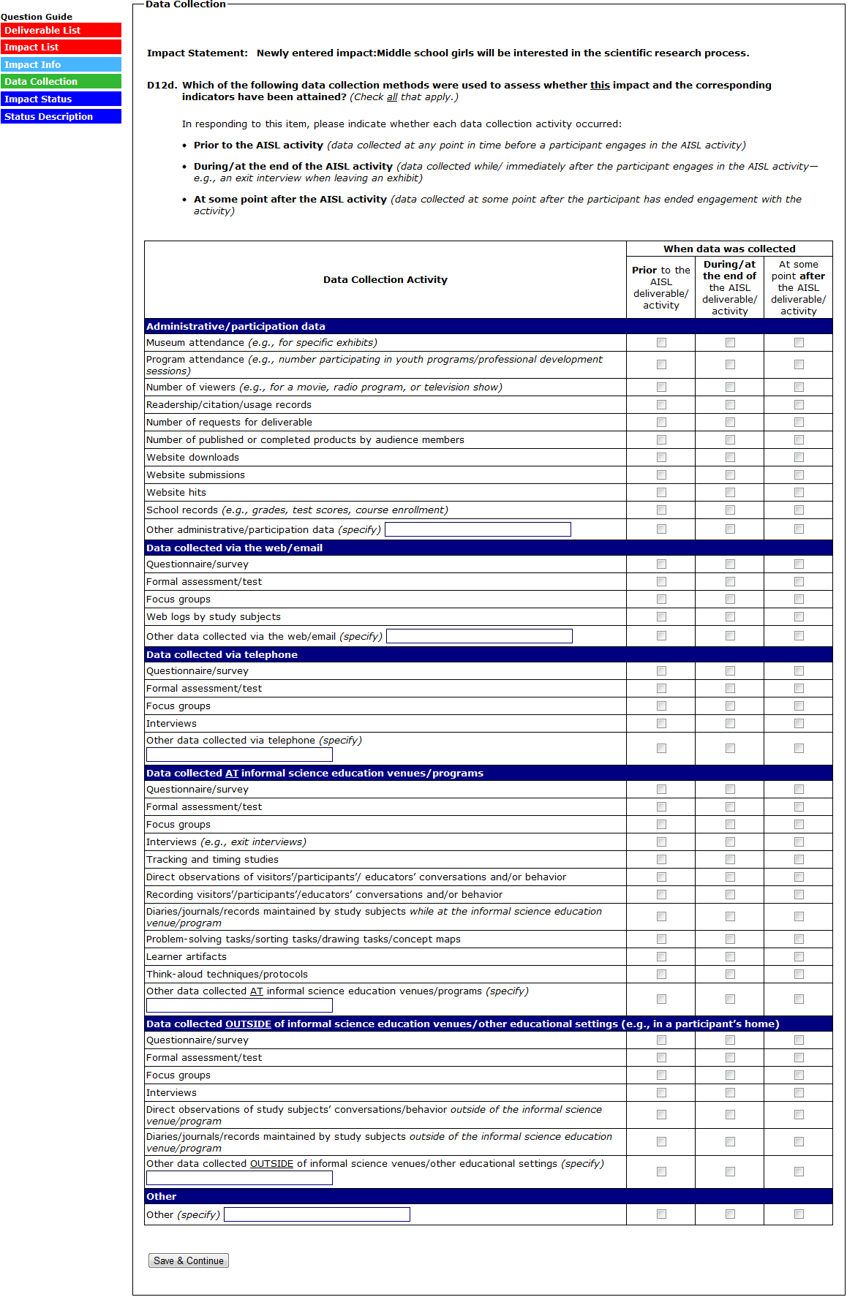
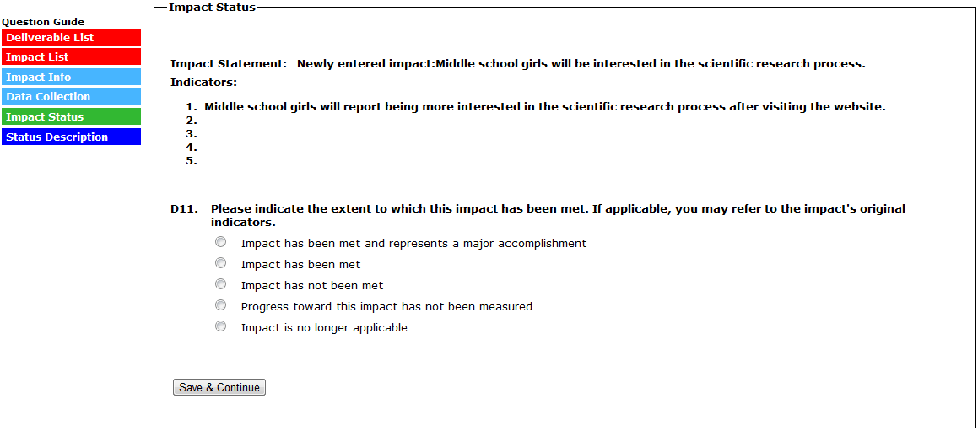
(IN D11, SELECTING “IMPACT HAS BEEN MET AND REPRESENTS A MAJOR ACCOMPLISHMENT” SKIPS TO D11A)
(IN D11, SELECTING “IMPACT HAS BEEN MET” SKIPS TO D11B)
(IN D11, SELECTING “IMPACT HAS NOT BEEN MET” SKIPS TO D11C)
(IN D11, SELECTING “PROGRESS TOWARD THIS IMPACT HAS NOT BEEN MEASURED” SKIPS TO D11D)
(IN D11, SELECTING “IMPACT IS NO LONGER APPLICABLE” SKIPS TO D11E)
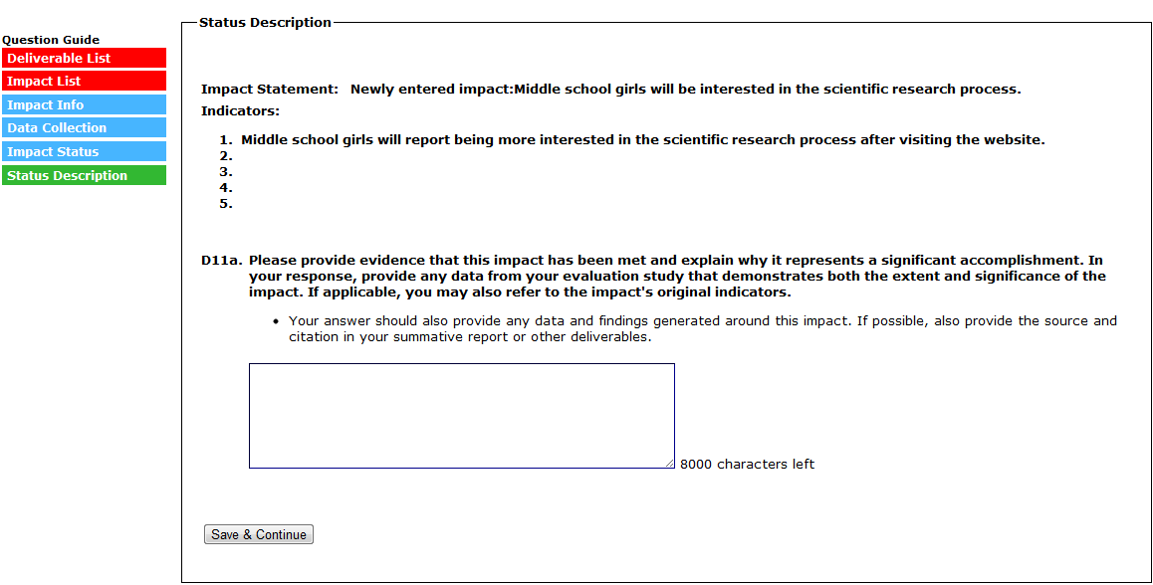
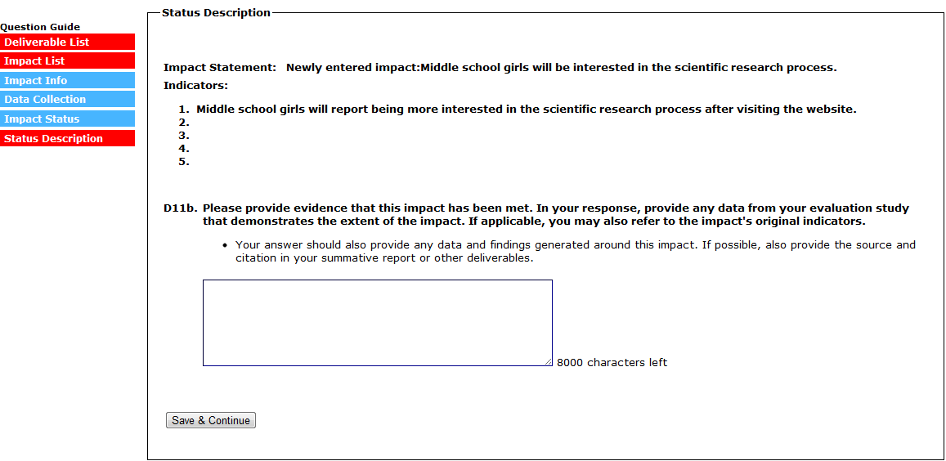
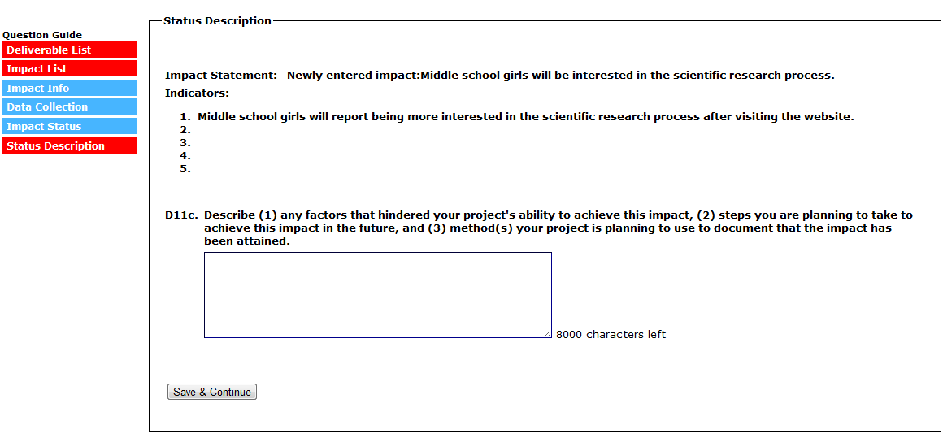
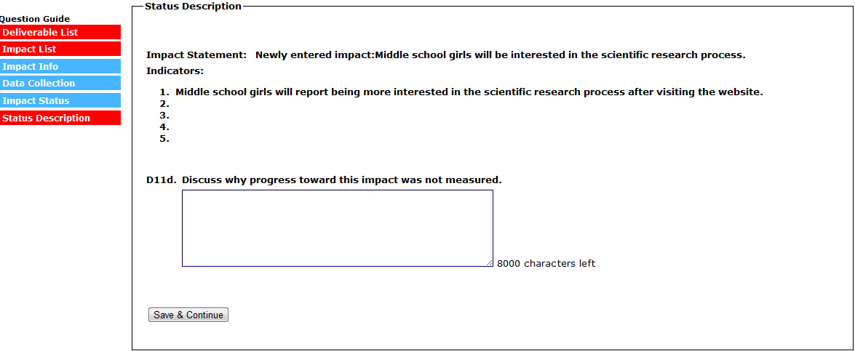
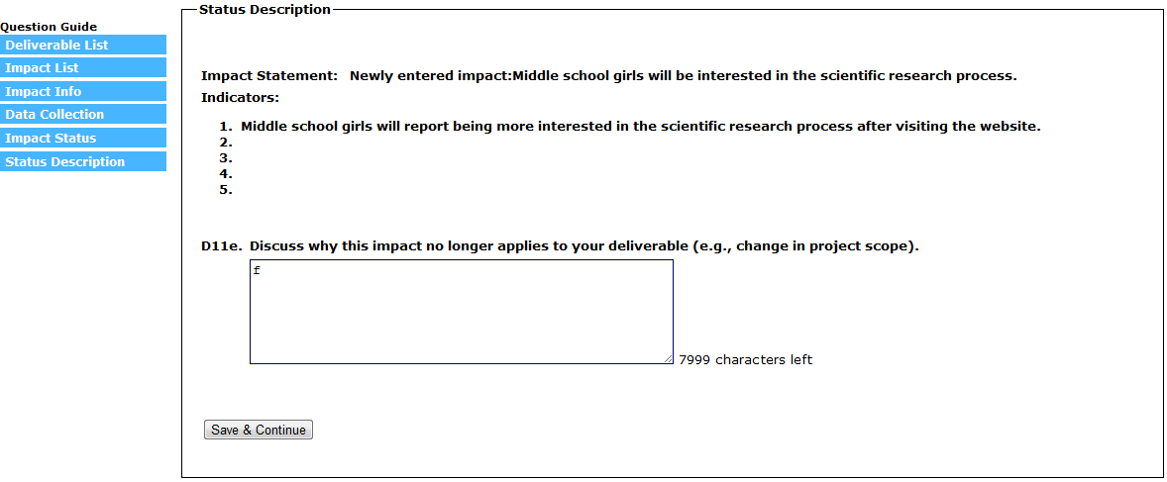
(SELECT “SAVE & CONTINUE” TO SUBMIT THE IMPACT AND RETURN TO THE IMPACT LIST)
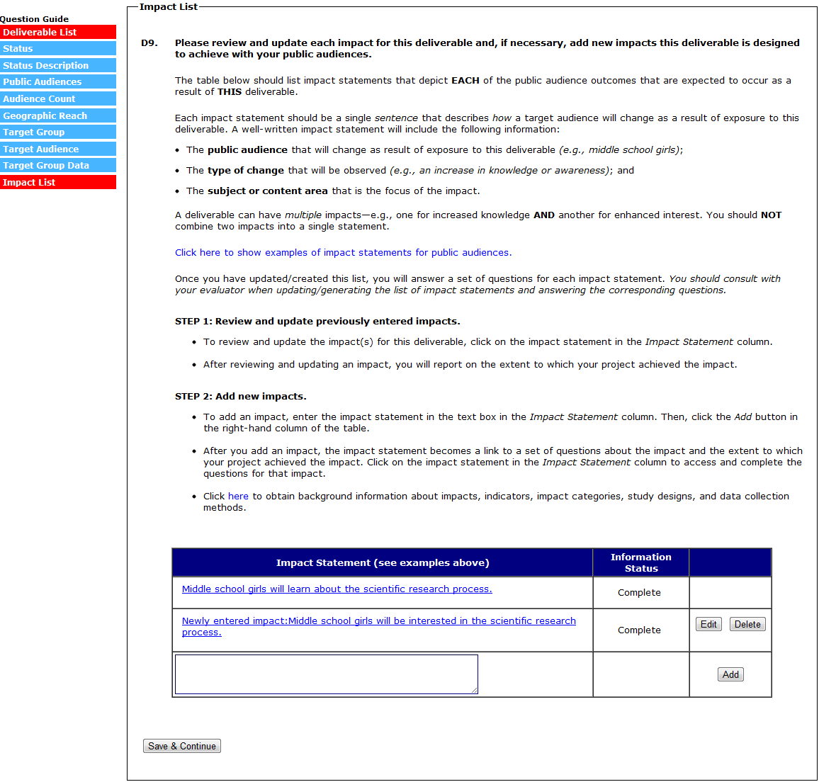
(SELECT “SAVE AND CONTINUE” TO SUBMIT THE DELIVERABLE AND RETURN TO THE DELIVERABLE LIST)
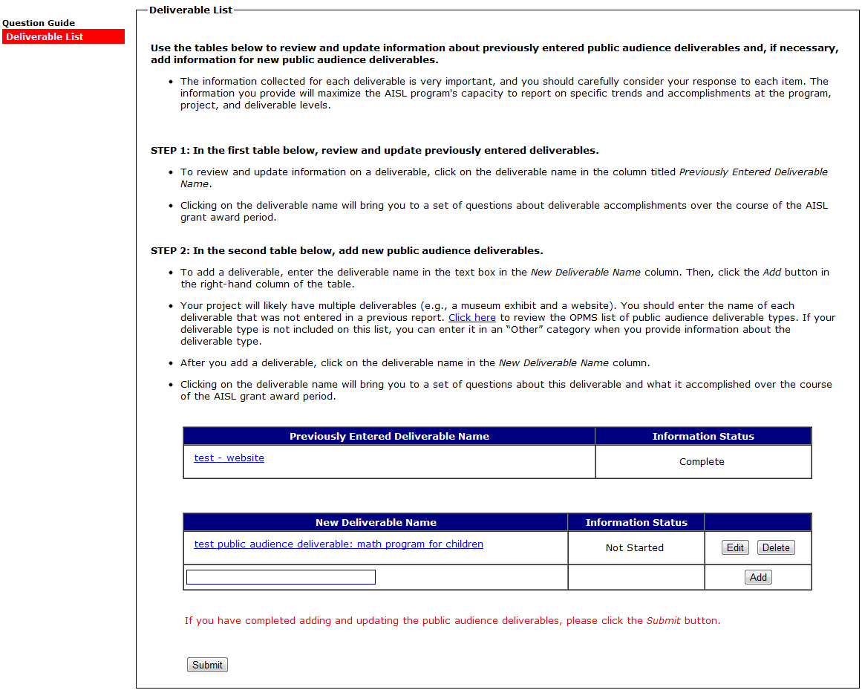
(SELECTING A DELIVERABLE IN THE “NEW DELIVERABLE” TABLE WILL BRING YOU TO D13-D25. D13-D25 ARE QUESTIONS ABOUT WHAT THE DELIVERABLE ACCOMPLISHED OVER THE COURSE OF THE GRANT.)

(SELECTING A DELIVERABLE IN THE “NEW DELIVERABLE” TABLE WILL BRING YOU TO D13)
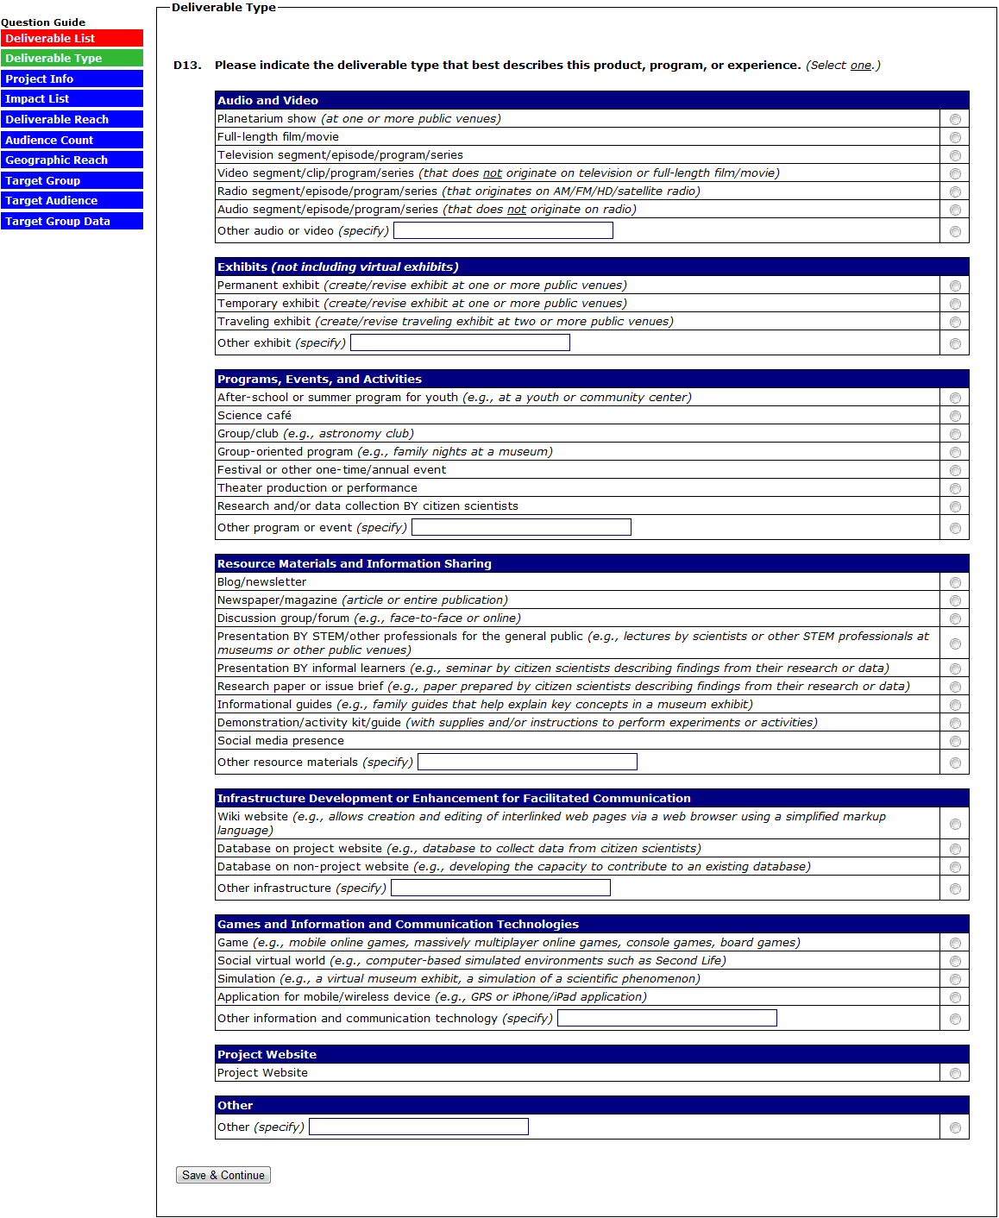
(D13A IS ONLY ANSWERED IF THE DELIVERABLE TYPE SELECTED IN D13 IS “WEBSITE”)
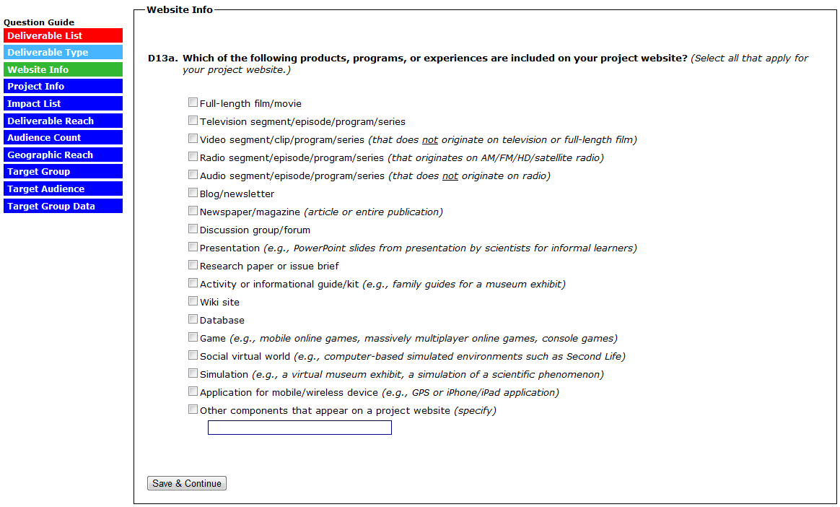

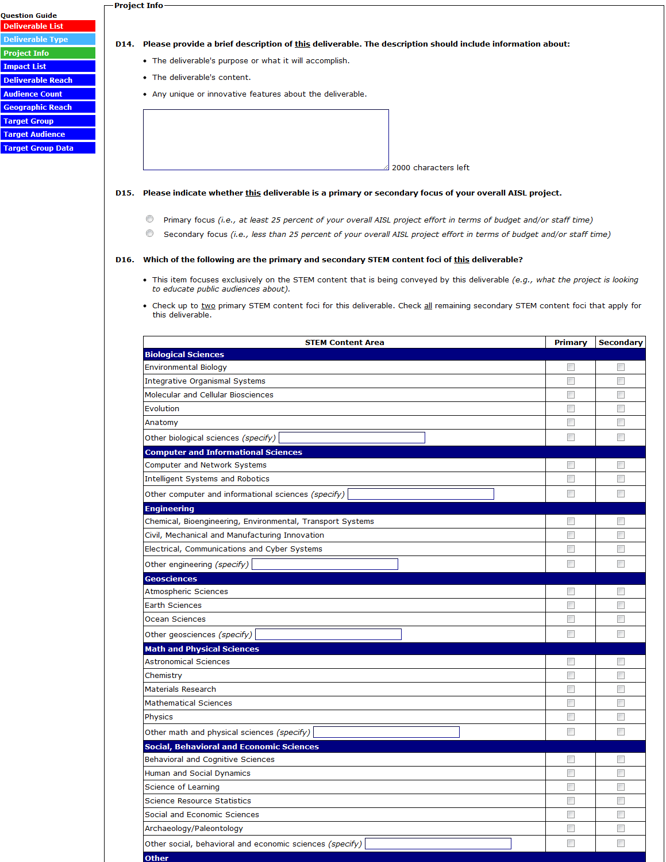
(CONTINUED ON NEXT PAGE)
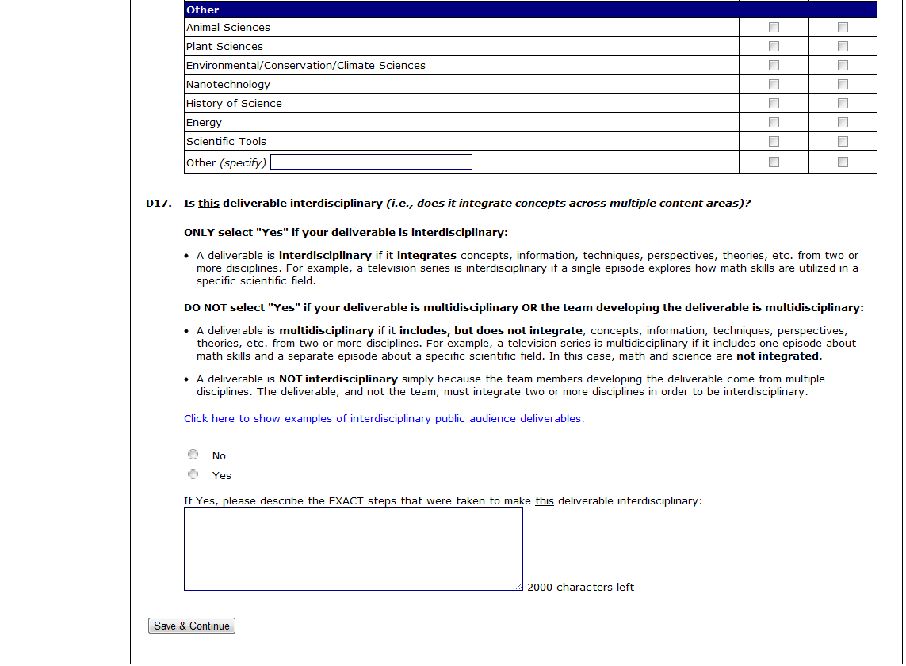

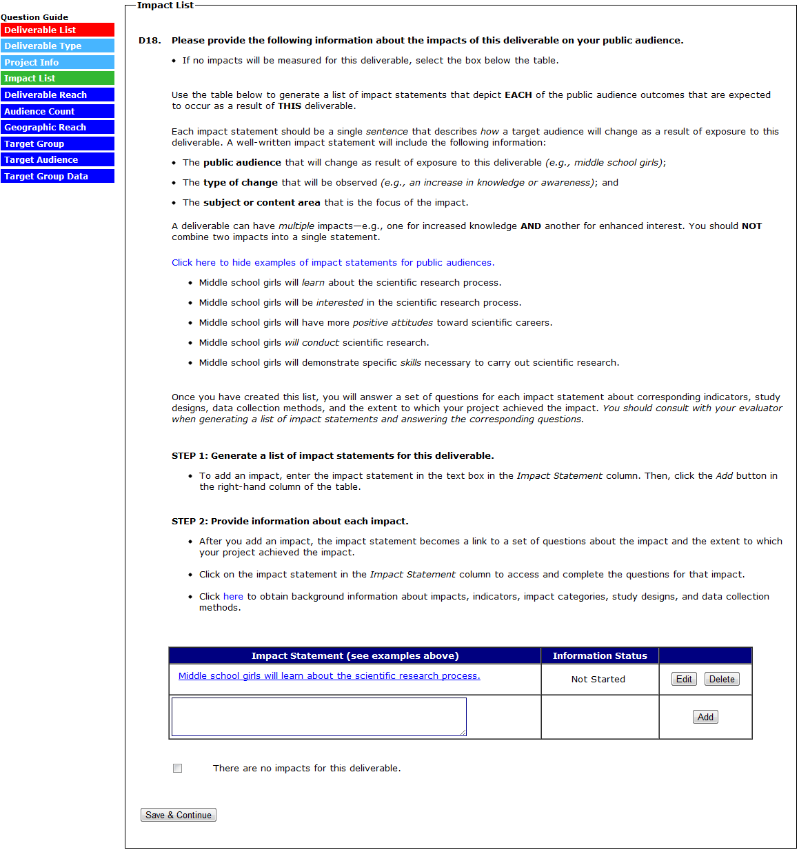
(SELECTING “THERE ARE NO IMPACTS FOR THIS DELIVERABLE” (OPTION AVAILABLE ONLY FOR DELIVERABLES MARKED “SECONDARY FOCUS” IN D15) WILL SKIP TO D20. FOR EACH IMPACT STATEMENT ENTERED INTO THE TABLE, ANSWER D18A TO D19A-E)

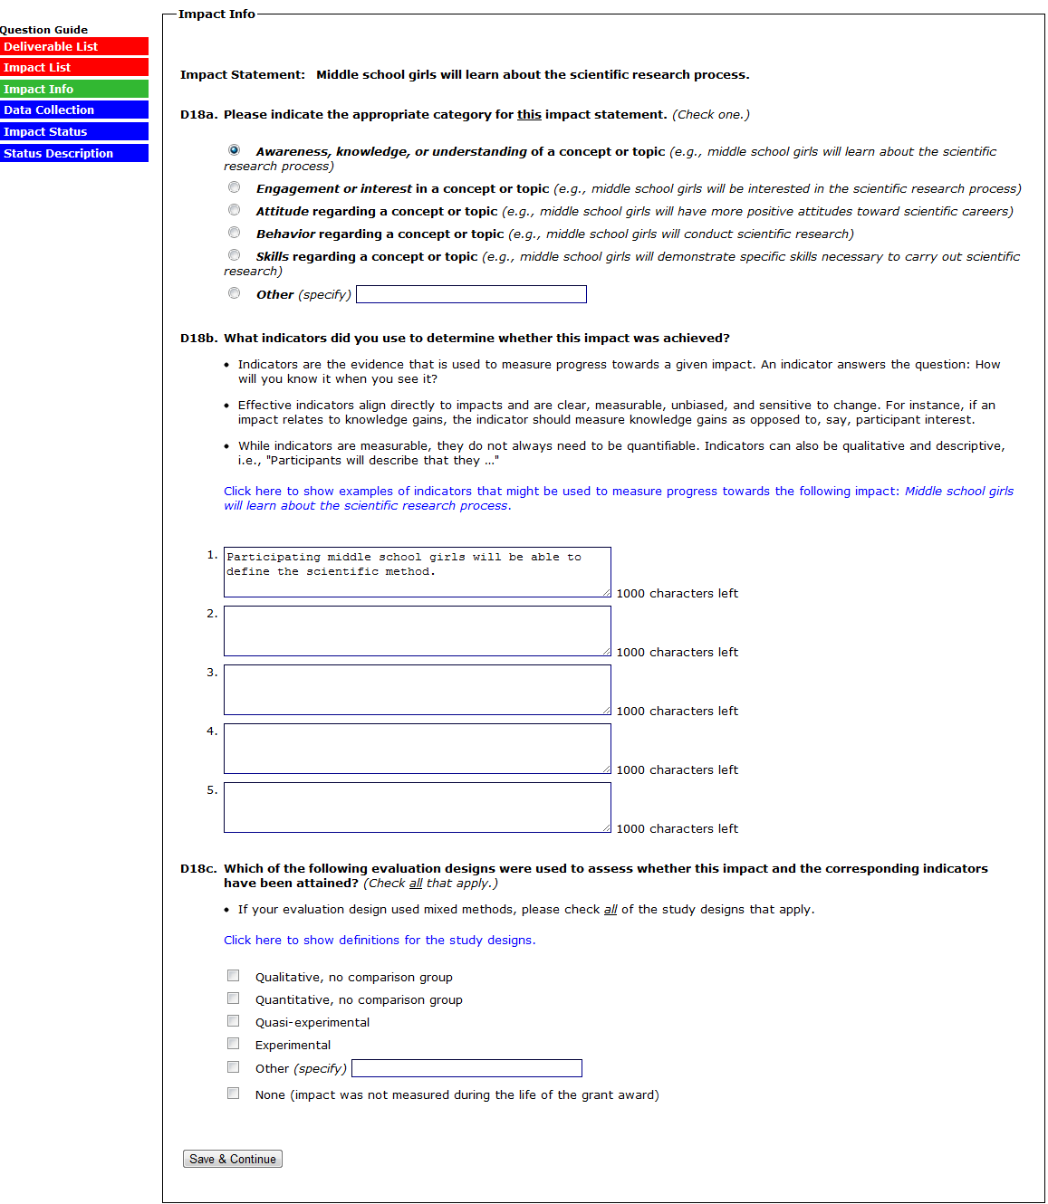
(SELECTING “NONE” TO D18C SKIPS D18D)

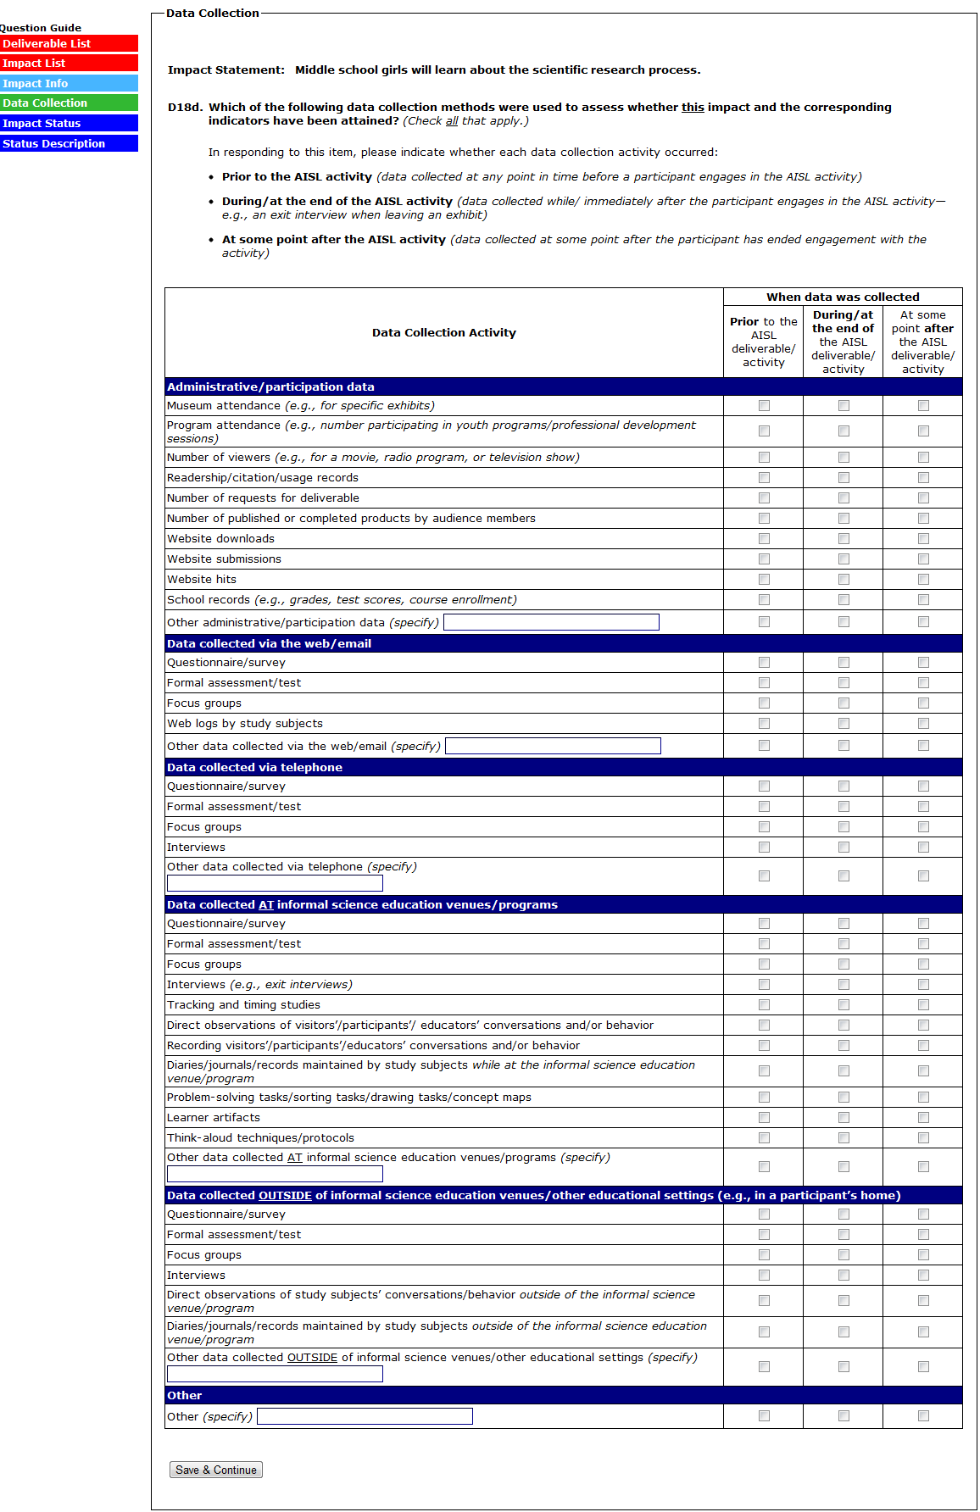
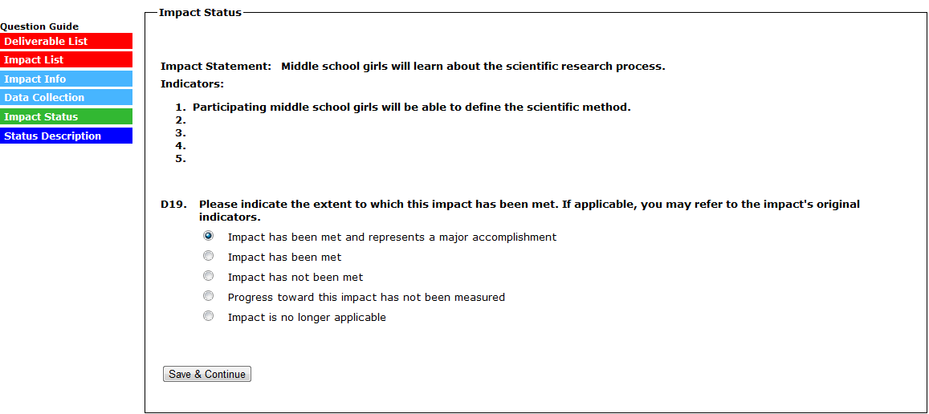
(IN D19, SELECTING “IMPACT HAS BEEN MET AND REPRESENTS A MAJOR ACCOMPLISHMENT” SKIPS TO D19A)
(IN D19, SELECTING “IMPACT HAS BEEN MET” SKIPS TO D19B)
(IN D19, SELECTING “IMPACT HAS NOT BEEN MET” SKIPS TO D19C)
(IN D19, SELECTING “PROGRESS TOWARD THIS IMPACT HAS NOT BEEN MEASURED” SKIPS TO D19D)
(IN D19, SELECTING “IMPACT IS NO LONGER APPLICABLE” SKIPS TO D19E)
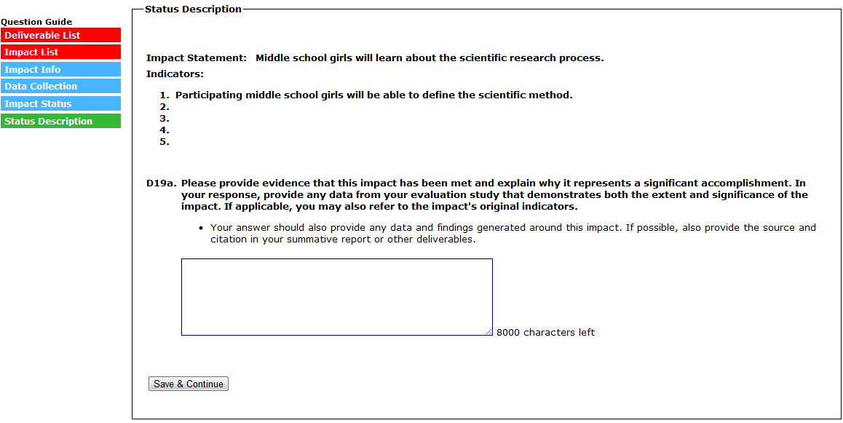
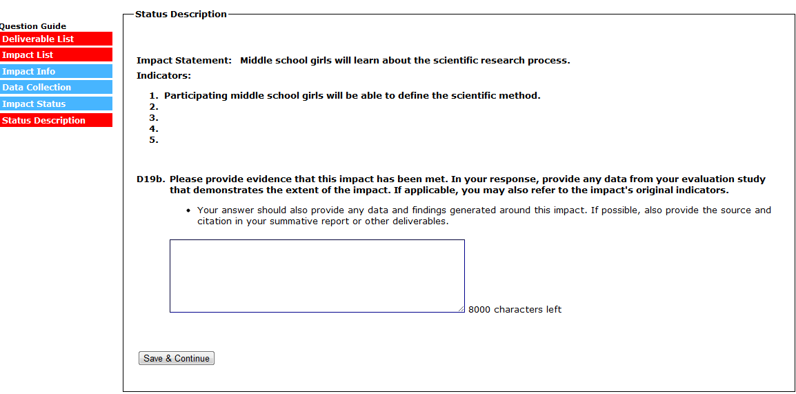
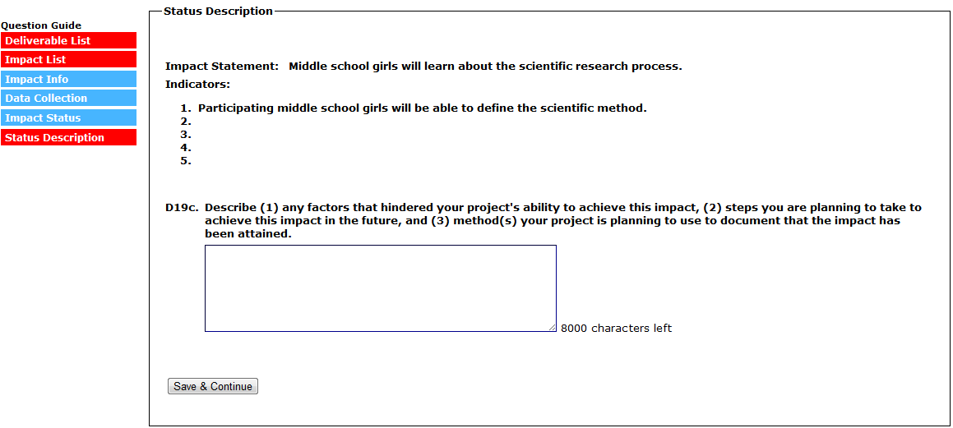
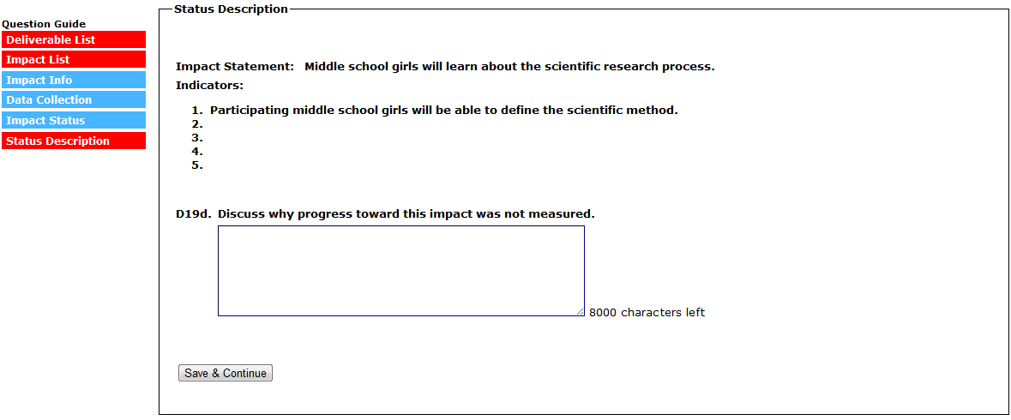
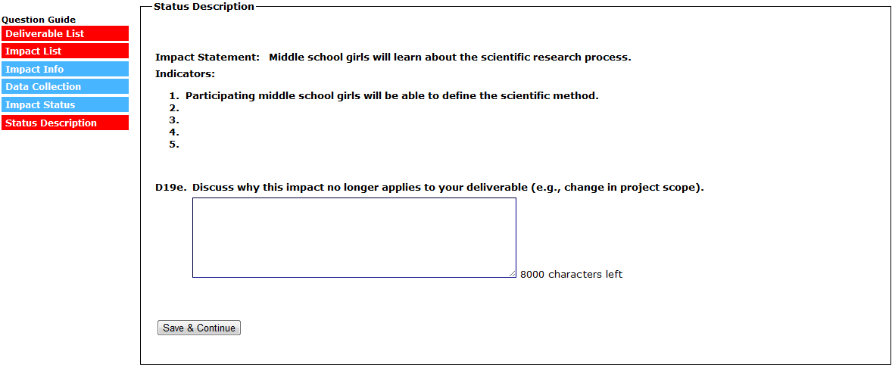
(SELECTING “SAVE & CONTINUE” RETURNS YOU TO THE IMPACT LIST)
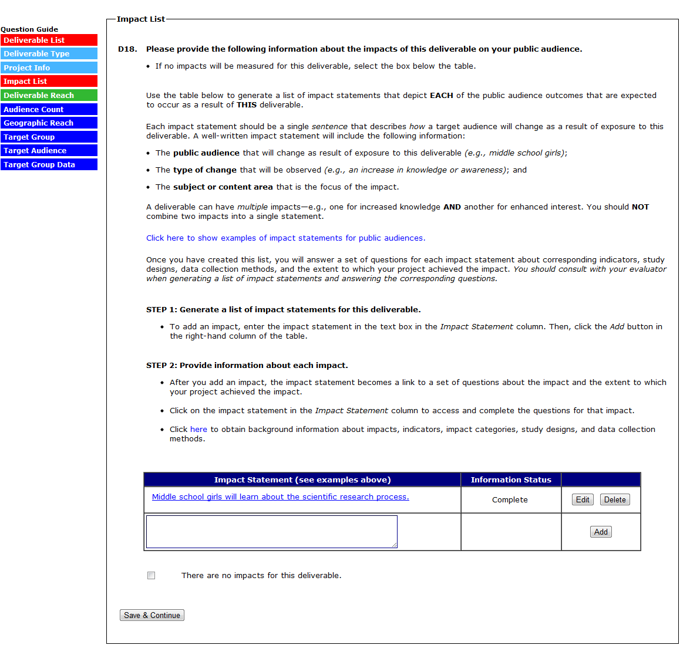
(SELECTING “NO” TO D20 SKIPS THE REMAINING QUESTIONS, SUBMITS THE DELIVERABLE, AND RETURNS YOU TO THE DELIVERABLE LIST)
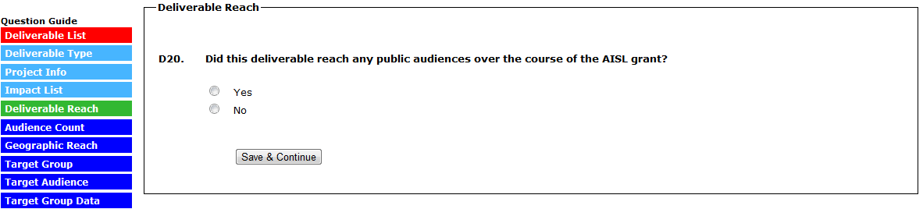
(THE VERSION OF D21 THAT APPEARS FOR “AUDIENCE COUNT” DEPENDS ON THE DELIVERABLE TYPE SELECTED IN D13. THE VERSION OF D13 BELOW CORRESPONDS TO A DELIVERABLE TYPE OF “AFTER-SCHOOL OR SUMMER PROGRAM FOR YOUTH.”)
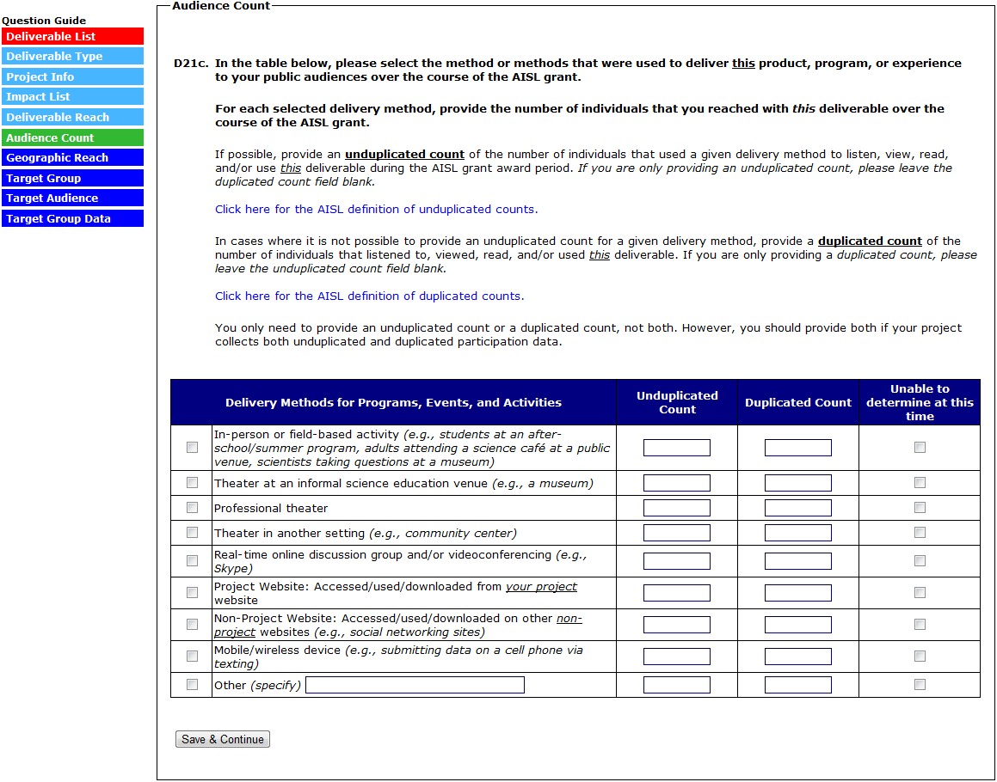

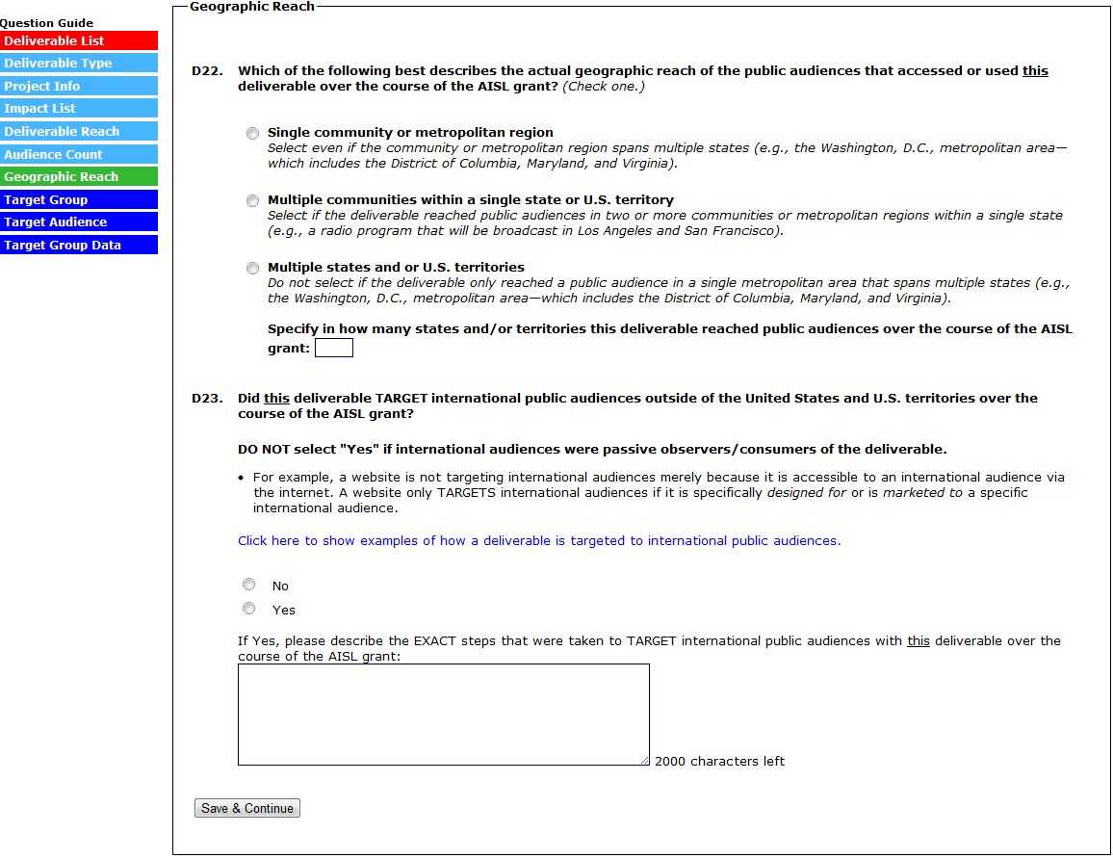
(IN D24, SELECTING “THE GENERAL PUBLIC ONLY” SKIPS D24A AND D24B)
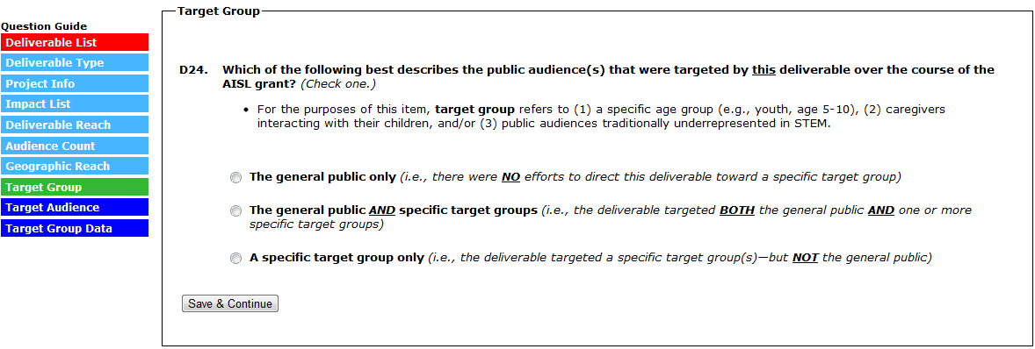
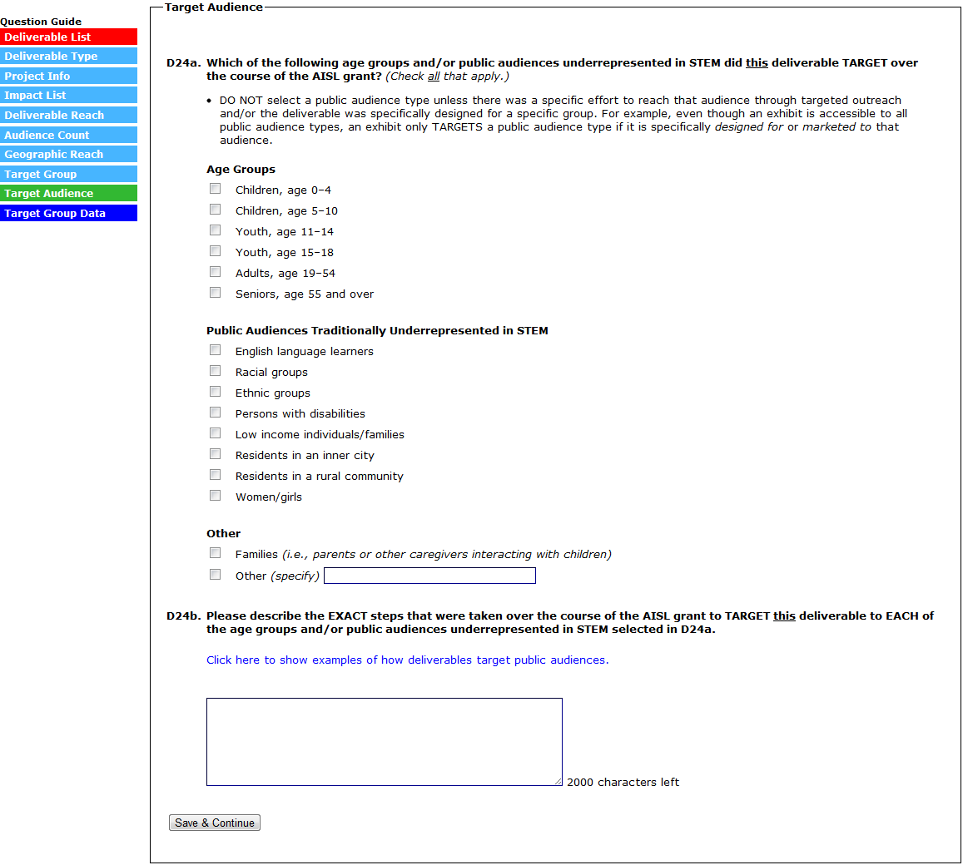
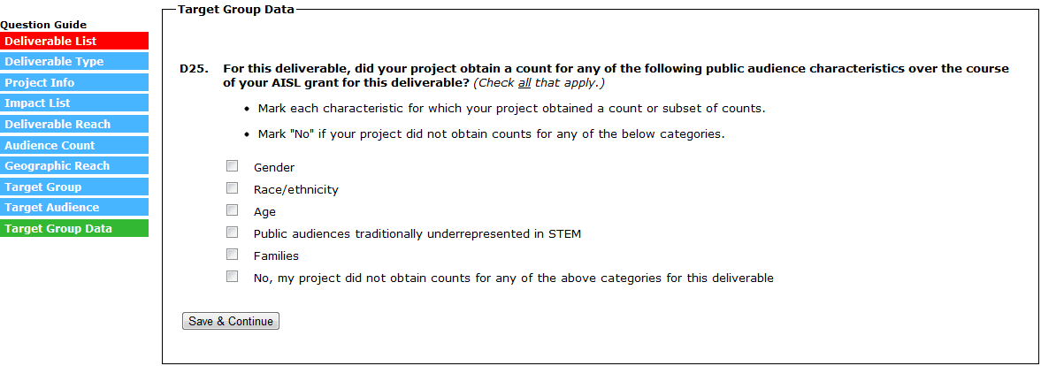
(SELECTING “SAVE & CONTINUE” SUBMITS THE DELIVERABLE AND RETURNS YOU TO THE DELIVERABLE LIST)
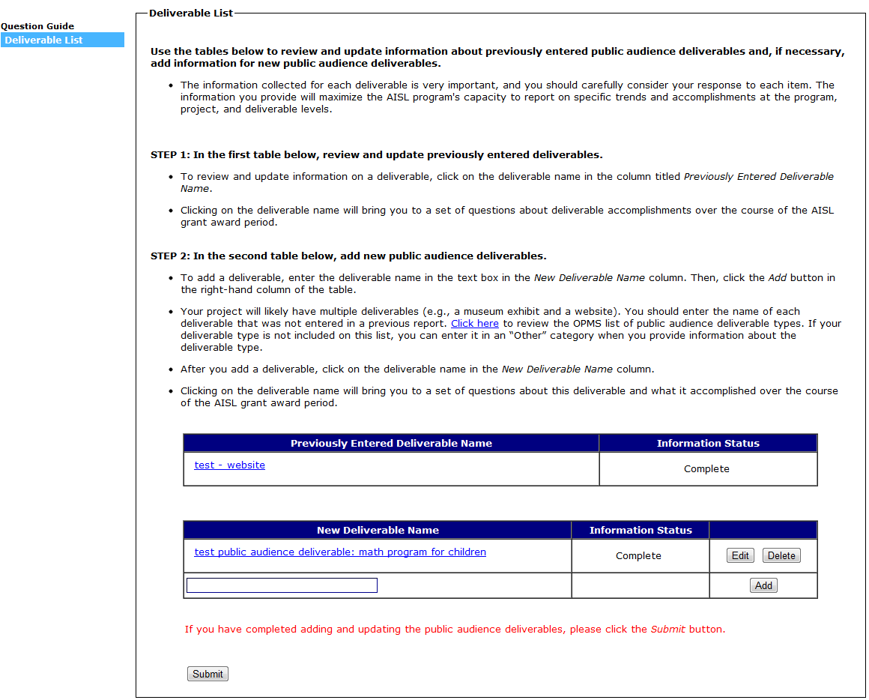
(SELECT “SUBMIT” TO SUBMIT SECTION D AND RETURN TO THE SECTION MENU)

Section E: Products, Programs, or Experiences for Professional Audiences
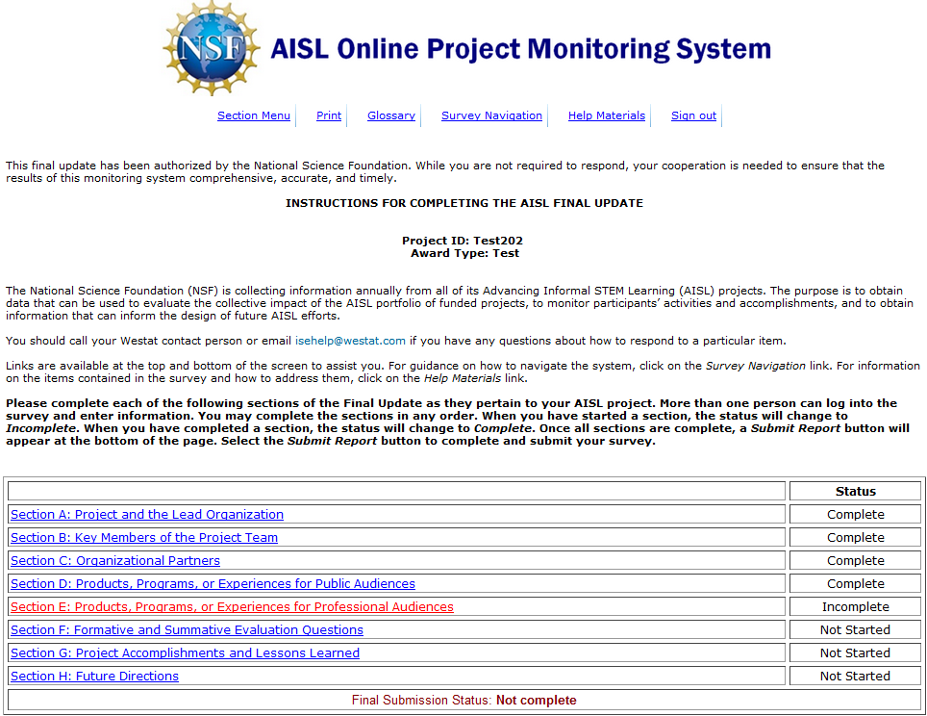

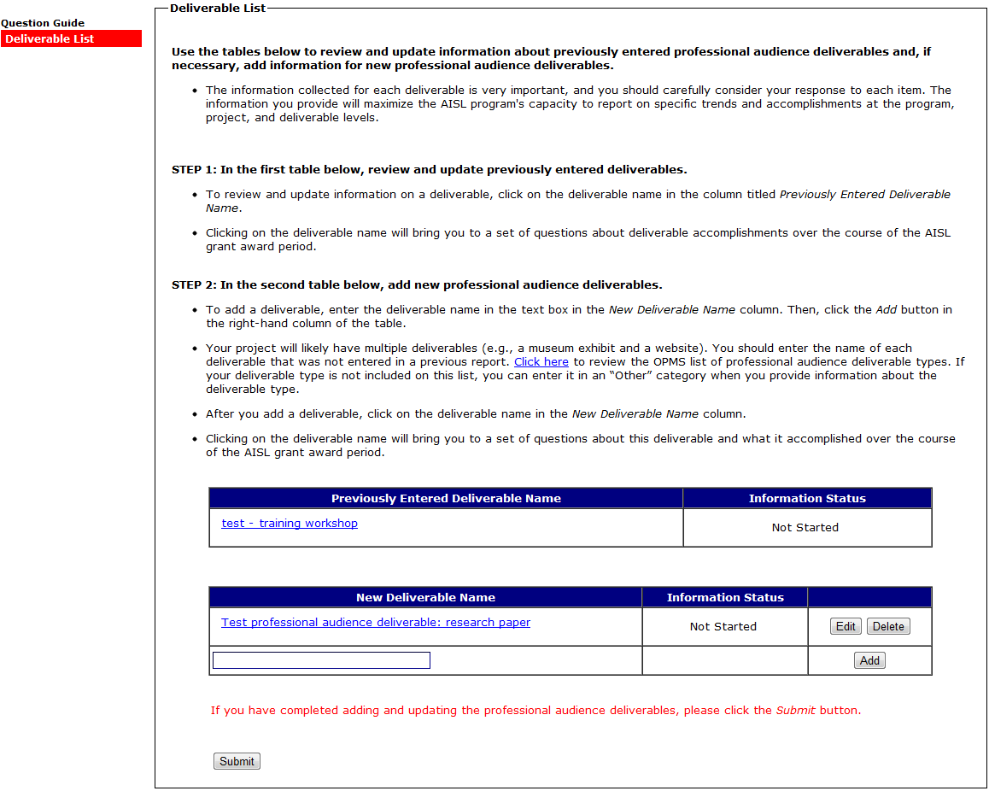
(SELECTING A DELIVERABLE IN THE “PREVIOUSLY ENTERED DELIVERABLE” TABLE WILL BRING YOU TO E2 TO E10A-E. E2 TO E10A-E ASK ABOUT DELIVERABLE ACTIVITIES OVER THE COURSE OF THE AISL GRANT.)
(SELECTING A DELIVERABLE IN THE “NEW DELIVERABLE” TABLE WILL BRING YOU TO E11-E23. E11-E23 ASK ABOUT DELIVERABLE ACTIVITIES OVER THE COURSE OF THE AISL GRANT.)

(SELECTING A DELIVERABLE IN THE “PREVIOUSLY ENTERED DELIVERABLE” TABLE WILL BRING YOU TO E2)
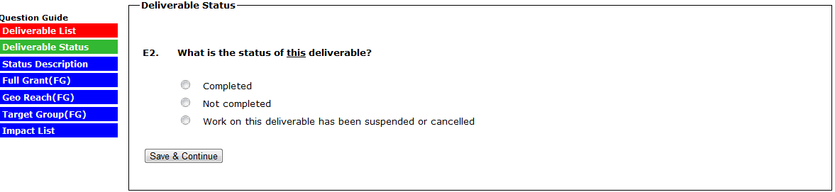
(IN E2, SELECTING “COMPLETE” SKIPS TO E2A)
(IN E2, SELECTING “NOT COMPLETE” SKIPS TO E2B)
(IN E2, SELECTING “WORK ON THE DELIVERABLE HAS BEEN SUSPENDED OR CANCELLED” SKIPS TO E2C)
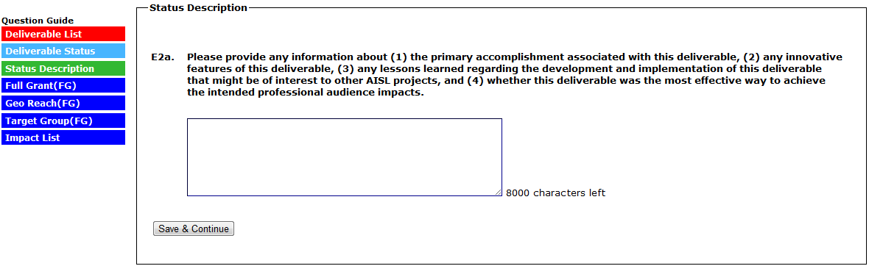
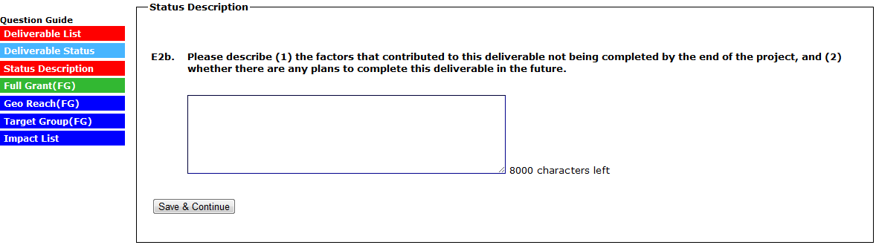
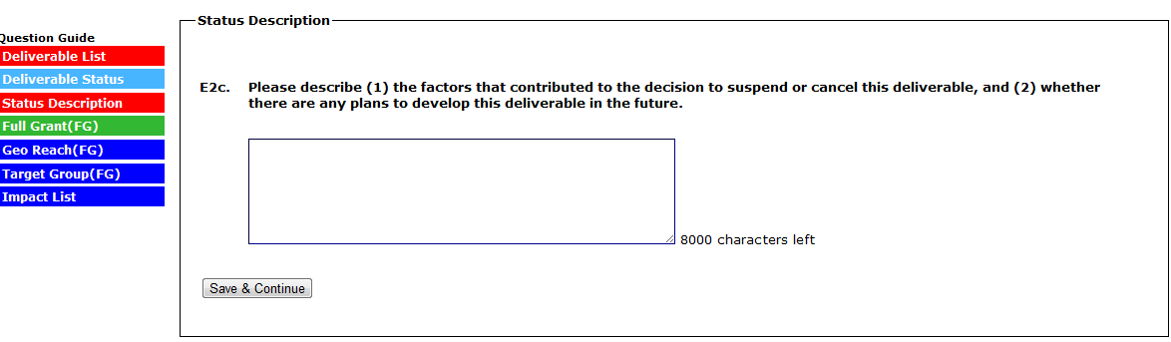
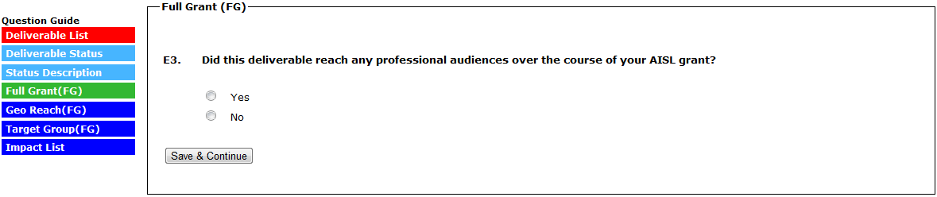
(SELECTING NO TO E3 SKIPS TO E7/IMPACT LIST)
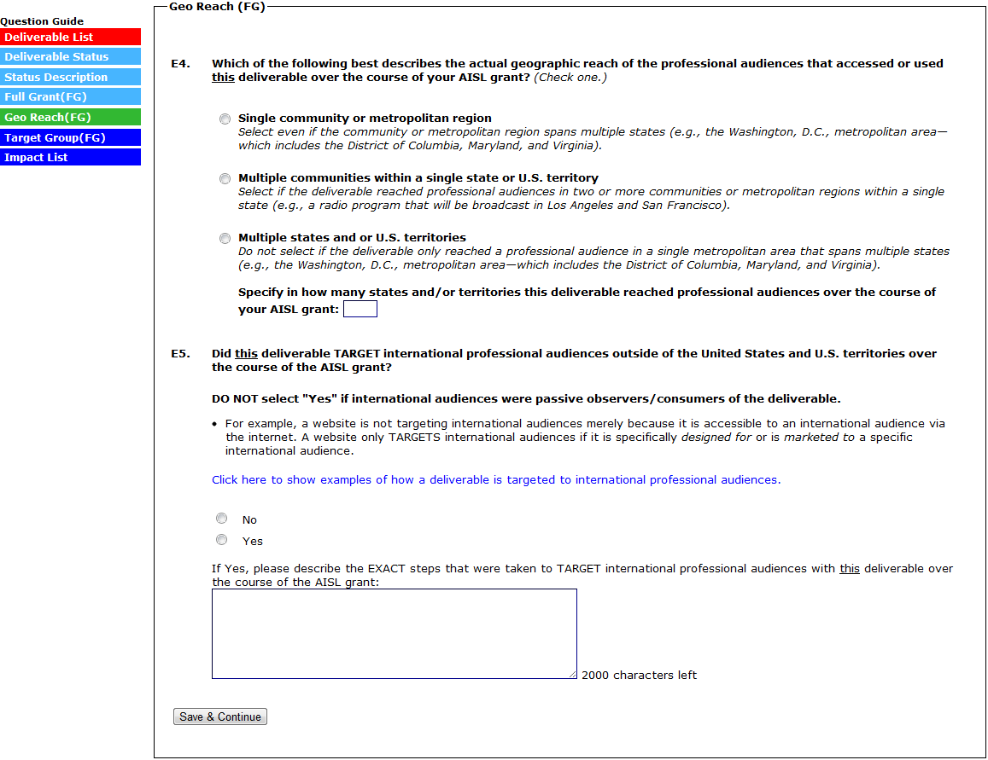
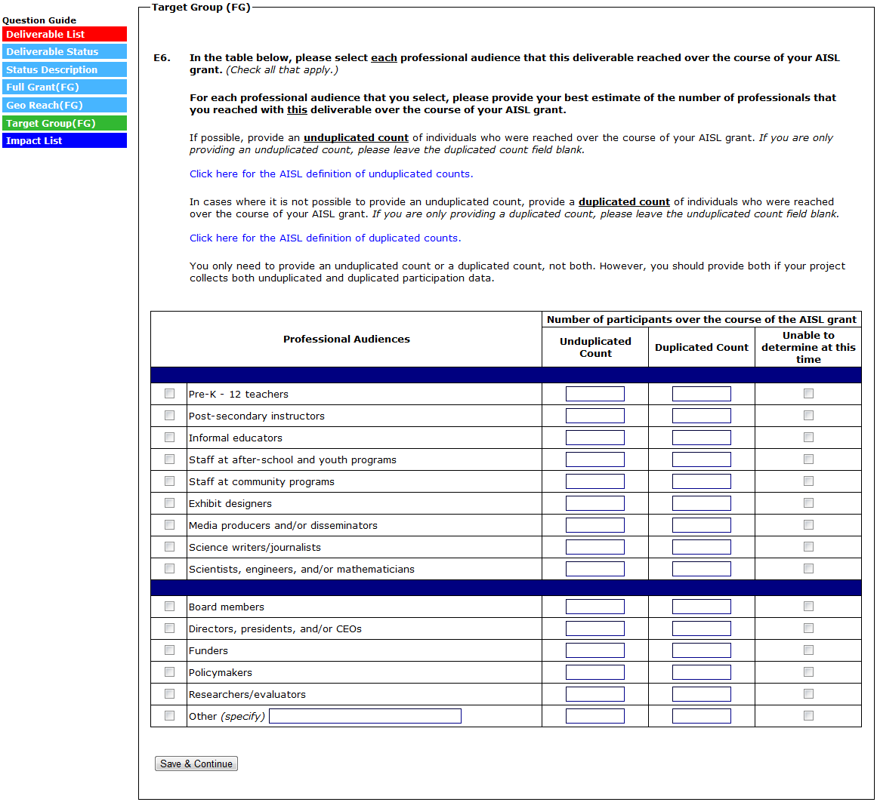
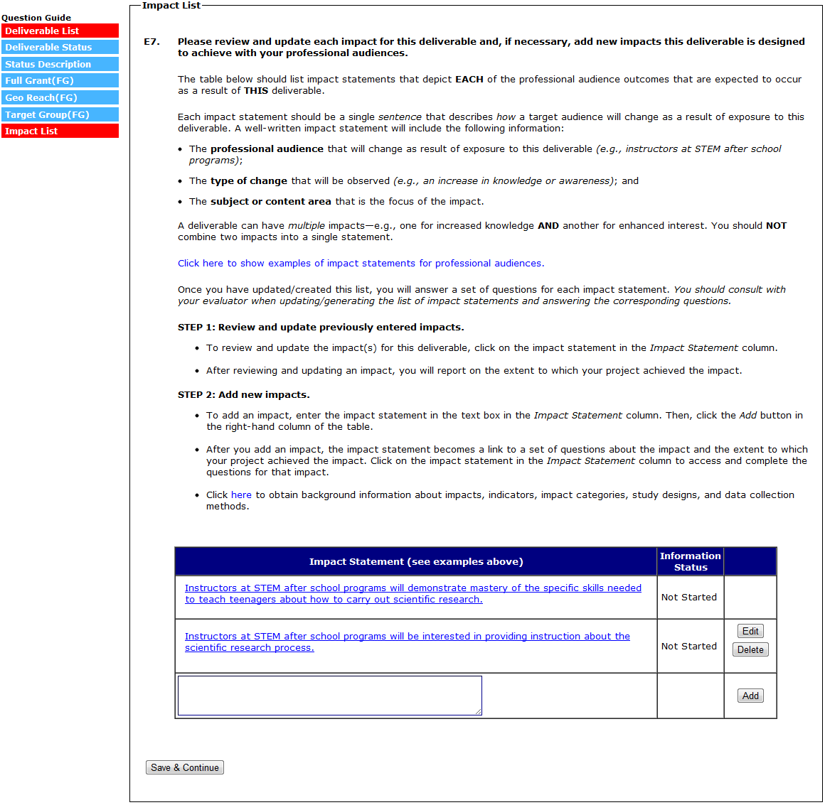

(E8A to E10A-E ARE COMPLETED/REVIEWED AND UPDATED FOR EACH IMPACT STATEMENT ENTERED IN A PREVIOUS REPORT. EACH IMPACT ENTERED IN A PREVIOUS REPORT WILL HAVE NO BUTTONS/OPTIONS IN THE FAR RIGHT COLUMN OF THE IMPACT TABLE.)
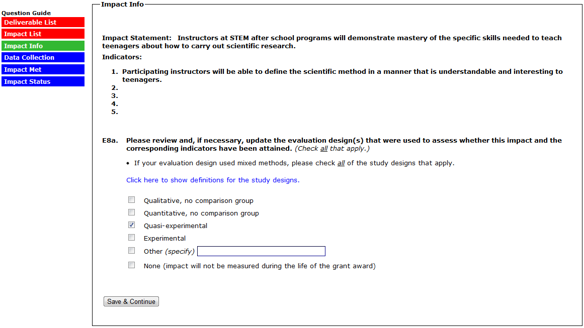
(SELECTING “NONE” TO E8A SKIPS E8B)
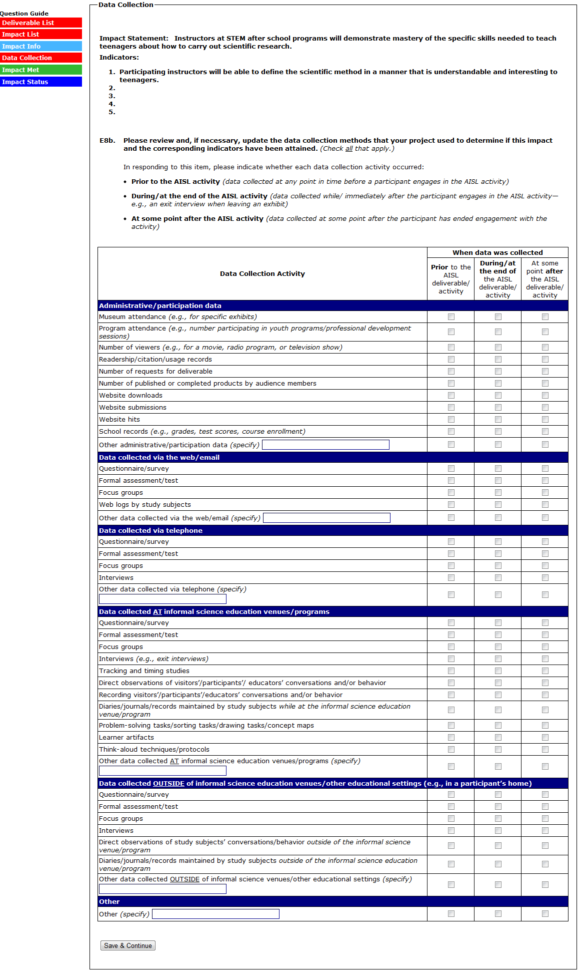
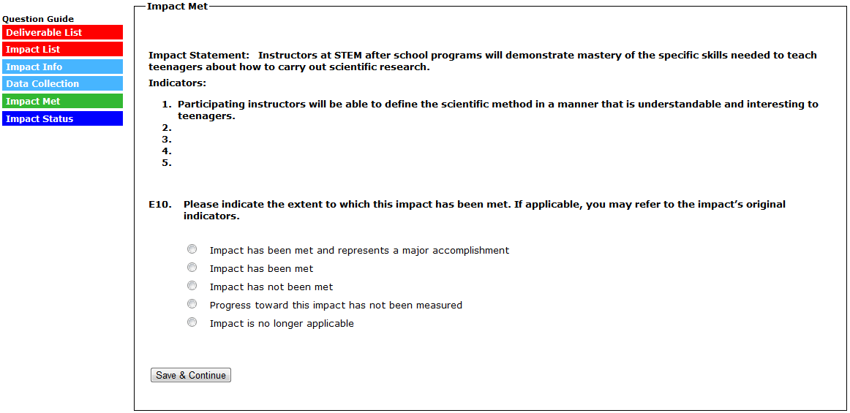
(IN E10, SELECTING “IMPACT HAS BEEN MET AND REPRESENTS A MAJOR ACCOMPLISHMENT” SKIPS TO E10A)
(IN E10, SELECTING “IMPACT HAS BEEN MET” SKIPS TO E10B)
(IN E10, SELECTING “IMPACT HAS NOT BEEN MET” SKIPS TO E10C)
(IN E10, SELECTING “PROGRESS TOWARD THIS IMPACT HAS NOT BEEN MEASURED” SKIPS TO E10D)
(IN E10, SELECTING “IMPACT IS NO LONGER APPLICABLE” SKIPS TO E10E)
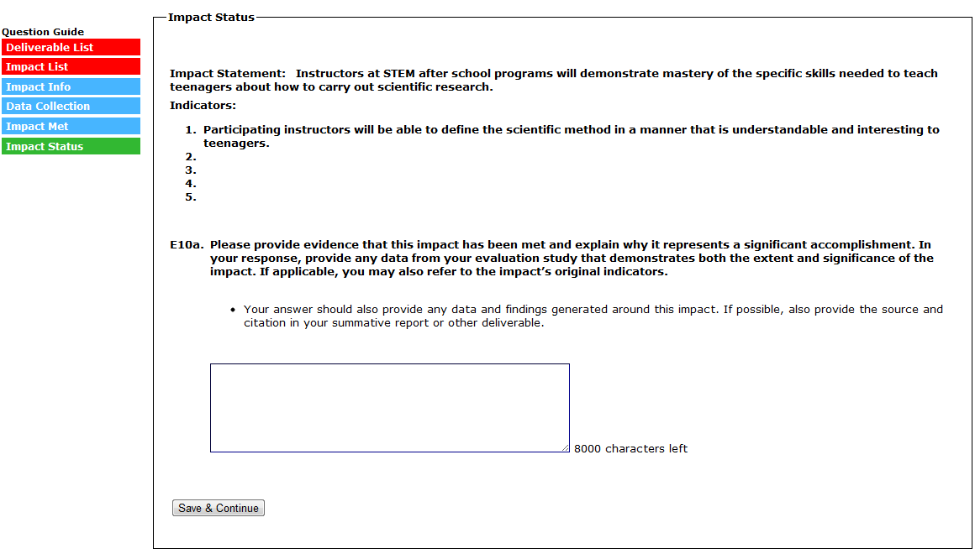
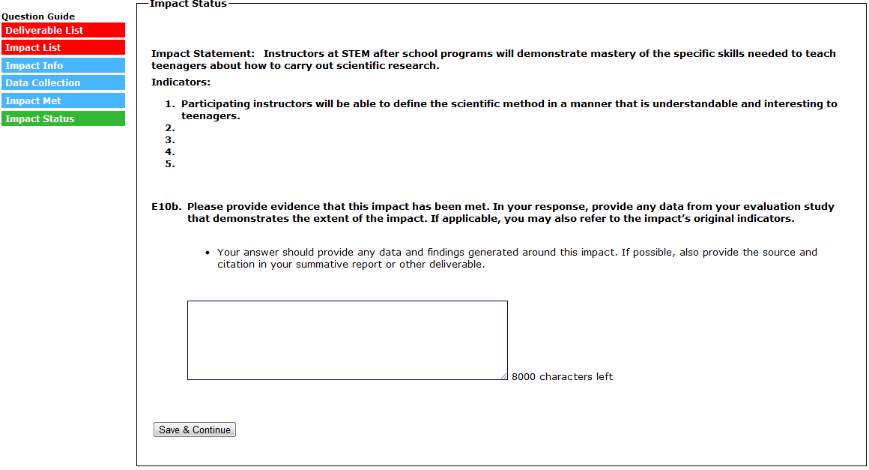
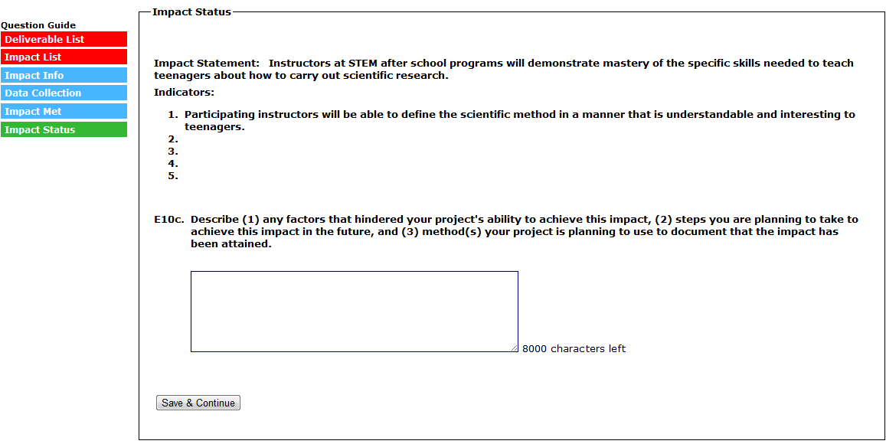
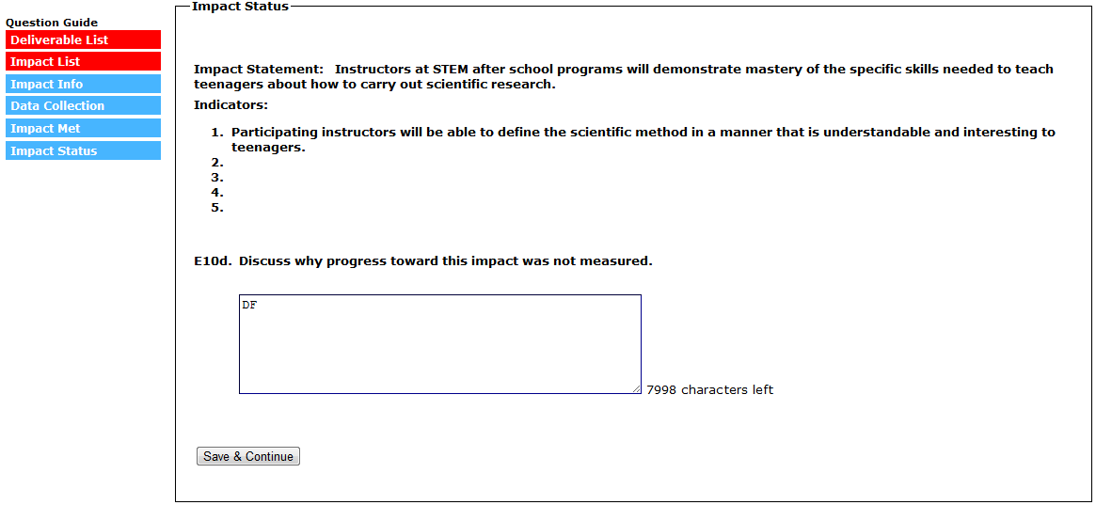
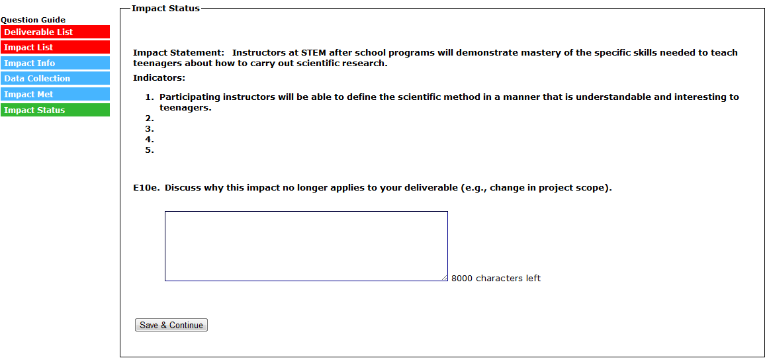
(SELECT “SAVE & CONTINUE” TO SUBMIT THE IMPACT AND RETURN TO THE IMPACT LIST)
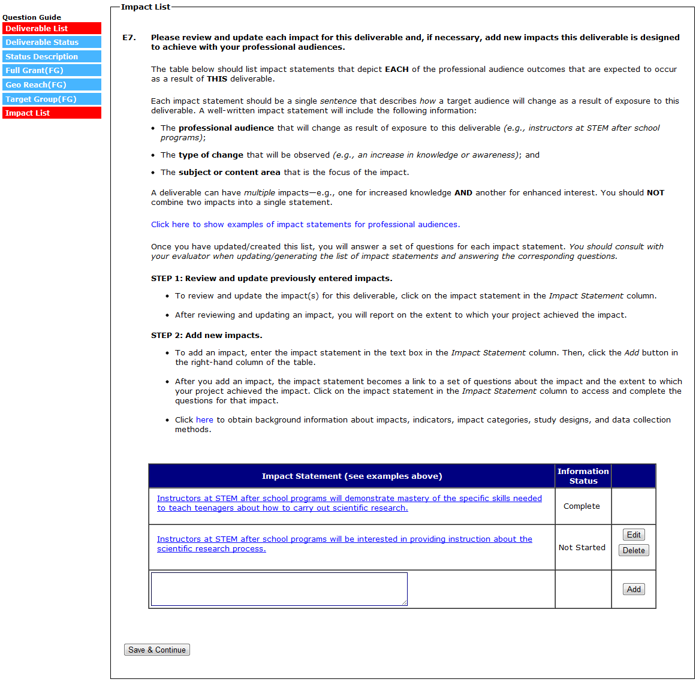
(E9A TO E10A-E ARE COMPLETED FOR EACH IMPACT STATEMENT ADDED IN THE CURRENT REPORT. EACH IMPACT ENTERED IN THE CURRENT REPORT WILL HAVE AN “EDIT” AND “DELETE” BUTTON IN THE FAR RIGHT COLUMN OF THE IMPACT TABLE.)
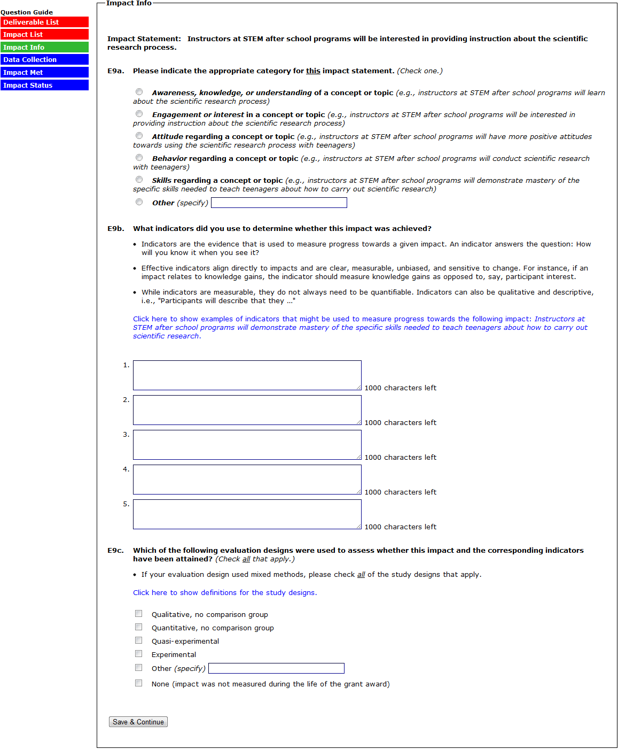
(SELECTING “NONE” TO E9C SKIPS E9D)
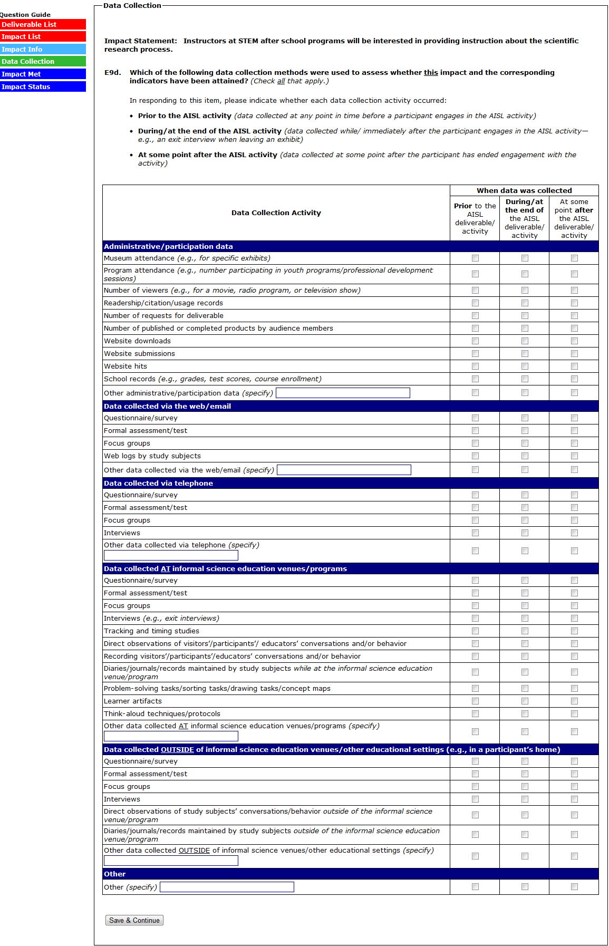
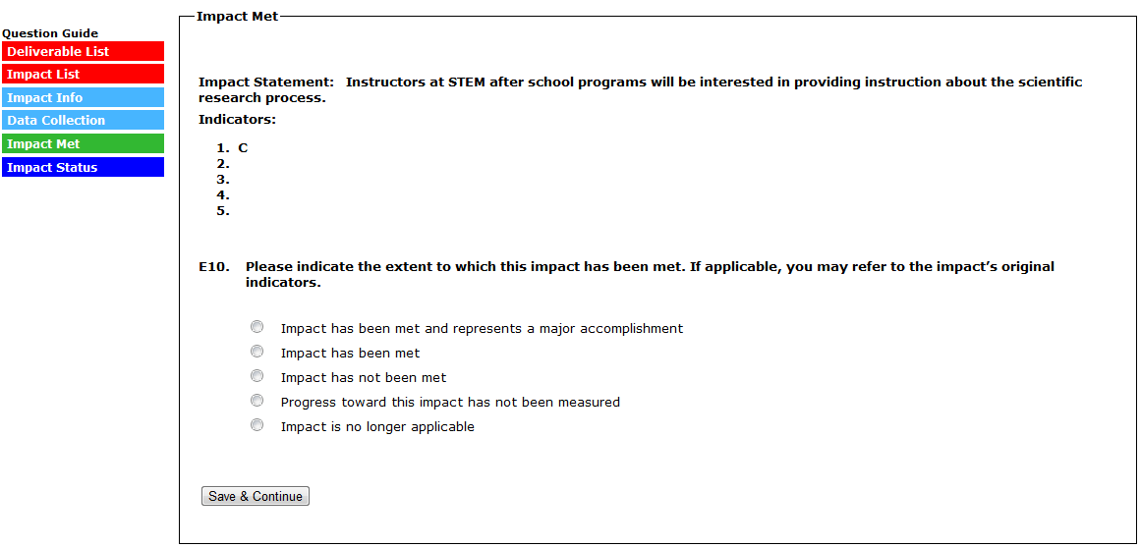
(IN E10, SELECTING “IMPACT HAS BEEN MET AND REPRESENTS A MAJOR ACCOMPLISHMENT” SKIPS TO E10A)
(IN E10, SELECTING “IMPACT HAS BEEN MET” SKIPS TO E10B)
(IN E10, SELECTING “IMPACT HAS NOT BEEN MET” SKIPS TO E10C)
(IN E10, SELECTING “PROGRESS TOWARD THIS IMPACT HAS NOT BEEN MEASURED” SKIPS TO E10D)
(IN E10, SELECTING “IMPACT IS NO LONGER APPLICABLE” SKIPS TO E10E)
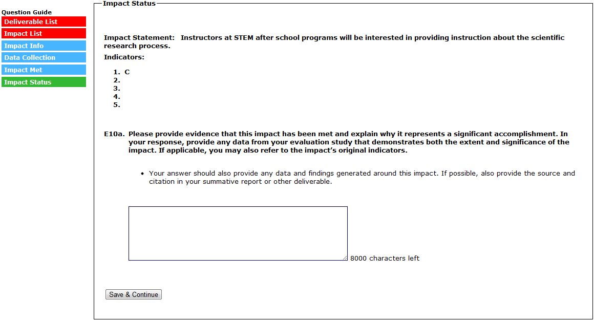
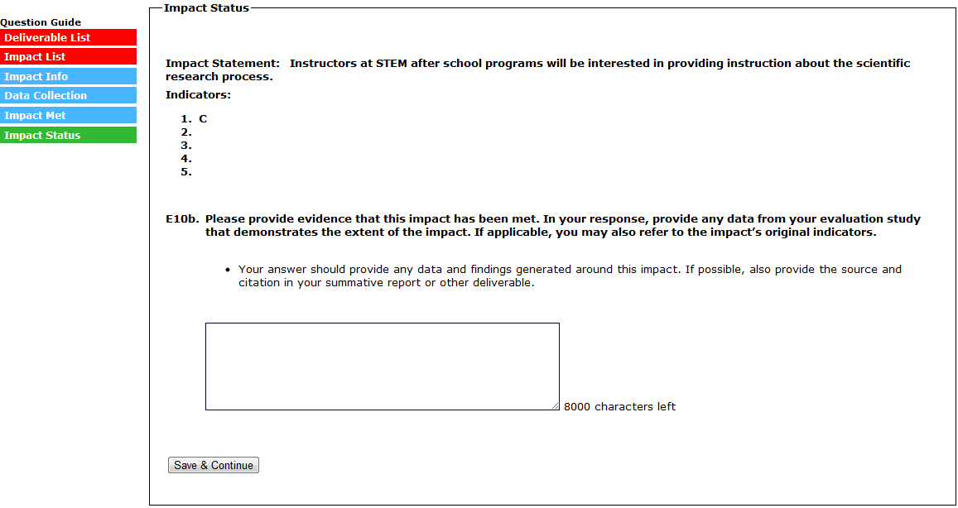
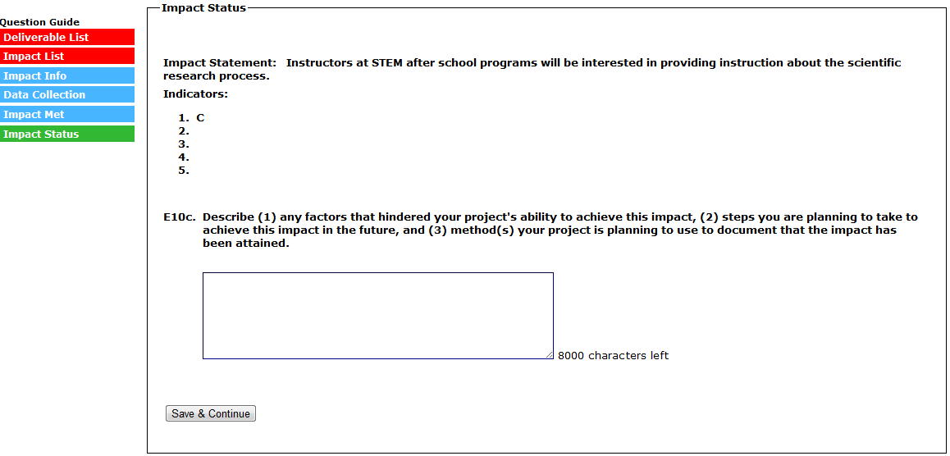
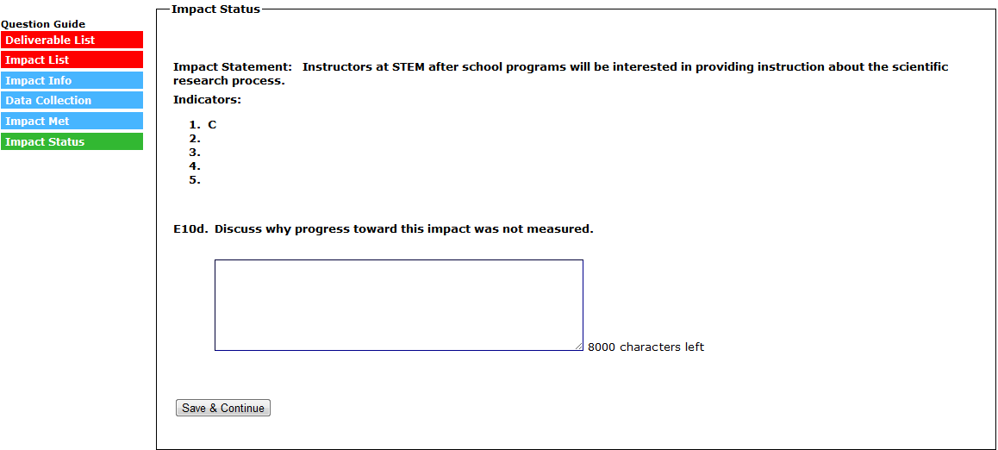
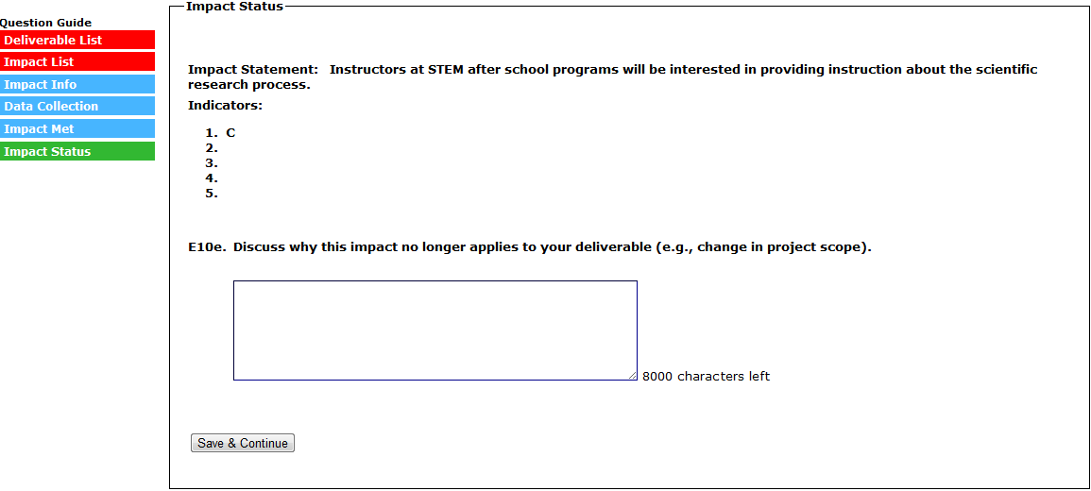
(SELECT “SAVE & CONTINUE” TO SUBMIT THE IMPACT AND RETURN TO THE IMPACT LIST)
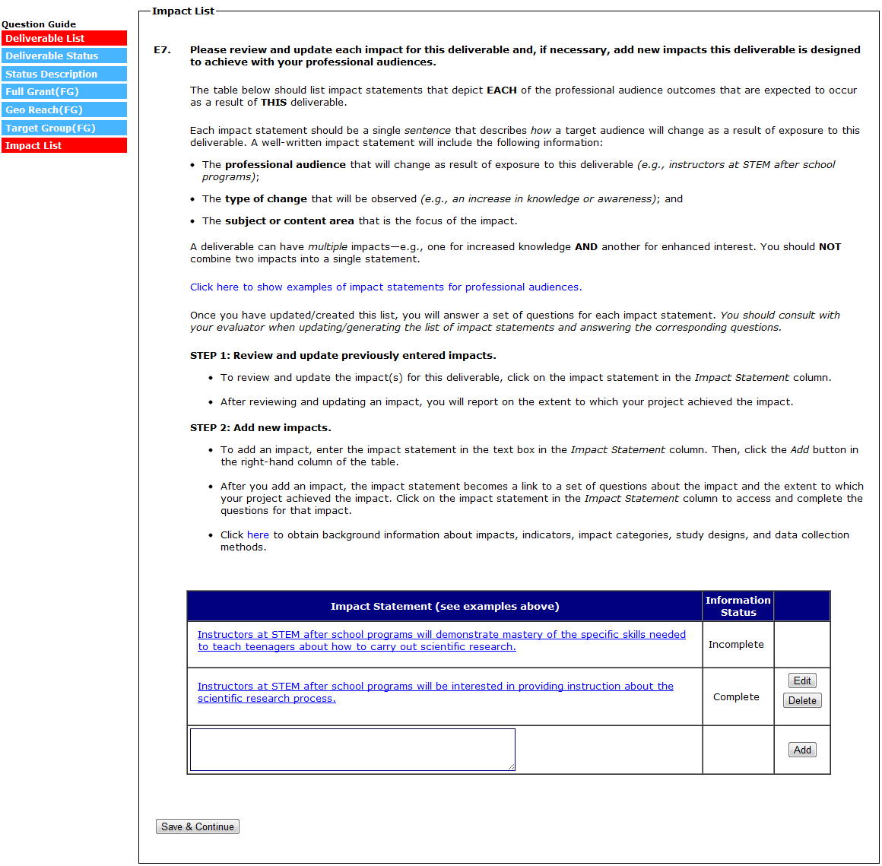
(SELECT “SAVE AND CONTINUE” TO SUBMIT THE DELIVERABLE AND RETURN TO THE DELIVERABLE LIST)
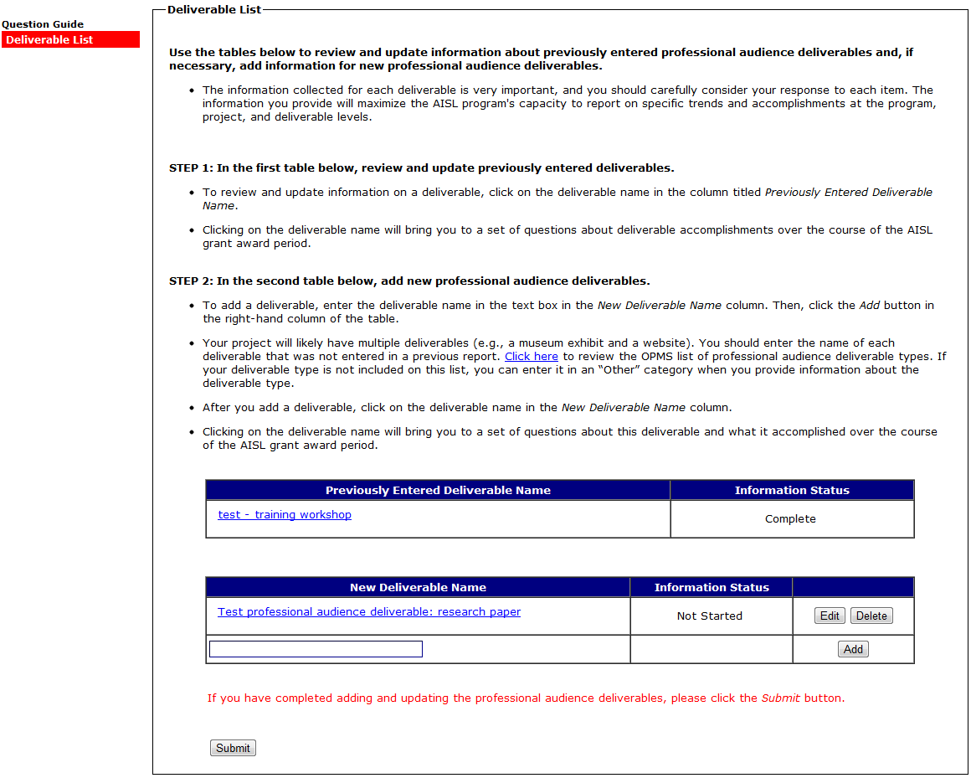
(SELECTING A DELIVERABLE IN THE “NEW DELIVERABLE” TABLE WILL BRING YOU TO E11-E23. E11-E23 ARE QUESTIONS ABOUT WHAT THE DELIVERABLE ACCOMPLISHED OVER THE COURSE OF THE AISL GRANT.)

(SELECTING A DELIVERABLE IN THE “NEW DELIVERABLE” TABLE WILL BRING YOU TO E11)
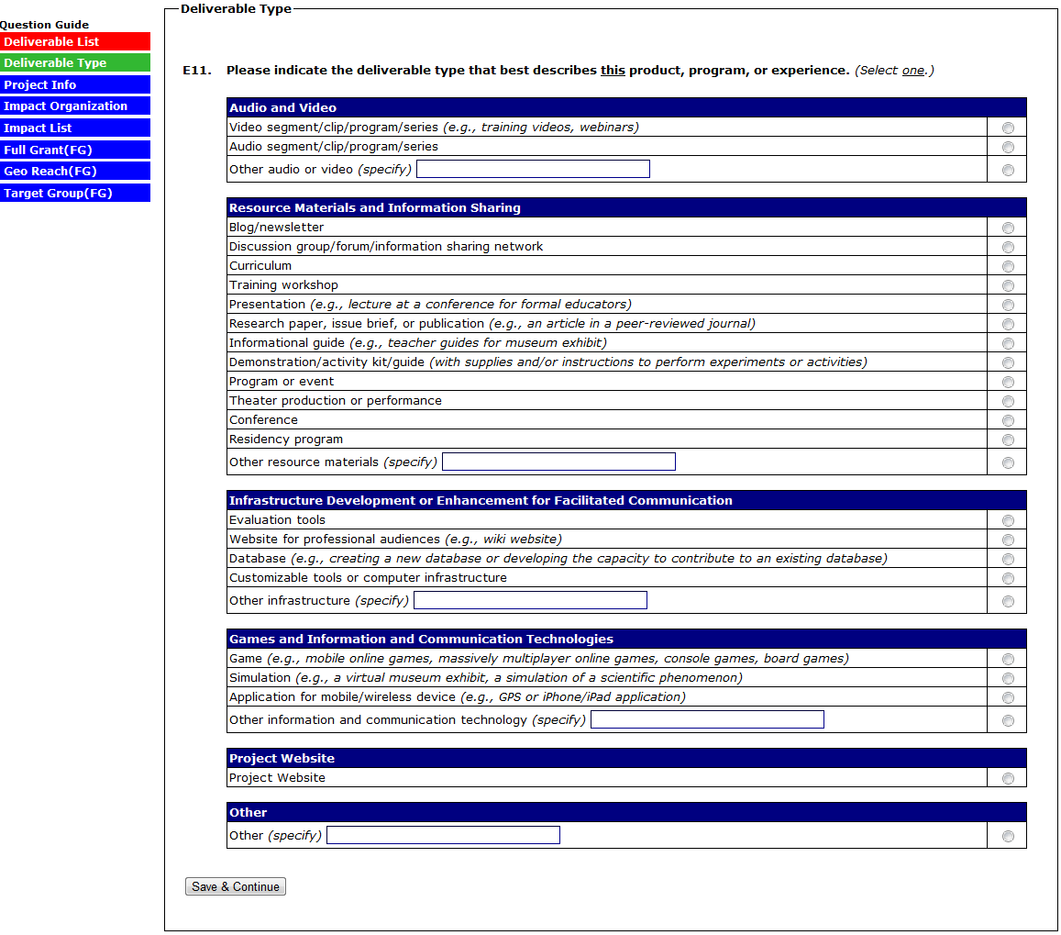
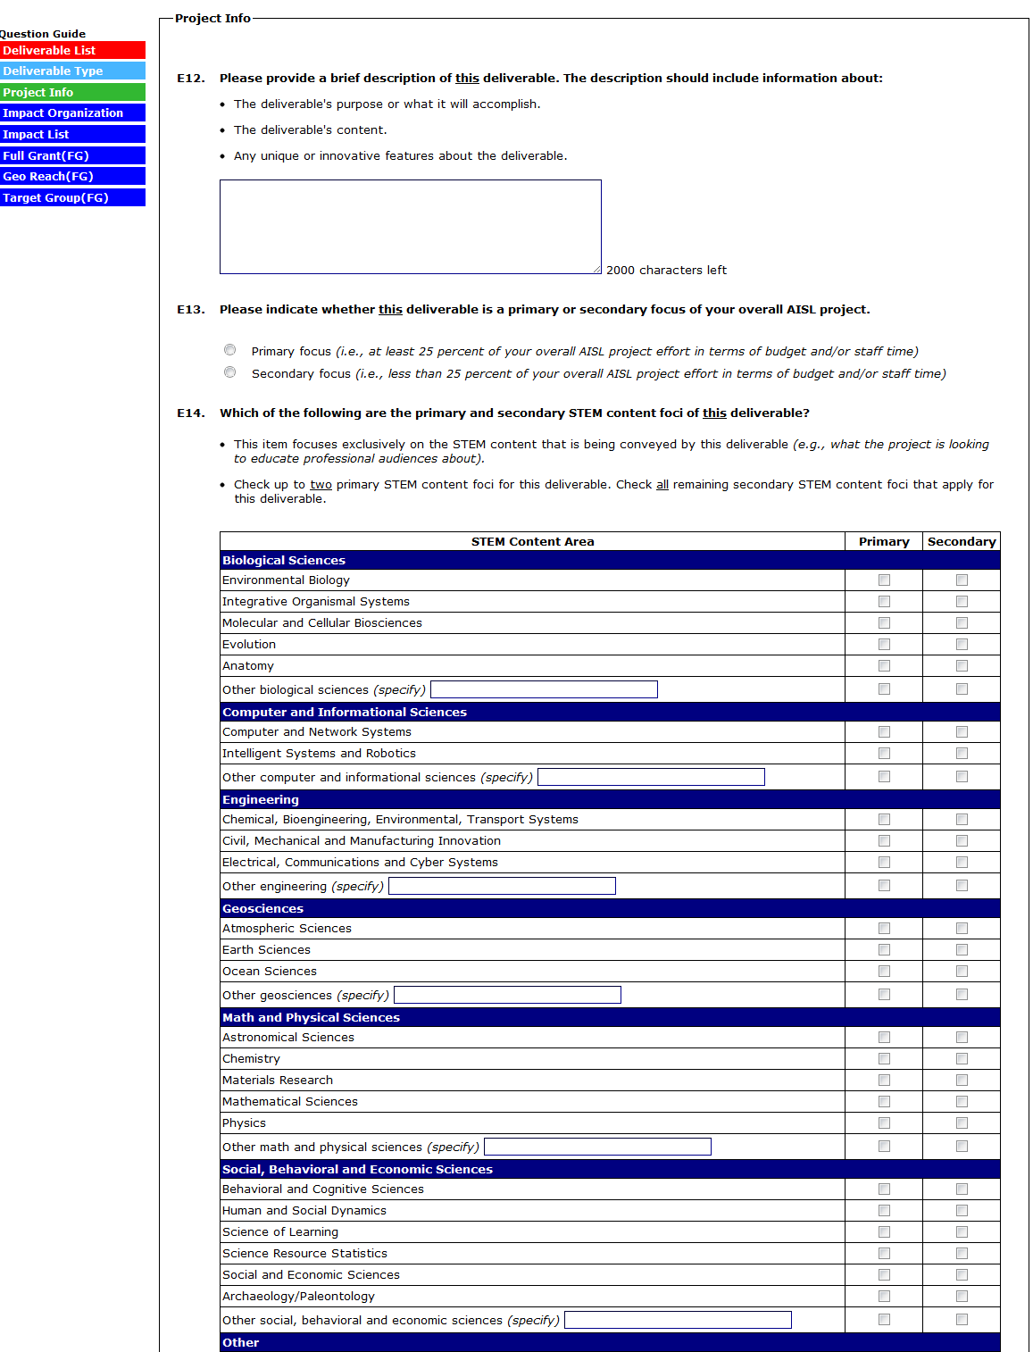
(CONTINUED ON NEXT PAGE)

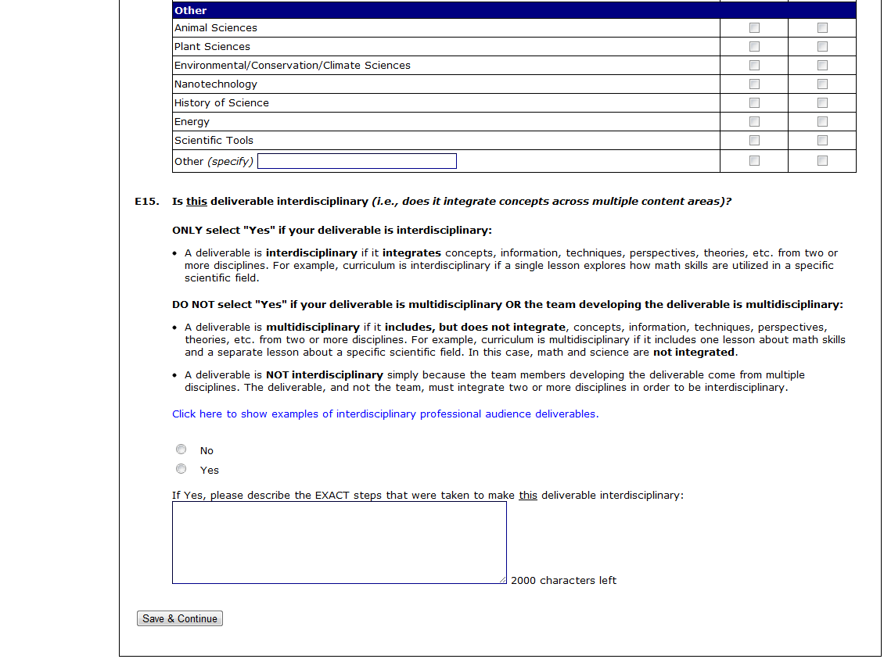

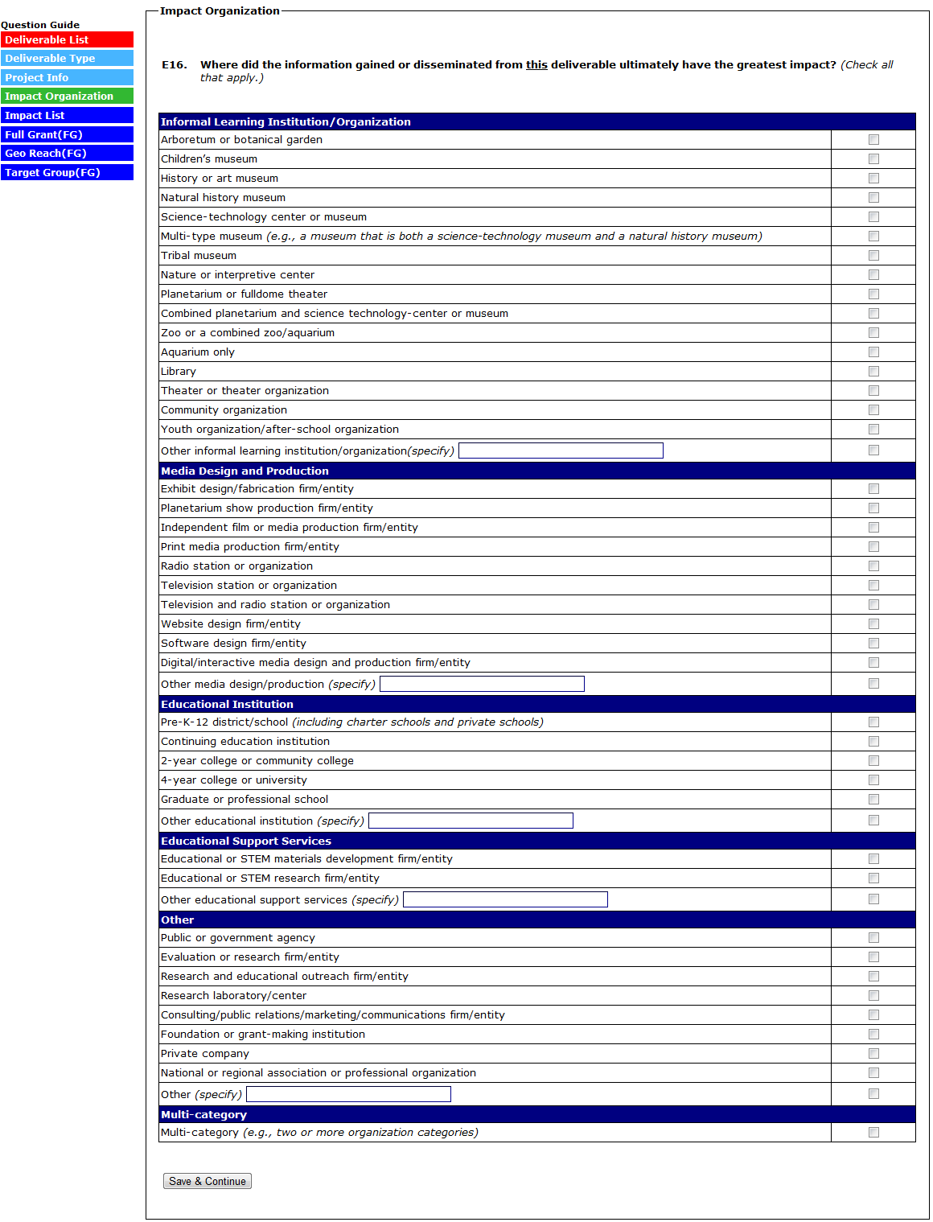
(SELECTING “THERE ARE NO IMPACTS FOR THIS DELIVERABLE” (OPTION AVAILABLE ONLY FOR DELIVERABLES MARKED “SECONDARY FOCUS” IN E13) WILL SKIP TO E20. FOR EACH IMPACT STATEMENT ENTERED INTO THE TABLE, ANSWER E18A TO E19A-E.)
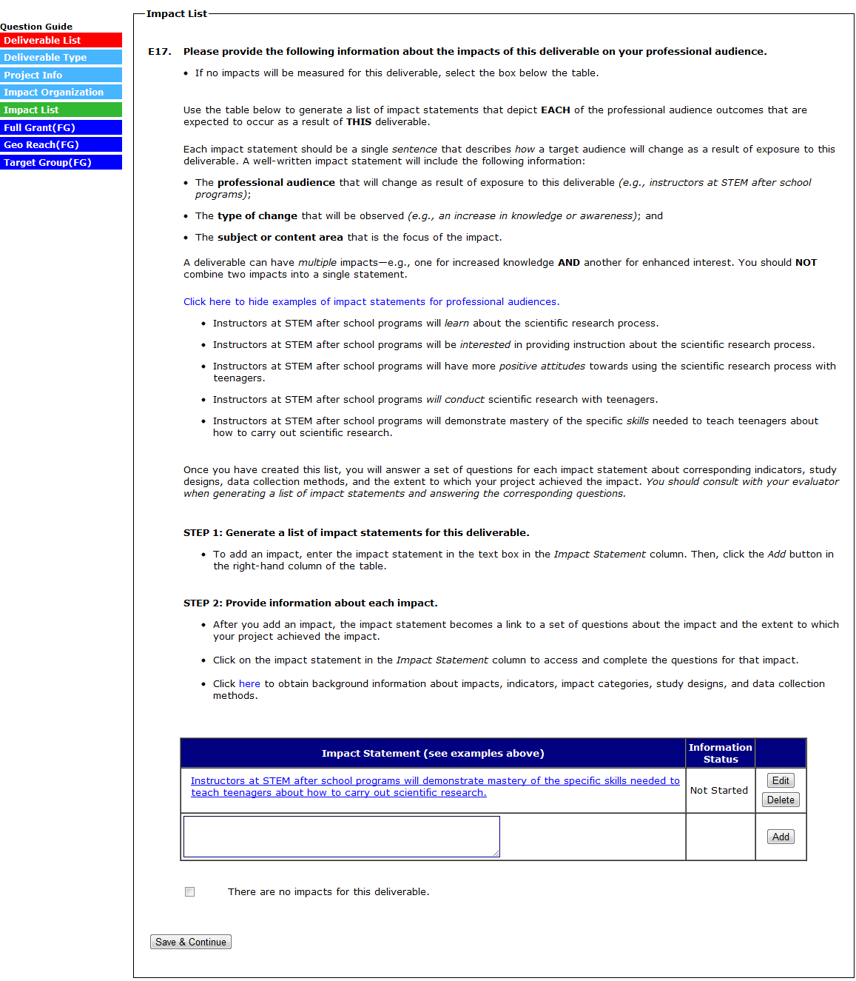
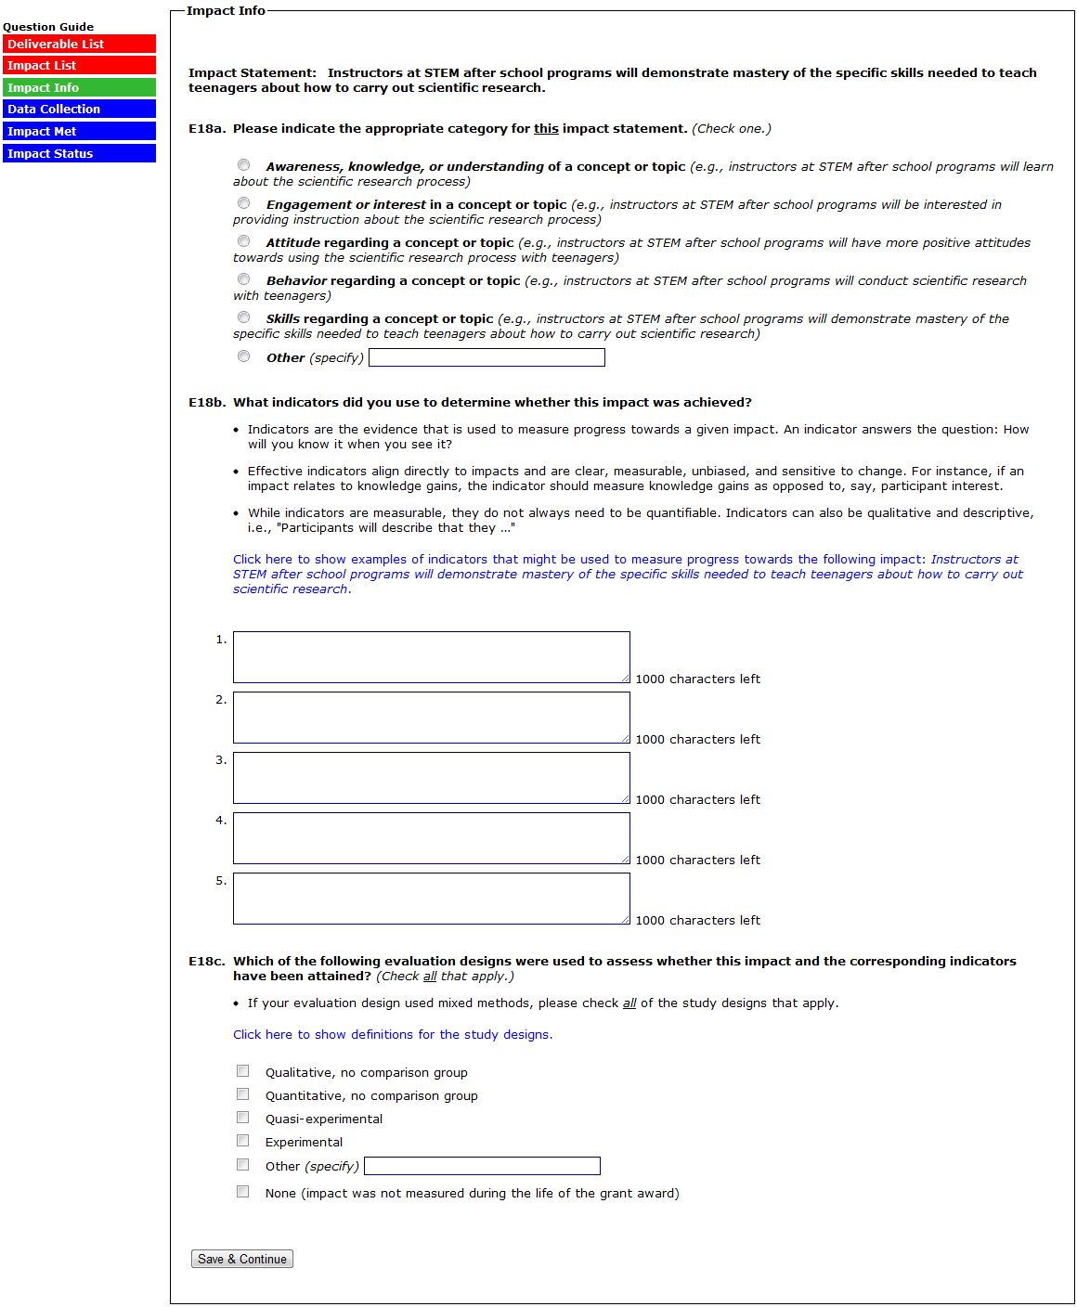
(SELECTING “NONE” TO E18C SKIPS E18C SKIPS E18D)

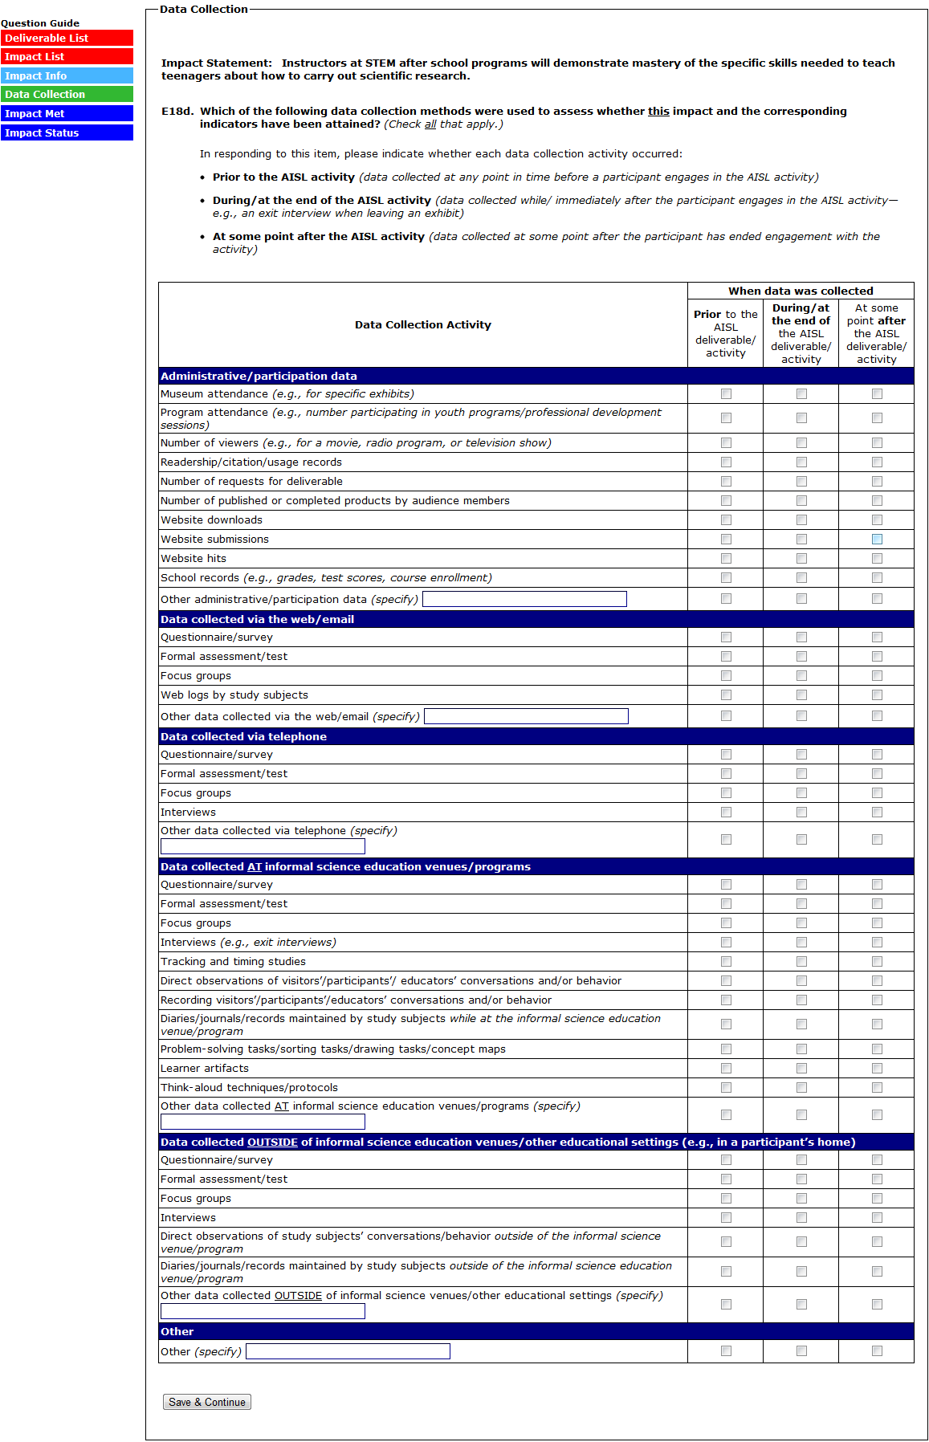
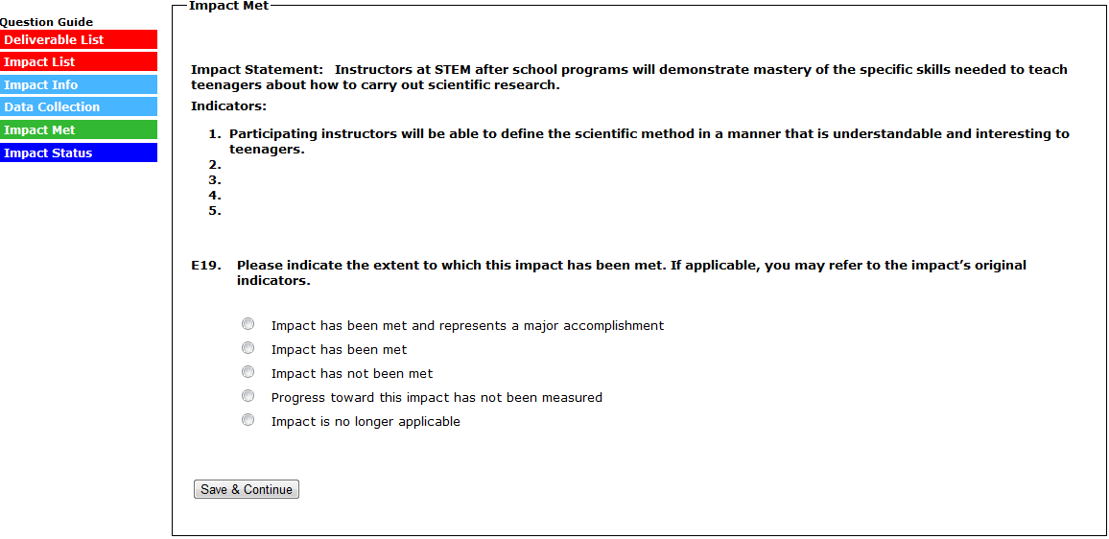
(IN E19, SELECTING “IMPACT HAS BEEN MET AND REPRESENTS A MAJOR ACCOMPLISHMENT” SKIPS TO E19A)
(IN E19, SELECTING “IMPACT HAS BEEN MET” SKIPS TO E19B)
(IN E19, SELECTING “IMPACT HAS NOT BEEN MET” SKIPS TO E19C)
(IN E19, SELECTING “PROGRESS TOWARD THIS IMPACT HAS NOT BEEN MEASURED” SKIPS TO E19D)
(IN E19, SELECTING “IMPACT IS NO LONGER APPLICABLE” SKIPS TO E19E)
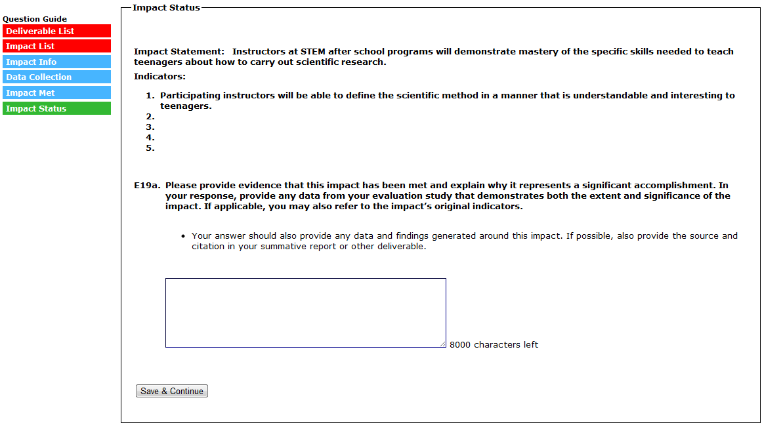
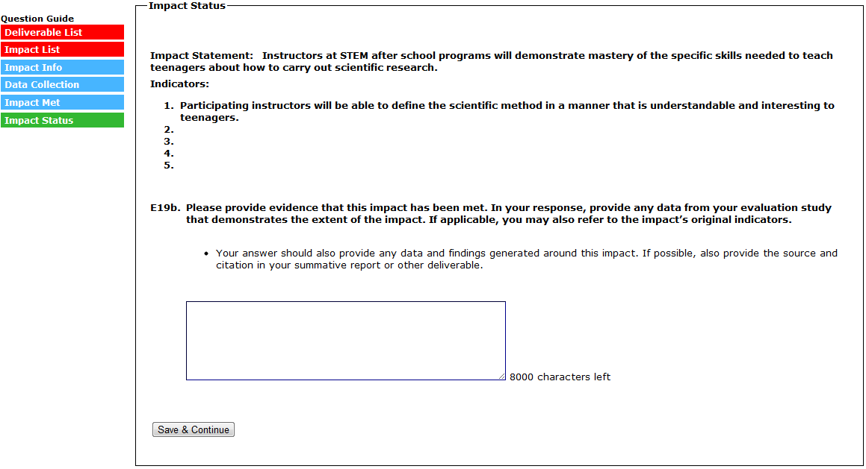
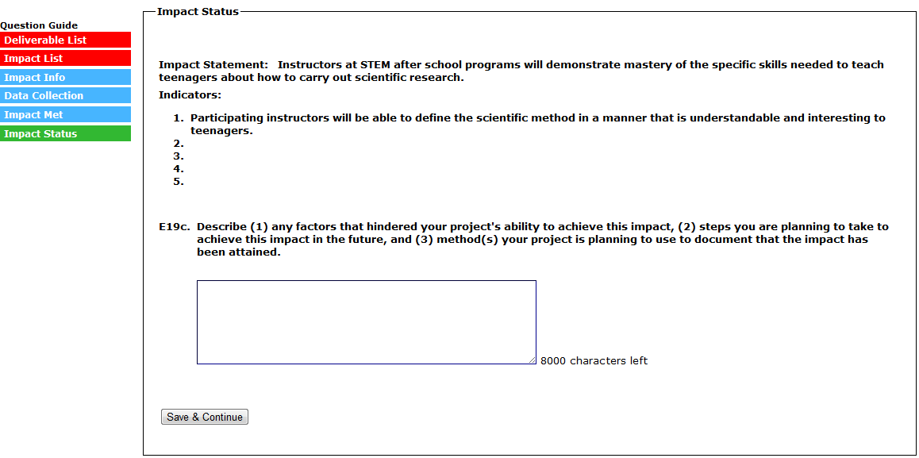
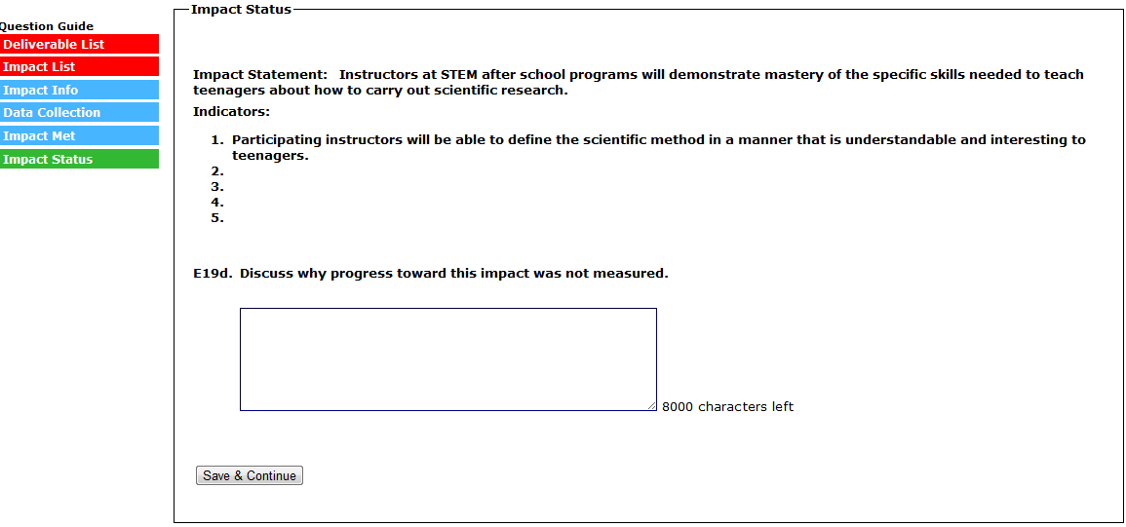
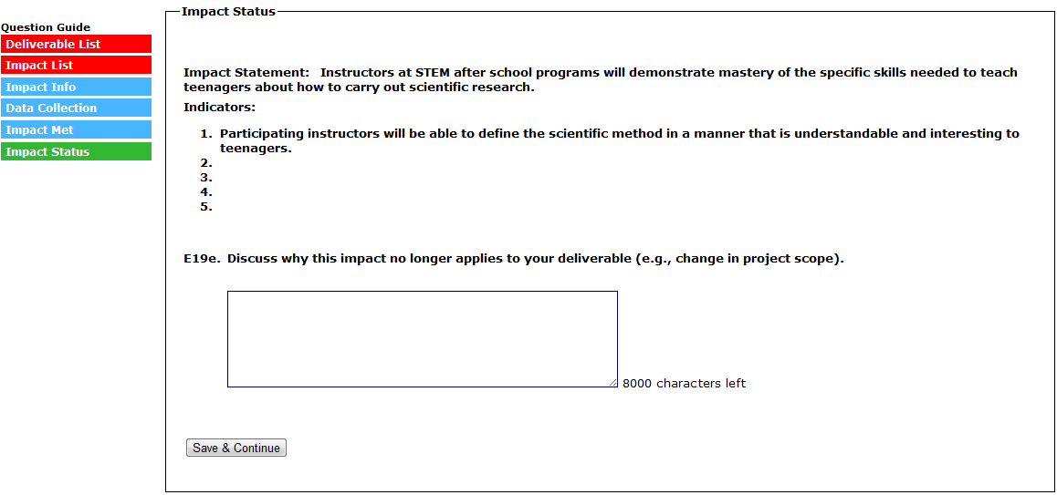
(SELECTING “SAVE & CONTINUE” RETURNS YOU TO THE IMPACT LIST)
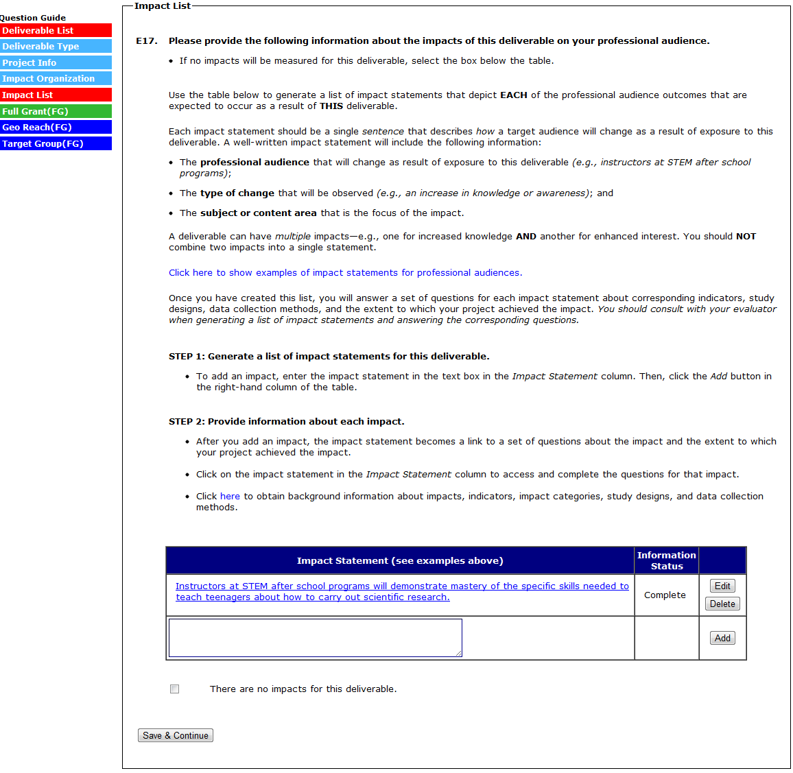
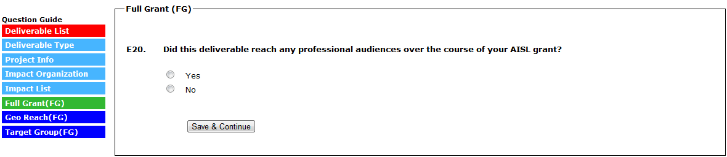
(SELECTING “NO” TO E20 SKIPS THE REMAINING QUESTIONS, SUBMITS THE DELIVERABLE, AND RETURNS YOU TO THE DELIVERABLE LIST)
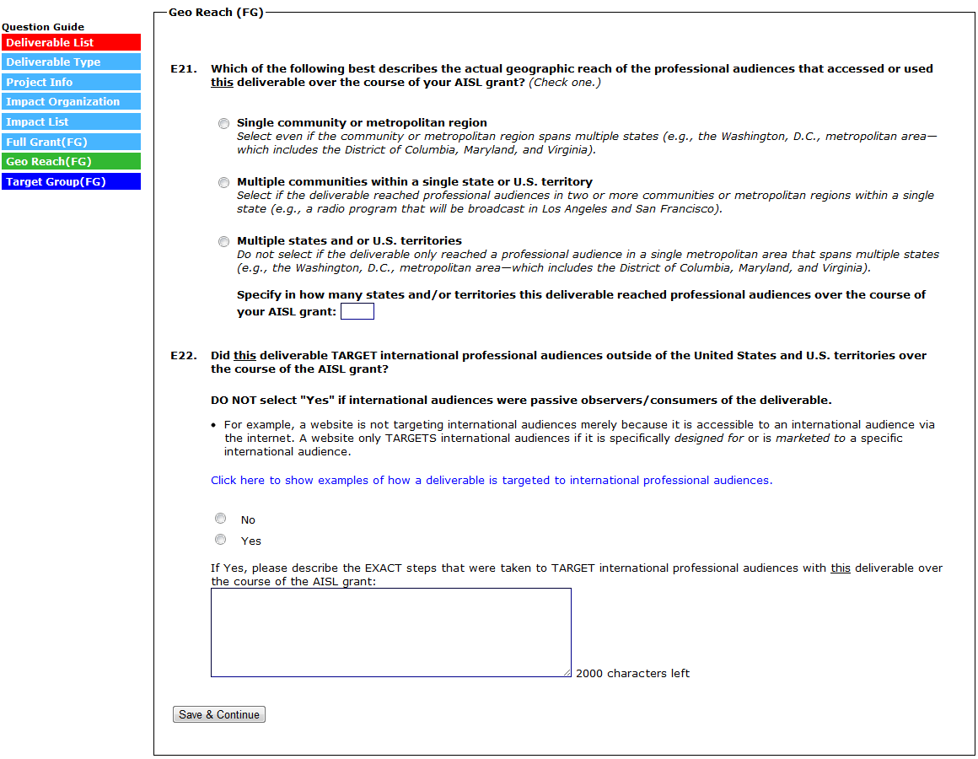
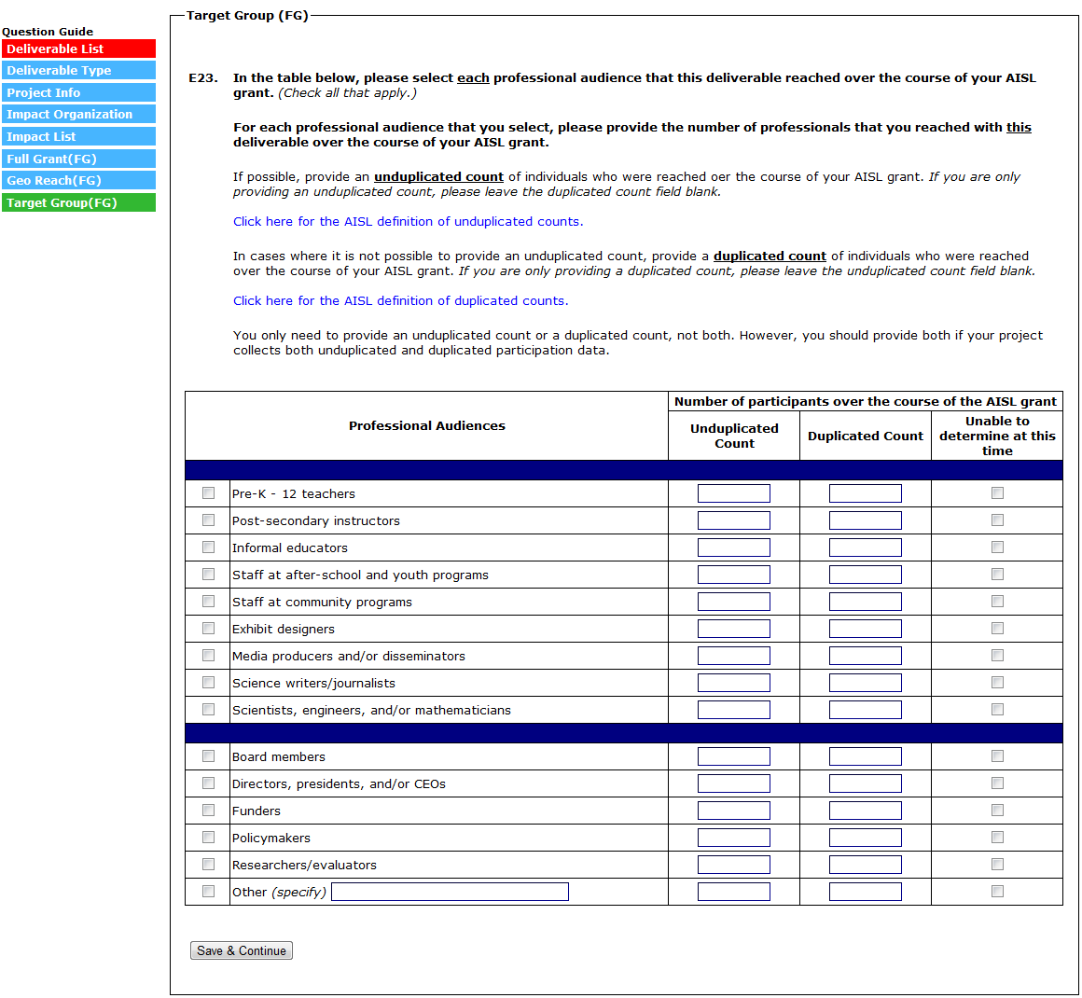
(SELECTING “SAVE & CONTINUE” SUBMITS THE DELIVERABLE AND RETURNS YOU TO THE DELIVERABLE LIST PAGE)
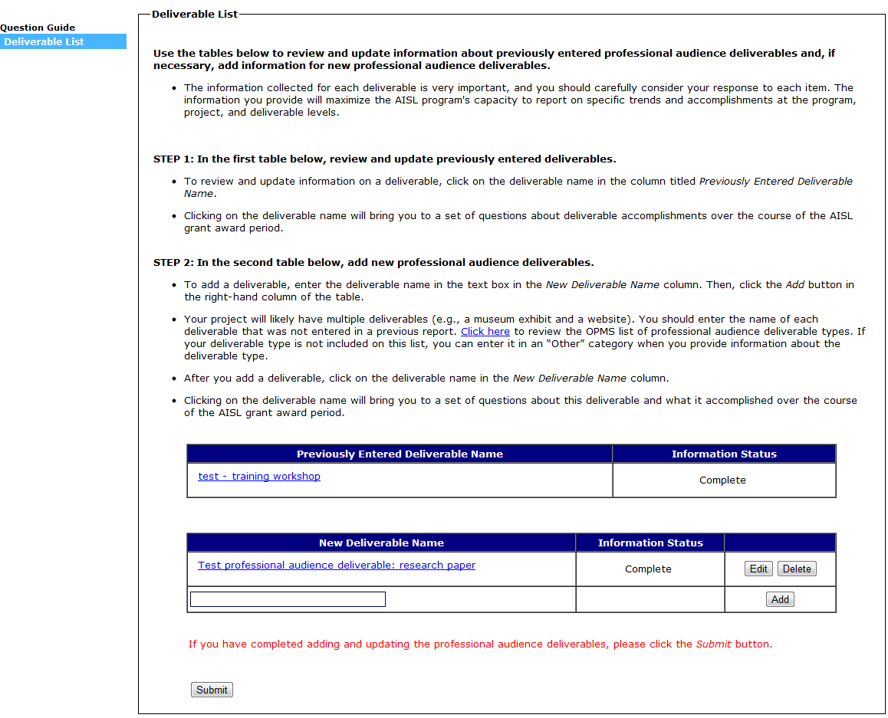
(SELECT “SUBMIT” TO SUBMIT SECTION E AND RETURN TO THE SECTION MENU)

Section F: Formative and Summative Evaluation Questions

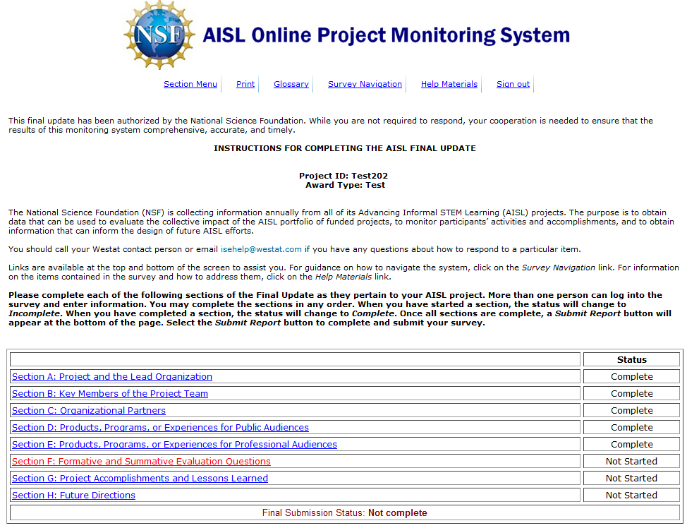

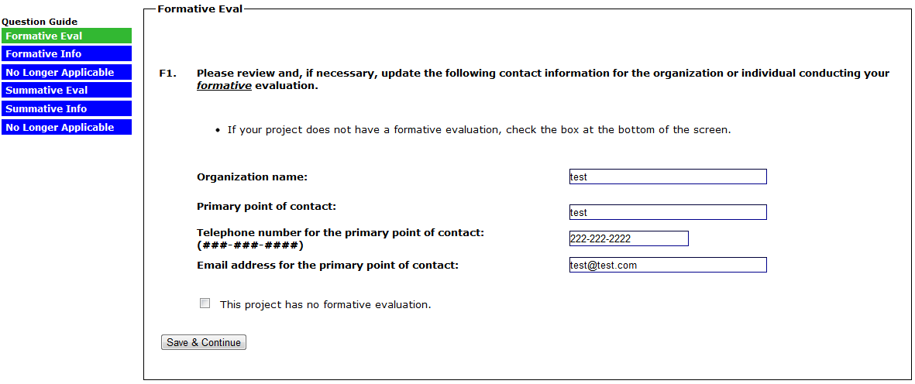
(SELECTING “THIS PROJECT HAS NO FORMATIVE EVALUATION” WILL SKIP TO F3)

(SELECT EACH EVALUATION QUESTION IN THE “FORMATIVE EVALUATION QUESTION” COLUMN TO ANSWER F2A. FOR EACH EVALUATION QUESTION MARKED IN THE “CHECK IF QUESTION IS NO LONGER APPLICABLE” COLUMN, ANSWER F2B)
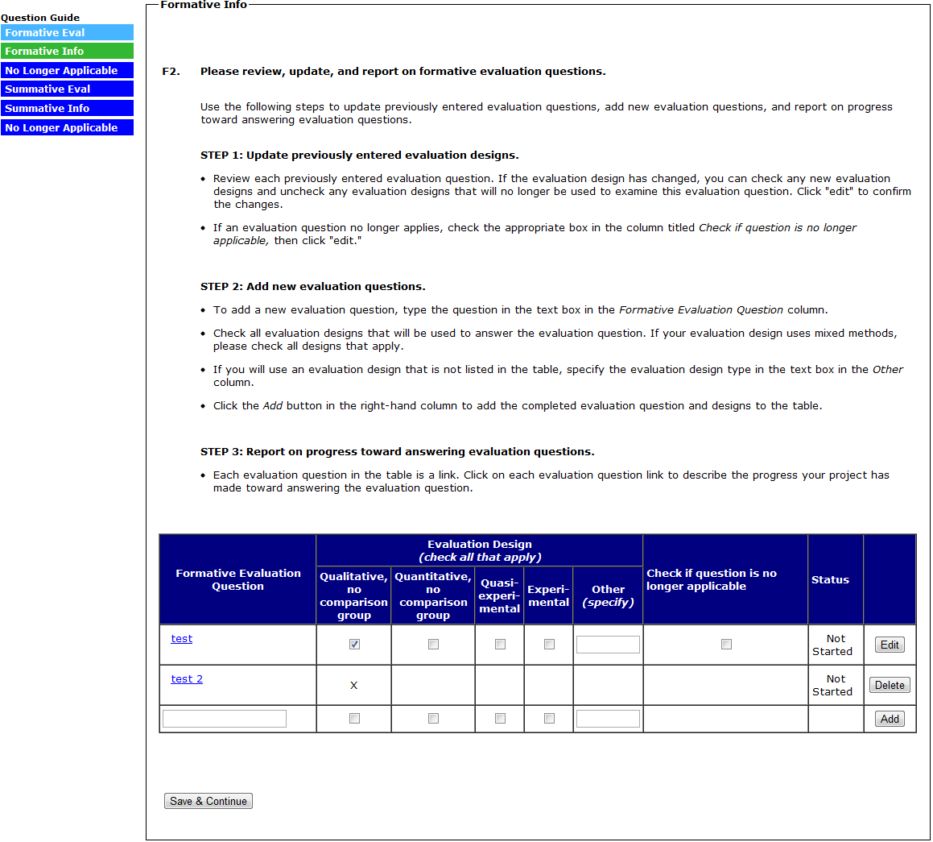
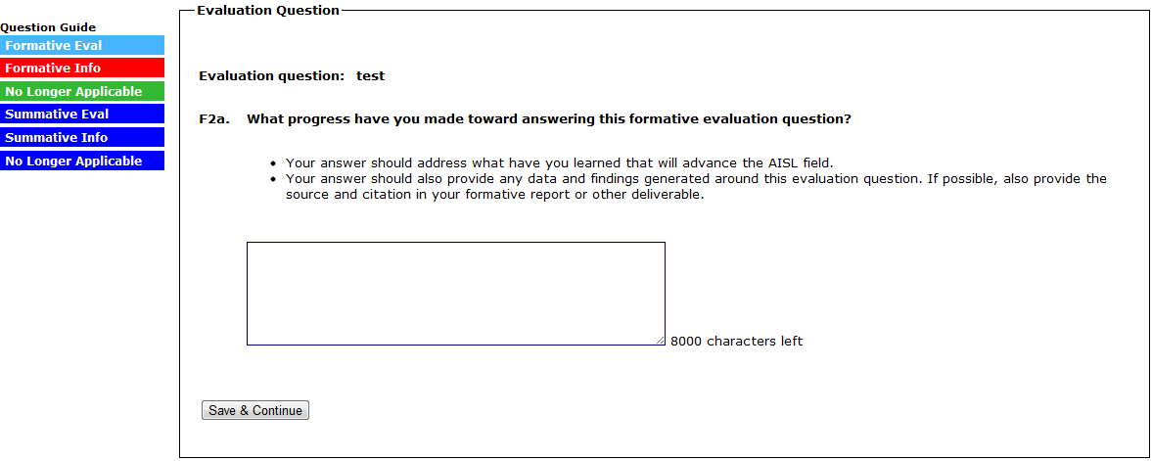
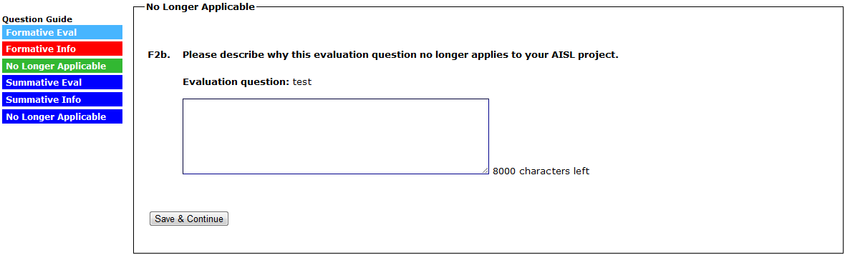
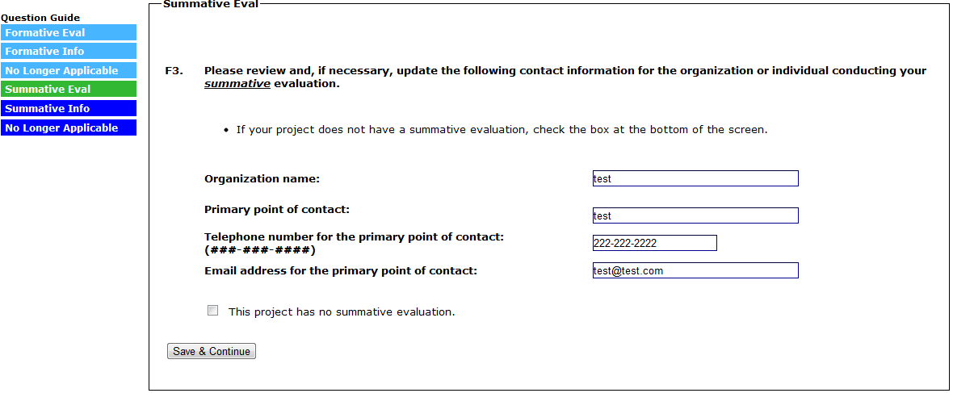
(SELECTING “THIS PROJECT HAS NO SUMMATIVE EVALUATION” WILL SKIP TO A SUBMIT PAGE FOR SECTION F)

(SELECT EACH EVALUATION QUESTION IN THE “SUMMATIVE EVALUATION QUESTION” COLUMN TO ANSWER F4A. FOR EACH EVALUATION QUESTION MARKED IN THE “CHECK IF QUESTION IS NO LONGER APPLICABLE” COLUMN, ANSWER F4B)
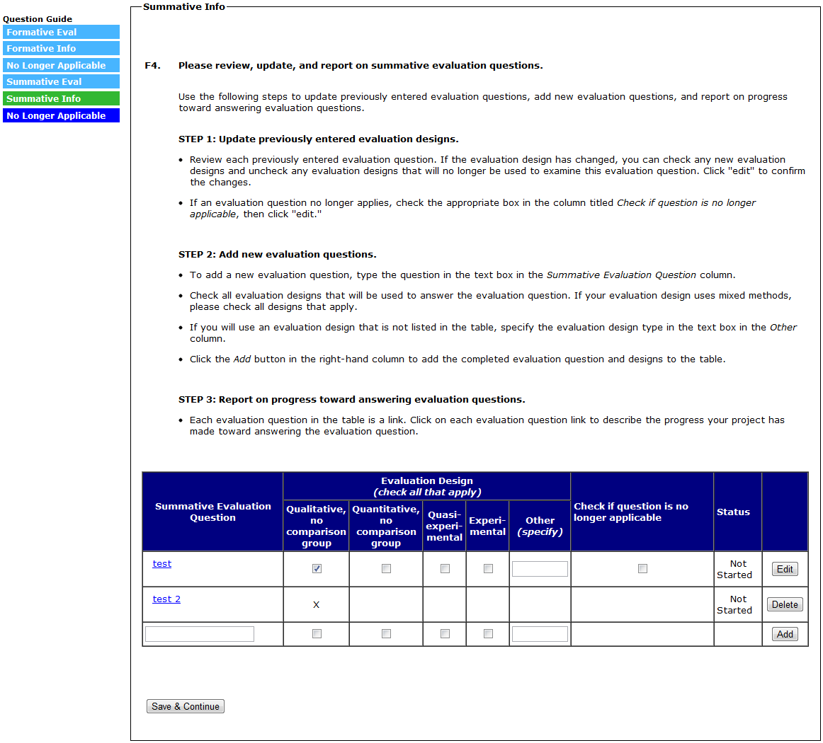

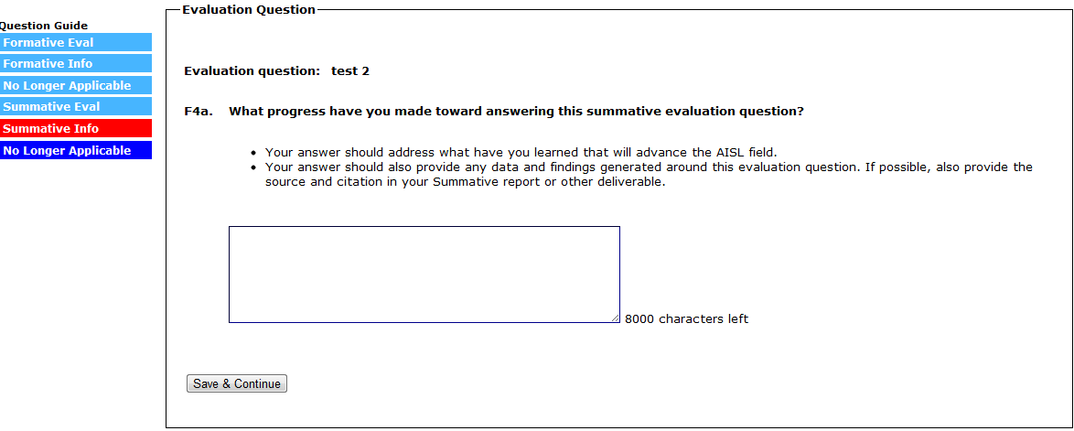
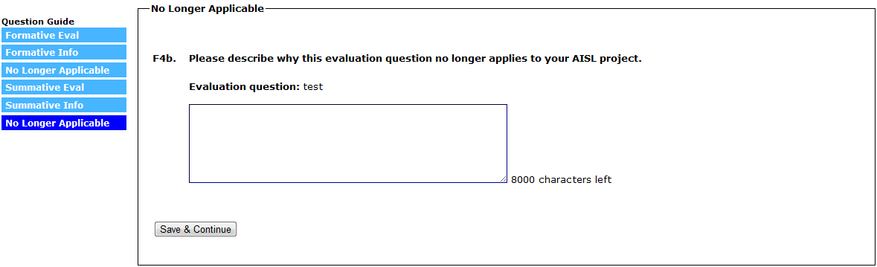
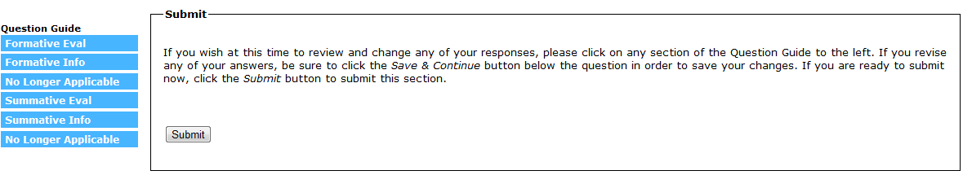
(SELECT “SUBMIT” TO SUBMIT SECTION F AND RETURN TO THE SECTION MENU)

Section G: Project Accomplishments and Lessons Learned

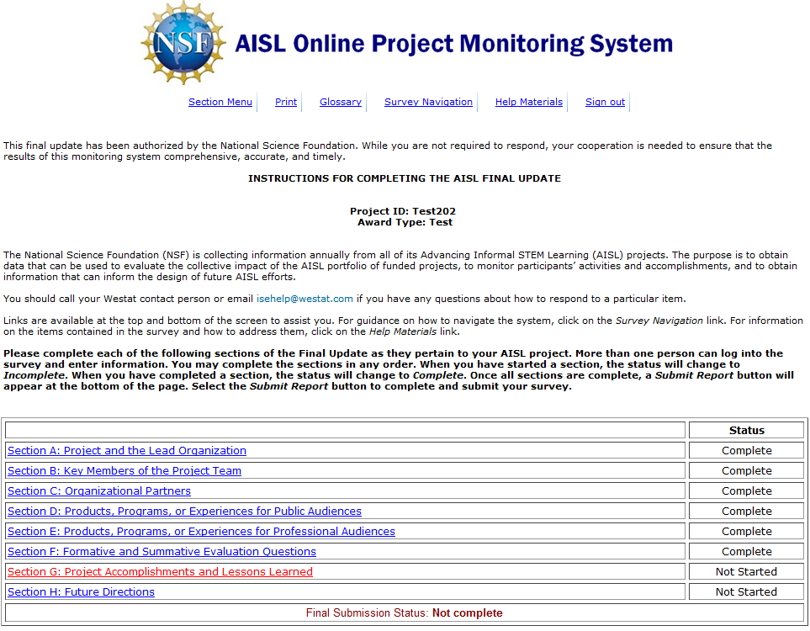

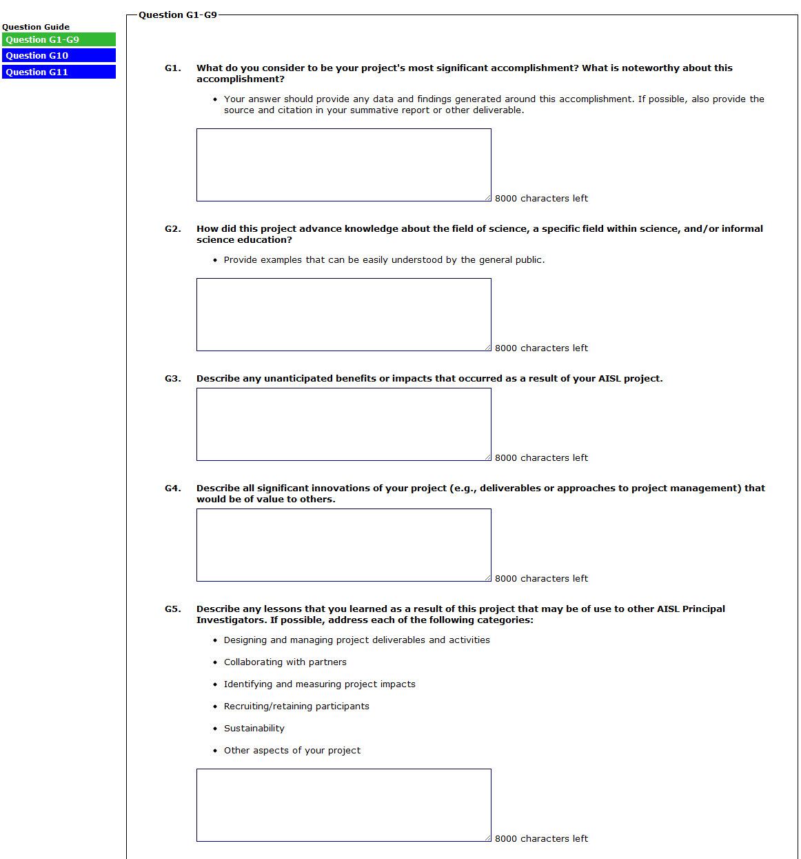
(CONTINUED ON NEXT PAGE)

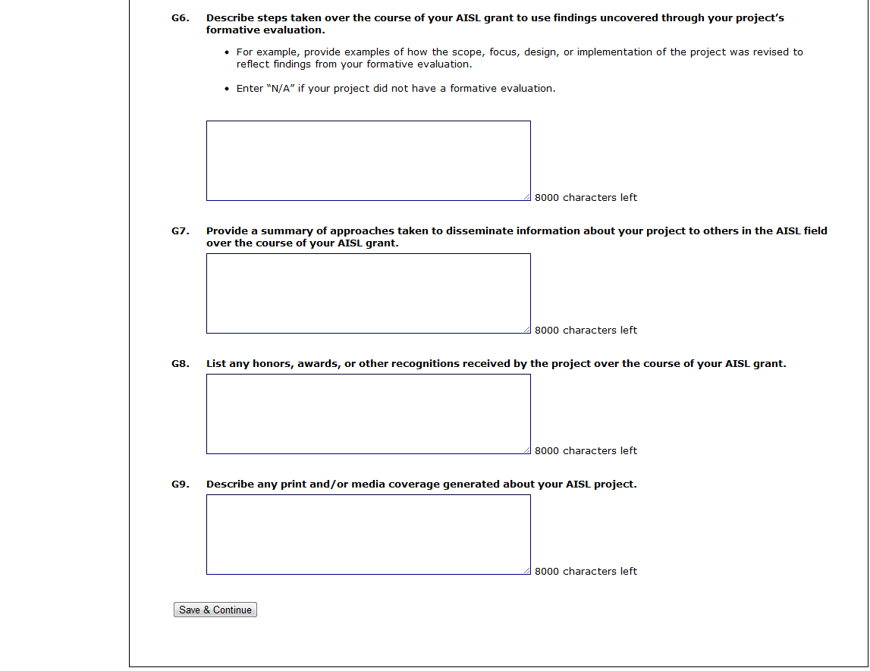

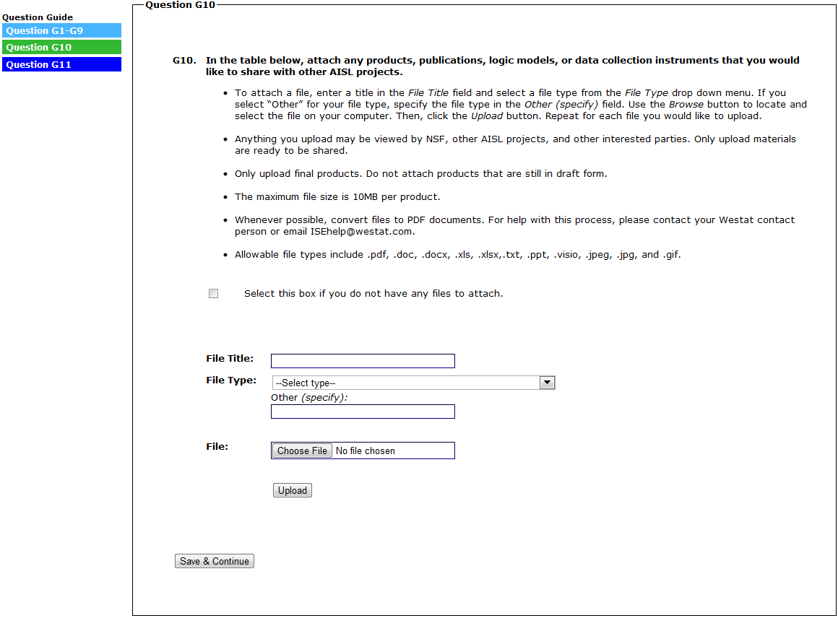
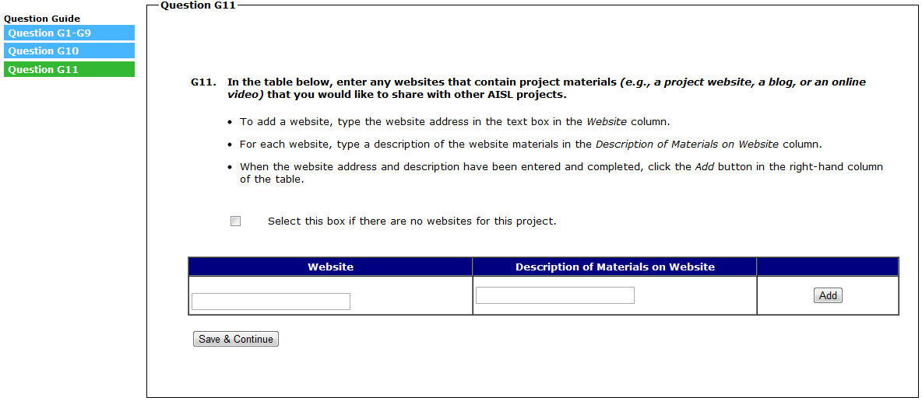
(SELECT “SAVE & CONTINUE” TO SUBMIT SECTION G AND RETURN TO THE SECTION MENU)

Section H: Future Directions

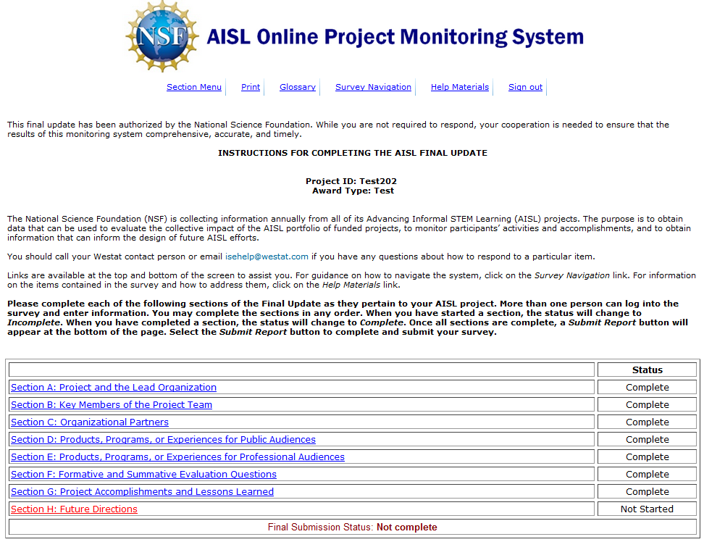

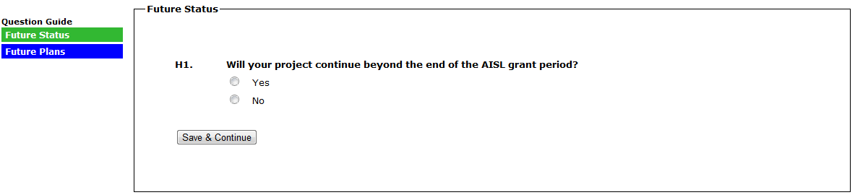
(IF THE RESPONSE TO H1 IS “YES,” ANSWER H2A)
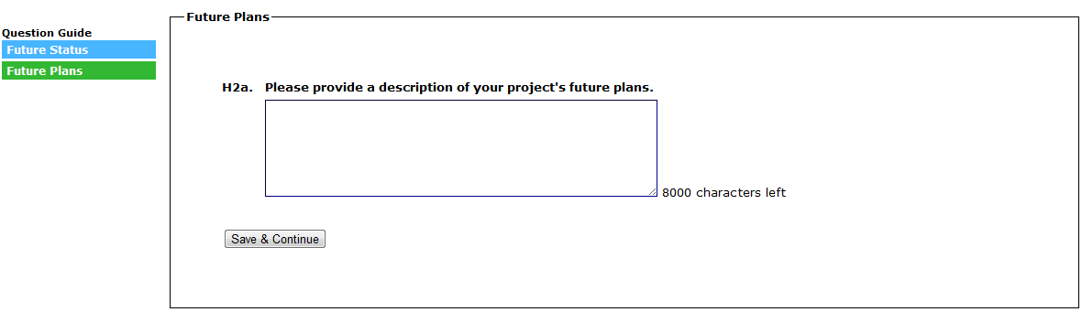
(IF THE RESPONSE TO H1 IS “NO,” ANSWER H2B)
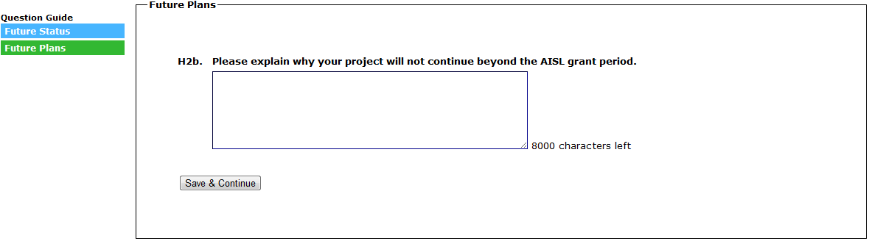
(SELECT “SAVE & CONTINUE” TO SUBMIT SECTION H AND RETURN TO THE SECTION MENU)

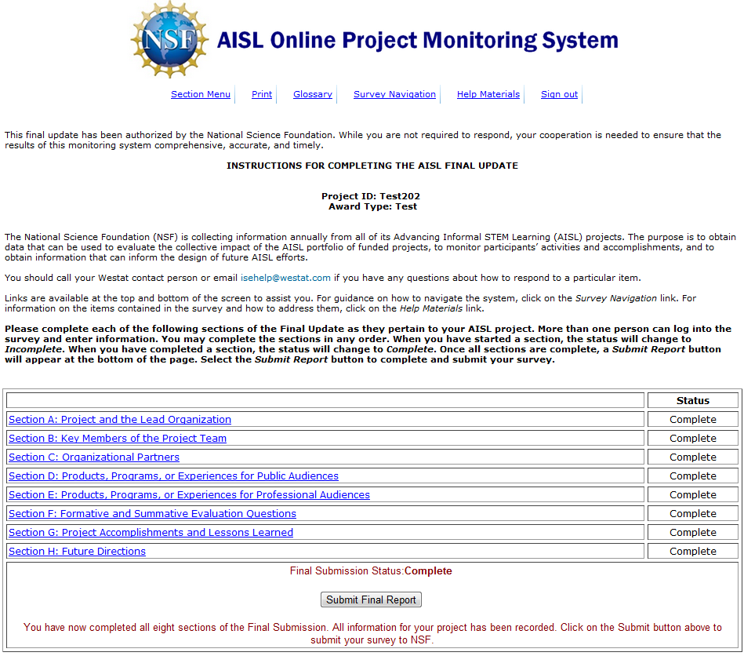
(SELECT “SUBMIT FINAL REPORT” TO SUBMIT THE REPORT)

