Please enter your survey code: _____
Coastal communities are facing ongoing threats from coastal hazards, such as storms and flooding. These hazards have many effects, including flooded or damaged homes and buildings, erosion, and loss of beaches, dunes, and coastal wetlands. Hurricane Sandy is a recent example. Scientists expect these threats to continue in the future.
There are many ways that coastal communities can respond to the risks of coastal storms and flooding, but all of these involve tradeoffs. This survey asks for your opinion about these tradeoffs. The goal of the survey is to identify the type of policies that would be supported by you and others in your region. Your answers will be compiled with those of other respondents and sent to local officials to help them decide how to best protect your community.
This research study is being conducted by _____ on behalf of the National Oceanic and Atmospheric Administration (NOAA). Your participation is voluntary and you may stop at any time. The survey will take approximately 20 minutes to complete. You will not be individually identified and your responses will be used for statistical purposes only. If you have questions about your rights as a participant in this survey, or are dissatisfied at any time with any aspect of the survey, you may contact _____.

RISKS AND ADAPTATION
- Please indicate how strongly you agree or disagree that the following are major problems facing your community.
[scale: strongly disagree, disagree, neither, agree, strongly agree]
  - Coastal storms
  - Coastal flooding
  - Riverine flooding
  - Shoreline erosion
- Please indicate whether you think the following will increase or decrease in the next 10 years.
[scale: decrease, stay about the same, increase, unsure]
  - Coastal storms
  - Coastal flooding
  - Riverine flooding
  - Shoreline erosion
- Do you own or rent property on a shoreline?
  - Yes
  - No
- Has your home or property suffered damage from the following in the past five years?
[scale: yes, no, unsure]
  - Coastal storms
  - Coastal flooding
  - Riverine flooding
  - Shoreline erosion
- [IF 3=TRUE] Have any of the following been done on your home or property in the past five years?
[scale: yes, no]
- Install shoreline walls or riprap (rocky material placed along a shoreline)
- Plant, restore, or preserve the natural shoreline
- Put all or part of your property into a conservation easement
- Improve drainage (e.g., drainage ditches/pipes)
- Raise all or part of your house
- Install wet floodproofing (e.g., flood vents)
- Install sump pumps
- [IF 3=TRUE] How likely are you to do any of the following on your home or property in the next 10 years?
[scale: not at all, slightly, moderately, very, extremely]
- Install shoreline walls or riprap (rocky material placed along a shoreline)
- Plant, restore, or preserve natural shoreline
- Put all or part of your property into a conservation easement
- Improve drainage (e.g., drainage ditches/pipes)
- Raise all or part of your house
- Install wet floodproofing (e.g., flood vents)
- Install sump pumps
- Move away
- [IF 3=TRUE] To what degree would the following factors make you more likely to install shoreline walls or riprap on your home or property?
[scale: no effect, minor effect, moderate effect, major effect]
- Effectiveness at reducing coastal flooding damage
- Effectiveness at reducing shoreline erosion damage
- My or my family’s attachment to the property
- Municipal or state regulations and ordinances
- If my neighbors have installed shoreline walls or riprap
- The way shoreline walls or riprap look
- Cost of installing shoreline walls or riprap
- [IF 3=TRUE] To what degree would the following factors make you more likely to plant, restore, or preserve the natural shoreline on your home or property?
[scale: no effect, minor effect, moderate effect, major effect]
- Effectiveness at reducing coastal flooding damage
- Effectiveness at reducing shoreline erosion damage
- My or my family’s attachment to the property
- Municipal or state regulations and ordinances
- If my neighbors have planted, restored, or preserved the natural shoreline
- The way the natural shoreline looks
- Cost of planting, restoring, or preserving the natural shoreline
- Buffer lands are naturally vegetated areas surrounding water bodies. The following is a list of potential policies or ordinances that could be implemented to better manage buffer lands in New Hampshire. How supportive would you be of each potential policy or ordinance?
[scale: strongly opposed, opposed, neither, supportive, strongly supportive]
  - Limit fertilizer and pesticide use within buffer lands
  - Restrict new development within buffer lands (development setback)
  - Restrict the cutting or removal of natural vegetation within buffer lands
  - Purchase buffer lands for conservation by public or private organizations
  - Reduce property taxes on privately owned buffer lands
- How often do you use the following methods to get information on local environmental issues?
[scale: never, rarely, sometimes, often, always]
- Newspapers, other print publications
- TV
- Websites/apps for news outlets
- Social media
- Directly from people (e.g., friends, family, neighbors)
- Community bulletin board
- An organized educational workshop or meeting
- How credible do you consider these informational sources on local environmental issues?
[scale: not at all, slightly, moderately, very, extremely]
- Local government
- State government
- Federal government
- Non-profit organizations
- Academic institutions
WHAT IS MOST IMPORTANT TO YOU?
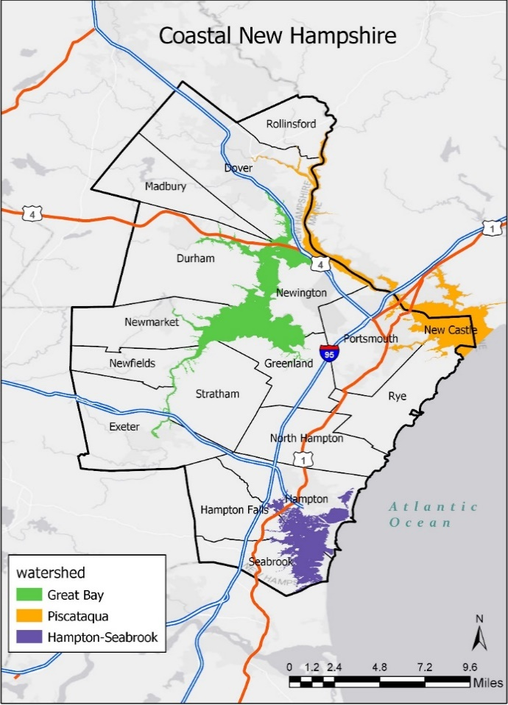
This and the following section refer to coastal New Hampshire, which is defined by the seventeen coastal zone communities shown in the map below. Regardless of how familiar you are with coastal New Hampshire, your opinions are important to us.

- Are you a seasonal or year-round resident of coastal New Hampshire?
  - Seasonal resident (I live in coastal New Hampshire only part of the year)
  - Year-round resident (I live in coastal New Hampshire all year)
  - Neither (I do not live in coastal New Hampshire during any part of the year)
- [IF #12.c = TRUE] Have you ever visited coastal New Hampshire?
  - Yes
  - No
- [IF 12.a = TRUE OR 12.b = TRUE OR 13 = TRUE] Please state your level of agreement or disagreement with the following statements about coastal New Hampshire.
[scale: strongly disagree, disagree, neither, agree, strongly agree]
- I feel coastal New Hampshire is a part of me
- I identify strongly with coastal New Hampshire
- Coastal New Hampshire means a lot to me
- Coastal New Hampshire is the best place for the activities I like to do
- No other place can compare to coastal New Hampshire
- I enjoy activities in coastal New Hampshire more than in any other place
- Coastal New Hampshire contributes to the character of my community
- My community’s history is strongly tied to coastal New Hampshire
- Coastal New Hampshire helped put my community on the map
- I feel a strong sense of community in coastal New Hampshire
- I feel connected to the other people who live in coastal New Hampshire
- I would feel less attached to coastal New Hampshire if the native plants and animals that live here disappeared
- I learn a lot about myself when spending time in the natural environment in coastal New Hampshire
- It is important to protect the natural environment in coastal New Hampshire
COMPARING MANAGEMENT OPTIONS
There are many different ways to manage estuarine and coastal shorelines in coastal New Hampshire. The most common approaches used by coastal communities are (1) hard defenses or armoring and (2) soft or natural defenses.
Hard defenses include the use of coastal armoring such as seawalls and bulkheads to hold back the sea. Roads and bridges can be raised to prevent flooding. Buildings can be retrofit, for example by raising them on pilings.
Advantages: Compared to other approaches, hard defenses often provide the most effective protection for homes, facilities and transportation.
Disadvantages: Hard defenses can be costly to build and maintain. Extreme floods can breach these defenses. While hard defenses can sometimes be used to maintain beaches, wetlands and other natural areas, they can also cause natural areas to be lost.
How can hard defenses cause the loss of natural areas? As waters rise, natural areas can be squeezed between the water and hard defenses. Hard defenses can also deflect wave energy onto other natural or developed areas. So natural areas can be flooded or washed away.
Soft defenses include beaches, dunes, wetlands and other natural areas that have the ability to absorb and slow floodwaters. Increasing soft defenses requires preservation and restoration of natural areas. It can also require restrictions on coastal development.
Advantages: Soft defenses can provide effective protection for homes, facilities and transportation. They also preserve beaches, wetlands and other natural areas as habitat and public amenities.
Disadvantages: Compared to hard defenses, soft defenses often provide less effective protection for homes, facilities and transportation. Some flooding can still occur in severe storms.
- When considering options to manage coastal New Hampshire shorelines, how important to you are each of the following?
[scale: not at all, slightly, moderately, very, extremely]
- Private homes and property are protected
- Government respects the right of private landowners to use and develop their land
- Recreational areas such as beaches and parks are protected
- Natural areas and habitat are protected
- The natural character of the waterfront is maintained
- Taxes and fees paid by my household do not increase
- Facilities such as police stations and schools are protected
- Roads and transportation facilities are protected
- Loss of human life is avoided
- Public services, such as electricity, water, and telephone, are protected
- Flood insurance rates paid by homeowners do not increase
This rest of this section will ask you to indicate your level of support or opposition to six different management policies. The technical details of each policy (for example, how/where to build a particular seawall or restore wetlands) would be determined by experts. Questions will look similar to the example below:
The proposed policy would...
Increase | the amount of wetlands covered by vegetation
Maintain | the amount of beach covered by sand dunes
Maintain | the amount of shoreline shielded by seawalls and coastal armoring
Decrease | the number of homes protected from flooding during a storm
Increase | the rate of shoreline erosion
The funds to implement this policy would come from ONLY residents of coastal New Hampshire

How supportive would you be of this proposed policy?
1 | 2 | 3 | 4 | 5 | 6 | 7 | 8 | 9
Strongly opposed |  |  |  |  |  |  |  | Strongly supportive
Please review each policy carefully. The results of this survey will be given to policy makers in coastal New Hampshire to help determine future actions.

The proposed policy would...
Increase | the amount of wetlands covered by vegetation
Maintain | the amount of beach covered by sand dunes
Maintain | the amount of shoreline shielded by seawalls and coastal armoring
Decrease | the number of homes protected from flooding during a storm
Increase | the rate of shoreline erosion
The funds to implement this policy would come from ONLY residents of coastal New Hampshire

How supportive would you be of this proposed policy?
1 | 2 | 3 | 4 | 5 | 6 | 7 | 8 | 9
Strongly opposed |  |  |  |  |  |  |  | Strongly supportive

The proposed policy would...
Decrease | the amount of wetlands covered by vegetation
Increase | the amount of beach covered by sand dunes
Maintain | the amount of shoreline shielded by seawalls and coastal armoring
Increase | the number of homes protected from flooding during a storm
Maintain | the rate of shoreline erosion
The funds to implement this policy would come from ONLY residents of coastal New Hampshire

How supportive would you be of this proposed policy?
1 | 2 | 3 | 4 | 5 | 6 | 7 | 8 | 9
Strongly opposed |  |  |  |  |  |  |  | Strongly supportive

The proposed policy would...
Maintain | the amount of wetlands covered by vegetation
Increase | the amount of beach covered by sand dunes
Decrease | the amount of shoreline shielded by seawalls and coastal armoring
Maintain | the number of homes protected from flooding during a storm
Increase | the rate of shoreline erosion
The funds to implement this policy would come from ONLY residents of coastal New Hampshire

How supportive would you be of this proposed policy?
1 | 2 | 3 | 4 | 5 | 6 | 7 | 8 | 9
Strongly opposed |  |  |  |  |  |  |  | Strongly supportive

The proposed policy would...
Maintain | the amount of wetlands covered by vegetation
Maintain | the amount of beach covered by sand dunes
Increase | the amount of shoreline shielded by seawalls and coastal armoring
Increase | the number of homes protected from flooding during a storm
Decrease | the rate of shoreline erosion
The funds to implement this policy would come from ONLY residents of coastal New Hampshire

How supportive would you be of this proposed policy?
1 | 2 | 3 | 4 | 5 | 6 | 7 | 8 | 9
Strongly opposed |  |  |  |  |  |  |  | Strongly supportive

The proposed policy would...
Increase | the amount of wetlands covered by vegetation
Decrease | the amount of beach covered by sand dunes
Increase | the amount of shoreline shielded by seawalls and coastal armoring
Maintain | the number of homes protected from flooding during a storm
Maintain | the rate of shoreline erosion
The funds to implement this policy would come from ONLY residents of coastal New Hampshire

How supportive would you be of this proposed policy?
1 | 2 | 3 | 4 | 5 | 6 | 7 | 8 | 9
Strongly opposed |  |  |  |  |  |  |  | Strongly supportive

The proposed policy would...
Decrease | the amount of wetlands covered by vegetation
Decrease | the amount of beach covered by sand dunes
Decrease | the amount of shoreline shielded by seawalls and coastal armoring
Decrease | the number of homes protected from flooding during a storm
Decrease | the rate of shoreline erosion
The funds to implement this policy would come from ONLY residents of coastal New Hampshire

How supportive would you be of this proposed policy?
1 | 2 | 3 | 4 | 5 | 6 | 7 | 8 | 9
Strongly opposed |  |  |  |  |  |  |  | Strongly supportive
- Please indicate how strongly you agree or disagree with the following statements.
[scale: strongly disagree, disagree, neither, agree, strongly agree]
- The survey provided enough information for me to make informed choices
- I feel confident about my answers
- It is important to manage estuarine and coastal lands in coastal New Hampshire, no matter how high the costs.
- I am against any more regulations and government spending.
- My household should not have to pay any amount to manage estuarine and coastal lands in coastal New Hampshire.
- My support levels would be the same if this were a public vote or referendum
- [IF #16 >=6 or C OR #17 >=6 or C OR #18 >=6 or C OR #19>=6 OR #20>=6 OR #21>=6] Thinking about the proposed policies you were supportive of, please indicate how strongly you agree or disagree with the following statements.
[scale: strongly disagree, disagree, neither, agree, strongly agree]
  - I was supportive of policies that I thought would improve the environment closer to my home.
  - I was supportive of policies more for future generations than for myself.
  - [IF 12c = TRUE] I was supportive of policies because I may visit coastal New Hampshire in the next few years.
  - I was supportive of policies because I believe it is our responsibility to preserve wildlife and habitat in coastal New Hampshire.
  - I was supportive of policies so others could enjoy coastal New Hampshire, rather than for myself.
MAKING SURE EVERYONE IS REPRESENTED
This is the final section of the survey. The following questions ensure that all groups are fairly represented. All answers are confidential.
- What is your sex?
- Male
- Female
- In what year were you born? __________
- Are you Hispanic or Latino?
- Yes
- No
- What is your race? (select all that apply)
- White/Caucasian
- Black/African American
- Asian
- Native Hawaiian/other Pacific Islander
- American Indian/Alaskan Native
- Other, please specify ______
- What is the highest level of education you have completed?
- Less than 9th grade
- 9th to 12th grade, no diploma
- High school graduate (includes equivalency)
- Some college, no degree
- Associate's degree
- Bachelor's degree
- Graduate or professional degree
- Are you currently employed?
- Yes
- No
- What was your annual household income in 2019?
- Less than $10,000
- $10,000 to $19,999
- $20,000 to $29,999
- $30,000 to $39,999
- $40,000 to $49,999
- $50,000 to $59,999
- $60,000 to $74,999
- $75,000 to $99,999
- $100,000 to $149,999
- $150,000 to $199,999
- $200,000 or more
- How long have you been a resident of your current county or town? __________ years
- Do you own or rent your main home?
  - Own
  - Rent
  - Unsure
- How many people, including yourself, live in your household? __________
- How many of these people are at least 18 years old? __________
- Please use the space below for additional comments.

