Appendix L:
Online Survey Formats
Figure F-1. Durham Cigarettes
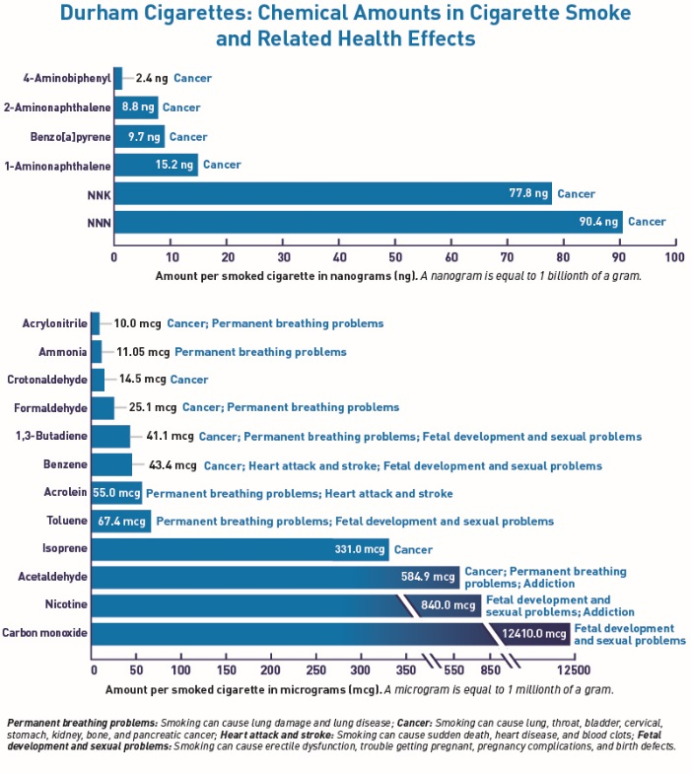

Figure F-2. Chemicals in Smoke
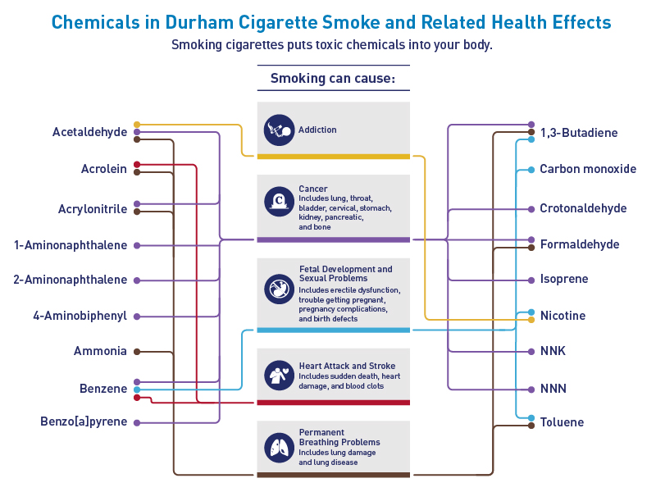

Figure F-3. Durham Cigarettes
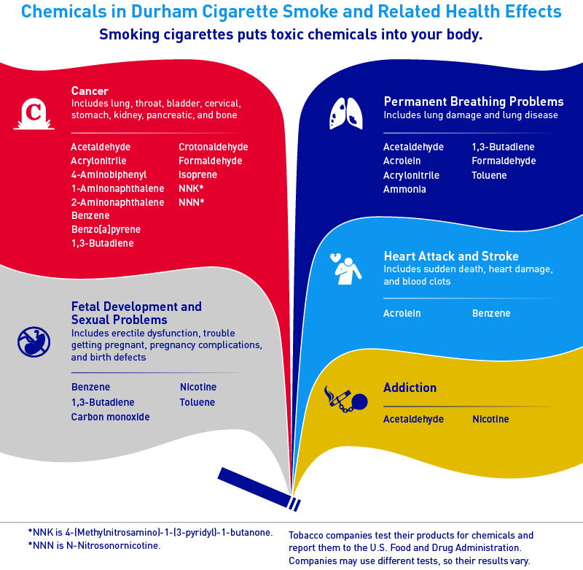

Figure F-4. Durham Cigarettes
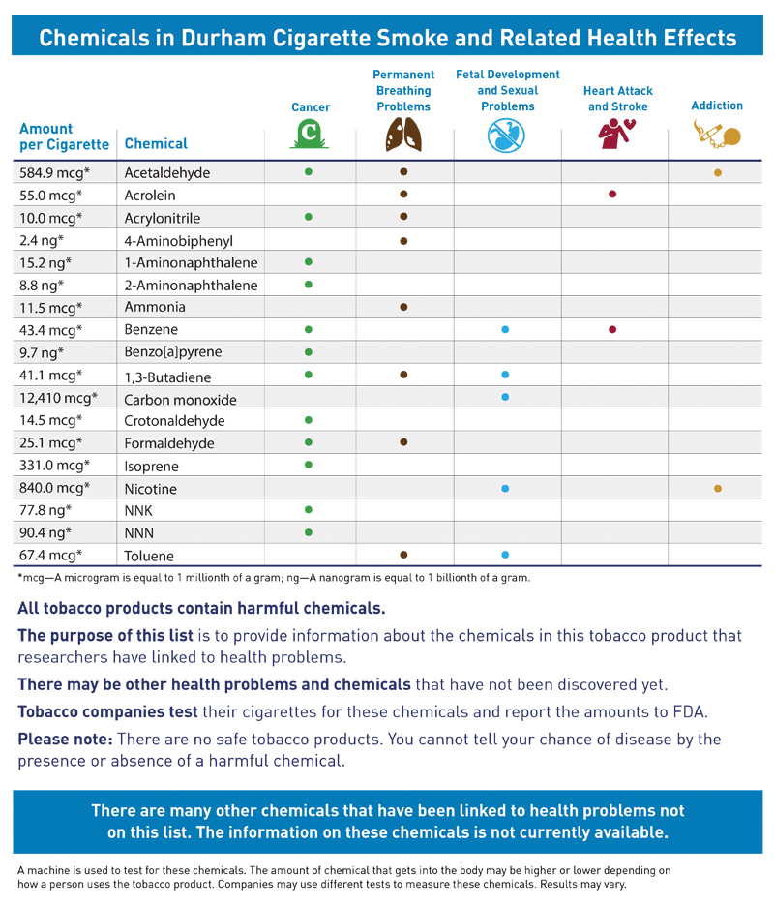
Figure F-5. Chemical Compounds Found in Cigarette Smoke
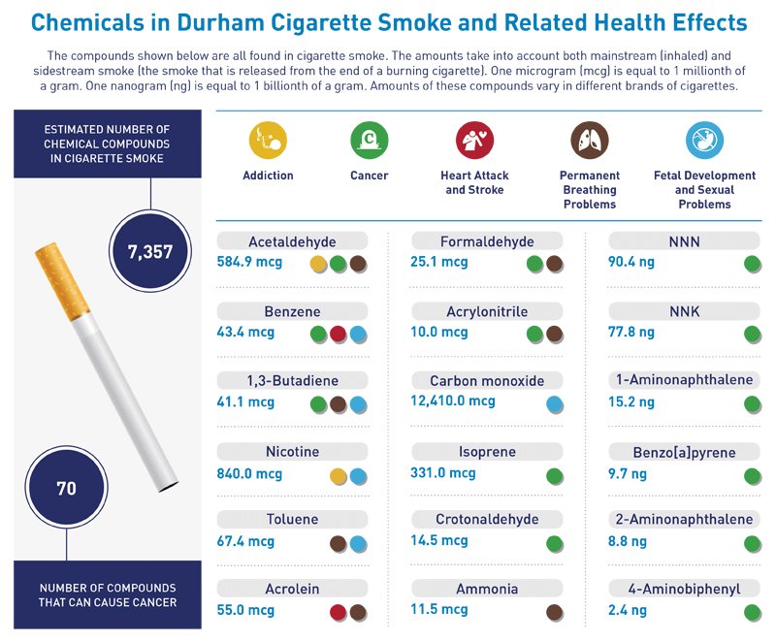

Figure F-6. Wildcard
