Flex PIMS Screenshots of electronic data submission forms
March 20, 2019
These screenshots show all of the information collected in this secure online system. Respondents use the Selection Page to unselect categories that don’t apply to their specific project so respondents only see and report a smaller subset of applicable measures when completing their annual PIMS report.
These screenshots are blinded examples of the reporting system without identifying information. In production the online reporting system reduces burden for respondents by providing a pre-populated list of critical access hospitals for each state.

Form 1, Selection Page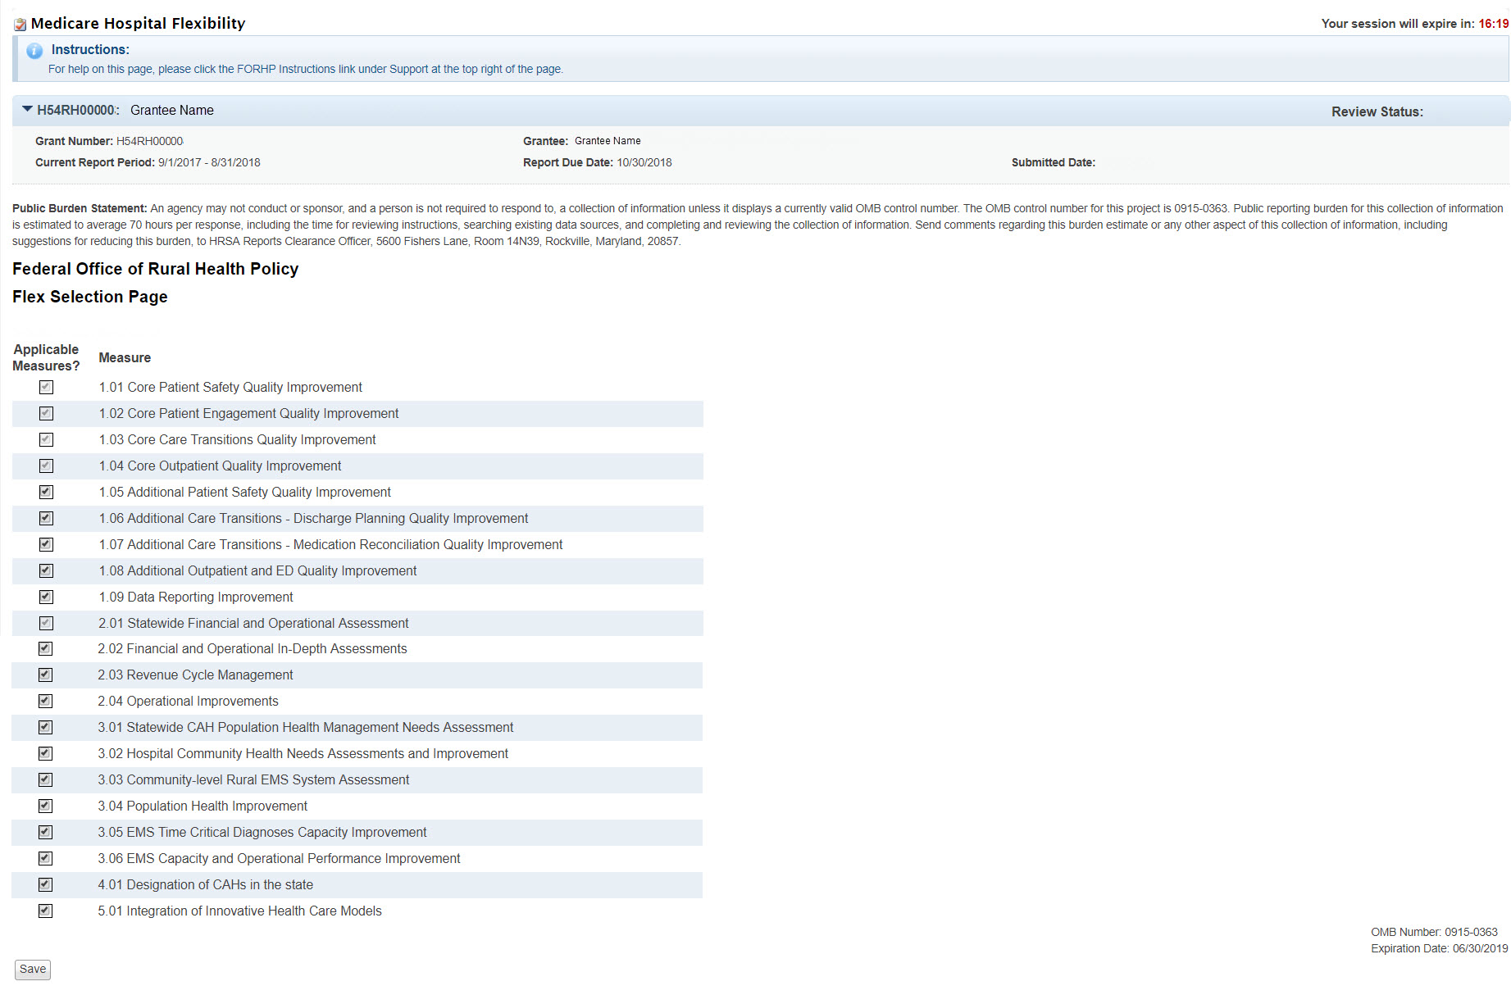
Public burden statement
OMB number
Form 2: Quality Improvement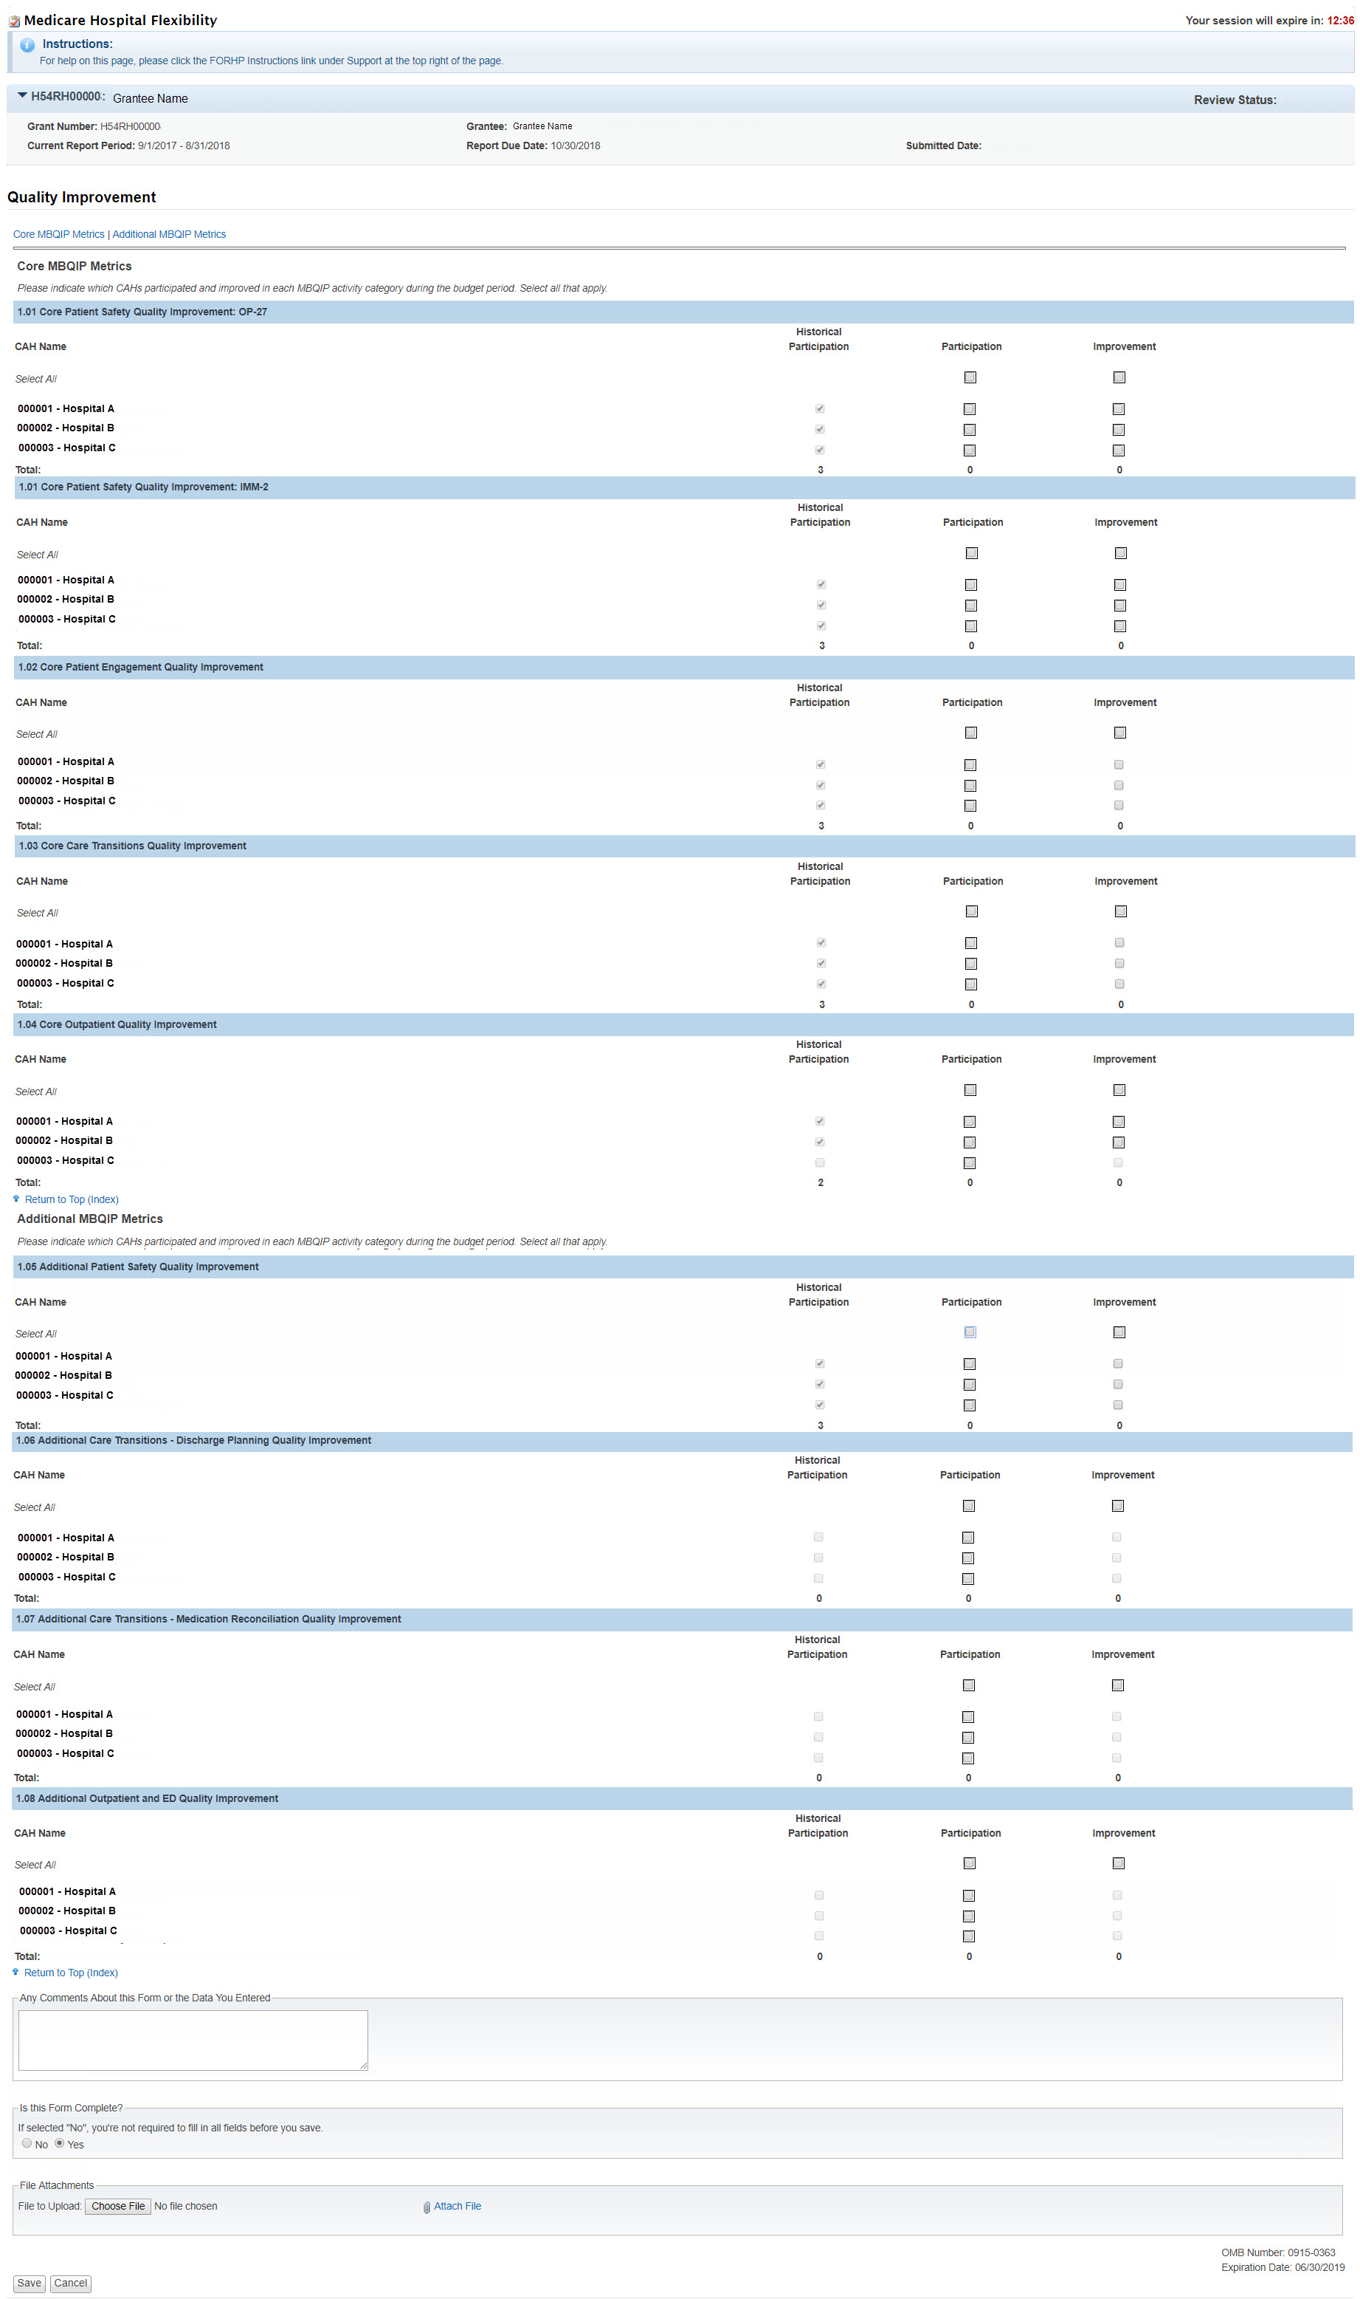
Form 3: Financial and Operations Improvement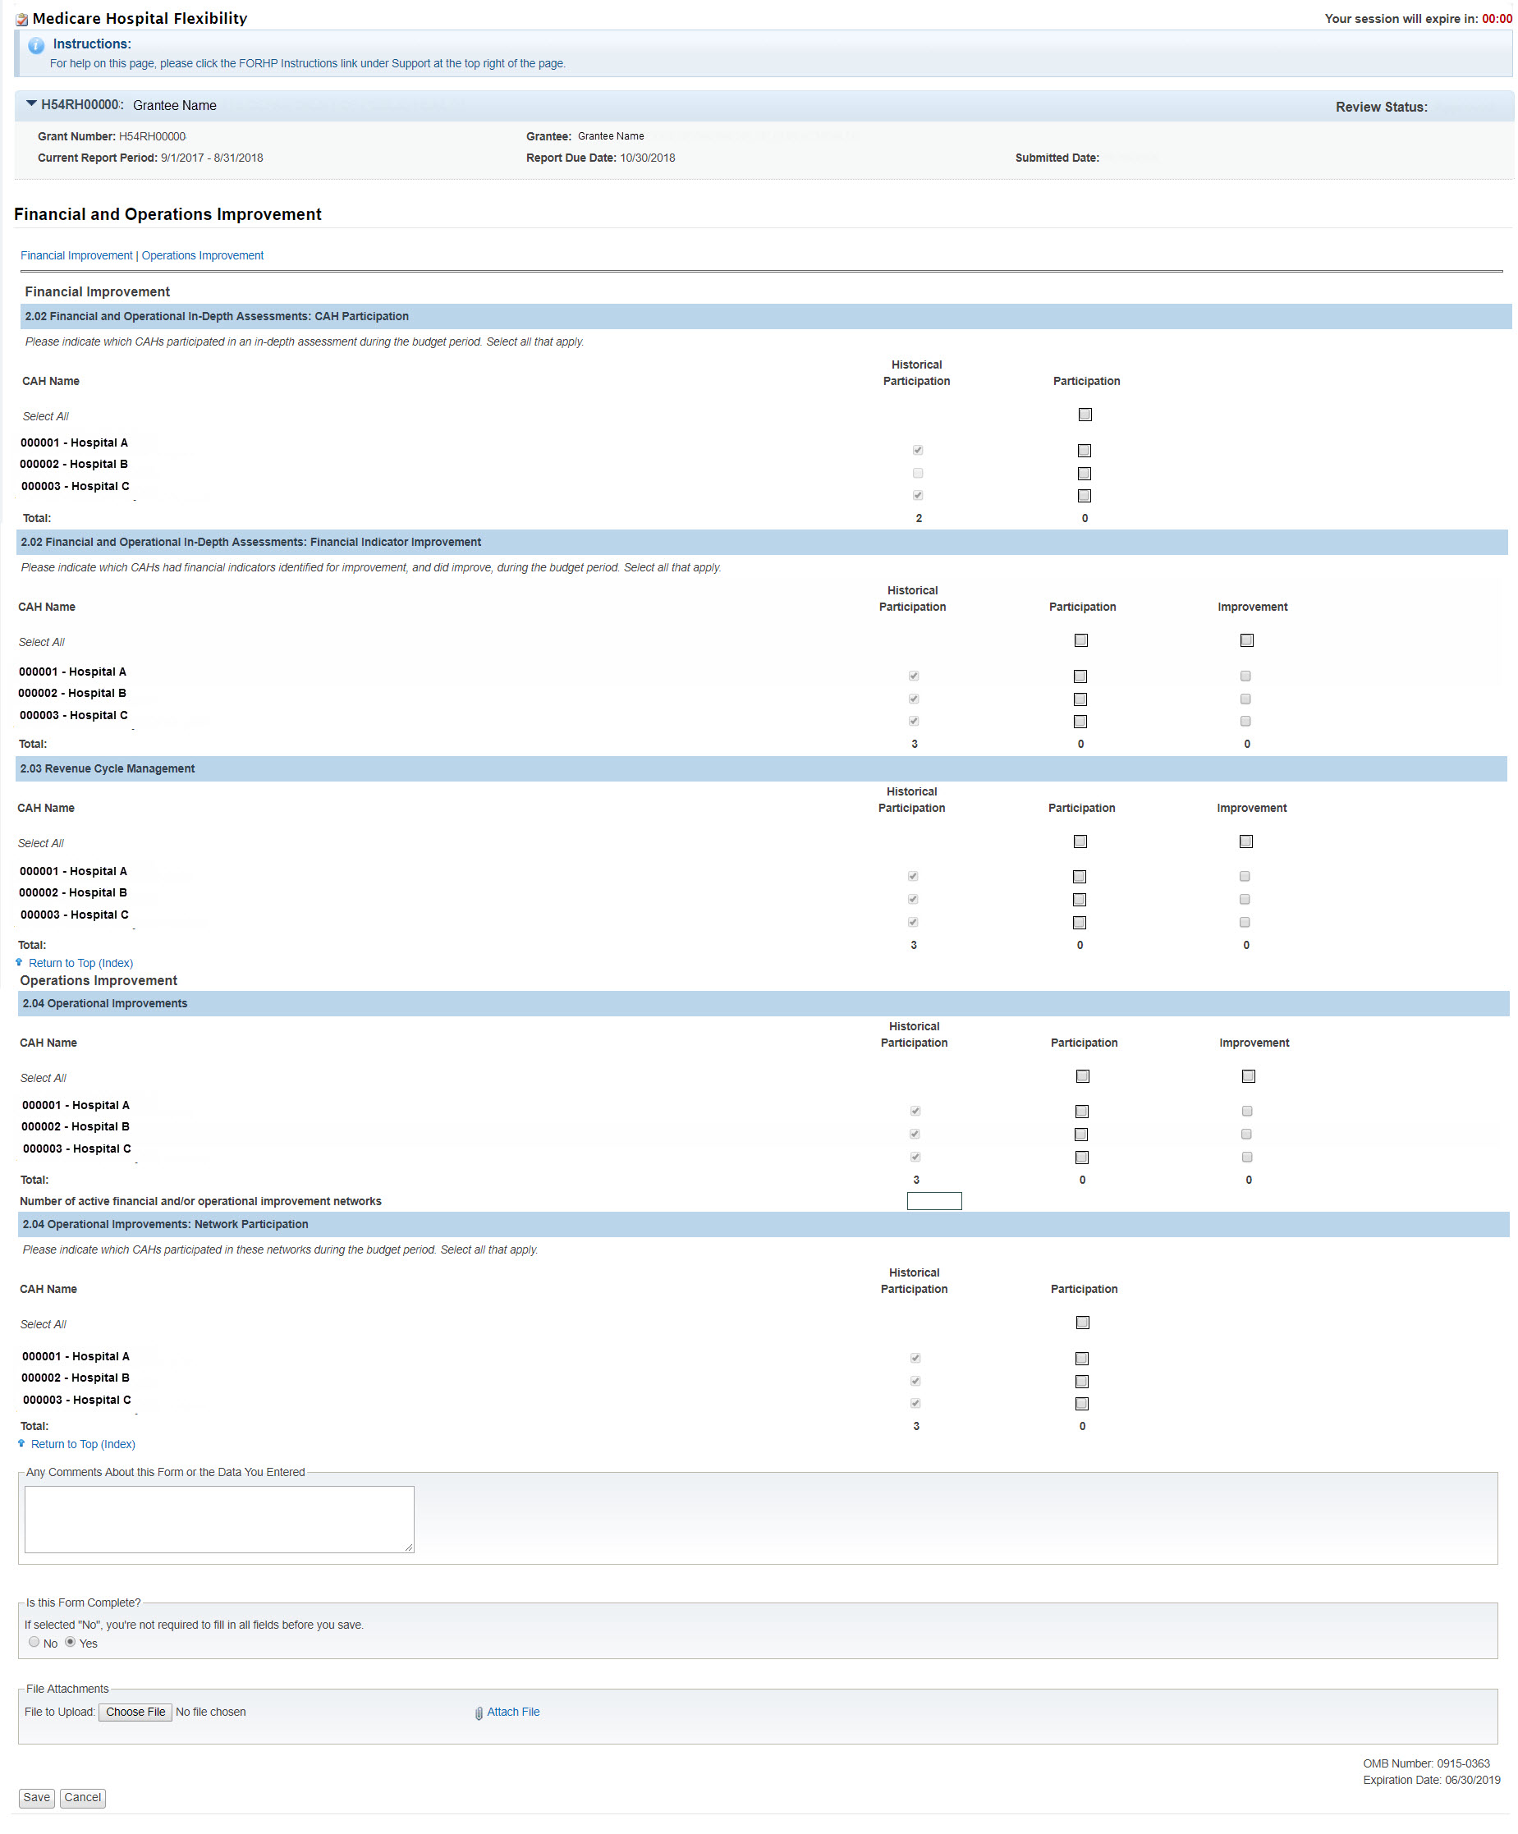

Form 4: Population Health and Emergency Medical Services Integration
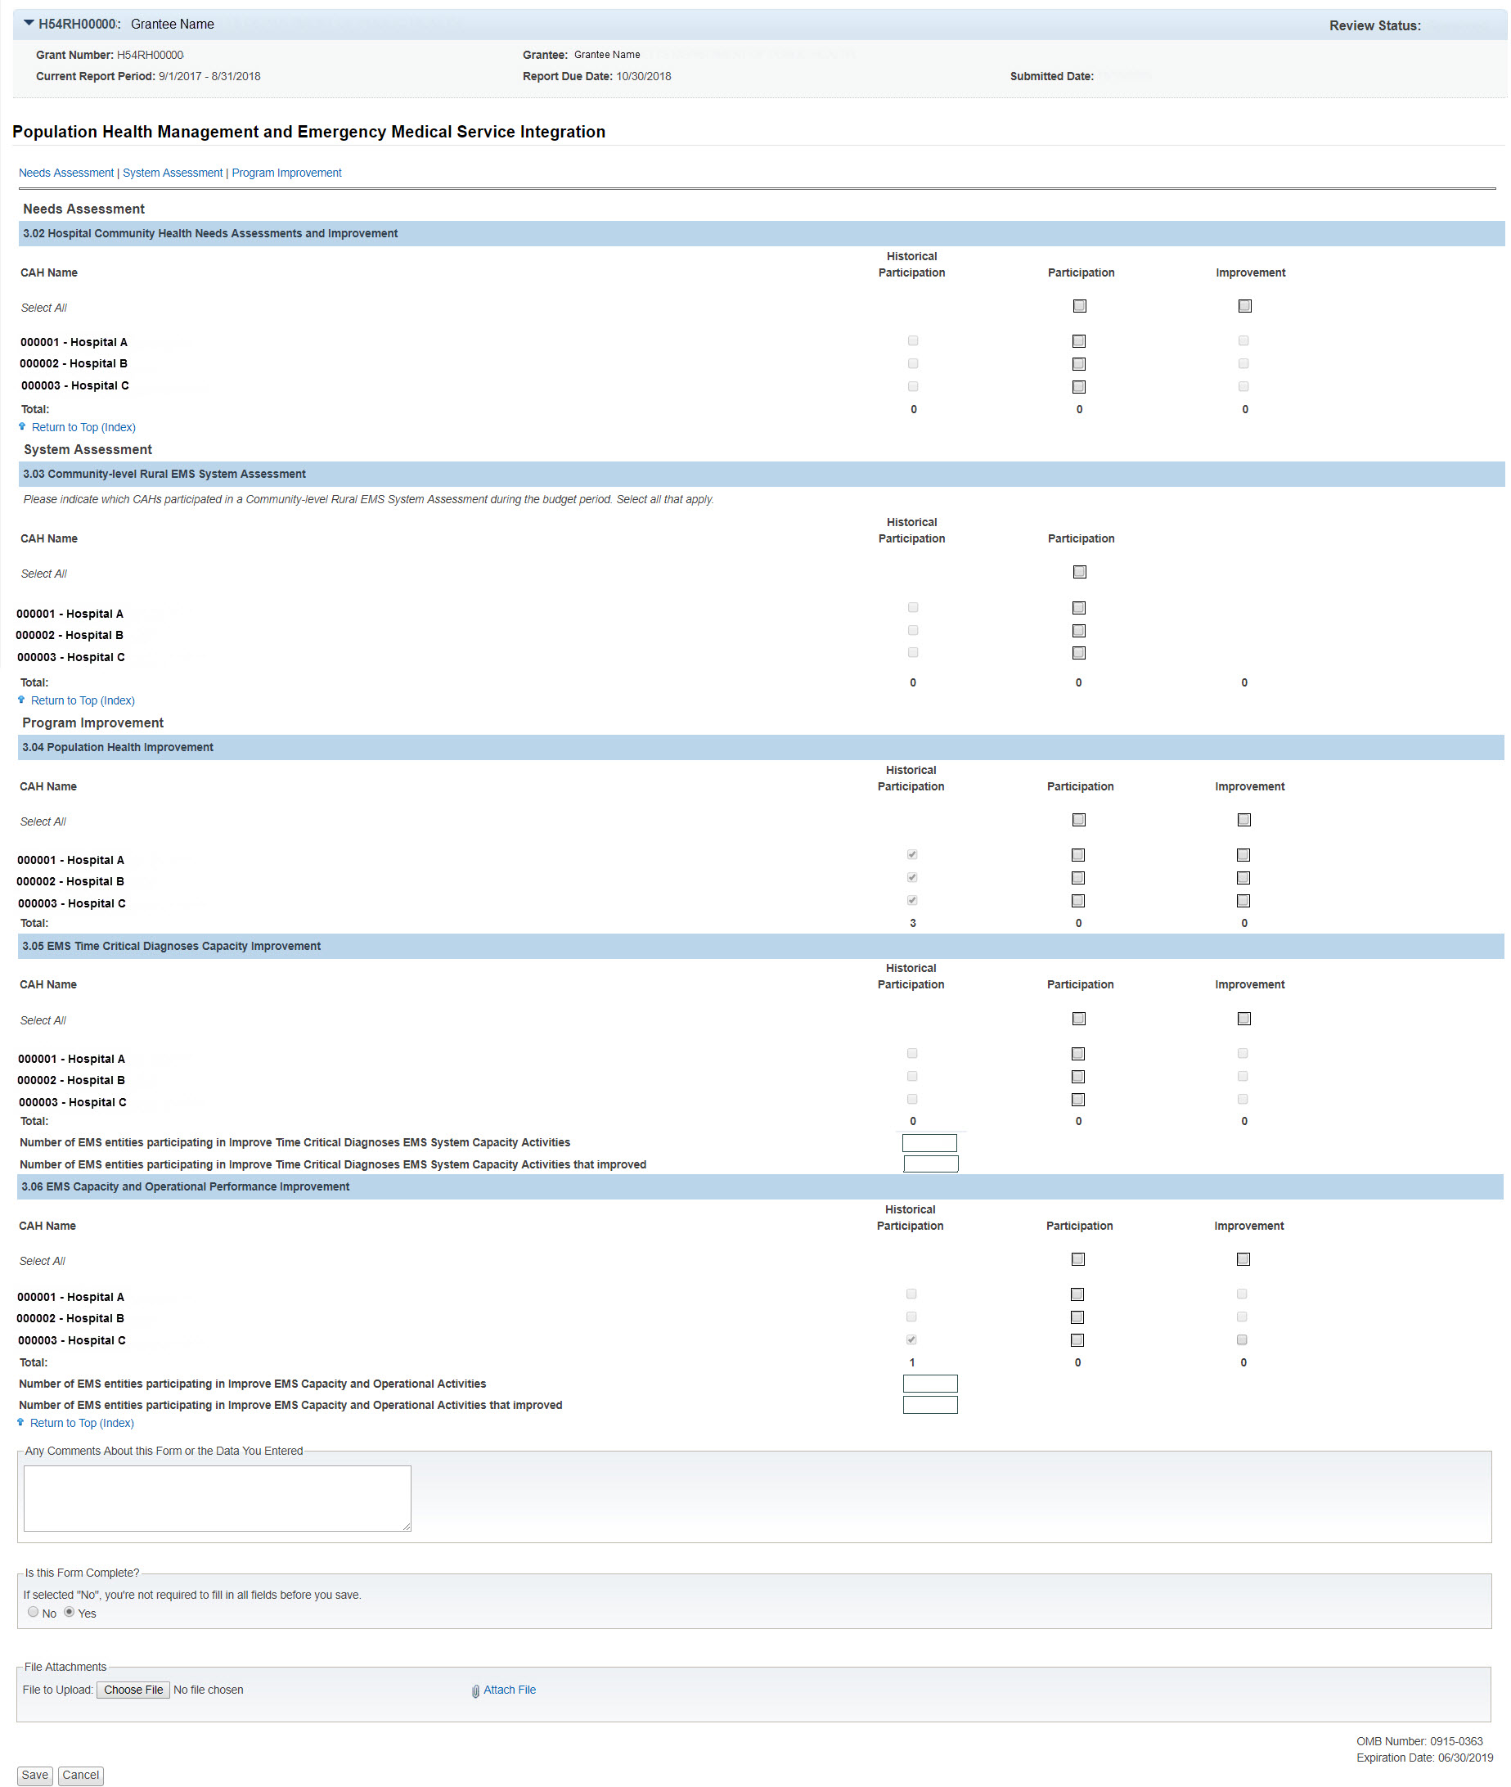

Form 5: CAH Conversion
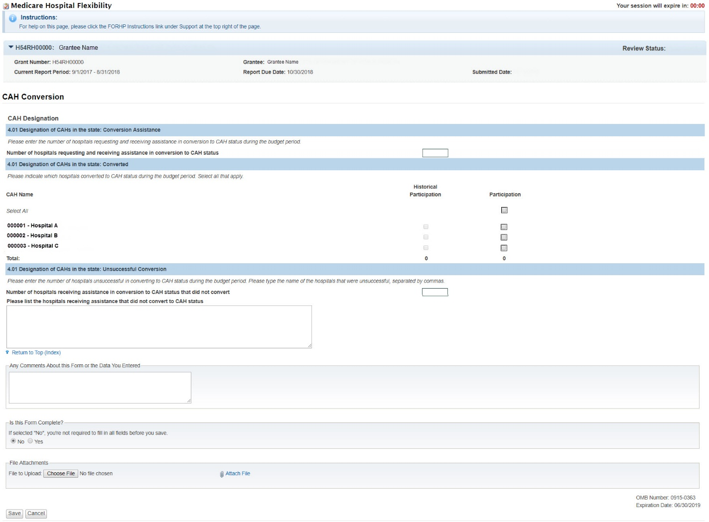

Form 6: Innovative Models of Care
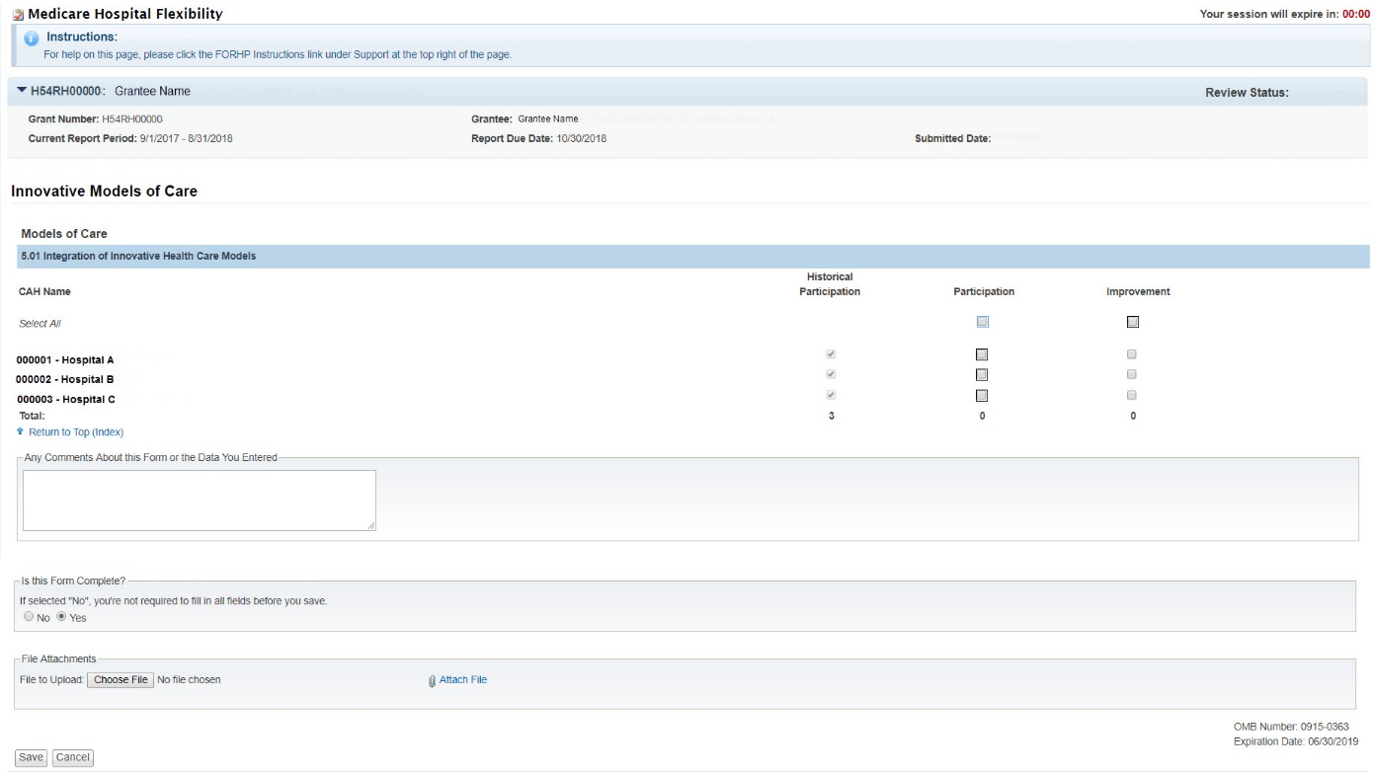

Form 7: Flex Spending
