**Attachment 1 – Screen Shots for Modifications and Additions to the Existing FMS Application Module**

**OMB CONTROL NUMBER 0920-0765**

**FELLOWSHIP MANAGEMENT SYSTEM**

**NON-SUBSTANTIVE CHANGE REQUEST**

**PROPOSED MODIFICATIONS FOR Public Health Associate Program (PHAP)**

**FMS APPLICATION MODULE**

**DATE SUBMITTED: JANAUARY 7, 2019**

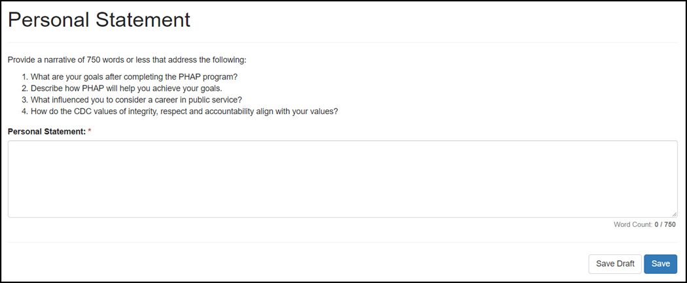

**Question 1-3: Removed and replaced with New Questions:**

1. What makes you a good candidate for PHAP?
2. Describe how PHAP will help you achieve your goals.
3. What influenced you to consider a career in public service?

**Added a New Question:**

4. How do the CDC values of integrity, respect and accountability align with your values?

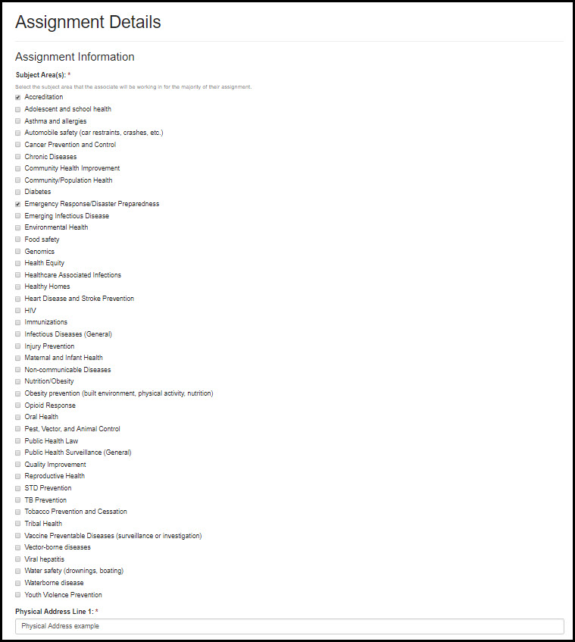

**Previous question asked about Program**

**New Question**: Assignment Information (Subject Area(s))

Select the subject area that the associate will be working in for the majority of the assignment

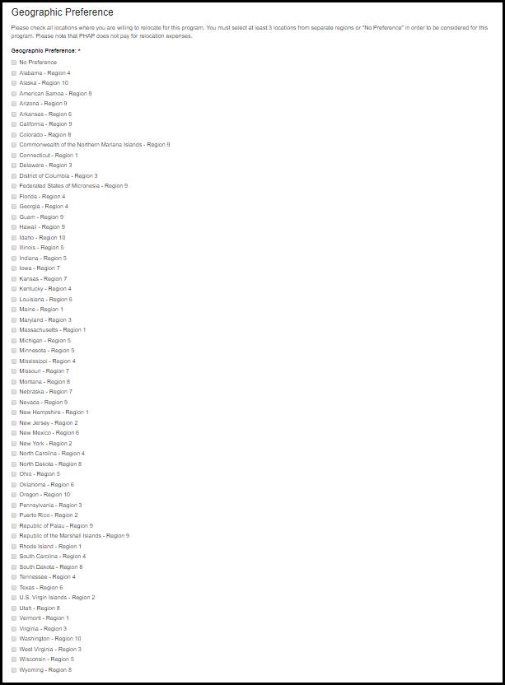

**Previous question:** asked applicants to rank HHS geographic regions by preference

**New Question:** Now lists geographic preferences by state for better matching based on geographic preference.