Attachment 1 – Screen Shots for Modifications and Additions to the Existing FMS Application Module
OMB CONTROL NUMBER 0920-0765
FELLOWSHIP MANAGEMENT SYSTEM
NON-SUBSTANTIVE CHANGE REQUEST

PROPOSED MODIFICATIONS FOR Public Health Associate Program (PHAP)
FMS APPLICATION MODULE
DATE SUBMITTED: JANAUARY 7, 2019

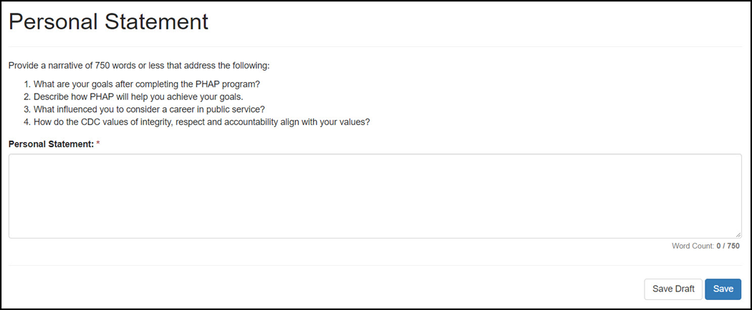
Question 1-3: Removed and replaced with New Questions:
- What makes you a good candidate for PHAP?
- Describe how PHAP will help you achieve your goals.
- What influenced you to consider a career in public service?

Added a New Question:
4. How do the CDC values of integrity, respect and accountability align with your values?

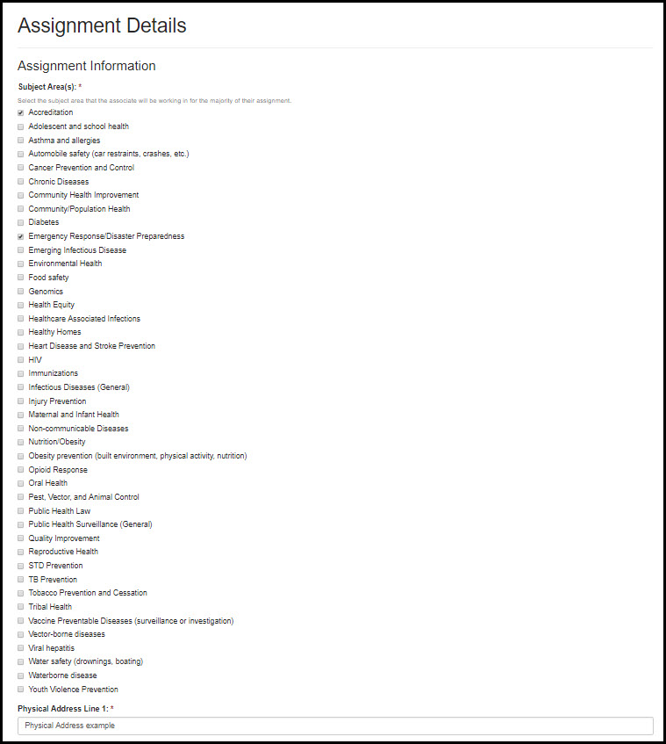
Previous question asked about Program

New Question: Assignment Information (Subject Area(s))

Select the subject area that the associate will be working in for the majority of the assignment

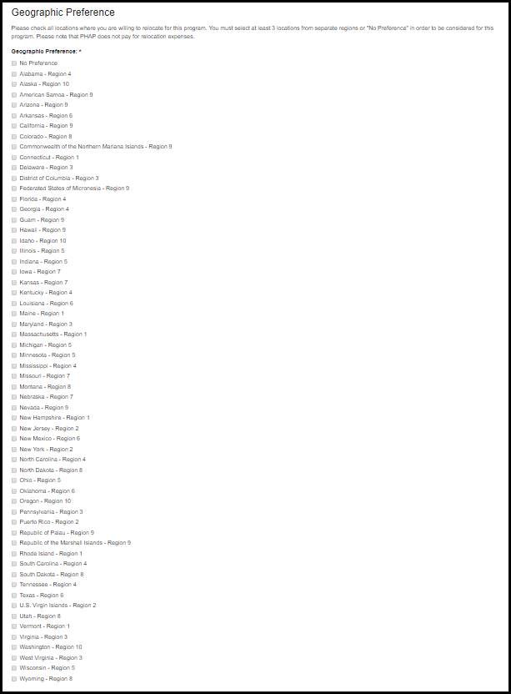
Previous question: asked applicants to rank HHS geographic regions by preference

New Question: Now lists geographic preferences by state for better matching based on geographic preference.

