iCURE Scholars Survey – Screenshots

OMB No.: 0925-0642
Expiration Date: 05/31/2020
Public reporting burden for this collection of information is estimated to average 30 minutes per response, including the time for reviewing instructions, searching existing data sources, gathering and maintaining the data needed, and completing and reviewing the collection of information. An agency may not conduct or sponsor, and a person is not required to respond to, a collection of information unless it displays a currently valid OMB control number. Send comments regarding this burden estimate or any other aspect of this collection of information, including suggestions for reducing this burden to: NIH, Project Clearance Branch, 6705 Rockledge Drive, MSC 7974, Bethesda, MD 20892-7974, ATTN: PRA (0925-0642). Do not return the completed form to this address.
iCURE Scholars Survey
Thank you for taking the time to provide your feedback regarding your iCURE experience. The information you provide will remain secure to the extent permitted by law – no individual responses will be shared with the iCURE management team, your PI, Daily Supervisor, or other persons associated with your research lab. All information will be reported in aggregate and will be used to make changes and improvements to the iCURE program as appropriate and possible. If you have any questions you may contact Fred Snyder, Senior Evaluation Research at fsnyder@novaresearch.com.
By continuing with this survey you agree to participate in the iCURE program survey.

Click here to launch the iCURE Scholars Survey
Figure 1. Survey launch page, with persistent header.
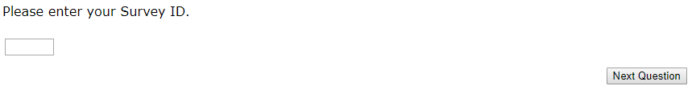
Figure 2. Survey ID
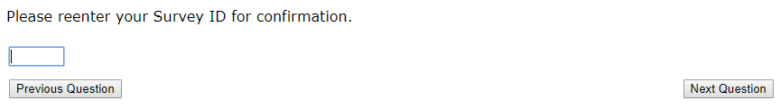
Figure 3. Survey ID Confirmation
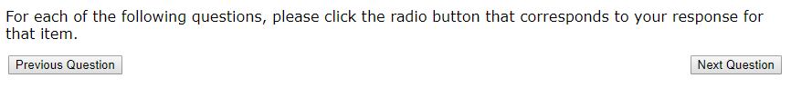
Figure 4. Survey Instructions Information Element
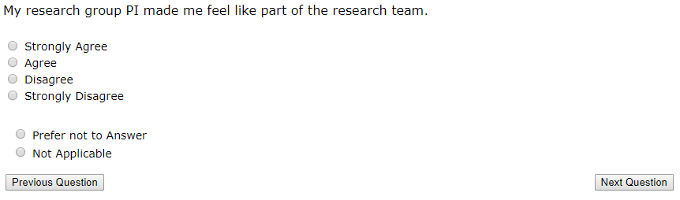
Figure 5. Question 1
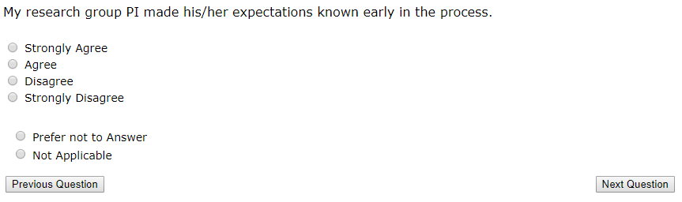
Figure 6. Question 2
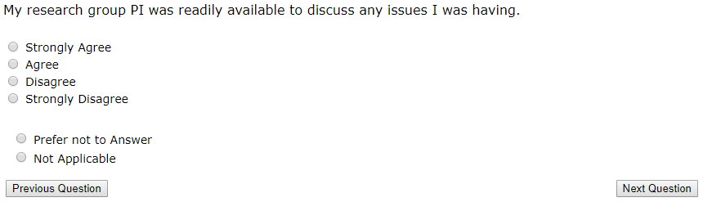
Figure 7. Question 3
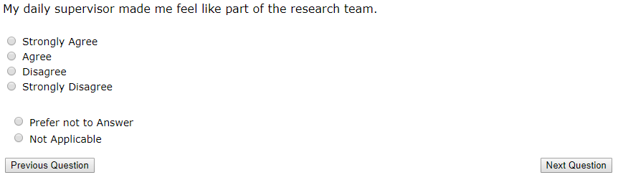
Figure 8. Question 4
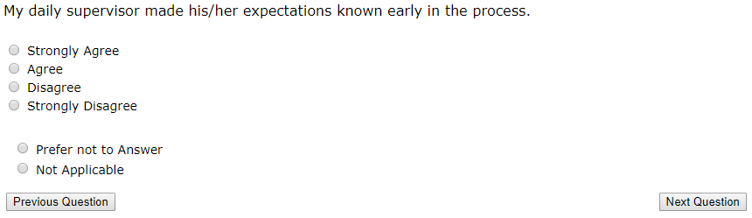
Figure 9. Question 5
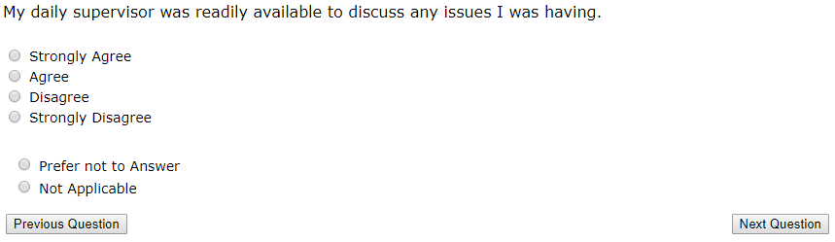
Figure 10. Question 6
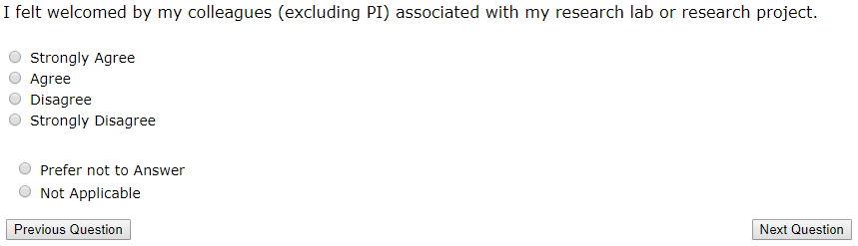
Figure 11. Question 7
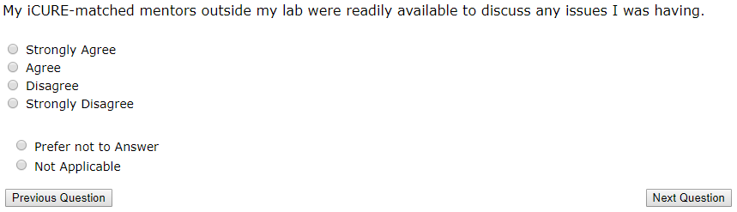
Figure 12. Question 8
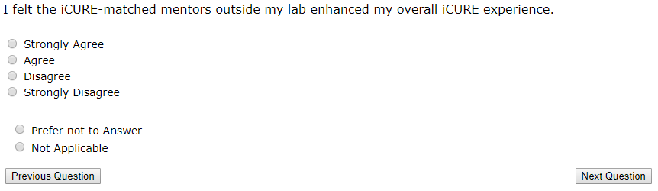
Figure 13. Question 9
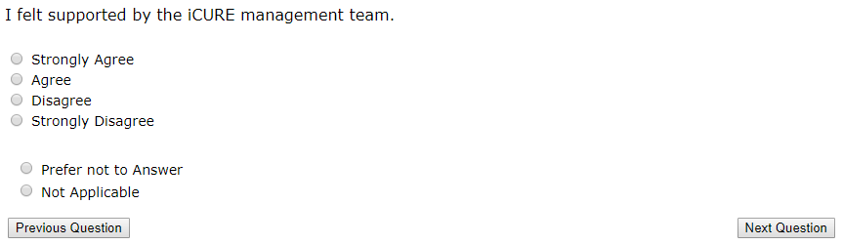
Figure 14. Question 10
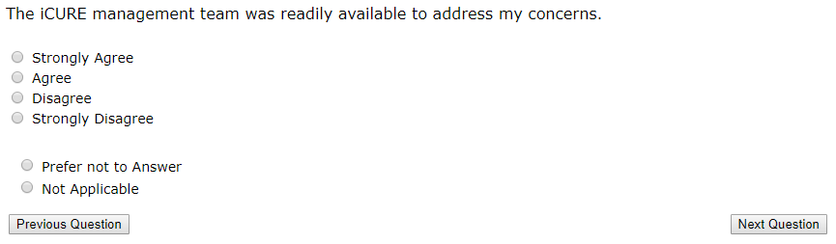
Figure 15. Question 11
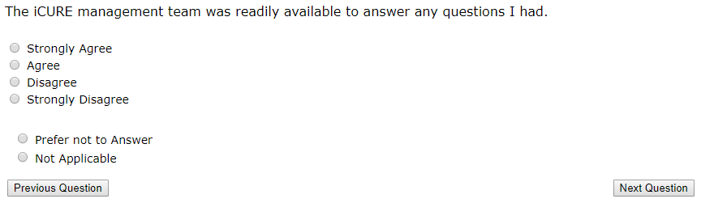
Figure 16. Question 12
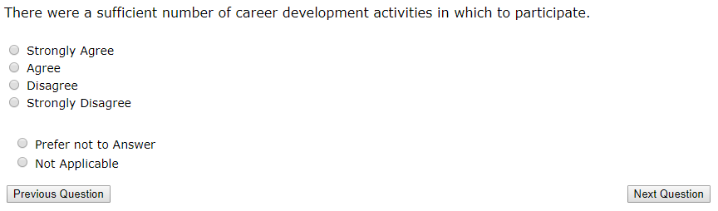
Figure 17. Question 13
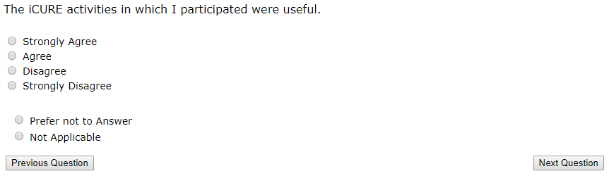
Figure 18. Question 14
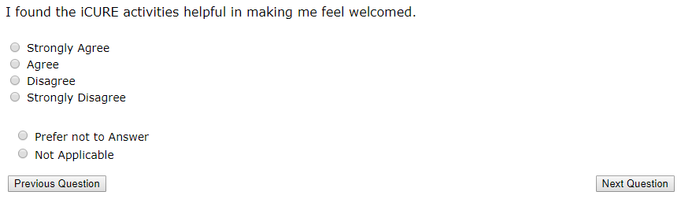
Figure 19. Question 15
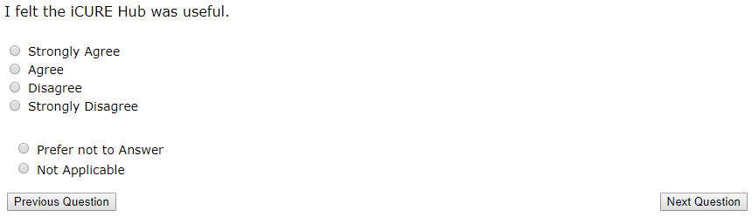

Figure 20. Question 16
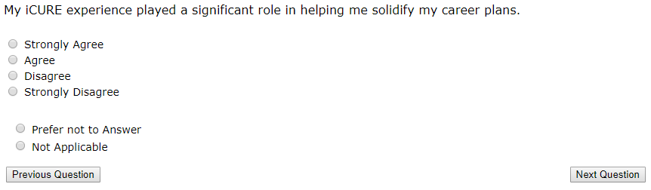
Figure 21. Question 17
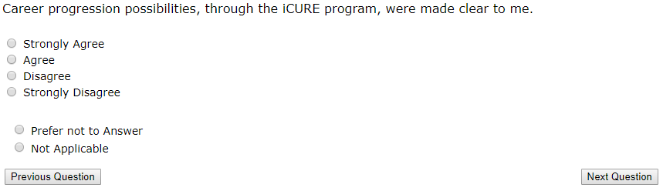
Figure 22. Question 18
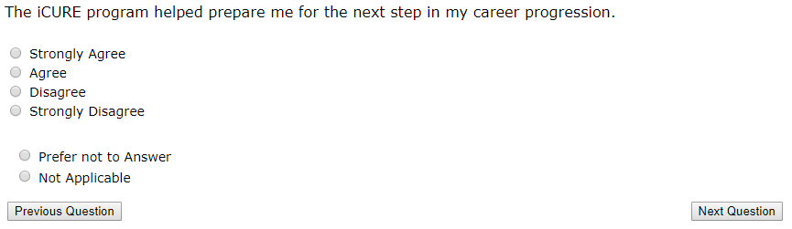
Figure 23. Question 19
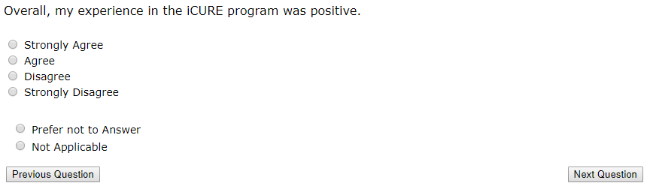

Figure 24. Question 20
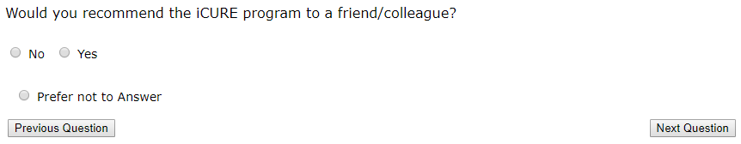
Figure 25. Question 21
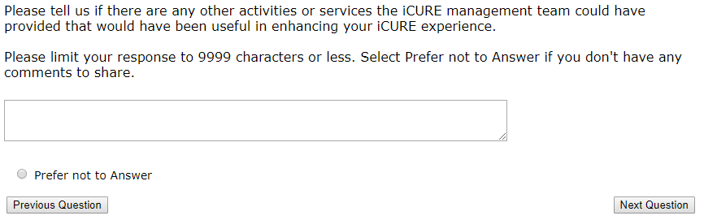
Figure 26. Question 22
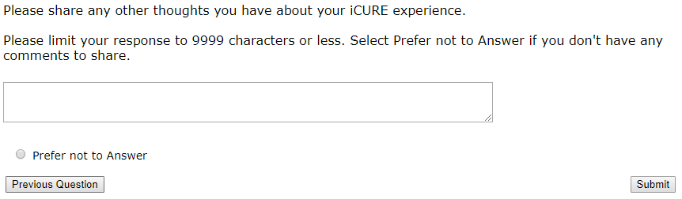
Figure 27. Question 23
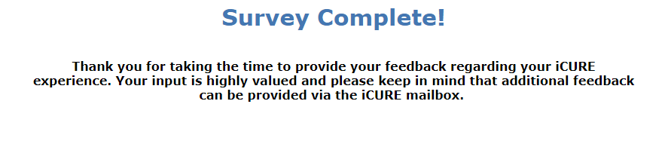
Figure 28. Survey Complete Screen

