APPENDIX L
AI/AN FACES 2019 RESPONDENT MATERIALS

This page has been left blank for double-sided copying.

AI/AN FACES 2019 FALL PARENT-TEACHER FREQUENTLY ASKED QUESTIONS (FAQS)

This page has been left blank for double-sided copying.

FREQUENTLY ASKED QUESTIONS ABOUT THE AMERICAN INDIAN AND ALASKA NATIVE HEAD START FAMILY AND CHILD EXPERIENCES SURVEY 2019 (AI/AN FACES 2019)
FOR TEACHERS AND PARENTS OF CHILDREN SELECTED FOR THE STUDY
- What is AI/AN FACES 2019 about?
AI/AN FACES 2019 is the second national study of children and families served by Head Start programs in American Indian and Alaska Native communities. AI/AN FACES 2019 will help us learn more about children and families in AI/AN Head Start programs and the services Head Start provides to them. It will allow Head Start to better serve the needs of children and families attending programs in Native communities.
- Who is conducting the study?
The U.S. Department of Health and Human Services, Administration for Children and Families, sponsors the study. The study is being conducted by Mathematica Policy Research, a respected, independent research organization whose studies of Head Start and other early childhood and education programs have been used to improve services to children and families for 50 years. Mathematica is working with directors of Head Start programs in AI/AN communities, Office of Head Start leadership, and child development researchers to make sure that the study meets the needs of AI/AN Head Start programs.
- When will the study take place?
The AI/AN FACES study begins in fall 2019 and ends in spring 2020.
- Who will collect data for the study?
This fall, a team of four Mathematica data collectors will visit your Head Start center for two to three days to do one-on-one assessments with children who were randomly picked to be part of the study and whose parents have given permission for them to be in the study. Mathematica data collectors will come back in spring 2020 to do assessments with the same group of children and to observe their classrooms. Where possible, we have partnered with Native field staff to help carry out data collection efforts. The spring visit will last about three days. Our classroom observers will be trained in AI/AN Head Start programs, and all Mathematica data collectors have completed cross-cultural understanding training.
- What is an AI/AN FACES 2019 child assessment?
Children whose parents gave permission will meet one-on-one with a Mathematica data collector. All Mathematica data collectors have completed cross-cultural understanding training and are trained to work with Native children and do assessments of their early math, language, and reading skills. Children will be asked to look at pictures, copy drawings, and answer some simple math questions. For example, children will be asked to name the letters of the alphabet and the sounds that go along with those letters, to point to pictures that go along with words they hear, and to name numbers and add two numbers or objects. Their height and weight will also be recorded.
- Will children get anything for taking part in the AI/AN FACES 2019 child assessment?
Yes, they will receive a children’s book for taking part.
- Where will the AI/AN FACES 2019 child assessment be done?
To not disrupt classroom activities, the child activities will take place outside the classroom in a space provided to us by the center director. The AI/AN FACES 2019 child assessment will be done within eye and earshot of Head Start center staff.
- How long does an AI/AN FACES 2019 child assessment take?
Each AI/AN FACES 2019 child assessment will take about 45 minutes. It will take a little longer for some children and less time for others. Children will be given breaks when needed.
- Will children’s AI/AN FACES 2019 assessment results be shared with parents, teachers, or their programs?
No. Individual children’s assessment results will not be shared. We will only report results for groups of children across all AI/AN Head Start programs. No individuals or programs will ever be identified in the reporting of results.
- Will taking part in the study affect the Head Start services the child and family receive?
No. Taking part in the AI/AN FACES 2019 study, or declining to participate will not affect any Head Start services the child or family receives.
- How did you pick classrooms and children for the study?
Classrooms were randomly picked from all classrooms in this Head Start center. Children in those selected classrooms were then randomly picked and, along with their parents, were invited to be in the study. Only children whose parents gave permission are in the study.
- What will you ask teachers to do?
In fall 2019 and spring 2020, we will ask teachers who have children participating in AI/AN FACES 2019 in their classrooms to complete a brief form. This form will ask questions about the behavior and skills of each child in AI/AN FACES 2019. It will also ask if a child has been diagnosed with a disability by a professional, what services or Individualized Education Plans (IEPs) are in place, or if there are any special concerns the teacher has about each child in AI/AN FACES 2019. Each form will take about 10 minutes to complete. Teachers can fill out the forms online or on paper. In spring 2020, we will also ask teachers to fill out a survey about their training and background, classroom activities, and their Head Start program. The survey will take about 35 minutes. In spring 2020, we will observe the teacher’s classroom for about four hours to get an idea of classroom activities and children’s interactions with the teacher and each other. Teachers will receive a $10 gift card for every form they complete about each child in AI/AN FACES 2019 and a gift for participating in the classroom observation.

- Do parents need to do anything besides signing the consent?
On the consent forms, parents should include their email address, phone number, and mailing address so we can contact them about filling out the parent survey.
- What will you ask parents to do?
We will ask parents to fill out a survey in fall 2019 and spring 2020. Parents may fill out the survey online or answer the questions over the phone. Each will last about 30 minutes. In both the fall and spring, parents will be mailed a $30 gift card after they finish the survey.
- Do parents need to be there for the AI/AN FACES 2019 child assessment?
No, parents do not need to be there. The AI/AN FACES 2019 child assessments will be done during the Head Start day.
- Is there a phone number or email parents and teachers can use if they have questions?
Parents can call 800-xxx-xxxx, toll-free, to ask questions. Teachers can call 800-xxx-xxxx, toll-free, to ask questions. Parents and teachers can also email the AI/AN FACES 2019 study team at [EMAIL].
- How will my privacy be protected?
Mathematica agrees to protect the privacy of all study participants to the extent permitted by law. All staff working on the study are required to sign a privacy agreement. The importance of protecting the privacy of each participant and the consequences of violating the agreement, including dismissal from the study, is part of the agreement and an important part of all study staff trainings. All information collected as part of AI/AN FACES 2019 will be kept private unless we learn that a child has been hurt or is in danger or you tell us that you plan to seriously hurt yourself or someone else—then by law, we must make a report to the appropriate legal authorities. The information we collect will be electronically and securely stored at the Mathematica offices, and will not be shared with anyone outside of the study team. Your personal information, including email address, phone number, and mailing address will be destroyed once the study is completed in 2020. Your survey responses will be stripped of any identifying features of you and your family and will be securely shared only with qualified individuals for additional learning purposes to better understand the strengths and needs of children and families served by Region XI Head Start.
We have also obtained a Certificate of Confidentiality from the National Institutes of Health. The Certificate helps us protect your privacy. This means no one can force the study team to give out information that identifies you, even in court. However, we may need to share your information if it shows a serious threat to you or to others, including reporting to authorities when required by law. The U.S. Department of Health and Human Services (DHHS) may ask for data for an audit or evaluation. If they do, we will need to provide it. However, only DHHS staff involved in the review will see it.

Paperwork Reduction Act Statement: The referenced collection of information is voluntary. An agency may not conduct or sponsor, and a person is not required to respond to, a collection of information unless it displays a currently valid OMB control number. The OMB control number for this collection is 0970-0151 and it expires XX/XX/XXXX.

This page has been left blank for double-sided copying.

AI/AN FACES 2019 FALL BROCHURE
This page has been left blank for double-sided copying.

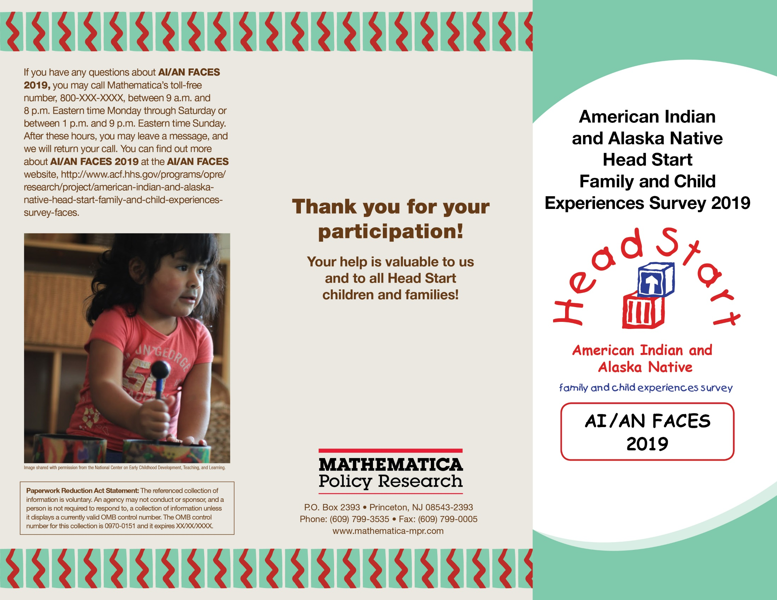

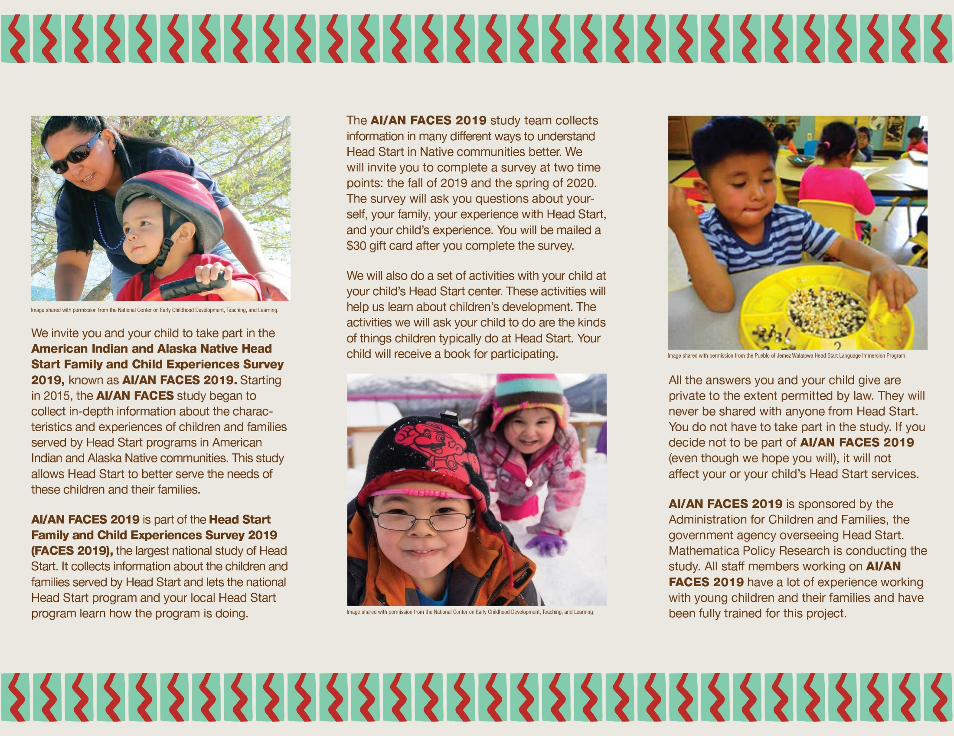

AI/AN FACES 2019 FALL PARENT SURVEY INVITATION EMAIL
This page has been left blank for double-sided copying.

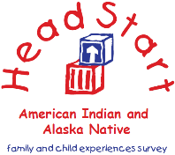

TO: [RESPONDENT EMAIL ADDRESS]
FROM: AI/AN FACES 2019 STUDY TEAM
SUBJECT: AI/AN FACES 2019 STUDY INVITATION
AI/AN FACES 2019: IMPORTANT PARENT SURVEY
Dear [First name] [Last name],
Thank you for taking part in the American Indian and Alaska Native Head Start Family and Child Experiences Survey 2019 (AI/AN FACES 2019). The purpose of AI/AN FACES 2019 is to provide details about the characteristics, experiences, and outcomes of children and families whom AI/AN Head Start programs serve. The information collected will help Head Start improve its services to children and families in AI/AN Head Start programs. The study is funded by the Administration for Children and Families, U.S. Department of Health and Human Services. Mathematica Policy Research, an independent research firm, is conducting the study. Mathematica has worked with directors of Head Start programs in AI/AN communities, Office of Head Start leadership, and child development researchers to make sure it meets the unique needs of AI/AN Head Start programs.
We invite you to be a part of this study by filling out a survey about you, your family, and your child. The survey will take about 30 minutes to finish. After you finish the survey, we will send you a $30 gift card to thank you for your participation. You can complete the survey online or by phone. If you would like to complete the survey online but do not have internet access, you can fill out the survey at your child’s Head Start center during the week the AI/AN FACES 2019 data collection team is visiting. The AI/AN FACES 2019 team will have computers you can use. To complete the survey by phone, or if you need to complete the survey in a language other than English, please call 800-xxx-xxxx toll-free.
We encourage you to complete the survey online at:
[WEBSITE].

Use the log-in ID and password shown.
LOG-IN ID: [LOG-IN ID]
PASSWORD: [PASSWORD]

Please finish the survey as soon as you can. Here are some points to keep in mind:
- Taking part in AI/AN FACES 2019 is up to you. There is no penalty if you decide not to participate. Taking part in the study, or deciding not to participate, will not affect any Head Start services you or your child receive. There are no risks from taking part in the study. However, you may be asked a few sensitive questions. You may choose not to answer those questions or any questions.
- Study results will only be reported for groups. Study results will never be reported in a way that identifies you, your child, any other individuals in your family, or your child’s Head Start program. No one from your Head Start program will see or hear your individual responses, and your name and your program’s name will not be shared with the Office of Head Start. We are, however, required to identify participants if they tell us something that suggests that they are very likely to harm themselves, that they are planning to hurt another person or child, or that someone is likely to harm them. In the future, survey responses from the study (with nothing identifying individuals, programs, or communities) may be securely shared with qualified individuals for additional learning purposes to better understand the strengths and needs of children and families in AI/AN Head Start and the programs that serve them.
If you have questions about AI/AN FACES 2019, please call the AI/AN FACES 2019 study team at 800-xxx-xxxx. This call is toll-free. You can also email us at [EMAIL]. To learn more about AI/AN FACES 2019, visit the study website at https://www.acf.hhs.gov/opre/research/project/american-indian-and-alaska-native-head-start-family-and-child-experiences-survey-faces.
Thanks again for taking part in AI/AN FACES 2019.
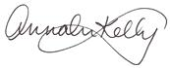
Sincerely,
Annalee Kelly
AI/AN FACES 2019 Survey Director

Paperwork Reduction Act Statement: The referenced collection of information is voluntary. An agency may not conduct or sponsor, and a person is not required to respond to, a collection of information unless it displays a currently valid OMB control number. The OMB control number for this collection is 0970-0151 and it expires XX/XX/XXXX.

AI/AN FACES 2019 FALL PARENT SURVEY INVITATION LETTER

This page has been left blank for double-sided copying.
Annalee Kelly  AI/AN FACES 2019 Survey Director | P.O. Box 2393  Princeton, NJ 08543-2393  Telephone (609) 799-3535  Fax (609) 799-0005  www.mathematica-mpr.com
[DATE]
[PARENT NAME]
[PARENT ADDRESS]

Dear [PARENT]:
Thank you for taking part in the American Indian and Alaska Native Head Start Family and Child Experiences Survey 2019 (AI/AN FACES 2019). The purpose of AI/AN FACES 2019 is to provide details about the characteristics, experiences, and outcomes of children and families whom AI/AN Head Start programs serve. The information collected will help Head Start improve its services to children and families in AI/AN Head Start programs. The study is funded by the Administration for Children and Families, U.S. Department of Health and Human Services. Mathematica Policy Research, an independent research firm, is conducting the study. Mathematica has worked with directors of Head Start programs in AI/AN communities, Office of Head Start leadership, and child development researchers to help make sure it meets the unique needs of AI/AN Head Start programs.
As part of this study, we invite you to fill out a survey about you and your child. The survey will take about 30 minutes to finish. After you finish the survey, we will send you a $30 gift card to thank you for your participation. You can complete the survey over the phone or online. If you want to fill out the survey online but do not have internet access, you can fill out the survey at your child’s Head Start center during the week the AI/AN FACES 2019 data collection team is visiting. The AI/AN FACES 2019 team will have computers you can use. To complete the survey by phone, or if you need to complete the survey in a language other than English, please call 800-xxx-xxxx toll-free.
We encourage you to complete the survey online at:
[WEBSITE].

Use the log-in ID and password shown.
LOG-IN ID: [LOG-IN ID]
PASSWORD: [PASSWORD]
Please finish the survey as soon as you can. Here are some points to keep in mind:
- Taking part in AI/AN FACES 2019 is up to you. There is no penalty if you decide not to participate. Taking part in the study, or deciding not to participate, will not affect any Head Start services you or your child receive. There are no risks from taking part in the study. However, you may be asked a few sensitive questions. You may choose not to answer those questions or any questions.
- Study results will only be reported for groups. Study results will never be reported in a way that identifies you, your child, any other individuals in your family, or your child’s Head Start program. No one from your Head Start program will see or hear your individual responses, and your name and your program’s name will not be shared with the Office of Head Start. We are required, however, to identify participants if they tell us something that suggests that they are very likely to harm themselves, that they are planning to hurt another person or child, or that someone is likely to harm them. In the future, survey responses from the study (with nothing identifying individuals, programs, or communities) may be securely shared with qualified individuals for additional learning purposes to better understand the strengths and needs of children and families in AI/AN Head Start and the programs that serve them.
If you have questions about AI/AN FACES 2019, please call the AI/AN FACES 2019 study team at 800-xxx-xxxx. This call is toll-free. You can also email us at [EMAIL]. To learn more about AI/AN FACES 2019, visit the study website at https://www.acf.hhs.gov/opre/research/project/american-indian-and-alaska-native-head-start-family-and-child-experiences-survey-faces.
Thanks again for taking part in AI/AN FACES 2019.
Sincerely,
Annalee Kelly
AI/AN FACES 2019 Survey Director

Paperwork Reduction Act Statement: The referenced collection of information is voluntary. An agency may not conduct or sponsor, and a person is not required to respond to, a collection of information unless it displays a currently valid OMB control number. The OMB control number for this collection is 0970-0151 and it expires XX/XX/XXXX.
Paperwork Reduction Act Statement: The referenced collection of information is voluntary. An agency may not conduct or sponsor, and a person is not required to respond to, a collection of information unless it displays a currently valid OMB control number. The OMB control number for this collection is 0970-0151 and it expires XX/XX/XXXX.
Paperwork Reduction Act Statement: The referenced collection of information is voluntary. An agency may not conduct or sponsor, and a person is not required to respond to, a collection of information unless it displays a currently valid OMB control number. The OMB control number for this collection is 0970-0151 and it expires XX/XX/XXXX.
Paperwork Reduction Act Statement: The referenced collection of information is voluntary. An agency may not conduct or sponsor, and a person is not required to respond to, a collection of information unless it displays a currently valid OMB control number. The OMB control number for this collection is 0970-0151 and it expires XX/XX/XXXX.

AI/AN FACES 2019 SPRING PARENT SURVEY INVITATION EMAIL
This page has been left blank for double-sided copying.

TO: [RESPONDENT EMAIL ADDRESS]
FROM: AI/AN FACES 2019 STUDY TEAM
SUBJECT: AI/AN FACES 2019 STUDY INVITATION
AI/AN FACES 2019: IMPORTANT PARENT SURVEY
Dear [First name] [Last name],
Thank you for your and your child’s participation in the American Indian and Alaska Native Head Start Family and Child Experiences Survey 2019 (AI/AN FACES 2019) last fall. The purpose of AI/AN FACES 2019 is to provide details about the characteristics, experiences, and outcomes of children and families whom AI/AN Head Start programs serve. The information collected will help Head Start improve its services to children and families in AI/AN Head Start programs. As one of only about 800 families taking part in this important study of AI/AN Head Start programs, your help is vital to the study’s success. The study is funded by the Administration for Children and Families, U.S. Department of Health and Human Services. Mathematica Policy Research, an independent research firm, is conducting the study.
We invite you to be a part of this study by filling out a spring survey about you, your family, and your child. The survey will take about 30 minutes to finish. After you finish the survey, we will send you a $30 gift card to thank you for your participation. You can complete the survey online or by phone. If you would like to complete the survey online but do not have internet access, you can fill out the survey at your child’s Head Start center during the week the AI/AN FACES 2019 data collection team is visiting. The AI/AN FACES 2019 team will have computers you can use. To complete the survey by phone, or if you need to complete the survey in a language other than English, please call 800-xxx-xxxx toll-free.
We encourage you to complete the survey online at:
[WEBSITE].

Use the log-in ID and password shown.
LOG-IN ID: [LOG-IN ID]
PASSWORD: [PASSWORD]

Please finish the survey as soon as you can. Here are some points to keep in mind:
- Taking part in AI/AN FACES 2019 is up to you. There is no penalty if you decide not to participate. Taking part in the study, or deciding not to participate, will not affect any Head Start services you or your child receive. There are no risks from taking part in the study. However, you may be asked a few sensitive questions. You may choose not to answer those questions or any questions.
- Study results will only be reported for groups. Study results will never be reported in a way that identifies you, your child, any other individuals in your family, or your child’s Head Start program. No one from your Head Start program will see or hear your individual responses, and your name and your program’s name will not be shared with the Office of Head Start. We are, however, required to identify participants if they tell us something that suggests that they are very likely to harm themselves, that they are planning to hurt another person or child, or that someone is likely to harm them. In the future, survey responses from the study (with nothing identifying individuals, programs, or communities) may be securely shared with qualified individuals for additional learning purposes to better understand the strengths and needs of children and families in AI/AN Head Start and the programs that serve them.
If you have questions about AI/AN FACES 2019, please call the AI/AN FACES 2019 study team at 800-xxx-xxxx. This call is toll-free. You can also email us at [EMAIL]. To learn more about AI/AN FACES 2019, visit the study website at https://www.acf.hhs.gov/opre/research/project/american-indian-and-alaska-native-head-start-family-and-child-experiences-survey-faces.
Thanks again for taking part in AI/AN FACES 2019.
Sincerely,
Annalee Kelly
AI/AN FACES 2019 Survey Director

Paperwork Reduction Act Statement: The referenced collection of information is voluntary. An agency may not conduct or sponsor, and a person is not required to respond to, a collection of information unless it displays a currently valid OMB control number. The OMB control number for this collection is 0970-0151 and it expires XX/XX/XXXX.

AI/AN FACES 2019 SPRING PARENT SURVEY INVITATION LETTER
This page has been left blank for double-sided copying.

Annalee Kelly  AI/AN FACES 2019 Survey Director | P.O. Box 2393  Princeton, NJ 08543-2393  Telephone (609) 799-3535  Fax (609) 799-0005  www.mathematica-mpr.com

[DATE]
[PARENT NAME]
[PARENT ADDRESS]

Dear [PARENT]:
Thank you for your and your child’s participation in the American Indian and Alaska Native Head Start Family and Child Experiences Survey 2019 (AI/AN FACES 2019) last fall. The purpose of AI/AN FACES 2019 is to provide details about the characteristics, experiences, and outcomes of children and families whom AI/AN Head Start programs serve. The information collected will help Head Start improve its services to children and families in AI/AN Head Start programs. As one of only about 800 families taking part in this important study of AI/AN Head Start programs, your help is vital to the study’s success. The study is funded by the Administration for Children and Families, part of the U.S. Department of Health and Human Services. Mathematica Policy Research, an independent research firm, is conducting the study.
As part of this study, we invite you to fill out a spring survey about you and your child. The survey will take about 30 minutes to finish. After you finish the survey, we will send you a $30 gift card to thank you for your participation. You can complete the survey online or by phone. If you want to fill out the survey online but do not have internet access, you can fill out the survey at your child’s Head Start center during the week the AI/AN FACES 2019 data collection team is visiting. The AI/AN FACES 2019 team will have computers you can use. To complete the survey by phone, or if you need to complete the survey in a language other than English, please call 800-xxx-xxxx toll-free.
We encourage you to complete the survey online at:
[WEBSITE].

Use the log-in ID and password shown.
LOG-IN ID: [LOG-IN ID]
PASSWORD: [PASSWORD]

Please finish the survey as soon as you can. Here are some points to keep in mind:
- Taking part in AI/AN FACES 2019 is up to you. There is no penalty if you decide not to participate. Taking part in the study, or deciding not to participate, will not affect any Head Start services you or your child receives. There are no risks from taking part in the study. However, you may be asked a few sensitive questions. You may choose not to answer those questions or any questions.
- Study results will only be reported for groups. Study results will never be reported in a way that identifies you, your child, any other individuals in your family, or your child’s Head Start program. No one from your Head Start program will see or hear your individual responses, and your name and your program’s name will not be shared with the Office of Head Start. We are, however, required to identify participants if they tell us something that suggests that they are very likely to harm themselves, that they are planning to hurt another person or child, or that someone is likely to harm them. In the future, survey responses from the study (with nothing identifying individuals, programs, or communities) may be securely shared with qualified individuals for additional learning purposes to better understand the strengths and needs of children and families in AI/AN Head Start and the programs that serve them.
If you have questions about AI/AN FACES 2019, please call the AI/AN FACES 2019 study team at 800-xxx-xxxx. This call is toll-free. You can also email us at [EMAIL]. To learn more about AI/AN FACES 2019, visit the study website at http://www.acf.hhs.gov/programs/opre/research/project/american-indian-and-alaska-native-head-start-family-and-child-experiences-survey-faces.
Thanks again for taking part in AI/AN FACES 2019.
Sincerely,
Annalee Kelly
AI/AN FACES 2019 Survey Director

Paperwork Reduction Act Statement: The referenced collection of information is voluntary. An agency may not conduct or sponsor, and a person is not required to respond to, a collection of information unless it displays a currently valid OMB control number. The OMB control number for this collection is 0970-0151 and it expires XX/XX/XXXX.

AI/AN FACES 2019 FALL/SPRING PARENT SURVEY REMINDER EMAIL

This page has been left blank for double-sided copying.

TO: [PARENT]
FROM: AI/AN FACES 2019 STUDY TEAM
SUBJECT: AI/AN FACES 2019 STUDY REMINDER
Dear [First name] [Last name],
Thank you for taking part in the American Indian and Alaska Native Head Start Family and Child Experiences Survey 2019 (AI/AN FACES 2019). As a reminder, the purpose of AI/AN FACES 2019 is to provide details about the characteristics, experiences, and outcomes of children and families whom AI/AN Head Start programs serve. The information collected will help Head Start improve its services to children and families in AI/AN Head Start programs. The study is funded by the Administration for Children and Families, U.S. Department of Health and Human Services. Mathematica Policy Research, an independent research firm, is conducting the study. Mathematica has worked with directors of Head Start programs in AI/AN communities, Office of Head Start leadership, and child development researchers to help make sure it meets the unique needs of AI/AN Head Start programs.
Recently, we invited you to complete a survey online or by phone about you, your family and your child. The survey will take about 30 minutes to finish. After you finish the survey we, will send you a $30 gift card to thank you for your participation. If you want to fill out the survey online but do not have internet access, you can fill out the survey at a computer at your child’s Head Start center during the week the AI/AN FACES 2019 data collection team is visiting. To complete it by phone, or if you need to complete the survey in a language other than English, please call 800-xxx-xxxx toll-free.

We encourage you to complete the survey online at:
[WEBSITE].

Use the log-in ID and password shown.
LOG-IN ID: [LOG-IN ID]
PASSWORD: [PASSWORD]
We hope you will finish the survey as soon as you can. Here are some points to keep in mind:
- Taking part in AI/AN FACES 2019 is up to you. There is no penalty if you decide not to participate. Taking part in the study, or deciding not to participate, will not affect any Head Start services you or your child receive. There are no risks from taking part in the study. However, you may be asked a few sensitive questions. You may choose not to answer those questions or any questions.
- Study results will only be reported for groups. Study results will never be reported in a way that identifies you, your child, any other individuals in your family, or your child’s Head Start program. No one from your Head Start program will see or hear your individual responses, and your name and your program’s name will not be shared with the Office of Head Start. We are, however, required to identify participants if they tell us something that suggests that they are very likely to harm themselves, that they are planning to hurt another person or child, or that someone is likely to harm them. In the future, survey responses from the study (with nothing identifying individuals, programs, or communities) may be securely shared with qualified individuals for additional learning purposes to better understand the strengths and needs of children and families in AI/AN Head Start and the programs that serve them.
If you have questions about AI/AN FACES 2019, please call the AI/AN FACES 2019 study team at 800-xxx-xxxx. This call is toll-free. You can also email us at [EMAIL]. To learn more about AI/AN FACES 2019, visit the study website at https://www.acf.hhs.gov/opre/research/project/american-indian-and-alaska-native-head-start-family-and-child-experiences-survey-faces.
Thanks again for taking part in AI/AN FACES 2019.
Sincerely,
Annalee Kelly
AI/AN FACES 2019 Survey Director
Paperwork Reduction Act Statement: The referenced collection of information is voluntary. An agency may not conduct or sponsor, and a person is not required to respond to, a collection of information unless it displays a currently valid OMB control number. The OMB control number for this collection is 0970-0151 and it expires XX/XX/XXXX.
Paperwork Reduction Act Statement: The referenced collection of information is voluntary. An agency may not conduct or sponsor, and a person is not required to respond to, a collection of information unless it displays a currently valid OMB control number. The OMB control number for this collection is 0970-0151 and it expires XX/XX/XXXX.
Paperwork Reduction Act Statement: The referenced collection of information is voluntary. An agency may not conduct or sponsor, and a person is not required to respond to, a collection of information unless it displays a currently valid OMB control number. The OMB control number for this collection is 0970-0151 and it expires XX/XX/XXXX.
Paperwork Reduction Act Statement: The referenced collection of information is voluntary. An agency may not conduct or sponsor, and a person is not required to respond to, a collection of information unless it displays a currently valid OMB control number. The OMB control number for this collection is 0970-0151 and it expires XX/XX/XXXX.

AI/AN FACES 2019 FALL/SPRING PARENT SURVEY REMINDER LETTER

This page has been left blank for double-sided copying.

Annalee Kelly  AI/AN FACES 2019 Survey Director | P.O. Box 2393  Princeton, NJ 08543-2393  Telephone (609) 799-3535  Fax (609) 799-0005  www.mathematica-mpr.com
[DATE]
[PARENT NAME]
[PARENT ADDRESS]

Dear [PARENT]:
Thank you for taking part in the American Indian and Alaska Native Head Start Family and Child Experiences Survey (AI/AN FACES 2019). As a reminder, the purpose of AI/AN FACES 2019 is to provide details about the characteristics, experiences, and outcomes of children and families whom AI/AN Head Start programs serve.
Recently, we invited you to complete a survey online or by phone about you and your child. The survey will take about 30 minutes to finish. After you finish the survey, we will send you a $30 gift card to thank you for your participation. If you want to fill out the survey online but do not have internet access, you can fill out the survey at a computer at your child’s Head Start center during the week the AI/AN FACES 2019 data collection team is visiting. To complete it by phone, or if you need to complete the survey in a language other than English, please call 800-xxx-xxxx toll-free.
The information collected will help Head Start improve its services to children and families in AI/AN Head Start programs. The study is funded by the Administration for Children and Families, U.S. Department of Health and Human Services. Mathematica Policy Research, an independent research firm, is conducting the study. Mathematica has worked with directors of Head Start programs in AI/AN communities, Office of Head Start leadership, and child development researchers to help make sure it meets the unique needs of AI/AN Head Start programs.
We encourage you to complete the survey online at:
[WEBSITE].

Use the log-in ID and password shown.
LOG-IN ID: [LOG-IN ID]
PASSWORD: [PASSWORD]
We hope you will complete the survey as soon as you can. Here are some points to keep in mind:
- Taking part in AI/AN FACES 2019 is up to you. There is no penalty if you decide not to participate. Taking part in the study, or deciding not to participate, will not affect any Head Start services you or your child receive. There are no risks from taking part in the study. However, you may be asked a few sensitive questions. You may choose not to answer those questions or any questions.
- Study results will only be reported for groups. Study results will never be reported in a way that identifies you, your child, any other individuals in your family, or your child’s Head Start program. No one from your Head Start program will see or hear your individual responses, and your name and your program’s name will not be shared with the Office of Head Start. We are, however, required to identify participants if they tell us something that suggests that they are very likely to harm themselves, that they are planning to hurt another person or child, or that someone is likely to harm them. In the future, survey responses from the study (with nothing identifying individuals, programs, or communities) may be securely shared with qualified individuals for additional learning purposes to better understand the strengths and needs of children and families in AI/AN Head Start and the programs that serve them.
If you have questions about AI/AN FACES 2019, please call the AI/AN FACES 2019 study team at 800-xxx-xxxx. This call is toll-free. You can also email us at [EMAIL]. To learn more about AI/AN FACES 2019, visit the study website at https://www.acf.hhs.gov/opre/research/project/american-indian-and-alaska-native-head-start-family-and-child-experiences-survey-faces.
Thanks again for taking part in AI/AN FACES 2019.
Sincerely,
Annalee Kelly
AI/AN FACES 2019 Survey Director

Paperwork Reduction Act Statement: The referenced collection of information is voluntary. An agency may not conduct or sponsor, and a person is not required to respond to, a collection of information unless it displays a currently valid OMB control number. The OMB control number for this collection is 0970-0151 and it expires XX/XX/XXXX.

AI/AN FACES 2019 FALL/SPRING POSTED FLYERS
This page has been left blank for double-sided copying.

Get ready!
We will be participating in the
American Indian and Alaska Native
Head Start Family and Child
Experiences Survey 2019
(AI/AN FACES 2019) soon!
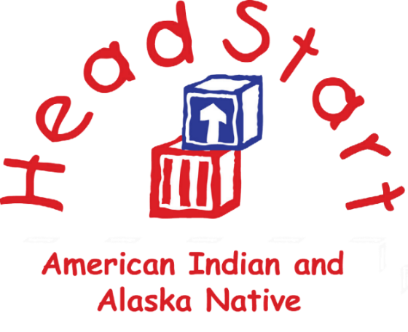

AI/AN FACES 2019

You may be seeing some new “faces” that you don’t recognize. Our program is taking part in this national study, which is sponsored by the Administration for Children and Families.
In a few weeks, a team from Mathematica Policy Research, a respected independent organization, will be at our center to conduct AI/AN FACES 2019.
Thank you for your participation!

OMB Number: 0970-0151
Expires: XX/XX/XXXX

Get ready! We will be participating in the
American Indian and Alaska Native
Head Start Family and Child Experiences Survey 2019 (AI/AN FACES 2019) soon!

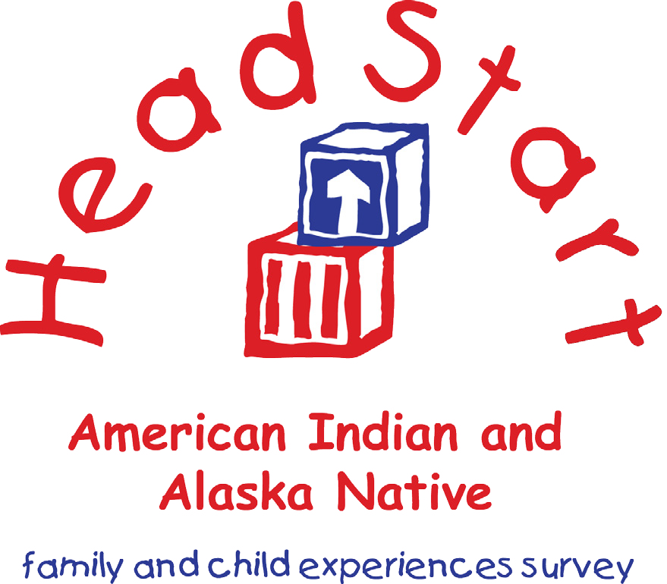
AI/AN FACES 2019

You may be seeing some new “faces” that you don’t recognize. Our program is taking part in this national study, which is sponsored by the Administration for Children and Families.

In a few weeks, a team from Mathematica Policy Research, a respected independent organization, will be at our center to conduct AI/AN FACES 2019.
Thank you for your participation!

OMB Number: 0970-0151
Expires: XX/XX/XXXX

Get ready!
We will be participating in the American Indian and Alaska Native Head Start Family and Child Experiences Survey 2019 (AI/AN FACES 2019) soon!

You may be seeing some new “faces” that you don’t recognize. Our program is taking part in this national study, which is sponsored by the Administration for Children and Families.

In a few weeks, a team from Mathematica Policy Research,
a respected independent organization, will be at our center to conduct AI/AN FACES 2019.
Thank you for your participation!
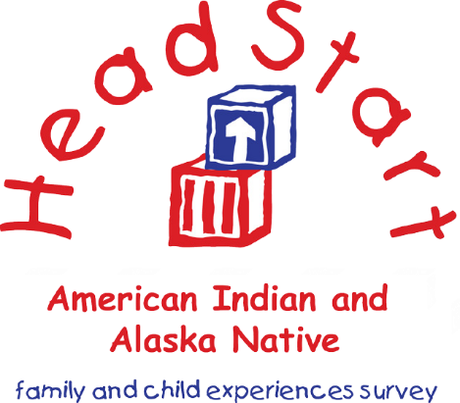

AI/AN FACES 2019
OMB Number: 0970-0151
Expires: XX/XX/XXXX

Get ready!
We will be participating in the
American Indian and Alaska Native
Head Start Family and Child Experiences Survey 2019 (AI/AN FACES 2019) next week!
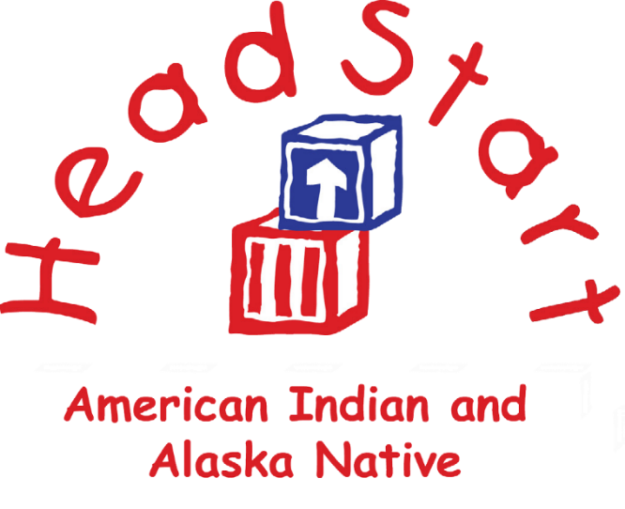

AI/AN FACES 2019

A team from Mathematica Policy Research, a respected independent organization,
will be at our center to conduct
AI/AN FACES 2019.
PLEASE BE SURE YOUR CHILD ATTENDS HEAD START NEXT WEEK
FOR THIS VISIT!
Thank you for your participation!
OMB Number: 0970-0151
Expires: XX/XX/XXXX

Get ready! We will be participating in the
American Indian and Alaska Native
Head Start Family and Child Experiences Survey 2019 (AI/AN FACES 2019) next week!

AI/AN FACES 2019

A team from Mathematica Policy Research, a respected independent organization,
will be at our center to conduct
AI/AN FACES 2019.
PLEASE BE SURE YOUR CHILD ATTENDS HEAD START NEXT WEEK
FOR THIS VISIT!
Thank you for your participation!

OMB Number: 0970-0151
Expires: XX/XX/XXXX

Get ready! We will be participating in the American Indian and Alaska Native Head Start Family and Child Experiences Survey 2019 (AI/AN FACES 2019) next week!
A team from Mathematica Policy Research, a respected independent organization, will be at our center to conduct AI/AN FACES 2019.
PLEASE BE SURE
YOUR CHILD
ATTENDS HEAD START
NEXT WEEK FOR THIS VISIT!
Thank you for your participation!

AI/AN FACES 2019
OMB Number: 0970-0151
Expires: XX/XX/XXXX

AI/AN FACES 2019 FALL/SPRING CHILD ASSESSMENT REMINDER NOTICE

This page has been left blank for double-sided copying.

OMB Number: 0970-0151
Expiration Date: XX/XX/XXXX

NAME OF CHILD:

REMINDER
The AI/AN FACES 2019 team will be visiting your child’s Head Start center soon to conduct activities with your child. If you haven’t already done so, please sign your permission form and return it to your child’s teacher right away. If you do not have a permission form, please notify your child’s teacher. Thank you for participating in this important study!

OMB Number: 0970-0151
Expiration Date: XX/XX/XXXX

NAME OF CHILD:
REMINDER
The AI/AN FACES 2019 team will be visiting your child’s Head Start center soon to conduct activities with your child. If you haven’t already done so, please sign your permission form and return it to your child’s teacher right away. If you do not have a permission form, please notify your child’s teacher. Thank you for participating in this important study!

This page has been left blank for double-sided copying.

AI/AN FACES 2019 FALL TEACHER CHILD REPORT INVITATION LETTER

This page has been left blank for double-sided copying.

Annalee Kelly  AI/AN FACES 2019 Survey Director | P.O. Box 2393  Princeton, NJ 08543-2393  Telephone (609) 799-3535  Fax (609) 799-0005  www.mathematica-mpr.com
[DATE]
Dear [TEACHER]:
Welcome to the American Indian and Alaska Native (AI/AN) Head Start Family and Child Experiences Survey 2019, known as AI/AN FACES 2019. In 2015, AI/AN FACES was the first study to collect descriptive information on children’s skills and the experiences families attending Head Start in Region XI to help inform policies and practices. The study is being conducted again to provide details about the characteristics, experiences, and outcomes of children and families whom Region XI AI/AN Head Start programs serve. The information collected will help Head Start improve its services to children and families in AI/AN Head Start programs.
[ENTER PROGRAM NAME] has been selected to take part in this important study. Mathematica Policy Research, an independent research company, is conducting AI/AN FACES 2019. The Administration for Children and Families, part of the U.S. Department of Health and Human Services, funds the study. Mathematica worked with a group of directors and leaders of Head Start programs in AI/AN communities, federal officials, and early childhood researchers with experience with Native communities to design the study and to guide how the study is being carried out.
This fall, we will ask about 800 3- and 4-year-old children and their families as well as 80 teachers from 22 Head Start programs to take part in AI/AN FACES 2019. We are excited about the study and hope you will be too. As one of only 80 teachers taking part, your help is vital to the study’s success.
Your program director has selected [OSC NAME] to work with us. [OSC NAME] will help us gain consent from the parents of children who were chosen to take part in the study and schedule the data collection visits to your center. We appreciate any help with obtaining consents from parents that you can offer [OSC NAME] or our team.
In fall 2019 and spring 2020, our staff will spend two to three days in your center. Staff will give a 45-minute one-on-one assessment to children whose parents have agreed to take part in the study. We will also ask these children’s parents to take a short survey.
To enhance this information, we will ask you to complete a short form, the Teacher Child Report (TCR), for each child participating in AI/AN FACES 2019 in your class. The form asks about the skills, behaviors, and approaches to learning that you have seen these children use. Each report should only take about 10 minutes to finish. As a thank you, we will send you a $10 gift card for each TCR you complete and return. We think you will enjoy completing these forms online. If you do not have internet access or prefer to fill out these forms on paper, you may use paper copies. Please return them in the envelope provided.
[IF TEACHER HAS MORE THAN ONE CLASS SELECTED FOR AI/AN FACES 2019] Because you have more than one classroom participating in AI/AN FACES 2019, you will find separate log-in IDs and passwords below for each class. When you log in to the AI/AN FACES 2019 teacher website for the first classroom listed below, you will be asked to complete this survey and the TCRs for children in the first classroom. Then you will log in to the website using the second ID and password to complete just the TCRs for the second classroom.
In spring 2020, we will also ask you, your program director, and your center director to each fill out a short survey. Your survey will ask about children’s classroom activities, the materials used in the classroom, Native culture and language experiences that happen in the classroom, and the ways that you involve and interact with children’s parents. It will also ask about your feelings, education and training, and about any professional development you may have taken part in over the past year. A member of Mathematica’s AI/AN FACES data collection staff will also observe your classroom for about four hours. We will work with [OSC NAME] to schedule the observation. You should not make special preparations for this visit. Your classroom will receive a gift for taking part in the study.
Taking part in AI/AN FACES 2019 is voluntary. You do not have to take part in this study. If you choose to take part in the study but then decide you want to leave the study at any point, that is okay. Study results will only be reported for groups. No one from your Head Start program will see or hear your individual responses, and your name and your program’s name will not be shared with the Office of Head Start. In the future, survey responses from the study (with nothing identifying individuals, programs, or communities) may be securely shared with qualified individuals for additional learning purposes to better understand the strengths and needs of children and families in Region XI Head Start and the programs that serve them. We have a Certificate of Confidentiality from the National Institutes of Health. The Certificate helps us protect your privacy. This means no one can force the study team to give out information that identifies you, even in court. However, we may need to share your information if it shows a serious threat to you or to others, including reporting to authorities when required by law. The U.S. Department of Health and Human Services (DHHS) may ask for data for an audit or evaluation. If they do, we will need to provide it. However, only DHHS staff involved in the review will see it. If you choose to fill out the TCR online, please use the log-in ID and password below. The website, your log-in ID and password are secure and will not be shared with anyone. All information you provide will be kept private to the extent permitted by law. Only selected members of the study team will see your responses. Using the log-in ID and password ensures that your responses will be protected.

We encourage you to complete the Teacher Child Reports online at:
[WEBSITE].

Use the log-in ID and password shown.
LOG-IN ID: [LOG-IN ID]
PASSWORD: [PASSWORD]

We have enclosed a list of frequently asked questions and some helpful tips for completing your survey online. Mathematica staff will be happy to answer any questions about AI/AN FACES 2019 and to assist you in any way you need. You can contact us toll-free at 800-xxx-xxxx or email us at [EMAIL]. To learn more about AI/AN FACES 2019, visit the study website at https://www.acf.hhs.gov/opre/research/project/american-indian-and-alaska-native-head-start-family-and-child-experiences-survey-faces. Thank you in advance for your help with this important study.
Sincerely,
Annalee Kelly
AI/AN FACES 2019 Survey Director

Paperwork Reduction Act Statement: The referenced collection of information is voluntary. An agency may not conduct or sponsor, and a person is not required to respond to, a collection of information unless it displays a currently valid OMB control number. The OMB control number for this collection is 0970-0151 and it expires XX/XX/XXXX.
Paperwork Reduction Act Statement: The referenced collection of information is voluntary. An agency may not conduct or sponsor, and a person is not required to respond to, a collection of information unless it displays a currently valid OMB control number. The OMB control number for this collection is 0970-0151 and it expires XX/XX/XXXX.
Paperwork Reduction Act Statement: The referenced collection of information is voluntary. An agency may not conduct or sponsor, and a person is not required to respond to, a collection of information unless it displays a currently valid OMB control number. The OMB control number for this collection is 0970-0151 and it expires XX/XX/XXXX.
Paperwork Reduction Act Statement: The referenced collection of information is voluntary. An agency may not conduct or sponsor, and a person is not required to respond to, a collection of information unless it displays a currently valid OMB control number. The OMB control number for this collection is 0970-0151 and it expires XX/XX/XXXX.

This page has been left blank for double-sided copying.

AI/AN FACES 2019 FALL TEACHER CHILD REPORT
REMINDER EMAIL

This page has been left blank for double-sided copying.

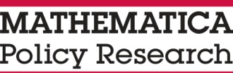
TO: [RESPONDENT EMAIL ADDRESS]
FROM: AI/AN FACES 2019 STUDY TEAM
SUBJECT: AI/AN FACES 2019 STUDY REMINDER
Dear [TEACHER FNAME TEACHER LNAME]:
Thank you for taking part in the American Indian and Alaska Native Head Start Family and Child Experiences Survey 2019, known as AI/AN FACES 2019. As a reminder, the purpose of AI/AN FACES 2019 is to provide details about the characteristics, experiences, and outcomes of children and families whom Region XI AI/AN Head Start programs serve. The information collected will help Head Start improve its services to children and families in AI/AN Head Start programs. It is funded by the Administration for Children and Families, U.S. Department of Health and Human Services. Mathematica Policy Research, an independent research firm, is conducting the study.
A few weeks ago, you were invited to complete a Teacher Child Report (TCR) for each child participating in AI/AN FACES 2019 in your class. Each TCR should take only about 10 minutes to complete. According to our records, you have [XX] TCRs left to complete. As a thank you gesture, when you have completed all of your TCRs, we will send you a $10 gift card for each TCR you completed.
We encourage you to complete the Teacher Child Reports online at:
[WEBSITE].
Use the log-in ID and password shown.
LOG-IN ID: [LOG-IN ID]
PASSWORD: [PASSWORD]

If you have questions about AI/AN FACES 2019 or you prefer to complete the TCRs on paper, please call the AI/AN FACES 2019 study team toll-free at 800-xxx-xxxx. To learn more about AI/AN FACES 2019, visit the AI/AN FACES website at http://www.acf.hhs.gov/programs/opre/research/project/american-indian-and-alaska-native-head-start-family-and-child-experiences-survey-faces.
Sincerely,

Annalee Kelly
AI/AN FACES 2019 Survey Director
Paperwork Reduction Act Statement: The referenced collection of information is voluntary. An agency may not conduct or sponsor, and a person is not required to respond to, a collection of information unless it displays a currently valid OMB control number. The OMB control number for this collection is 0970-0151 and it expires XX/XX/XXXX.
Paperwork Reduction Act Statement: The referenced collection of information is voluntary. An agency may not conduct or sponsor, and a person is not required to respond to, a collection of information unless it displays a currently valid OMB control number. The OMB control number for this collection is 0970-0151 and it expires XX/XX/XXXX.
Paperwork Reduction Act Statement: The referenced collection of information is voluntary. An agency may not conduct or sponsor, and a person is not required to respond to, a collection of information unless it displays a currently valid OMB control number. The OMB control number for this collection is 0970-0151 and it expires XX/XX/XXXX.
Paperwork Reduction Act Statement: The referenced collection of information is voluntary. An agency may not conduct or sponsor, and a person is not required to respond to, a collection of information unless it displays a currently valid OMB control number. The OMB control number for this collection is 0970-0151 and it expires XX/XX/XXXX.
This page has been left blank for double-sided copying.

AI/AN FACES 2019 SPRING TEACHER SURVEY AND
TEACHER CHILD REPORT INVITATION LETTER
This page has been left blank for double-sided copying.

Annalee Kelly P. O. Box 2393
AI/AN FACES 2019 Survey Director Princeton, NJ 08543-2393
Telephone (609) 799-3535
Fax (609) 799-0005
www.mathematica-mpr.com
[DATE]
Dear [TEACHER]:
Thank you for taking part in the American Indian and Alaska Native Head Start Family and Child Experiences Survey 2019 (AI/AN FACES 2019). This past fall [ENTER PROGRAM NAME] was selected to participate in AI/AN FACES 2019. The purpose of AI/AN FACES 2019 is to provide details about the characteristics, experiences, and outcomes of children and families whom Region XI AI/AN Head Start programs serve. The information collected will help Head Start improve its services to children and families in AI/AN Head Start programs. This spring, you are one of about 80 teachers who are being invited to take part in this important study. Participation by teachers like you is vital to the study’s success. The Administration for Children and Families, part of the U.S. Department of Health and Human Services, is funding the study. Mathematica Policy Research, an independent research company, is conducting AI/AN FACES 2019.
[OSC NAME] will be working with us again this spring to help coordinate our data collection visit to your program. This spring, our staff will spend about one week in your center. Just as in the fall, Mathematica staff will give a 45-minute one-on-one assessment to children whose parents gave permission and will ask these children’s parents to complete a short survey.
You will be asked to do three things this spring:
- Complete the Teacher Child Report (TCR), a short form for each child participating in AI/AN FACES 2019 in your class that asks about social skills, problem behaviors, and approaches to learning that you have observed or seen these children use. Each TCR should only take about 10 minutes to complete. As a thank you, we will send you a $10 gift card for each TCR you complete. It can be completed online or on paper. If you decide to answer the questions using the paper copies, you will be asked to return them to the Mathematica staff, or in the envelope provided.
- Answer a short Teacher Survey that should take about 35 minutes to complete. The survey will ask about children’s classroom activities, the materials used in the classroom, Native culture and language experiences that happen in the classroom, and the ways that you involve and interact with children’s parents. It will also ask about your feelings, education and training, and any professional development you may have taken part in over the past year.
[IF TEACHER HAS MORE THAN ONE CLASS SELECTED FOR AI/AN FACES 2019] Because you have more than one classroom participating in AI/AN FACES 2019, you will find a separate log-in ID and password below for each class. When you log in to the AI/AN FACES 2019 teacher website for the first classroom listed below, you will be asked to complete the Teacher Survey and a set of TCRs for children in the first classroom. Please complete the survey and TCRs for this classroom first. Then you will log in to the website using the second ID and password to complete just the TCRs for the second classroom. You will only complete the Teacher Survey once.
Have an AI/AN FACES 2019 study team member observe your classroom once for about four hours. We will work with [OSC NAME] to schedule the observation. You should not make any special preparations for this visit. We will offer your classroom a gift for taking part.
Taking part in AI/AN FACES 2019 is voluntary. You can decide not to continue in the study at any point. All information you provide will be kept private to the extent permitted by law. Study results will only be reported for groups. No one from your Head Start program will see or hear your individual responses, and your name and your program’s name will not be shared with the Office of Head Start, and will never be associated with or identified in any study reports. In the future, survey responses from the study (with nothing identifying individuals, programs, or communities) may be securely shared with qualified individuals for additional learning purposes to better understand the strengths and needs of children and families in Region XI Head Start and the programs that serve them. Additionally, we have a Certificate of Confidentiality from the National Institutes of Health. The Certificate helps us protect your privacy. This means no one can force the study team to give out information that identifies you, even in court. However, we may need to share your information if it shows a serious threat to you or to others, including reporting to authorities when required by law. The U.S. Department of Health and Human Services (DHHS) may ask for data for an audit or evaluation. If they do, we will need to provide it. However, only DHHS staff involved in the review will see it.
We have enclosed a list of frequently asked questions and some helpful tips for completing your Teacher Survey and the TCRs online. When you visit the website, you should use the log-in ID and password below. These are secure and will not be shared with anyone. Using the log-in ID and password ensures that your responses will be protected.
We encourage you to complete the survey online at:
[WEBSITE].
Use the log-in ID and password shown.
LOG-IN ID: [LOG-IN ID]
PASSWORD: [PASSWORD]
Mathematica staff will be happy to answer any questions about AI/AN FACES 2019 and to assist you in any way you need with the study. You can contact us toll-free at 800-xxx-xxxx or email us at [EMAIL]. To learn more about AI/AN FACES 2019, visit the AI/AN FACES website at http://www.acf.hhs.gov/ programs/opre/research/project/american-indian-and-alaska-native-head-start-family-and-child-experiences-survey-faces. Thank you in advance for your help with this important study.
Sincerely,
Annalee Kelly
AI/AN FACES 2019 Survey Director

Paperwork Reduction Act Statement: The referenced collection of information is voluntary. An agency may not conduct or sponsor, and a person is not required to respond to, a collection of information unless it displays a currently valid OMB control number. The OMB control number for this collection is 0970-0151 and it expires XX/XX/XXXX.
Paperwork Reduction Act Statement: The referenced collection of information is voluntary. An agency may not conduct or sponsor, and a person is not required to respond to, a collection of information unless it displays a currently valid OMB control number. The OMB control number for this collection is 0970-0151 and it expires XX/XX/XXXX.
Paperwork Reduction Act Statement: The referenced collection of information is voluntary. An agency may not conduct or sponsor, and a person is not required to respond to, a collection of information unless it displays a currently valid OMB control number. The OMB control number for this collection is 0970-0151 and it expires XX/XX/XXXX.
Paperwork Reduction Act Statement: The referenced collection of information is voluntary. An agency may not conduct or sponsor, and a person is not required to respond to, a collection of information unless it displays a currently valid OMB control number. The OMB control number for this collection is 0970-0151 and it expires XX/XX/XXXX.

AI/AN FACES 2019 SPRING teacher child report AND TEACHER SURVEY REMINDER EMAIL

This page has been left blank for double-sided copying.

TO: [RESPONDENT EMAIL ADDRESS]
FROM: AI/AN FACES 2019 STUDY TEAM
SUBJECT: AI/AN FACES 2019 STUDY REMINDER
Dear [TEACHER FNAME TEACHER LNAME]:
Thank you for taking part in the American Indian and Alaska Native Head Start Family and Child Experiences Survey 2019, known as AI/AN FACES 2019. As a reminder, the purpose of AI/AN FACES 2019 is to provide details about the characteristics, experiences, and outcomes of children and families whom Region XI AI/AN Head Start programs serve. The information collected will help Head Start improve its services to children and families in AI/AN Head Start programs. It is funded by the Administration for Children and Families, U.S. Department of Health and Human Services. Mathematica Policy Research, an independent research firm, is conducting the study.
A few weeks ago, you were invited to [IF TEACHER SURVEY NOT COMPLETE: answer a short Teacher Survey and] complete a Teacher Child Report (TCR) for each child participating in AI/AN FACES 2019 in your class. Each TCR should take only about 10 minutes to complete. According to our records, you have [IF TEACHER SURVEY NOT COMPLETE: not completed the Teacher Survey and have] [XX] TCRs left to complete. As a thank you gesture, when you have completed all of your TCRs, we will send you a $10 gift card for each TCR you completed.
We encourage you to complete the Teacher Survey and Teacher Child Reports online at:
[WEBSITE].
Use the log-in ID and password shown.
LOG-IN ID: [LOG-IN ID]
PASSWORD: [PASSWORD]
If you have questions about AI/AN FACES 2019 or you prefer to complete these surveys on paper, please call the AI/AN FACES 2019 study team toll-free at 800-xxx-xxxx. To learn more about AI/AN FACES 2019, visit the AI/AN FACES website at http://www.acf.hhs.gov/programs/opre/research/project/american-indian-and-alaska-native-head-start-family-and-child-experiences-survey-faces.
Sincerely,
Annalee Kelly
AI/AN FACES 2019 Survey Director
Paperwork Reduction Act Statement: The referenced collection of information is voluntary. An agency may not conduct or sponsor, and a person is not required to respond to, a collection of information unless it displays a currently valid OMB control number. The OMB control number for this collection is 0970-0151 and it expires XX/XX/XXXX.
This page has been left blank for double-sided copying.

AI/AN FACES 2019 SPRING PROGRAM DIRECTOR
SURVEY INVITATION LETTER

This page has been left blank for double-sided copying.

Annalee Kelly P. O. Box 2393
AI/AN FACES 2019 Survey Director Princeton, NJ 08543-2393
Telephone (609) 799-3535
Fax (609) 799-0005
www.mathematica-mpr.com
[DATE]
Dear [PROGRAM DIRECTOR]:
Thank you for your program’s participation in the American Indian and Alaska Native Head Start Family and Child Experiences Survey 2019 (AI/AN FACES 2019) last fall. We are excited about the new spring activities and hope you are too. The purpose of AI/AN FACES 2019 is to provide details about the characteristics, experiences, and outcomes of children and families whom Region XI AI/AN Head Start programs serve. The information collected will help Head Start improve its services to children and families in AI/AN Head Start programs. Your help is vital to the study’s success. The Administration for Children and Families, part of the U.S. Department of Health and Human Services, funds the study. Mathematica Policy Research, an independent research company, is conducting AI/AN FACES 2019.
This spring, we invite you to complete a short 20-minute online survey. Your survey will ask about staff education and training, curriculum and assessment, program management, children and families served, Native culture and language in the program, use of data to make decisions, resources available to your program, support for staff working with families affected by substance use, and your feelings about your job and program. It will also ask about your education and training and any professional development you may have taken part in over the past year. We are also asking the teachers in selected classrooms and center directors at the centers selected for AI/AN FACES 2019 to complete a short survey.
Taking part in AI/AN FACES 2019 is voluntary. You can decide not to continue in the study at any point. All information you provide will be kept private to the extent permitted by law. Study results will only be reported for groups. No one from your Head Start program will see or hear your individual responses, and your name and your program’s name will not be shared with the Office of Head Start, and will never be associated with or identified in any study reports. In the future, survey responses from the study (with nothing identifying individuals, programs, or communities) may be securely shared with qualified individuals for additional learning purposes to better understand the strengths and needs of children and families in Region XI Head Start and the programs that serve them. Additionally, we have a Certificate of Confidentiality from the National Institutes of Health. The Certificate helps us protect your privacy. This means no one can force the study team to give out information that identifies you, even in court. However, we may need to share your information if it shows a serious threat to you or to others, including reporting to authorities when required by law. The U.S. Department of Health and Human Services (DHHS) may ask for data for an audit or evaluation. If they do, we will need to provide it. However, only DHHS staff involved in the review will see it. We have enclosed some helpful tips for completing your survey online. When you visit the website, you should use the log-in ID and password below. These are secure and will not be shared with anyone. Using the log-in ID and password ensures that your responses will be protected.
We encourage you to complete the survey online at: [WEBSITE].

Use the log-in ID and password shown.
LOG-IN ID: [LOG-IN ID]
PASSWORD: [PASSWORD]

Mathematica staff will be happy to answer any questions about AI/AN FACES 2019 and to assist you in any way you need with the study. You can contact [LIAISON] at [xxx-xxx-xxxx] or [LIAISON EMAIL]. To learn more about AI/AN FACES 2019, visit the AI/AN FACES website at http://www.acf.hhs.gov/programs/ opre/research/project/american-indian-and-alaska-native-head-start-family-and-child-experiences-survey-faces. Thank you in advance for your help with this important study.
Sincerely,

Annalee Kelly
AI/AN FACES 2019 Survey Director

Paperwork Reduction Act Statement: The referenced collection of information is voluntary. An agency may not conduct or sponsor, and a person is not required to respond to, a collection of information unless it displays a currently valid OMB control number. The OMB control number for this collection is 0970-0151 and it expires XX/XX/XXXX.

AI/AN FACES 2019 SPRING PROGRAM DIRECTOR SURVEY INVITATION LETTER (ONE-CENTER PROGRAM)

This page has been left blank for double-sided copying.

Annalee Kelly P. O. Box 2393
AI/AN FACES 2019 Survey Director Princeton, NJ 08543-2393
Telephone (609) 799-3535
Fax (609) 799-0005
www.mathematica-mpr.com

[DATE]
Dear [PROGRAM DIRECTOR]:
Thank you for your program’s participation in the American Indian and Alaska Native Head Start Family and Child Experiences Survey 2019 (AI/AN FACES 2019) last fall. We are excited about the new spring activities and hope you are too. The purpose of AI/AN FACES 2019 is to provide details about the characteristics, experiences, and outcomes of children and families whom Region XI AI/AN Head Start programs serve. The information collected will help Head Start improve its services to children and families in AI/AN Head Start programs. Your help is vital to the study’s success. The Administration for Children and Families, part of the U.S. Department of Health and Human Services, funds the study. Mathematica Policy Research, an independent research company, is conducting AI/AN FACES 2019.
This spring, we invite you to complete a short 20-minute online survey. Your survey will ask about staff education and training, curriculum and assessment, program management, children and families served, Native culture and language in the program, use of data to make decisions, resources available to your program, support for staff working with families affected by substance use, and your feelings about your job and program. It will also ask about your education and training and any professional development you may have taken part in over the past year. We are also asking the teachers in selected classrooms for AI/AN FACES 2019 to complete a short survey.
We understand that in addition to being the program director, you are also the center director for the center selected for this study. After you have completed the program director survey on the web, you will be prompted to answer an abbreviated set of questions about staffing and recruitment at your center.
Taking part in AI/AN FACES 2019 is voluntary. You can decide not to continue in the study at any point. All information you provide will be kept private to the extent permitted by law. Study results will only be reported for groups. No one from your Head Start program will see or hear your individual responses, and your name and your program’s name will not be shared with the Office of Head Start, and will never be associated with or identified in any study reports. In the future, survey responses from the study (with nothing identifying individuals, programs, or communities) may be securely shared with qualified individuals for additional learning purposes to better understand the strengths and needs of children and families in Region XI Head Start and the programs that serve them. Additionally, we have a Certificate of Confidentiality from the National Institutes of Health. The Certificate helps us protect your privacy. This means no one can force the study team to give out information that identifies you, even in court. However, we may need to share your information if it shows a serious threat to you or to others, including reporting to authorities when required by law. The U.S. Department of Health and Human Services (DHHS) may ask for data for an audit or evaluation. If they do, we will need to provide it. However, only DHHS staff involved in the review will see it. We have enclosed some helpful tips for completing your survey online. When you visit the website, you should use the log-in ID and password below. These are secure and will not be shared with anyone. Using the log-in ID and password ensures that your responses will be protected.
We encourage you to complete the survey online at:
[WEBSITE].

Use the log-in ID and password shown.
LOG-IN ID: [LOG-IN ID]
PASSWORD: [PASSWORD]
Mathematica staff will be happy to answer any questions about AI/AN FACES 2019 and to assist you in any way you need with the study. You can contact [LIAISON] at [xxx-xxx-xxxx] or [LIAISON EMAIL]. To learn more about AI/AN FACES 2019, visit the AI/AN FACES website at http://www.acf.hhs.gov/ programs/opre/research/project/american-indian-and-alaska-native-head-start-family-and-child-experiences-survey-faces. Thank you in advance for your help with this important study.
Sincerely,

Annalee Kelly
AI/AN FACES 2019 Survey Director

Paperwork Reduction Act Statement: The referenced collection of information is voluntary. An agency may not conduct or sponsor, and a person is not required to respond to, a collection of information unless it displays a currently valid OMB control number. The OMB control number for this collection is 0970-0151 and it expires XX/XX/XXXX.
Paperwork Reduction Act Statement: The referenced collection of information is voluntary. An agency may not conduct or sponsor, and a person is not required to respond to, a collection of information unless it displays a currently valid OMB control number. The OMB control number for this collection is 0970-0151 and it expires XX/XX/XXXX.
Paperwork Reduction Act Statement: The referenced collection of information is voluntary. An agency may not conduct or sponsor, and a person is not required to respond to, a collection of information unless it displays a currently valid OMB control number. The OMB control number for this collection is 0970-0151 and it expires XX/XX/XXXX.
Paperwork Reduction Act Statement: The referenced collection of information is voluntary. An agency may not conduct or sponsor, and a person is not required to respond to, a collection of information unless it displays a currently valid OMB control number. The OMB control number for this collection is 0970-0151 and it expires XX/XX/XXXX.

AI/AN FACES 2019 SPRING PROGRAM DIRECTOR survey REMINDER EMAIL

This page has been left blank for double-sided copying.

TO: [PROGRAM DIRECTOR EMAIL ADDRESS]
FROM: AI/AN FACES 2019 STUDY TEAM
SUBJECT: AI/AN FACES 2019 STUDY REMINDER

Dear [PROGRAM DIRECTOR FNAME PROGRAM DIRECTOR LNAME]:
Thank you for taking part in the American Indian and Alaska Native Head Start Family and Child Experiences Survey 2019, known as AI/AN FACES 2019. As a reminder, the purpose of AI/AN FACES 2019 is to provide details about the characteristics, experiences, and outcomes of children and families whom Region XI AI/AN Head Start programs serve. The information collected will help Head Start improve its services to children and families in AI/AN Head Start programs. It is funded by the Administration for Children and Families, U.S. Department of Health and Human Services. Mathematica Policy Research, an independent research firm, is conducting the study.
A few weeks ago, you were invited to complete a Program Director Survey. We encourage you to complete the survey on the web. It should take only 20 minutes to complete.

We encourage you to complete the survey online at:
[WEBSITE].

Use the log-in ID and password shown.
LOG-IN ID: [LOG-IN ID]
PASSWORD: [PASSWORD]

If you have questions about AI/AN FACES 2019 or you prefer to complete the survey on paper, please call the AI/AN FACES 2019 study team at 800-xxx-xxxx. To learn more about AI/AN FACES 2019, visit the AI/AN FACES website at http://www.acf.hhs.gov/programs/opre/
research/project/american-indian-and-alaska-native-head-start-family-and-child-experiences-survey-faces.
Sincerely,
Annalee Kelly
AI/AN FACES 2019 Survey Director

Paperwork Reduction Act Statement: The referenced collection of information is voluntary. An agency may not conduct or sponsor, and a person is not required to respond to, a collection of information unless it displays a currently valid OMB control number. The OMB control number for this collection is 0970-0151 and it expires XX/XX/XXXX.
Paperwork Reduction Act Statement: The referenced collection of information is voluntary. An agency may not conduct or sponsor, and a person is not required to respond to, a collection of information unless it displays a currently valid OMB control number. The OMB control number for this collection is 0970-0151 and it expires XX/XX/XXXX.
Paperwork Reduction Act Statement: The referenced collection of information is voluntary. An agency may not conduct or sponsor, and a person is not required to respond to, a collection of information unless it displays a currently valid OMB control number. The OMB control number for this collection is 0970-0151 and it expires XX/XX/XXXX.
Paperwork Reduction Act Statement: The referenced collection of information is voluntary. An agency may not conduct or sponsor, and a person is not required to respond to, a collection of information unless it displays a currently valid OMB control number. The OMB control number for this collection is 0970-0151 and it expires XX/XX/XXXX.

This page has been left blank for double-sided copying.

AI/AN FACES 2019 SPRING CENTER DIRECTOR SURVEY INVITATION LETTER

This page has been left blank for double-sided copying.

Annalee Kelly P. O. Box 2393
AI/AN FACES 2019 Survey Director Princeton, NJ 08543-2393
Telephone (609) 799-3535
Fax (609) 799-0005
www.mathematica-mpr.com

[DATE]
Dear [CENTER DIRECTOR]:
Thank you for your Head Start center’s participation in the American Indian and Alaska Native Head Start Family and Child Experiences Survey 2019 (AI/AN FACES 2019) last fall. We are excited about the new spring activities and hope you are too. The purpose of AI/AN FACES 2019 is to provide details about the characteristics, experiences, and outcomes of children and families whom Region XI AI/AN Head Start programs serve. The information collected will help Head Start improve its services to children and families in AI/AN Head Start programs. Your help is vital to the study’s success. The Administration for Children and Families, part of the U.S. Department of Health and Human Services, funds the study. Mathematica Policy Research, an independent research company, is conducting AI/AN FACES 2019.
This spring, we invite you to complete a short 20-minute online survey. Your survey will ask about staffing and staff education and training, curriculum and assessment, program management, Native culture and language at your center, and your feelings about your job and center. It will also ask about your education and training and any professional development you may have taken part in over the past year. We are also asking your program director and teachers in classrooms selected for AI/AN FACES 2019 to complete a short survey.
Taking part in AI/AN FACES 2019 is voluntary. You can decide not to continue in the study at any point. All information you provide will be kept private to the extent permitted by law. Study results will only be reported for groups. No one from your Head Start program will see or hear your individual responses, and your name and your center’s name will not be shared with the Office of Head Start, and will never be associated with or identified in any study reports. In the future, survey responses from the study (with nothing identifying individuals, programs, or communities) may be securely shared with qualified individuals for additional learning purposes to better understand the strengths and needs of children and families in Region XI Head Start and the programs that serve them. Additionally, we have a Certificate of Confidentiality from the National Institutes of Health. The Certificate helps us protect your privacy. This means no one can force the study team to give out information that identifies you, even in court. However, we may need to share your information if it shows a serious threat to you or to others, including reporting to authorities when required by law. The U.S. Department of Health and Human Services (DHHS) may ask for data for an audit or evaluation. If they do, we will need to provide it. However, only DHHS staff involved in the review will see it.
We have enclosed some helpful tips for completing your survey online. When you visit the website, you should use the log-in ID and password below. These are secure and will not be shared with anyone. Using the log-in ID and password ensures that your responses will be protected.

We encourage you to complete the survey online at: [WEBSITE].

Use the log-in ID and password shown.
LOG-IN ID: [LOG-IN ID]
PASSWORD: [PASSWORD]

Mathematica staff will be happy to answer any questions about AI/AN FACES 2019 and to assist you in any way you need with the study. You can contact us toll-free at 800-xxx-xxxx or email us at [EMAIL]. To learn more about AI/AN FACES 2019, visit the AI/AN FACES website at http://www.acf.hhs.gov/programs/opre/research/project/american-indian-and-alaska-native-head-start-family-and-child-experiences-survey-faces. Thank you in advance for your help with this important study.
Sincerely,

Annalee Kelly
AI/AN FACES 2019 Survey Director

Paperwork Reduction Act Statement: The referenced collection of information is voluntary. An agency may not conduct or sponsor, and a person is not required to respond to, a collection of information unless it displays a currently valid OMB control number. The OMB control number for this collection is 0970-0151 and it expires XX/XX/XXXX.

AI/AN FACES 2019 SPRING CENTER DIRECTOR SURVEY INVITATION LETTER (MULTI-CENTER DIRECTOR)

This page has been left blank for double-sided copying.

Annalee Kelly P. O. Box 2393
AI/AN FACES 2019 Survey Director Princeton, NJ 08543-2393
Telephone (609) 799-3535
Fax (609) 799-0005
www.mathematica-mpr.com

[DATE]
Dear [CENTER DIRECTOR]:
Thank you for your Head Start centers’ participation in the American Indian and Alaska Native Head Start Family and Child Experiences Survey 2019 (AI/AN FACES 2019) last fall. We are excited about the new spring activities and hope you are too. The purpose of AI/AN FACES 2019 is to provide details about the characteristics, experiences, and outcomes of children and families whom Region XI AI/AN Head Start programs serve. The information collected will help Head Start improve its services to children and families in AI/AN Head Start programs. Your help is vital to the study’s success. The Administration for Children and Families, part of the U.S. Department of Health and Human Services, funds the study. Mathematica Policy Research, an independent research company, is conducting AI/AN FACES 2019.
This spring, we invite you to complete a short 20-minute online survey for the [FIRST CENTER]. Your survey will ask about staffing and staff education and training, curriculum and assessment, program management, Native culture and language at your center, and your feelings about your job and center. It will also ask about your education and training and any professional development you may have taken part in over the past year. We are also asking your program director and teachers in classrooms selected for AI/AN FACES 2019 to complete a short survey.
We understand that you are the center director for two of the centers selected for this study. After you have completed the survey for the [FIRST CENTER] on the web, you will be prompted to answer an abbreviated set of questions about the [SECOND CENTER].
Taking part in AI/AN FACES 2019 is voluntary. You can decide not to continue in the study at any point. All information you provide will be kept private to the extent permitted by law. Study results will only be reported for groups. No one from your Head Start program will see or hear your individual responses, and your name and your center’s name will not be shared with the Office of Head Start, and will never be associated with or identified in study reports. In the future, survey responses from the study (with nothing identifying individuals, programs, or communities) may be securely shared with qualified individuals for additional learning purposes to better understand the strengths and needs of children and families in Region XI Head Start and the programs that serve them. Additionally, we have a Certificate of Confidentiality from the National Institutes of Health. The Certificate helps us protect your privacy. This means no one can force the study team to give out information that identifies you, even in court. However, we may need to share your information if it shows a serious threat to you or to others, including reporting to authorities when required by law. The U.S. Department of Health and Human Services (DHHS) may ask for data for an audit or evaluation. If they do, we will need to provide it. However, only DHHS staff involved in the review will see it.
We have enclosed some helpful tips for completing your survey online. When you visit the website, you should use the log-in ID and password below. These are secure and will not be shared with anyone. Using the log-in ID and password ensures that your responses will be protected.
We encourage you to complete the survey online at:
[WEBSITE].

Use the log-in ID and password shown.
LOG-IN ID: [LOG-IN ID]
PASSWORD: [PASSWORD]
Mathematica staff will be happy to answer any questions about AI/AN FACES 2019 and to assist you in any way you need with the study. You can contact us toll-free at 800-xxx-xxxx or email us at [EMAIL]. To learn more about AI/AN FACES 2019, visit the AI/AN FACES website at http://www.acf.hhs.gov/programs/opre/research/project/american-indian-and-alaska-native-head-start-family-and-child-experiences-survey-faces. Thank you in advance for your help with this important study.
Sincerely,

Annalee Kelly
AI/AN FACES 2019 Survey Director

Paperwork Reduction Act Statement: The referenced collection of information is voluntary. An agency may not conduct or sponsor, and a person is not required to respond to, a collection of information unless it displays a currently valid OMB control number. The OMB control number for this collection is 0970-0151 and it expires XX/XX/XXXX.
Paperwork Reduction Act Statement: The referenced collection of information is voluntary. An agency may not conduct or sponsor, and a person is not required to respond to, a collection of information unless it displays a currently valid OMB control number. The OMB control number for this collection is 0970-0151 and it expires XX/XX/XXXX.
Paperwork Reduction Act Statement: The referenced collection of information is voluntary. An agency may not conduct or sponsor, and a person is not required to respond to, a collection of information unless it displays a currently valid OMB control number. The OMB control number for this collection is 0970-0151 and it expires XX/XX/XXXX.
Paperwork Reduction Act Statement: The referenced collection of information is voluntary. An agency may not conduct or sponsor, and a person is not required to respond to, a collection of information unless it displays a currently valid OMB control number. The OMB control number for this collection is 0970-0151 and it expires XX/XX/XXXX.

AI/AN FACES 2019 SPRING CENTER DIRECTOR REMINDER EMAIL

This page has been left blank for double-sided copying.
TO: [CENTER DIRECTOR EMAIL ADDRESS]
FROM: AI/AN FACES 2019 STUDY TEAM
SUBJECT: AI/AN FACES 2019 STUDY REMINDER

Dear [CENTER DIRECTOR FNAME CENTER DIRECTOR LNAME]:
Thank you for taking part in the American Indian and Alaska Native Head Start Family and Child Experiences Survey 2019, known as AI/AN FACES 2019. As a reminder, the purpose of AI/AN FACES 2019 is to provide details about the characteristics, experiences, and outcomes of children and families whom Region XI AI/AN Head Start programs serve. The information collected will help Head Start improve its services to children and families in AI/AN Head Start programs. It is funded by the Administration for Children and Families, U.S. Department of Health and Human Services. Mathematica Policy Research, an independent research firm, is conducting the study.
A few weeks you were invited to complete a Center Director Survey. We encourage you to complete the survey on the web. It should take only 20 minutes to complete.
We encourage you to complete the survey online at:
[WEBSITE].

Use the log-in ID and password shown.
LOG-IN ID: [LOG-IN ID]
PASSWORD: [PASSWORD]
If you have questions about AI/AN FACES 2019 or you prefer to complete the survey on paper, please call the AI/AN FACES 2019 study team toll-free at 800-xxx-xxxx. To learn more about AI/AN FACES 2019, visit the AI/AN FACES website at http://www.acf.hhs.gov/programs/opre/research/project/american-indian-and-alaska-native-head-start-family-and-child-experiences-survey-faces.
Sincerely,
Annalee Kelly
AI/AN FACES 2019 Survey Director

Paperwork Reduction Act Statement: The referenced collection of information is voluntary. An agency may not conduct or sponsor, and a person is not required to respond to, a collection of information unless it displays a currently valid OMB control number. The OMB control number for this collection is 0970-0151 and it expires XX/XX/XXXX.
Paperwork Reduction Act Statement: The referenced collection of information is voluntary. An agency may not conduct or sponsor, and a person is not required to respond to, a collection of information unless it displays a currently valid OMB control number. The OMB control number for this collection is 0970-0151 and it expires XX/XX/XXXX.
Paperwork Reduction Act Statement: The referenced collection of information is voluntary. An agency may not conduct or sponsor, and a person is not required to respond to, a collection of information unless it displays a currently valid OMB control number. The OMB control number for this collection is 0970-0151 and it expires XX/XX/XXXX.
Paperwork Reduction Act Statement: The referenced collection of information is voluntary. An agency may not conduct or sponsor, and a person is not required to respond to, a collection of information unless it displays a currently valid OMB control number. The OMB control number for this collection is 0970-0151 and it expires XX/XX/XXXX.

This page has been left blank for double-sided copying.

