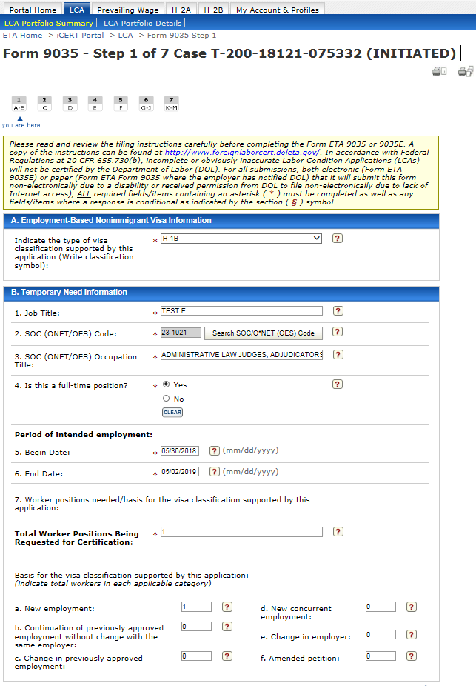
Figure 1 New 9035 Step 1, Sections A and B
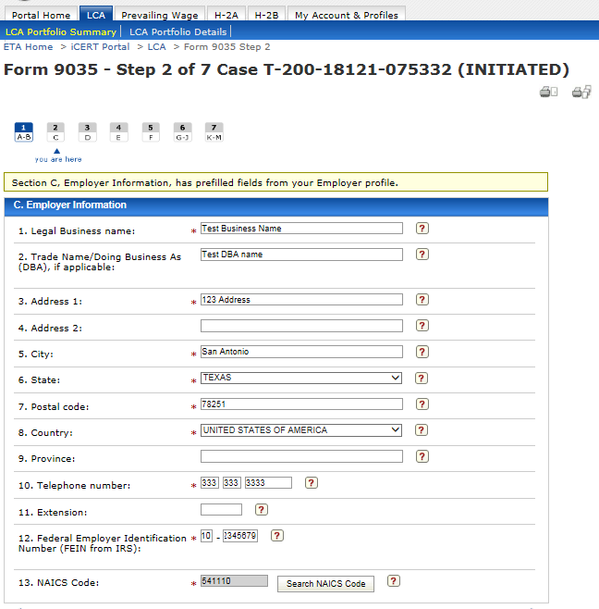
Figure 2 New 9035 Step 2, Section C

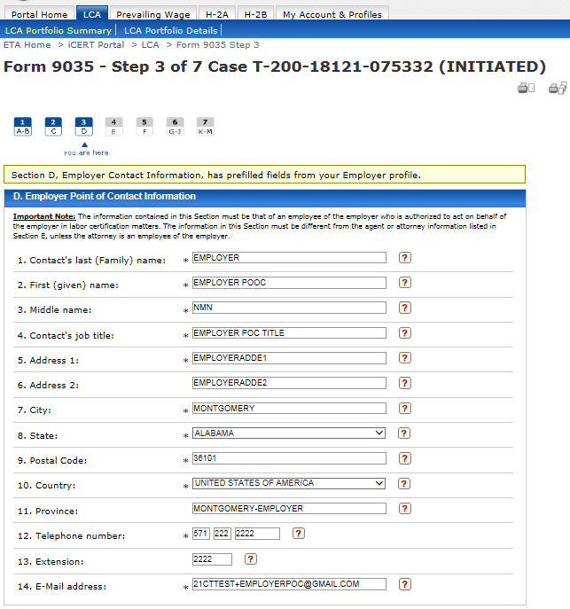
Figure 3 New 9035 Step 3, Section D
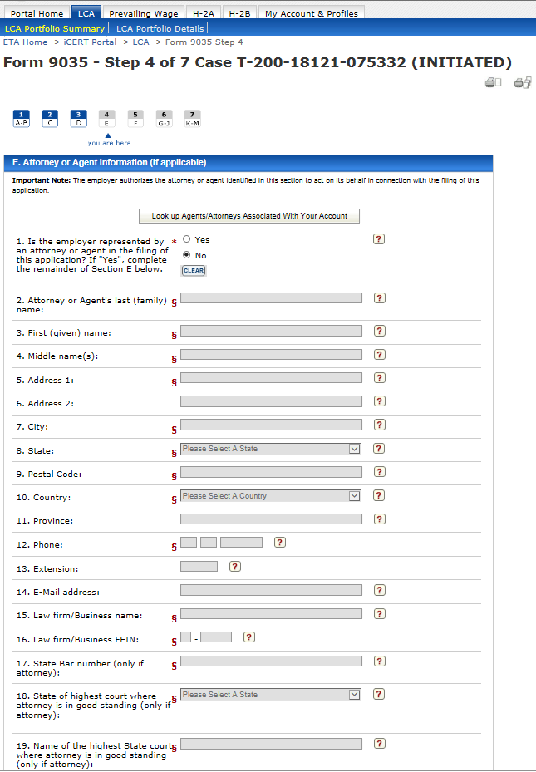
Figure 4 New 9035 Step 4, Section E
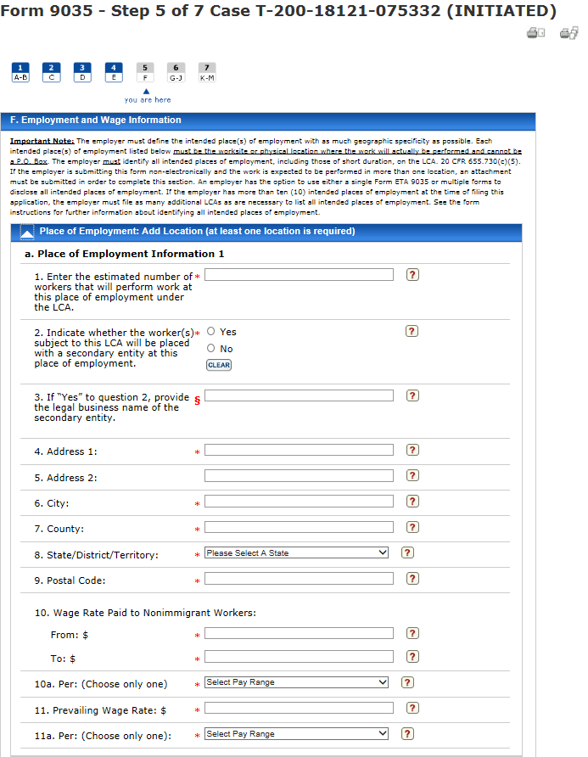
Figure 5 New 9035 Step 5, Section Fa
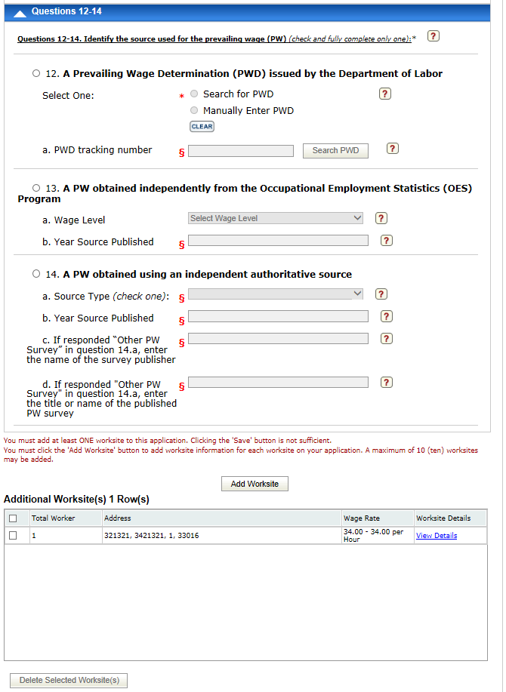
Figure 6 New 9035 Step 5, Section F, questions 12-14 and additional worksite table

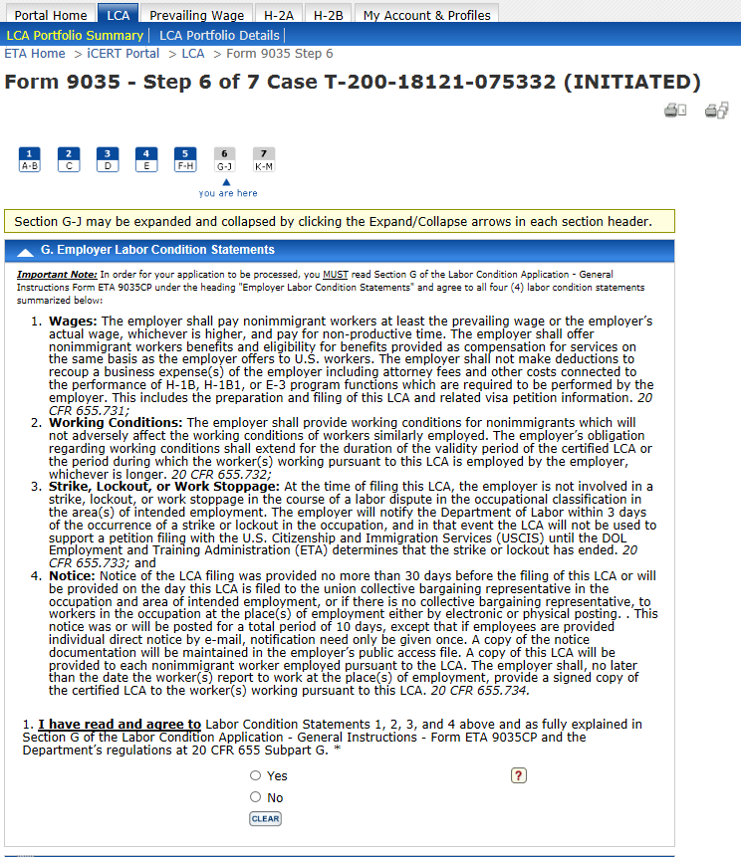
Figure 7 New 9035 Step 6, Section G
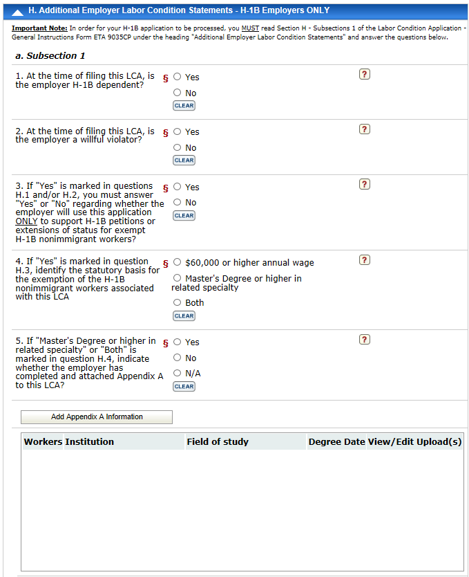
Figure 8 New 9035 Step 6, Section H.a
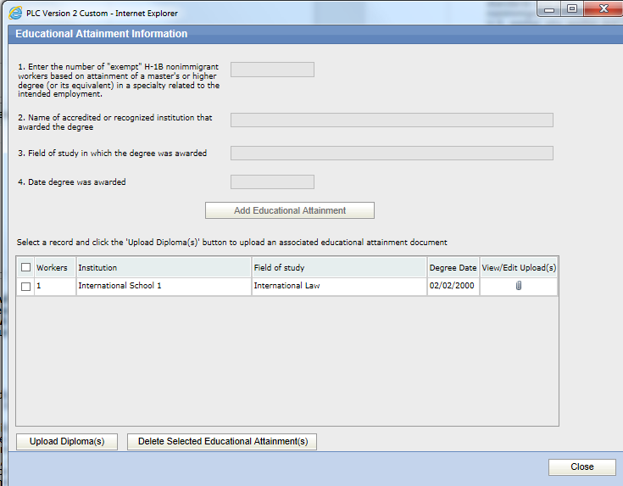
Figure 9 New 9035 Step 6, Section H.a Add Appendix A Information
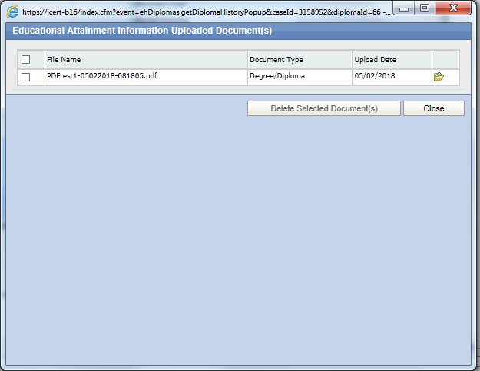
Figure 10 New 9035 Step 6, Section H.a View Educational Document Upload Record
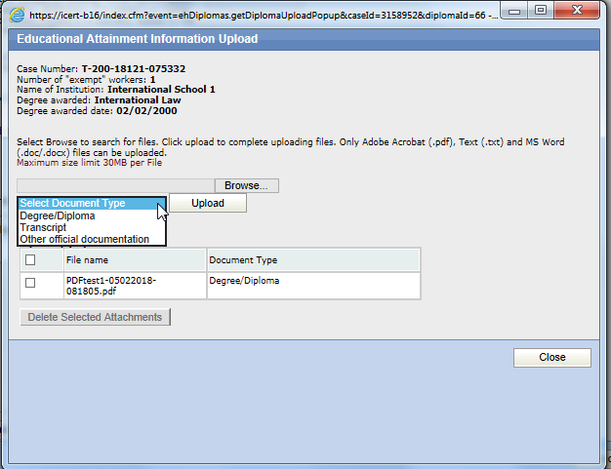
Figure 11 New 9035 Step 6, Section H.a Educational Document Upload

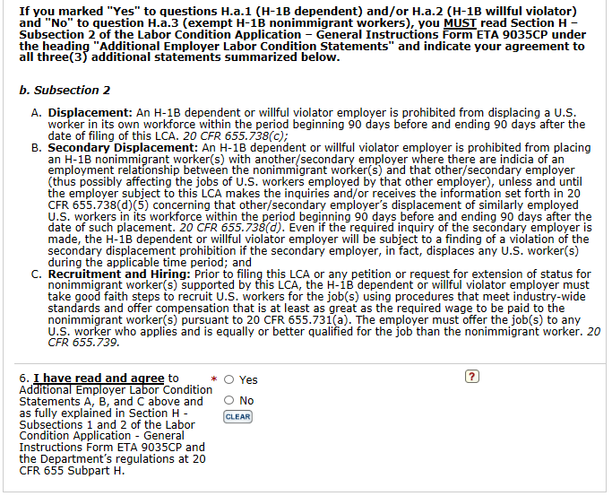
Figure 12 New 9035 Step 6, Section H.b

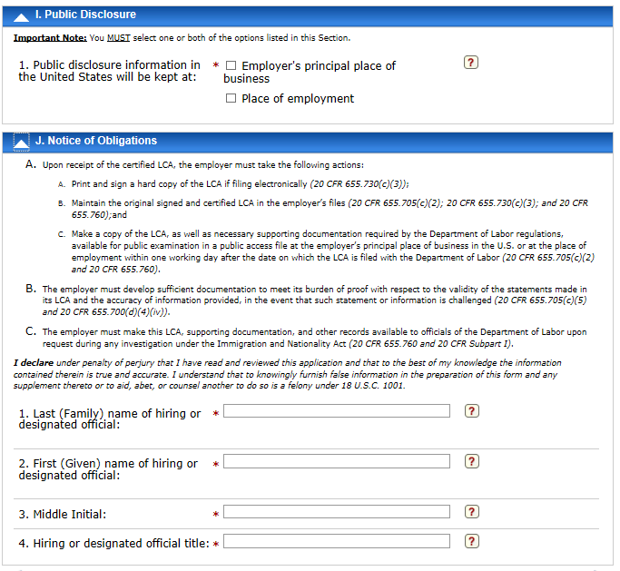
Figure 13 New 9035 Step 6, Section I-J

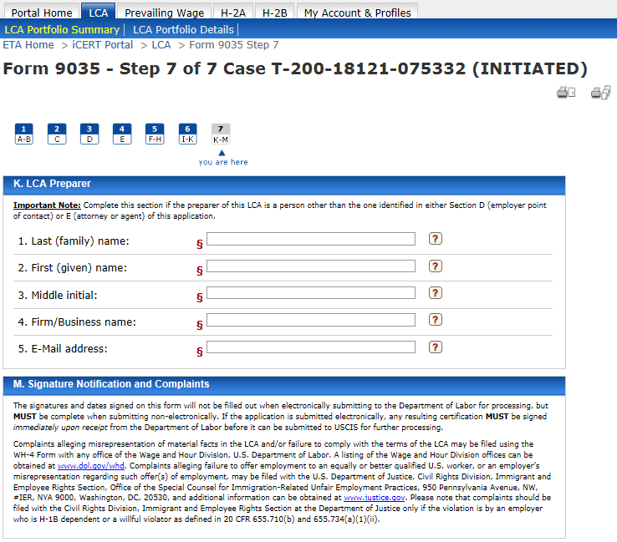
Figure 14 New 9035 Step 7, Section K-M
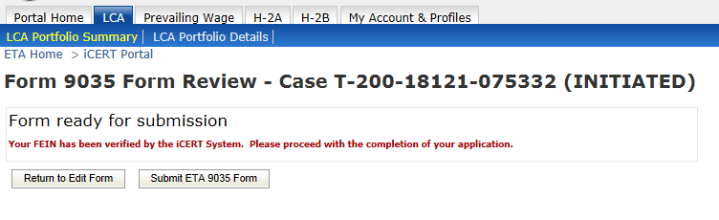
Figure 15 New 9035 Presubmission
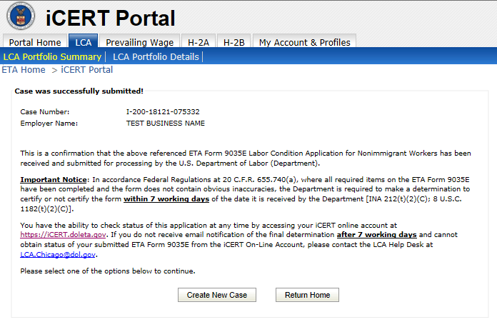
Figure 16 New 9035 Submission Confirmation

Case Prep Generated PDF View:
