**TREAT Astronaut Act screenshots**

Johnson Space Center (JSC) Flight Medicine Clinic (FMC) Information Collection electronic forms are presented as screenshots in this document.

Summary below, regarding the screenshots listed here that are used to collect information in the Electronic Medical Records (EMR) software used at the JSC, FMC:

1. Privacy Act popup all EMR users see when they access the EMR.

2. Screenshots of EMR Patient Registration tabs

1. **Privacy Act screen view.**

This screenshot is of the privacy notice displayed to all authorized clinic staff logging into JSC, FMC EMR to collect information from public, former astronauts and/ or former payload specialists.

Privacy Act Notification

Furnishing us this information is voluntary. Failure to provide this information may result in NASA’s inability to track you for health monitoring and follow-up.

The Flight Medicine Clinic (FMC) will use this information to maintain accurate records to render routine care. Its collection is authorized by 42 USC § 2473; 44 USC § 3101; Pub L. 92-255 and managed under NASA 10HIMS, Health and Information Management System. NASA FMC may share your information, together with medical information for the following purposes, called routine uses: (1) this system of records may be granted to Federal, State, or local agencies or to foreign governments in cases of accident investigations, including mishap and collateral investigations; and (2) other entities outlined as Routine Uses in NASA 10HIMS and in NASA Standard Routine uses for all NASA systems of records. The full System of Records notice and Standard Routine Uses may be found at https://www.nasa.gov/content/nasa-privacy-act-system-of-records-notices-sorns.

Paperwork Reduction Act Notification

This information collection meets the requirements of 44 U.S.C § 3507 as amended by section 2 of the

Paperwork Reduction Act of 1995. You do not need to answer these questions unless we display a valid

Office of Management and Budget (OMB) control number. The OMB control number for this collection is 2700-XXXX and this information collection expires on MM/DD/YYYY. We estimate that it will take XX minutes/hours to read the instructions, gather the facts, and answer the questions. Send only comments relating to our time estimate to: larona.k.smith@nasa.gov

1. **EMR Patient Registration screen views**
2. This screenshot is of the first electronic form to collect information by authorized clinic staff as former astronauts and/ or former payload specialists arrive at the JSC clinic and are checked in by clinic staff. This form is labeled Patient and is part of the Electronic Medical Record (EMR) software used by JSC FMC.

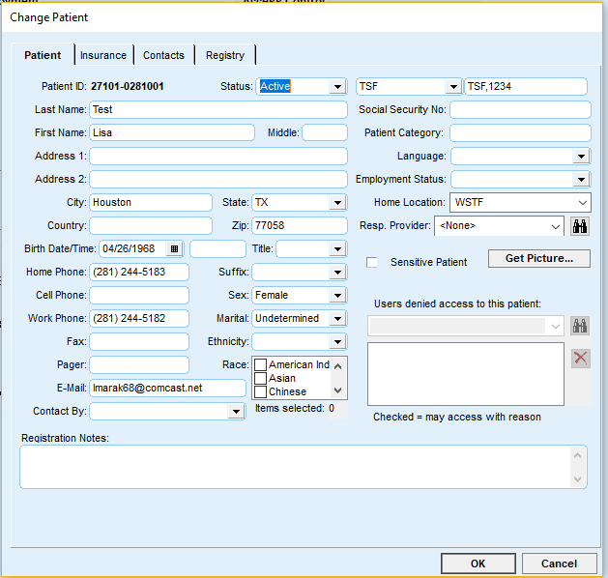

Note

1. This second screenshot, titled Insurance, is used to collect information by authorized clinic staff from former astronauts and/ or former payload specialists regarding their insurance coverage. This form is a built-in part of the Electronic Medical Record (EMR) software used by JSC FMC.

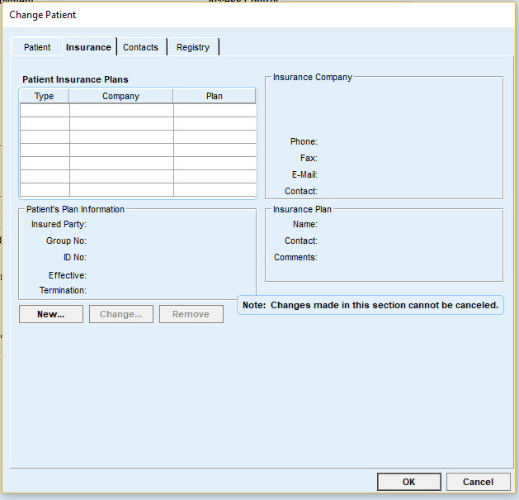

1. This third screenshot is of the electronic form titled Contacts. This form is used to collect information by authorized clinic staff as former astronauts and/ or former payload specialists at the JSC clinic about their emergency contacts. This form is part of the Electronic Medical Record (EMR) software used by JSC FMC.

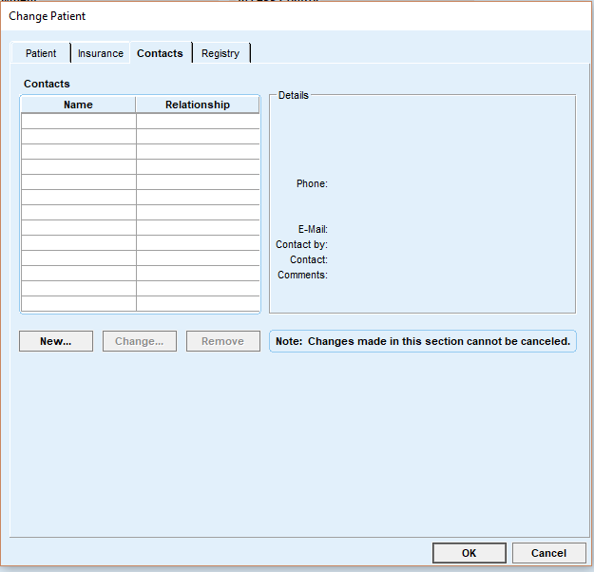

1. The fourth and last screen shot is regarding the tab titled Registry. JSC FMC staff do not use this electronic information collection form. In the software design by the vendor, this form is for registry with outside databases, such as the national immunization registry for children. The JSC FMC operations do not connect to any of these types of registries and thus, it is an unused tab in the clinic.

