**Attachment 1:** **SED Field of Study (FOS) Coding Method Test (Conditions A and B) Overview**

**Condition A – Respondent Use of Auto-Search Textbox to Select FOS Code**

**Condition B – Respondent Use of Auto-Coding Verbatim Bank to Select FOS Code**

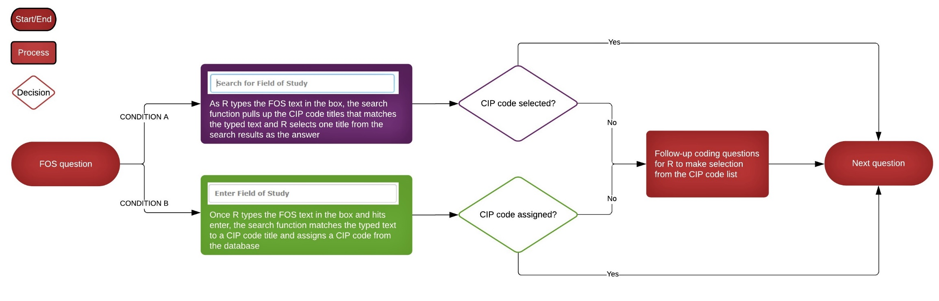

**Condition A: Same as current SED FOS coding method**

**Field of Study (FOS) questions for all degree types**

|  |  |
| --- | --- |
| **What was the field of study for your degree? Please type the field of study in the search box below and choose the field name that best matches your degree field.** | |
| Field Name: | As the respondent types the field of study text in the search box, the search function in the web instrument pulls up the FOS names that include the text for the respondent to select one title and the associated code is assigned in the system. |
| IF FIELD NAME IS SELECTED, RESPONDENT PROCEEDS TO THE NEXT QUESTION ABOUT DEGREE DATES (SEE Q12 IN ATTACHMENT 3 FOR EXAMPLE).  IF FIELD NAME IS NOT SELECTED, RESPONDENT IS ASKED TO SPECIFY THE FIELD OF STUDY. | |
| **Please specify your field of study in the box below.** | |
| Alternate Field Name: | [Text box] |
| RESPONDENT IS THEN ASKED TWO-STAGE QUESTIONS THAT GUIDE THEM TO SELECT THE CIP CODE TITLE THAT BEST FITS THEIR FIELD OF STUDY (SEE Q6 & Q7 IN ATTACHMENT 3 FOR EXAMPLE) | |

**Condition B: Same as current FOS coding method in the National Survey of College Graduates**

**Field of Study (FOS) questions for all degree types**

|  |  |
| --- | --- |
| **What was the field of study for your degree? Please type the field of study in the text box below.** | |
| Field Name: | Once the respondent types the field of study text in the text box, the search function in the web instrument matches the text against the FOS names from the database and assigns the associated code in the system. |
| IF FIELD NAME IS ASSIGNED A CODE, RESPONDENT PROCEEDS TO THE NEXT QUESTION ABOUT DEGREE DATES.  IF FIELD NAME IS NOT ASSIGNED A CODE, RESPONDENT IS THEN ASKED TWO-STAGE QUESTIONS THAT GUIDE THEM TO SELECT THE CIP CODE TITLE THAT BEST FITS THEIR FIELD OF STUDY. | |