Appendix E. Posting of OMB Control Number and Expiration Date
Snapshot of WebNEERS Log in Page
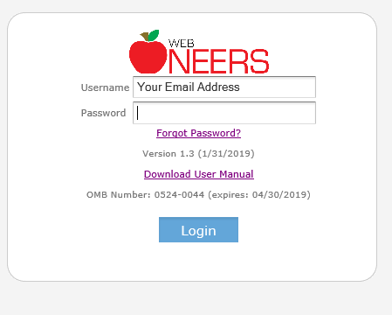

Snapshot of WebNEERS home page (same information is listed at bottom of every webpage in system)
