Project 136 QID 035219 |  |  |  | OMB No. 0535-0218 Approval Expires XX/XX/XXXX
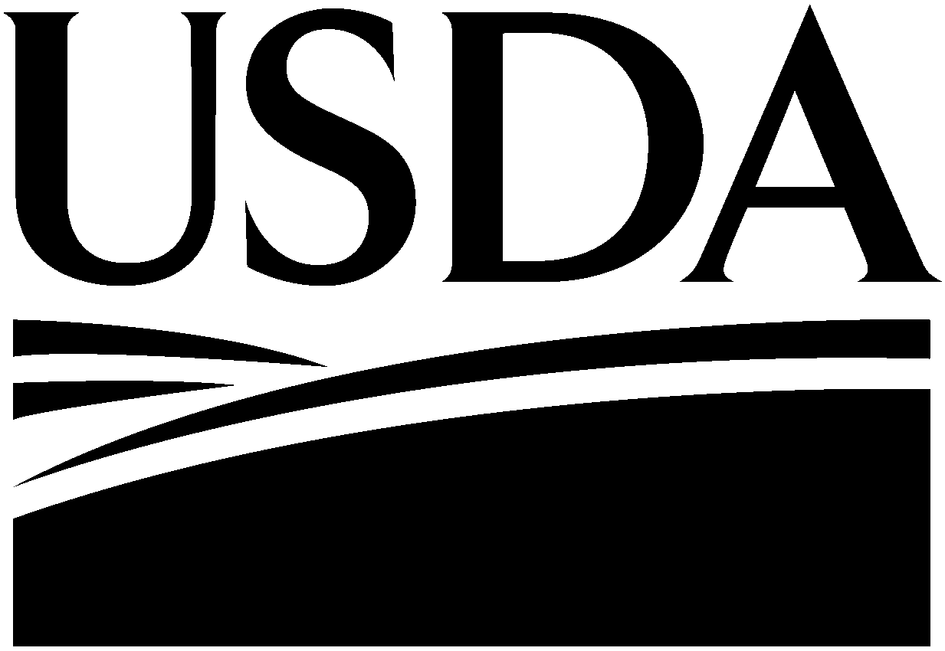 | 2018 Vegetable Chemical Use Survey  Chemical Applications Consent Form |  |  |  |  |  | 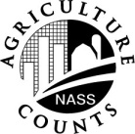 | NATIONAL  AGRICULTURAL  STATISTICS  SERVICE
U.S Department of Agriculture
Rm. 5030, South Building
1400 Independence Avenue, S.W.
Washington, D.C. 20250-2000
1-800-727-9540
Fax: 202-690-2090
Email: nass@nass.usda.gov
VERSION  01 | POID  ___ ___ ___ ___ ___ ___ ___ ___ ___ |  | SUBTRACT  ___ ___

The National Agricultural Statistics Service (NASS) of the U.S. Department of Agriculture is conducting a survey of the Vegetable Chemical Usage for the 2018 crop year. The survey will be conducted from October, 2018 through January, 2019.

By signing this Consent Form, the Owner agrees to allow the vegetable caretaking company listed below to provide the necessary information for the completion of the Vegetable Chemical Use Survey for the selected operation to the National Agricultural Statistics Service. Authority for collection of information on the Vegetable Chemical Use Survey is Title 7, Section 2204 of the U.S. Code. Under Title 7 of the U.S. Code and CIPSEA (Public Law 107-347), facts about your operation are kept confidential and used only for statistical purposes. Response is voluntary. Results of the survey, showing State and National level results for the selected vegetables will be available at the end of July, 2019.

 | Operation Name: | _____________________________________________________________________
 | Owner Name: | _____________________________________________________________________
 | Owner Address: | _____________________________________________________________________
 |  | _____________________________________________________________________
 | Owner Signature: | _____________________________________________________________________
 | Date: | _________________________________
 | Vegetable Caretaking  Company Name: | _____________________________________________________________________
 | Vegetable Caretaking  Company Address: | _____________________________________________________________________
 |  | _____________________________________________________________________
 | Phone Number: | _________________________________

NASDA Field Enumerator: ____________________________________________________

According to the Paperwork Reduction Act of 1995, an agency may not conduct or sponsor, and a person is not required to respond to, a collection of information unless it displays a valid OMB control number. The valid OMB number is 0535-0218. The time required to complete this information collection is estimated to average 5 minutes per response, including the time for reviewing instructions, searching existing data sources, gathering and maintaining the data needed, and completing and reviewing the collection of information.

