December XX, 2019

Dear Grower,

The U.S. Department of Agriculture’s National Agricultural Statistics Service (NASS) is conducting the 2019 Census of Horticultural Specialties to gather information for the U.S. nursery, floriculture, and specialty crop industries. This census is important because it provides the only source of comparable and consistent data to help associations, businesses, and policymakers advocate for your operation and industry.

Your response is critical. Please respond promptly in one of the following ways:

* **Online** at [www.agcensus.usda.gov](http://www.agcensus.usda.gov). Responding online is fast and secure. All you need is your 17-digit survey code from the mailing label to begin.
* **By mail.** Complete the enclosed form and return it in the envelope provided.

This census is part of the Census of Agriculture Program, and as such is required and protected by law (Title 7 USC 2204(g) Public Law 105-113). These federal laws also require that NASS keeps your identity and your answers **confidential**.

Please respond by **February XX, 2020.** The enclosed instructions provide additional details of terms and definitions to help you complete the form. For more information about the Census of Horticultural Specialties, visit www.nass.usda.gov/AgCensus.

If you have questions or need assistance completing your form, call (888) 424-7828. Thank you in advance for your participation.

Sincerely,

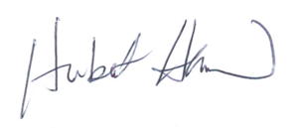

Hubert Hamer

Administrator, National Agricultural Statistics Service

United States Department of Agriculture

Enclosures

It’s Convenient. It’s Secure.

**Online Survey Response**

The online form:

* allows you to skip questions that don’t apply to you
* calculates totals automatically

To complete your survey online, follow these steps:

1. Go to www.agcounts.usda.gov.
2. Enter your unique 17-digit Survey Code from the label on the report form, then click “Continue.”

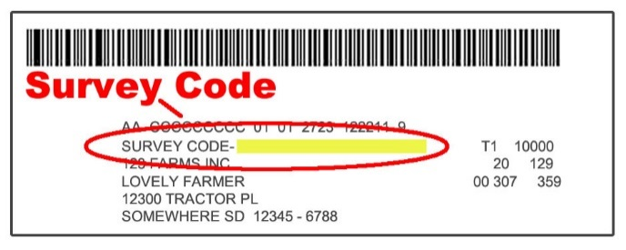

1. Find the survey you are completing and click on it.
2. Verify and complete your contact information, then continue to the survey.
3. Complete the survey questions.

*If you need to stop, click “Save & Return Later” at the top of the page. When you return, go back to Step 1 above. After the opening page, you will be taken to the last page you completed.*

1. When you finish the survey, click “Submit.” *If you do not see the Submit button, reduce the zoom setting on your screen.*

You will receive a confirmation code and can choose to view your completed survey form. Using the options provided by your browser (Internet Explorer, Chrome, Mozilla, etc.), you can print, copy, or save the completed form.