2019 CENSUS OF HORTICULTURAL SPECIALTIES PRE-SURVEY POSTCARD TEXT
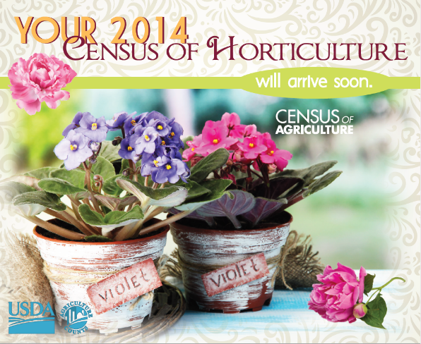 (previous postcard shown)

Postcard Front:
Your 2019 Census of Horticulture will arrive soon.

Logos/Graphics:
USDA
NASS
CENSUS OF AGRICULTURE

Design Elements:
- Colorful
- Nursery, horticulture, specialty crops

Back:
It’s almost here!
Top 3 Reasons to Respond to the Census of Horticulture:
- Your operation and products are a valuable part of the ag industry and should be counted – nursery and floriculture products were more than a $XX billion industry in the U.S. according to the 2017 Census of Agriculture.
- Your input serves as the foundation for many decisions involving the sustainability and growth of your industry.

- Your responses are required and protected by Federal law. Confidentiality is guaranteed.

Learn more at www.nass.usda.gov/AgCensus.

2019 CENSUS OF HORTICULTURAL SPECIALTIES REMINDER POSTCARD TEXT

Postcard Front:
A Reminder about your 2019 Census of Horticulture

Logos/Graphics:
USDA
NASS
CENSUS OF AGRICULTURE

Design Elements:
- Colorful
- Nursery, horticulture, specialty crops

Back:
If you’ve already completed the 2019 Census of Horticulture, thank you! If not, please do so online or by mail by February XX, 2020.

This census is your voice. Your input will be the foundation for many decisions involving the sustainability and growth of your industry for the next several years.

We guarantee that your individual responses will be kept confidential as required by federal law. The same law also makes your participation in the 2019 Census of Horticulture mandatory, as the survey is part of the Census of Agriculture Program.

If you have questions or need assistance completing your form, call (888) 424-7828. Learn more at www.nass.usda.gov/AgCensus.

