C17. Next Steps for Principals EMAIL (GROUP 2)

**This page has been left blank for double-sided copying.**

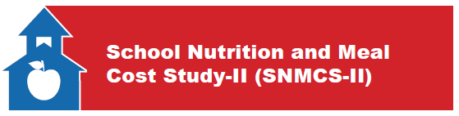OMB Control Number: 0584-XXXX

Expiration Date: XX/XX/XXXX

Next Steps for Principals and School Liaisons

According to the Paperwork Reduction Act of 1995, an agency may not conduct or sponsor, and a person is not required to respond to, a collection of information unless it displays a valid OMB control number. The valid OMB control number for this information collection is 0584-xxxx. The time required to complete this information collection is estimated to average 2 minutes per response, including the time for reviewing instructions, searching existing data sources, gathering and maintaining the data needed, and completing and reviewing the collection of information. Send comments regarding this burden estimate or any other aspect of this collection of information, including suggestions for reducing this burden, to: U.S. Department of Agriculture, Food and Nutrition Service, Office of Policy Support, 3101 Park Center Drive, Room 1014, Alexandria, VA 22302, ATTN: PRA (0584-xxxx). Do not return the completed form to this address.

* **Principal selects a school liaison and sends their name, email, and phone number to the study contact**
* The school liaison should be someone who has familiarity with your school’s operations and access to students’ schedules and contact information. A liaison may be a teacher, counselor, or administrator.
* **School liaison completes a web survey to help plan the on-site data collection**
* The planning interview will ask questions about your schedule, best times to reach you, the address of the school, lunch and breakfast schedules, and your preference for how we should distribute study materials to students.
* **School liaison provides student roster information in preparation for student and parent surveys**
* To select the students for the study we will need you to upload student roster information to a secure file transfer site in advance of the visit. We will send a document that details the specific data that we need for students. The study team will select some students from the roster.
* Depending on your district’s policies, we may ask you to help distribute and collect parental consent forms for the study.
* **School liaison serves as a contact for study staff during on-site data collection**
* You will work with the study team to provide a location for the study staff to interview a sample of students.
* **[IF SFA ALLOWS INCENTIVES: School liaison receives an incentive as a token of appreciation]**

***Thank you for your time and efforts – we look forward to working with you!***

**This page has been left blank for double-sided copying.**