D2. SCHOOL ENDORSEMENT LETTER- ENGLISH (GROUP 2)

**This page has been left blank for double-sided copying.**

**[TO BE PRINTED ON SCHOOL OR DISTRICT LETTERHEAD]**

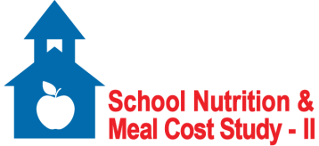

OMB Control Number: 0584-XXXX

Expiration Date: XX/XX/XXXX

Dear Parent/Guardian,

I’m writing to let you know that our school district has been selected for an important study for the U.S. Department of Agriculture (USDA)/Food and Nutrition Service (FNS). It is called the School Nutrition and Meal Cost Study-II (SNMCS-II). FNS oversees the school lunch and breakfast programs. It also helps to fund our school meals. The study team is led by Mathematica Policy Research. They are reaching out to students and their families in the district about the study. The goal is to learn more about student nutrition and school meals. The district supports this effort. I fully encourage you to participate.

Participation in the study is voluntary. Your decision to complete a survey will not affect your student’s receipt of school meals or participation in any other school activities. But this is a chance to help these programs best serve the needs of our students. If you have any questions about the study, please contact the study team directly at 1-8xx-xxx-xxxx or [EMAIL]@mathematica-mpr.com.

Sincerely,

[SCHOOL ADMINISTRATOR]

**This page has been left blank for double-sided copying.**