I5. AUTOMATED MULTIPLE PASS METHOD (Group 2)

This page has been left blank for double-sided copying.

OMB Control Number: 0584-XXXX
Expiration Date: XX/XX/XXXX
The 24-hour dietary recall will be conducted using the U.S. Department of Agriculture (USDA) Automated Multiple Pass Method (AMPM). The AMPM interview consists of five steps that utilize different strategies to encourage respondents to think about their intake in different ways in order to maximize their ability to remember and report the foods they have eaten. The five steps of the AMPM 24-hour dietary recall include:
- Step 1 - Quick List: The first step obtains a quick report of easily remembered foods and beverages. The interviewer reads a standard memory prompt that suggests strategies for remembering foods and beverages consumed the previous day (see Exhibit A).
- Step 2 - Forgotten Foods List: The interviewer encourages respondents to think about specific categories of foods that are frequently forgotten, such as beverages, sweets, savory snacks, fruits, vegetables, cheese, breads, tortillas, and rolls (see example in Exhibit B).
- Step 3 - Time and Occasion pass: The interviewer encourages additional recall and reporting by helping the respondent to think about eating patterns over the past 24 hours, including the times that foods and beverages were consumed and the types of eating occasions like at breakfast, for a snack, or at lunch (see Exhibit C).
- Step 4 - Detail and Review Cycle: At this step, the interviewer probes for food descriptions and amounts, where foods were obtained, and where they were eaten. Each eating occasion and the periods between are reviewed to check whether the respondent remembers any additional foods. Respondents use measuring guides to help estimate the amounts of foods and beverages consumed (see example in Exhibit D).
- Step 5 - Final Review: The respondent is asked one last time to remember anything else consumed in the previous day (see Exhibit E).
According to the Paperwork Reduction Act of 1995, an agency may not conduct or sponsor, and a person is not required to respond to, a collection of information unless it displays a valid OMB control number. The valid OMB control number for this information collection is 0584-xxxx. The time required to complete this information collection is estimated to average 48 minutes per response for students’ first dietary recall, 45 minutes per response for students’ second dietary recall, 15 minutes per response for parents assisting with the first dietary recall, and 45 minutes per response for parents assisting with the second dietary recall. These time estimates include the time for reviewing instructions, searching existing data sources, gathering and maintaining the data needed, and completing and reviewing the collection of information. Send comments regarding this burden estimate or any other aspect of this collection of information, including suggestions for reducing this burden, to: U.S. Department of Agriculture, Food and Nutrition Service, Office of Policy Support, 3101 Park Center Drive, Room 1014, Alexandria, VA 22302, ATTN: PRA (0584-xxxx). Do not return the completed form to this address.

Exhibit A. Quick List Screenshot
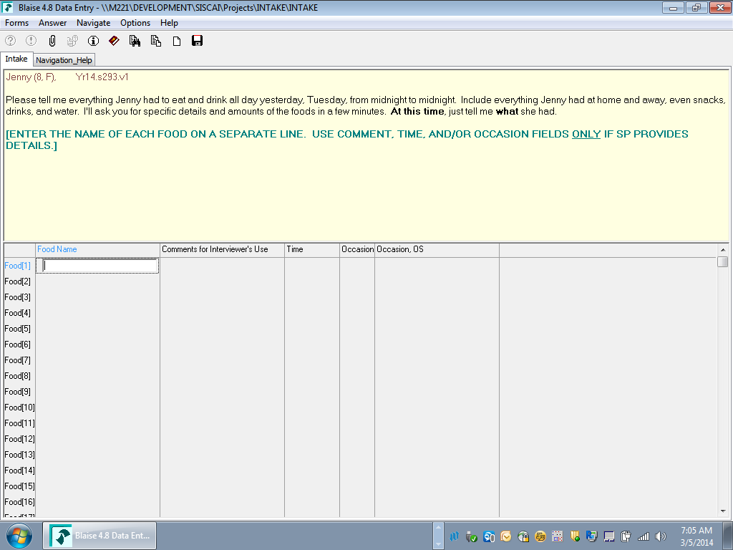

Exhibit B. Forgotten Foods List Screenshot (Example question)
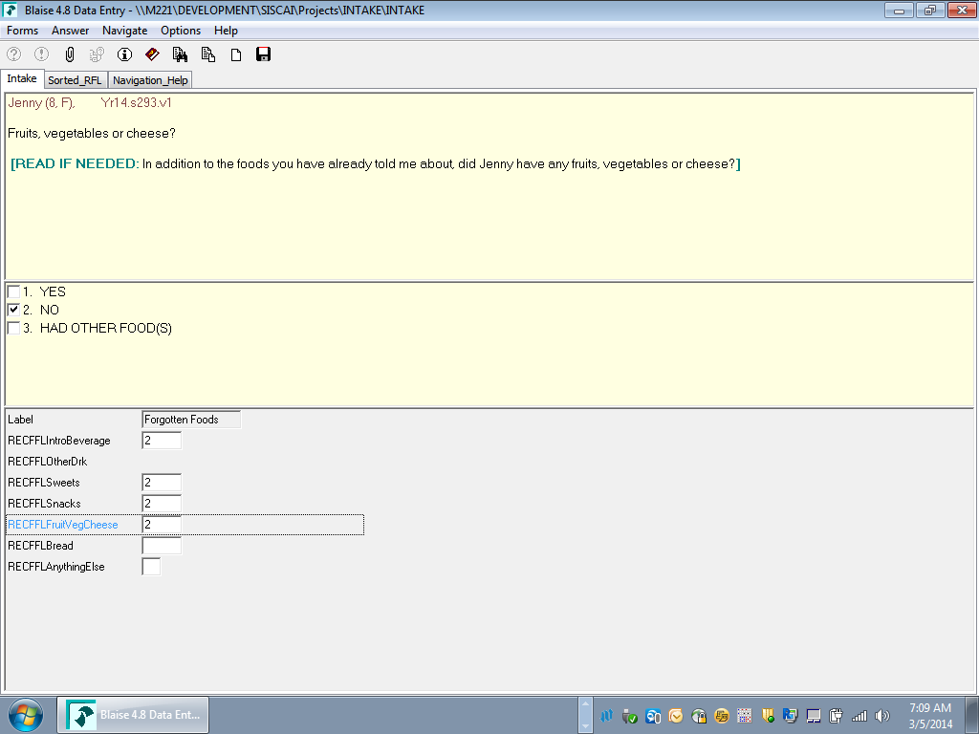

Exhibit C. Time and Occasion Pass Screenshot
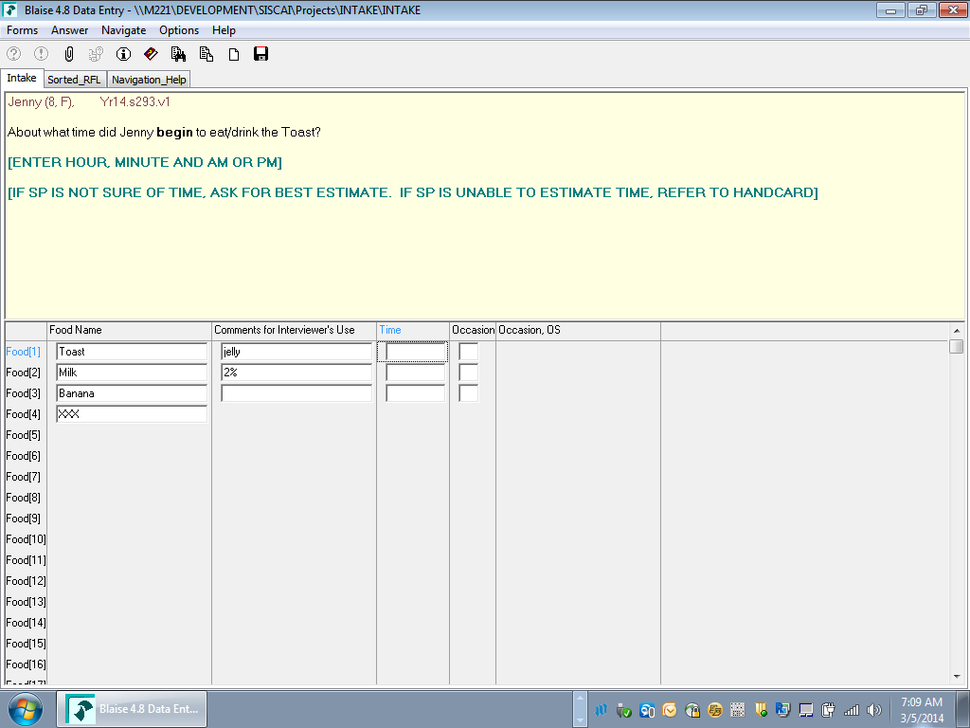

Exhibit D. Detail and Review Cycle Screenshot (Example question)
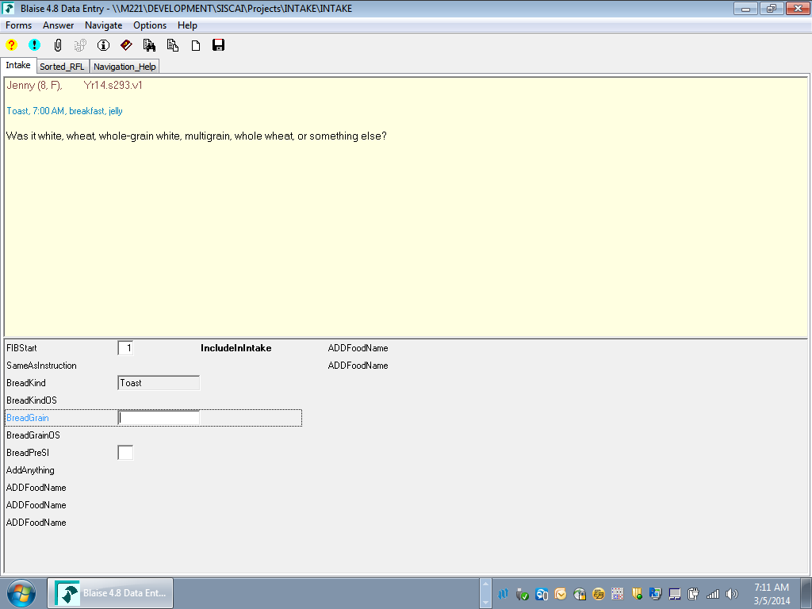

Exhibit E. Final Review Cycle Screenshot
