K3. Electronic Menu Survey Example Screenshots

This page has been left blank for double-sided copying.

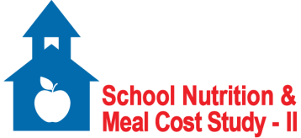

**School Nutrition and Meal Cost Study-II**

***Electronic Menu Survey***

According to the Paperwork Reduction Act of 1995, an agency may not conduct or sponsor, and a person is not required to respond to, a collection of information unless it displays a valid OMB control number. The valid OMB control number for this information collection is 0584-xxxx. The time required to complete this information collection is estimated to average 40 minutes per response, including the time for reviewing instructions, searching existing data sources, gathering and maintaining the data needed, and completing and reviewing the collection of information. Send comments regarding this burden estimate or any other aspect of this collection of information, including suggestions for reducing this burden, to: U.S. Department of Agriculture, Food and Nutrition Service, Office of Policy Support, 3101 Park Center Drive, Room 1014, Alexandria, VA 22302, ATTN: PRA (0584-xxxx). Do not return the completed form to this address.

OMB Clearance Number: 0584-XXXX

Expiration Date: XX/XX/XXXX

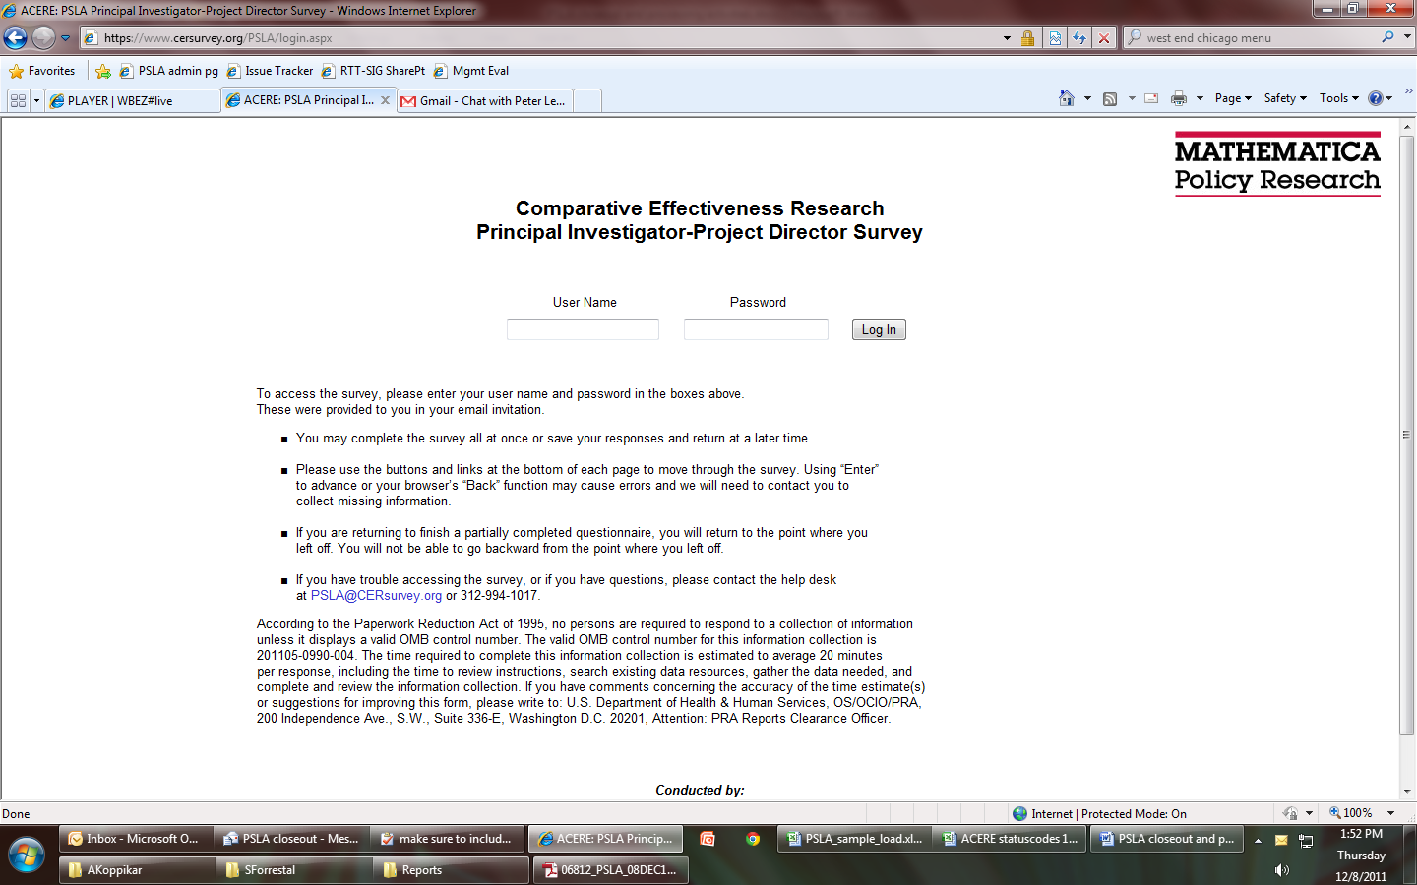

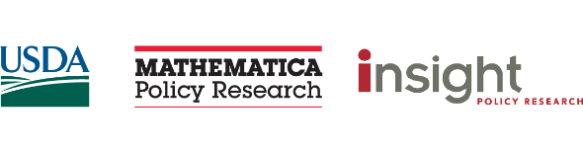



OMB Control Number: 0584-XXXX

Expiration Date: XX/XX/XXXX

According to the Paperwork Reduction Act of 1995, an agency may not conduct or sponsor, and a person is not required to respond to, a collection of information unless it displays a valid OMB control number. The valid OMB control number for this information collection is 0584-xxxx. The time required to complete this information collection is estimated to average 8 hours per response, including the time for reviewing instructions, searching existing data sources, gathering and maintaining the data needed, and completing and reviewing the collection of information. Send comments regarding this burden estimate or any other aspect of this collection of information, including suggestions for reducing this burden, to: U.S. Department of Agriculture, Food and Nutrition Service, Office of Policy Support, 3101 Park Center Drive, Room 1014, Alexandria, VA 22302, ATTN: PRA (0584-xxxx). Do not return the completed form to this address.

**Welcome to the SNMCS-II Basic Menu Survey!**

Thank you for participating in the **School Nutrition and Meal Cost Study-II**. Without your help, and the help of school nutrition professionals like you across the country, this important study could not be done.

As part of this study, you are being asked to complete a **Menu Survey**. The objective of the Menu Survey is to obtain a complete and accurate description of the foods prepared and served by your school nutrition program, including foods offered in reimbursable meals, sold a la carte, and in afterschool snacks (if reimbursed through the National School Lunch Program). You will complete the survey forms during a specified time period, referred to as the “target week.” *The target week for your school is shown on the front of the Menu Survey Folder.*

The information you provide will be combined with information from many other schools across the country and will be used to examine the food and nutrient content of school meals and afterschool snacks.

Next

Back



OMB Control Number: 0584-XXXX

Expiration Date: XX/XX/XXXX

According to the Paperwork Reduction Act of 1995, an agency may not conduct or sponsor, and a person is not required to respond to, a collection of information unless it displays a valid OMB control number. The valid OMB control number for this information collection is 0584-xxxx. The time required to complete this information collection is estimated to average 10 hours per response, including the time for reviewing instructions, searching existing data sources, gathering and maintaining the data needed, and completing and reviewing the collection of information. Send comments regarding this burden estimate or any other aspect of this collection of information, including suggestions for reducing this burden, to: U.S. Department of Agriculture, Food and Nutrition Service, Office of Policy Support, 3101 Park Center Drive, Room 1014, Alexandria, VA 22302, ATTN: PRA (0584-xxxx). Do not return the completed form to this address.

**Welcome to the SNMCS-II Expanded Menu Survey!**

Thank you for participating in the **School Nutrition and Meal Cost Study-II**. Without your help, and the help of school nutrition professionals like you across the country, this important study could not be done.

As part of this study, you are being asked to complete a **Menu Survey**. The objective of the Menu Survey is to obtain a complete and accurate description of the foods prepared and served by your school nutrition program, including foods offered in reimbursable meals, sold a la carte, and in afterschool snacks/suppers. You will complete the survey forms during a specified time period, referred to as the “target week.” *The target week for your school is shown on the front of the Menu Survey Folder.*

The information you provide will be combined with information from many other schools across the country and will be used to examine the food and nutrient content of school meals and afterschool snacks.

Next

Back



**Welcome to the SNMCS-II Menu Survey (Expanded, Outlying Areas)!**

Thank you for participating in the **School Nutrition and Meal Cost Study-II**. Without your help, and the help of school nutrition professionals like you in the outlying areas, this important study could not be done.

As part of this study, you are being asked to complete a **Menu Survey**. The objective of the Menu Survey is to obtain a complete and accurate description of the foods prepared and served by your school nutrition program, including foods offered in reimbursable meals [for full approach only] and sold a la carte or in other non-reimbursable venues. You will complete the survey forms during a specified time period, referred to as the “target week.” *The target week for your school is shown on the front of the Menu Survey Folder.*

The information you provide will be used to estimate the cost of producing reimbursable meals for the National School Lunch Program and School Breakfast Program. This study is important because an accurate assessment of meal costs could eventually be used to adjust per-meal reimbursement rates in outlying areas

OMB Control Number: 0584-XXXX

Expiration Date: XX/XX/XXXX

Next

Back

According to the Paperwork Reduction Act of 1995, an agency may not conduct or sponsor, and a person is not required to respond to, a collection of information unless it displays a valid OMB control number. The valid OMB control number for this information collection is 0584-xxxx. The time required to complete this information collection is estimated to average 8 hours and 20 minutes per response for school nutrition managers in the full-approach outlying areas, and 3 hours and 30 minutes per response for SFA directors in the limited-approach outlying areas, including the time for reviewing instructions, searching existing data sources, gathering and maintaining the data needed, and completing and reviewing the collection of information. Send comments regarding this burden estimate or any other aspect of this collection of information, including suggestions for reducing this burden, to: U.S. Department of Agriculture, Food and Nutrition Service, Office of Policy Support, 3101 Park Center Drive, Room 1014, Alexandria, VA 22302, ATTN: PRA (0584-xxxx). Do not return the completed form to this address.