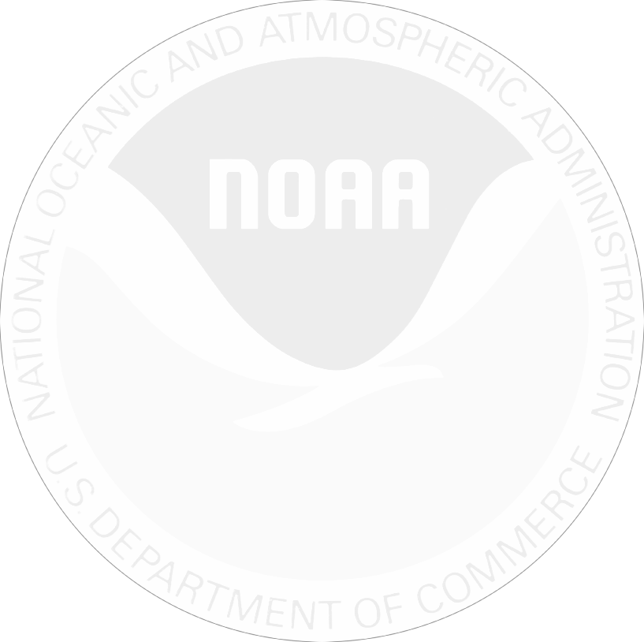

*February 12, 2019*

*Two weeks ago we invited you to complete an online survey on behalf of the National Oceanic and Atmospheric Administration. If you have already completed the survey online, please accept our sincere thanks. If not, I encourage you to do so today. Go to* ***www.study.fish*** *and enter the* ***Survey ID: 730roundscad****.*

*Information collected in this study will help us to better understand how people use recreation resources in Florida. Please know that your answers are completely confidential and will be used only for this study in accordance with the Magnuson-Stevens Act and NOAA Administrative Order 216-100.*

*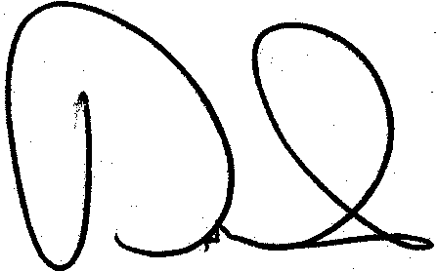If you did not receive the survey information, please call 1-800-229-5220 x5.*

*Sincerely,*

David W. Carter

Economist, Social Science Research Group

NOAA Southeast Fisheries Science Center

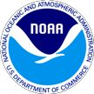 Florida Boating and Fishing Survey

QuanTech, Inc.

6110 Executive Blvd, Suite 480

Rockville, MD 20852

|  |  |
| --- | --- |
|  |  |
| ADAM BALLANS |  |
| 12914 RAYSBROOK DR |  |
| RIVERVIEW FL 33569-8720 |  |