
Contractor Logo

<<Date>>

Florida Boat Owner - <<Last Name>> Household
Add 2
Add 2
City, State, Zip

Dear <<Last Name>> Household
You are invited to participate in a survey that <<Contractor>> is conducting on behalf of the National Oceanic and Atmospheric Administration (NOAA). The survey asks about your boating and fishing activities in Florida. The results will be used to learn more about the environment and help improve the quality of marine and coastal resources.
For this study to be accurate, we need all boat owners who are selected to complete this short survey online. Your address was randomly picked from a list of licensed boater owners in Florida, and we can’t replace you with someone else. Your responses will help all boat owners in Florida have their voices heard.
This survey should be completed by an adult living at this address. We have included a small gift as a way of saying thank you for your help. To participate in the online survey:
- Take note of your unique survey ID: {RESTORE ID}
- Go to www.boatfishsurvey.com and enter your survey ID in the space provided.
This is a voluntary survey, and your responses are confidential and will only be used in combination with answers from other households. If you have any questions or comments about this study, we will be happy to talk to you. Please call 1-888-xxx-xxxx.
Please keep this letter until you have completed your survey, as it contains your personal password and you cannot complete the survey without it. Thank you very much for your help with this important study.
Yours sincerely,
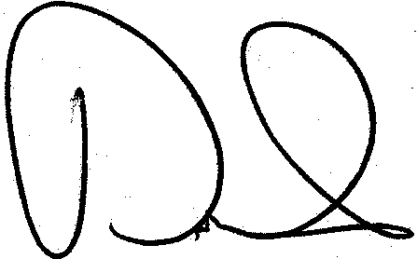
David W. Carter, Ph. D.
Economist, Social Science Research Group
NOAA Southeast Fisheries Science Center

Responses are kept confidential as required by section 402(b) of the Magnuson-Stevens Act and NOAA Administrative Order 216-100, Confidentiality of Fisheries Statistics, and will not be released for public use except in aggregate statistical form without identification as to its source.

Commonly Asked Questions

How did you get my address?
Your address was randomly selected from a list of all boat owners in Florida. You represent many other boat owners in Florida.

Nobody in my household participates in recreational fishing. Should I still complete the survey?
Yes. It is important that everyone who receives this short survey complete it. For the results of the study to be accurate, we need basic information about all boat owners who received the survey – regardless of whether they participate in boating, fishing, or both.

Why can’t you interview another boat owner instead of me?
We can’t select another household. For the results to be accurate, we need all boat owners who receive this short survey to complete it.

How much time will this survey take?
On average, it should take less than five minutes to complete, including reviewing instructions, and answering the questions.

Who is sponsoring the survey?
This study is being sponsored by the National Oceanic and Atmospheric Administration (NOAA). NOAA’s mission is to understand and predict changes in the Earth’s environment and conserve and manage coastal and marine resources to meet our nation’s economic, social, and environmental needs.

How will the information I provide be used?
This survey collects information about how outdoor and marine resources in Florida are used and will help us better manage these resources for the future.
Your answers are completely confidential and will be used only for this study in accordance with the Privacy Act of 1974. Call, toll-free, at 1-888-xxx-xxxx with questions about this survey.

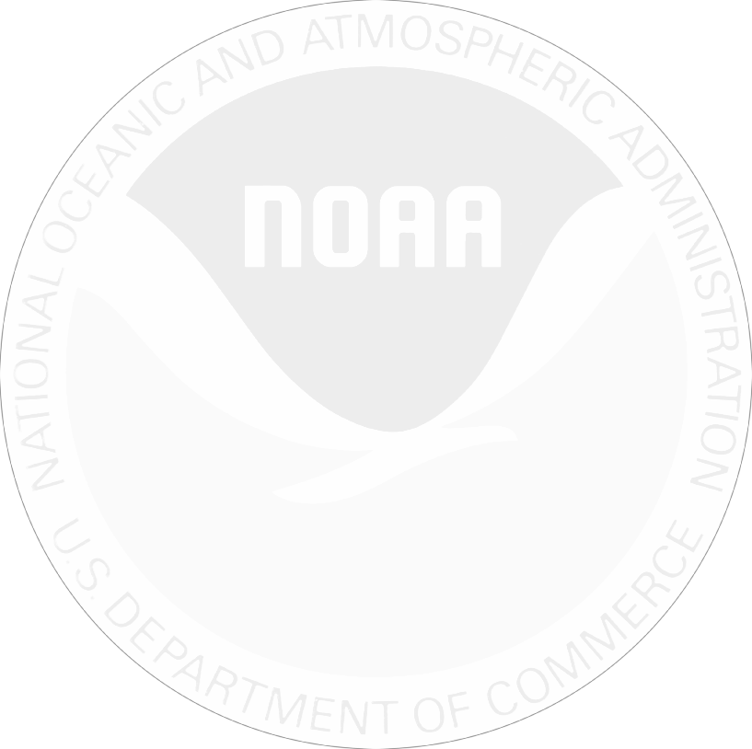
July 6, 2018

Last week we invited you to complete an online survey on behalf of the National Oceanic and Atmospheric Administration. If you have already completed the survey online, please accept our sincere thanks. If not, I encourage you to do so today. Go to www.boatfishsurvey.com and enter the ID from your letter.
Information collected in this study will help us to better understand how people use recreation resources in Florida. Please know that your answers are completely confidential and will be used only for this study in accordance with the Magnuson-Stevens Act and NOAA Administrative Order 216-100.
If you did not receive the survey information, please call XXXXXXXX toll- free at 1-XXX-XXX-XXXX.
Sincerely,
David W. Carter
Economist, Social Science Research Group
NOAA Southeast Fisheries Science Center
Florida Boating and Fishing Survey 1234 Main St, Ste A
Anywhere, FL 33149

Florida Boat Owner Add1
Add2
City, St Zip
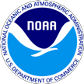

Contractor Logo

<<Date>>

Florida Boat Owner -- <<Last Name>> Household Add 1
Add 2
City, State, Zip

Dear <<Last Name>> Household,
A few weeks ago we invited you to participate in an online survey on Florida boat and fishing activities. The Contractor is conducting this study on behalf of the National Oceanic and Atmospheric Administration (NOAA). If you have already completed the survey, we thank you. If you have not completed it, then we ask you to please complete the enclosed survey and return it in the postage-paid envelope as soon as possible.
Your completed survey will help our understanding of the environment and coastal resources in the state of Florida.
Your address was randomly selected from a list of all <<addresses -- licensed anglers>> in <<State>>. For this study to be accurate, we need all households who receive this short survey to fill it out and send it back – even if you have not fished or participated in outdoor activities. The survey should be completed by an adult member of the household.
We are very grateful for your help. If you have any questions or comments, we will be happy to talk with you. Please call 1-888-xxx-xxxx.
Yours sincerely,
David W. Carter, Ph. D.
Economist, Social Science Research Group
NOAA Southeast Fisheries Science Center

This is a voluntary survey. Responses are kept confidential as required by section 402(b) of the Magnuson-Stevens Act and NOAA Administrative Order 216-100, Confidentiality of Fisheries Statistics, and will not be released for public use except in aggregate statistical form without identification as to its source.

Commonly Asked Questions

How did you get my address?
Your address was randomly selected from a list of all boat owners in Florida. You represent many other boat owners in Florida.

Nobody in my household participates in recreational fishing. Should I still complete the survey?
Yes. It is important that everyone who receives this short survey complete it. For the results of the study to be accurate, we need basic information about all boat owners who received the survey – regardless of whether they participate in boating, fishing, or both.

Why can’t you interview another boat owner instead of me?
We can’t select another household. For the results to be accurate, we need all boat owners who receive this short survey to complete it.

How much time will this survey take?
On average, it should take less than five minutes to complete, including reviewing instructions, and answering the questions.

Who is sponsoring the survey?
This study is being sponsored by the National Oceanic and Atmospheric Administration (NOAA). NOAA’s mission is to understand and predict changes in the Earth’s environment and conserve and manage coastal and marine resources to meet our nation’s economic, social, and environmental needs.

How will the information I provide be used?
This survey collects information about how outdoor and marine resources in Florida are used and will help us better manage these resources for the future.
Your answers are completely confidential and will be used only for this study in accordance with the Privacy Act of 1974. Call, toll-free, at 1-888-xxx-xxxx with questions about this survey.

