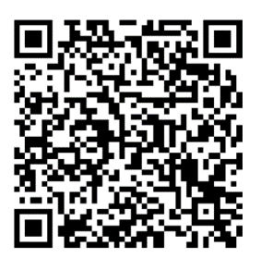
If you have a view on how public money should be invested in R&D for the Internet of Things (IoT) we want to hear from you. https://www.surveymonkey.com/r/695JP3W
The survey will take less than 15 minutes to complete.
Your input will support a National Institute of Standards and Technology’s (NIST) study on the “National Need for Technology Infrastructure to support the Internet of Things (IoT)”.
There is no reward or commercial opportunities in participating and no identifying information recorded. We are only interested in your opinion on industry needs and how investments in IoT technology infrastructure would improve services.
Your views will be incorporated into an economic analysis, final report and presentation materials that will be publicly available in 2021.
More information on the work can be found at https://strategyofthings.io/nist
_____________________________________________________________________________________
If you didn’t get a chance to do the IoT survey last week, the survey is still open. Just 15 minutes to include your views on IoT R&D investments. Survey is at https://www.surveymonkey.com/r/695JP3W
And no more follow up emails from us.

