Location-Based Services User Survey v2.2
The two pages are always presented in the same way: 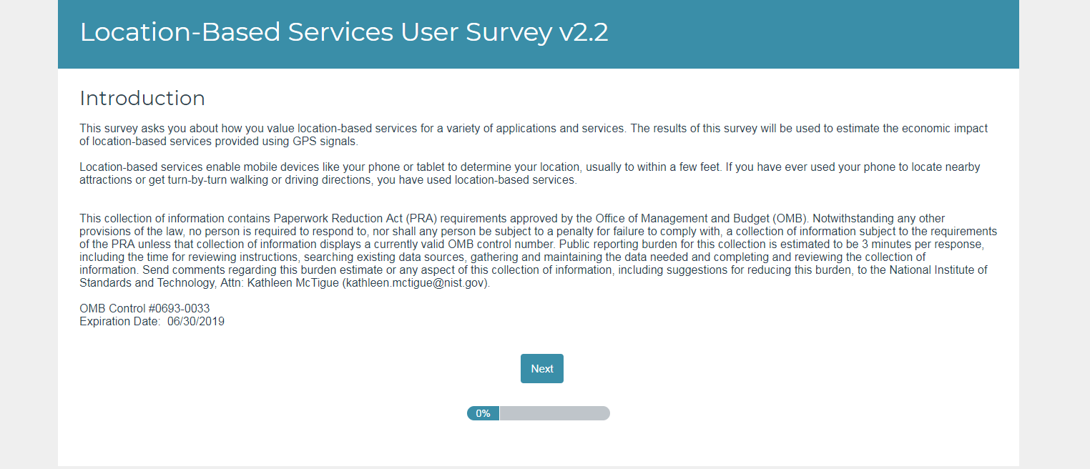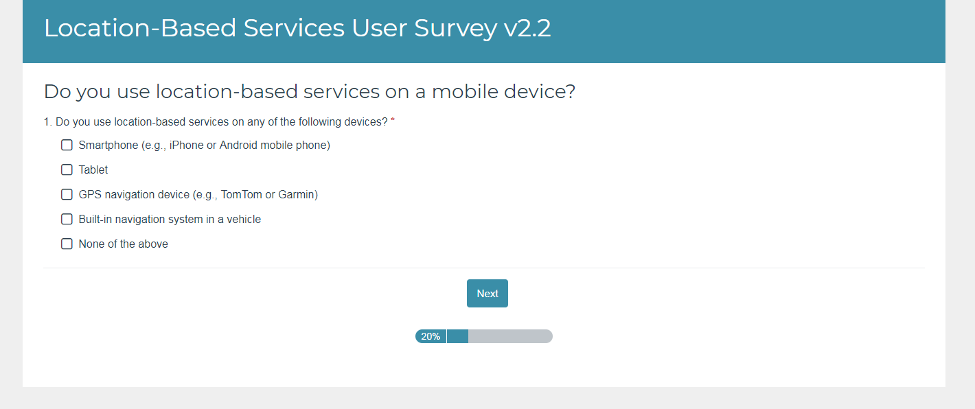
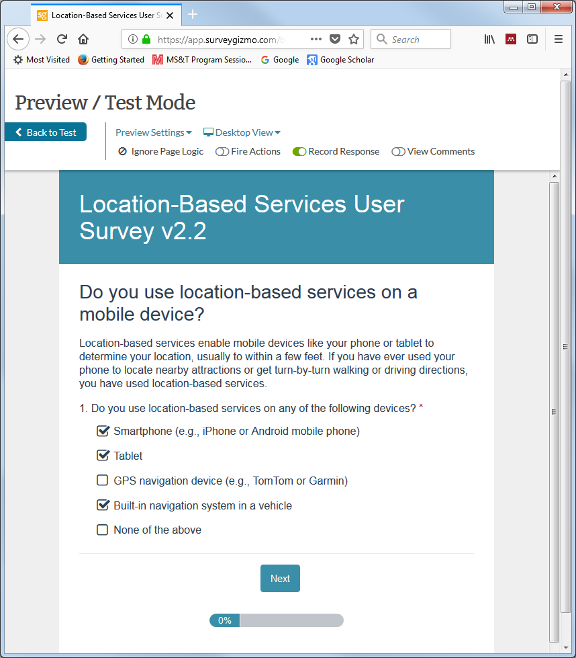
If the user says ‘None of the above’ the survey skips to the end. Otherwise, the second page is presented. Except for ‘Other,’ which always appears last, the options are presented in random order:
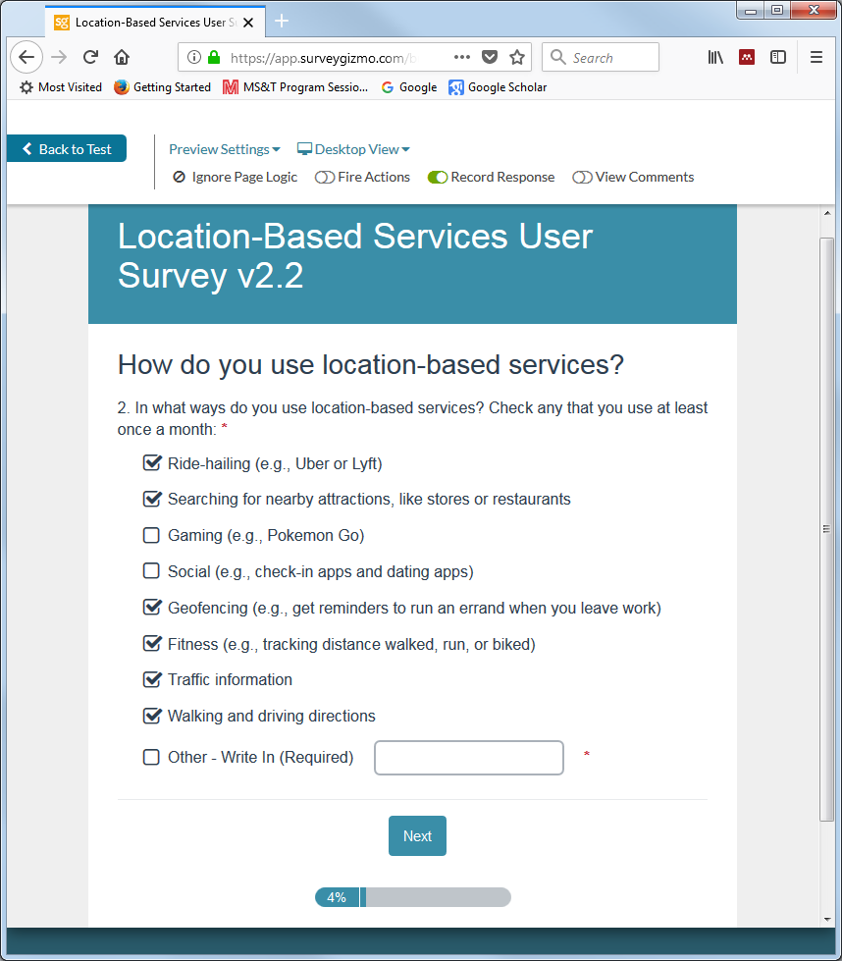
Then, no matter how many boxes are checked, one—and only one—of the things checked is randomly chosen for a follow-up question or questions about how much the respondent values the ability to use location-based services for that thing:
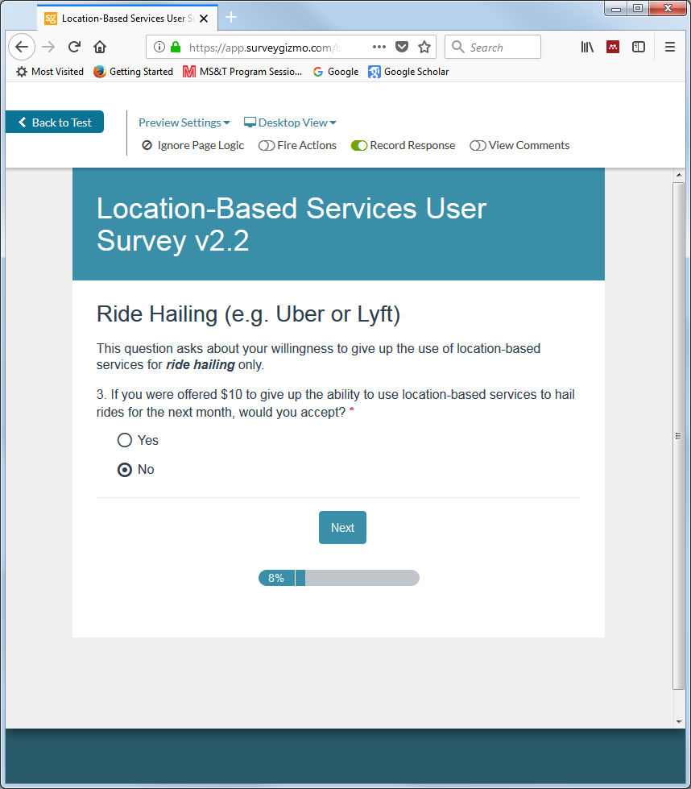
Sometimes, as in this case, the user is presented with an offer and a take-it-or-leave-it choice. If the first offer is rejected, a higher offer is made and the question posed again. If the first offer is accepted, a lower offer is made and the question posed again. The offers are randomized: different initial and follow-up offers are made to each respondent.
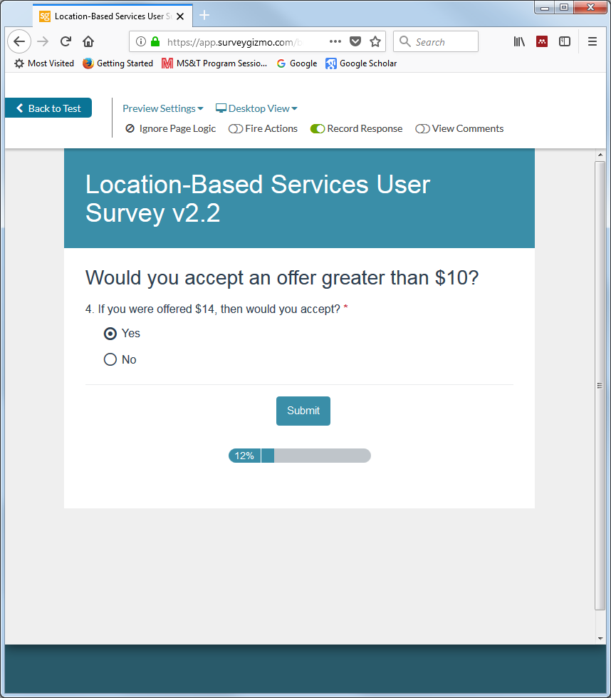
After responding to the second offer, the survey is complete:
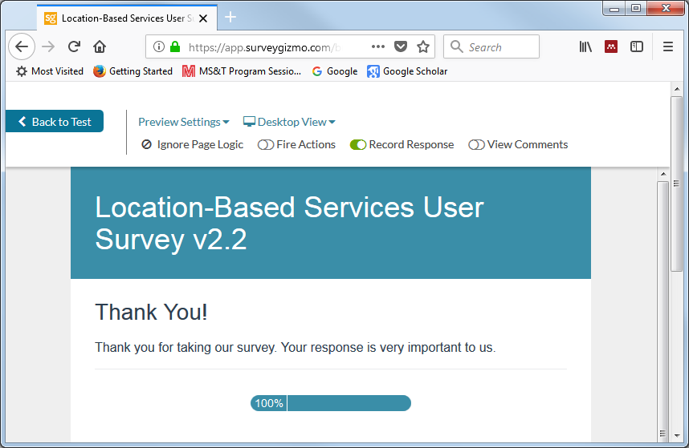
Some respondents will be randomized to receive instead a single Question 3 that asks them to provide an exact value, chosen from a drop-down list. The values in the list are randomized to be in either ascending or descending order:
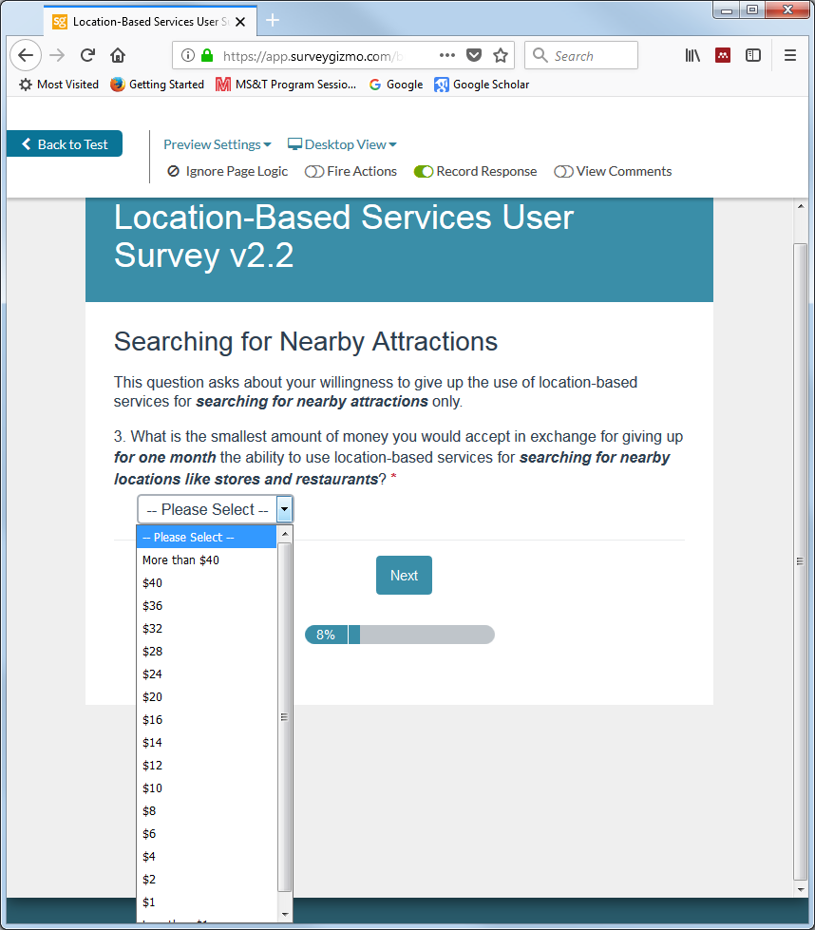
After making a selection, the respondent is taken to the final screen:
Each respondent is presented with either 3 or 4 questions:
- What devices? What applications? Initial offer Follow-up offer.
- What devices? What applications? Specify a value.

