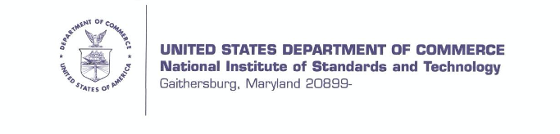

[addressee information]

The National Institute of Standards and Technology (NIST) is an agency of the U.S. Department of Commerce. We seek your cooperation with an investigation of impacts of Hurricane Maria on Puerto Rico: www.nist.gov/topics/disaster-failure-studies/hurricane-maria. NIST has a long history of conducting investigations on natural disasters and building failures. For more information, please see: https://www.nist.gov/topics/disaster-failure-studies/about-disaster-and-failure-studies-program.

NIST is conducting this investigation under the authority of the National Construction Safety
Team Act (Public Law 107-231). Disaster investigations of this nature often take several years to complete and are focused on producing technical facts and information, not in assigning blame. Our project’s aim is to develop recommendations that can improve current building codes, standards, and practices will lessen future deaths, injuries, damages, downtime, and disruption to communities. Ultimately, our goal is to make communities across the United States, including Puerto Rico, more resilient to hurricanes and other disasters.

To succeed in these efforts NIST must partner with individuals and organizations in the affected communities to develop a full understanding of impacts and relevant context and conditions leading to hazardous outcomes. More specifically, NIST requests your assistance to understand the distribution of emergency communications (including evacuation messages and hazard advisories) prior to Hurricane Maria’s landfall. We would like to better understand your role in providing information to your community/ constituency to prepare for and respond to Hurricane Maria. We would appreciate it if you would please participate in an interview with one of our contractors that will allow us to capture this information, and in turn recommend emergency communications best practices and public safety in the future. The interview will take approximately one hour.

Horsley Witten Group, Inc. is an environmental engineering and planning firm, and has contracted with NIST to collect data in Puerto Rico. They have organized a team based in Puerto Rico (the “Horsley-Witten team”) to conduct surveys and interviews needed for our investigations and research. Students from Albizu University, who are part of the Horsley-Witten team, will be reaching out to you to request your participation.

NIST intends to publish its findings and recommendations and will take all appropriate measures to protect sensitive, proprietary, and personally identifiable information. If you have any questions or concerns, please contact me at maria.dillard@nist.gov or 202-281-0908 or Dr. Domingo Marques of the Horsley Witten Group team at dmarques@albizu.edu or 787-725-6500, ext. 1999. We hope that you will be able to assist NIST and the Horsley Witten team with this important investigation. The results of our work can go a long way to improving public safety in Puerto Rico and
more broadly in the future.

Sincerely,

[Dillard signature]

Maria Dillard, Ph.D.
Associate Team Lead, Hurricane Maria Program

cc: Dr. Joe Main, NIST Hurricane Maria Program Team Lead
Dr. Katherine Johnson, NIST Hurricane Maria Program Project Lead
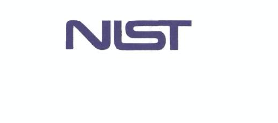
Dr. Domingo Marqués, Associate Professor Albizu University

