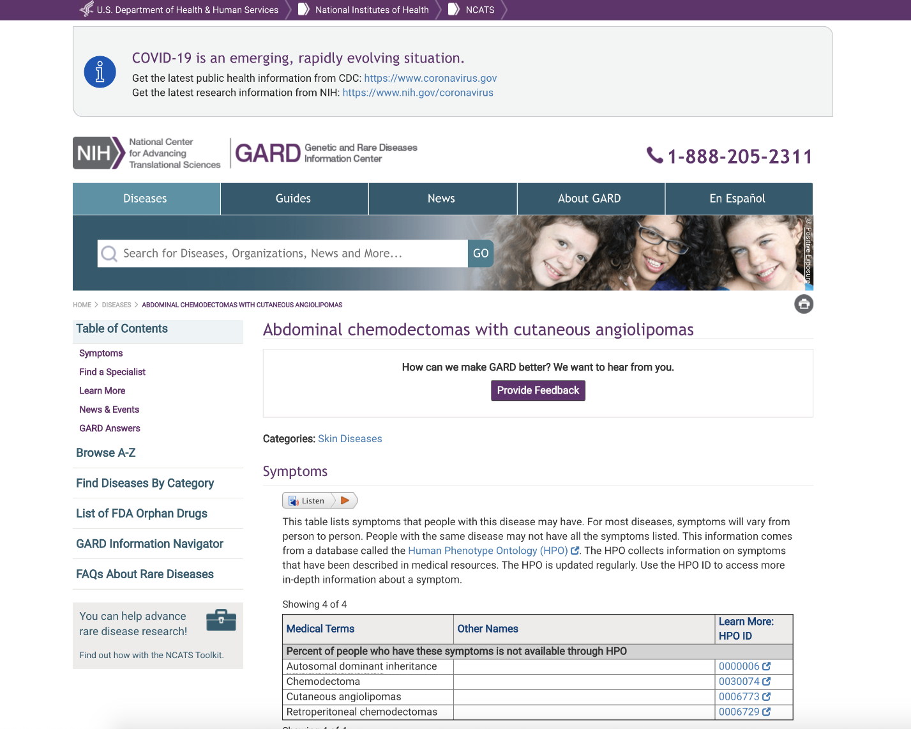

GARD Survey
OMB#: 0925-0648 Exp., date: 05/2021
Thank you for taking the time to help improve this website. Be assured that your responses will remain completely anonymous and will only be used for the purpose of improving the website.
* Required
1. How did you first learn about this website? *
Search engine (Google, Yahoo, etc.)
Recommended by friend or colleague
Social Media
Doctor / Specialist
Patient Advocacy Group
Other:
2. Are you seeking information for yourself or on behalf of someone else? *
For myself
For someone else
Other:
3. What information were you looking to find on the website? *
Select all that apply
Signs & symptoms
Cause
Inheritance
Diagnosis
Treatment
Statistics
Long-term outlook
Support
Research
Financial aid
Experts & specialists
Keep up to date
Other:
4. Did you find what you were looking for? *
Yes, easily
Yes, eventually
No
5. Is anything missing from the website? *
No
Other:
6. How easy is it to understand the information on the website? *
Not east at all
1
2
3
4
5
Very easy
7. How likely are you to recommend the website to a friend or colleague? *
Not at all likely
1
2
3
4
5
Extremely likely
8. How accurate do you think the information on the website is? *
Very inaccurate
1
2
3
4
5
Very accurate
9. What do you like the most about visiting the website? *
Your answer
10. What could we have done better? *
Your answer
Disclaimer
Public reporting burden for this collection of information is estimated to average ten minutes per response, including the time for reviewing instructions, searching existing data sources, gathering and maintaining the data needed, and completing and reviewing the collection of information. An agency may not conduct or sponsor, and a person is not required to respond to, a collection of information unless it displays a currently valid OMB control number. Send comments regarding this burden estimate or any other aspect of this collection of information, including suggestions for reducing this burden, to: NIH, Project Clearance Branch, 6705 Rockledge Drive, MSC 7974, Bethesda, MD 20892-7974, ATTN: PRA (0925-0648). Do not return the completed form to this address.
Submit
Page 1 of 1

