Request for Approval under the “Generic Clearance for the Collection of Routine Customer Feedback” (OMB#: 0925-0648 ExpDate: 03/2018 )
TITLE OF INFORMATION COLLECTION: The NINDS Public site widget

TECHNICAL INFORMATION

Widget placement at the bottom of the pages
Widget is a drupal module

Yes option:

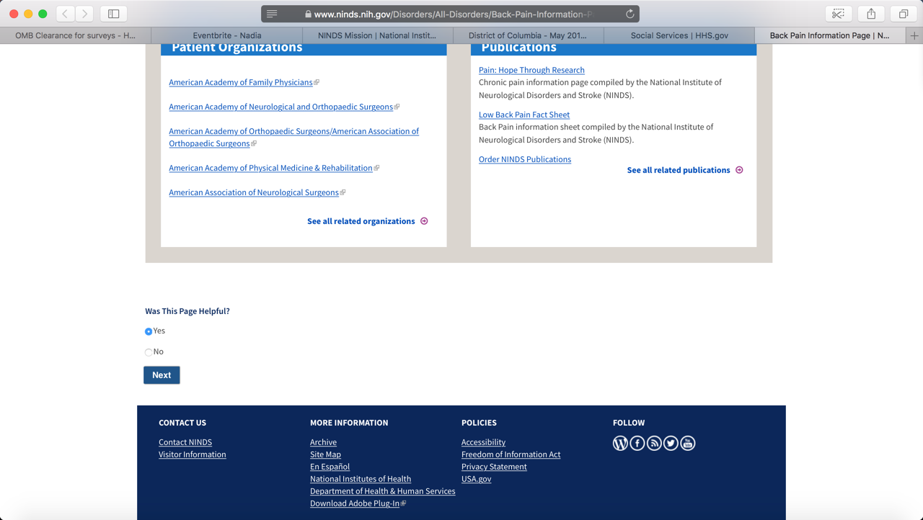
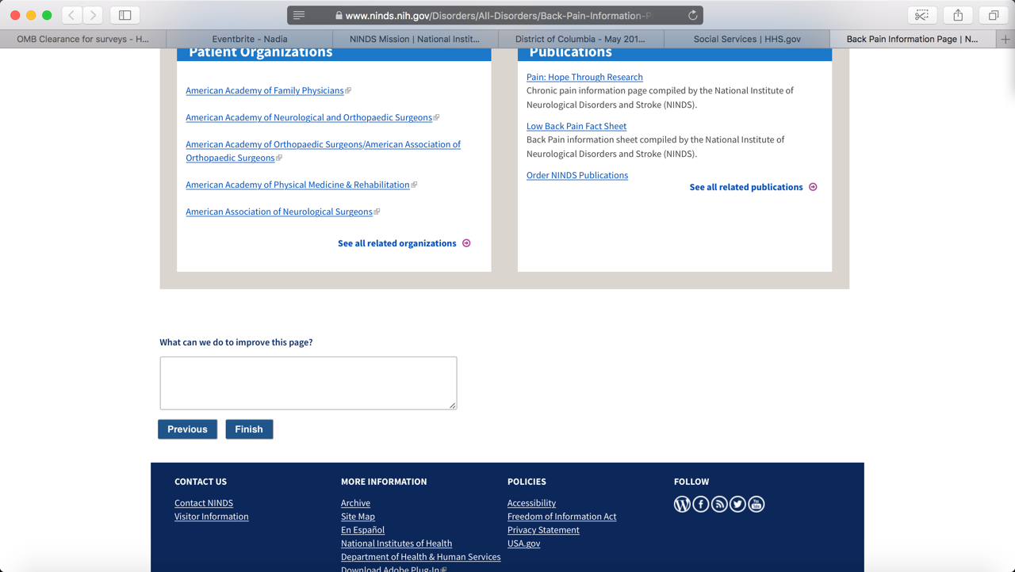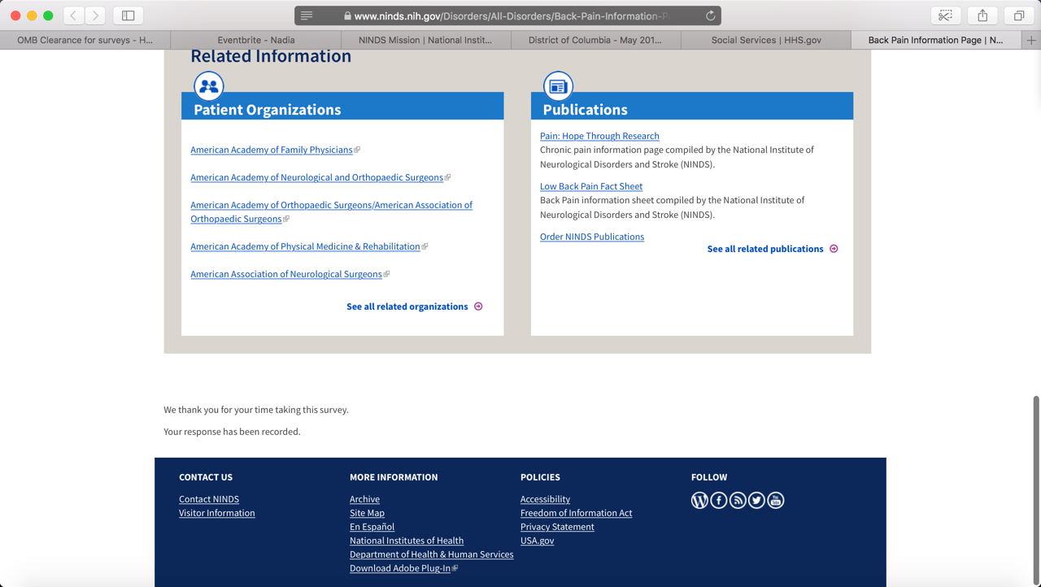

No Option:
