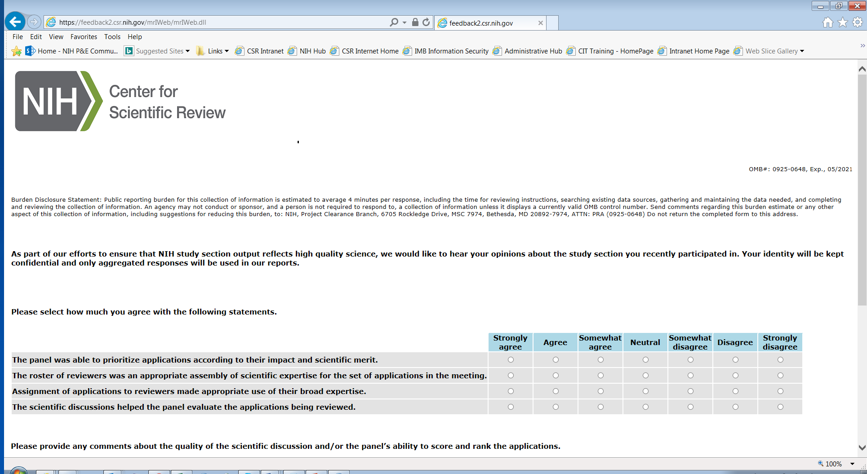
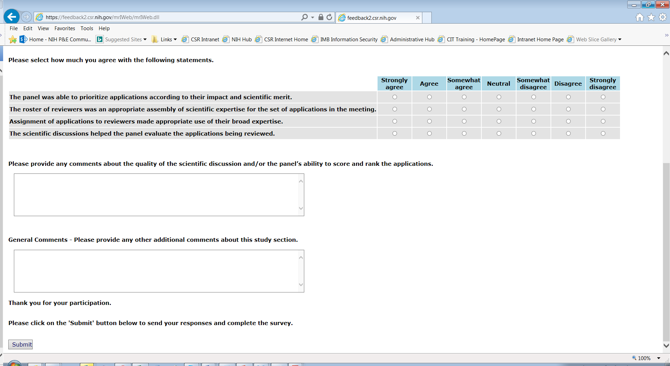
TITLE OF INFORMATION COLLECTION: Survey to Assess the Quality of Grant Review Among NIH Center for Scientific Review (CSR) Reviewers

