Figure 1: Login page of the secure data submission web site. Users register by clicking “Register for an account.”

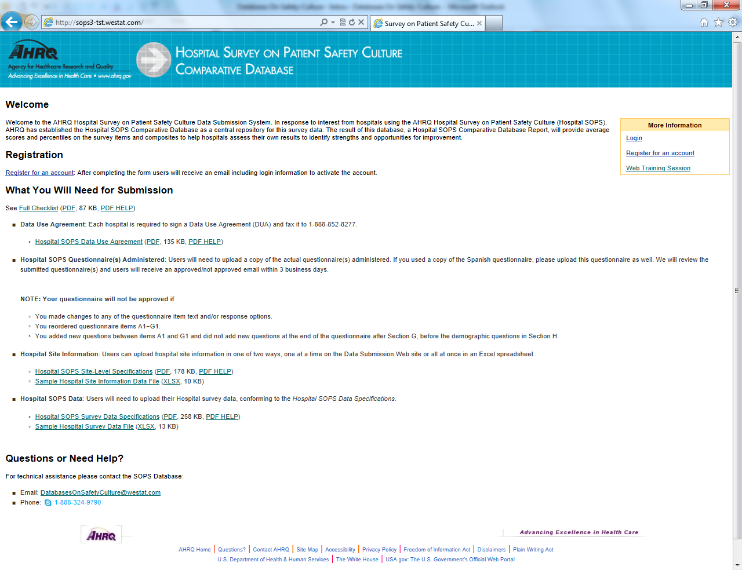

Figure 2: Main page/menu of secure data submission web site

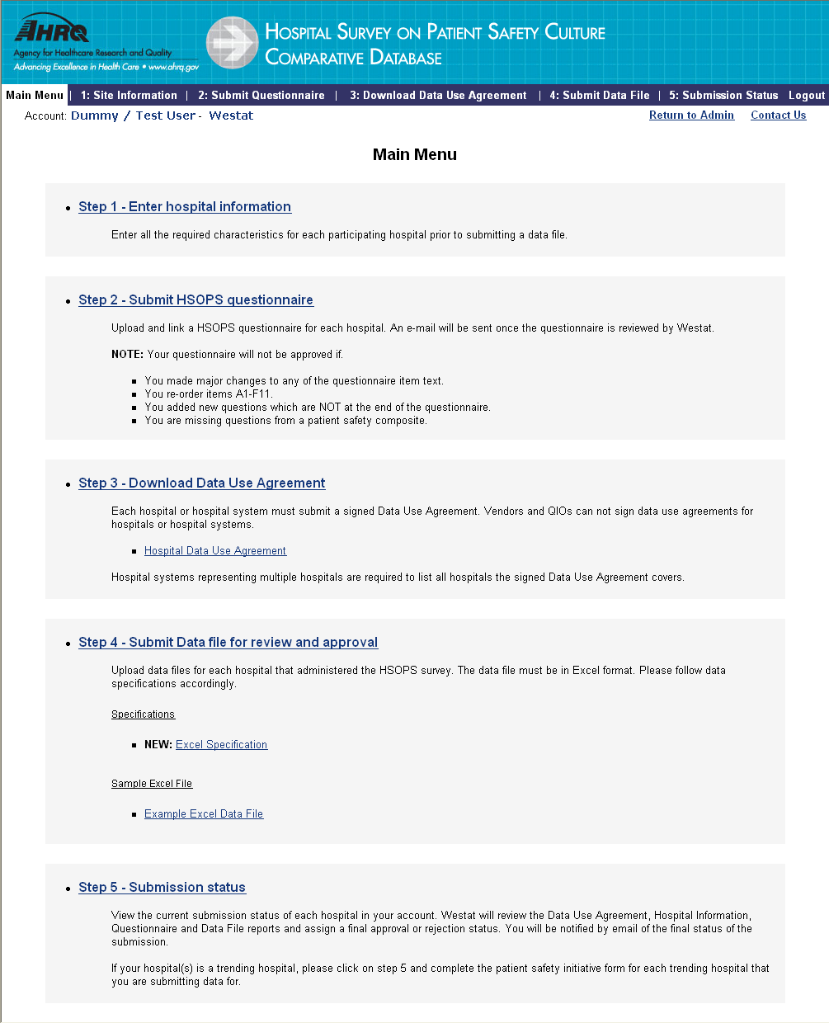

Figure 3: Submit questionnaire and link questionnaire to hospital(s).

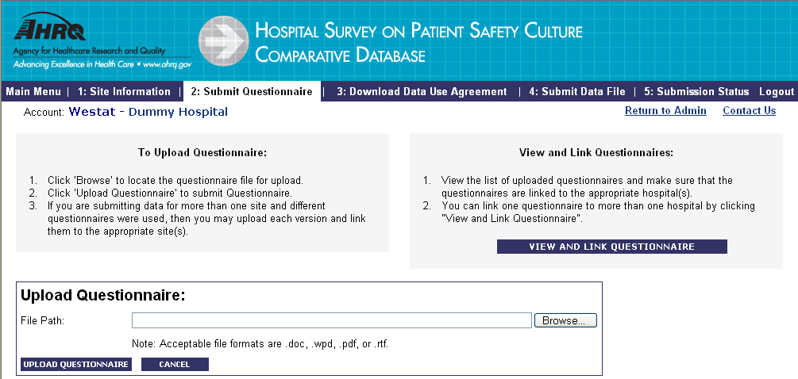

Figure 4: Upload data for each participating hospital

