OMB NO. 1293-0002 (EXP xx/xx/201x) VETS/USERRA/VP Form 1010 (REV 04/2014)

ELIGIBILITY DATA FORM: For claims under the Uniformed Services Employment and Reemployment Rights Act (USERRA)
and/or claims under the Veterans’ Preference (VP) provisions of the Veterans Employment Opportunities Act of 1998
U.S. Department of Labor, Veterans’ Employment and Training Service

Mail (or FAX) to:

Veterans' Employment and Training Service Phone: (866) 4-USA-DOL ((866)-487-2365))
U.S. Department of Labor FAX: (404) 562-2313
ATTENTION: Form 1010
61 Forsyth Street, S.W., Room 6T85
Atlanta, Georgia 30303

PLEASE TYPE OR PRINT

Section I: Claimant Information

1. Name:

Last Name First Name M.I.

2. Address:

Street City State ZIP

3. Social Security No:
4. Home Phone:
5. Cell Phone:

6. Email Address:
7. Do you have a military service-connected disability? Yes No

Section II: Uniformed Service Information
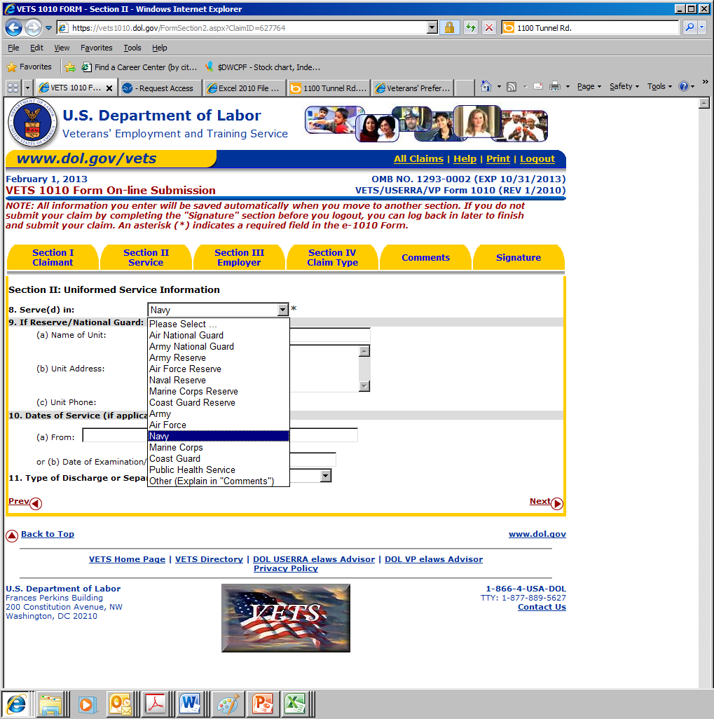
8. Serve(d) In: Air National Guard Army National Guard Army Reserve Air Force Reserve Naval Reserve
Marine Corps Reserve Coast Guard Reserve Army Air Force Navy Marine Corps Coast Guard
Public Health Service Other (Explain in “Comments”) None (Retaliation Claim – Explain in “Comments”)
9. If Reserve/National Guard:

(a) Name of Unit:

(b) Unit Address:

(c) Unit Phone:

10. Dates of Service (If applicable): (a) From:
To:

OR (b) Date of Examination/Rejection for Service:

11. Type of Discharge or Separation: Honorable Conditions Entry Level Uncharacterized Medical Other than Honorable
Other (Explain in “Comments”) Not Applicable

Section III: Employer Information

12. Employer or Prospective Employer’s Name:

13. Address:

Street City State ZIP

14. Principal Employer Contact (PEC):
(a) PEC Name/Title:

(b) PEC Phone:

15. Employment Dates (If applicable): From:
To:

16. Since beginning work with this employer, has your cumulative uniformed service exceeded 5 years? Yes No
If YES, explain in Comments box at end of this claim form.

17. Name of Union(s) That Represent You:

18. Title of the Position or Occupation that is related to your claim (the job that you either now hold, or used to hold, or applied for, with this employer):
Section IV: Claim Information

19. Was the Employer Support of the Guard and Reserve (ESGR) involved in handling your claim initially? Yes No
Use items #20 and #21 to identify the program(s). (NOTE: Most claims – but not all – apply to only one program.)
- For this claim to apply only to Veterans’ Preference (VP) in Federal Employment: Complete item #20, and skip #21.
- For this claim to apply only to USERRA: …………………………………………….. Skip item #20, and complete #21.
- For this claim to apply to both VP and USERRA: …………………………………… Complete both items #20 and #21.
20. Veterans’ Preference Issue (Check One): Hiring Reduction-in-Force (RIF)
21. USERRA Issue(s): Military Obligations Discrimination Reinstatement Initial Hiring Discrimination
Discrimination as Retaliation for any Action Status Pay Rate Seniority Other Non-Seniority Benefits
Pension Layoff Promotion Vacation Health Benefits Special Protected Period Discharge
Reasonable Accommodations/Retraining for Disabled Reasonable Accommodations/Retraining for Non-Qualified/Non-Disabled Other

If Claim Concerns Hiring, Promotion, RIF or Termination

22. Title of Position Held or Applied For:

23. Pay Rate:

24. Date of Application Employment/Promotion:

(a) Vacancy Announcement Number:

(b) Date Vacancy Opened:
(c) Date Vacancy Closed: _

If Claim Concerns Reemployment Following Service

25. Was Prior Notice of Service Provided to Employer? Yes No (If “No,” Explain in Comments)

26. (a) Who Provided Notice of Service to Employer? Self Other (name):

(b) Was the Notice of Service: Written Oral Both

(c) Date Notice of Service was given to Employer:

27. Name/Title of Person to Whom Notice of Service was Provided:

28. Date Applied for Reemployment: OR Date Returned to Work:

29. Reemployment Application Made To: Name:
Title:

30. Reemployed or Reinstated? Yes (date): No

(a) If YES, what position?
at what pay rate?

(b) If NO, Date denied:
Reason(s) given:

(c) Who denied (Name and Title):

PUNISHMENT FOR UNLAWFUL STATEMENTS
The information provided in this complaint will be utilized by the U.S. Department of Labor, Veterans’ Employment and Training Service (VETS) to initiate an investigation of alleged violations of the Uniformed Services Employment and Reemployment Rights Act (USERRA) Title 38, U.S.C., Sections 4301-4335; and/or the Veterans’ Preference (VP), provisions of
the Veterans Employment Opportunities Act of 1998 (VEOA), 5 U.S.C. §3330a-3330c. Potential claimants should keep in mind that it is unlawful to “knowingly and willfully” make any “materially false, fictitious, or fraudulent statements or representation” to a federal agency. Violations can be punished under Section 2 of the False Statements Accountability Act of 1996 by a fine and/or imprisonment of not more than 5 years. 18 U.S.C. § 1001.

I certify that the above information is true and correct to the best of my knowledge and belief. I authorize the U.S. Department of Labor to contact my employer or any other person for information concerning this claim. I further authorize my employer or any other person to release such information to the U.S. Department of Labor. Pursuant to 5 U.S.C., Section
552a(b) of the Privacy Act, I authorize the U.S. Department of Labor and the U.S. Department of Defense to release information and records necessary for the investigation and prosecution of my claim.

SIGNATURE:

DATE:

Persons are not required to respond to the collection of information unless it displays a currently valid OMB control number. Public reporting burden for this collection of information is estimated to average 30 minutes per response, including the time for reviewing instructions, searching existing data sources, gathering and maintaining the data needed, and completing and reviewing the collection of information. Send comments regarding this burden estimate or any other aspect of this collection of information, including suggestions for reducing this burden, to the U.S. Department of Labor, Veterans’ Employment and Training Service, Room-S1316, 200 Constitution Avenue, N.W., Washington, DC 20210.

NOTIFICATION OF USERRA CLAIMANT’S RIGHTS
For claims arising under USERRA, a person has a right to commence an action for relief directly against the employer in the appropriate federal district court (in the case of a complaint against a State or private employer), pursuant to 38 U.S.C. § 4323(a)(3), or the Merit Systems Protection Board (in the case of a complaint against a Federal executive agency or the
Office of Personnel Management), pursuant to 38 U.S.C. § 4324(b).

PRIVACY ACT STATEMENT
The primary use of this information is by staff of the Veterans’ Employment and Training Service in investigating cases under USERRA or laws/regulations relating to veterans’
preference in Federal employment. Disclosure of this information may be made to: a Federal, state or local agency for appropriate reasons; in connection with litigation; and to an individual or contractor performing a Federal function. Furnishing the information on this form, including your Social Security Number, is optional; however, providing information this form requests is required in order for the Department of Laborovide assistance on your claim.
Continue in Comments box &/or use additional sheet(s) to explain items if needed – Sign and date form (above)
OMB NO. 1293-0002 (EXP xx/xx/201x) VETS/USERRA/VP Form 1010 (REV 12/2016) – Page 2

Explain your claim in detail – List all remedies you seek
Use additional sheet(s) if needed – Initial & date each page at bottom

Comments:

Mail (or FAX) to:
INITIALS: DATE:

Veterans' Employment and Training Service Phone: (866) 4-USA-DOL ((866)-487-2365))
U.S. Department of Labor FAX: (404) 562-2313
ATTENTION: Form 1010
61 Forsyth Street, S.W., Room 6T85
Atlanta, Georgia 30303
OMB NO. 1293-0002 (EXP xx/xx/201x) VETS/USERRA/VP Form 1010 (REV 12/2016) – Page 3

