Redlined Draft FFIEC 051 Reporting Form for the Call Report Revisions Effective September 30, 2019 (subject to OMB approval) – June 24, 2019

Draft FFIEC 051 Instructions for the Call Report Revisions Effective September 30, 2019 (subject to OMB approval) – June 24, 2019

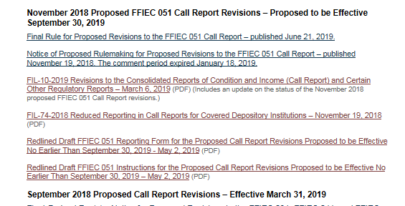

(subject to OMB approval)