Form that is changing:
USA.gov Contact Center Web Chat Customer Satisfaction Survey
3090-0278
Basis for the change:
- Remove questions for which analysis has deemed the responses predictable based on responses to other questions.
- Fine tune questions in order to improve quality of responses
Description of changes:
- STRIKING TWO QUESTIONS BECAUSE RESPONSES ARE PREDICTABLE BASED ON RESPONSES TO OTHER QUESTIONS:

Q4 How likely are you to use the USA.GOV online chat service again? Please use a scale from 0 to 10 where 0 is not at all likely and 10 is extremely likely.
(Please select one response)

10 Extremely likely
9
8
7
6
5
4
3
2
1
0 Not at all likely

(SCREEN BREAK)

Q5 How likely is it that you would recommend the USA.GOV online chat service to a friend or colleague? Please use a scale from 0 to 10 where 0 is not at all likely and 10 is extremely likely.
(Please select one response)

10 Extremely likely
9
8
7
6
5
4
3
2
1
- Not at all likely

ANALYTIC NOTE: CLIENT USES Q1, Q3, Q4, AND Q5 FOR THEIR INDEX SCORE

****************************************

- CHANGE TEXT IN QUESTION TO SPECIFY FOCUS ON AGENT

CURRENT VERSION:

Q2 Why did you provide a rating of (INSERT RATING FROM Q1) for the overall quality of service you received?

PROPOSED NEW VERSION with new text highlighted, bolded, and underlined.

Q10_1 Why did you provide a rating of (INSERT RATING FROM Q10A) for the overall quality of service you received from the Information Specialist?

*********************************************

- PROPOSED CHANGE TO WORDING TO BETTER REFLECT ROLE OF AGENT with new text highlighted, bolded, and underlined:

Q10 And thinking again about that same Information Specialist who handled your online chat session, on a scale of 1 to 10, where 1 is poor and 10 is excellent, how would you rate that Information Specialist on …
(Please select a single response for each row)

10 Excellent
9
8
7
6
5
4
3
2
1 Poor

a Overall quality of service
b Understanding your question or concern
c Having the desire to resolve assist you with your question or concern
d Being knowledgeable about what to do
e Removed
f Being courteous
g Removed
h The timeliness of the chat response

PREVIEW OF NEW UPDATED SURVEY
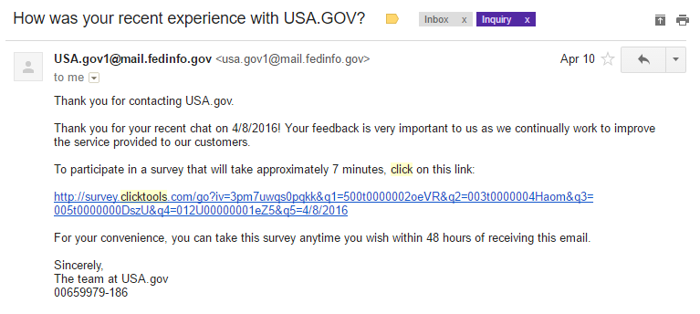

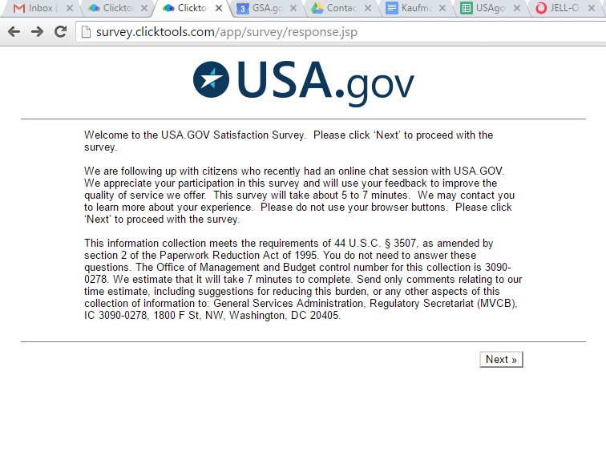
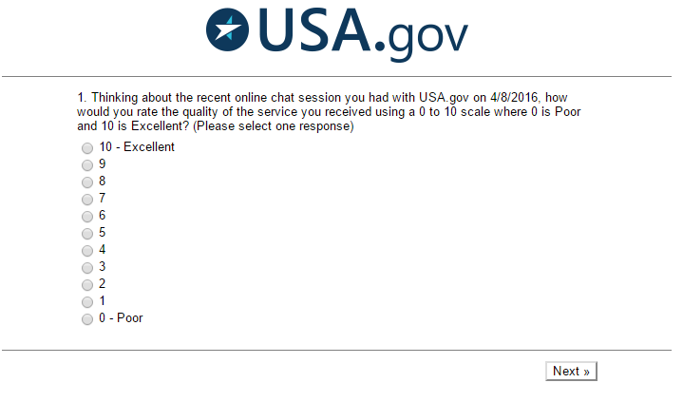

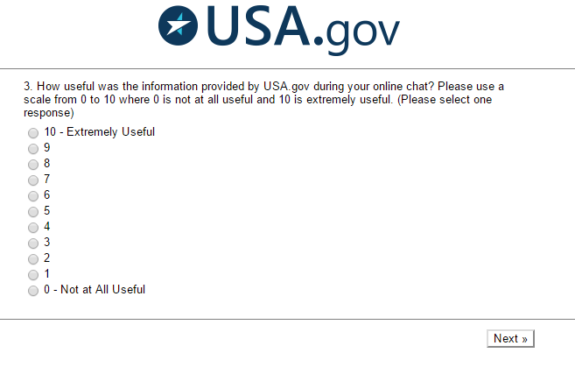

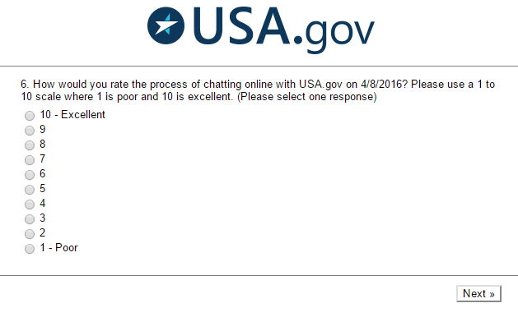
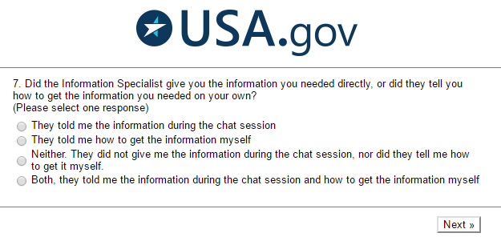
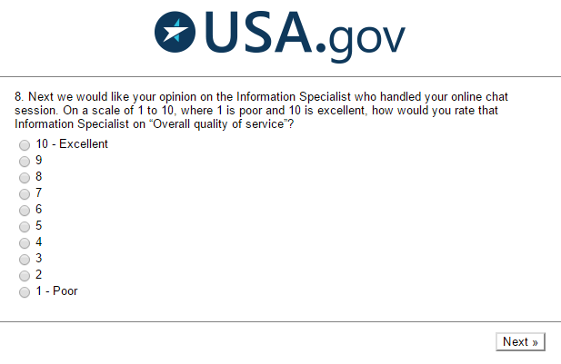
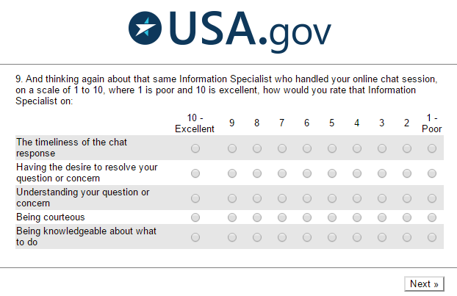
Having the desire to assist you with your question or problem
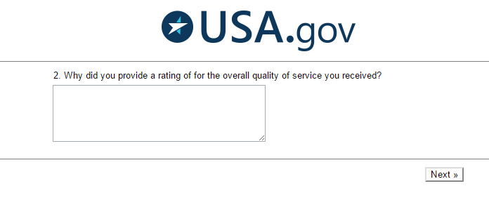
from the Information Specialist?
