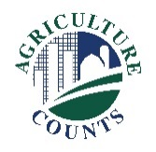
United States Department of Agriculture
National Agricultural Statistics Service

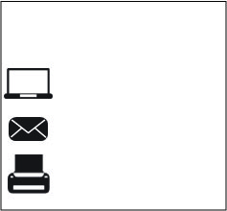
What should I do next?
Complete your survey in one of the following ways:
Online at www.agcounts.usda.gov.
Online reporting is fast, cost-effective, and secure. All you need is the 17-digit survey code on the enclosed form to begin.

By mail or fax. Complete the survey questionnaire and mail it back in the return envelope provided or fax it to (855) 415-3687.

April 23, 2019

Why am I getting this letter?

Enclosed is your Maple Syrup Survey questionnaire. This questionnaire measures the size and condition of the maple industry in your state each year. Please complete the questionnaire at your earliest convenience. Your information is important.

How will the data be used?

Maple syrup producers, processors and commodity markets all rely on the results from this survey to make sound and informed business decisions and to help promote the maple syrup industry.

If we do not hear from you by Thursday, May 09, 2019, we may attempt to contact you by telephone or in person to conduct an interview.

The results of this survey will be kept confidential and available in aggregate form only, ensuring that no individual operation or producer can be identified, as required by federal law. We will publish the survey findings in the monthly Crop Production report, to be released Tuesday, June 11, 2019.
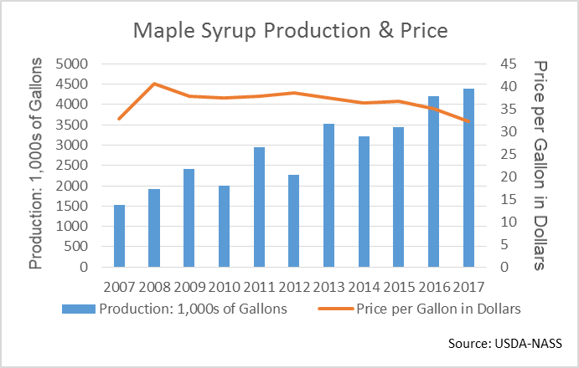
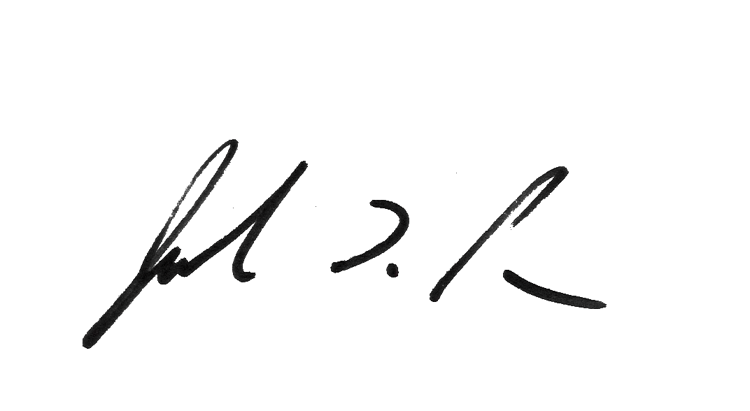
Thank you for participating and for your support of the maple syrup industry and U.S. agriculture. If you have any questions, please feel free to contact us at (888) 424-7828.

Sincerely,

Joseph L. Parsons
Chair, Agricultural Statistics Board

Enclosure

