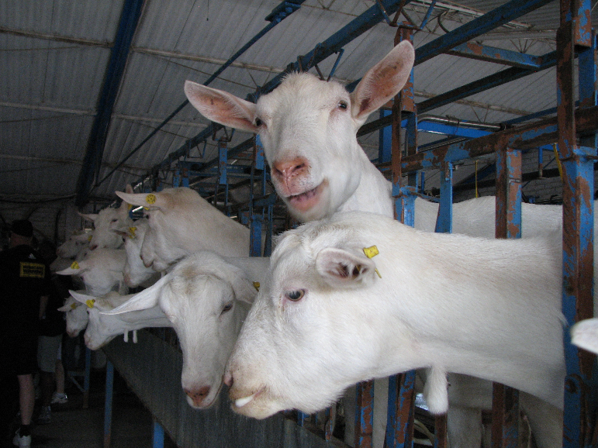

According to the Paperwork Reduction Act of 1995, an agency may not conduct or sponsor, and a person is not required to respond to, a collection of information unless it displays a valid OMB control number. The valid OMB control number for this information collection is 0579-0354. The time required to complete this information collection is estimated to average from .17 hours per response, including the time for reviewing instructions, searching existing data sources, gathering and maintaining the data needed, and completing and reviewing the collection of information.

Thank you for participating in the NAHMS Goat 2019 study. We appreciate the time you took to answer all of our questions. We know these studies can be time consuming, however they provide valuable information to the U.S. goat industry. These studies could not be completed without you.
Thanks again,
NAHMS Goat 2019 Team

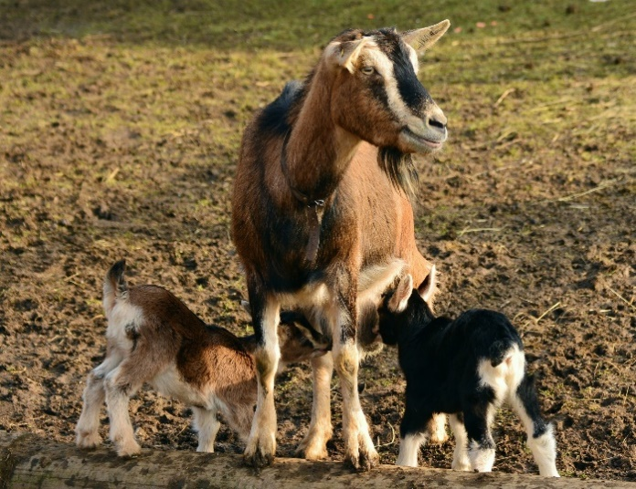

According to the Paperwork Reduction Act of 1995, an agency may not conduct or sponsor, and a person is not required to respond to, a collection of information unless it displays a valid OMB control number. The valid OMB control number for this information collection is 0579-0354. The time required to complete this information collection is estimated to average from .17 hours per response, including the time for reviewing instructions, searching existing data sources, gathering and maintaining the data needed, and completing and reviewing the collection of information.

Thank you for participating in the NAHMS Goat 2019 study. We appreciate the time you took to answer all of our questions. We know these studies can be time consuming, however they provide valuable information to the U.S. goat industry. These studies could not be completed without you.
Thanks again,
NAHMS Goat 2019 Team

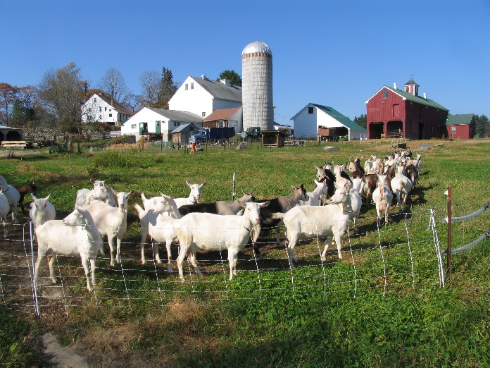

According to the Paperwork Reduction Act of 1995, an agency may not conduct or sponsor, and a person is not required to respond to, a collection of information unless it displays a valid OMB control number. The valid OMB control number for this information collection is 0579-0354. The time required to complete this information collection is estimated to average from .17 hours per response, including the time for reviewing instructions, searching existing data sources, gathering and maintaining the data needed, and completing and reviewing the collection of information.

Thank you for participating in the NAHMS Goat 2019 study. We appreciate the time you took to answer all of our questions. We know these studies can be time consuming, however they provide valuable information to the U.S. goat industry. These studies could not be completed without you.
Thanks again,
NAHMS Goat 2019 Team

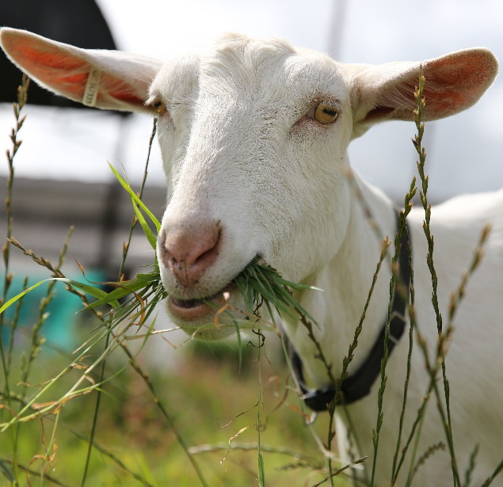

According to the Paperwork Reduction Act of 1995, an agency may not conduct or sponsor, and a person is not required to respond to, a collection of information unless it displays a valid OMB control number. The valid OMB control number for this information collection is 0579-0354. The time required to complete this information collection is estimated to average from .17 hours per response, including the time for reviewing instructions, searching existing data sources, gathering and maintaining the data needed, and completing and reviewing the collection of information.

Thank you for participating in the NAHMS Goat 2019 study. We appreciate the time you took to answer all of our questions. We know these studies can be time consuming, however they provide valuable information to the U.S. goat industry. These studies could not be completed without you.
Thanks again,
NAHMS Goat 2019 Team

