https://www.cdc.gov/niosh/topics/ables/default.html

(MAIN PAGE)

Adult Blood Lead Epidemiology and Surveillance (ABLES)

The goal of the ABLES program is to examine the extent of workplace lead exposure in adults through measurement of blood lead levels. This goal is identical to the Occupational Safety and Health Objective 7 in Healthy People 2020. In addition, the ABLES program strives to improve state capacity to monitor trends in workplace lead exposure and conduct intervention activities to prevent lead exposures.

Why work-related lead surveillance is important
In the United States, when the lead exposure source is known, almost all adult blood lead levels higher than 25 μg/dL are work-related. Lead exposure occurs mainly in battery manufacturing, lead and zinc ore mining, and painting and paper hanging industries.
Workplace lead exposure is an ongoing health problem in the United States. Lead exposure causes short-term and long-term health effects in many organ systems, ranging from changes in function to life-threatening intoxication. Lead exposure at low doses can lead to:
- adverse cardiovascular and kidney effects
- cognitive dysfunction
- adverse reproductive outcomes

Contact
To learn more about NIOSH-supported adult blood lead epidemiology surveillance activities, please contact Rebecca Tsai, PhD (rtsai@cdc.gov).
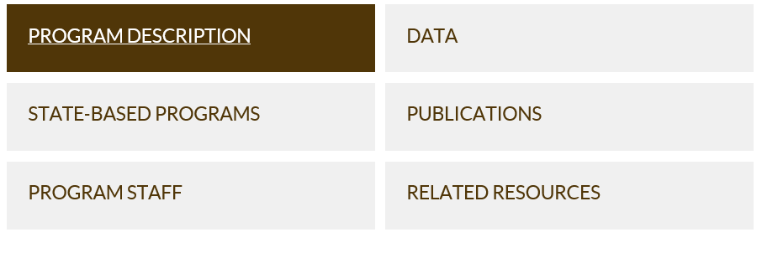

https://www.cdc.gov/niosh/topics/ables/description.html
(Program Description Page)

About ABLES
ABLES was created to reduce the rate of adults (age 16+) who have blood lead levels (BLL) equal or greater than ten micrograms per deciliter (BLLs ≥10 µg/dL) as a result of work-related lead exposure.
The public health objective of the ABLES program is identical to the Occupational Safety and Health Objective 7 in Healthy People 2020, which is to “Reduce the proportion of persons who have elevated blood lead concentrations from work exposures” The ABLES program aims to accomplish Objective 7 by working with state ABLES programs to build state capacity to initiate or improve adult blood lead surveillance programs which can accurately measure trends in adult BLLs and which can effectively target interventions to prevent lead exposures.
ABLES works with state programs to accurately measure trends in work-related adult BLLs, to better target interventions and prevent lead exposures. As of April 2018, 37 states collaborate with NIOSH to conduct adult BLL surveillance, and among them, 23 states have submitted blood lead data for 2016. ABLES states are required to have a mandatory state requirement that laboratories report BLL results to the State Health Department or designee. Most states require reporting all BLLs, elevated or not. Reporting all BLLs is extremely useful and is recommended for any state planning to initiate or change their reporting requirements.
ABLES states are encouraged to develop effective working relationships with Environmental Public Health Tracking and Childhood Lead Poisoning Prevention programs within their state. Lead may be taken home from the workplace on clothes or in cars thus potentially exposing spouses and children. ABLES states are also encouraged to develop effective working relationships with other federal and state agencies involved in preventing lead exposure including:
- Occupational Safety and Health Administration (OSHA)
- Department of Housing and Urban Development (HUD)
- Environmental Protection Agency (EPA)
- Department of Transportation (DOT)
- Department of Defense (DOD)
Besides the 37 state ABLES programs, other partners collaborating with ABLES to achieve the Healthy People 2020 adult lead objective include:
- CPWR. Center for Construction Research and Training
- Council of State and Territorial Epidemiologists – Occupational Health
To facilitate communications on issues involving lead exposure among adults, the ABLES program maintains a listserv, and meets once a year in conjunction with the Annual Conference of the Council of State and Territorial Epidemiologists.

Lead-related health effects
Occupational lead exposure is an important health problem in the United States. Lead exposure causes acute and chronic adverse effects in multiple organ systems ranging from subclinical changes in function to symptomatic life-threatening intoxication. Moreover, evidence indicates that lead exposure at low doses can lead to adverse cardiovascular and kidney effects, cognitive dysfunction, and adverse reproductive outcomes. Current research has found decreased renal function associated with BLLs at 5 µg/dL and lower, and increased risk of hypertension and essential tremor at BLLs below 10 µg/dL. (National Toxicology Program. Health Effects of Low-level Lead Evaluation).

Reference blood lead level for adults
In 2015, NIOSH designated 5 µg/dL (five micrograms per deciliter) of whole blood, in a venous blood sample, as the reference blood lead level for adults. An elevated BLL is defined as a BLL ≥5 µg/dL. This case definition is used by the ABLES program, the Council of State and Territorial Epidemiologists (CSTE), and CDC’s National Notifiable Diseases Surveillance System (NNDSS). Previously (i.e. from 2009 until November 2015), the case definition for an elevated BLL was a BLL ≥10 µg/dL. The U.S. Department of Health and Human Services recommends that BLLs among all adults be reduced to <10 µg/dL. The U.S. Occupational Safety and Health Administration (OSHA) Lead Standards require workers to be removed from lead exposure when BLLs are equal or greater than 50 µg/dL (construction industry) or 60 µg/dL (general industry) and allow workers to return to work when the BLL is below 40 µg/dL. Data from the National Health and Nutrition Examination Survey (NHANES) show that the average BLL (geometric mean) of all adults in the United States in 2009–2010 was 1.2 µg/dL. See Reference Blood Levels for Adults that illustrates these reference values.
OSHA Lead Standards give the examining physician broad flexibility to tailor special protective procedures to the needs of individual employees. Therefore, the most current guidelines for management of lead-exposed adults should be implemented by the medical community at the current CDC/NIOSH reference BLL of 5 µg/dL. Recommendations for medical management are available from the Association of Occupational and Environmental Clinics, California Department of Public Health, and the Council of State and Territorial Epidemiologist (CSTE) Occupational Health Surveillance Subcommittee.

State ABLES programs activities
ABLES state interventions to prevent lead exposures include:
- conducting follow-up interviews with physicians, employers, and workers
- investigating work sites
- providing technical assistance
- providing referrals for technical assistance and enforcement of the lead standards
- developing and disseminating educational materials and outreach programs.
ABLES states are required to have a mandatory state requirement that laboratories report BLL results to the State Health Department or designee. The lowest BLL to be reported varies from state to state. Most states require reporting of all BLLs. The reporting of all BLLs, elevated or not, is extremely useful for the analysis of these data and is recommended for any state planning to either initiate or change their reporting requirements.

ABLES Impact
In 2008, OSHA updated its National Emphasis Program for Lead to reduce occupational exposures by targeting unsafe conditions or high hazard industries. OSHA used ABLES program data to identify industries where elevated BLLs indicated a need for increased national focus. State ABLES programs also work with OSHA by sharing lead exposure data, which OSHA then uses to initiate investigations and promote prevention interventions.
Over the last 18 years, a 54% decrease in the national prevalence rates of BLL ≥25 μg/dL has been documented using ABLES surveillance data. In 1994 the rate was 14.0 employed adults per 100,000; in 2011 the rate was reduced to 6.4. In 2010, 40 state ABLES programs that provided data reported 31,081 adults with BLLs ≥10 μg/dL. Among these, 8,793 had BLLs ≥25 μg/dL, and 1,388 had BLLs ≥40 μg/dL. Based on data from 37 reporting states, ABLES established the 2010 baseline rate for Healthy People 2020 objective to reduce adult lead exposure. This 2010 baseline rate for BLLs ≥10 µg/dL is 26.4 adults per 100,000 employed adults.
Though rates of BLL ≥25 μg/dL have decreased, the work to prevent elevated BLLs is still far from complete. The ABLES data from 2010 establish that lead exposure remains a national occupational health problem, and that continued efforts to reduce lead exposures are needed. Because BLLs are often not available for many lead-exposed workers (e.g., the workers may not be tested or their tests may not be reported to public health authorities), ABLES data should be considered a low estimate of the true magnitude of elevated adult lead exposures in the United States. (See also Data into Action: NIOSH Blood Lead Surveillance Program Contributes to a Decline in National Prevalence Rates).

