Form Approved
OMB No. 0920-New
Expiration Date: XX/XX/XXXX

Web-based Approaches to reach black or African American and Hispanic/Latino MSM for HIV Testing and Prevention Services

Attachment 3g
Product ordering

Public reporting burden of this collection of information is estimated to average 3 minutes per response, including the time for reviewing instructions, searching existing data sources, gathering and maintaining the data needed, and completing and reviewing the collection of information. An agency may not conduct or sponsor, and a person is not required to respond to a collection of information unless it displays a currently valid OMB control number. Send comments regarding this burden estimate or any other aspect of this collection of information, including suggestions for reducing this burden to CDC/ATSDR Reports Clearance Officer; 1600 Clifton Road NE, MS D-74, Atlanta, Georgia 30333; Attn: OMB-PRA (0920-New)

Order Survey

Consent form
You have requested to order health items from the study you are participating in. All the items you order will be mailed to you free of charge to an address of your preference. Additionally, we will request a contact number and an email address so that we can contact you regarding your order status as well as lab results. It is important to remember that if you order an at-home STI CareKit, study staff will attempt to contact you regarding your results using the contact information you provide in the order form.
If you have any questions, please contact the CareKit Team at Carekit@emory.edu or 404-435-4513. You can also contact the study coordinator at iSTAMP@emory.edu or 404-727-4340.
Ordering items is entirely your choice. You have a right to stop the process at any time.
If you agree to the above information and would like to proceed with ordering health items, please click the “I Agree” box below.

I agree

I do not agree

Please check the items you wish to order. Check all that apply.

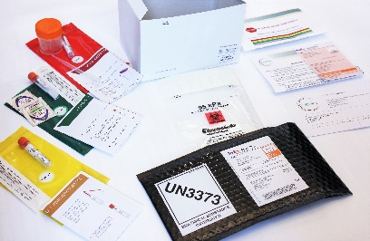
STI CareKit
STI CareKits are developed to allow you to test for STIs at the convenience of your home. CareKits can be designed to test for gonorrhea, chlamydia, and/or syphilis and will come with instructions, specimen collection equipment, and a pre-paid bubble mailer to ship specimen to the lab.

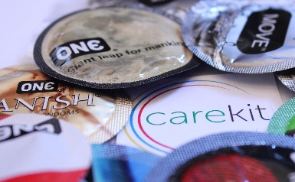

Condoms: ONE Variety Pack
Includes 2 classic, 1 flavor wave, 1 glowing pleasures, 1 hyperthin, and 1 sensations, and 7 packs water-based lubricant.

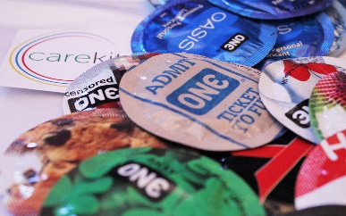
Condoms: ONE Standard
Includes 10 standard condoms and 10 packs of water-based lubricant.

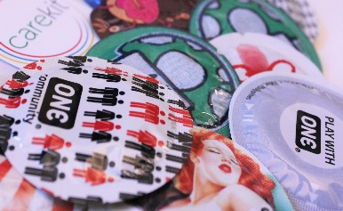

Condoms: ONE Sensation
Includes 10 sensation condoms and 10 packs of water-based lubricant.

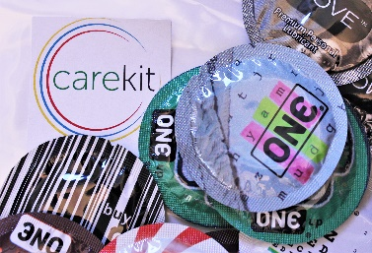
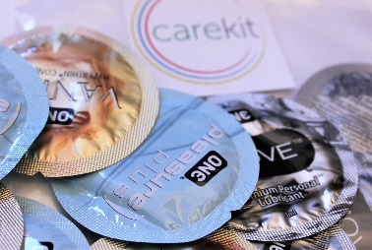
Condoms: ONE Pleasure
Includes 3 hyperthin, 3 super sensitive, and 4 pleasure plus, and 10 packs of water-based lubricant.

Lubricant: Silicone-based
Includes 10 packs of silicone-based lubricant.

Lubricant: Water-based
Includes 10 packs of water-based lubricant.

Condoms: ONE Latex free
Includes 10 latex free condoms and 10 packs of water-based lubricant.

Condoms: ONE Adventure
Includes 5 flavor wave and 5 glowing pleasure, and 10 packs of water-based lubricant.

Condoms: ONE Large
Includes 10 large condoms and 10 packs of water-based lubricant.

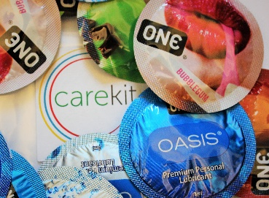
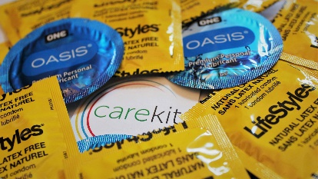
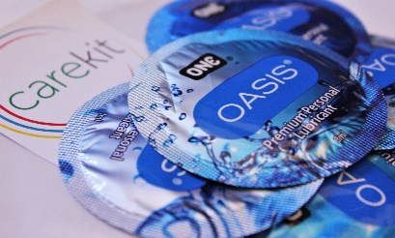
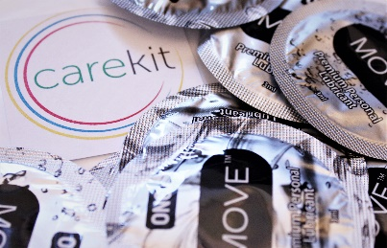

ACTION: Webhook pushes survey completion/results to SMART
Thank you for your order. Please fill in the fields below to ensure that your items are delivered to you. All items are required.
Name (first and last)

Delivery Address

Email

Cell phone number

Please select your cell phone carrier (Options in drop down box: AT&T, Verizon, Sprint, T Mobile, Cricket, Boost Mobile, MetroPCS, Virgin Mobile, Straight Talk, …)
How do you prefer to be contacted? (Options in drop down box: email or cell phone)
Thank you for your order. You will receive an email or text message from Carekit@emory.edu once the order has been shipped. If you have any questions regarding your order, please contact us at Carekit@emory.edu or 404-435-4513. You can also contact the study coordinator at iSTAMP@emory.edu or 404-727-4340.
Thank you!
CareKit Team

