Attachment 3
OASYS/FCAS Email Invitations

Invitation to Submit Revised Proposal, Task Order Proposal or Blanket Purchase Agreement (BPA) Call Quote Email Invitation:
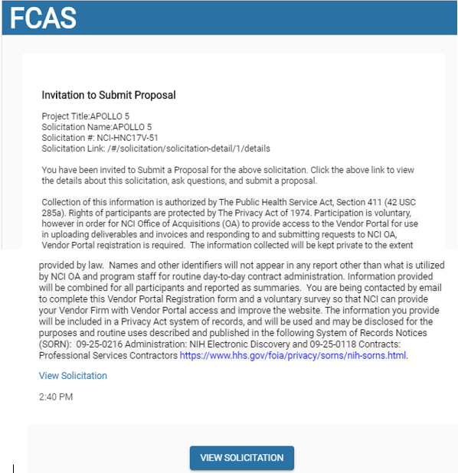

Request to Submit Revised Proposal:
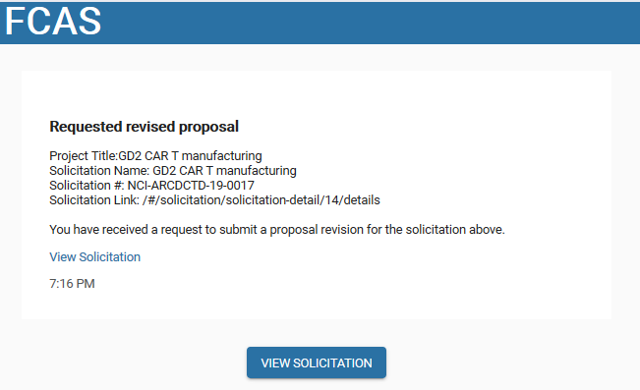

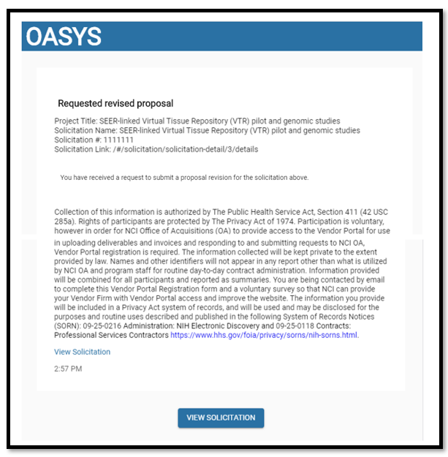

Sample Registration Invitations
Subject: FCAS Registration Invitation
You have been invited to create a user account in the FFRDC Contract Administration System (FCAS). Click the following link to accept the invitation and complete the registration process.
Accept Invitation

The information in this e-mail and any attachments is confidential and may contain sensitive information. It should not be used by anyone who is not the original intended recipient. If you have received this e-mail in error, please inform the sender and delete it from your mailbox or any other storage devices. The National Cancer Institute (NCI) shall not accept liability for any statements made that are the sender’s own and not expressly made on behalf of the NCI by one of its legal representatives.

Subject: OASYS Registration Invitation
You have been invited to create a user account in the Office of Acquisitions System (OASYS). Click the following link to accept the invitation and complete the registration process.
Accept Invitation

The information in this e-mail and any attachments is confidential and may contain sensitive information. It should not be used by anyone who is not the original intended recipient. If you have received this e-mail in error, please inform the sender and delete it from your mailbox or any other storage devices. The National Cancer Institute (NCI) shall not accept liability for any statements made that are the sender’s own and not expressly made on behalf of the NCI by one of its legal representatives.

