What MEPS tells us about ... children

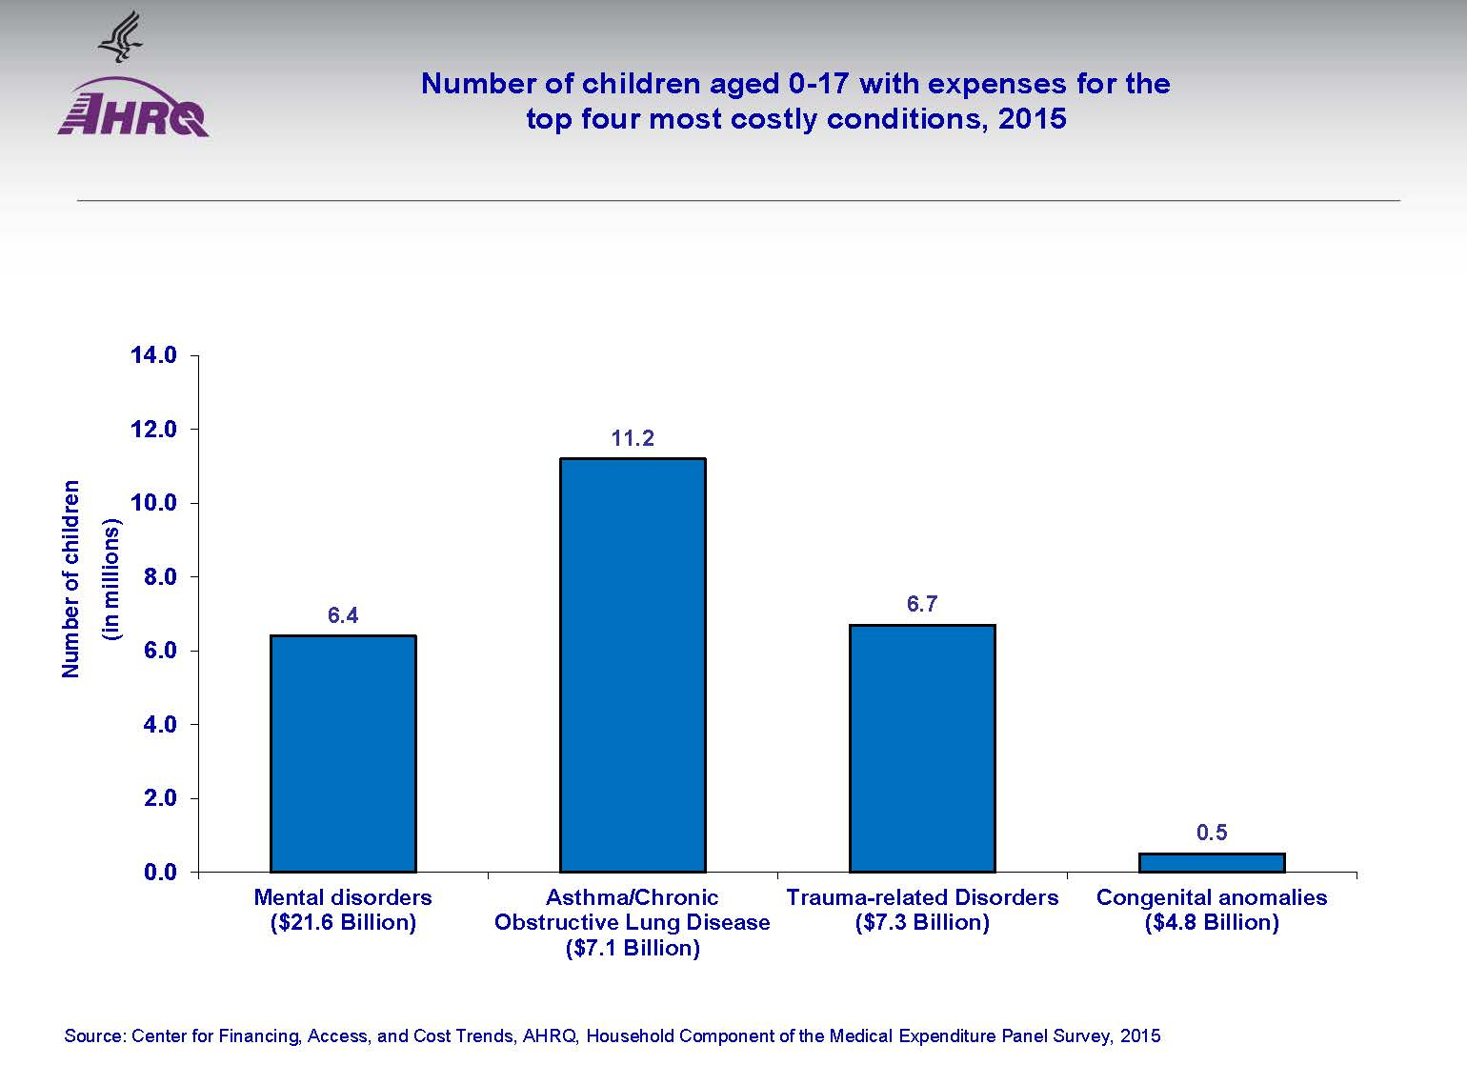

- Of the four most costly conditions for children, congenital anomalies affect the fewest children and are the least expensive conditions to treat.

- The most expensive conditions to treat for children are mental disorders.

- 11 million children had asthma or similar chronic respiratory condition.

- In 2015, it cost about the same to treat children with asthma or similar chronic respiratory diseases as it did to treat children with trauma-related disorders.

What MEPS tells us about … children

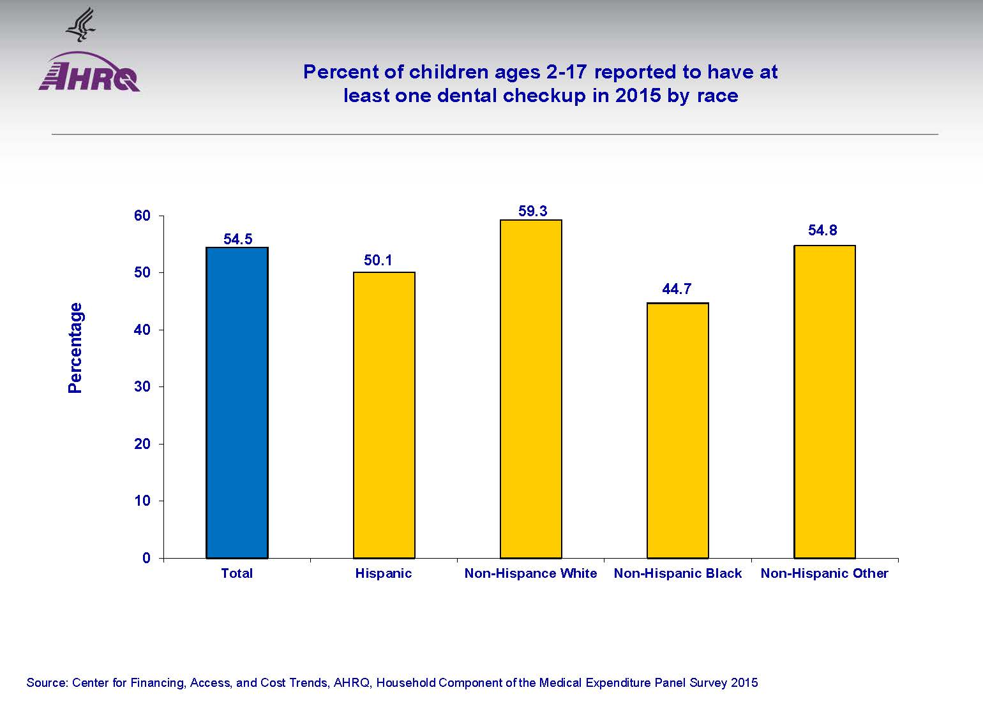
- General guidelines suggest children 2 years old and older visit the dentist two times a year.
- However, in 2015, only about half of all children in that age group had at least one dental checkup. Which means about half of 2-17 year old children did not have any dental check-ups in 2015.
- In 2015, there was little variation by race or ethnicity in the percentage of children with at least one dental check-up.
- About half of Hispanic children reported having at least one dental check-up in 2015.
- A little over half of white, non-Hispanic children had at least one dental checkup in 2015.
What MEPS tells us about … young men

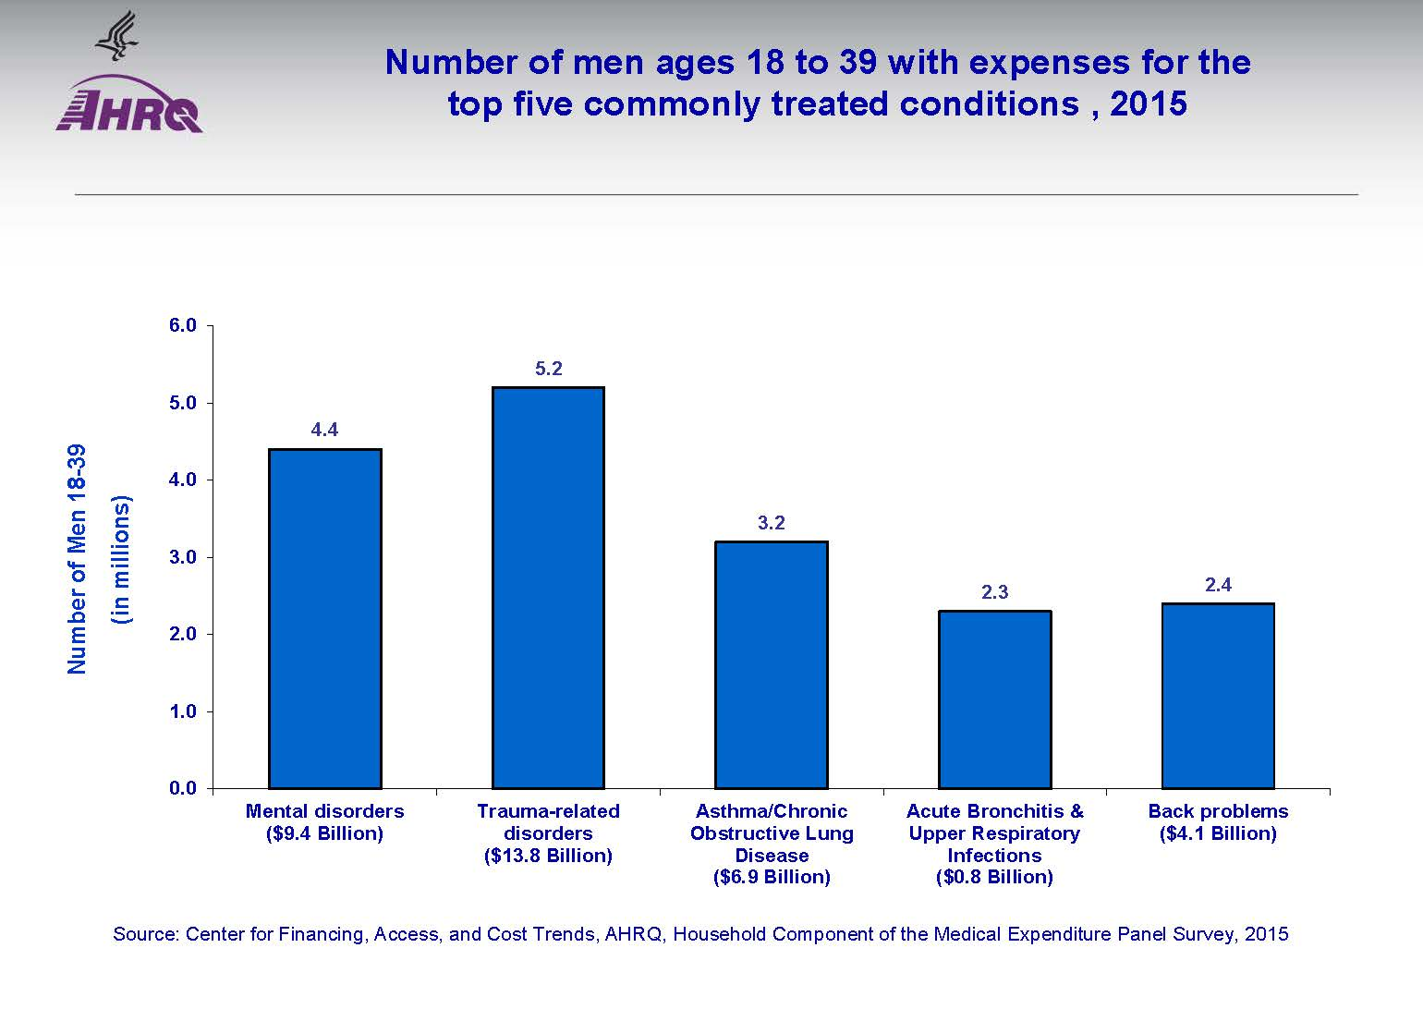

- Of the five most costly conditions for men between 18 and 39, trauma-related disorders such as injuries from car accidents and sports affect young men the most and are the most expensive to treat.

- In 2015, treating trauma-related disorders in men 18-39 years old cost just about the same as treating asthma, bronchitis, and back problems combined.

- In 2015 about the same number of men between 18 and 39 received treatment for bronchitis and other respiratory infections as they did for back problems.

What MEPS tells us about … young women

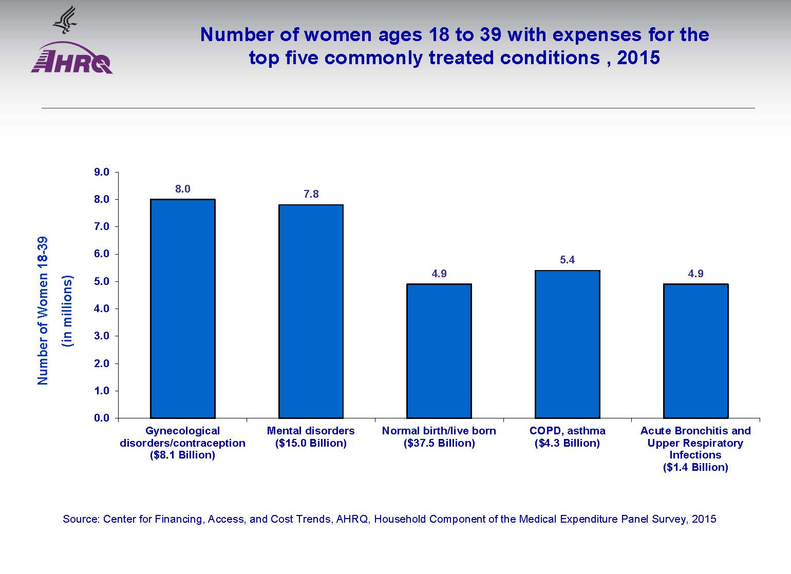

- In 2015, more money was spent on care associated with child birth than other health care for women ages 18-39.
- However, over 3 million more women between the ages of 18-39 received gynecological care, including contraception, than women who gave birth.
- In 2015, for women ages 18 to 39, giving birth cost $22 billion more than care for mental disorders, the second most costly condition.

What MEPS tells us about … seniors

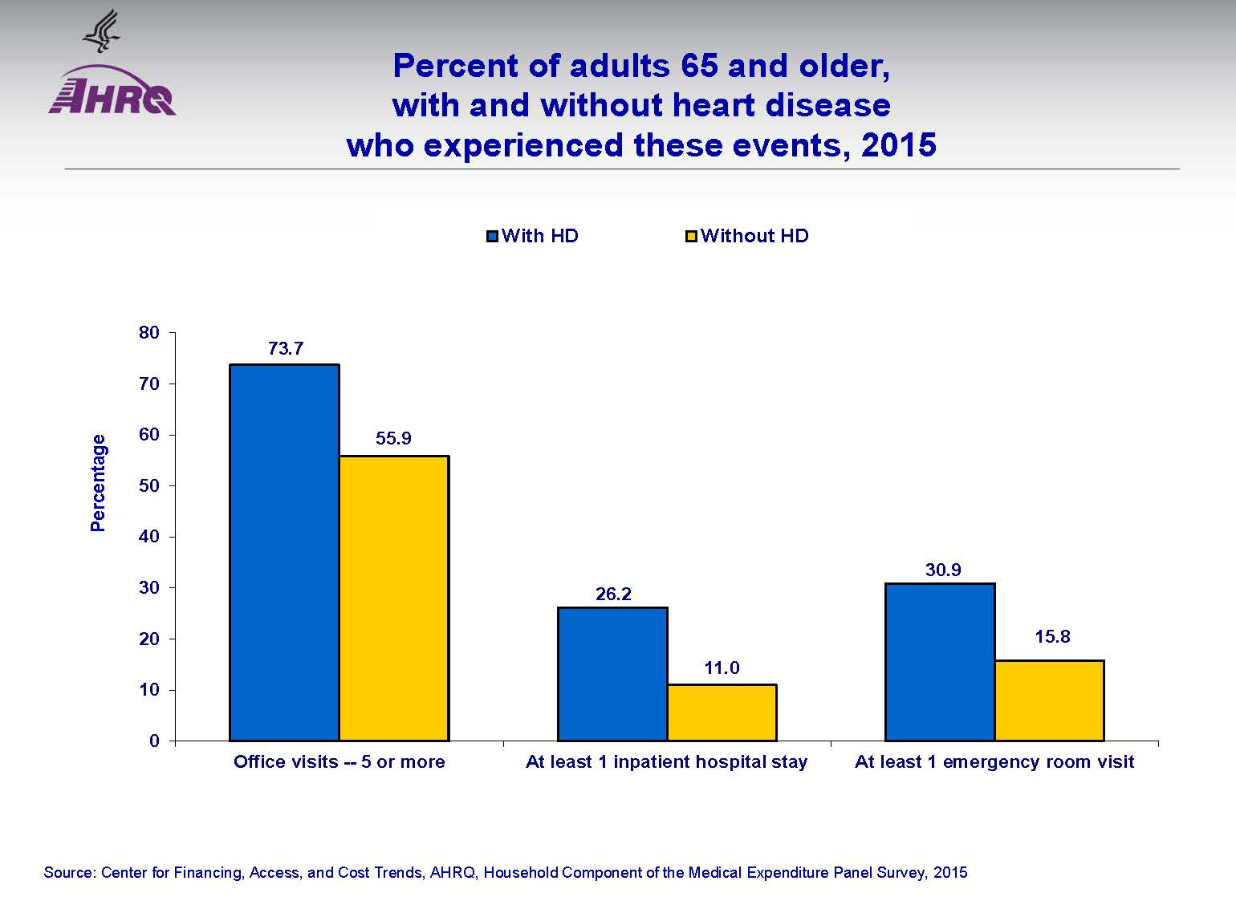

- Over half of all adults 65 and older had 5 or more visits to a health provider office in 2015.
- Almost 3/4 of seniors with heart disease saw a health care provider 5 or more times in 2015.
- In 2015, adults ages 65 or older with heart disease were nearly two times more likely to have at least one emergency room visit than seniors without heart disease.
- For adults ages 65 or older, having heart disease meant you were much more likely than those without heart disease to have a large number of office visits, inpatient hospital stays and emergency room visits.

What MEPS tells us about … chronic conditions

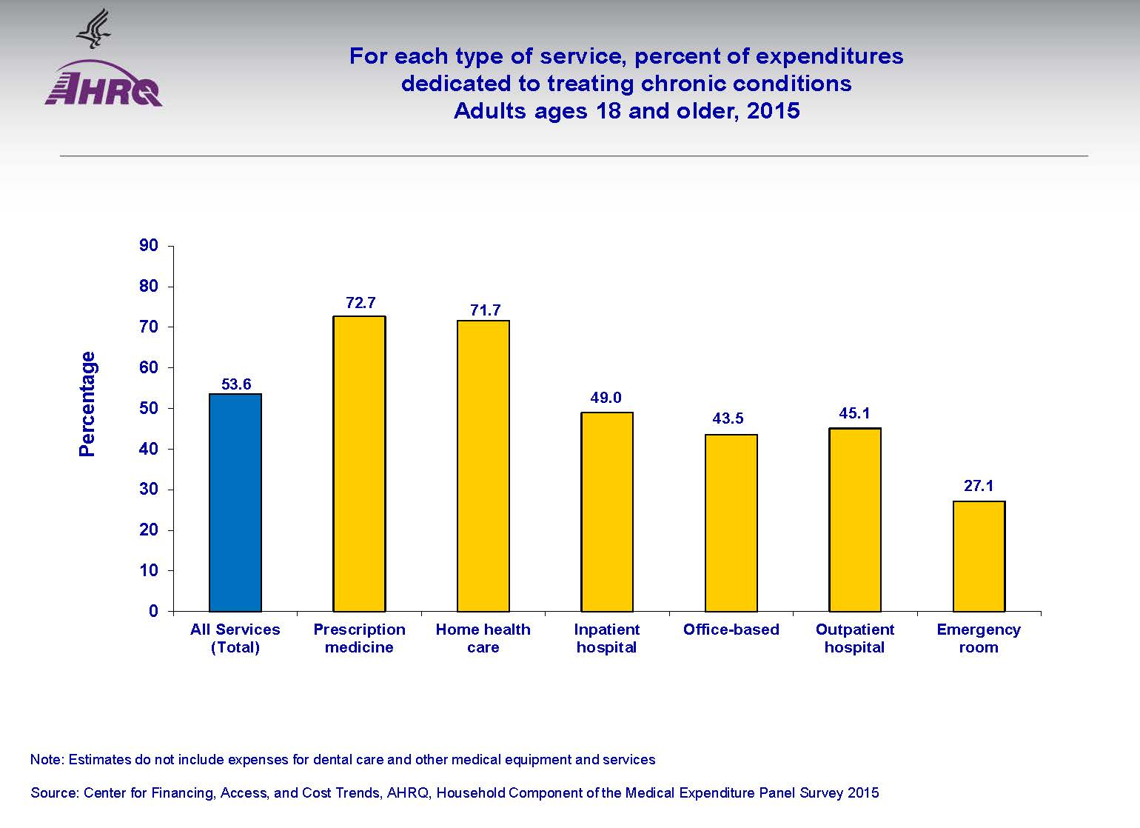

- Over half of all money spent on health care for adults is for treating chronic conditions (54%) such as diabetes or asthma.
- Almost 75% of all money spent on prescription medicines was for treating chronic conditions.
- Almost 3/4 of all money spent on home health care was for treating chronic conditions.
- A little more than 1/4 of all money spent on emergency room visits is associated with treating chronic conditions.

