First level of appeal is a Reconsideration. Claimant / Appointed Rep can file in person or online (iAppeals.) iAppeals data is imported into MCS similar to iClaim to MCS propagation.

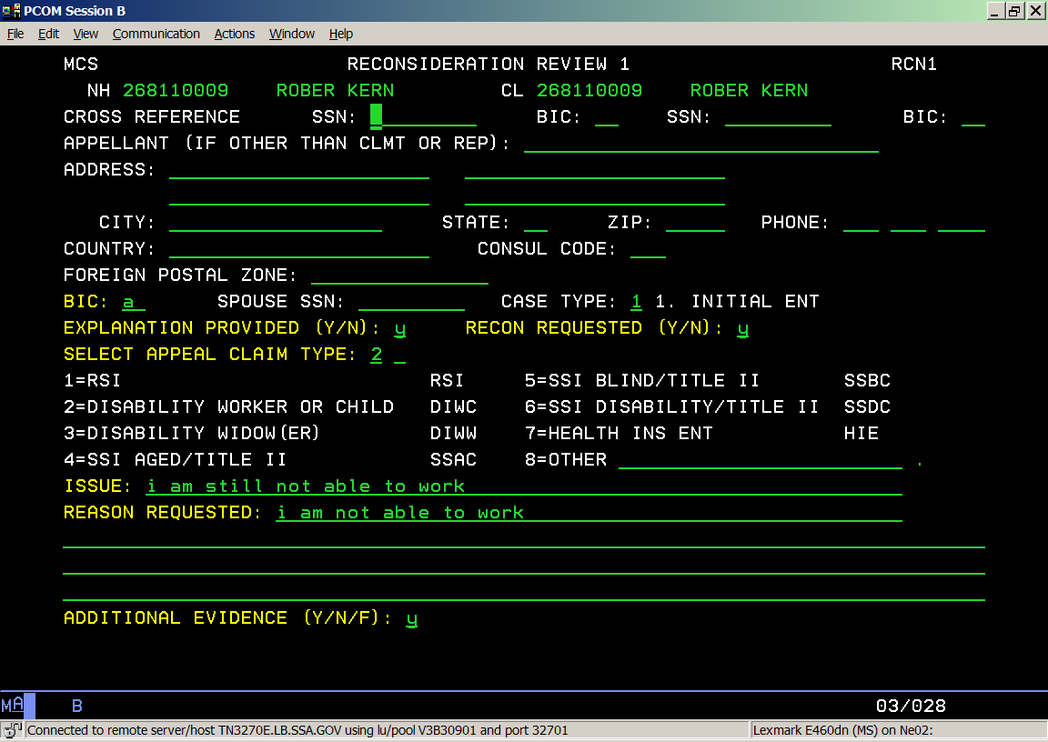
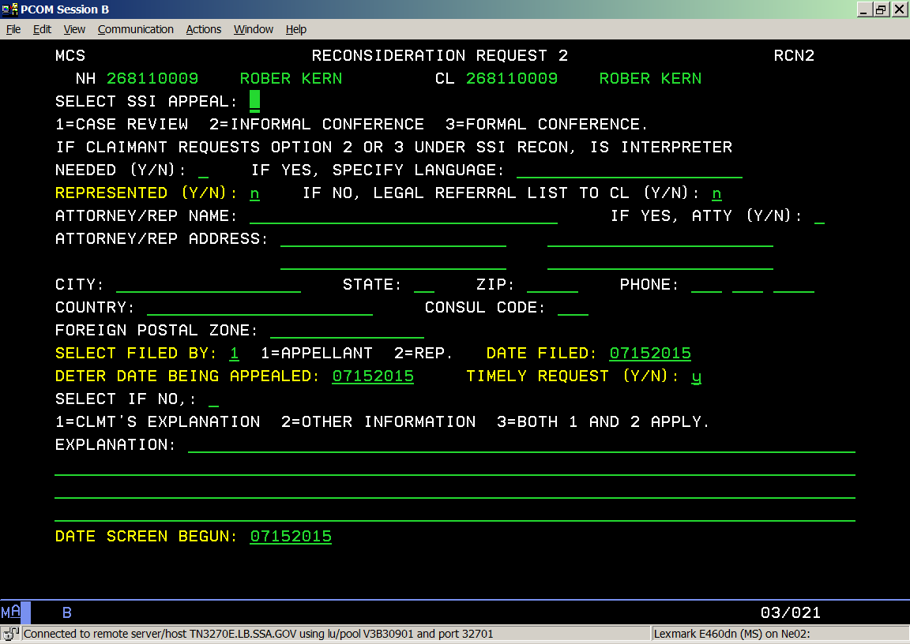

Second level of an appeal is a Hearing. Below are Hearing screens

